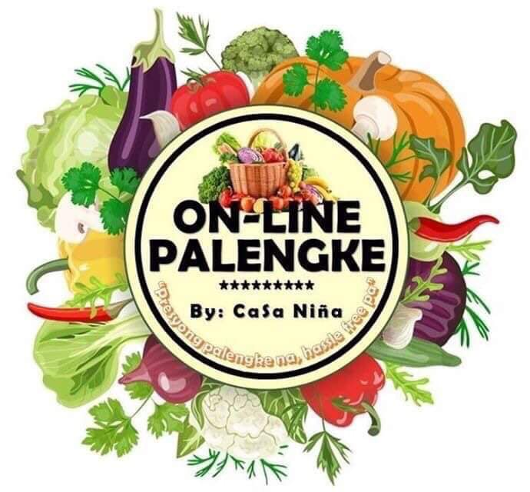

“Preyong palengke na,

hassle free pa.”

PALENGKE

ONLINE