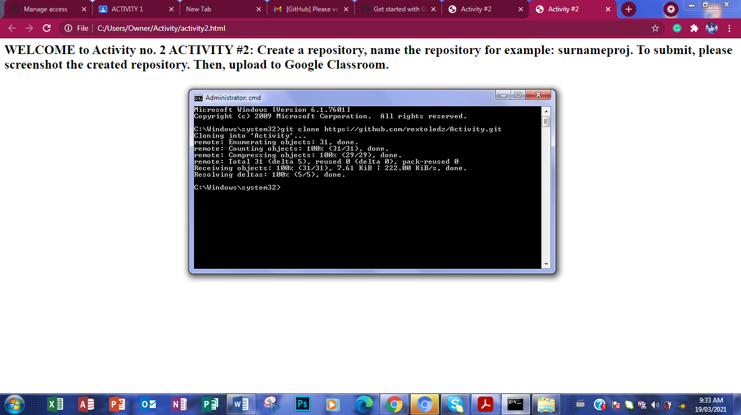1. git clone <https://github.com/rextoledz/Activity.git>