The Militarization of Police &

Police Killings of Civilians

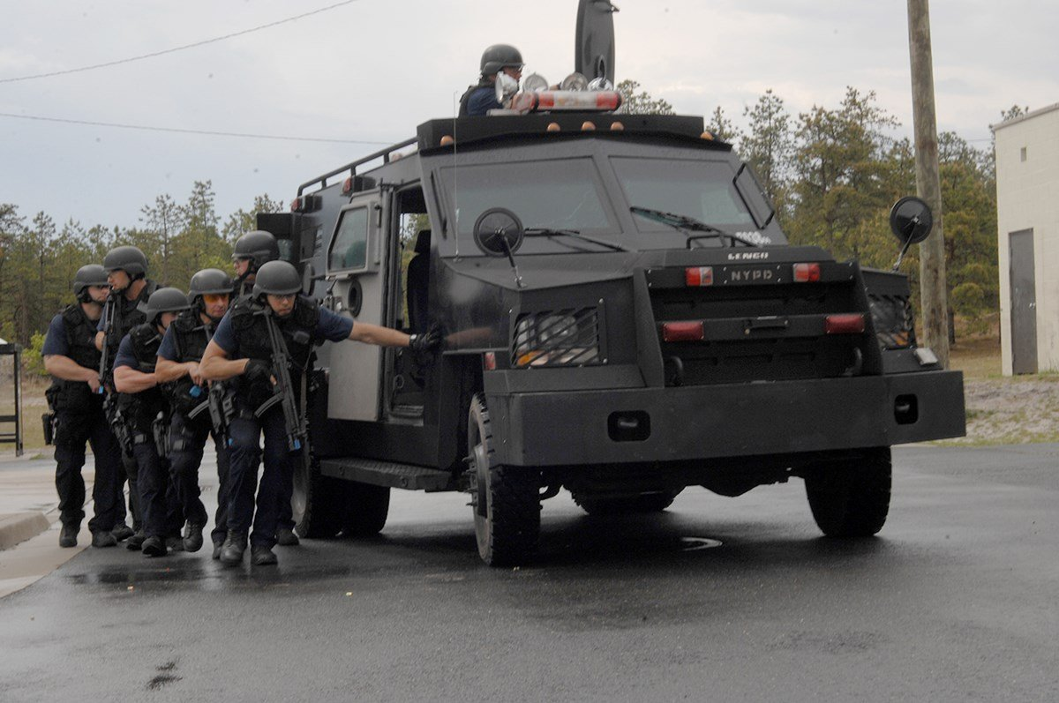

# Introduction

Beginning in 1990, the National Defense Authorization Act allowed for surplus DOD equipment, weapons, and tactical vehicles to be transferred to law enforcement for use in drug enforcement as part of the “War on Drugs.” The use of military equipment by police forces has been on display against civilian protestors in recent months. The protests themselves have been focused on police violence against the civilian population.

The police force is intended to protect and serve the public, but is it possible that military equipment is leading to a militarized mindset? Do officers from departments that make more purchases from the DOD more likely to use deadly force against the public?

# Data Sources & Methods.

The datasets used for this analysis came from the Kaggle dataset below:

* [Police Violence in the US](https://www.kaggle.com/jpmiller/police-violence-in-the-us?select=dod_equipment_purchases.csv)

The datasets provided come from multiple sources including MappingPoliceViolence.org, the Washington Post, FiveThirtyEight, FatalEncounters.org, and census data. Originally, I wanted to explore this data on a precinct by precinct basis and look at the individual precincts, however, multiple precincts can exist within the same city and some city data spans metro-areas across state lines. For this reason, I chose to aggregate data by state and look for larger, regional patterns.

One of the biggest hurdles to understanding police violence is the lack of a uniform, national reporting system.  
  
Exploratory Analysis

How frequently do states see police killings in the states? The graph below shows the distribution of civilian deaths within the united states between 2012 and 2019. The majority of states saw less than 250 deaths in the span of those 7 years. There are four states in particular that stand out away from the rest of the states.

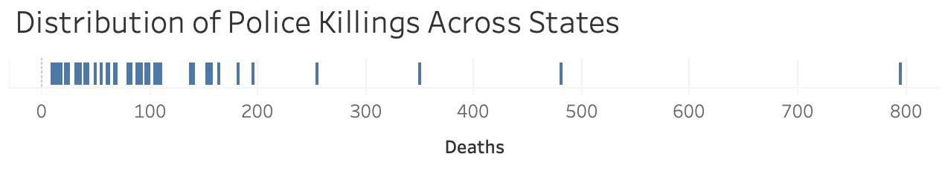

When we take a look at the deaths compared to state population, the three of the four outliers are not only outliers in deaths but in population as well. Those three states are California, Texas, and Florida respectively. However when we look at deaths per 100k citizens in a state we begin to see a different picture.

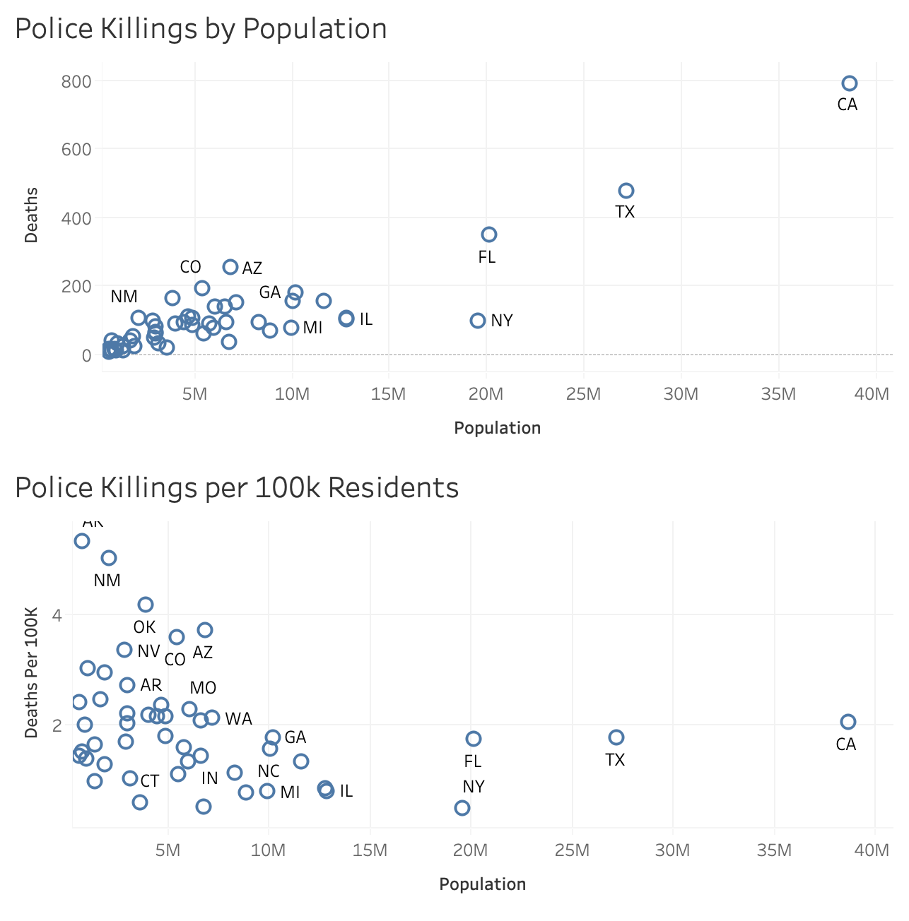

While California, Texas, Florida, and New York have large populations, they remain close to or below the mean across the states (1.97 Killings/100k). States in the upper left-hand section of the chart – Alaska, New Mexico, Oklahoma, Montana, Nevada, etc – all show an above average rate of police killings with below average population.

The next three figures show the trendlines of Department of Defense expenditures by state and how they compare

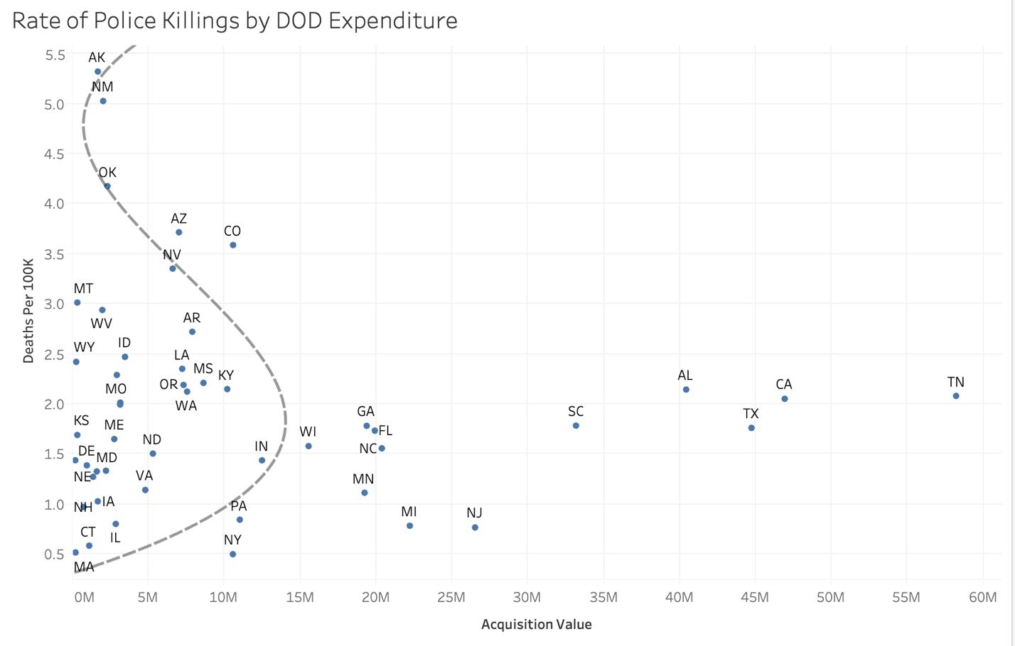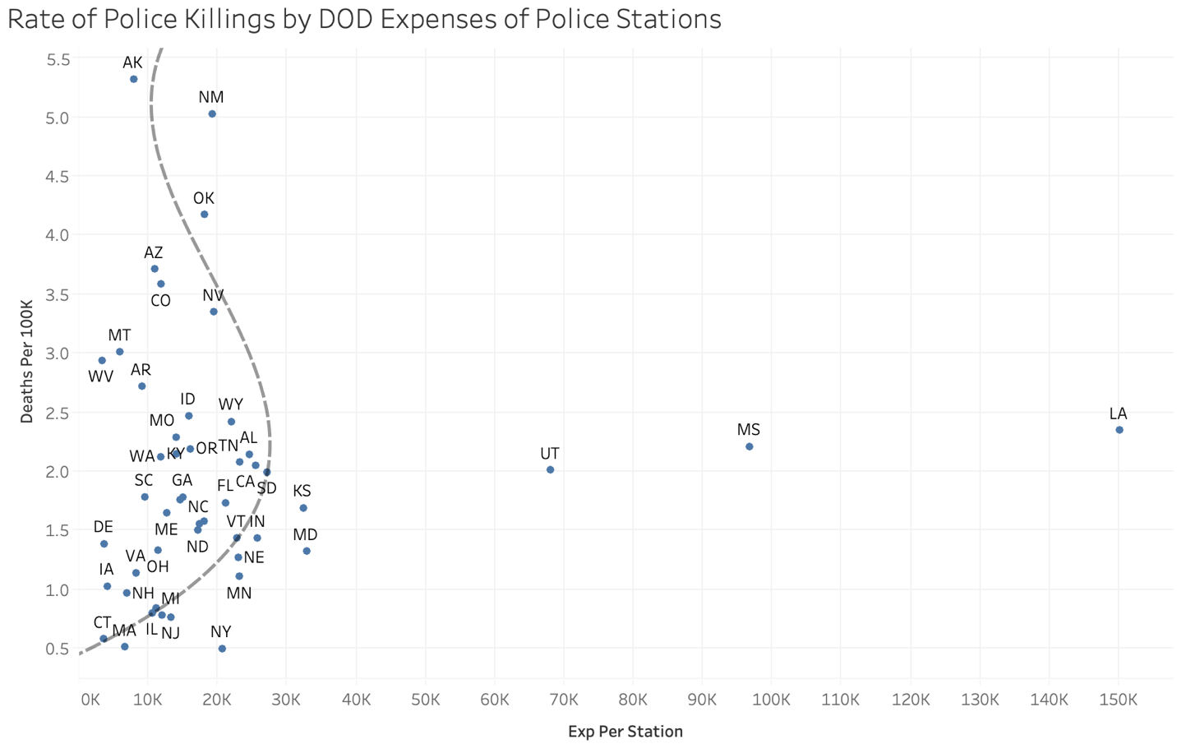

The trend line that best fits the relationship between Policing Expenditure is a polynomial curve. Up to a certain point, increased DOD purchases have an increase in police killings, but not in all instances. After a certain point, the DOD purchase influence seems to vanish. That is to say states with few purchases from the DOD have both high and low rates of police killing, but states with higher expenditures tend to fall around the average rate of police killings.

# Modeling & Observations

I used multiple regression models to determine what factors played the highest role in determining the rate of police killings per state – KNeighbors, XGBoost, and Lasso Regression. I ran the XGB model twice, one time dropping Alaska as an potential outlier but it had little effect on the results.

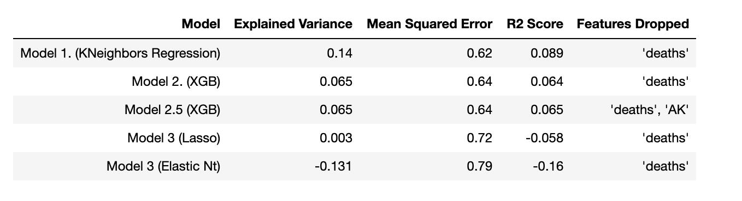

The final model I selected was Model 2, and exported the feature weights to determine which factors carried the most weight in predicting the killings/100k residents. I was surprised to find that the most heavily weighted factor was the percent of the state population consisting of Indigenous peoples, with the second most being the percent of population consisting of Asian peoples. The DOD elements we were looking for – Quantity of Purchases and Value of Purchases did appear in the top 10 factors, but below various racial factors, numbers of police stations in the state, and overall state population.

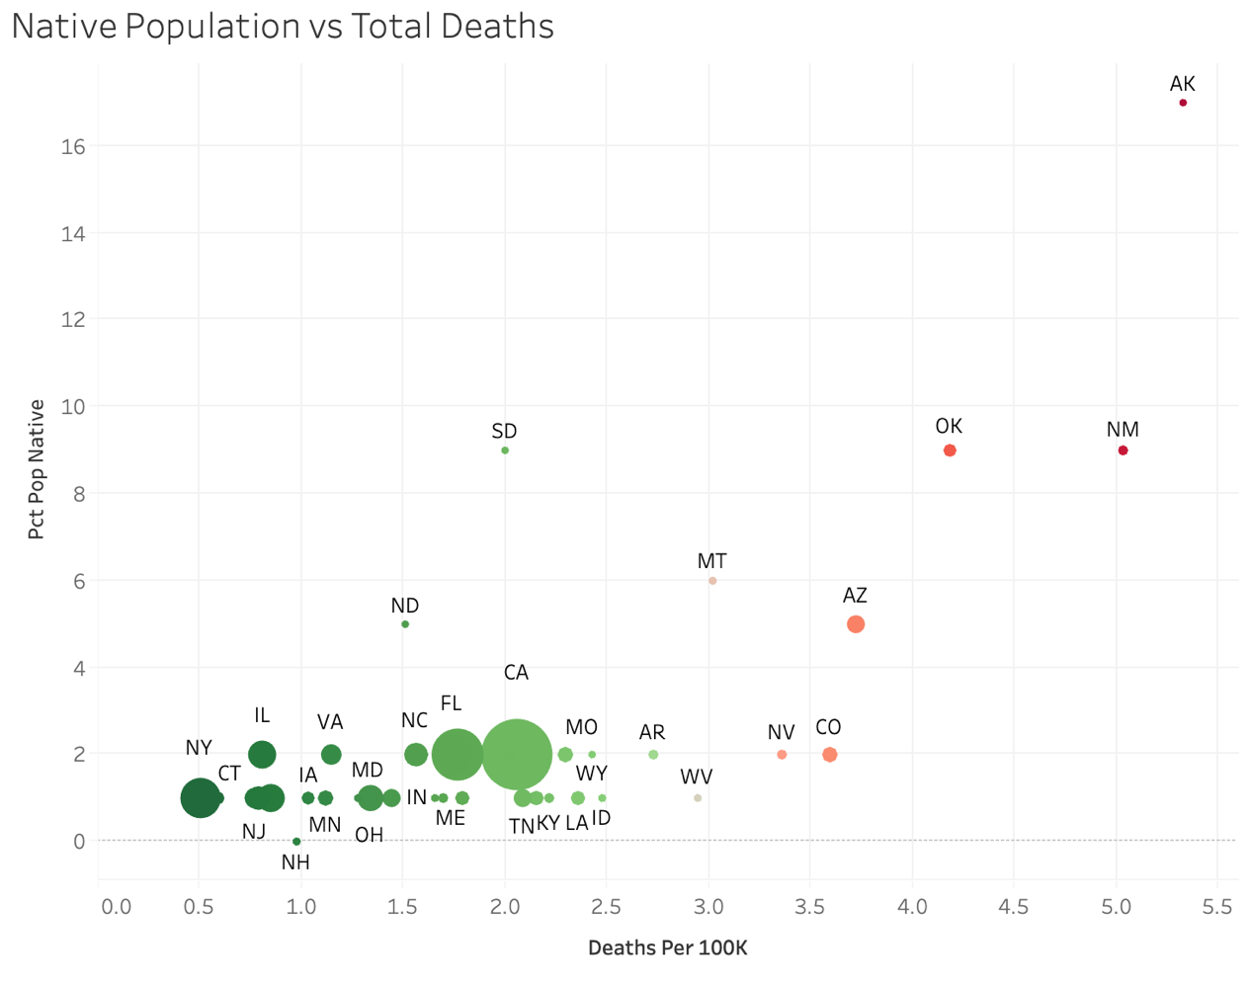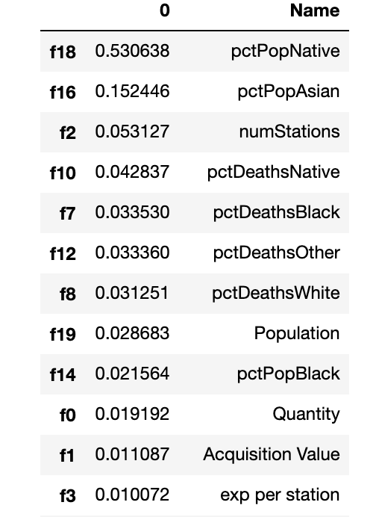

## Conclusions and Next Steps

It is no surprise that Indigenous Peoples are a heavily marginalized group in the United States with a history of tensions and dehumanization with the European settlers that colonized this country. However, this remains a high-level overview.

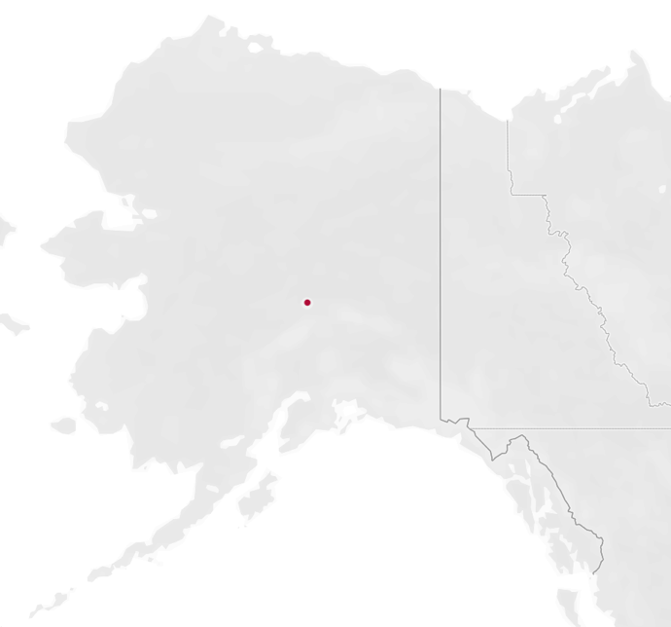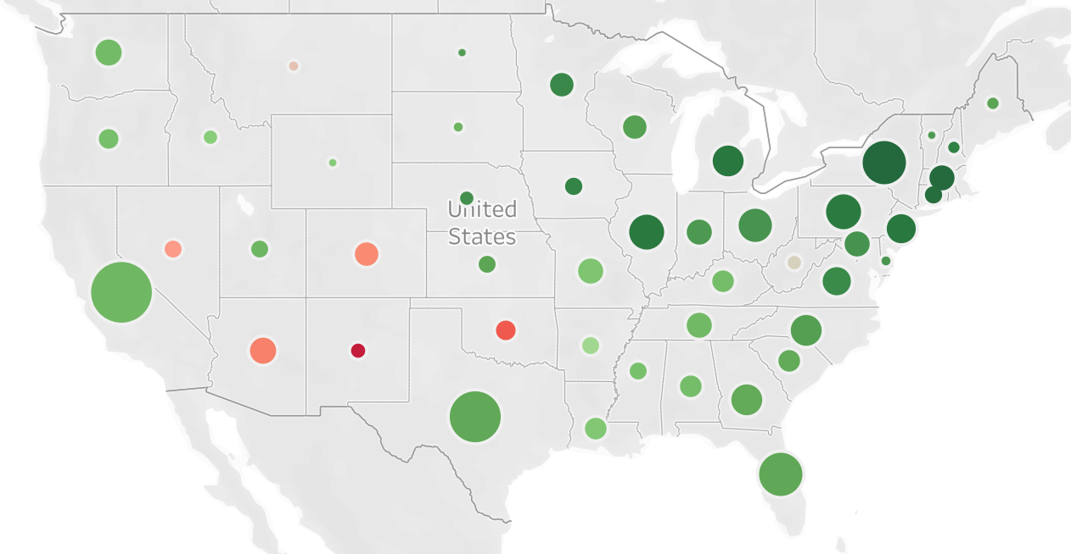

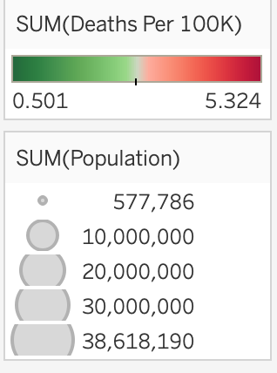

Looking at a visualization of the concentration of states with higher per capita killings, you can see a group of 5 in the southwest and the states with the lowest per capita killings are in the northeast.

Further exploration should examine city vs urban vs rural police killings, as well as socioeconomic and perhaps even environmental factors playing into the death rates – i.e. do extreme temperatures lead to increased police killings.