M.J. BILLONES TRANSPORT SERVICE
Delivery Management System
User Manual: every screen, every button, from start to finish
For: Owner / Administrator and office staff
Covers: Dashboard, Operations, Resources, Payments, Master Data and Settings
Edition: October 2026

How to use this manual
Each chapter follows the order of a normal working day. Every screen is shown as a real screenshot from the system. Red numbered circles with arrows point to the parts of the screen; the table under each picture explains each number.
# | Part of the screen | What it does / what happens when you click it
1 | Red numbered circle | Find the same number in the table below the picture.
2 | Arrow | Points to the exact button, box or column being explained.

Rules that apply on every screen
- Fields marked * are required. The form will not save until they are filled in correctly, and the problem field is highlighted.
- Save, Add, Update, Delete and Reset always ask “Are you sure?” first. Click Yes to continue or No to go back. Nothing is changed when you click No.
- Nothing is permanently deleted. Orders and invoices are cancelled, receipts and reports are voided, and trucks, crew, clients and users are deactivated. They stay in history and in the audit log.
- Duplicates are blocked. Plate numbers, client names, route codes, store codes, usernames and reference numbers must be unique. The system warns you while you type.
- Unfinished forms are kept as drafts. If you leave a form, a yellow “Unsaved draft” bar offers Restore or Discard the next time you open it.
- Number-only fields (crates, amounts, capacity) do not accept letters.
- Right-click any row in a list for quick actions, and double-click a row to open it.

Contents

The daily workflow, from start to finish
This is the order in which work moves through the system. Each step has its own chapter later in this manual.
- Set up once: add your clients and their stores, delivery routes, trucks (with category and capacity), crew (drivers with licence details, and aides) and user accounts. Check your business details and company logo in Settings → Preferences & Customization.
- Create the order: Operations → Loading Schedule & Dispatch → + Add Order (or + New loading order on the Dashboard). Choose the client (the dispatch number fills in by itself, e.g. Red Ribbon → RR0001), route, truck, driver, aides, date and time, then SAVE DISPATCH.
- Truck leaves: the order status becomes In Transit (at the departure time, or when you change it).
- Truck returns: Operations → Trip Reports → + New trip report. Enter what each store received and returned, check each crew member’s wage and meal allowance, attach the POD and receipts, then ✓ Complete trip.
- Problems on the trip: record damaged or missing crates in Incident & Damage Logs, and tick Charge Crew if the loss is charged to the crew.
- Bill the client: Payments → Billing Invoices → + New invoice, choose the completed trip, then ISSUE INVOICE. (Or open Operations → Order History → Completed, click the trip and press Create invoice.)
- Record the payment: Payments → Collections & Receipts → + New receipt, choose the invoice, enter the amount and method, then RECORD PAYMENT.
- Month end: Payments → Statement of Account → + New statement for each client, and print the official SOA.
- Look up any past transaction: Operations → Order History. Search for anything, pin the records you use often, or use 🔎 Find a transaction when you have forgotten the number.
- Protect your data: Settings → Backup & Restore → CREATE BACKUP SNAPSHOT, and copy the file to a USB drive or cloud storage.

Tip: The Dashboard’s “Needs attention” list always tells you which of these steps is waiting, marked Urgent, Incoming or Notice, and its buttons take you straight to that step.

Signing in and out
- Open the M.J. Billones Delivery Management System from the desktop or Start menu.
- Type your Username and Password. Click the eye icon to show the password while typing.
- Tick Remember Me if you want your username filled in next time (the password is never remembered).
- Click LOGIN (or press Enter). The Dashboard opens.

Wrong password: After 5 wrong attempts the account is locked for 60 seconds. Every sign-in, success or failure, is recorded in the Security Audit Logs.

Forgot Password? Click the link on the login screen and answer your security question to set a new password. If you have no security question, ask the administrator to reset it in Settings → User Accounts.

To sign out, click Log out at the top right and confirm. Closing the window with ✕ (even from the taskbar while the app is minimized) asks the same question: Yes, log out / Stay / Close the program instead. If a form has unsaved changes, the draft is kept.

Getting around

The Dashboard (home screen)
This is the first screen you see after signing in. It shows the day's work at a glance and lists what needs your attention next. The whole page scrolls as one, and every row can be clicked to go straight to the related record.
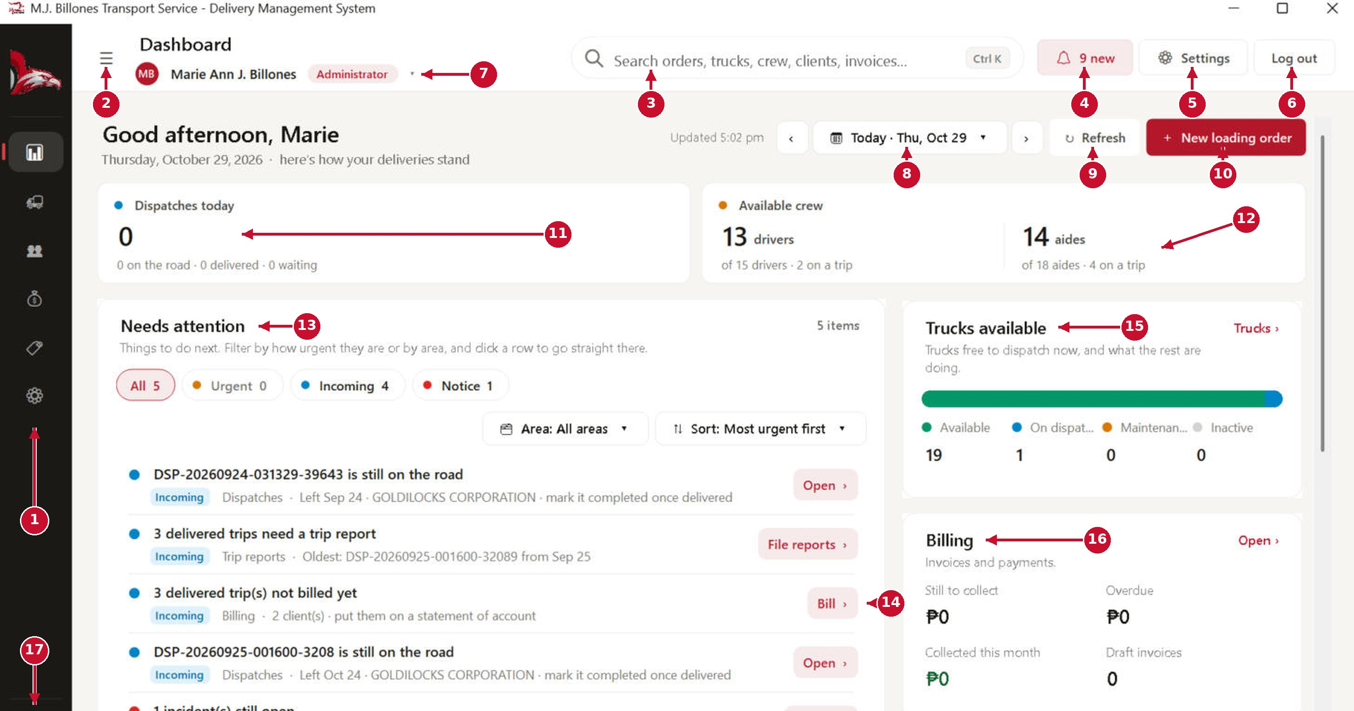
# | Part of the screen | What it does / what happens when you click it
1 | Sidebar (module icons) | The main menu. Each icon opens a module: Dashboard, Operations, Resources, Payments, Master Data and Settings. Hover over it to see the names; click an icon to open that module.
2 | Menu button ☰ | Pins the sidebar open so the module names are always visible. Click it again to make the sidebar hide itself when you are not using it.
3 | Global search (Ctrl + K) | Finds dispatches, trucks, crew, clients and invoices from any screen. Type at least 2 letters; results appear in a list. Click a result (or press Enter) to open it.
4 | Notifications bell | Shows how many new notifications you have. Click it to open the notifications panel; click a notification to open the record it is about.
5 | Settings | Opens System Settings (users, appearance, backup and restore, audit logs).
6 | Log out | Signs you out and returns to the login screen. You will be asked to confirm. Closing the window (even while it is minimized) asks the same question first.
7 | Your name and role ▾ | Opens your user profile: your details, password and security question, your sign-in history and your recent activity.
8 | Date button ‹ Today › | Pick the period the tiles and lists count: Today, Tomorrow, This week, Next 7 days, This month and more, a specific date, or a date range. The ‹ › arrows step to the previous or next day, week or month.
9 | Refresh | Reloads the numbers from the database. The time beside “Updated” shows when it last refreshed.
10 | + New loading order | Opens a new dispatch / loading order form, the first step of every delivery.
11 | Dispatches tile | How many dispatches fall in the chosen period, and how many are on the road, delivered or still waiting. Click it to open the dispatch list.
12 | Available crew | Drivers and aides side by side: how many are free right now and how many are on a trip. Click it to open Crew Management.
13 | Needs attention | Your to-do list. Each item is marked Urgent (orange), Incoming (blue) or Notice (red). The buttons and chips at the top filter and sort it; see the next page.
14 | Action buttons (Open, File reports, Review, Bill) | Takes you straight to the screen where that item is finished. For example, “Bill ›” opens billing with those trips ready to invoice.
15 | Trucks available | How many trucks are available to dispatch now, on a dispatch, under maintenance or inactive. “Trucks ›” opens the truck list.
16 | Billing | Amounts still to collect, overdue, collected this month and draft invoices. “Open ›” opens the invoice list.
17 | Dark / light mode | Switches the whole system between light and dark colours. You stay on the same screen.

Needs attention: filter and sort
Every to-do item on the dashboard is marked Urgent, Incoming or Notice and belongs to an area (Dispatches, Loading orders, Trip reports, Incidents, Billing, Trucks or Accounts). Your filter and sort choices stay the same when you come back to the dashboard. When there are more than 6 items, click “Show all” at the bottom to see the rest (“Show fewer” folds them again).
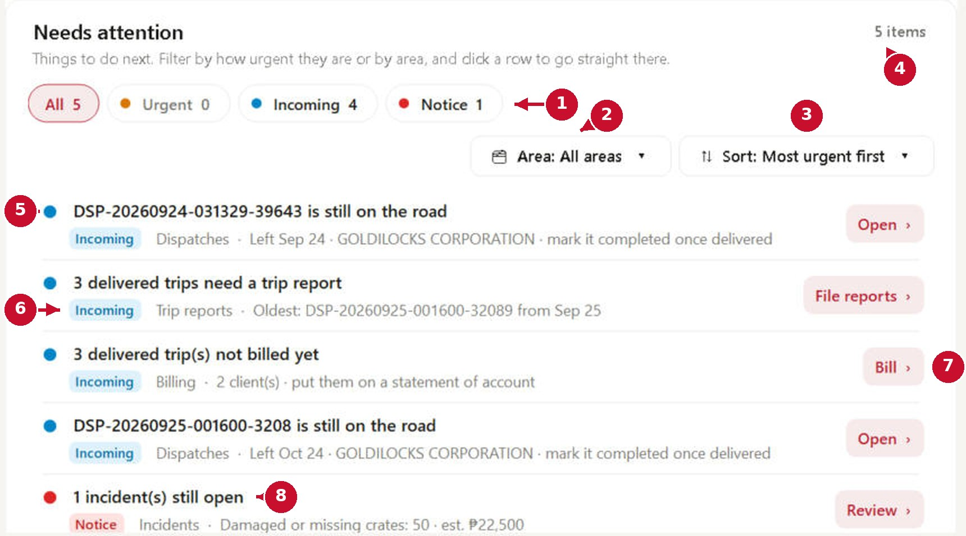
# | Part of the screen | What it does / what happens when you click it
1 | All · Urgent · Incoming · Notice | Show everything, or only one level. The number on each button is how many items it has. Urgent (orange): dispatches that have not left on time and overdue invoices. Incoming (blue): trips still on the road, missing trip reports, unbilled trips and accounts waiting for approval. Notice (red): loading orders without a dispatch, open incidents, draft invoices and trucks under maintenance.
2 | Area | Show only one part of the work, for example Billing or Trip reports. The level buttons then count only that area.
3 | Sort | Most urgent first (Urgent, then Incoming, then Notice), Oldest first, Newest first, Most records first, or Group by area with a heading for each area.
4 | Item count | How many items there are, or “2 of 5 items” while a filter is on. If nothing matches, click “Clear the filters” to see everything again.
5 | Item | The coloured dot shows the level. The title says what needs doing.
6 | Level tag and area | The level in words, the area, and the details (client, date, number of records).
7 | Action button | Click the row or its button to go straight to the screen where the item is finished.
8 | Notice item | Notice items are shown in red; here an open incident with damaged or missing crates.

The sidebar menu (pinned open)
Click ☰ to pin the menu open. Each module groups related screens into tabs.
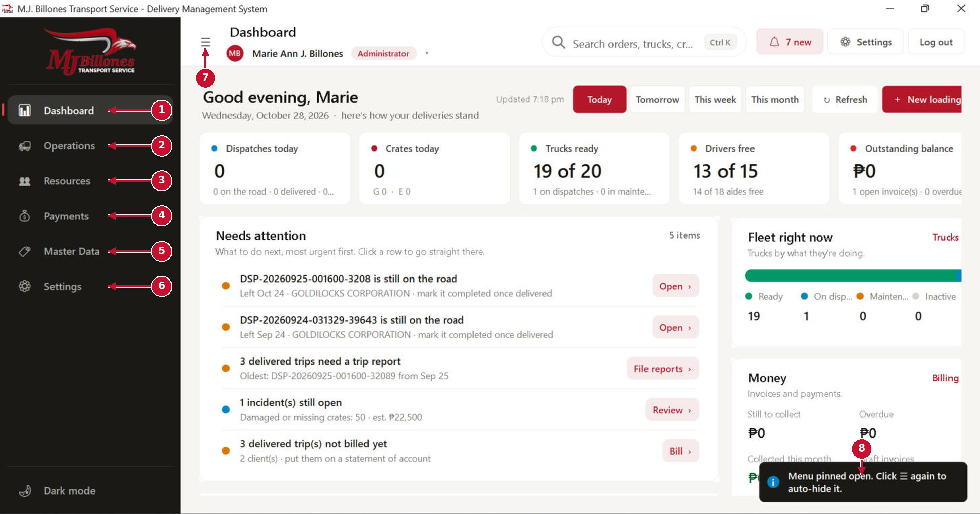
# | Part of the screen | What it does / what happens when you click it
1 | Dashboard | Home screen with today's summary and to-do list.
2 | Operations | Loading schedule and dispatch, special trips, incidents, trip reports and Order History (which also lists every completed trip).
3 | Resources | Trucks, crew (drivers and aides), crew trip history and resource history.
4 | Payments | Statements of account, billing invoices, collections and receipts, and finance history.
5 | Master Data | Clients and their stores, delivery routes, and master data history.
6 | Settings | Dispatch rules, user accounts, appearance, preferences, change history, backup and restore, audit logs.
7 | ☰ (pin / unpin) | Click again to un-pin. The menu then shrinks back to icons and opens only when you hover over it.
8 | Message (toast) | Short confirmations appear here in the bottom-right corner and disappear on their own.

Global search
Click the search box (or press Ctrl + K anywhere) and start typing. Results are grouped by type.
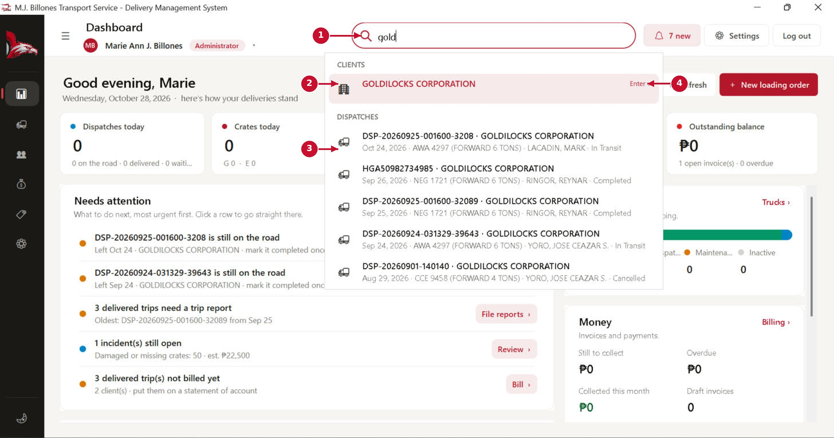
# | Part of the screen | What it does / what happens when you click it
1 | Search box | Type part of a dispatch number, plate number, crew name, client name or invoice number. Press Esc to close.
2 | Results by group | Clients, Dispatches, Trucks, Crew and Invoices are shown in separate groups. The highlighted result opens when you press Enter.
3 | Dispatch result | Shows the date, truck, driver and status, so you can pick the right one. Click it to open the dispatch details.
4 | Enter ↵ | Shortcut hint: Enter opens the highlighted result; use the ↑ ↓ arrow keys to move between results.

Operations: dispatching deliveries

Loading Schedule & Dispatch (order list)
Operations → Loading Schedule & Dispatch lists every delivery order. From here you create new orders and follow each one until it is completed. Finished orders are also listed in Order History → Completed.
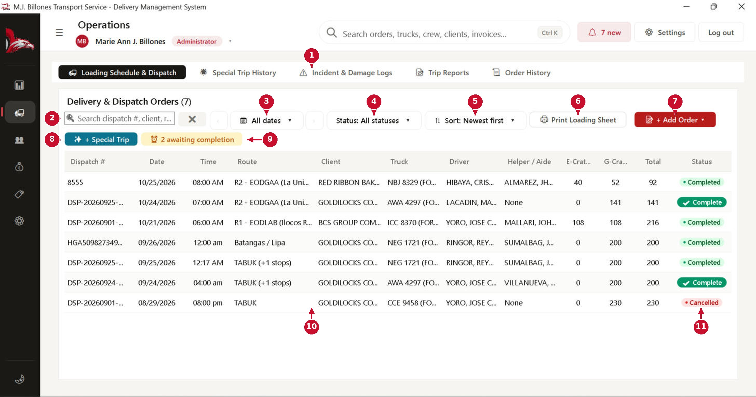
# | Part of the screen | What it does / what happens when you click it
1 | Operations tabs | Switch between Loading Schedule & Dispatch, Special Trip History, Incident & Damage Logs, Trip Reports and Order History.
2 | Search | Filters the list as you type (dispatch number, client, route, truck, driver). Click ✕ to clear it.
3 | Date button ‹ All dates › | Show orders for a day, week or month, a specific date or a date range. ‹ › step to the previous or next period.
4 | Status | Show all orders, or only Scheduled, In Transit, Completed or Cancelled ones.
5 | Sort | Newest first, oldest first, by client, by crates and more.
6 | Print Loading Sheet | Prints the loading sheet of the selected order for the warehouse and the driver.
7 | + Add Order | Opens the New Dispatch Order form (see the next pages).
8 | + Special Trip | Creates a special trip, for non-crate or specialised cargo that does not follow a normal route.
9 | Awaiting completion | How many orders have been delivered but are not yet marked Complete. Click it to show only those.
10 | Order rows | Double-click a row to open its full details. Right-click a row for quick actions (open, edit, set status, print, copy, cancel).
11 | Status | Scheduled → In Transit → Completed. Cancelled orders stay in the list for history; nothing is permanently deleted.

New Dispatch Order: 1. Route & store crates
Fill the form from top to bottom. Fields marked * are required. If you leave the form, what you typed is kept as a draft and offered back the next time you open it.
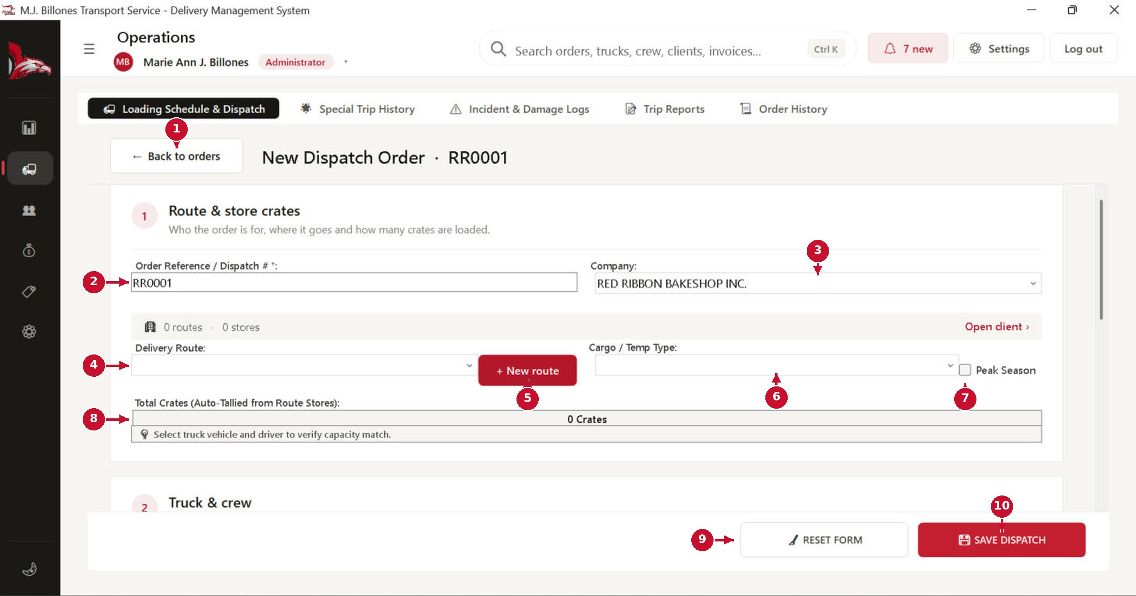
# | Part of the screen | What it does / what happens when you click it
1 | ← Back to orders | Returns to the order list without saving. Your inputs are kept as a draft.
2 | Order Reference / Dispatch # * | Filled in automatically when you choose the client: the client's initials plus a running number, for example Red Ribbon Bakeshop → RR0001, RR0002… You may type your own number instead; it must be unique.
3 | Company | The client this delivery is for. Choosing a client loads its routes and stores and creates the dispatch number.
4 | Delivery Route | Choose the route. The stores on that route and their crate counts are loaded automatically.
5 | + New route | Opens Quick Add Route, if the route does not exist yet. The new route is checked for duplicates before saving.
6 | Cargo / Temp Type | Cold / Chilled, Dry Goods, or a mix. Non-crate or specialised cargo must go through Special Trip instead.
7 | Peak Season | Tick it if the peak-season rate applies to this trip.
8 | Total crates & truck check | The system adds up the crates and warns you if the chosen truck is too small.
9 | RESET FORM | Asks “Are you sure?”, then clears every field on the form.
10 | SAVE DISPATCH | Asks for confirmation, checks every rule (truck free, driver licence valid, no duplicates) and then saves the order.

New Dispatch Order: 2. Truck & crew
Only trucks and crew who are free on the dispatch date are offered, so you can also schedule trips for future dates.
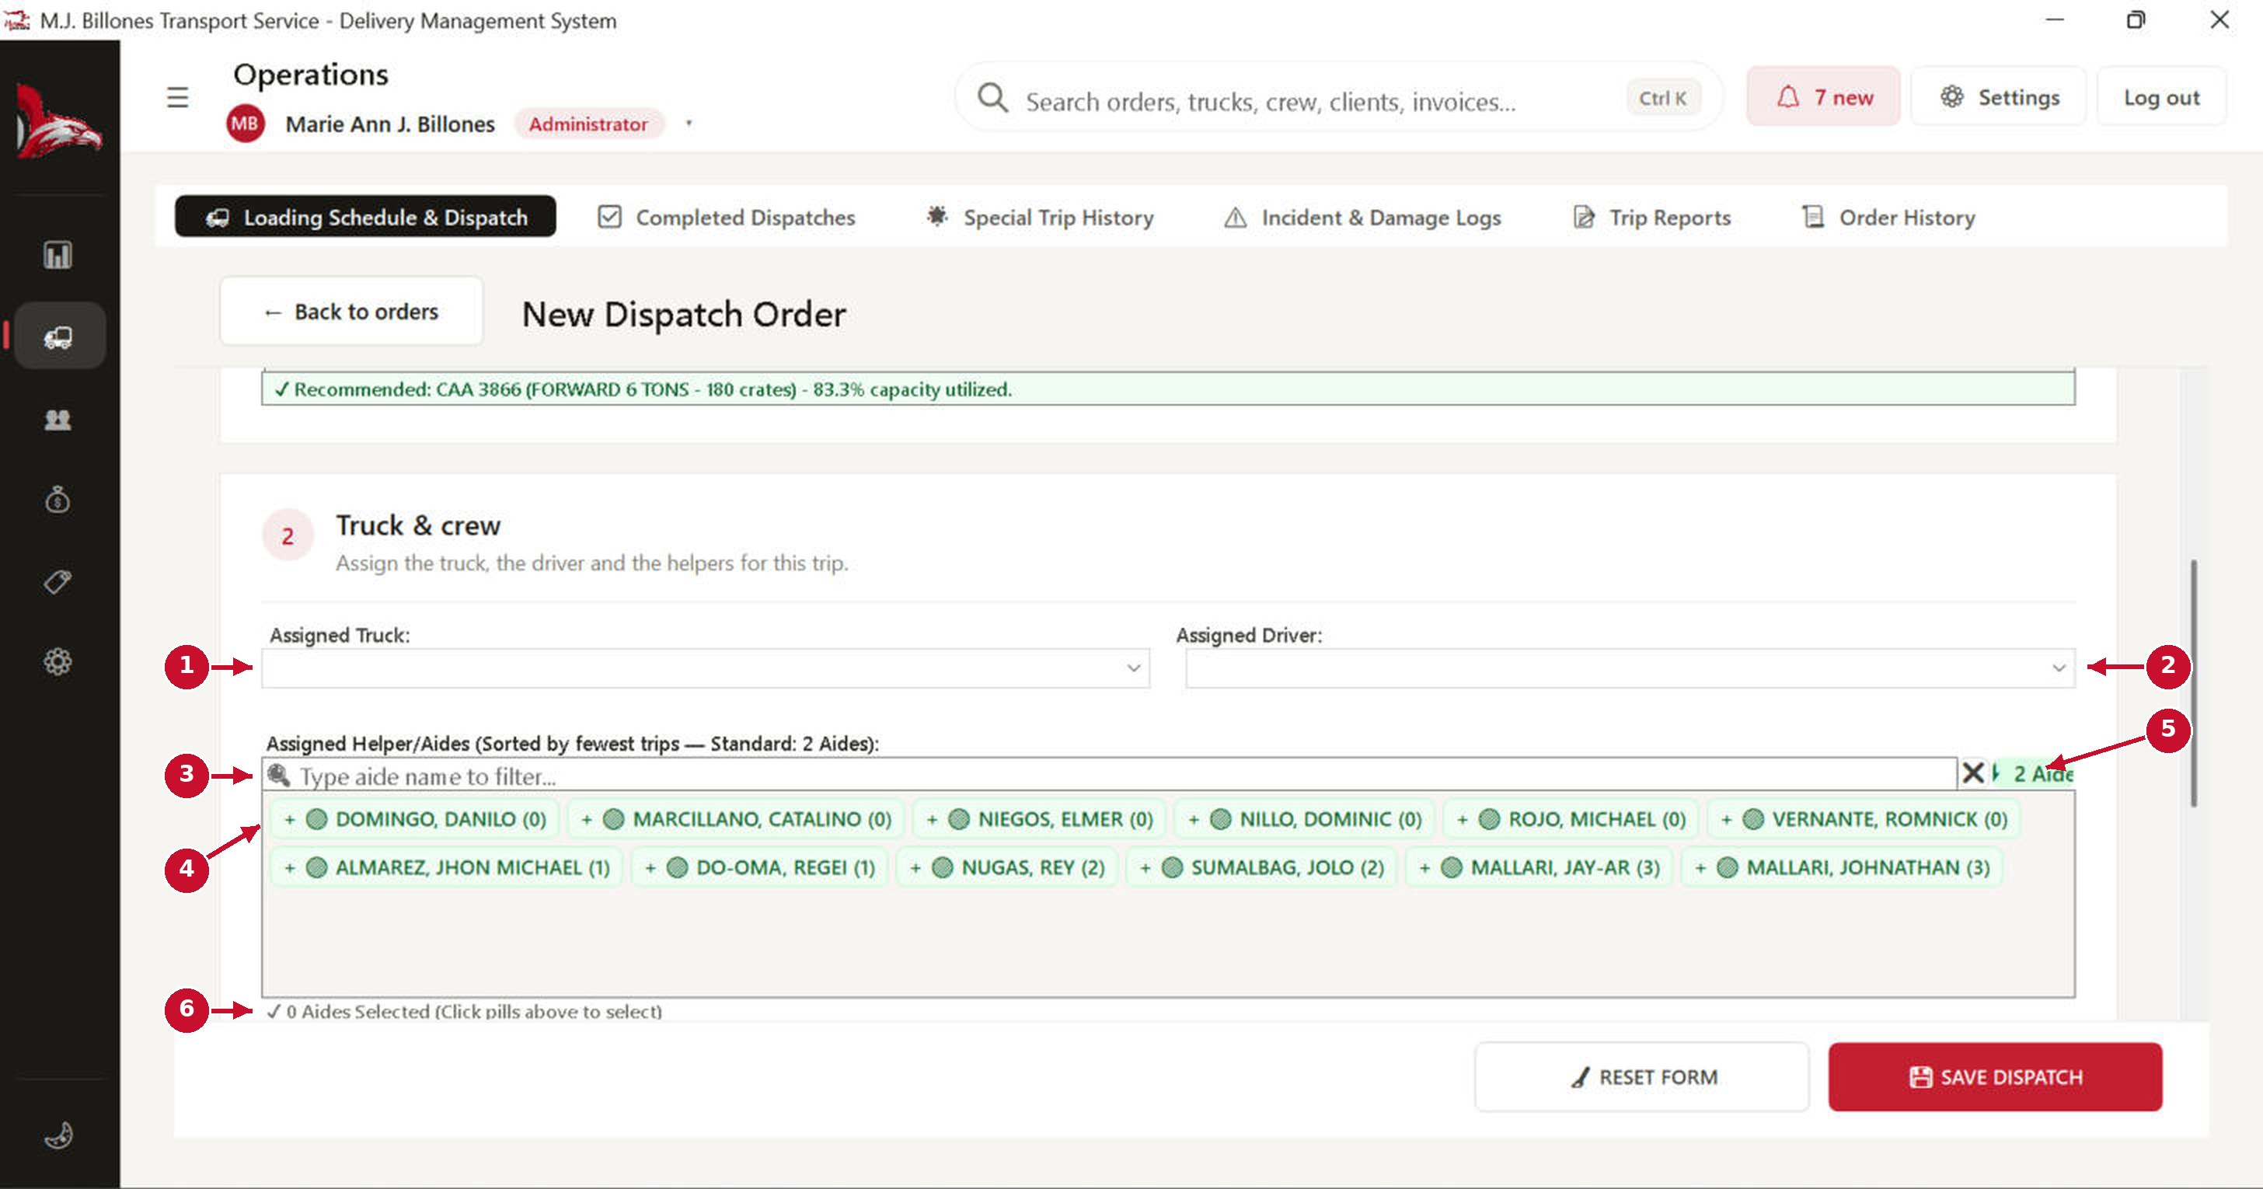
# | Part of the screen | What it does / what happens when you click it
1 | Assigned Truck | Pick a truck. Trucks already on another trip that day, under maintenance or inactive are not listed.
2 | Assigned Driver | Pick a driver. Drivers who are busy, or whose licence will have expired by the dispatch date, are not listed.
3 | Aide filter | Type part of a name to find an aide quickly.
4 | Aide pills | Click a name to add that aide to the trip; click again to remove them. The number in brackets is how many trips they already have, so you can share the work fairly.
5 | Standard aides | The usual number of aides per trip (2). The counter turns green when you have chosen enough.
6 | Selected count | How many aides you have selected.

New Dispatch Order: 3. Schedule & status
Set when the truck leaves. Then press SAVE DISPATCH.
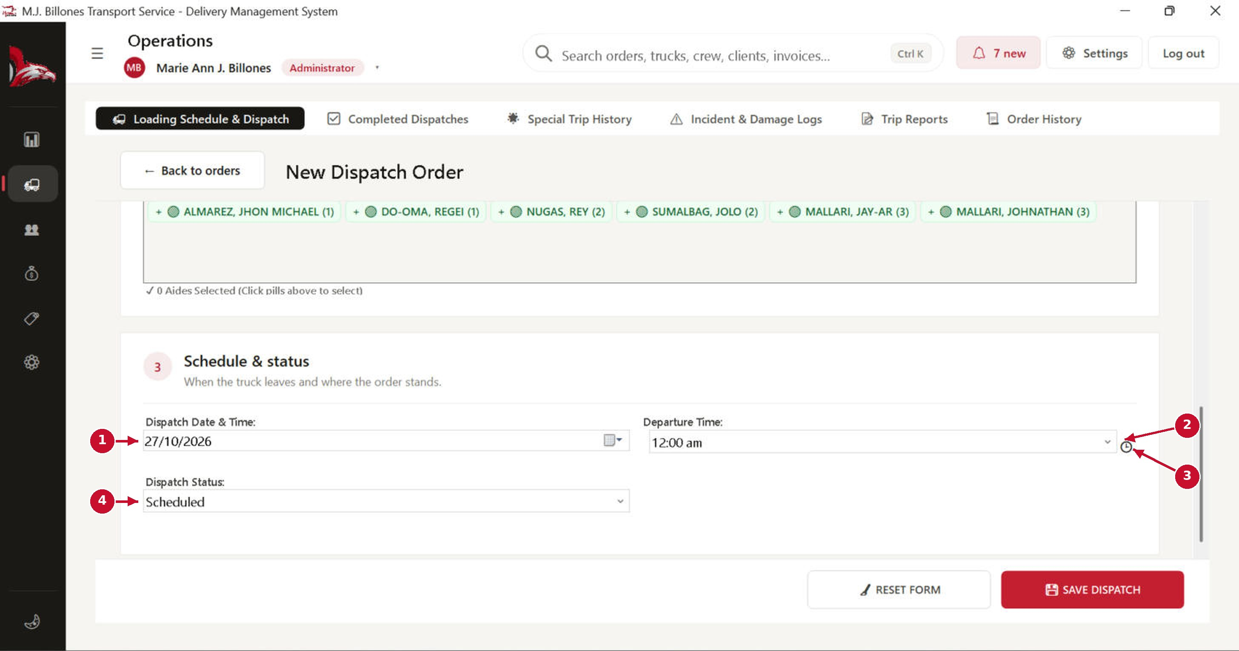
# | Part of the screen | What it does / what happens when you click it
1 | Dispatch Date | The day of the trip. Changing it refreshes which trucks and crew are free.
2 | Departure Time | The time the truck leaves the plant.
3 | Clock picker | Opens a clock to pick the time with the mouse.
4 | Dispatch Status | Usually Scheduled for a new order. It changes to In Transit when the truck leaves and to Completed after delivery.

Dispatch details window
Double-click any order to open this window. It shows the whole life of one delivery, from schedule to payment.
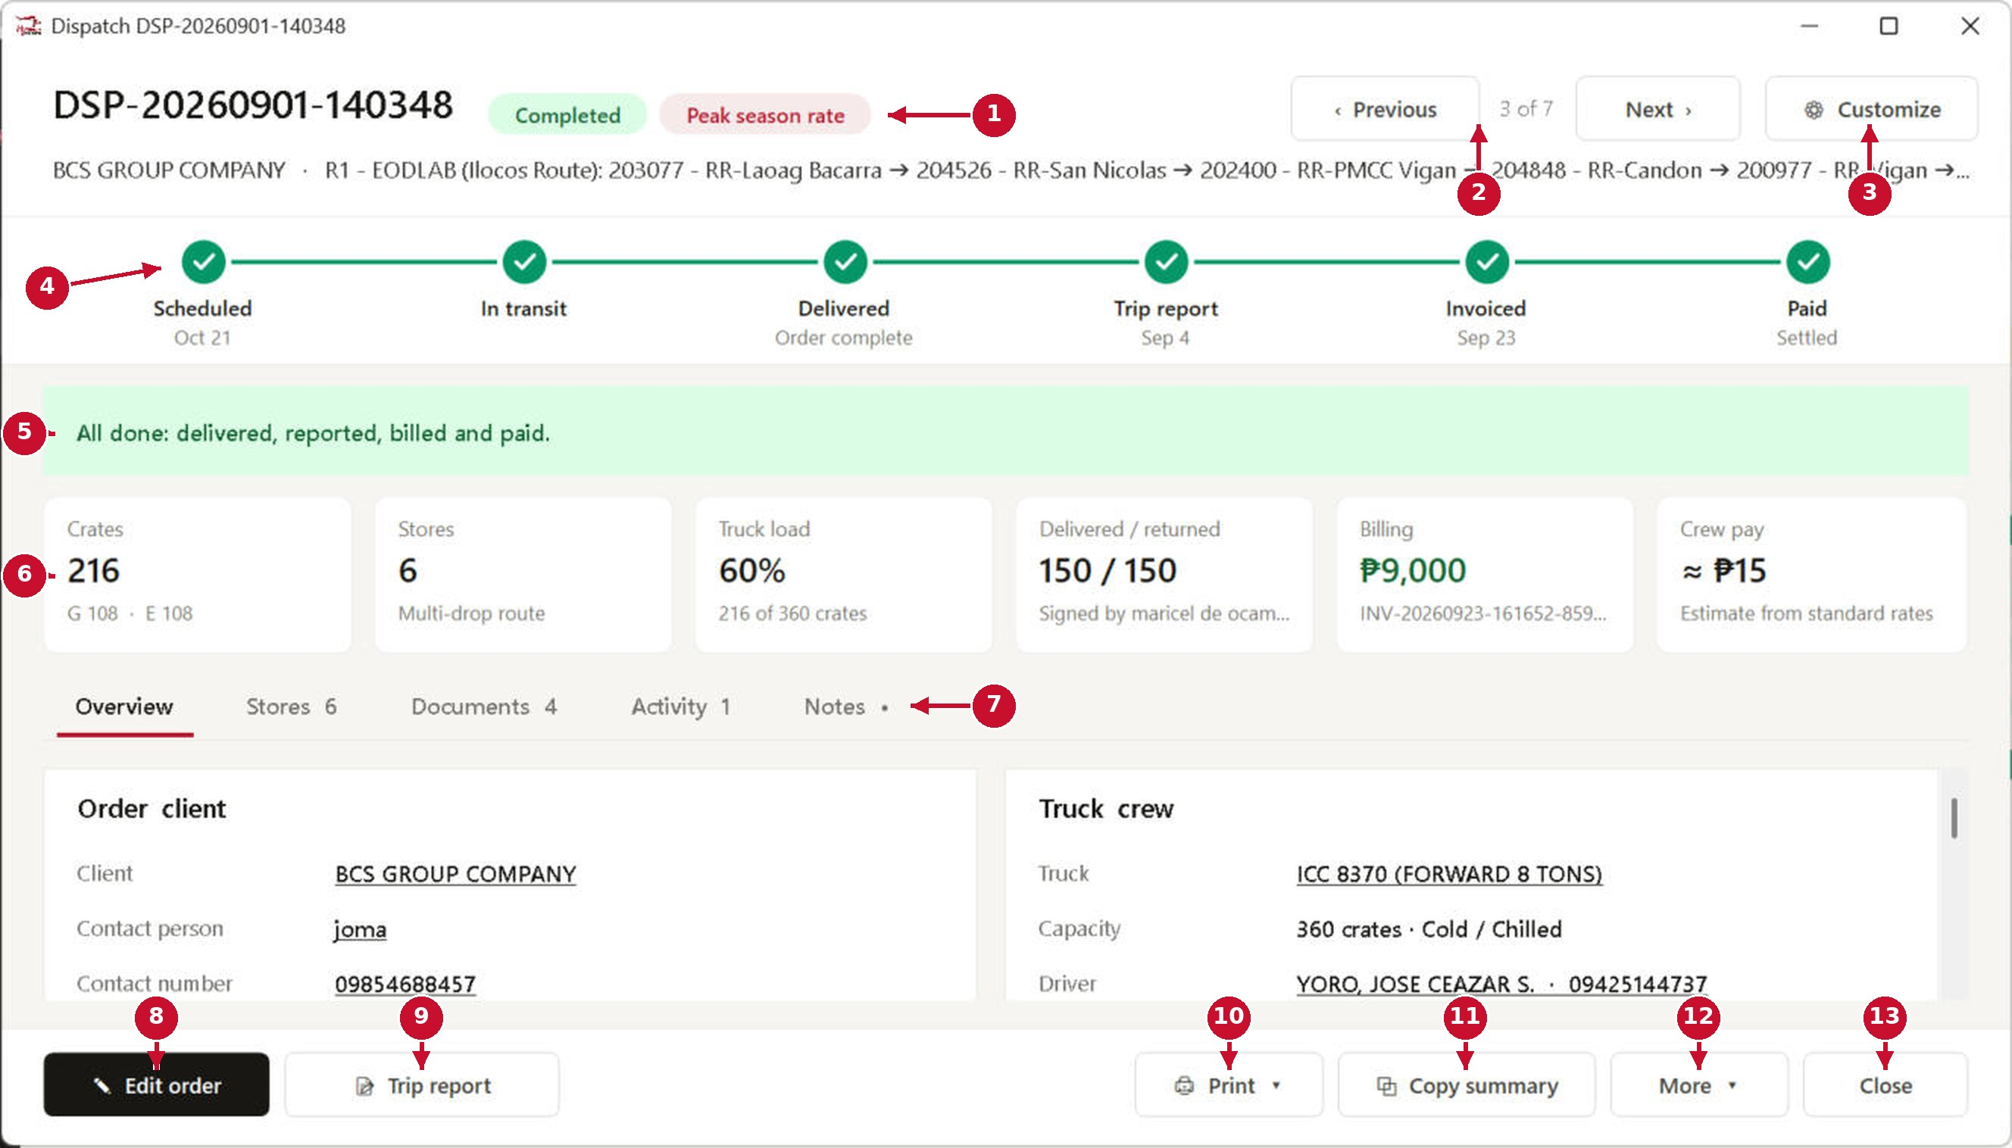
# | Part of the screen | What it does / what happens when you click it
1 | Status chips | Current status, plus tags such as Peak season rate.
2 | ‹ Previous / Next › | Move to the previous or next order in the list without closing the window.
3 | Customize | Choose which sections and fields this window shows.
4 | Progress timeline | Scheduled → In transit → Delivered → Trip report → Invoiced → Paid. Green ticks show what is done.
5 | What to do next | A plain message telling you the next step, or “All done” when finished.
6 | Summary tiles | Crates, stores, truck load %, delivered/returned crates, billing amount and crew pay estimate.
7 | Tabs | Overview, Stores, Documents (linked schedule, trip report, invoice, receipt, attachments), Activity (history) and Notes.
8 | Edit order | Opens the order in the dispatch form so you can change it.
9 | Trip report | Opens (or starts) the trip report for this dispatch.
10 | Print ▾ | Print the loading sheet, trip report, or a full dossier of this delivery.
11 | Copy summary | Copies a short text summary you can paste into a message.
12 | More ▾ | More actions, such as changing status or cancelling the order.
13 | Close | Closes the window (Esc works too).

Special Trip History
Special trips are on-demand deliveries for non-crate or specialised cargo (furniture, machinery, bulk, oversize). They have their own form and history.
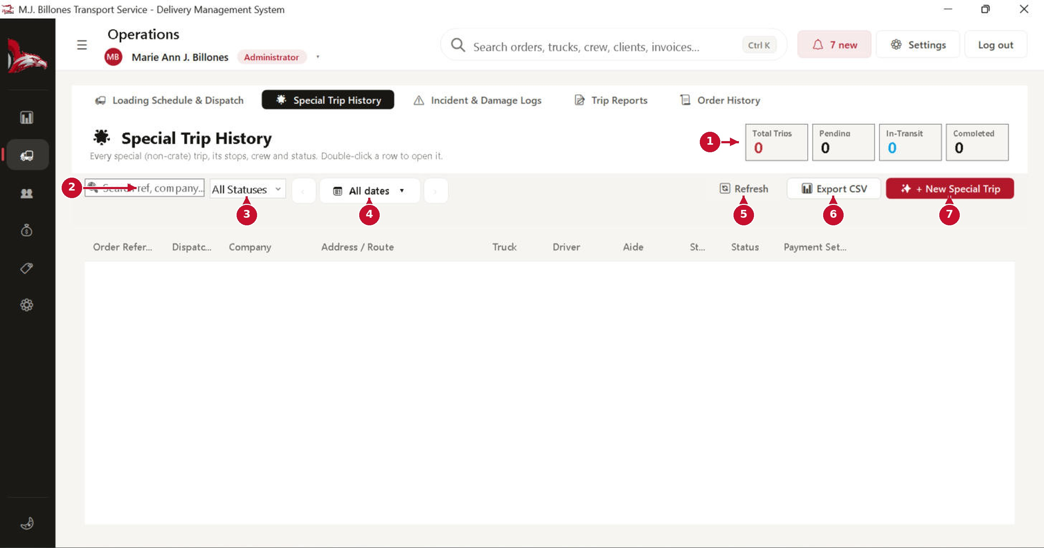
# | Part of the screen | What it does / what happens when you click it
1 | Counters | Total, pending, in-transit and completed special trips.
2 | Search | Find by reference, company or driver.
3 | Status filter | Show only one status.
4 | Date button | A day, week, month, a specific date or a date range. ‹ › step back or forward.
5 | Refresh | Reloads the list.
6 | Export CSV | Saves the list as a spreadsheet file.
7 | + New Special Trip | Opens the special trip form (next page).

New Special Trip
Fill in the trip from top to bottom. Several aides can be assigned to one special trip.
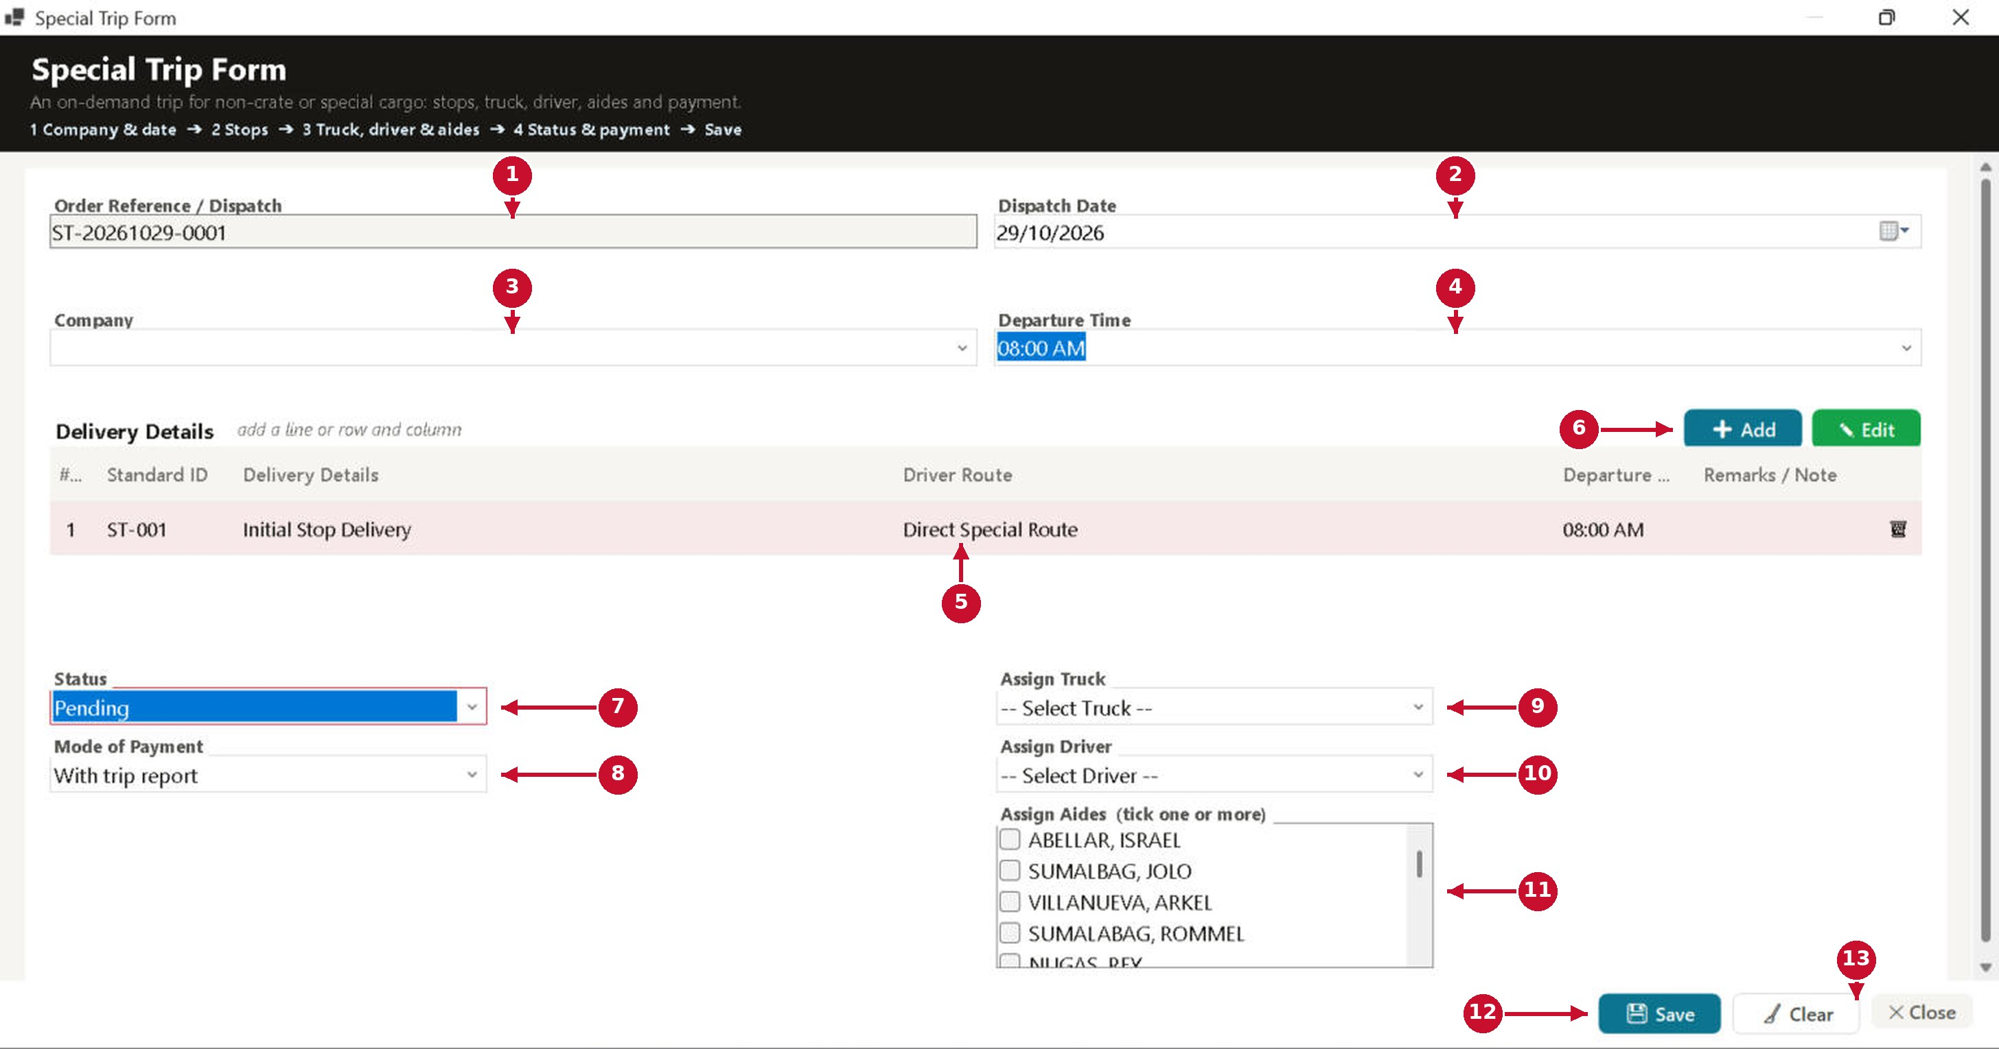
# | Part of the screen | What it does / what happens when you click it
1 | Order Reference | Created automatically (ST-date-number).
2 | Dispatch Date | The day of the trip.
3 | Company | The client. Their address is filled in for you.
4 | Departure Time | When the truck leaves.
5 | Delivery Details | One line per stop or item. Click a cell to edit it; the bin icon removes a line.
6 | + Add / Edit | Add a line, or change the table's columns and title.
7 | Status | Pending, In-Transit, Completed or Cancelled.
8 | Mode of Payment | Choose one: With trip report, With SOA, With Service Invoice or With collection.
9 | Assign Truck | Only trucks that are free on that date can be booked.
10 | Assign Driver | The driver for the trip.
11 | Assign Aides | Tick one or more aides. The label shows how many are ticked. The driver cannot also be an aide.
12 | Save | Asks for confirmation, checks the truck and crew are free, then saves the trip.
13 | Clear / Close | Clear empties the form; Close leaves without saving.

Incident & Damage Logs
Record damaged or missing crates, accidents and other problems on a trip. Incidents can be charged to the crew.
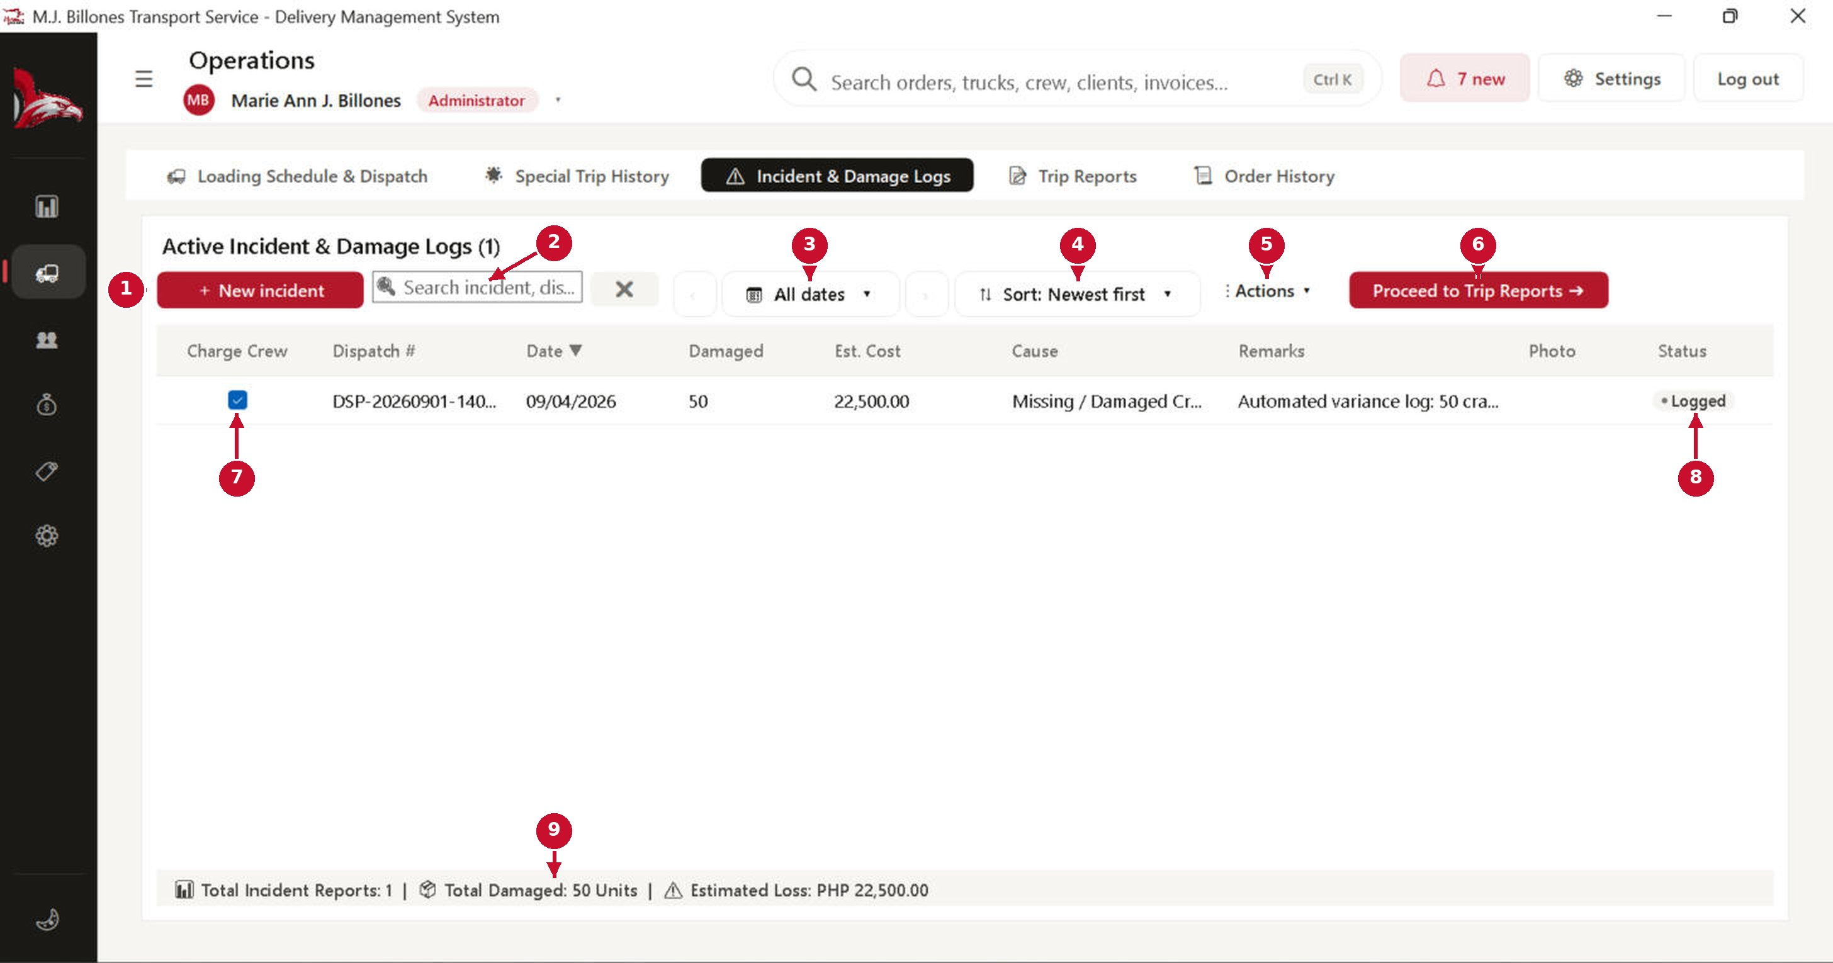
# | Part of the screen | What it does / what happens when you click it
1 | + New incident | Opens the incident form: dispatch, date, damaged quantity, estimated cost, cause, remarks and photo.
2 | Search | Find an incident by dispatch number or cause.
3 | Date button | Show incidents for a day, week, month or dates you pick.
4 | Sort | Newest, oldest, highest cost, most crates damaged or by status.
5 | Actions ▾ | Print, export, and void the selected incident (incidents are voided, never deleted).
6 | Proceed to Trip Reports | Opens the trip report of the selected incident's dispatch.
7 | Charge Crew | Tick it if the loss is charged to the crew of that trip. The change is saved immediately.
8 | Status | Logged, Resolved or Voided.
9 | Totals | Number of incidents, damaged units and estimated loss.

Order History: find any transaction
Every loading order, dispatch and special trip in one list, even when there are hundreds. Each record is one readable two-line row. Click a row to see everything about it on the right; double-click (or press Enter) to open the full record.
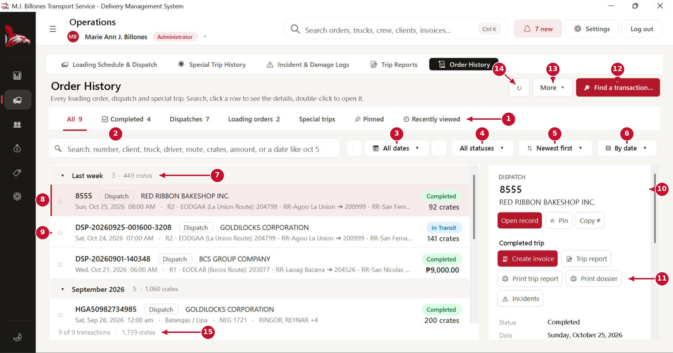
# | Part of the screen | What it does / what happens when you click it
1 | Category tabs | All · Completed · Dispatches · Loading orders · Special trips · Pinned · Recently viewed. Each tab shows how many records it has.
2 | Search anything | Type any part of a number, client, truck plate, driver, route, crates, amount, or a date such as “oct 5” or 10/05/2026. Press ↓ to jump into the list, Esc to clear.
3 | Date button | Show a day, week, month, a specific date or a date range. ‹ › step back or forward.
4 | Status | Waiting, On the road, Completed or Cancelled.
5 | Sort | Newest first, oldest first, client A–Z, most crates or by number.
6 | Group | Group the list by date (Today, Yesterday, This week, then by month), by month, client, status or type, or not at all.
7 | Group heading | Shows how many records and crates are in the group. Click it to fold or unfold the group.
8 | Record row | Top line: number, type and client, with a coloured status badge (green completed, blue on the road, orange waiting, red cancelled) and the invoice amount or crates on the right. Bottom line: date and time, route, truck and crew.
9 | ☆ Pin | Click the star to pin a record. Pinned records stay at the top of the list and in the Pinned tab (Ctrl + P also pins).
10 | Details panel | Everything about the selected record, with Open record, Pin and Copy # buttons, and links to find related records (same client, truck, driver or day).
11 | Completed trip buttons | For a completed dispatch: Create invoice (if not billed yet), Trip report, Print trip report, Print dossier and Incidents. These replace the old Completed Dispatches screen.
12 | 🔎 Find a transaction… | For when you have forgotten the number (next page).
13 | More ▾ | Export the current list to CSV, or open the change log (who changed what, and when).
14 | ↻ Refresh | Reloads the list.
15 | Totals | How many records match and their total crates.

Order History: Completed trips
The Completed tab lists every finished dispatch and special trip. Use it to bill trips, print trip reports and dossiers, or check incidents.
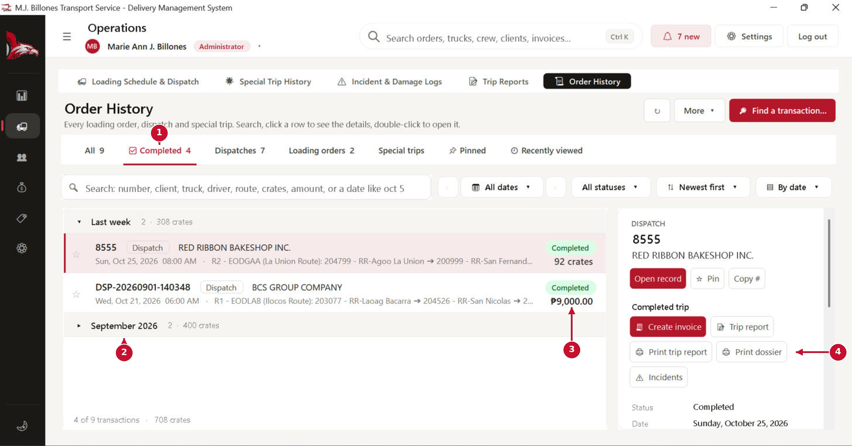
# | Part of the screen | What it does / what happens when you click it
1 | ✅ Completed tab | Only completed trips, with how many there are.
2 | Folded group | This group is folded (▸). Click it again to show its trips.
3 | Billed amount | A trip that is already invoiced shows the invoice amount; one that is not billed yet shows its crates.
4 | Completed-trip buttons | Create invoice (only while the trip is not billed yet; it opens Payments → Billing Invoices), Trip report, Print trip report, Print dossier and Incidents.

Find a transaction
Fill in only what you remember. Every clue you add narrows the list. Records that match every clue come first (✔); close matches follow with how many clues they match.
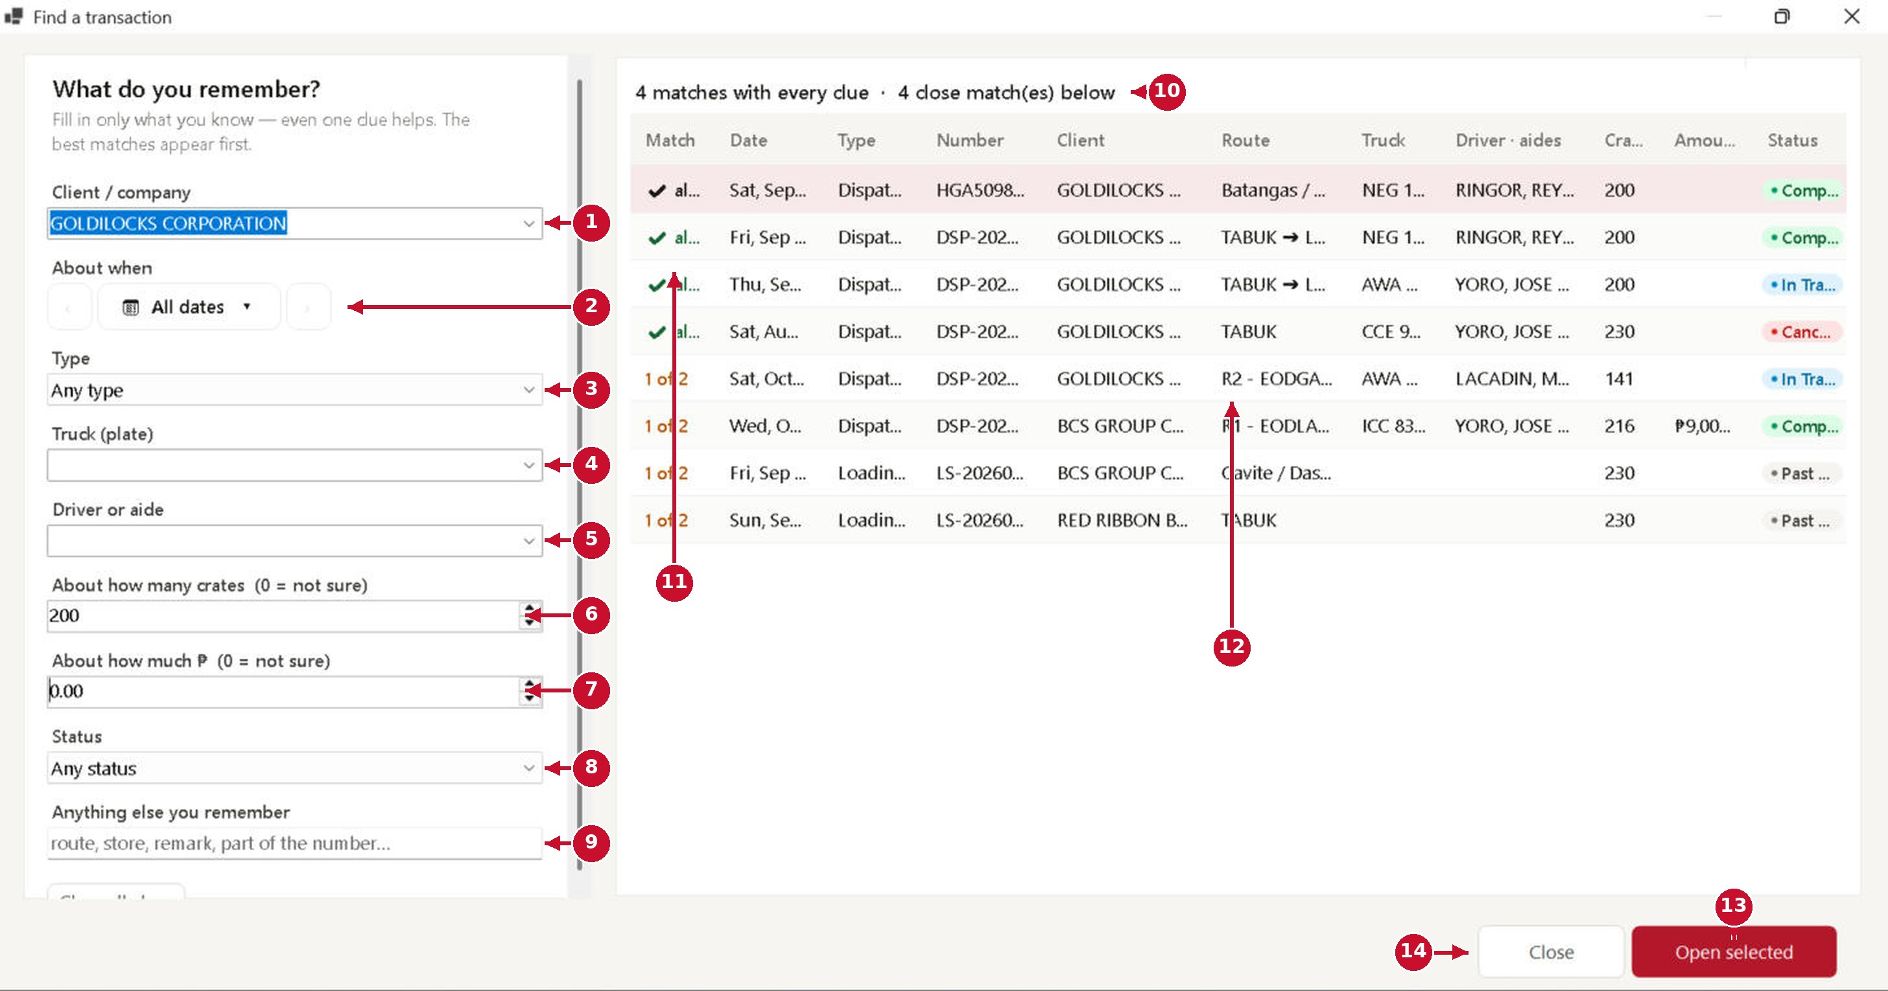
# | Part of the screen | What it does / what happens when you click it
1 | Client / company | Type part of the name or pick it from the list.
2 | About when | A day, week, month or a date range around when it happened.
3 | Type | Dispatch, loading order or special trip.
4 | Truck (plate) | Part of the plate number is enough.
5 | Driver or aide | Anyone who was on the trip.
6 | About how many crates | Matches trips within about 15% of the number.
7 | About how much ₱ | Matches invoices within about 10% of the amount (only for staff who can see billing).
8 | Status | Waiting, On the road, Completed or Cancelled.
9 | Anything else | Route, store, remark or part of the number.
10 | Result summary | How many records match every clue, and how many are close.
11 | Match | ✔ all clues, or how many of your clues the record matches.
12 | Results | Best matches first. Double-click a row (or press Enter) to open it.
13 | Open selected | Opens the highlighted record and shows it in the Order History list.
14 | Close | Closes the helper (Esc works too).

Operations: closing a trip

Trip Reports (list)
After the truck comes back, file a trip report. It records what each store received and returned, the crew's wage and meal allowance for the trip, sign-offs and proof-of-delivery files.
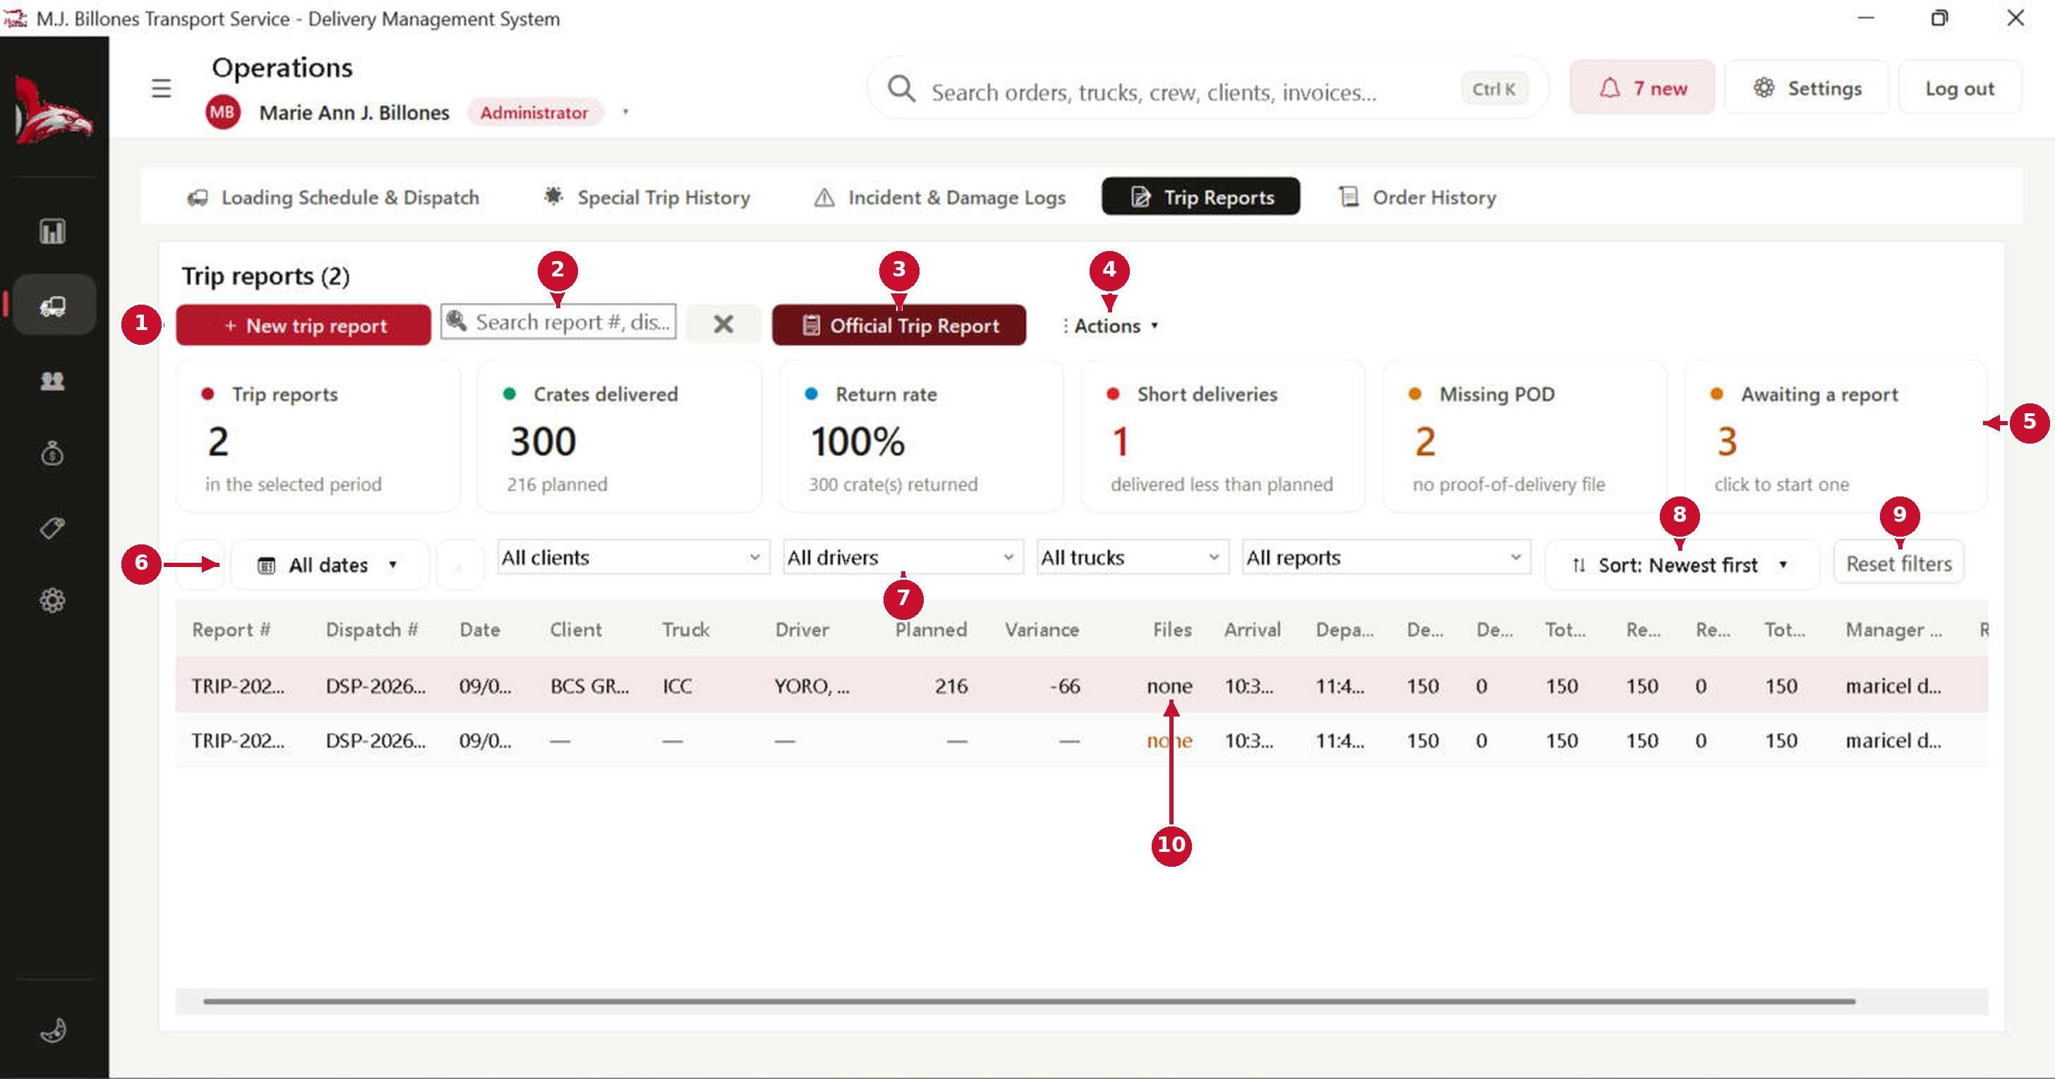
# | Part of the screen | What it does / what happens when you click it
1 | + New trip report | Opens the trip report form (next pages).
2 | Search | Find a report by report number or dispatch number.
3 | Official Trip Report | Prints the official trip report of the selected row.
4 | Actions ▾ | Export, print and void options for the selected report.
5 | Summary tiles | Reports, crates delivered, return rate, short deliveries, missing proof of delivery (POD) and trips awaiting a report. Click a tile to filter the list.
6 | Date button | A day, week, month, a specific date or a date range.
7 | Filters | Client, driver, truck and report type. Your choice is remembered next time.
8 | Sort | Order of the list.
9 | Reset filters | Asks for confirmation, then puts all filters back to default.
10 | Files | How many POD, receipt or trip sheet files are attached. “none” means proof of delivery is still missing.

New Trip Report: 1. Dispatch order & 2. Stores
Pick the dispatch this report closes. The route, truck, crew and stores load automatically.
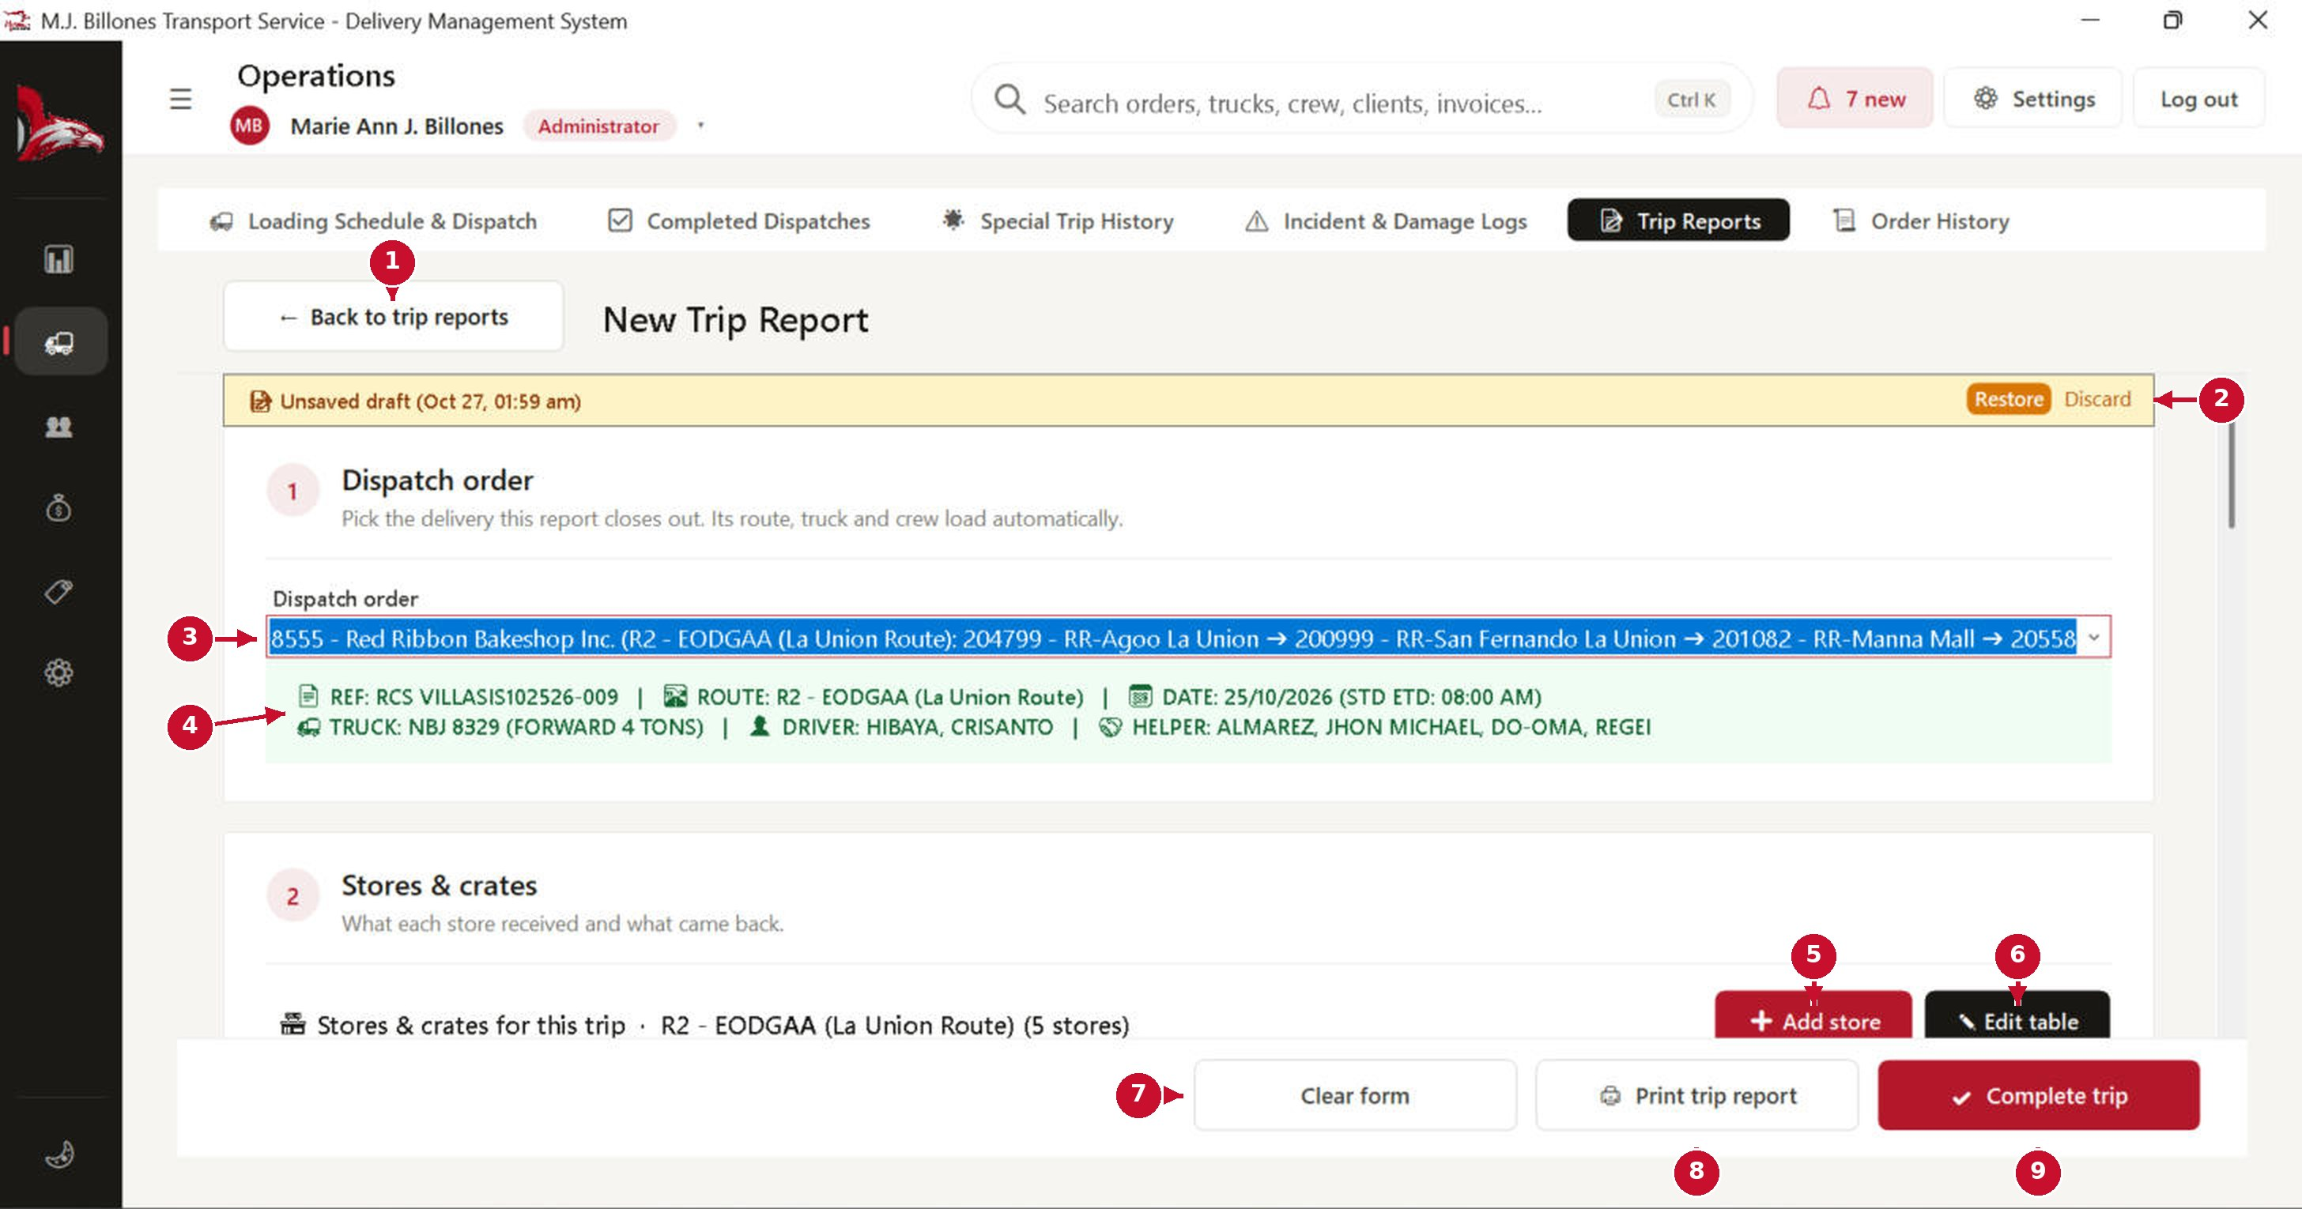
# | Part of the screen | What it does / what happens when you click it
1 | ← Back to trip reports | Leaves the form. What you typed is kept as a draft.
2 | Unsaved draft: Restore / Discard | Shown when you left a form unfinished. Restore brings your inputs back; Discard throws the draft away.
3 | Dispatch order | Choose the delivered dispatch. Only dispatches without a report are listed.
4 | Dispatch information | Reference, route, date, truck, driver and helpers, filled in automatically.
5 | + Add store | Adds a store that was not on the route.
6 | Edit table | Rename or add columns in the store table. Column names must be unique.
7 | Clear form | Asks for confirmation, then empties the form.
8 | Print trip report | Prints the report as it is now.
9 | ✓ Complete trip | Asks for confirmation, checks the numbers, saves the report and marks the dispatch Completed.

New Trip Report: 3. Driver & aide pay
Check each crew member's daily wage and meal allowance for this trip. These amounts are only recorded for reference; the system does not compute payroll, deductions or taxes.
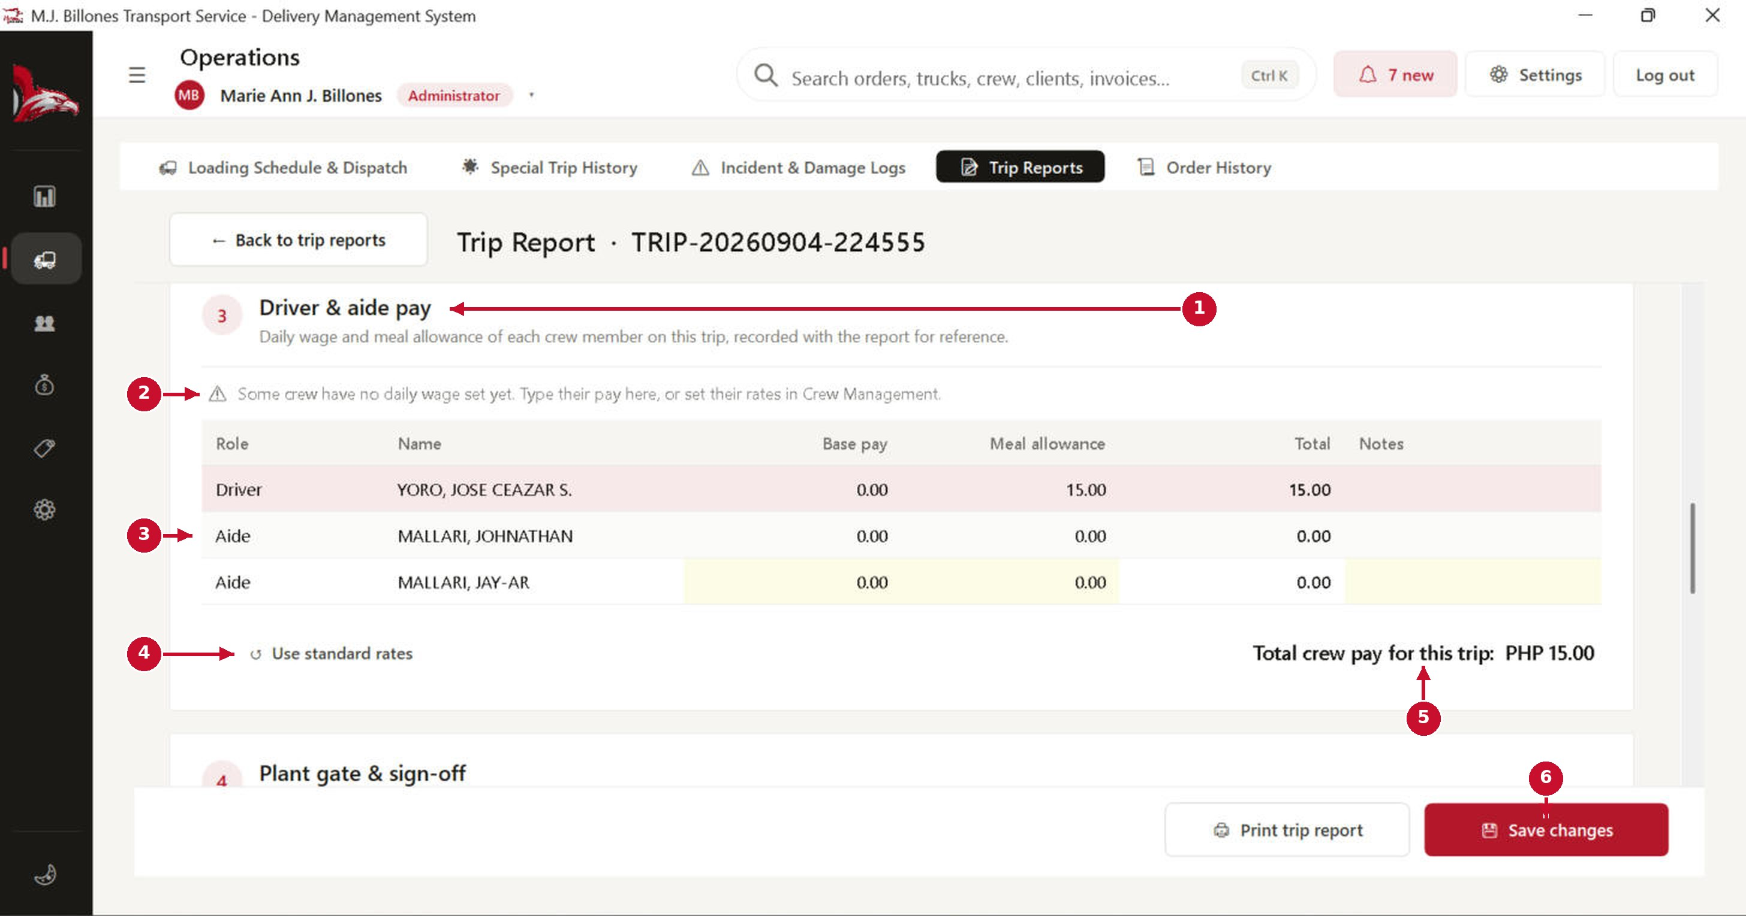
# | Part of the screen | What it does / what happens when you click it
1 | Driver & aide pay | One row for the driver and one for each aide on the dispatch.
2 | Missing wage warning | Shown when a crew member has no daily wage yet. Type their pay here, or set their rate in Crew Management.
3 | Pay table | Base pay (daily wage) and meal allowance per person, and their total. Type over a yellow cell to change it for this trip only.
4 | Use standard rates | Puts every row back to the rates saved in Crew Management.
5 | Total crew pay | The total recorded for this trip.
6 | Save changes | Asks for confirmation and saves the report with the pay table.

New Trip Report: 5. Attachments
Attach proof of delivery (POD), receipts, trip sheets and photos. Files are copied into the system's Attachments folder, so moving the original does not break them.
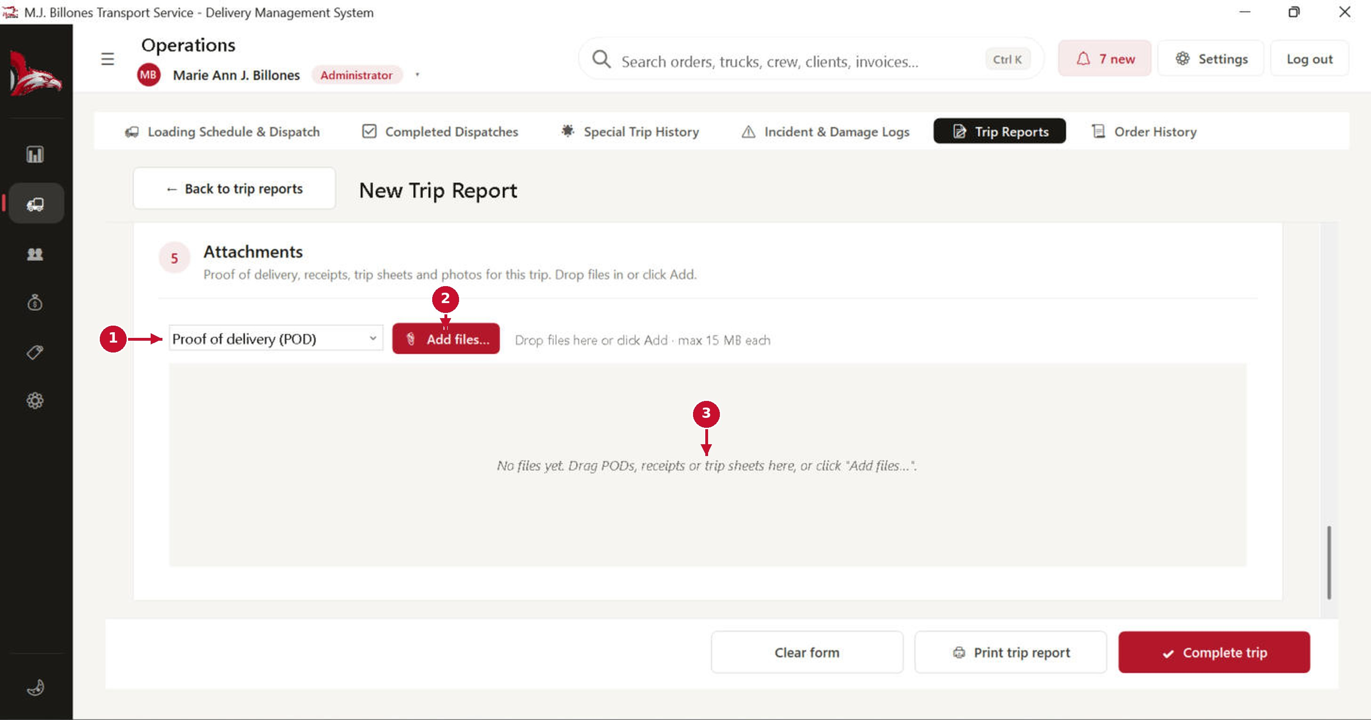
# | Part of the screen | What it does / what happens when you click it
1 | File category | Choose what the file is: POD, receipt, trip sheet, DR, photo and so on.
2 | Add files… | Opens a file picker. You can choose several files at once. Allowed: images, PDF, Word, Excel, CSV and text, up to 15 MB each.
3 | Drop area | Drag files from a folder and drop them here. Thumbnails appear; double-click one to view it. The same file cannot be attached twice.

Resources: trucks and crew

Trucks
Resources → Trucks lists your fleet and shows whether each truck is free to dispatch.
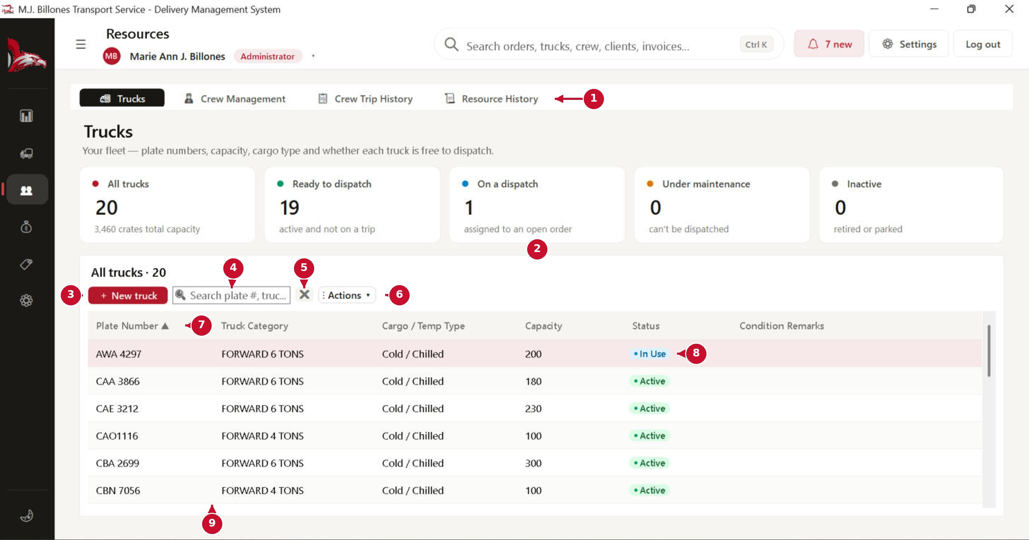
# | Part of the screen | What it does / what happens when you click it
1 | Resources tabs | Trucks, Crew Management, Crew Trip History and Resource History.
2 | Status tiles | All trucks, ready to dispatch, on a dispatch, under maintenance and inactive. Click a tile to show only those trucks.
3 | + New truck | Opens the truck form (next page).
4 | Search | Find by plate number, category or cargo type.
5 | ✕ Clear | Clears the search.
6 | Actions ▾ | Print or export the list, and other actions for the selected truck.
7 | Column headers | Click a header to sort by it; click again to reverse the order.
8 | Status | Active, In Use (on a trip), Under Maintenance or Inactive.
9 | Truck rows | Double-click a truck to open its profile. Right-click for quick actions (dispatch it, set status, edit).

New truck / Edit truck
Truck category and capacity are filled in on the same form. Pick an existing category, or type a new one and it is created when you save.
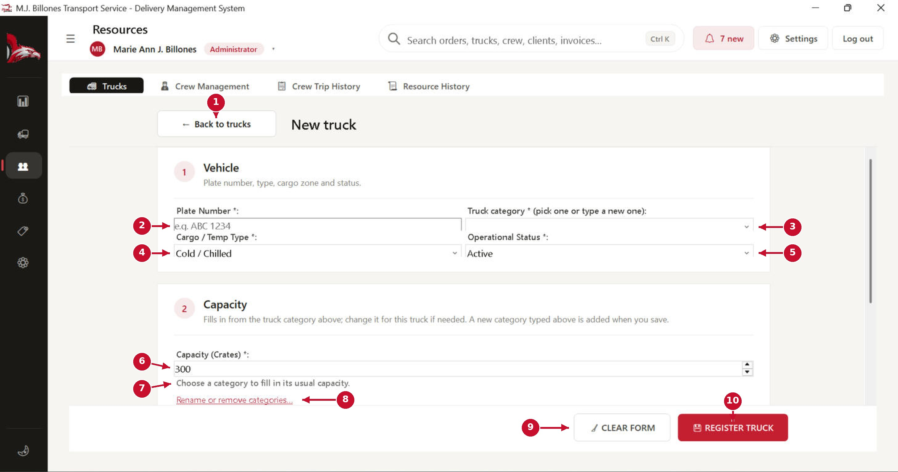
# | Part of the screen | What it does / what happens when you click it
1 | ← Back to trucks | Returns to the list without saving.
2 | Plate Number * | Philippine LTO format, for example ABC 1234. Duplicate plates are blocked.
3 | Truck category * | Pick a category or type a new one, for example FORWARD 6 TONS.
4 | Cargo / Temp Type * | Cold / Chilled, Dry Goods, or Dry and Chilled Mix.
5 | Operational Status * | Active, In Use, Under Maintenance or Inactive. A truck on an open trip cannot be set to maintenance or inactive.
6 | Capacity (Crates) * | Fills in from the category's usual capacity. You can change it for this one truck.
7 | Capacity hint | Tells you the category's usual capacity, warns if this truck is different, and offers to update the category too.
8 | Rename or remove categories… | Opens a small window to rename or delete truck categories (admins only).
9 | CLEAR FORM | Asks for confirmation, then empties the form.
10 | REGISTER TRUCK | Asks for confirmation, checks the fields and saves the truck (the button says UPDATE when editing).

Truck profile
Double-click a truck to open its profile: specifications, trip history, incidents and documents. (Truck maintenance is outside the scope of the system; a truck under repair is simply set to “Under Maintenance” so it cannot be dispatched.)
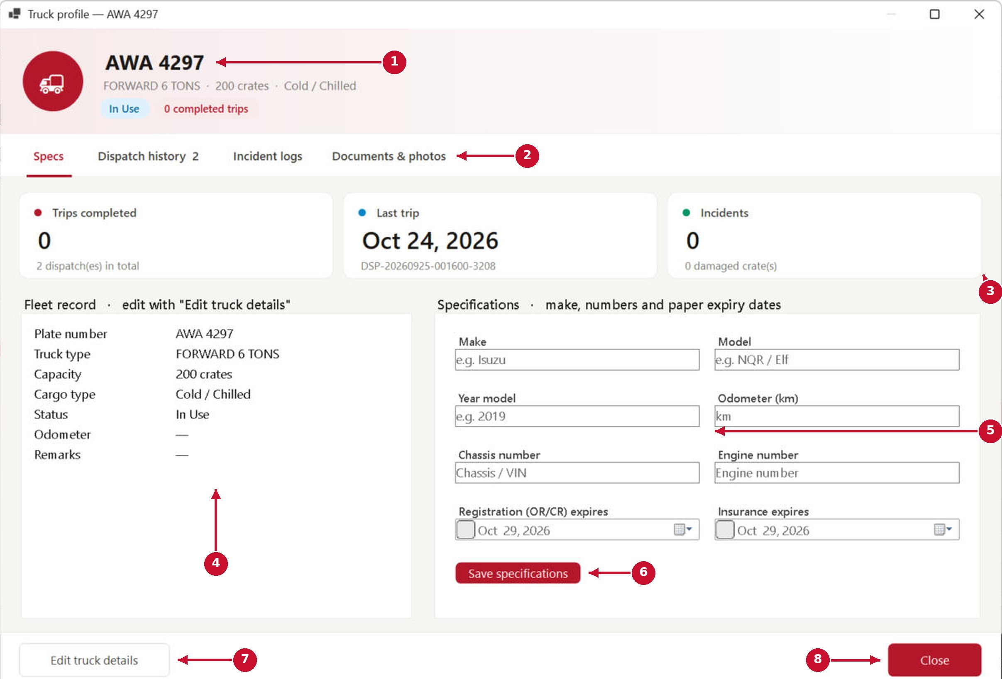
# | Part of the screen | What it does / what happens when you click it
1 | Truck header | Plate, category, capacity, cargo type, status and completed trips.
2 | Profile tabs | Specs, Dispatch history, Incident logs, and Documents & photos (OR/CR, insurance, photos).
3 | Summary tiles | Trips completed, last trip and incidents.
4 | Fleet record | The truck's main details. Change them with Edit truck details.
5 | Specifications | Make, model, year, odometer, chassis and engine numbers, and registration and insurance expiry dates. You are warned 30 days before a paper expires.
6 | Save specifications | Asks for confirmation and saves the specifications. The odometer cannot go down, and chassis and engine numbers must be unique.
7 | Edit truck details | Opens the truck form to edit plate, category, capacity and status.
8 | Close | Closes the profile.

Crew Management
Drivers and delivery aides/helpers: contact details, licence, and who is free for the next dispatch.
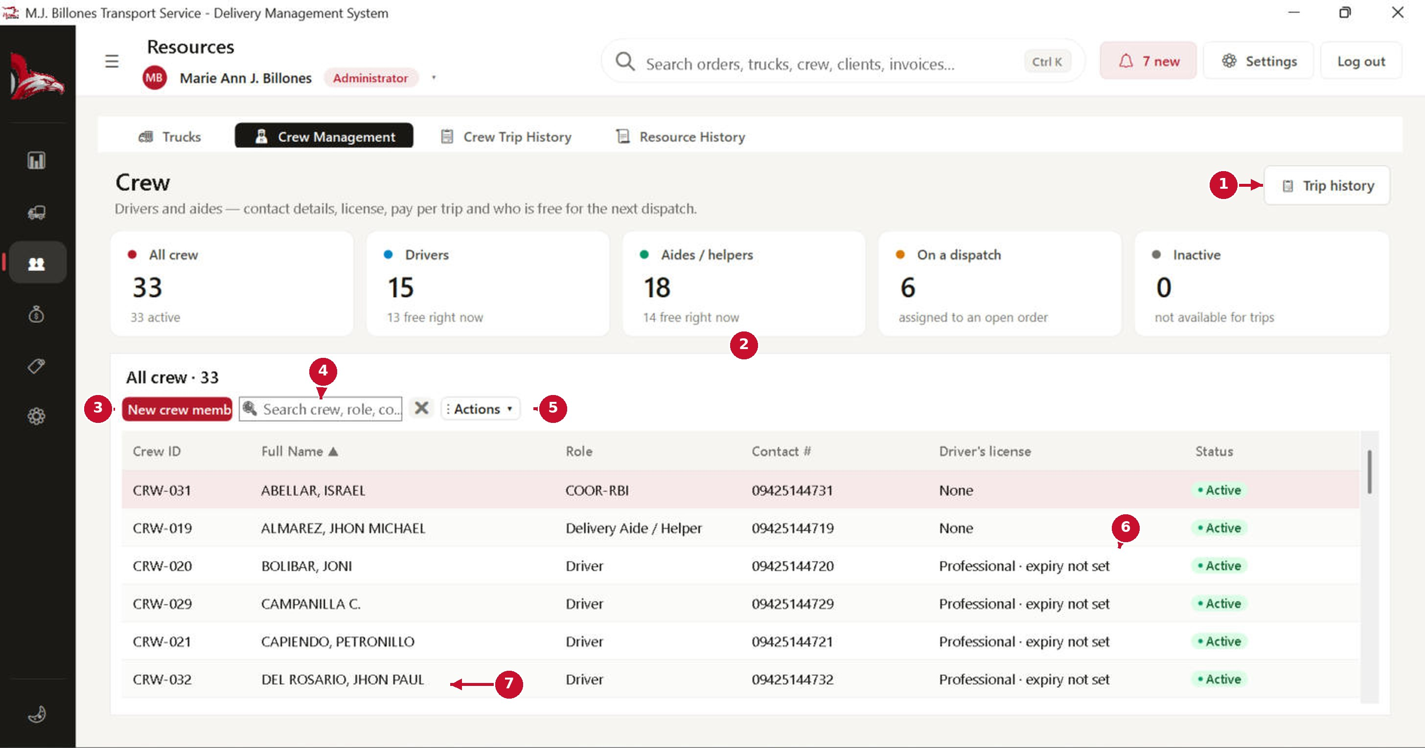
# | Part of the screen | What it does / what happens when you click it
1 | Trip history | Opens Crew Trip History.
2 | Crew tiles | All crew, drivers, aides, crew on a dispatch and inactive crew. Click a tile to filter the list.
3 | New crew member | Opens the crew form (next page).
4 | Search | Find by name, role or contact number.
5 | Actions ▾ | Print or export, and actions for the selected person.
6 | Driver's licence | Licence class and expiry. “expiry not set” means the date still needs to be entered.
7 | Crew rows | Double-click a person to open their profile. Right-click for quick actions.

New crew member: employment type & role
Pay and availability are not entered here. They come from completed trips.
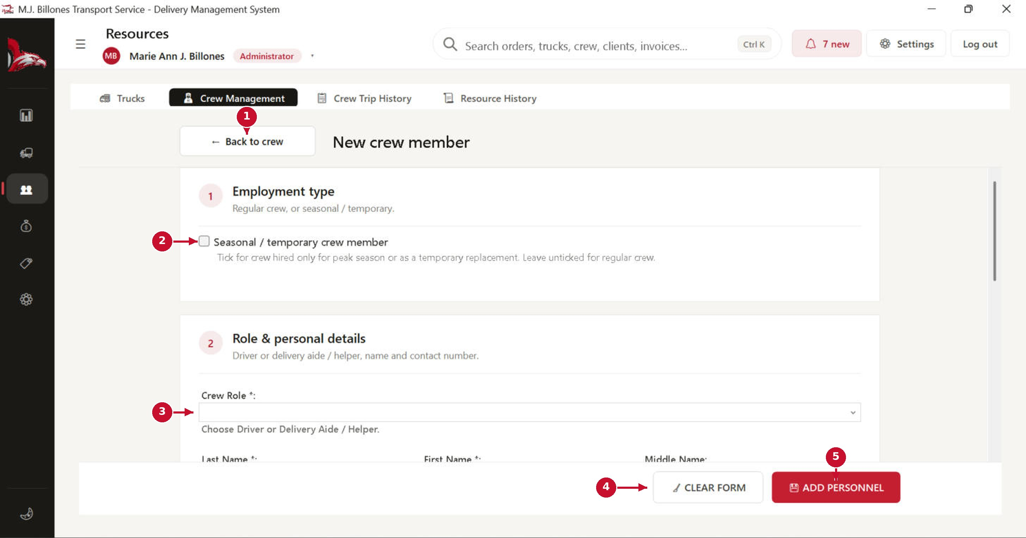
# | Part of the screen | What it does / what happens when you click it
1 | ← Back to crew | Returns to the list without saving.
2 | Seasonal / temporary | Tick it for crew hired only for peak season or as a temporary replacement.
3 | Crew Role * | Driver, or Delivery Aide / Helper.
4 | CLEAR FORM | Asks for confirmation, then empties the form.
5 | ADD PERSONNEL | Asks for confirmation, checks the fields and the licence rules, then saves the person.

New crew member: driver's licence
Only the licence class and validity are kept. The licence number is not stored.
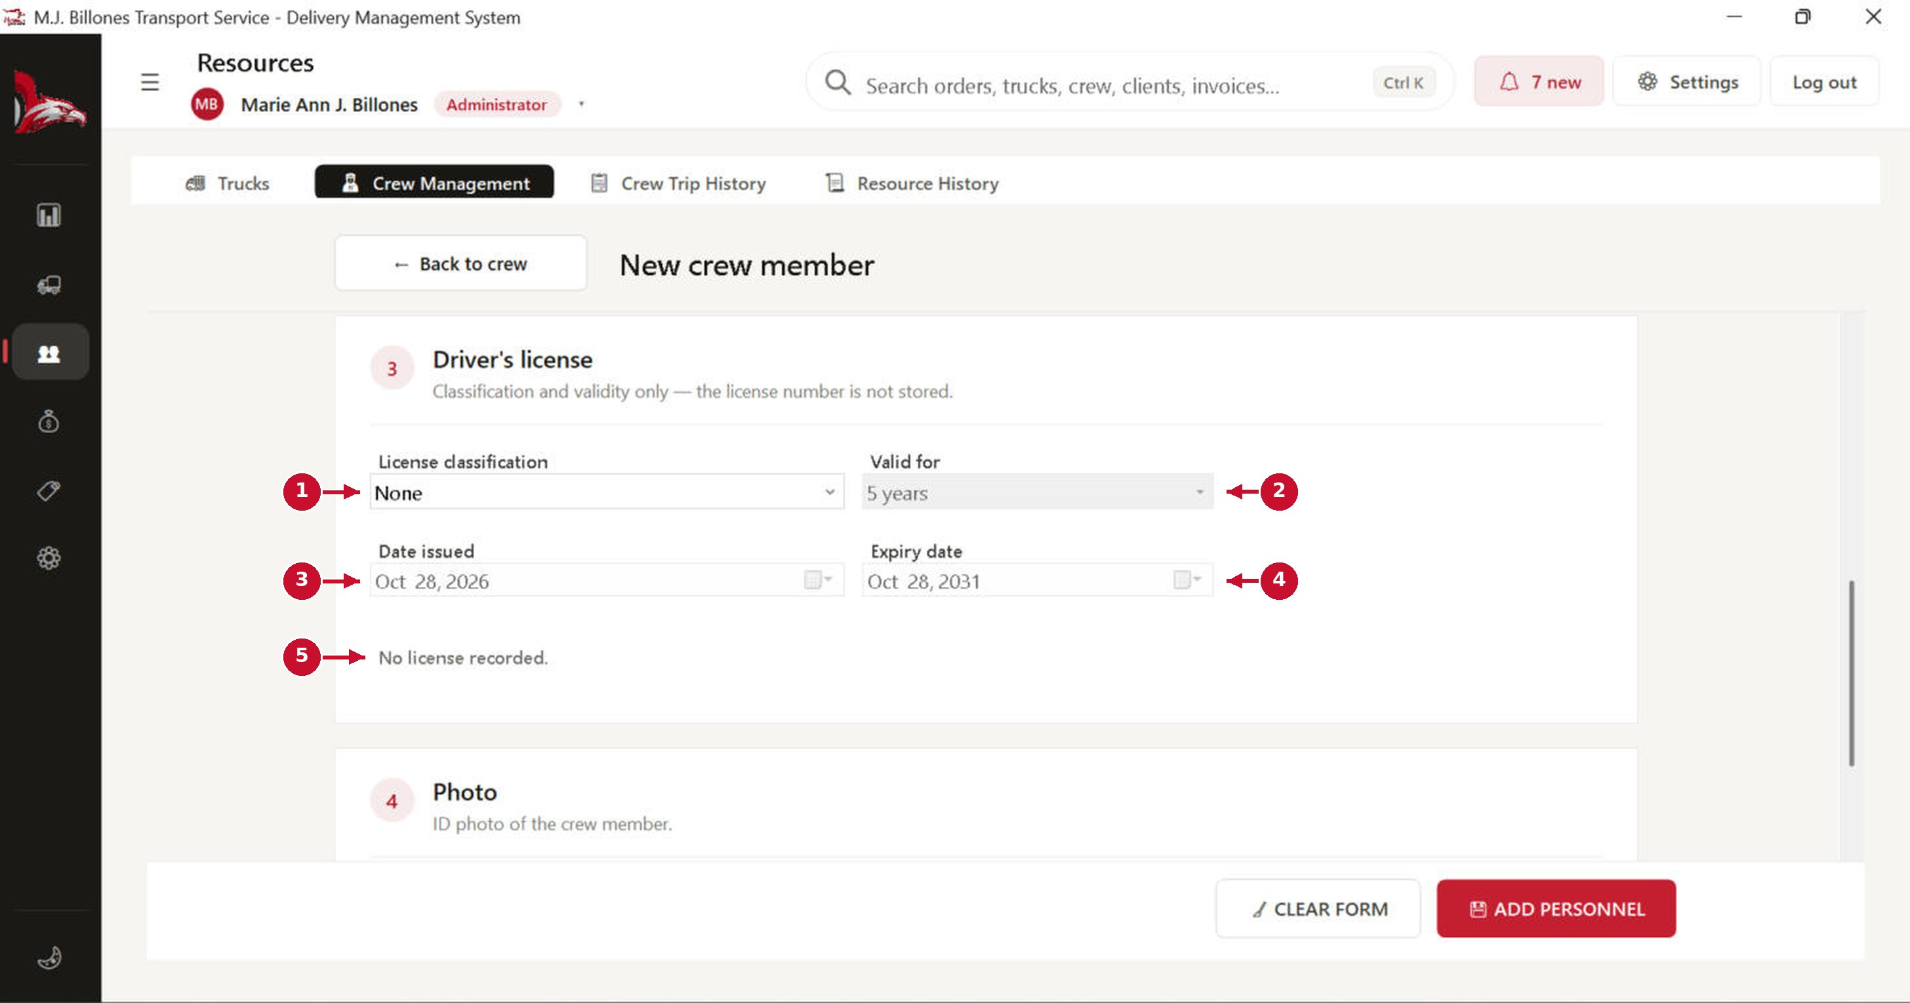
# | Part of the screen | What it does / what happens when you click it
1 | Licence classification | Professional, Non-Professional, or None. A driver must have a licence. Choosing Non-Professional for a driver asks you to confirm.
2 | Valid for | 5 years, 10 years, or a custom period. It fills in the expiry date for you.
3 | Date issued | Cannot be in the future.
4 | Expiry date | Must be after the issue date and at most 10 years later. A driver with an expired licence cannot be saved or dispatched.
5 | Licence status | A one-line summary, for example “No licence recorded” or “Valid until …”.

Crew profile
Double-click a crew member to see everything about them in one place.
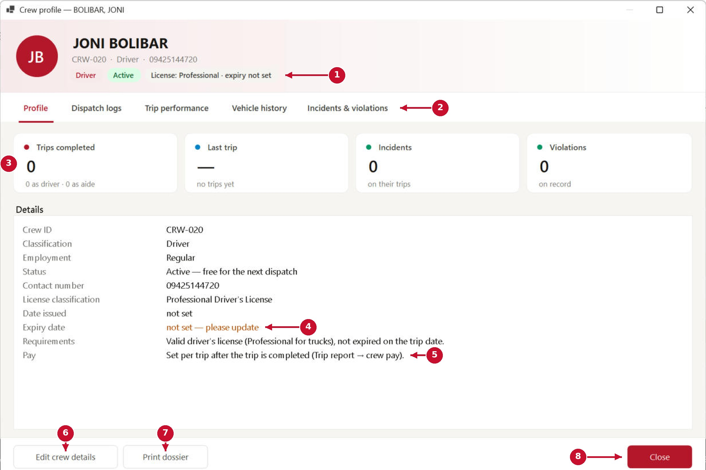
# | Part of the screen | What it does / what happens when you click it
1 | Header | Role, status and licence summary.
2 | Profile tabs | Profile, Dispatch logs, Trip performance, Vehicle history, and Incidents & violations.
3 | Summary tiles | Trips completed, last trip, incidents and violations.
4 | Expiry warning | Shown in orange when the licence expiry is missing or close. Update it with Edit crew details.
5 | Pay | A reminder that pay is set per trip in the trip report, after the trip is completed.
6 | Edit crew details | Opens the crew form for this person.
7 | Print dossier | Prints a full profile with trips and records.
8 | Close | Closes the profile.

Crew Trip History
Every trip each driver and aide was assigned to: truck, client, crates and status.
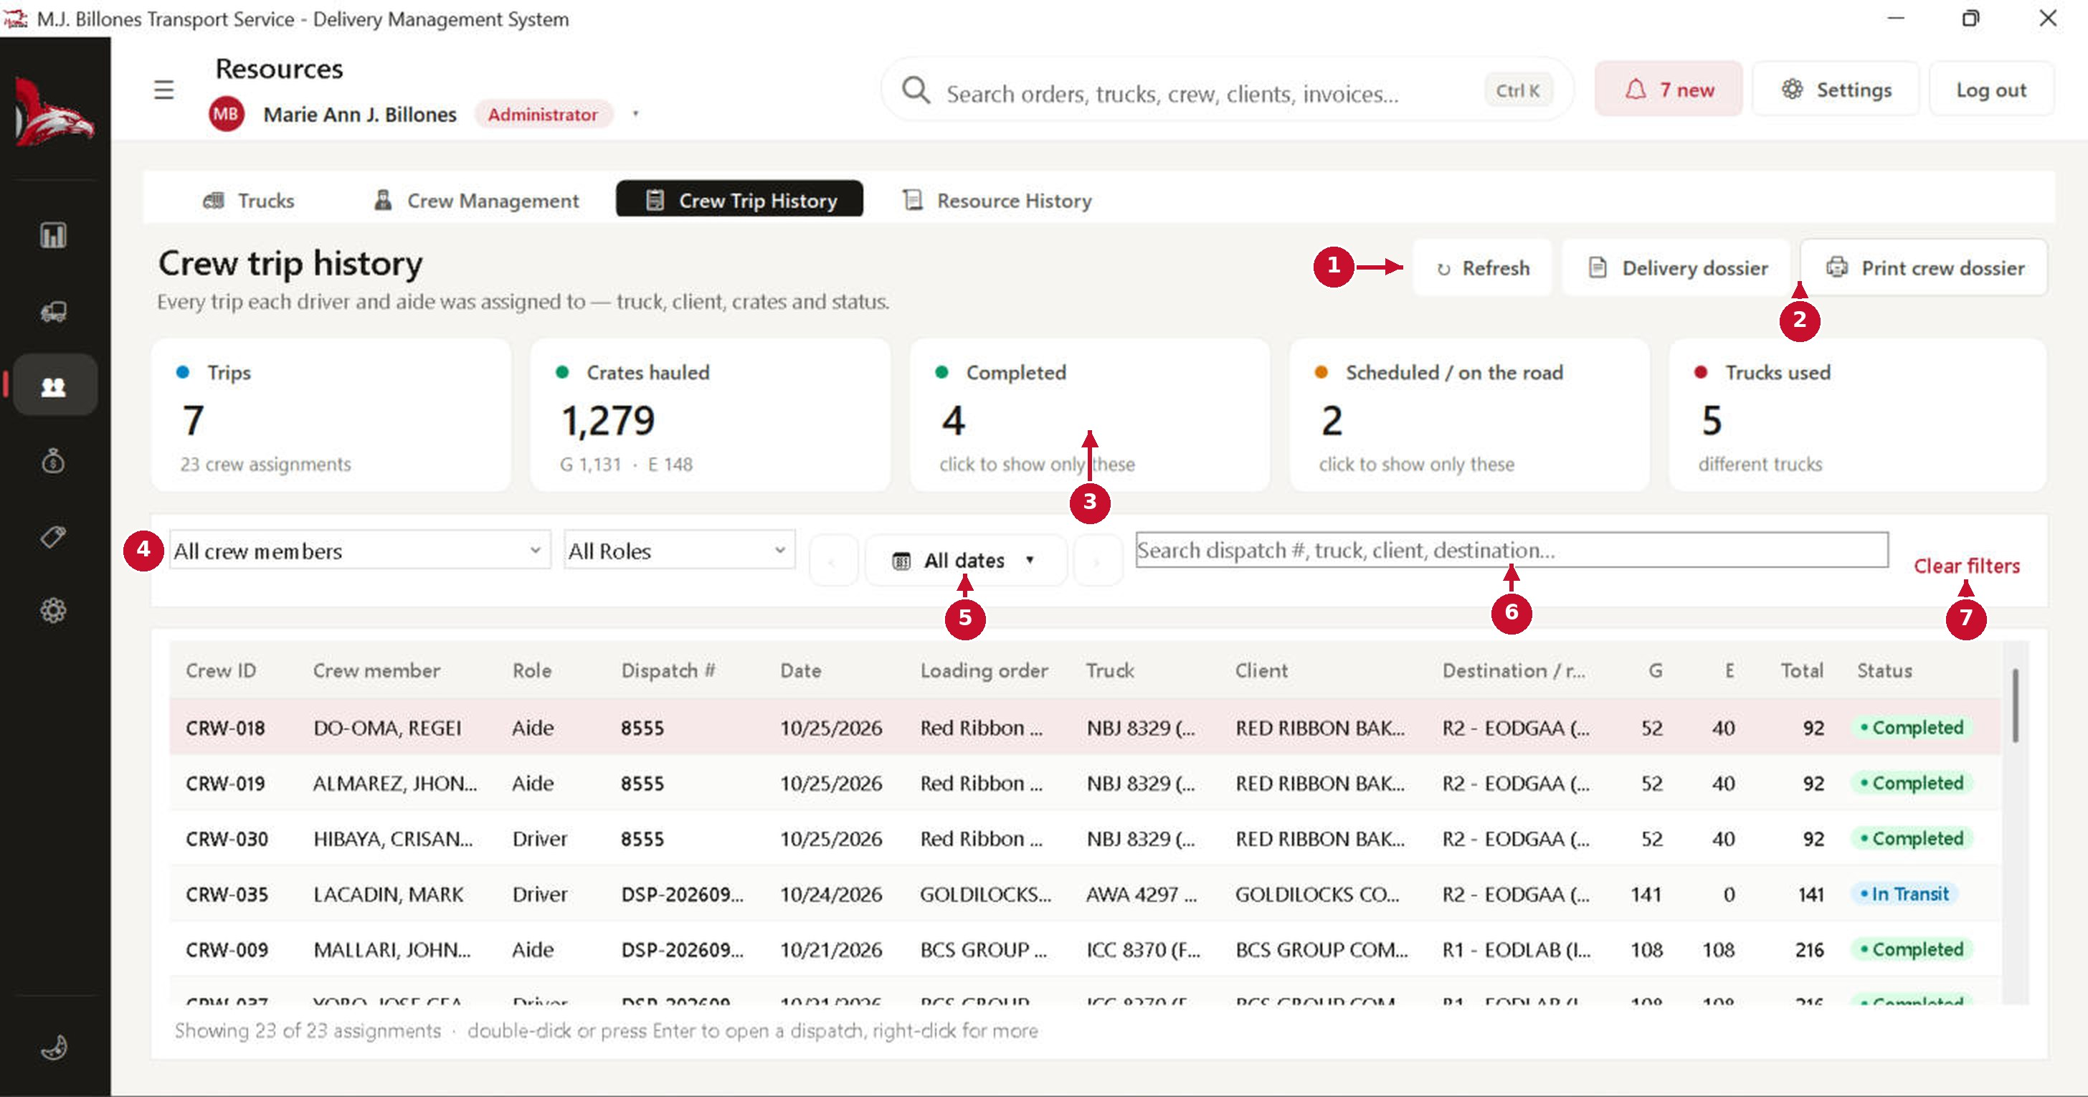
# | Part of the screen | What it does / what happens when you click it
1 | Refresh | Reloads the list.
2 | Delivery dossier / Print crew dossier | Prints the dossier of the selected dispatch, or the trip history of the selected crew member.
3 | Tiles | Trips, crates hauled, completed, scheduled/on the road and trucks used. Some tiles can be clicked to filter.
4 | Crew and role | Show one crew member or one role.
5 | Date button | A day, week, month, a specific date or a date range.
6 | Search | Find by dispatch number, truck, client or destination.
7 | Clear filters | Puts all filters back to default.
8 | Rows | Double-click (or press Enter) to open a dispatch. Right-click for more.

Payments: billing and collecting

Billing Invoices
Payments → Billing Invoices. Bill each completed dispatch (you can also start an invoice from Order History → Completed), then record the payment in Collections.
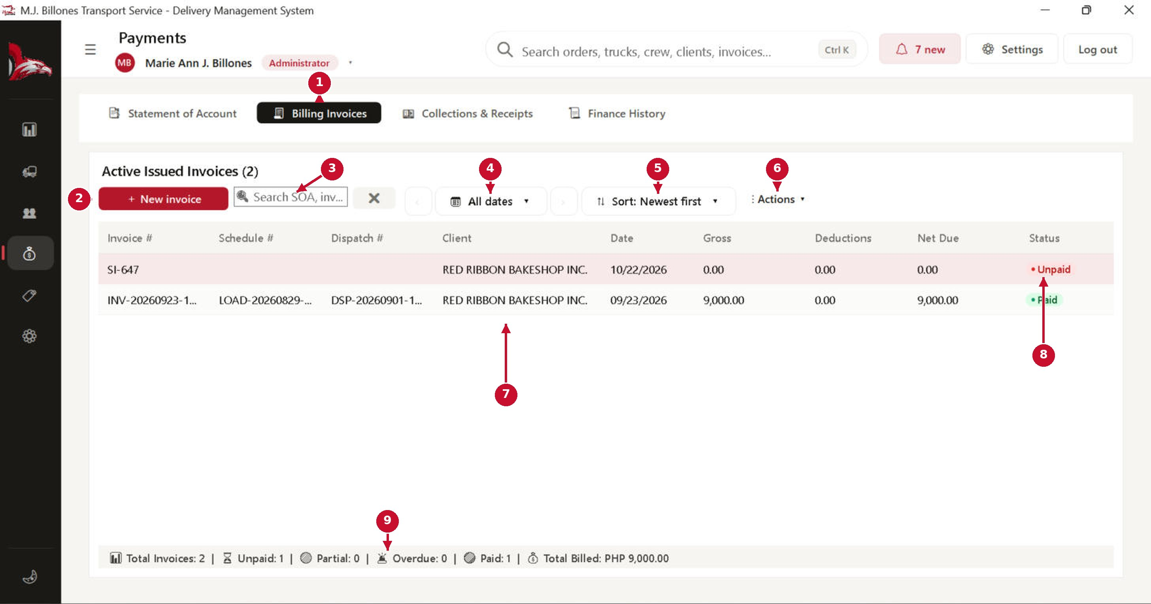
# | Part of the screen | What it does / what happens when you click it
1 | Payments tabs | Statement of Account, Billing Invoices, Collections & Receipts and Finance History.
2 | + New invoice | Opens the invoice form (next page).
3 | Search | Find by invoice, statement or client.
4 | Date button | Invoices issued on a day, week, month or dates you pick.
5 | Sort | Newest, oldest, due soonest, unpaid first, highest amount or client A–Z.
6 | Actions ▾ | Print the official invoice, export, or void the selected invoice.
7 | Invoice rows | Invoice, schedule and dispatch numbers, client, issue date, gross, deductions and net due. Double-click to open.
8 | Status | Unpaid, Partial, Overdue or Paid. It updates automatically when payments are recorded.
9 | Totals | How many invoices are unpaid, partial, overdue or paid, and the total billed.

New invoice
Choose the completed trip. The client and loading details fill in automatically; the amount comes from the rate for that route and truck type.
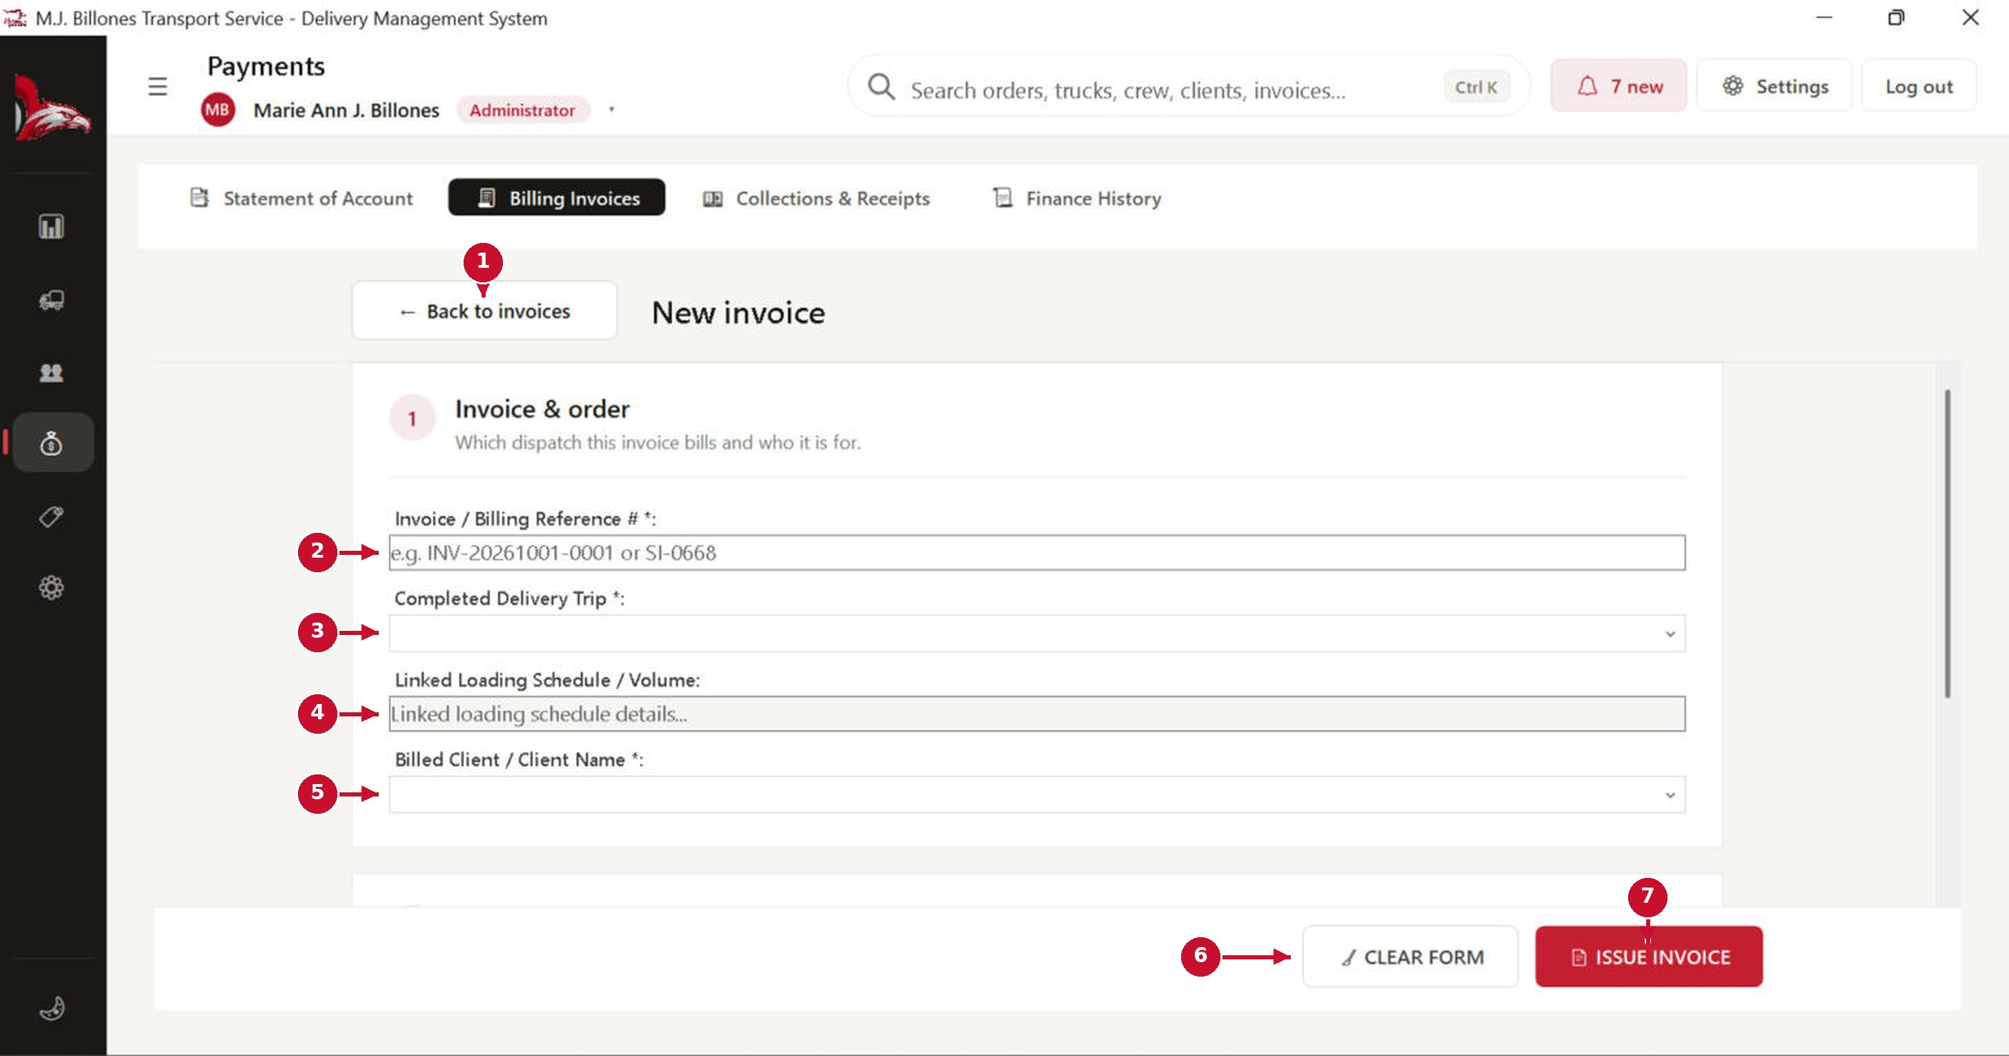
# | Part of the screen | What it does / what happens when you click it
1 | ← Back to invoices | Returns without saving.
2 | Invoice / Billing Reference # * | Your invoice or sales invoice number. It must be unique.
3 | Completed Delivery Trip * | Only completed trips that are not billed yet are listed.
4 | Linked Loading Schedule | Filled in automatically from the trip.
5 | Billed Client * | The client being billed.
6 | CLEAR FORM | Asks for confirmation, then empties the form.
7 | ISSUE INVOICE | Asks for confirmation, saves the invoice and marks the trip as invoiced.

Collections & Receipts
Record each payment a client makes against an invoice.
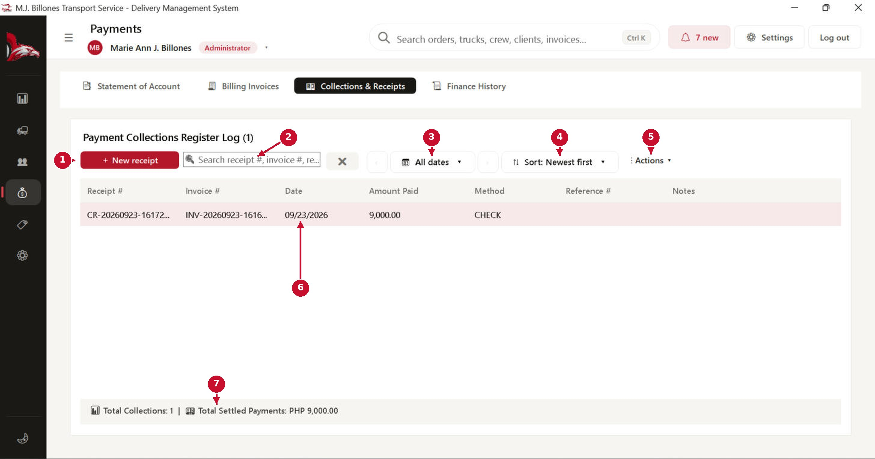
# | Part of the screen | What it does / what happens when you click it
1 | + New receipt | Opens the payment receipt form (next page).
2 | Search | Find by receipt, invoice or reference number.
3 | Date button | Payments received on a day, week, month or dates you pick.
4 | Sort | Newest, oldest, highest amount or receipt number.
5 | Actions ▾ | Print the official receipt, export, or void the selected receipt.
6 | Receipt rows | Each payment received: amount, date, method and reference.
7 | Totals | Number of collections and total settled payments.

New payment receipt
Pick the invoice being paid, then enter the payment.
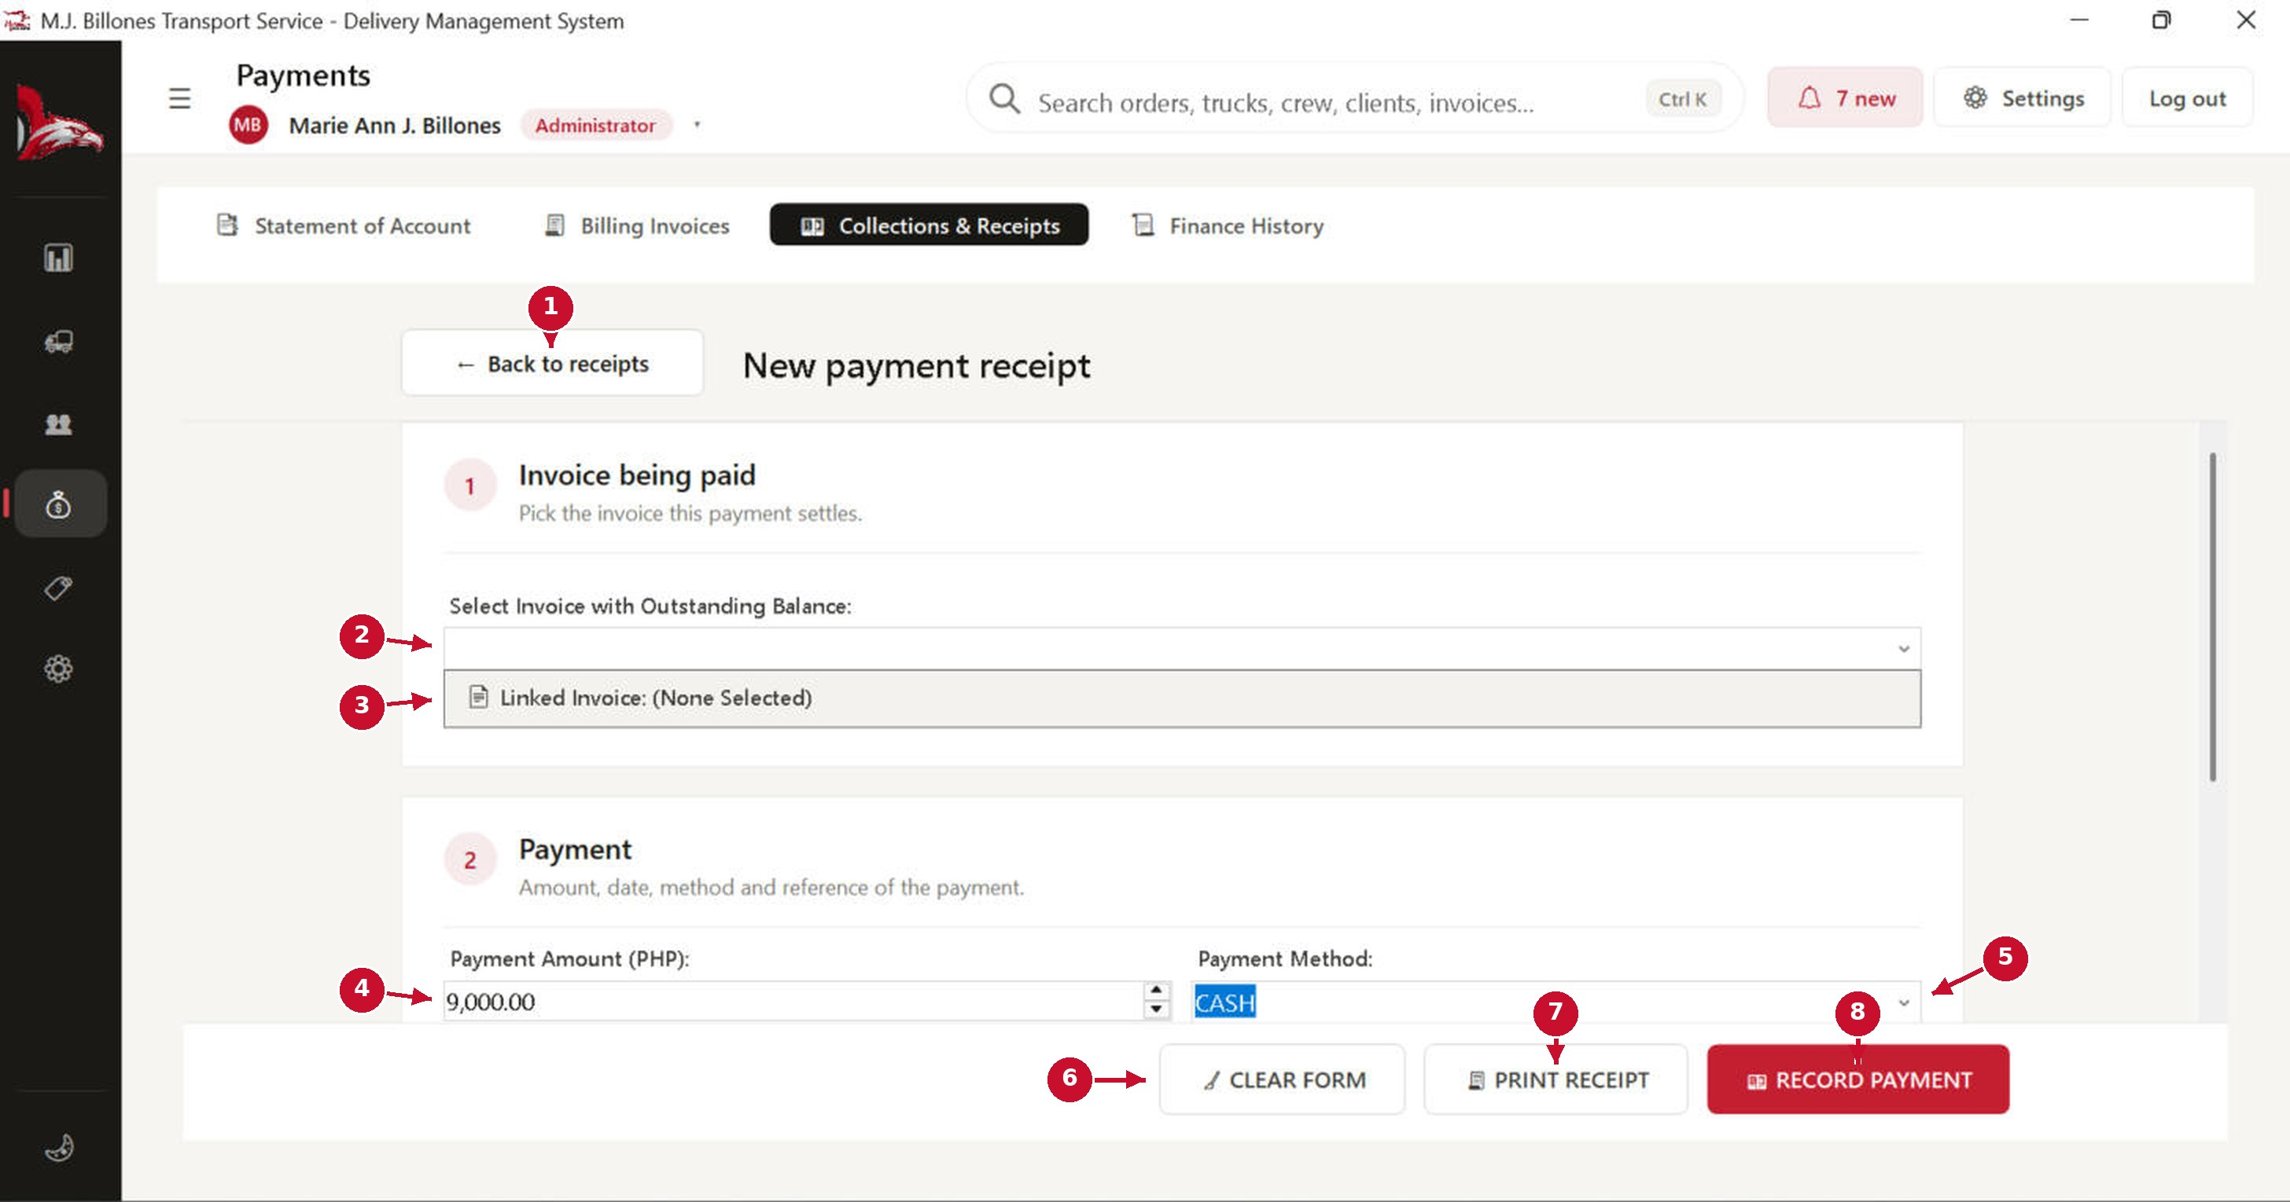
# | Part of the screen | What it does / what happens when you click it
1 | ← Back to receipts | Returns without saving.
2 | Select Invoice | Only invoices that still have an outstanding balance are listed.
3 | Linked invoice | Shows the invoice's client, total and balance.
4 | Payment Amount | Fills in with the balance due. Change it for partial payments; it cannot be more than the balance.
5 | Payment Method | Cash, check, bank transfer, e-wallet and so on. Add the reference number for non-cash payments.
6 | CLEAR FORM | Asks for confirmation, then empties the form.
7 | PRINT RECEIPT | Prints the official collection receipt.
8 | RECORD PAYMENT | Asks for confirmation, saves the payment and updates the invoice's balance and status.

Statement of Account (SOA)
A statement lists all of a client's invoices for a period, so the client can pay them together.
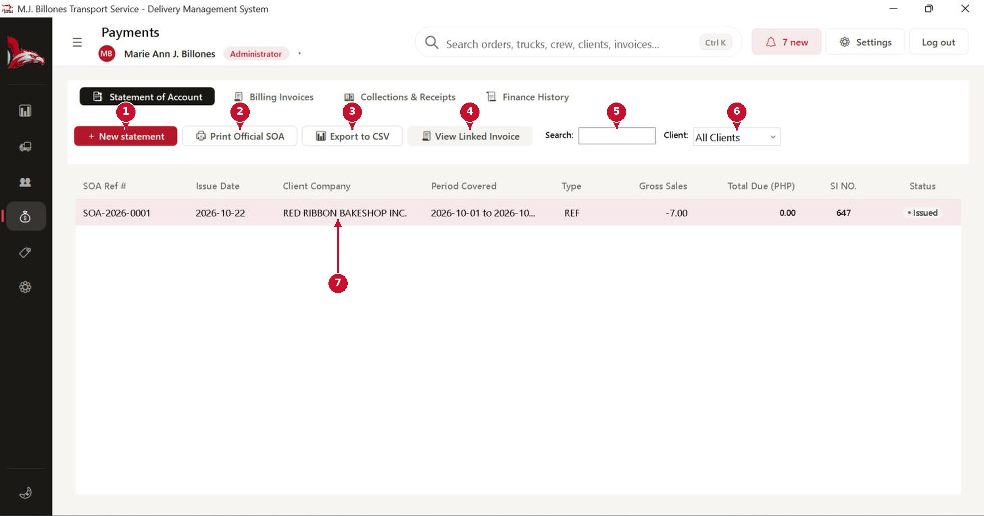
# | Part of the screen | What it does / what happens when you click it
1 | + New statement | Opens the SOA generator: choose the client and the period, and the system collects their invoices.
2 | Print Official SOA | Prints the selected statement.
3 | Export to CSV | Saves the list as a spreadsheet file.
4 | View Linked Invoice | Shows the invoices included in the selected statement.
5 | Search | Find a statement by number or client.
6 | Client filter | Show statements for one client only.
7 | Statement rows | SOA number, date, client, period, amounts and status.

Master Data: clients and routes

Clients
Master Data → Clients. Every company you deliver for, with its stores, trips and outstanding balance.
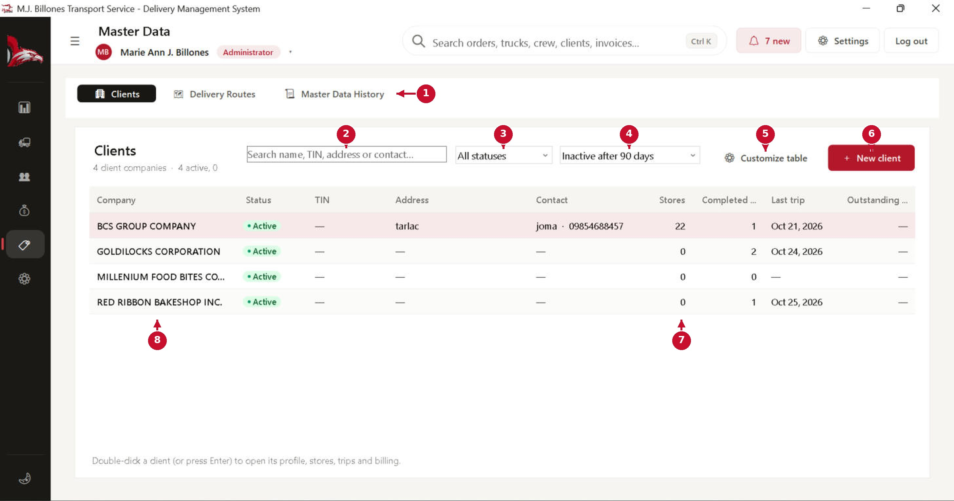
# | Part of the screen | What it does / what happens when you click it
1 | Master Data tabs | Clients, Delivery Routes and Master Data History.
2 | Search | Find by name, TIN, address or contact.
3 | Status filter | All, Active or Inactive clients. Inactive clients are listed at the bottom.
4 | Inactivity rule | A client with no dispatch, loading, special trip or invoice in 90 (or 180) days is shown as Inactive.
5 | Customize table | Choose which columns to show.
6 | + New client | Opens the client form. A new client starts with 0 stores.
7 | Stores / Completed / Last trip | How many stores the client has, completed trips and the date of the last trip.
8 | Client rows | Double-click a client to open its profile, stores, trips and billing.

Client profile: company details
Company name, TIN and contact details are printed on statements, invoices and receipts.
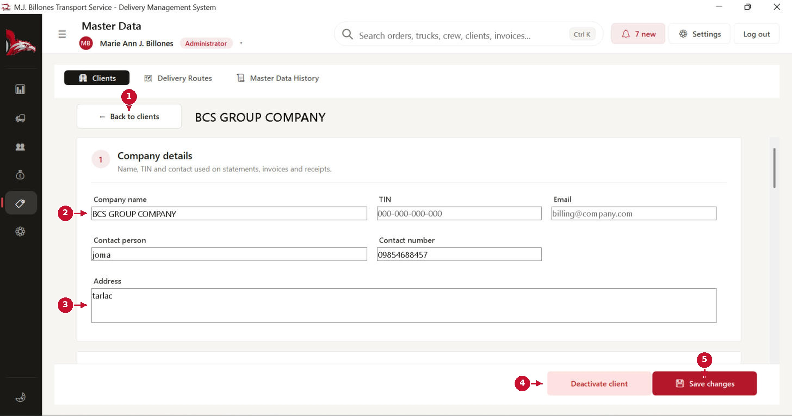
# | Part of the screen | What it does / what happens when you click it
1 | ← Back to clients | Returns to the list.
2 | Company details | Company name (must be unique), TIN, email, contact person and number. Fields cannot be left as spaces only.
3 | Address | The billing address.
4 | Deactivate client | Asks for confirmation, then marks the client Inactive (it is hidden from new dispatches but kept in history). It changes to Reactivate for inactive clients.
5 | Save changes | Asks for confirmation and saves the details.

Client profile: stores
The client's stores and the delivery route each one is on. These are the same stores the dispatch form loads.
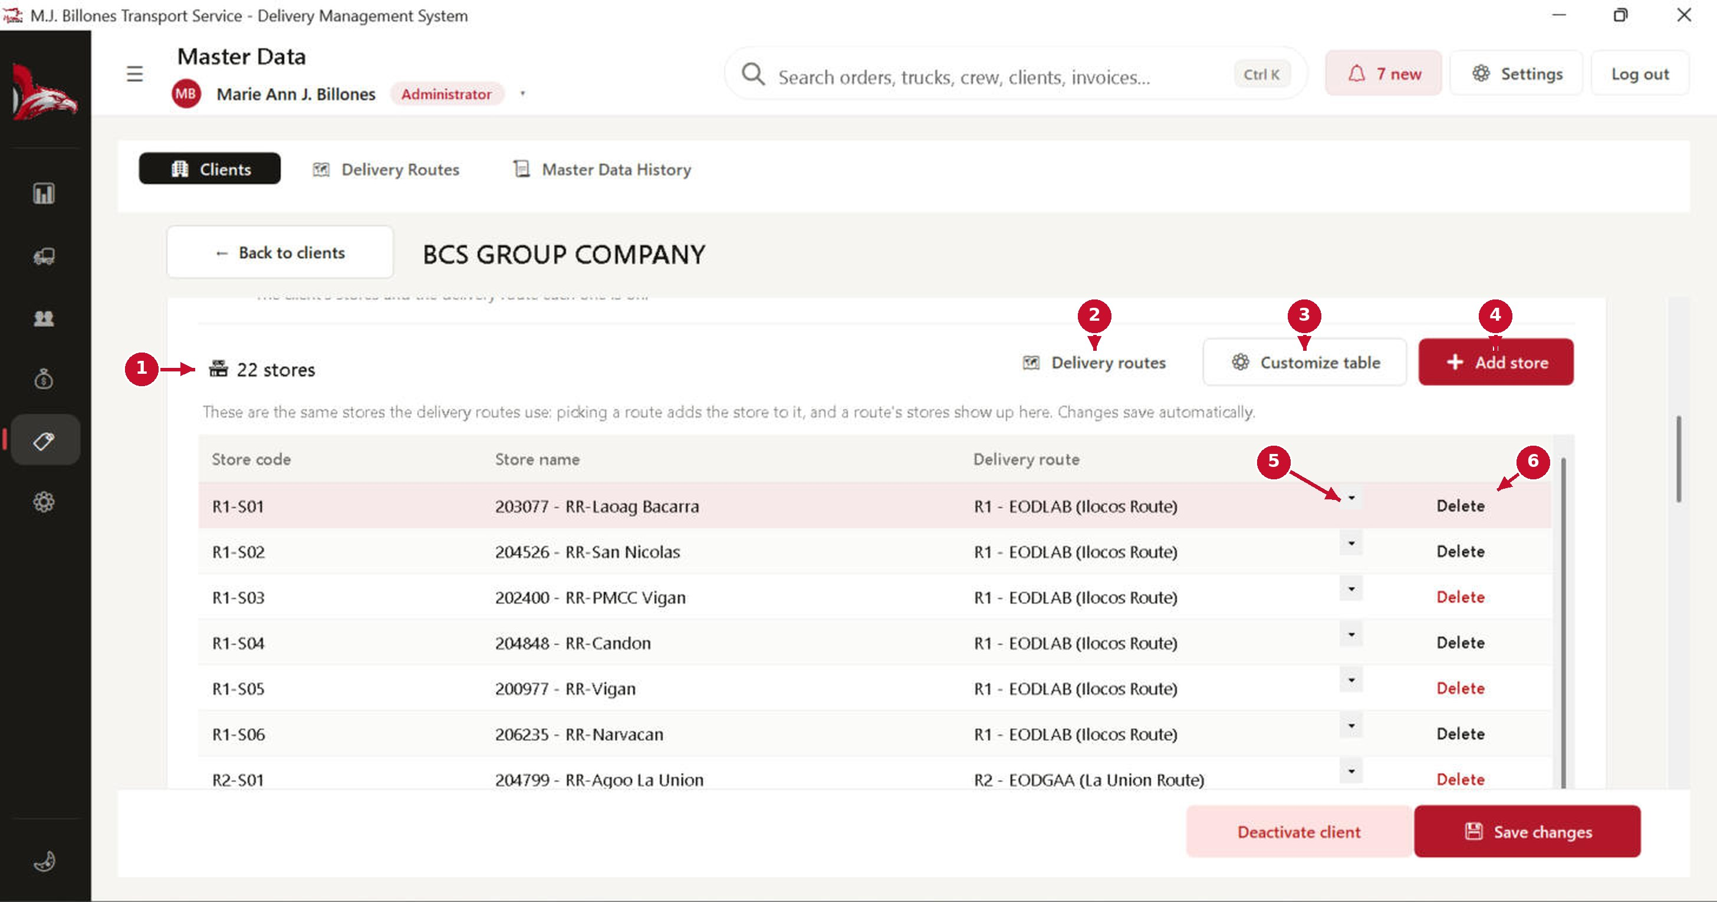
# | Part of the screen | What it does / what happens when you click it
1 | Store count | How many stores this client has.
2 | Delivery routes | Opens the Delivery Routes tab.
3 | Customize table | Choose which columns to show.
4 | + Add store | Adds a new row. Store codes must be unique for this client.
5 | Route picker | Choose which route the store is on.
6 | Delete | Asks for confirmation before removing the store. Stores already used in a dispatch cannot be removed.

Delivery Routes
Routes define the stores a truck visits, in order.
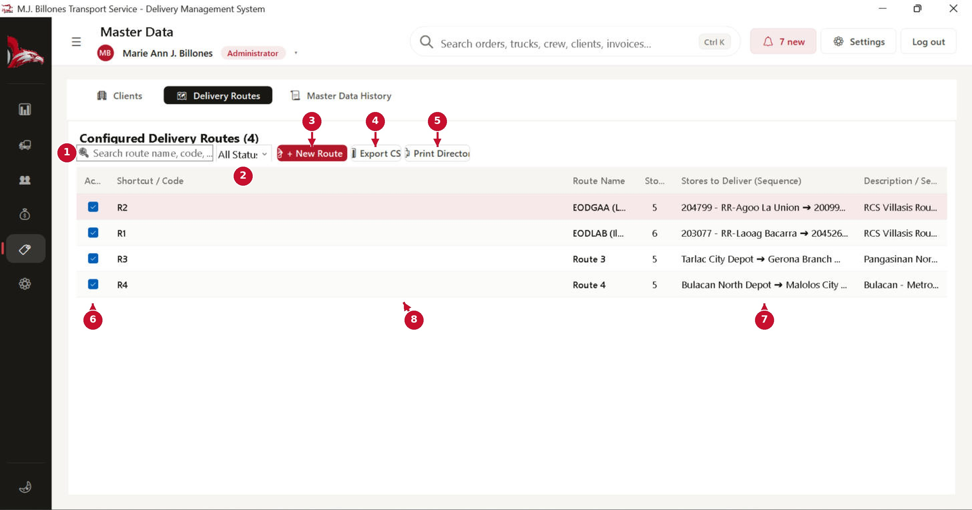
# | Part of the screen | What it does / what happens when you click it
1 | Search | Find by route name, code or store.
2 | Status filter | Active or inactive routes.
3 | + New Route | Opens Quick Add Route. It checks the code and name for duplicates as you type, and that origin and destination are different.
4 | Export CSV | Saves the list as a spreadsheet file.
5 | Print Directory | Prints the route directory.
6 | Active | Untick to deactivate a route (it stays in history).
7 | Stores to deliver | The stores in delivery order.
8 | Route rows | Double-click a route to edit it.

Settings and maintenance

Settings: Dispatch Rules
Settings (gear icon) holds system-wide options. Some tabs are only shown to administrators.
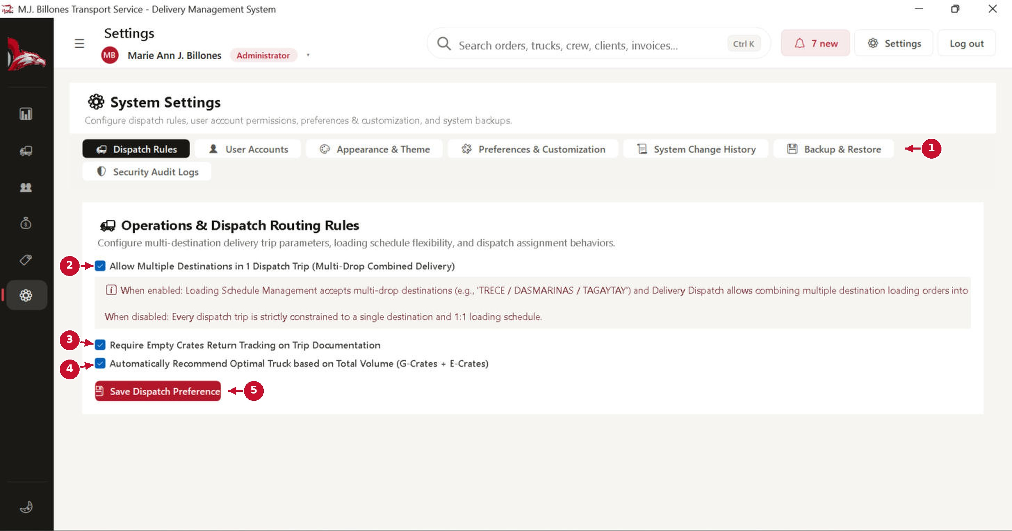
# | Part of the screen | What it does / what happens when you click it
1 | Settings tabs | Dispatch Rules, User Accounts, Appearance & Theme, Preferences & Customization, System Change History, Backup & Restore and Security Audit Logs.
2 | Multiple destinations | Allows one dispatch trip to deliver to several destinations (multi-drop).
3 | Empty crate tracking | Requires returned empty crates to be recorded on every trip report.
4 | Recommend optimal truck | Suggests the best-fitting free truck from the total crates.
5 | Save Dispatch Preferences | Asks for confirmation and saves these rules.

Settings: User Accounts
Administrators create and manage who can sign in. There are two roles: Owner/Admin and Office Staff.
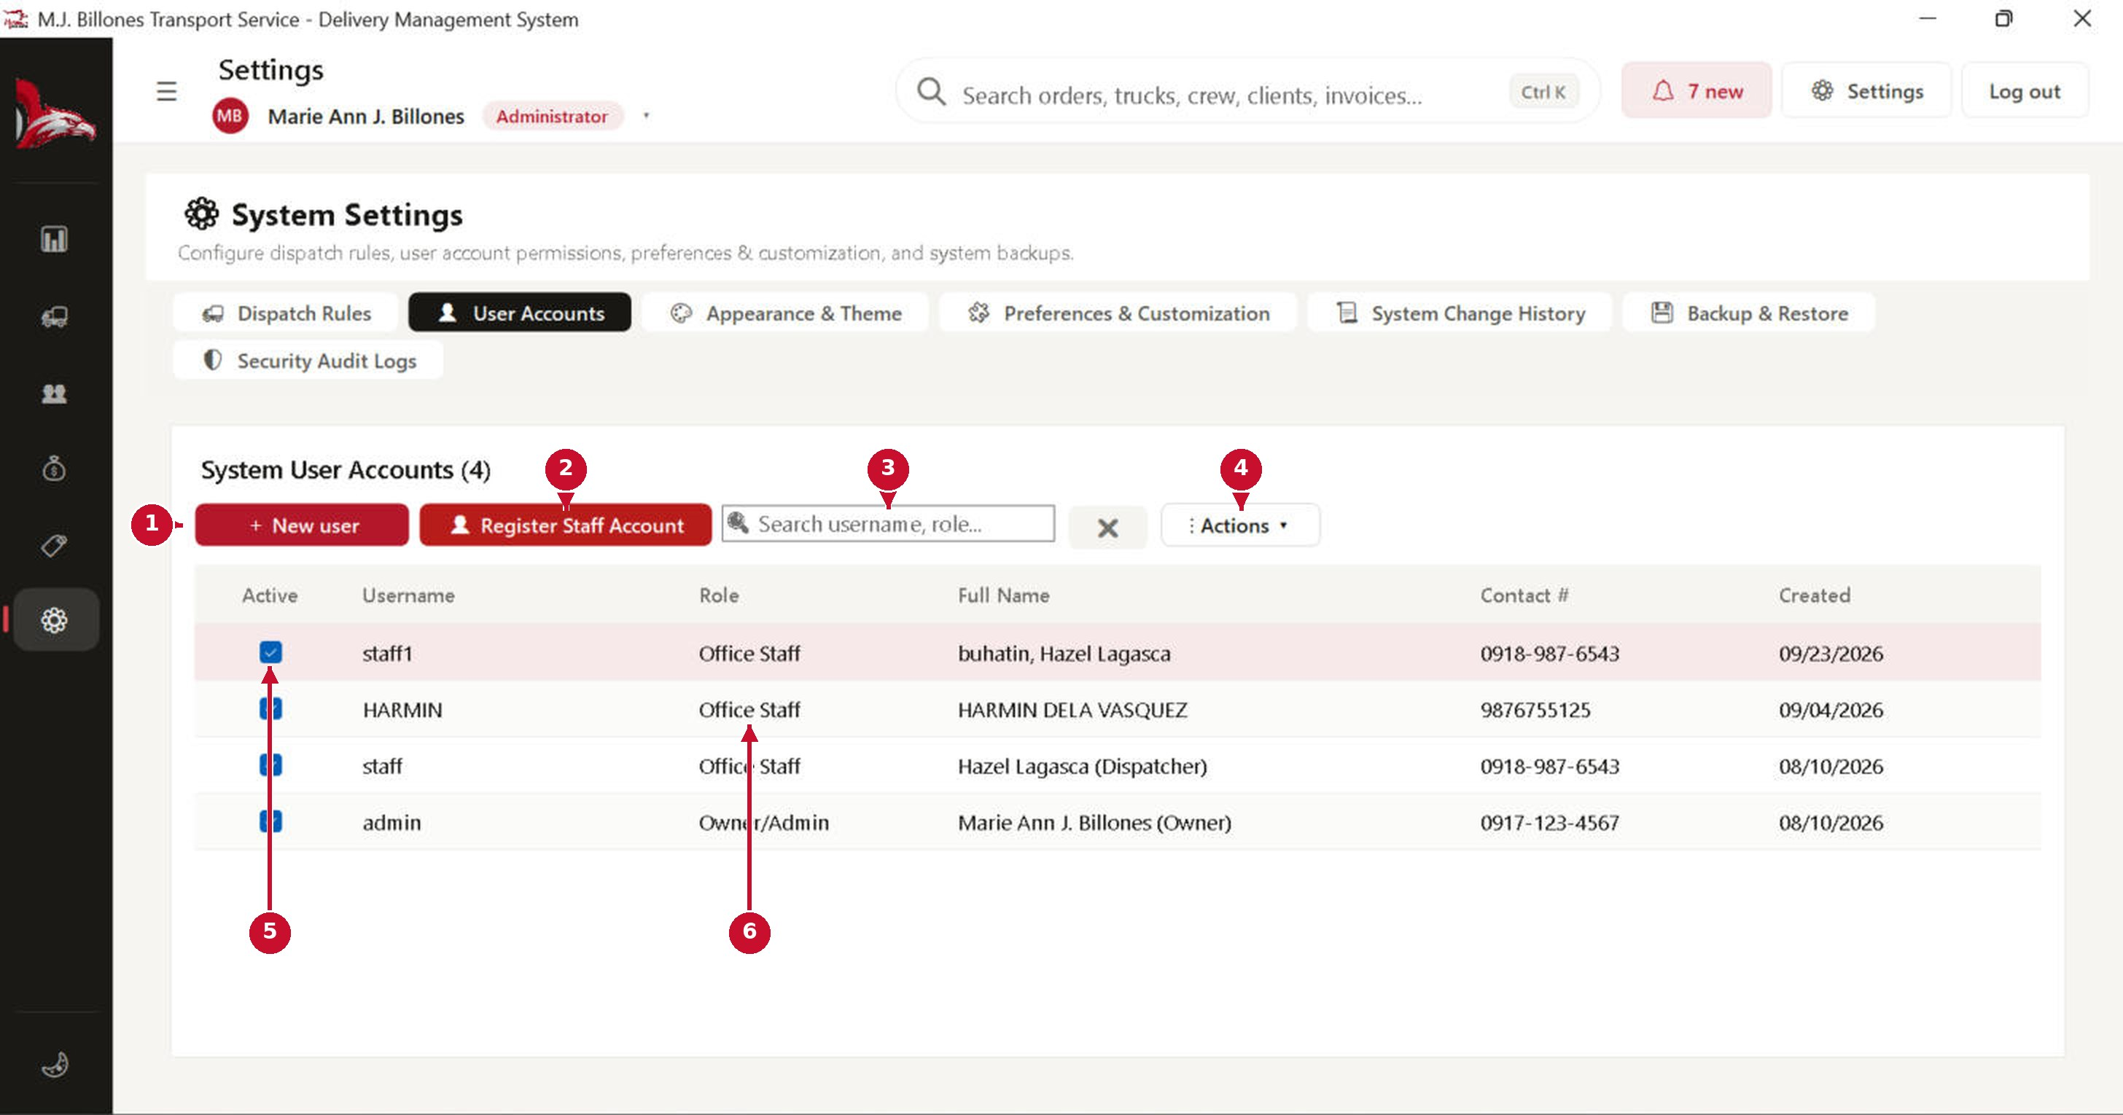
# | Part of the screen | What it does / what happens when you click it
1 | + New user | Opens the user form: username (unique), full name, role, contact and password.
2 | Register Staff Account | Quick form for a new office staff account.
3 | Search | Find by username, name or role.
4 | Actions ▾ | Reset password, deactivate or reactivate the selected account.
5 | Active | Untick to block an account from signing in. Accounts are deactivated, never deleted.
6 | Role | Owner/Admin sees and manages everything, including users, backups and audit logs. Office Staff handles day-to-day work: dispatching, trip reports, billing and collections.

Settings: Appearance & Theme
Change how the system looks for your account. Nothing changes until you press Apply.
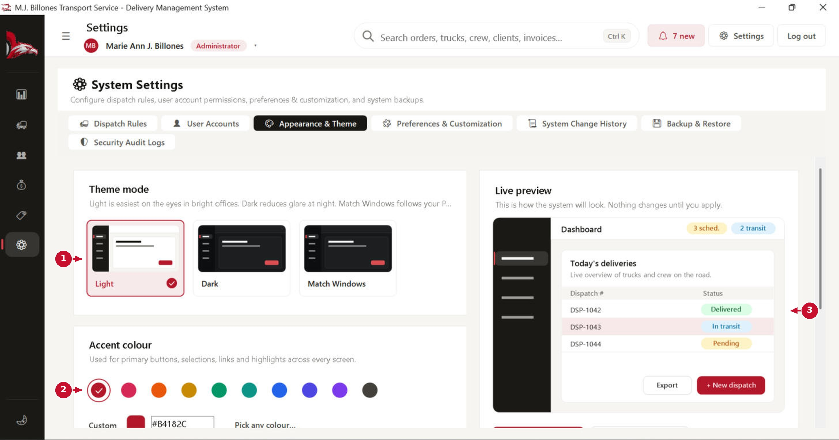
# | Part of the screen | What it does / what happens when you click it
1 | Theme mode | Light, Dark, or Match Windows (follows your Windows setting).
2 | Accent colour | The colour of main buttons, selections and highlights. Pick a swatch or type a custom colour.
3 | Live preview | Shows how the system will look. Scroll down and press Apply theme, or Reset to default.

Settings: Preferences & Customization
Business details printed on invoices, statements and receipts, the company logo, plus default schedule options.
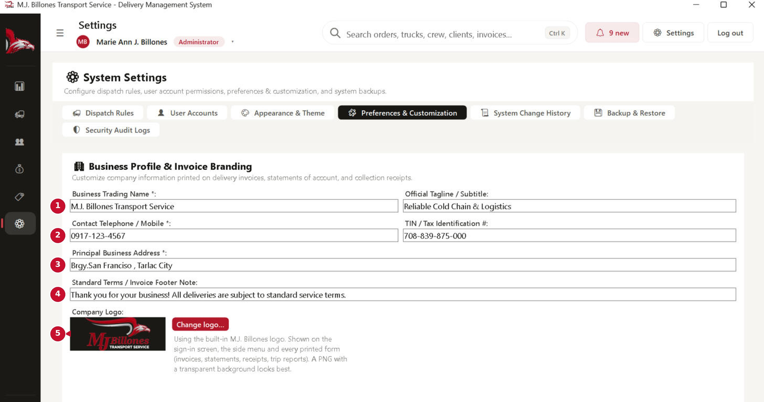
# | Part of the screen | What it does / what happens when you click it
1 | Business name & tagline | Printed at the top of every official document.
2 | Contact & TIN | Your telephone and tax identification number.
3 | Business address | Your principal business address.
4 | Footer note | Terms printed at the bottom of invoices. Scroll down for the default departure time, auto-refresh rate and the Save button.
5 | Company Logo | The logo used on the sign-in screen, the side menu and printed forms. See the next page to change it.

Settings: Company logo
Change the logo that appears on the sign-in screen, in the side menu and on every printed form (invoices, statements of account, receipts and trip reports). Only the Owner / Administrator can change it, and every change is recorded in the Security Audit Log. The logo is saved in the database, so it is included in your backups.
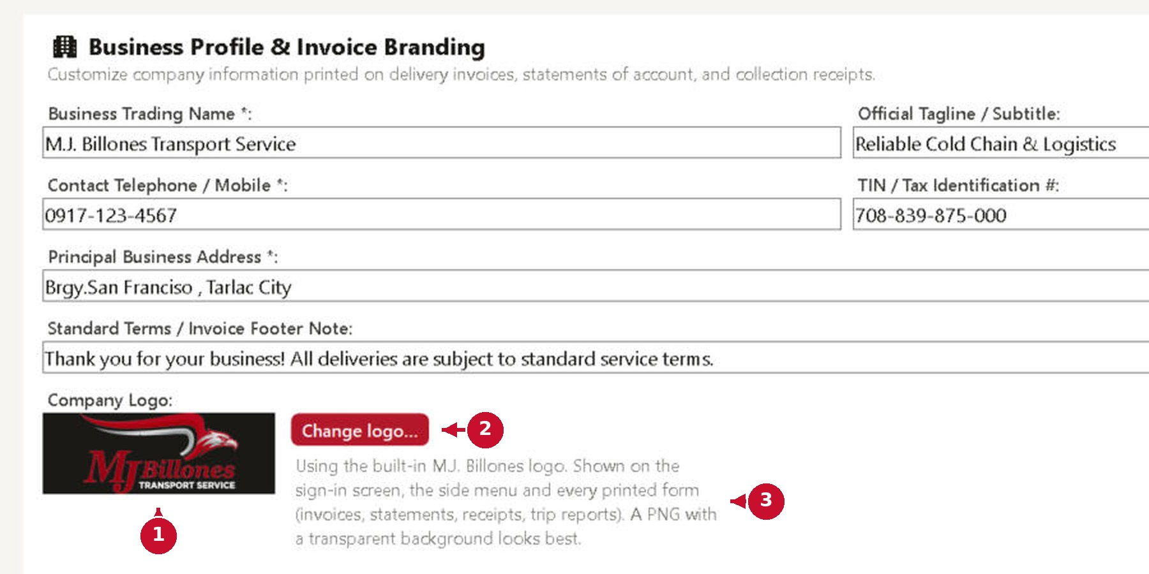
# | Part of the screen | What it does / what happens when you click it
1 | Logo preview | Shows the logo in use, on the same dark background as the side menu, so you can see how it will look.
2 | Change logo… | Choose a PNG, JPG, BMP or GIF picture (up to 10 MB; large pictures are scaled down automatically). The side menu changes straight away. A PNG with a transparent background looks best. After you upload a logo, a “Use default logo” button appears beside it: click it and confirm to go back to the original M.J. Billones logo.
3 | Help text | Says whether the built-in or your own logo is in use. With your own logo, a tick box “Turn black lettering white on the dark sidebar” also appears: untick it if your logo already reads well on dark colours.

Settings: Backup & Restore
Make a backup regularly (at least weekly) and keep a copy on a USB drive or cloud storage. Restoring replaces all current data with the backup.
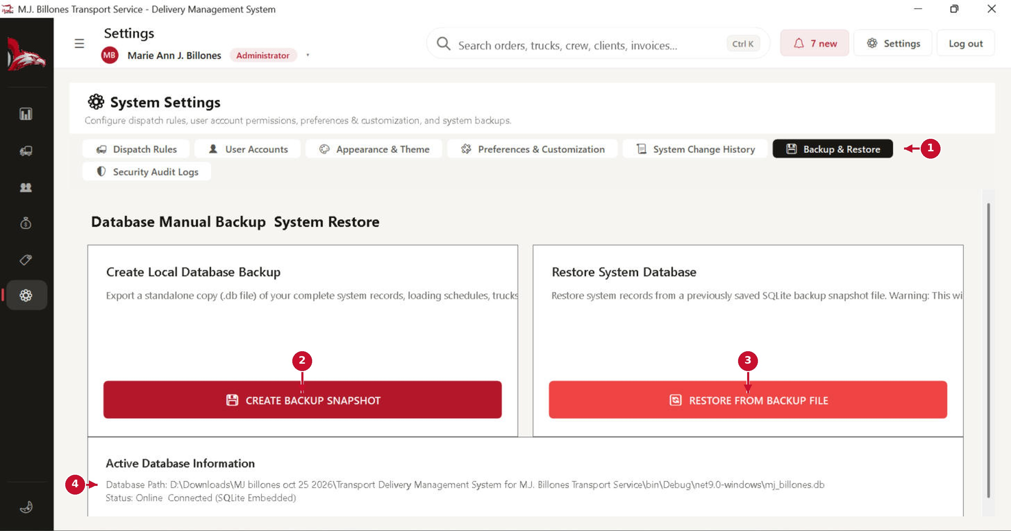
# | Part of the screen | What it does / what happens when you click it
1 | Backup & Restore tab | Only shown to administrators.
2 | CREATE BACKUP SNAPSHOT | Asks where to save, repairs any damaged indexes, writes a .db copy of all your data and checks it. A message confirms when it is done.
3 | RESTORE FROM BACKUP FILE | Asks you to confirm and choose a .db backup. It checks the file, saves a safety copy of your current data in the Backups folder, then restores. Restart the app afterwards.
4 | Active database information | Where the database file is stored and whether it is connected.

Settings: Security Audit Logs
Every add, update, delete, status change and sign-in is recorded here. Audit entries can never be changed or deleted.
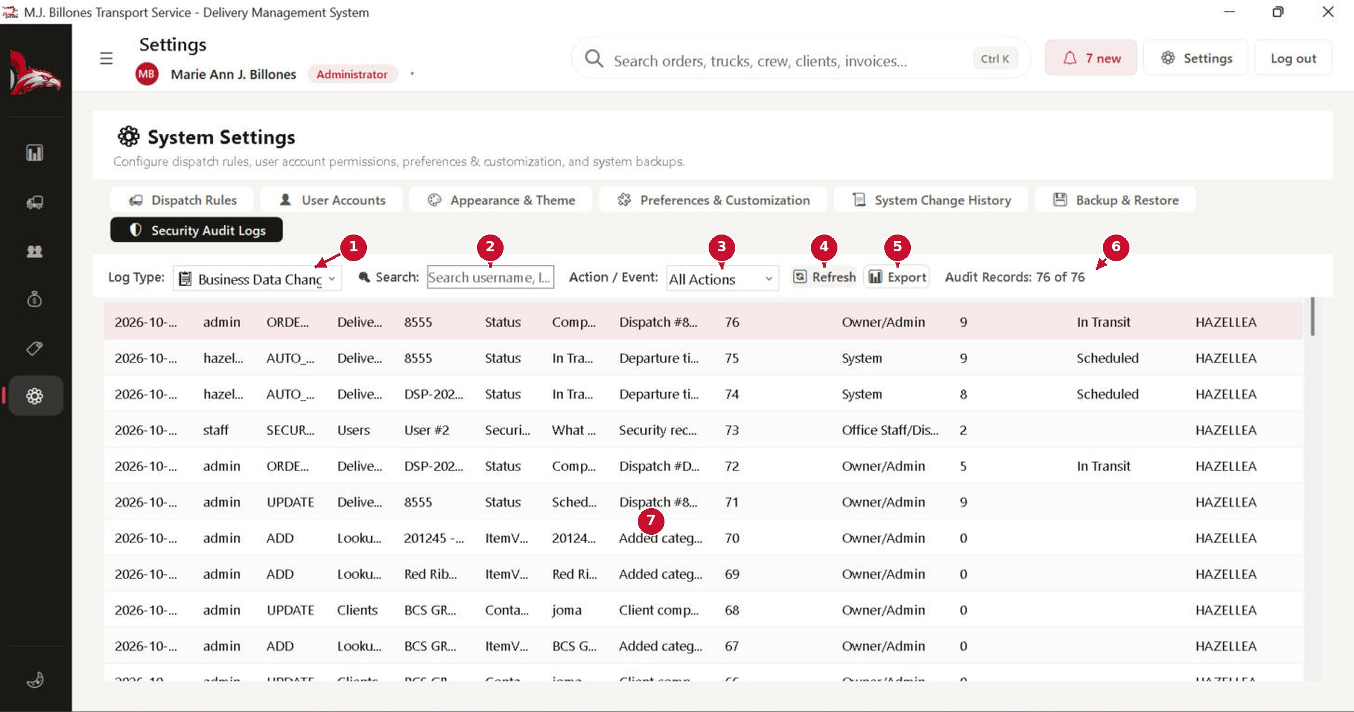
# | Part of the screen | What it does / what happens when you click it
1 | Log type | Business data changes, or sign-in (security) events.
2 | Search | Find by username or record.
3 | Action / Event | Show only one kind of action (add, update, delete, status, login).
4 | Refresh | Reloads the log.
5 | Export | Saves the log as a file.
6 | Record count | How many entries match your filters.
7 | Log rows | Date and time, user, action, module, record, field, old value, new value, role and computer name.

Messages you will see, and what to do
The system always explains itself in a message box. These are the most common ones.
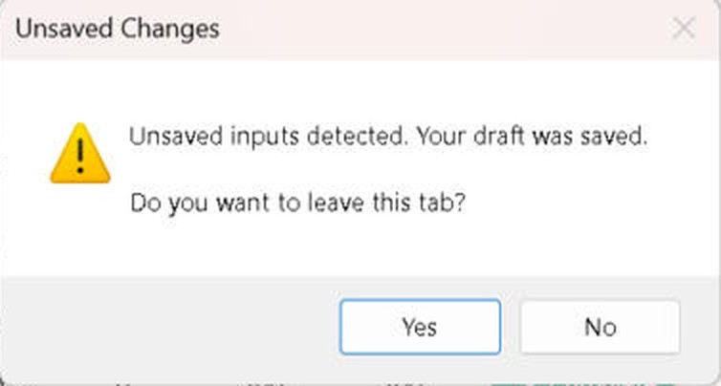
# | Part of the screen | What it does / what happens when you click it
1 | “Are you sure you want to …?” | Shown before every save, add, update, delete and reset. Yes continues; No cancels and changes nothing.
2 | “Unsaved inputs detected. Your draft was saved. Do you want to leave this tab?” | You are leaving a form you started. Yes leaves (the draft is kept for later); No stays on the form.
3 | “Please fix the following: …” | One or more fields are missing or wrong. Read the list, fix each field (it is highlighted), and save again.
4 | Duplicate … blocked | The plate, name, code or reference number already exists. Use a different one, or open the existing record instead.
5 | “… is assigned to an open dispatch” | A truck or crew member on an open trip cannot be set to maintenance or inactive. Complete or reassign the trip first.
6 | “This driver’s license expired on …” | Update the licence in Crew Management before saving or dispatching the driver.
7 | “… cannot be deleted. Cancel, void or deactivate them instead.” | History is protected. Use Cancel (orders), Void (receipts, reports, incidents) or Deactivate (trucks, crew, clients, users).
8 | “The database wasn’t restored. …” | The message says why (wrong file, damaged file, file in use). Nothing was changed; choose another backup file.

Shortcuts and good habits
# | Part of the screen | What it does / what happens when you click it
1 | Ctrl + K | Jump to the global search from any screen.
2 | Enter | Open the selected search result or list row.
3 | Esc | Close a window, search results or a full-page form (your draft is kept).
4 | Double-click a row | Open the record’s details or profile.
5 | Right-click a row | Quick actions: open, edit, set status, print, copy, export.
6 | Click a column header | Sort the list by that column; click again to reverse.

Good habits
- File the trip report on the same day the truck returns, with the POD attached.
- Keep drivers’ licence expiry dates up to date; expired drivers are not offered for dispatch.
- Check the Dashboard’s “Needs attention” list at the start and end of each day; deal with the Urgent (orange) items first.
- Make a backup at least once a week and keep one copy outside this computer.
- Give every staff member their own account, so the audit log shows who did what.

If the app stops responding: a message box may be waiting behind another window. Press Alt + Tab or click the app’s icon in the taskbar to bring it to the front, then answer it.

