SUMMARY REPORT
{{job scop}}
MV. “{{vessel}}”

Dear {{principal}},

We are pleased to confirm that our surveyor, {{surveyor}} has attended on board the vessel {{vessel}} at {{port}} to carry out {{principal}} on {{survey date}}. {{bunker1_sentence}} The bunker transferring of {{bunker1}} commenced at {{commenced_hour}} on {{commenced_date}} and completed {{completed_hour}} on (completed_date). {{bunker2_sentence}} The bunker transferring of {{bunker2}} commenced at {{commenced_hour}} on {{commenced_date}} and completed at {{completed_hour}} on {{completed_date}}.
Owner : {{owner }}
Charterer : {{charterer}}
Attending Surveyor : {{surveyor}}
Chief Engineer : {{chie_engineer}}
Master : {{master}}
BROB survey findings:
The Very Low Sulphur Fuel Oil and Low Sulphur Marine Gas Oil Tanks were sounded in the presence of the vessel's Chief Engineer and the quantities of VLS Fuel Oil and LS Marine Gas Oil on board were calculated on {{calculated date}} @ {{calculated hours}} to be as follows:

 | Actual quantity on board (MT) | Log Book Figures (MT) | Difference (MT)
Heavy Fuel Oil | 0.000 | 0.000 | 0.000
LS Fuel Oil | 417.769 MT | 410.080 MT | + 7.689 MT
LS Marine Gas Oil | 32.612 MT | 32.530 MT | + 0.082 MT

Supply of {[supply_bunker1}} & {{supply_bunker 2}}:
The quantities of ordered bunker to be supplied on board in {{port}} were {{quantity1}} of {{supply_name1}} & {{quantity2}} of {{supply_name2}}.

Supply barge: {{supply_barge1}} {{bunker1}}
1) Bunker delivery receipt quantity : 149.214 m/tons
2) Barge delivered quantity : 149.284 m/tons
3) Quantity received on vessel : 149.206 m/tons
4) Nominated quantity : 149.000 m/tons

Difference (2-1) : 0.070 m/tons (more)
Difference (3-1) : 0.008 m/tons (less)
Difference (4-1) : 0.214 m/tons (more)

Supply barge: {{supply_barge2} {{bunker2}}
1) Bunker delivery receipt quantity : 800.385 m/tons
2) Barge delivered quantity : 800.664 m/tons
3) Quantity received on vessel : 800.471 m/tons
4) Nominated quantity : 800.000 m/tons

Difference (2-1) : 0.279 m/tons (more)
Difference (3-1) : 0.086 m/tons (more)
Difference (4-1) : 0.385 m/tons (more)

Surveyor’s comments:
{{Comments}}

i) The Report is prepared for the sole use of the Client and is prepared based on the Services required by the Client and the conditions under which the Services are performed by GRM MARINE PTE LTD.
ii) The Report may not be used in any publicity material without the written consent of GRM MARINE PTE LTD.
iii) The Report may not be reproduced in part or in full unless approval in writing has been given by GRM MARINE PTE LTD.
iv) The results reported herein have been performed in accordance with the terms of accreditation under the Singapore Accreditation Council.
v) Our procedure for BQS is in accordance with Singapore Standard (Code of Practice for Bunkering), (SS) 600:2014 (SS) 648:2019 (Technical Reference for Mass Flow Metering), SS600:2022
(Code of Practice for Bunkering by Bunker Tankers Using Tank Gauging) and GRM MARINE PTE LTD S.O.P for bunker survey.

And the meantime, should you have any query, please feel free to contact us.

Best regards,
Authorized Signatory
Dhinesh
GRM MARINE PTE LTD
Mobile: +65 96576310

Date of Issue: {{date of issue}}

BUNKER TANKER MEASUREMENT REPORT LSMGO

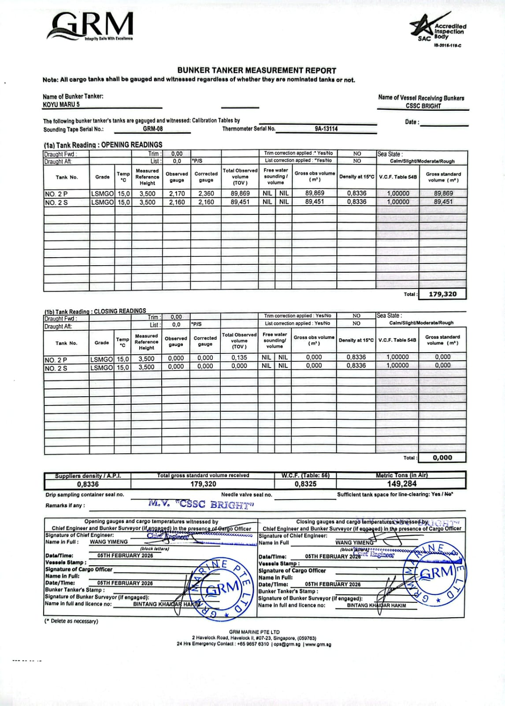

BUNKER TANKER MEASUREMENT REPORT VLSFO
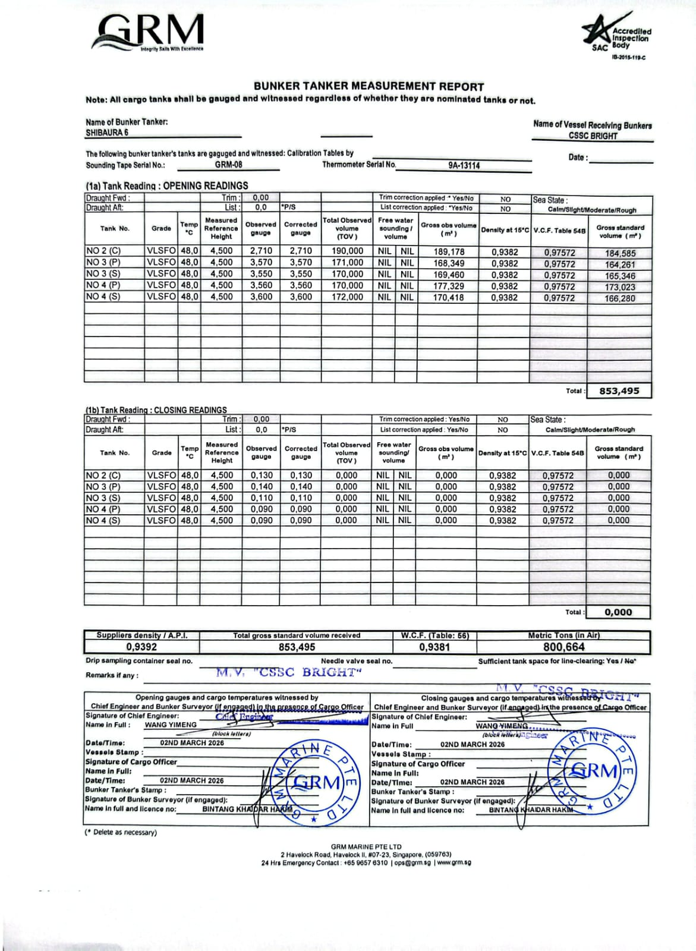

CONTINUOUS DRIP SAMPLING TAKEN AT VESSEL’S MANIFOLD FOR LSMGO BUNKERING
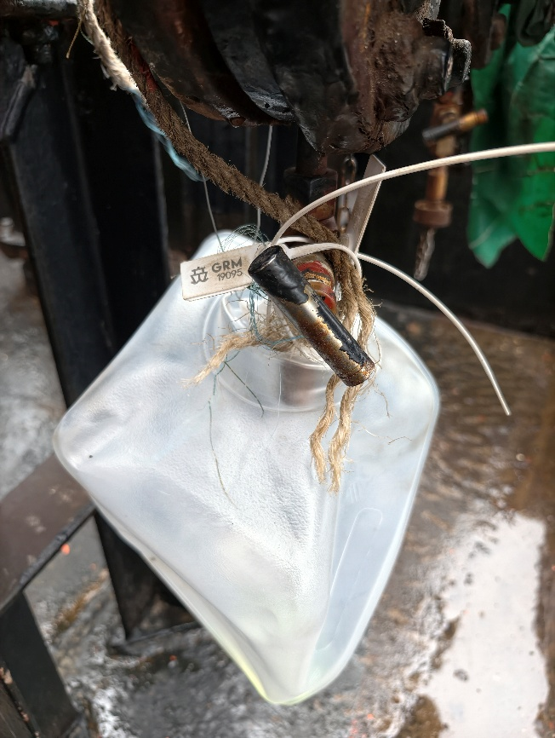 | 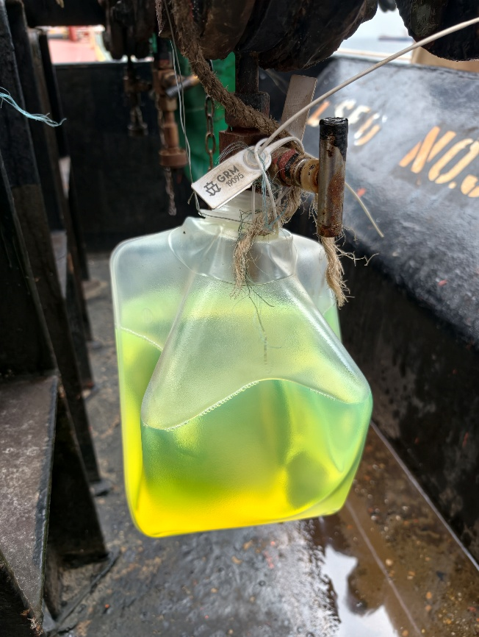
Before Bunkering | After Bunkering
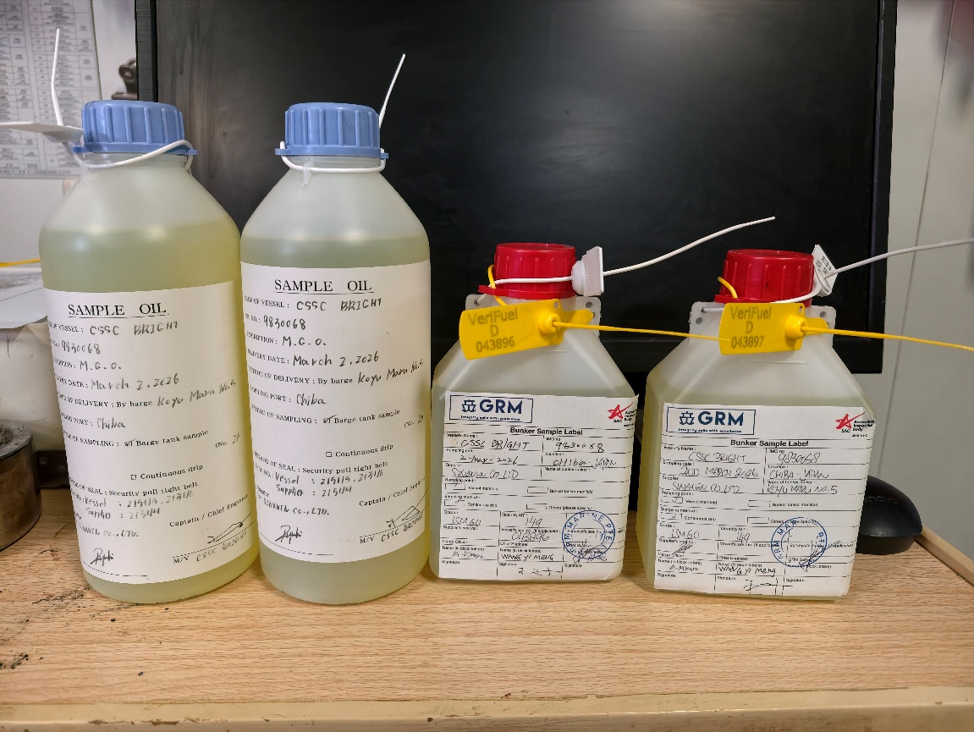
SAMPLES SEALED USING SUPPLIER AND VESSEL BOTTLES

CONTINUOUS DRIP SAMPLING TAKEN AT VESSEL’S MANIFOLD FOR VLSFO BUNKERING
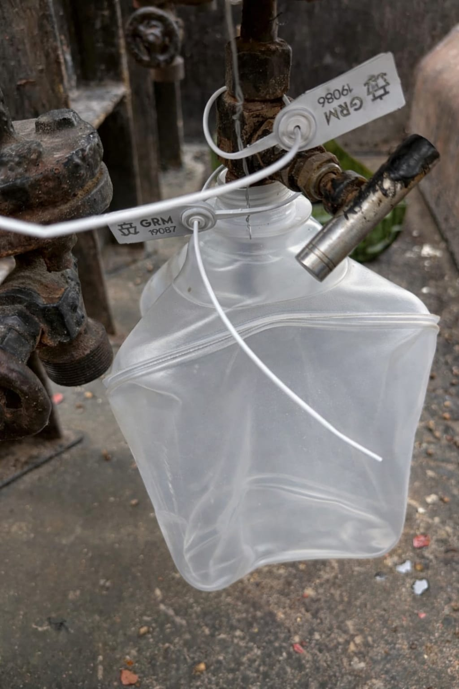 | 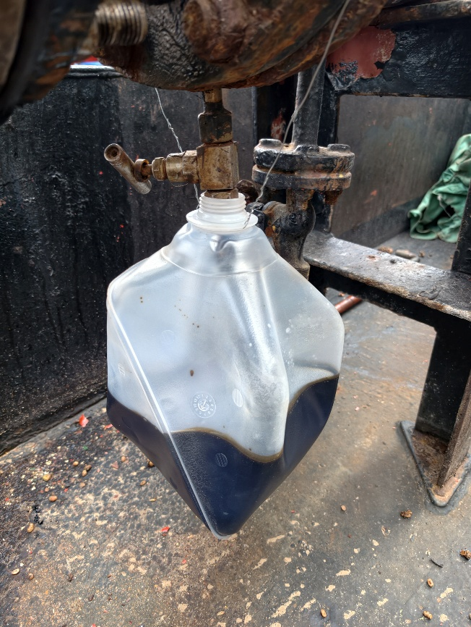
Before Bunkering | After Bunkering
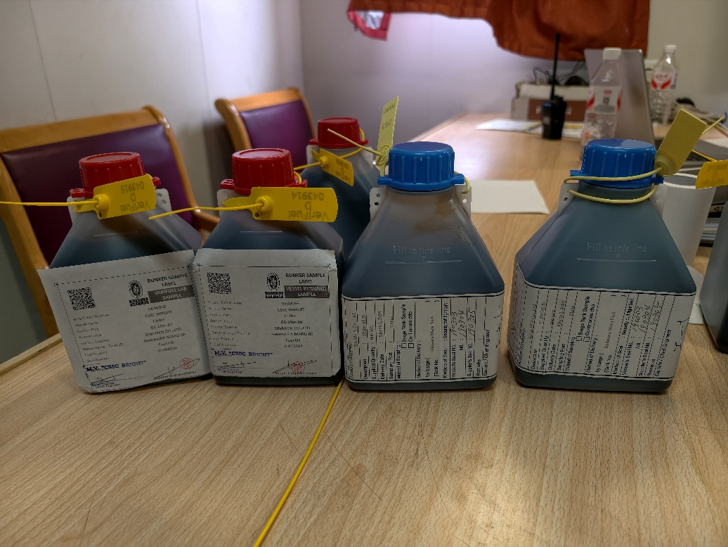
SAMPLES SEALED USING VESSEL AND SUPPLIER BOTTLES

