Sequence | Failed Commands
arm_14393.0000a.sol00729_arm_deactivate | 1 failed instance of SEQ_DEACTIVATE.
clnp00729.0000a | 3 failed instances of SEQ_DEACTIVATE.
clnp00730.0000a | 15 failed instances of SEQ_DEACTIVATE.
clnp01729.0000a | 2 failed instances of SEQ_DEACTIVATE.
clnp01730.0000a | 10 failed instances of SEQ_DEACTIVATE.
clnp02729.0000a | 15 failed instances of SEQ_DEACTIVATE.
clnp02730.0000a | 5 failed instances of SEQ_DEACTIVATE.
clnp03729.0000a | 6 failed instances of SEQ_DEACTIVATE.
clnp03730.0000a | 2 failed instances of SEQ_DEACTIVATE.
clnp04729.0000a | 14 failed instances of SEQ_DEACTIVATE.
clnp04730.0000a | 2 failed instances of SEQ_DEACTIVATE.
clnp05729.0000a | 3 failed instances of SEQ_DEACTIVATE.
clnp05730.0000a | 2 failed instances of SEQ_DEACTIVATE.
clnp06729.0000a | 3 failed instances of SEQ_DEACTIVATE.
clnp06730.0000a | 4 failed instances of SEQ_DEACTIVATE.
clnp07729.0000a | 2 failed instances of SEQ_DEACTIVATE.
clnp07730.0000a | 2 failed instances of SEQ_DEACTIVATE.
clnp08729.0000a | 3 failed instances of SEQ_DEACTIVATE.
clnp08730.0000a | 2 failed instances of SEQ_DEACTIVATE.
clnp09729.0000a | 2 failed instances of SEQ_DEACTIVATE.
clnp09730.0000a | 2 failed instances of SEQ_DEACTIVATE.
clnp10729.0000a | 4 failed instances of SEQ_DEACTIVATE.
clnp11729.0000a | 4 failed instances of SEQ_DEACTIVATE.
clnp12729.0000a | 2 failed instances of SEQ_DEACTIVATE.
clnp13729.0000a | 1 failed instance of SEQ_DEACTIVATE.
clnp14729.0000a | 4 failed instances of SEQ_DEACTIVATE.
eng_00000.0004a.engineering_keepout | 73 failed instances of SEQ_RUN.  73 failed instances of SEQ_DELETE.
heli15110.0001a.cleanup2 | 3 failed instances of MHS_ABORT.
mstr00729.0000a | 38 failed instances of SEQ_DEACTIVATE.
mstr00730.0000a | 26 failed instances of SEQ_DEACTIVATE.  4 failed instances of SEQ_ACTIVATE.
pixl00001.0000a.surf_contingency_deactivate_cleanup | 8 failed instances of PIXL_ABORT.  4 failed instances of PIXL_PULSE_DISCRETE.
scam03730.0000a.10x1_H_LIBS_MIC_RMI_AEGIS_1 | 10 failed instances of SCAM_LIBS_OBS.
scam15001.0000a.Cleanup_IR1 | 2 failed instances of SCAM_ABORT.  2 failed instances of SCAM_BU_THERMAL.  8 failed instances of SCAM_MU_THERMAL.
scam15003.0000a.Cleanup_noIR | 4 failed instances of SCAM_ABORT.  4 failed instances of SCAM_BU_THERMAL.  12 failed instances of SCAM_MU_THERMAL.

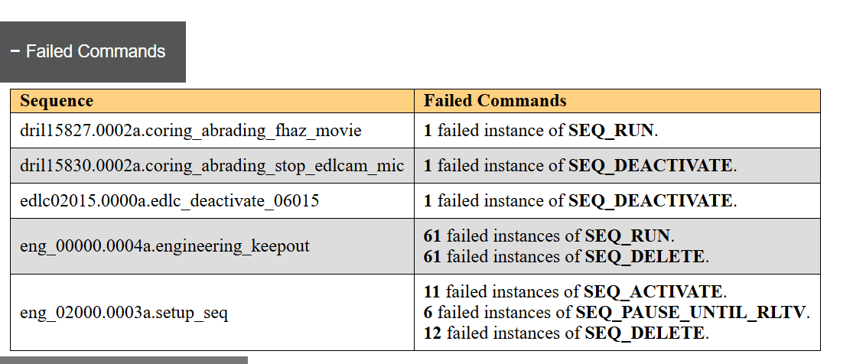
Explanation of command failures:

