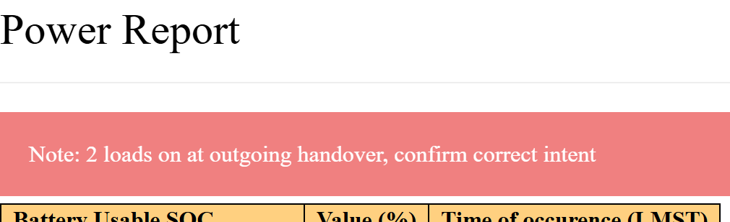

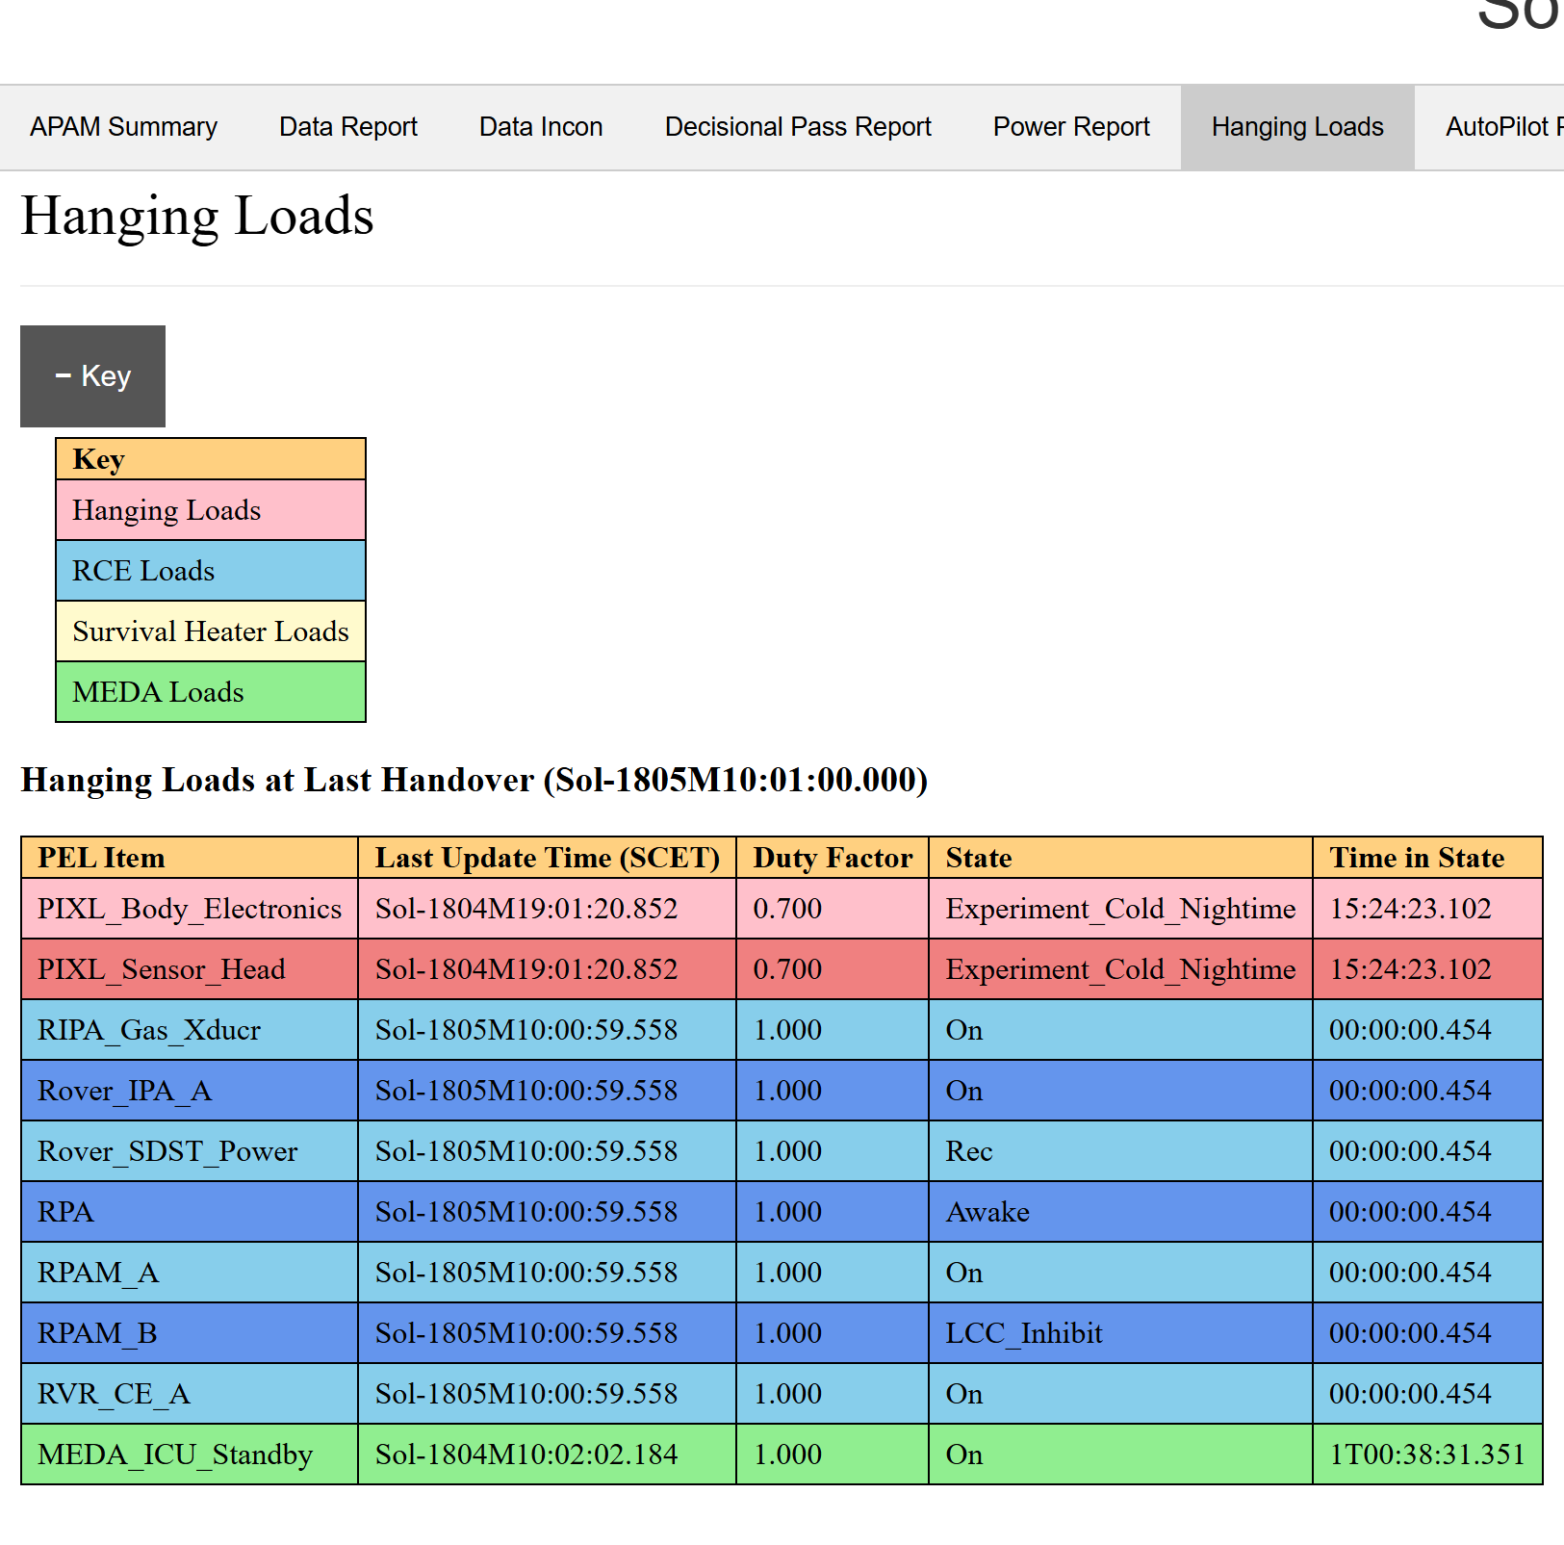
Hanging loads are power states other than “off” at the outgoing inter-plan handover. The warning will flag if there non-standard hanging loads. The TUL must manually verify the loads are expected or correct the problem.
Context: Power modeling definitions on M2020 are translated from the PEL (Power Equipment List); in its simplest form, PEL_Item, State, Load (in Watts). This information is referenced from any given activity in that activity’s entry in the Activity Dictionary (AD). For power modeling in the COCPIT application, the AD, the PEL, and MMPAT configuration files are all available to it to real-time calculate and “roll-up” all states, duty cycles, transitions, and durations to derive energy values such as average load, max power, Whrs for the duration, for any given planning unit in the plan RML. As a general rule, activity definitions should end in the off-state. However, while manual review process is meant to enforce this, there is nothing mechanically preventing an AD author from leaving PEL item state “on” such that it will outlive the borders of its planning unit and potentially persist through the end of the planning cycle, effectively acting as anchor/drag to the overall system power model. This check in the power report looks at the results of the simulated power model and checks the states of all loads at the last outgoing handover to see if any are not “off.” There are some loads that are expected to be on at handover, the rover compute element/avionics, the survival heaters, and the atmospheric monitoring payload MEDA. All load states associated with those particular categories are whitelisted, color coded in the report legend, and ignored for the purposes of the warning. We may elect to support some activities across the inter-plan boundary, but it requires manually disposition if that is the case. This check is not foolproof as people may have intra-plan state transitions where a load is incorrectly on, but turned off before getting to the plan end boundary, but those cases are usually localized, less than a few hours, and not sapping energy in modeling across 1-4 days! This check is meant to catch accidental timeline issues – someone place an activity overlapping the outgoing handover by mistake (common), or it could be a miss from the strategic review process for AD updates.
Annotation:
ACCEPT: In this particular case, looking at the 1803 planning cycle (2-sol plan), the PIXL Scan is indeed so long that it needed to spill over into the 1805 planning cycle, the PIXL* loads are appropriate. TUL should follow their procedure instructions for “activities spanning outgoing handover.”
FIX: Tactical timeline mistake - If it were not the case of desiring to do a PIXL Scan over handover, the PIXL activity setting those states (from the AD) would need to be moved to the left and/or shortened (in COCPIT) so that it does not overlap/go past the handover boundary.
Strategic mistake – if it is a bad activity definition (verify by inspecting the latest Approved AD in the AD Editor application), the intervention options are replace the offending activity with a placeholder and enter parameters manually or descope the activity entirely and talk with ML about precluding it’s inclusion in ops until a fix is in place. The non-intervention option (for tactical) is to accept the artificial drag on the system power model. In all cases, inform the tactical owner of the activity (e.g. PUL, RP, etc.) which option you decide, and email the TUL team & Parcel Lead to let them know about the issue and impacts.

