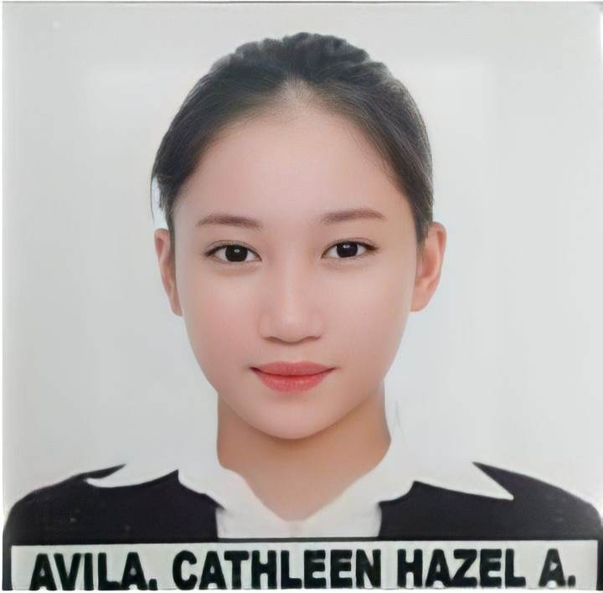

**Cathleen Hazel A. Avila** Tabacao, Talavera, Nueva Ecija (+63) 9121314212

[zelynavila@gmail.com](mailto:zelynavila@gmail.com)

# OBJECTIVES:

I am particularly attracted to your company because I want to work for someone who is innovative and gives their employees the opportunity to thrive, I actually work better under pressure and I’ve found that I enjoy working in a challenging environment.

# Education:

Central Luzon State University Bachelor of Science Information and Technology

Science City of Moñuz (2018-2021)

Tabacao National High School Senior High school (2016-2018) Tabacao, Talavera, Nueva Ecija Junior High School (2012-2016)

San Jose Elementary School Elementary School (2011-2012) Tabacao, Talavera, Nueva Ecija

# Career Related Experience:

Nagkakaisang Magsasaka Agricultural Primary Multi-Purpose Cooperative

Far East Botica

Barangay Tabcao,Talavera Nueva Ecija (February 2019 – September 2021)

# Awards, Affiliation and Achievements

* Deans Lister (2020-2022)
* Competent in Computer System Servicing NC II (valid until 02/19/23)

# Skills:

My interpersonal skills have allowed me to successfully manage various international projects. has a piece of knowledge in using a computer (Microsoft word and PowerPoint) also other computer software and hardware good communication skills, good at time management, and can work independently, group or team.

# Seminars Attended

* Stack league x GDG Bacolod Tech Session: Smart agriculture

via zoom (March 5, 2022)

* Coding 101: PHP Tutorial via zoom Central Luzon State University (March 2, 2022)
* ASEAN Data Science Explorers - Enablement Session 2022 via zoom
* AWS Academy Seminar

# PERSONAL INFORMATION:

Date of Birth: July 3, 2000

Age: 21 years old

Mother: Cecile A. Avila

Father: Harold C. Avila

Religion: Iglesia Ni Cristo

Place of Birth: San Miguel Bulacan

Civil Status: Single

Occupation: Head Teacher

Occupation: Teacher



Cathleen Hazel A. Avila

APPLICANT SIGNATURE OVER PRINTED NAME