FACE DETECTION PROJECT REPORT
Computer Engineering Department | Digital Image Processing

Section | القسم | اسم الطالب
3 | AI | محمد شحته ابراهيم احمد
1 | AI | حازم منصور ميصر يوسف
3 | AI | محمد احمد محمد عبدالعزيز
3 | AI | محمد عبداللطيف محمد
3 | AI | محمود حاتم محمود
3 | AI | محمد عماد رمضان

Introduction
This report presents a comparative study of three fundamental face detection algorithms: Haar Cascade, HOG + SVM, and Deep Learning (DNN). The goal is to evaluate their performance in terms of detection accuracy (Precision, Recall, F1-Score) and computational efficiency (Speed) on a large-scale dataset.

Algorithm Descriptions

Haar Cascade Classifier
Mechanism: Uses Haar-like features and an AdaBoost-based cascade classifier.
Pros: Fast performance on CPU, suitable for real-time mobile applications.
Cons: Higher false-positive rates compared to modern methods.
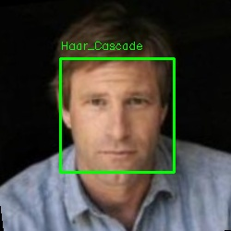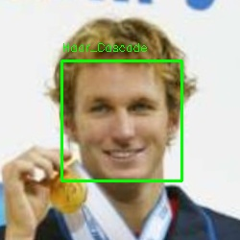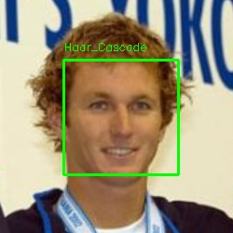

HOG + Linear SVM
Mechanism: Extracts Histogram of Oriented Gradients to capture edge directions.
Pros: Excellent balance between speed and accuracy; robust to illumination.
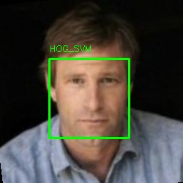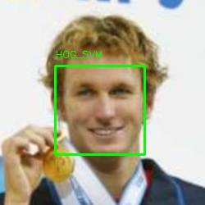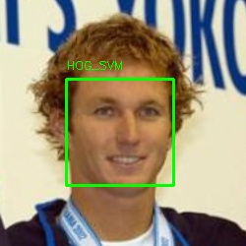

Deep Learning (DNN - SSD/ResNet)
Mechanism: A Single Shot Detector (SSD) using a ResNet backbone for deep feature extraction.
Pros: Extremely high recall, capable of detecting faces in challenging poses.
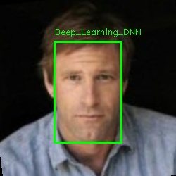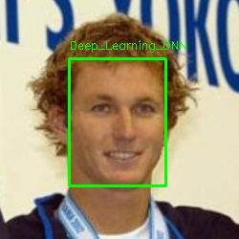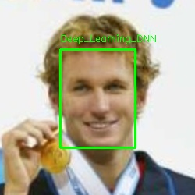

Dataset Description
Total Images: 914 images.
Diversity: Includes various lighting conditions, poses, and multiple face scenarios.

Results & Analysis
The table below shows the performance recorded from processing 914 images:
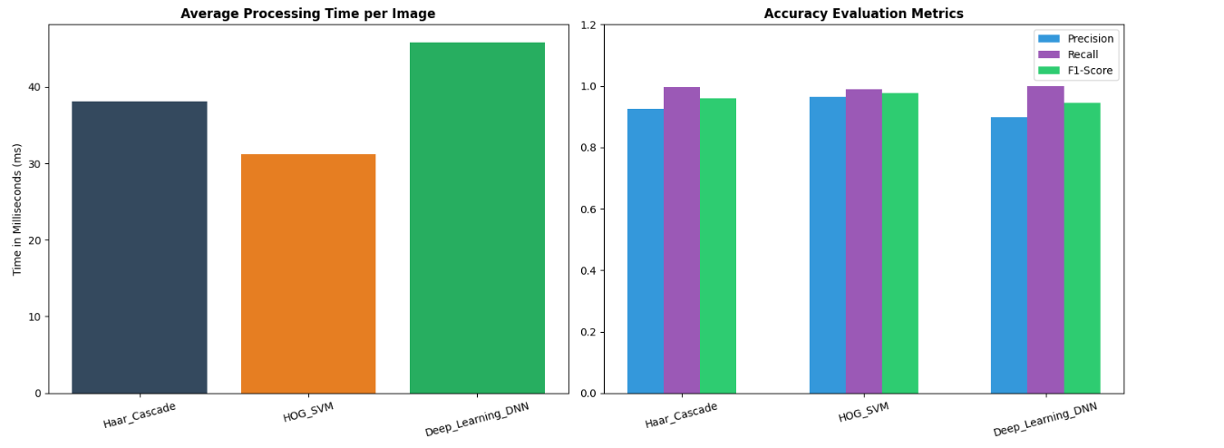
Algorithm Name | Precision | Recall | F1-Score | Avg Time (ms)
Haar_Cascade | 0.93 | 1.00 | 0.96 | 38.15
HOG_SVM | 0.96 | 0.99 | 0.98 | 31.20
Deep_Learning_DNN | 0.90 | 1.00 | 0.95 | 45.85
Analysis: HOG_SVM achieved the best overall performance with an F1-Score of 0.98 and the fastest processing time (31.20 ms). Haar_Cascade and DNN achieved perfect Recall (1.00), meaning they missed zero faces, though DNN had slightly more false positives (lower precision).

Conclusion
Based on the empirical evidence, HOG_SVM is the recommended algorithm for general PC-based applications due to its superior speed and precision. Deep Learning (DNN) remains the best choice for maximum recall in complex environments where computational power is not a constraint.

