



PHASE A



PHASE B





PHASE C





Fault type effect AB







Fault type effect AB to ground







ABC







FAULT INCEPTION ANGLE

0.03:0.04

0.03





0.032





0.034





0.036





0.038





0.04





Fault distance



















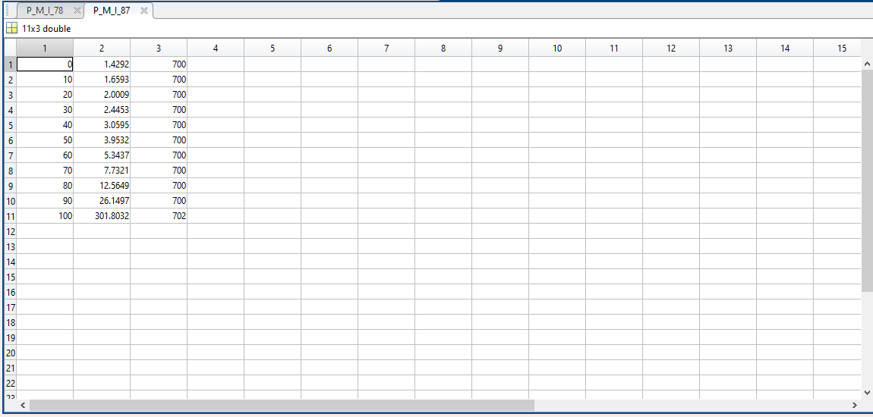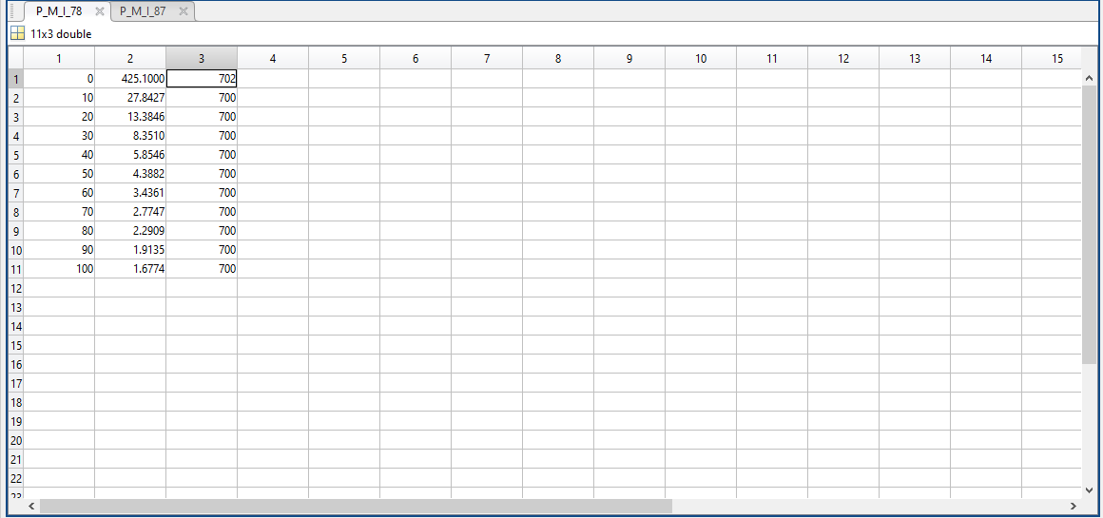

conclusions

* Using wavelet analysis to create an algorithm for fault detection require a threshold to every fault case and considering the same directionality of current at the end and beginning of each line.
* Fault inception angle has a tremendous effect on the protection algorithm used and must be considered carefully
* The fault resistance variation also results in distinct maximum values for the detailed coefficients
* The fault distance at which the fault occurred needs to be taken into calculations to design a flawless protection algorithm for the relays in every transmission line.

The value of the maximum first level wavelet details **decreases** with the increase in fault distance for the I78 current monitored at bus7 by the relay.

The value of the maximum first level wavelet details **increases** with the increase in fault distance for the I87 current monitored at bus8 by the other relay.

The used detection algorithm is based on two criteria. One is detection by the predetermined 1st level detailed coefficient threshold and the other one is the directionality of both monitored currents at both endings of the line.

**Effect of Fault Inception Angle**

* From the previous figures, we can deduce that the inception angle has a huge effect on the wavelet analysis
* When the fault occurs at the zero-crossing line, the current maximum coefficient is low and must be readjusted by the algorithm to be detected.
* As the angle varies, the current maximum coefficient is clear and detectable
* As the angle moves past the zero-crossing line, the oscillations in the current wave result in a distinguished maximum current value because of the different frequencies in the analyzed signal by the wavelet algorithm

As shown, Line 7-8 is divided onto two lines to represent different cases of internal line faults based on varying the distance of both divided lines.

The current is monitored at the beginning of Line 7-8 at bus 7 with the shown polarity and the same exact current is monitored with the opposite polarity at the end of the line at bus 8.