**Chapter (4)**

**Fault detection using wavelet analysis**

**4.1. Introduction to wavelet**

**4.1.1. Wavelet Analysis definition**

Wavelet analysis is a powerful signal processing method. This method

is well suited to detect abrupt, local changes in a signal (e.g., short time

phenomena such as transient processes). Note that wavelet analysis does not

use a time frequency, but rather a time-scale region. The analyze signal is

decomposed into different scales using a wavelet analyzing function called

‘Mother Wavelet’. This wavelet is scaled and translated to match an input

signal locally. The subsequent calculated wavelet coefficients represent the

correlation between the (scaled) wavelet and the signal.

**4.1.2.** **Traveling Waves**

Any electrical disturbance causes high frequency electromagnetic

impulses called traveling waves to propagate on a transmission line. The

occurrence of a fault results in an abrupt change in voltage at the point of the

fault and sets up these traveling waves which propagate from the fault point

towards the line terminals where relays are located. It is possible to design

relays which utilize these propagation phenomena to detect the presence of a

fault, and to determine the fault location.

Since the traveling waves are the earliest possible evidence available to a

relay that a fault has occurred, these relays have the potential of becoming

the fastest responding relays [1].

The traveling waves contain high frequency transients, and consequently

their detection requires a high sampling frequency and a suitable signal

processing technique such as the wavelet transform.

**4.1.3. Wavelet Transform**

The wavelet transform decomposes signals over dilated and translated

wavelets. A wavelet is a function ψ with a zero average

$\int_{\text{-∞}}^{\text{∞}}{ψ(t) dt = 0 }$ (1)

A wavelet transformation is characterized by a translation parameter u and a

dilation parameter ||s||. The dilation parameter determines the size of the

window in which the wavelet transform is performed. The translation

parameter determines the time corresponding to the center point of each

window. A wavelet is normalized ||ψ|| = 1 and centered in the neighborhood

of t = 0. For each ‘mother wavelet’ ψ, a family can be obtained by scaling ψ

by s and translation of ψ by u.

ψu,s(t) = $\frac{1}{\sqrt{s}}$ ψ $(\frac{t-u}{s})$ (2)

Also, the scaled and translated wavelets remain normalized. The wavelet

transform of a signal f (t) at time u and scale s is calculated by

WT(u, s) = (3)

With ψ* the complex conjugated of the wavelet function ψ, Wavelets can be

an appropriate tool for detecting disturbances, for example, faults, in power

systems.

**4.1.4. Use of wavelets for fault detection**

In general, three types of wavelet transforms can be distinguished,

namely the continuous wavelet transform (CWT), the discrete wavelet

transform (DWT), and the stationary wavelet transform (SWT). The CWT is

the convolution of the signal multiplied by scaled and shifted versions of the

mother wavelet. This continuous process results in many wavelet coefficients

and a long calculation process. In fault detection applications, it is of great

importance that all data points are treated in the same way. For example,

when a wavelet transform of a current signal in one cable is compared with

one from another cable, it is crucial that both wavelet transforms are

compared with each other without any shift in time. Therefore, a translation

invariant wavelet transform is necessary. A strategy for maintaining the

translation invariance of a wavelet transform is to apply a wavelet transform

where the scale ||s|| is discretized but not the translation parameter u The

calculation is carried out based on the window. In this case, the window is

each step shifted by one sample. A wavelet transform with this property is

the SWT. The SWT has been successfully applied in singularity detection in

a noisy environment and is mainly applied in de-noising applications.

It is also known as the e -decimated DWT , the undecimated DWT ,

the over-complete DWT , the shift-invariant DWT or the redundant

DWT . All these algorithms use the same concept: the signal is not

down sampled at each decomposition level. In the different methods, this

concept is implemented each time in a slightly different way. By this, the

translation variance problem caused by decimation can be avoided .

The DWT is given by:



where  is the mother wavelet that is discretely dilated by the scale parameter  and translated using the translation parameter ,  and  are integers.

Implementation of the DWT involves multistage successive pairs of high-pass and low-pass filters as shown in Figure x.x. This can be thought of as successive approximations of the same function, each approximation providing information related to a particular frequency range. The first scale covers a broad frequency range at the high frequency end of the spectrum and the higher scales cover the lower end of the frequency spectrum. At each level, the filters produce two sets of coefficients: detail coefficients (represent high frequency content of the signal) and approximation coefficients (represent low frequency content of the signal).

The effectiveness of the wavelet analysis is influenced by the choice of the mother wavelet. The selection of mother wavelet is based on the type of application. The wavelet Daubechies 4 (db4) provides an accurate detection of the transients in power systems .

Figure x.x

**4.2. Protection Algorithm**

**4.2.1. Fault Detection**

It is assumed that every line in the transmission system is divided into two lines to simulate an internal fault in changeable location over the line. The used detection algorithm is based on two criteria. One is detection by the predetermined 1st level detailed coefficient threshold and the other one is the directionality of both monitored currents at both endings of the line as shown in Figure x.x.

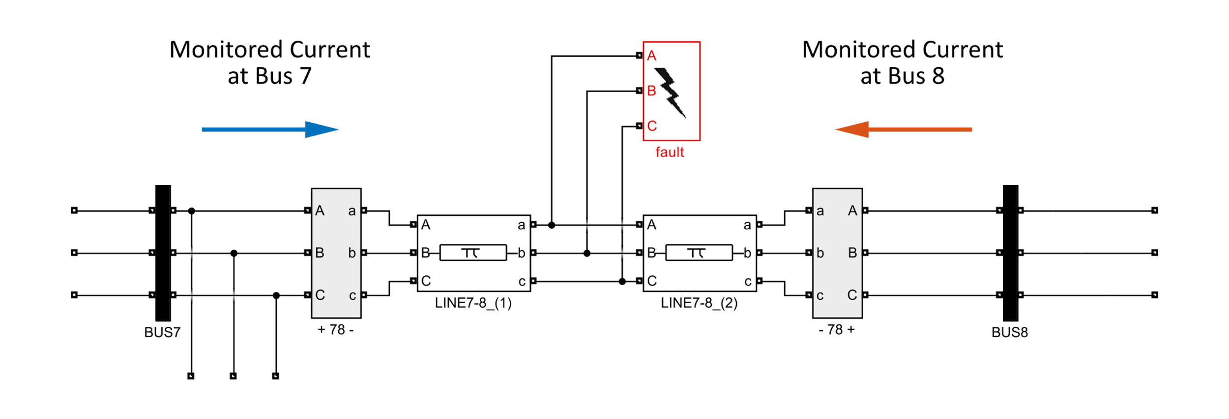

Assuming that the fault occurred in the middle of the line at instant 0.03 with

fault resistance Rf = 0.01 ohm. In Figure x.x we can see that both current

monitored have the same polarity although the polarity of connections at

each end is opposite which indicate a fault using directionality and at fault

instant 0.03 sec we can see the 1st detailed maximum coefficient spikes as

shown in the figure which also indicates the threshold for the algorithm at

this instant.



**4.2.2 Fault Type Classification**

**4.2.2.1 Line to Ground**

**4.2.2.2 Line to Line**

**4.2.2.3 Line to Line to Ground**

**4.2.2.4 three phase**

**4.2.3 Effect of Fault Inception Angle**

**4.2.4 Effect of Distance**

**4.3 discussion**

* Using wavelet analysis to create an algorithm for fault

detection require a threshold to every fault case and considering the same directionality of current at the end and beginning of each line.

* Fault inception angle has a tremendous effect on the protection algorithm used and must be considered carefully
* The fault resistance variation also results in distinct maximum values for the detailed coefficients
* The fault distance at which the fault occurred needs to be taken into calculations to design a flawless protection algorithm for the relays in every transmission line.

**References:**

13 Zaciu, R., Lamba, C., Burlacu, C., Nicula, G.: ‘Image compression using an over complete discrete wavelet transform’, IEEE Trans. Consum.Electron., 1996, 42, (3), pp. 800–807

14 Fowler, J.E.: ‘The redundant discrete wavelet transform and additive

noise’, IEEE Signal Process. Lett., 2005, 12, (9), pp. 629–632

15 Mallat, S., Hwang, W.L.: ‘Singularity detection and processing’, IEEE Trans. Inf. Theory, 1992, 38, (2), pp. 617–643