**?**

# ??????????????????????????????????????????????



## Traveling Waves?

Any electrical disturbance causes high frequency electromagnetic impulses called traveling waves to propagate on a transmission line. The occurrence of a fault results in an abrupt change in voltage at the point of the fault and sets up these traveling waves which propagate from the fault point towards the line terminals where relays are located. It is possible to design relays which utilize these propagation phenomena to detect the presence of a fault, and to determine the fault location.

Since the traveling waves are the earliest possible evidence available to a relay that a fault has occurred, these relays have the potential of becoming the fastest responding relays [1].

The traveling waves contain high frequency transients, and consequently their detection requires a high sampling frequency and a suitable signal processing technique such as the wavelet transform.

## The Wavelet Transform

Wavelets are families of functions generated from one single function, called the mother wavelet, by means of scaling and translating operations. They are oscillatory, decay quickly to zero, and must have an average value of zero. The scaling operation is used to dilate and compress the mother wavelet to obtain the respective low and high frequency information of the function to be analyzed. Then the translation is used to obtain the time information. In this way a family of scaled and shifted wavelets is created and serves as the basis for representing the function to be analyzed [2]. In other words, the wavelet transform is a correlation analysis which determines the amount of similarity of a given signal to the scaled and shifted versions of the mother wavelet.

When implemented digitally, the wavelet transform is called Discrete Wavelet Transform (DWT). The DWT is given by:



where  is the mother wavelet that is discretely dilated by the scale parameter  and translated using the translation parameter ,  and  are integers.

Implementation of the DWT involves multistage successive pairs of high-pass and low-pass filters as shown in Figure x.x. This can be thought of as successive approximations of the same function, each approximation providing information related to a particular frequency range. The first scale covers a broad frequency range at the high frequency end of the spectrum and the higher scales cover the lower end of the frequency spectrum. At each level, the filters produce two sets of coefficients: detail coefficients (represent high frequency content of the signal) and approximation coefficients (represent low frequency content of the signal).

The effectiveness of the wavelet analysis is influenced by the choice of the mother wavelet. The selection of mother wavelet is based on the type of application. The wavelet Daubechies 4 (db4) provides an accurate detection of the transients in power systems [3].

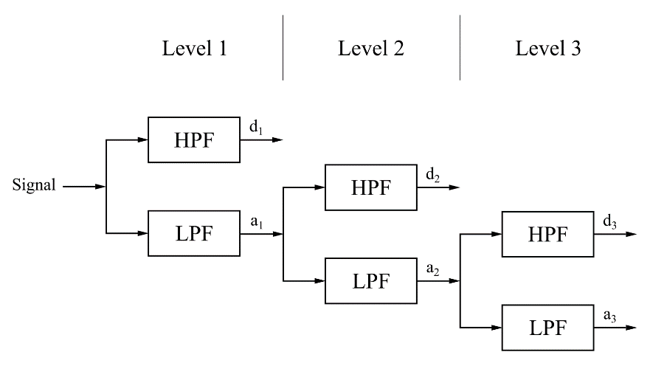

Figure x.x

## Wavelet Based Protection Scheme

The

#### Line to Ground Faults

#### Line to Line to Ground Faults

#### Line to Line Faults

#### Three Phase Faults

### Effect of Fault Inception Angle

### Effect of Fault Distance

In order to evaluate the performance of the wavelet-based method for fault detection, a number of line-to-ground faults on line 7-8 of the IEEE 9 bus system were simulated, each one with different value of fault distance (0:100% of line length from bus 7), fault inception angle = 95°, and fault resistance = 0.01 Ω.

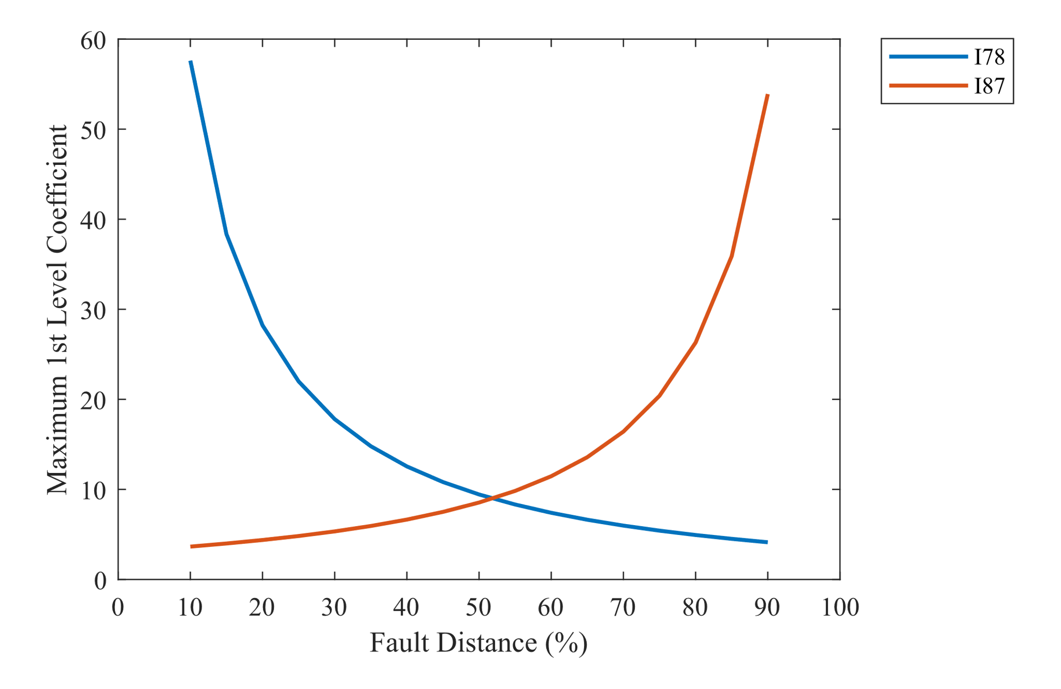The wavelet coefficients regarding the transients usually present very high values. However, they are affected by the fault distance. The maximum first level wavelet details of the faulted phase versus fault distance at buses 7 and 8 is shown in Figure x.x. As shown in the figure, the value of the maximum first level wavelet details decrease with the increase in fault distance. Hence, when selecting a threshold value, it is selected to cover a considerable length of the line.

Figure x.x

### Effect of Fault Resistance

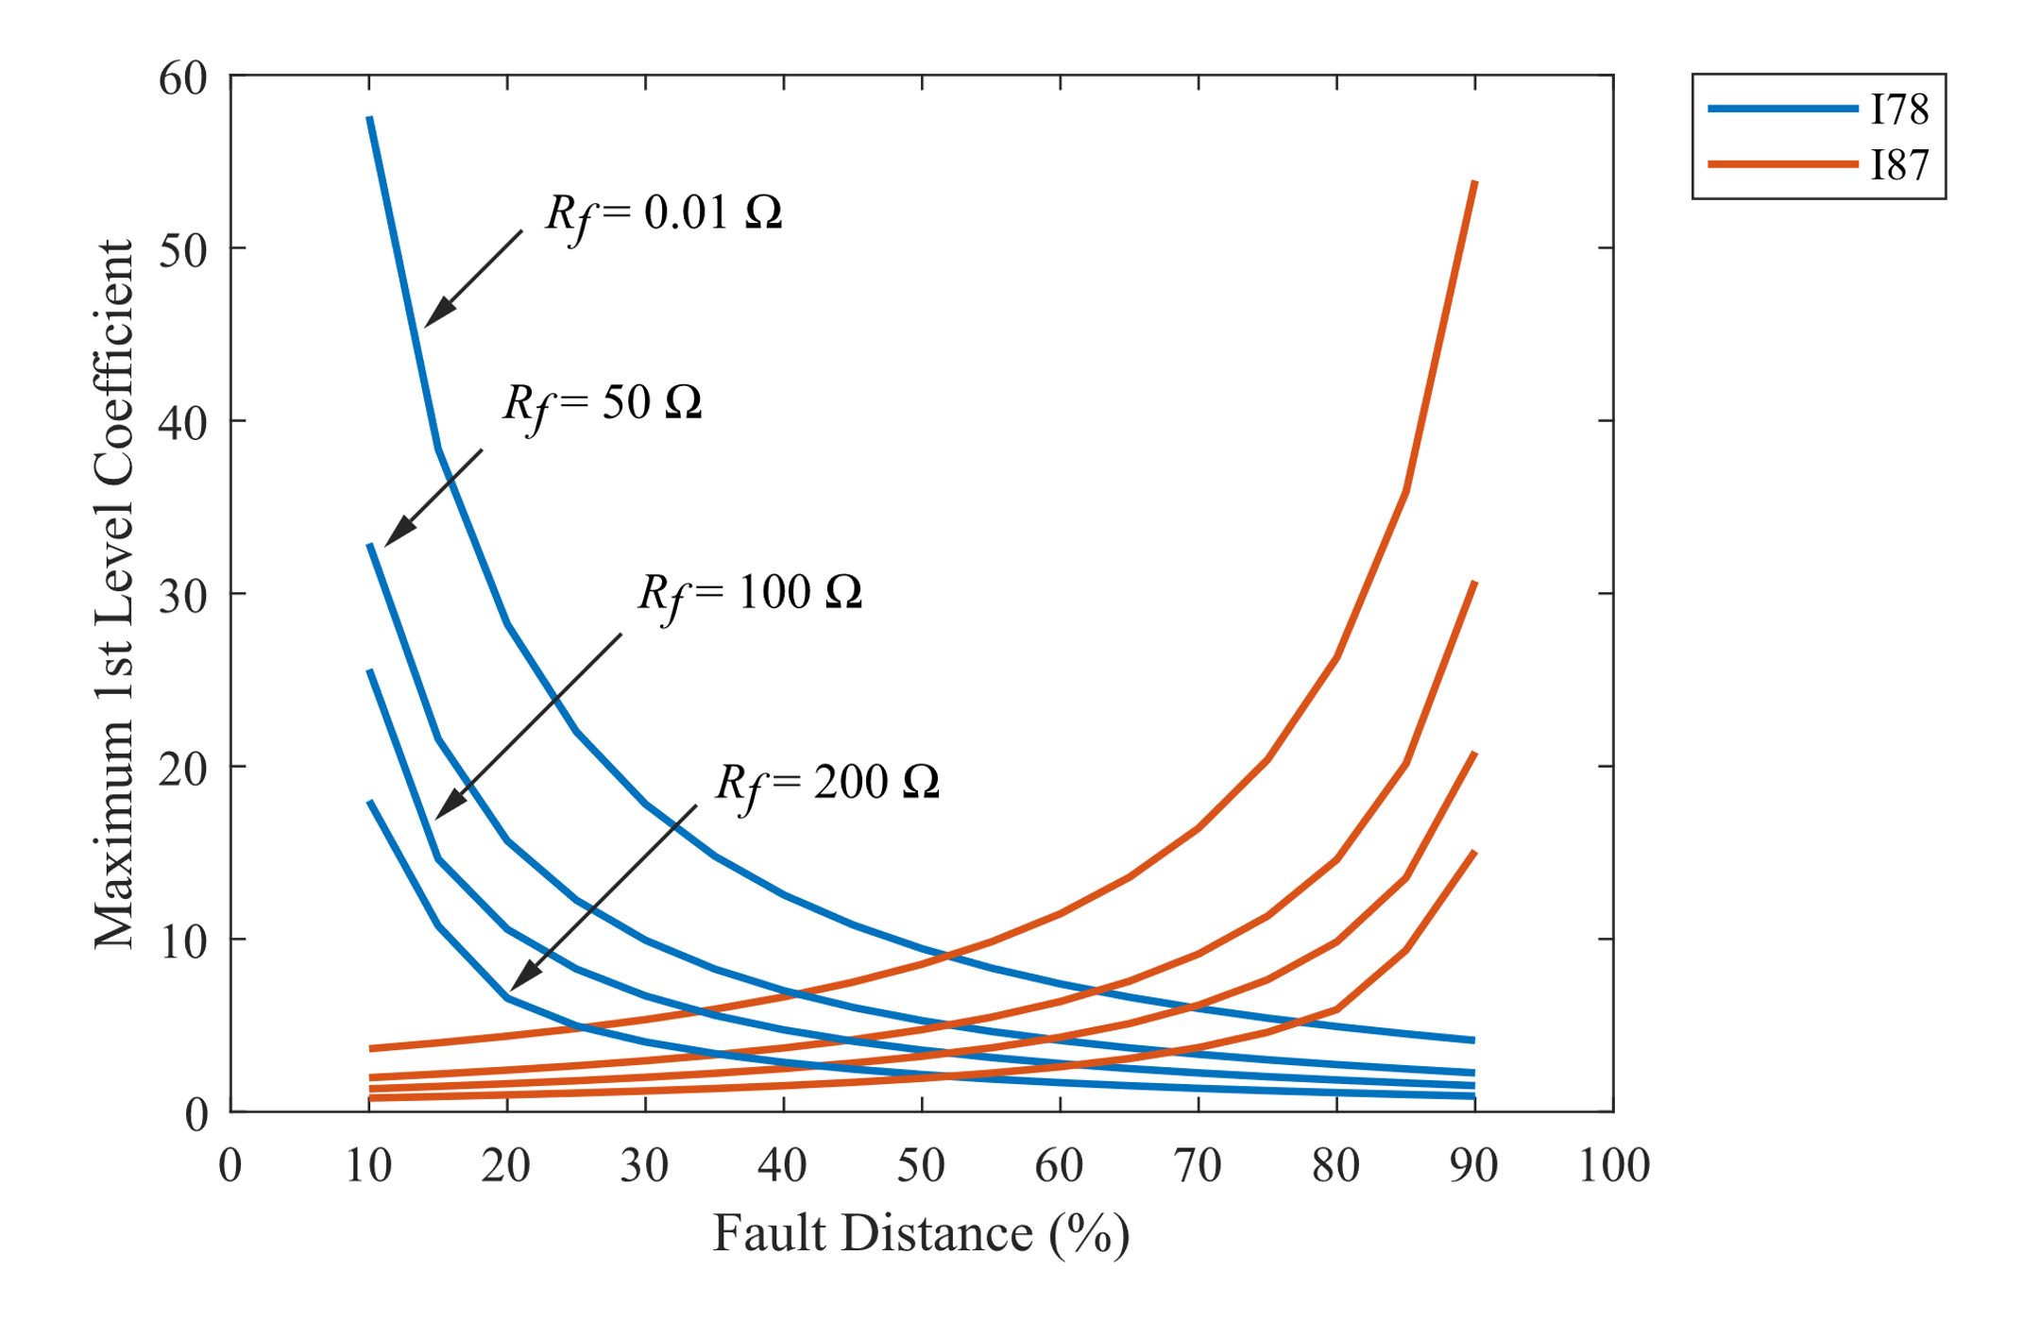

## Conclusion

A wavelet-based transmission line protection scheme has been presented in this chapter. The wavelet first level detail coefficients of current signals are used to detect fault-induced transients. These coefficients are used to distinguish faults from steady-state; The wavelet coefficients due to the fault-induced transients are higher than the ones related to steady-state. If the coefficients value of each phase exceeds a predetermined threshold value, the disturbance is identified as a fault in that phase. When these transients are detected at one of the line ends, a communication link is used in order to send information to the other end. The fault is considered as internal fault if the first peaks of the wavelet coefficients at both line ends have the same polarity.

In order to evaluate the performance of the wavelet-based method, the IEEE 9 bus system was modelled and various faults were simulated on line 7-8. All types of faults were simulated at different locations on the line, with different fault resistances (0:200 Ω) and different fault inception angles (0:180°). The simulations were carried out using Simulink at a sampling frequency of 20 kHz, and the current signals were analyzed using the MATLAB Wavelet Toolbox.

The wavelet coefficients regarding the transients usually present very high values. However, they are affected by the fault distance, the fault resistance, and the fault inception angle. The value of the first level wavelet details decreases with the increase in fault distance or the increase in fault resistance. However, the detail values are still relatively high and can be used to detect faults but their effect is taken into consideration when selecting a threshold value. The fault inception angle affects the coefficients greatly. Faults occurring near voltage zero (inception angle near 0 or 180) generate weak transients. Therefore, the wavelet coefficient values are small. This will affect the detection of single-phase-to-ground faults occurring at small voltage magnitudes. To overcome this, a conventional distance or overcurrent scheme may be used.

The analysis is severely limited by my lack of understanding of what I am doing.

## References

**[1] Arun G. Phadke, James S. Thorp, “Computer Relaying for Power Systems”, 2nd Edition, Wiley, 2009.**

**[2]** **M. Solanki, Y. Song, S. Potts and A. Perks, "Transient protection of transmission line using wavelet transform", 7th Intern. Conf. Developments in Power System Protection, (IEE), pp. 299–302, 2001.**

**[3] M. H. J. Bollen and I. Y.-H. Gu, Signal Processing of Power Quality Disturbances, IEEE, 2006.**