BUSINESS INTELLIGENCE
AND DATA ANALYTICS
Data Warehousing Project

PD1 — Bronze & Silver Layers

PROJECT TEAM
Youssef Hassan ID: 14002686
Ali Mohamed ID: 13003013
Omar Samer ID: 13001857
Bahaa Ahmed ID: 13002233
Hazem Adel ID: 13006278
Instructor: Dr. Shaimaa Masry
TAs: Mr. Ahmed El Naggar | Ms. Toka Alsayed | Ms. Gannatuallah Assad
Deadline: April 29, 2025

1. Project Description
This project implements a fully functional data warehouse for a retail business using the Medallion Architecture. The system ingests raw data from 19 flat CSV source files representing two operational systems — a CRM (Customer Relationship Management) system and an ERP (Enterprise Resource Planning) system — and processes the data through three successive layers of increasing quality.

The ultimate goal is to build a Galaxy schema in the Gold layer consisting of at least two star schemas, which will serve as the foundation for an interactive Power BI dashboard. This deliverable (PD1) covers the implementation of the Bronze and Silver layers.

Attribute | Detail
Architecture | Medallion Architecture (Bronze → Silver → Gold)
Database Platform | Microsoft SQL Server
Source System | CRM and ERP flat CSV files (19 tables)
Bronze Load Method | Batch Processing, Full Load, TRUNCATE & BULK INSERT
Silver Load Method | Batch Processing, Full Load, TRUNCATE & INSERT via stored procedure
Deliverable | PD1 — Bronze and Silver Layers

2. Dataset Description
The source dataset represents the OLTP (Online Transaction Processing) schema of a retail business that operates both physical stores and an online channel. The data is organized into 19 CSV files covering customers, products, sales transactions, inventory, deliveries, and HR data.

2.1 Source Tables Overview
Table | Key Columns | Row Count | Source
CUSTOMERS | Customer_ID, First_Name, Last_Name, Gender, City, Loyalty_Level, Email | 4,000 | CRM
EMPLOYEES | Employee_ID, Name, Gender, Position, Store_ID, Hire_Date | 800 | CRM
PRODUCTS | Product_ID, SKU, Product_Name, Brand_ID, Department_ID, Package_Size | 600 | ERP
BRANDS | Brand_ID, Brand_Name | 30 | ERP
DEPARTMENTS | Department_ID, Department_Name | 12 | ERP
STORES | Store_ID, Store_Name, City, State, Region, Opening_Date | 64 | ERP
WAREHOUSES | Warehouse_ID, Warehouse_Name, City, State | 8 | ERP
SUPPLIERS | Supplier_ID, Supplier_Name, Country, Phone | 80 | ERP
PRODUCT_SUPPLIERS | Product_ID, Supplier_ID, Supply_Price | 1,214 | ERP
ONLINE_ORDERS | Order_ID, Customer_ID, Warehouse_ID, Order_Time, Order_Status, Order_Total | 3,000 | CRM
ONLINE_ORDER_ITEMS | Order_Item_ID, Order_ID, Product_ID, Promotion_ID, Quantity, Unit_Price | 7,151 | CRM
POS_TRANSACTIONS | Transaction_ID, Store_ID, Register_ID, Employee_ID, Customer_ID, Transaction_Time | 6,000 | ERP
TRANSACTION_ITEMS | Line_ID, Transaction_ID, Product_ID, Promotion_ID, Quantity, Unit_Price | 14,962 | ERP
PAYMENTS | Payment_ID, Order_ID, Payment_Method, Payment_Amount, Payment_Time | 3,000 | CRM
DELIVERIES | Delivery_ID, Order_ID, Provider_ID, Ship_Date, Delivery_Date, Delivery_Status | 1,927 | CRM
DELIVERY_PROVIDERS | Provider_ID, Provider_Name, Phone | 8 | CRM
INVENTORY | Inventory_ID, Store_ID, Product_ID, Stock_Level, Last_Updated | 3,600 | ERP
PROMOTIONS | Promotion_ID, Promo_Type, Discount_Percent, Start_Date, End_Date | 120 | ERP
REGISTERS | Register_ID, Store_ID, Register_Number | 218 | ERP

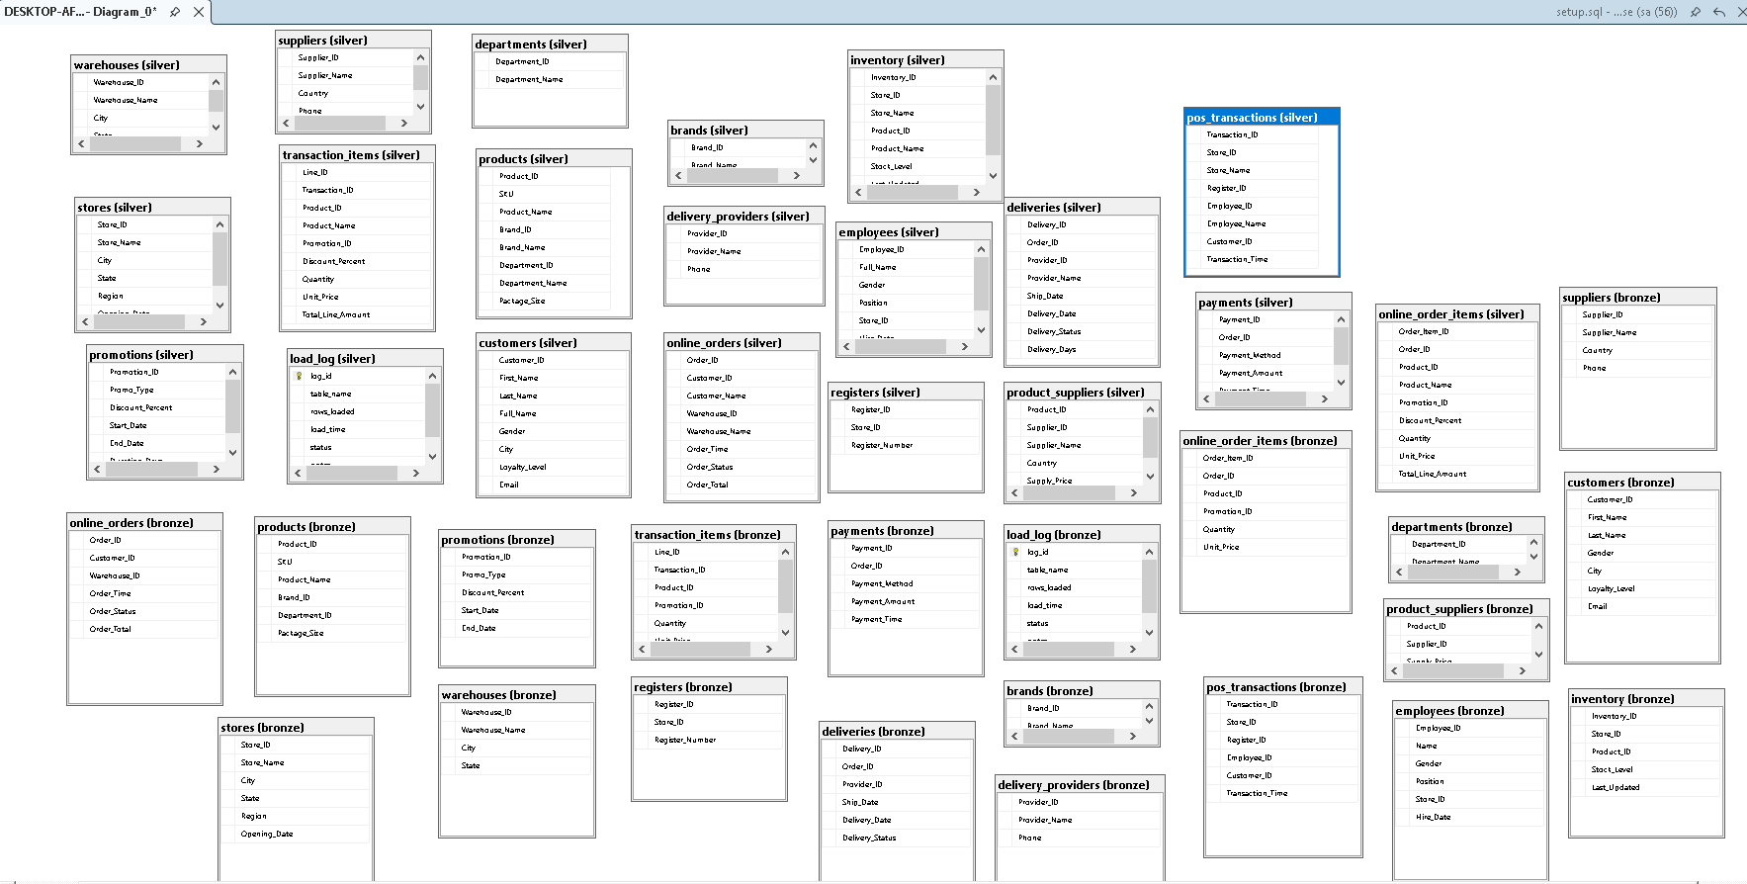
🥉 BRONZE LAYER

3. Bronze Layer
The Bronze layer is the first and lowest tier of the Medallion Architecture. Its sole responsibility is to ingest raw data from the CSV source files into SQL Server with zero transformations. The data is stored exactly as it arrives — including any inconsistencies, null values, or formatting issues — serving as an immutable audit trail of the original source data.

3.1 Technical Specifications
Aspect | Specification
Schema Name | bronze
Object Type | Tables (19 total)
Load Method | Batch Processing, Full Load, TRUNCATE & BULK INSERT
Transformations | None — data loaded exactly as received
Data Types | All columns stored as NVARCHAR to preserve raw format
Automation | Stored procedure: bronze.load_bronze
Auditing | Log table: bronze.load_log

3.2 Implementation Steps
- Created the DataWarehouse database and the bronze schema
- Created 19 Bronze tables — one per CSV source file — mirroring the exact column names and order from each file
- All columns defined as NVARCHAR since no type conversion is performed at this layer
- Created a bronze.load_log table to audit every load with table name, row count, timestamp, and status
- Implemented the bronze.load_bronze stored procedure that TRUNCATES each table then uses BULK INSERT to reload from the CSV files
- Executed the procedure and validated row counts against the DATA_QUALITY_REPORT.csv source file

3.3 Bronze Tables Created
The following 19 tables were created in the bronze schema, each exactly mirroring its source CSV file:

Table Name | Columns
bronze.brands | Brand_ID, Brand_Name
bronze.customers | Customer_ID, First_Name, Last_Name, Gender, City, Loyalty_Level, Email
bronze.departments | Department_ID, Department_Name
bronze.stores | Store_ID, Store_Name, City, State, Region, Opening_Date
bronze.warehouses | Warehouse_ID, Warehouse_Name, City, State
bronze.employees | Employee_ID, Name, Gender, Position, Store_ID, Hire_Date
bronze.suppliers | Supplier_ID, Supplier_Name, Country, Phone
bronze.products | Product_ID, SKU, Product_Name, Brand_ID, Department_ID, Package_Size
bronze.product_suppliers | Product_ID, Supplier_ID, Supply_Price
bronze.promotions | Promotion_ID, Promo_Type, Discount_Percent, Start_Date, End_Date
bronze.registers | Register_ID, Store_ID, Register_Number
bronze.delivery_providers | Provider_ID, Provider_Name, Phone
bronze.online_orders | Order_ID, Customer_ID, Warehouse_ID, Order_Time, Order_Status, Order_Total
bronze.online_order_items | Order_Item_ID, Order_ID, Product_ID, Promotion_ID, Quantity, Unit_Price
bronze.payments | Payment_ID, Order_ID, Payment_Method, Payment_Amount, Payment_Time
bronze.deliveries | Delivery_ID, Order_ID, Provider_ID, Ship_Date, Delivery_Date, Delivery_Status
bronze.pos_transactions | Transaction_ID, Store_ID, Register_ID, Employee_ID, Customer_ID, Transaction_Time
bronze.transaction_items | Line_ID, Transaction_ID, Product_ID, Promotion_ID, Quantity, Unit_Price
bronze.inventory | Inventory_ID, Store_ID, Product_ID, Stock_Level, Last_Updated

3.4 Bronze Load Procedure
The stored procedure bronze.load_bronze performs a full load on every Bronze table. For each table it: (1) truncates the existing data, (2) bulk inserts from the CSV file, and (3) logs the result to bronze.load_log.

Validation query run after execution:
SELECT table_name, rows_loaded, load_time, status
FROM bronze.load_log
ORDER BY load_time DESC;
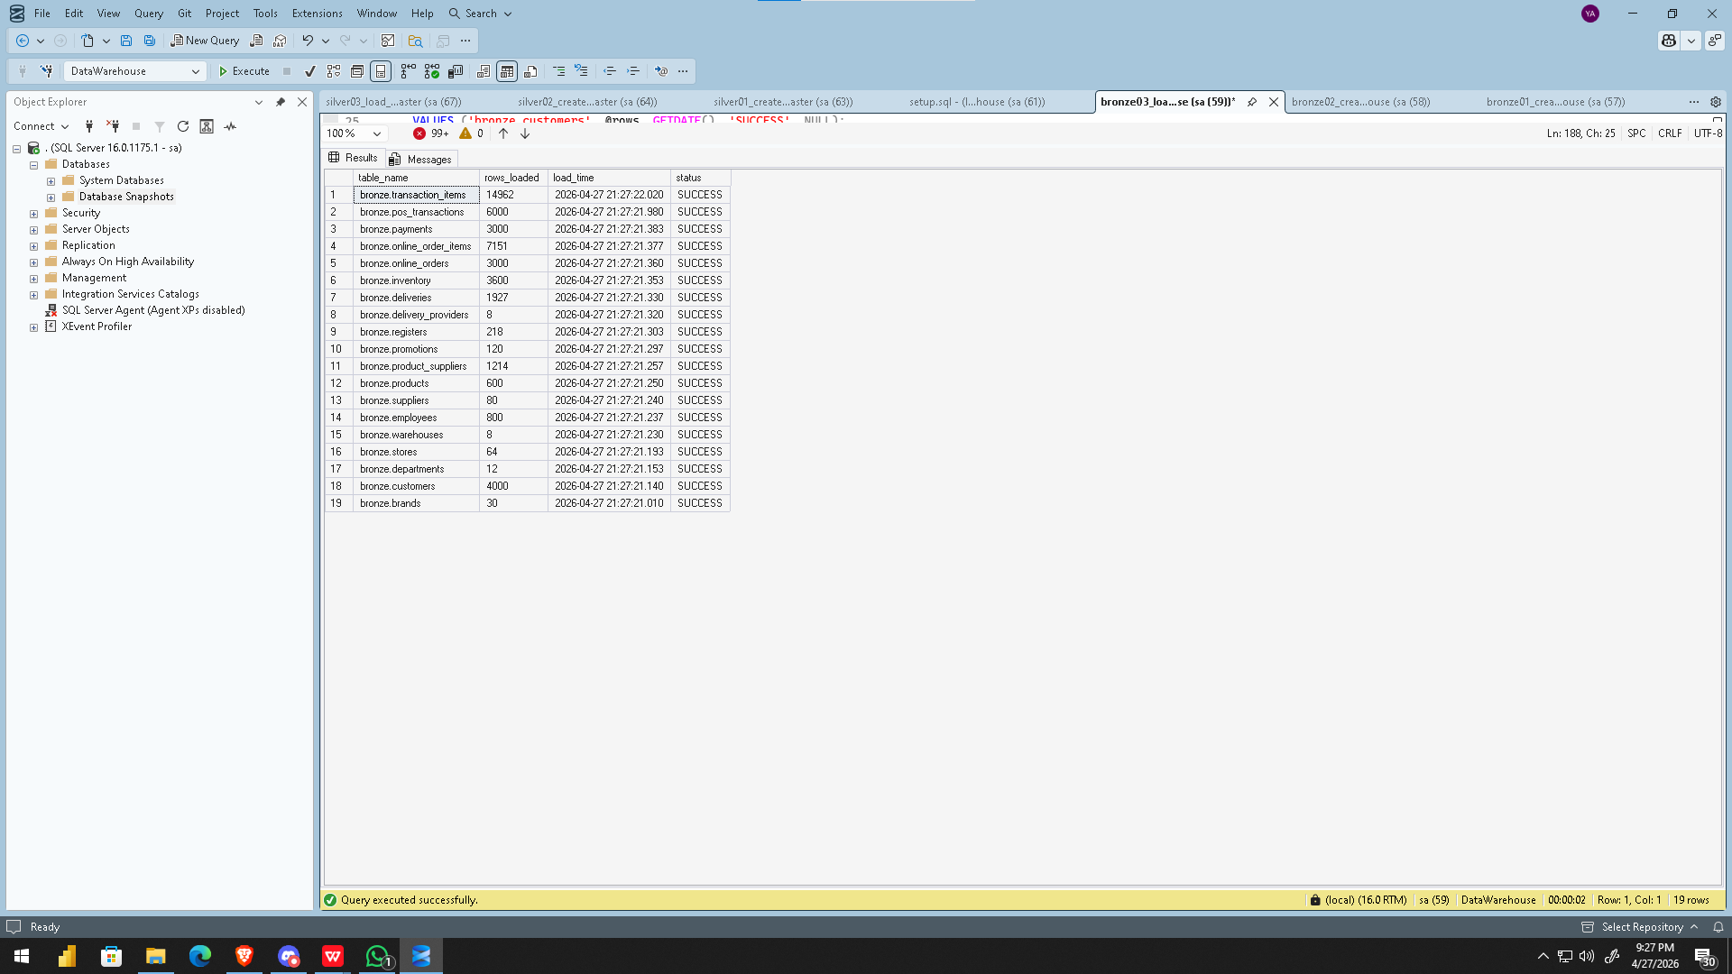

🥈 SILVER LAYER

4. Silver Layer
The Silver layer is the transformation tier of the Medallion Architecture. It reads from Bronze and produces a cleansed, standardized, and enriched version of the data with proper data types, corrected values, and calculated derived columns. The Silver layer retains the operational structure of the source data — it does not reshape into star schemas, which is reserved for the Gold layer.

4.1 Technical Specifications
Aspect | Specification
Schema Name | silver
Object Type | Tables (19 total)
Load Method | Batch Processing, Full Load, TRUNCATE & INSERT
Source | Reads from bronze schema tables
Transformations | Cleansing, Standardization, Normalization, Derived Columns, Enrichment
Automation | Stored procedure: silver.load_silver
Auditing | Log table: silver.load_log

4.2 Data Quality Issues Identified and Resolved
The following data quality issues were identified during analysis of the Bronze layer and resolved in the Silver transformation procedure:

Table(s) | Issue Found | Resolution Applied | SQL Technique
All tables | All columns stored as NVARCHAR in Bronze | Cast to proper types (INT, DATE, DATETIME, DECIMAL) | TRY_CAST()
All text columns | Leading/trailing whitespace in text values | Whitespace removed from all text fields | TRIM()
customers | First_Name and Last_Name stored separately | Derived Full_Name column combining both | TRIM(First_Name) + ' ' + TRIM(Last_Name)
customers | Email stored in original mixed case | Standardized to lowercase for consistency | LOWER(TRIM(Email))
employees | Potential inconsistent Gender codes | Standardized M/MALE → Male, F/FEMALE → Female | CASE WHEN UPPER(TRIM(...))
online_orders | Order_Status in inconsistent casing | Standardized: DELIVERED → Delivered, etc. | CASE WHEN UPPER(TRIM(...))
online_order_items | No line total available in source | Derived Total_Line_Amount = Quantity * Unit_Price | TRY_CAST(Qty) * TRY_CAST(Price)
transaction_items | No line total available in source | Derived Total_Line_Amount = Quantity * Unit_Price | TRY_CAST(Qty) * TRY_CAST(Price)
deliveries | No delivery duration metric in source | Derived Delivery_Days = days from Ship to Delivery | DATEDIFF(DAY, Ship_Date, Delivery_Date)
promotions | No duration metric in source | Derived Duration_Days = End_Date - Start_Date | DATEDIFF(DAY, Start_Date, End_Date)
products | Package_Size may contain NULL values | NULL replaced with 'N/A' for readability | ISNULL(Package_Size, 'N/A')
All tables | Rows with NULL or blank primary keys | Filtered out using WHERE clause on key column | WHERE TRIM(ISNULL(id, '')) != ''

4.3 Derived Columns Added
The following new columns were added in the Silver layer that do not exist in the source files:

Derived Column | Formula / Logic
customers.Full_Name | TRIM(First_Name) + ' ' + TRIM(Last_Name)
online_order_items.Total_Line_Amount | TRY_CAST(Quantity AS INT) * TRY_CAST(Unit_Price AS DECIMAL(10,2))
transaction_items.Total_Line_Amount | TRY_CAST(Quantity AS INT) * TRY_CAST(Unit_Price AS DECIMAL(10,2))
deliveries.Delivery_Days | DATEDIFF(DAY, TRY_CAST(Ship_Date AS DATETIME), TRY_CAST(Delivery_Date AS DATETIME))
promotions.Duration_Days | DATEDIFF(DAY, TRY_CAST(Start_Date AS DATE), TRY_CAST(End_Date AS DATE))

4.4 Silver Validation Queries
The following quality checks were run after executing silver.load_silver to verify data integrity:

-- Row count check across all Silver tables
SELECT table_name, rows_loaded, load_time, status
FROM silver.load_log ORDER BY load_time DESC;

-- Check for NULL derived columns
SELECT * FROM silver.customers WHERE Full_Name IS NULL;
SELECT * FROM silver.online_order_items WHERE Total_Line_Amount IS NULL;
SELECT * FROM silver.transaction_items WHERE Total_Line_Amount IS NULL;

-- Check for negative derived values (data quality)
SELECT * FROM silver.deliveries WHERE Delivery_Days < 0;
SELECT * FROM silver.promotions WHERE Duration_Days < 0;
SELECT * FROM silver.inventory WHERE Stock_Level < 0;

-- Verify gender standardization
SELECT Gender, COUNT(*) AS Count FROM silver.employees GROUP BY Gender;

.
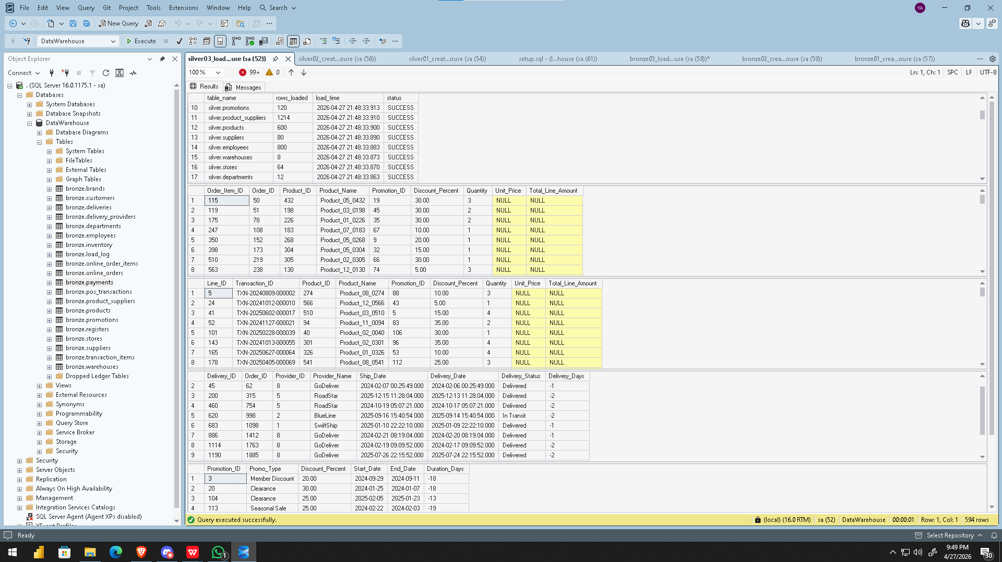

5. Project Technical Audit

5.1 Results Tab

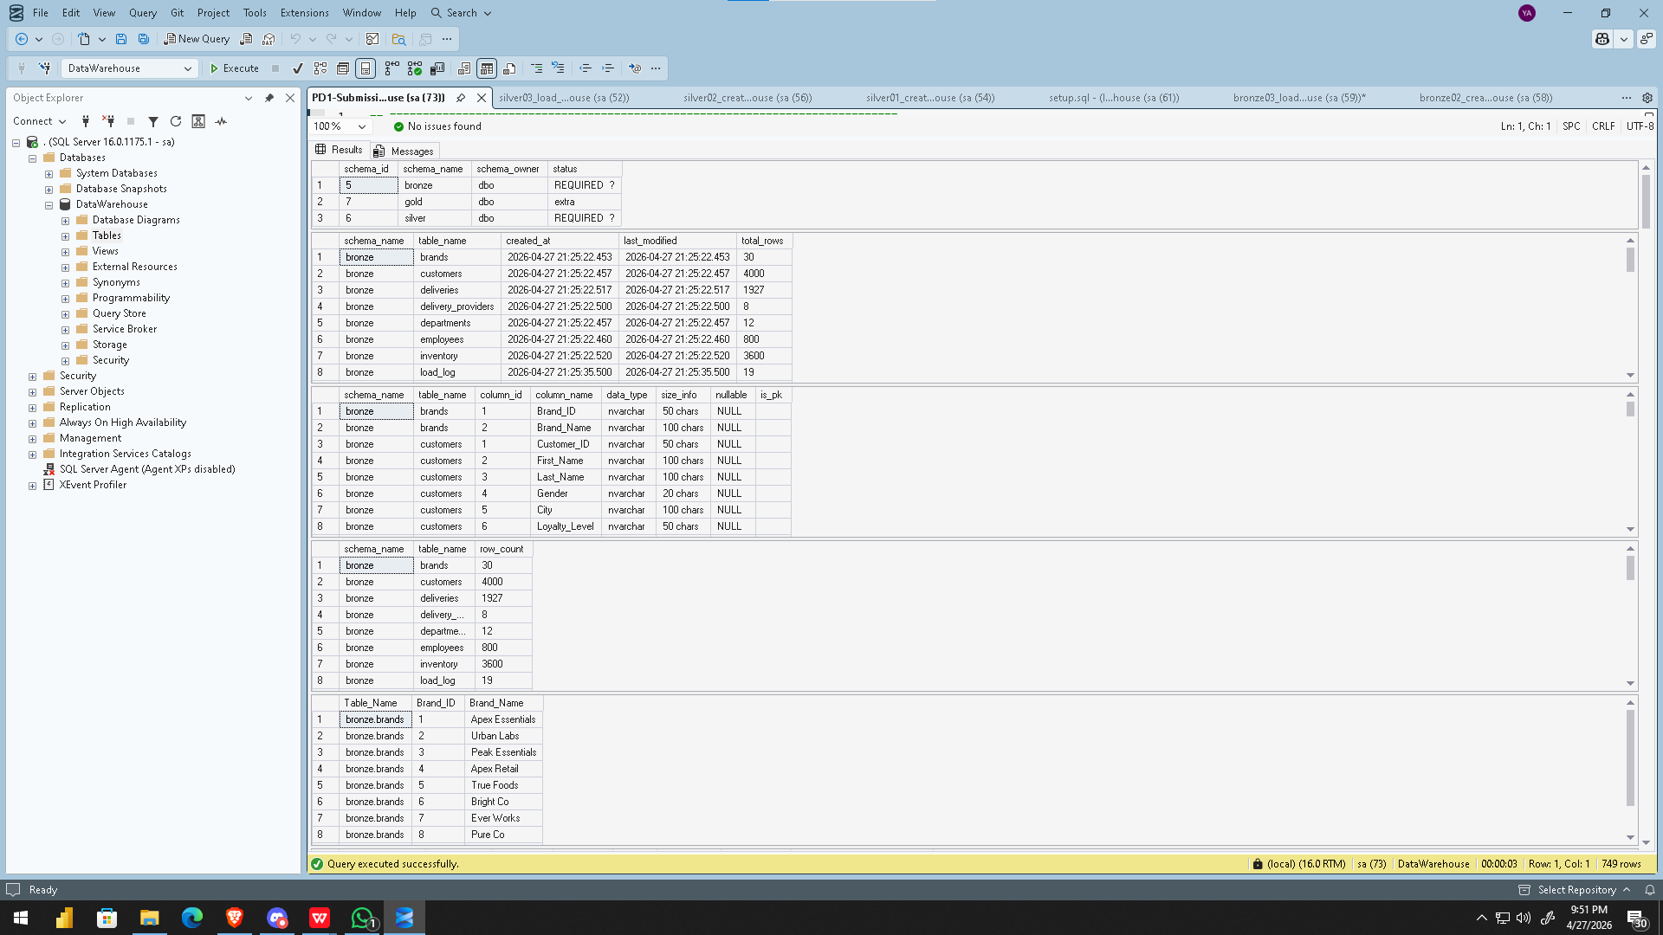
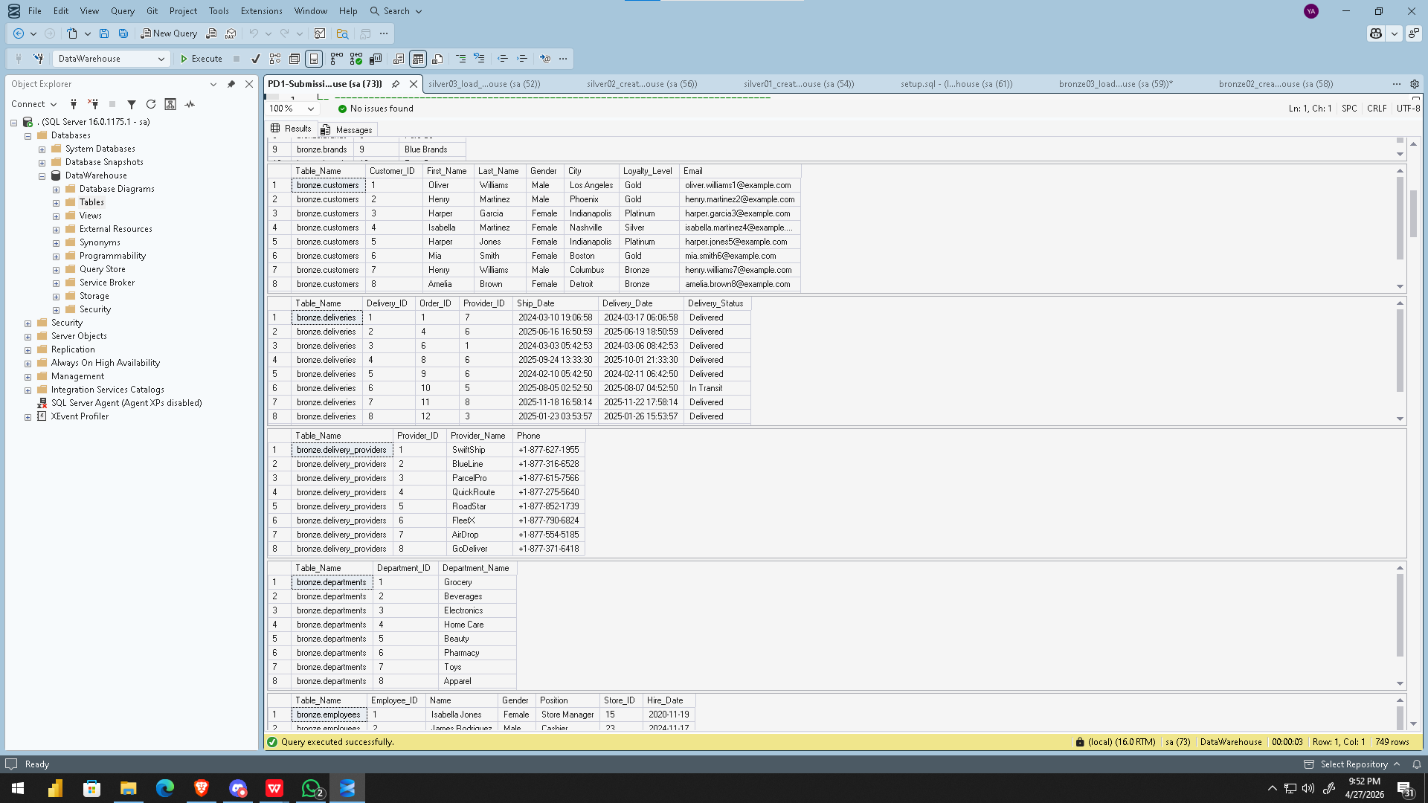
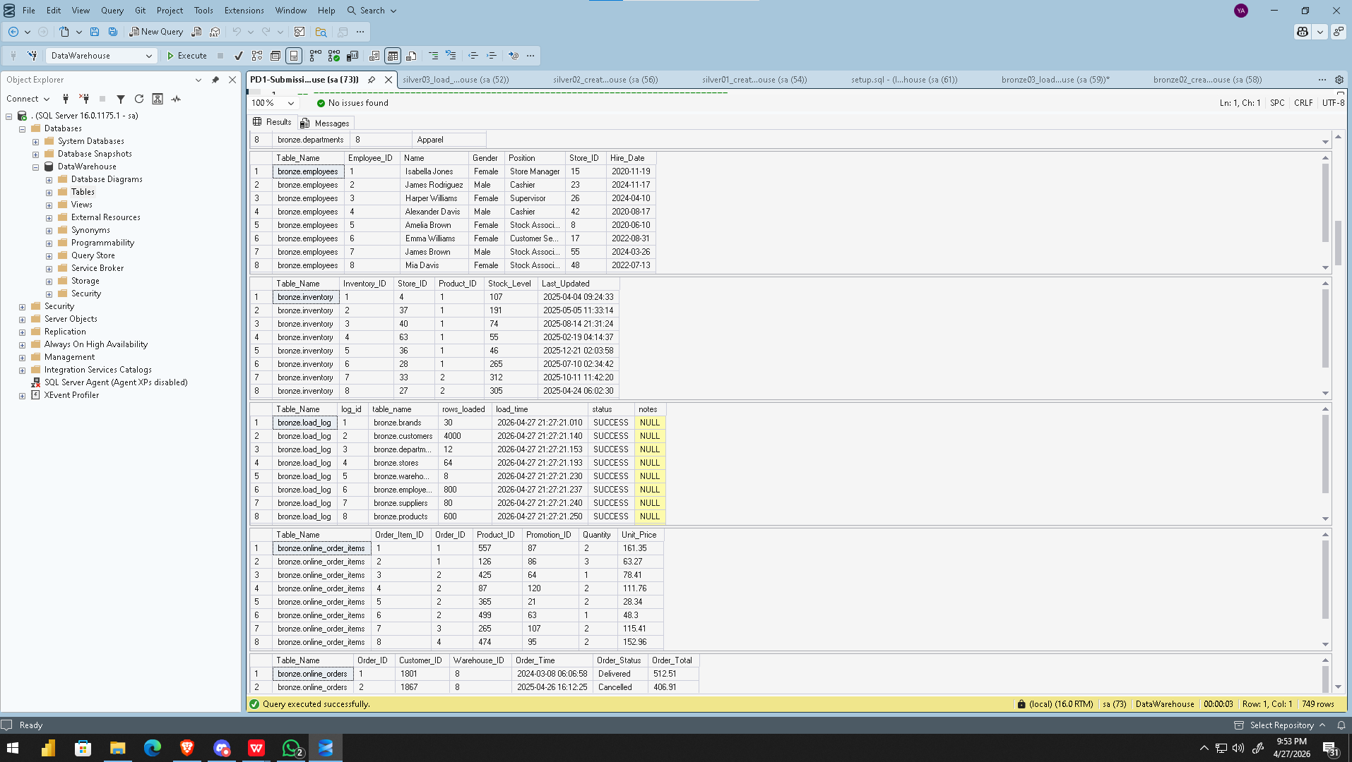
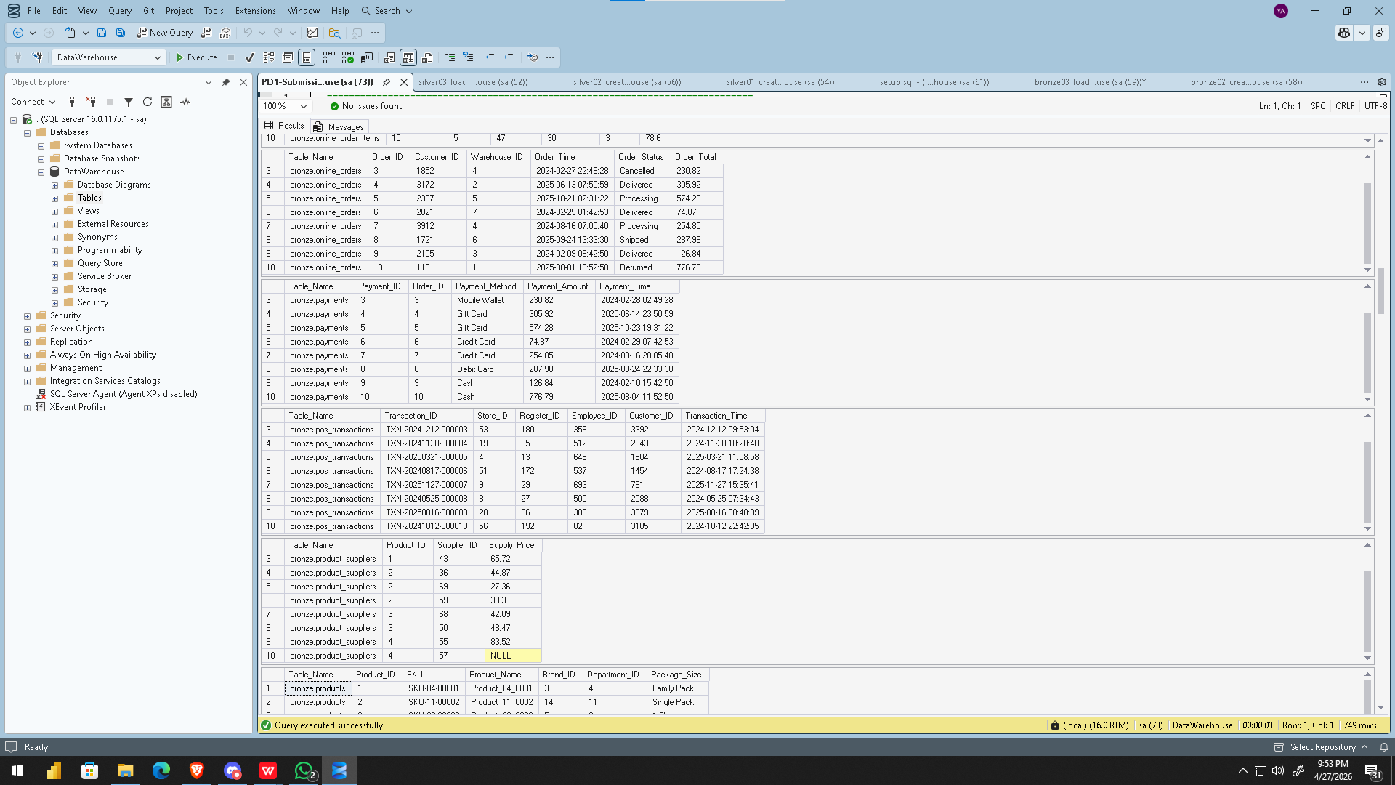
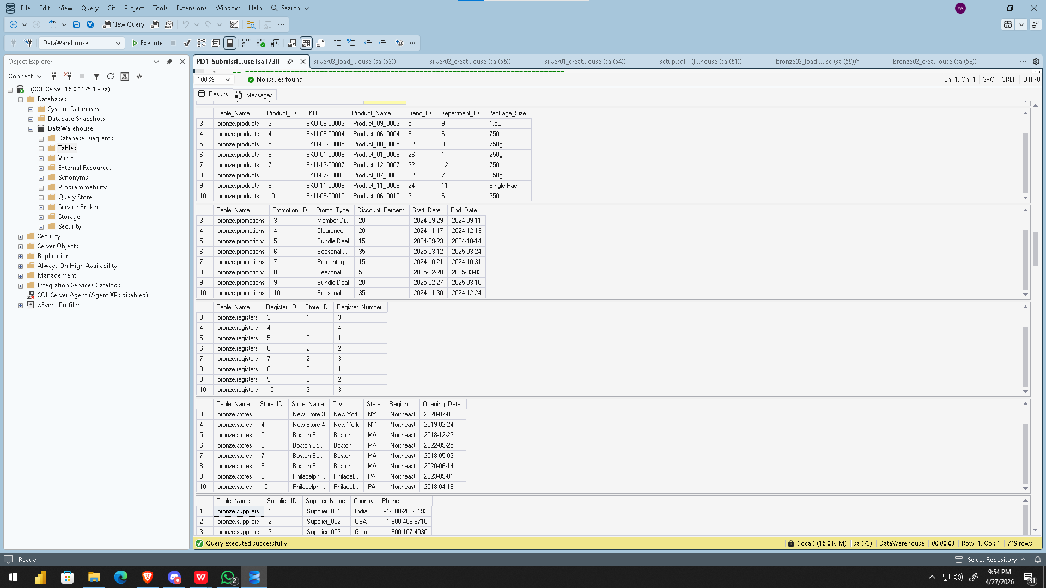
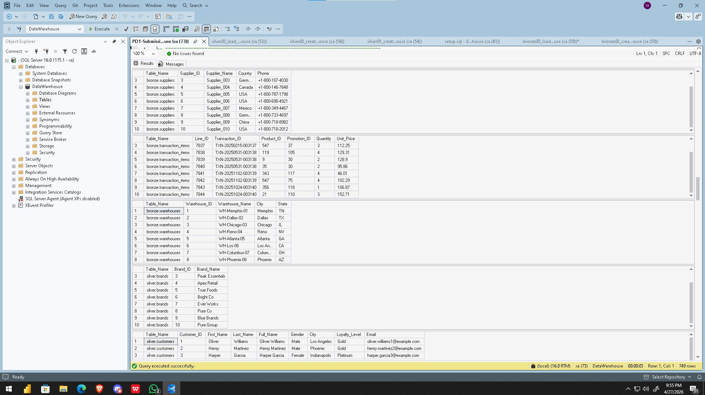
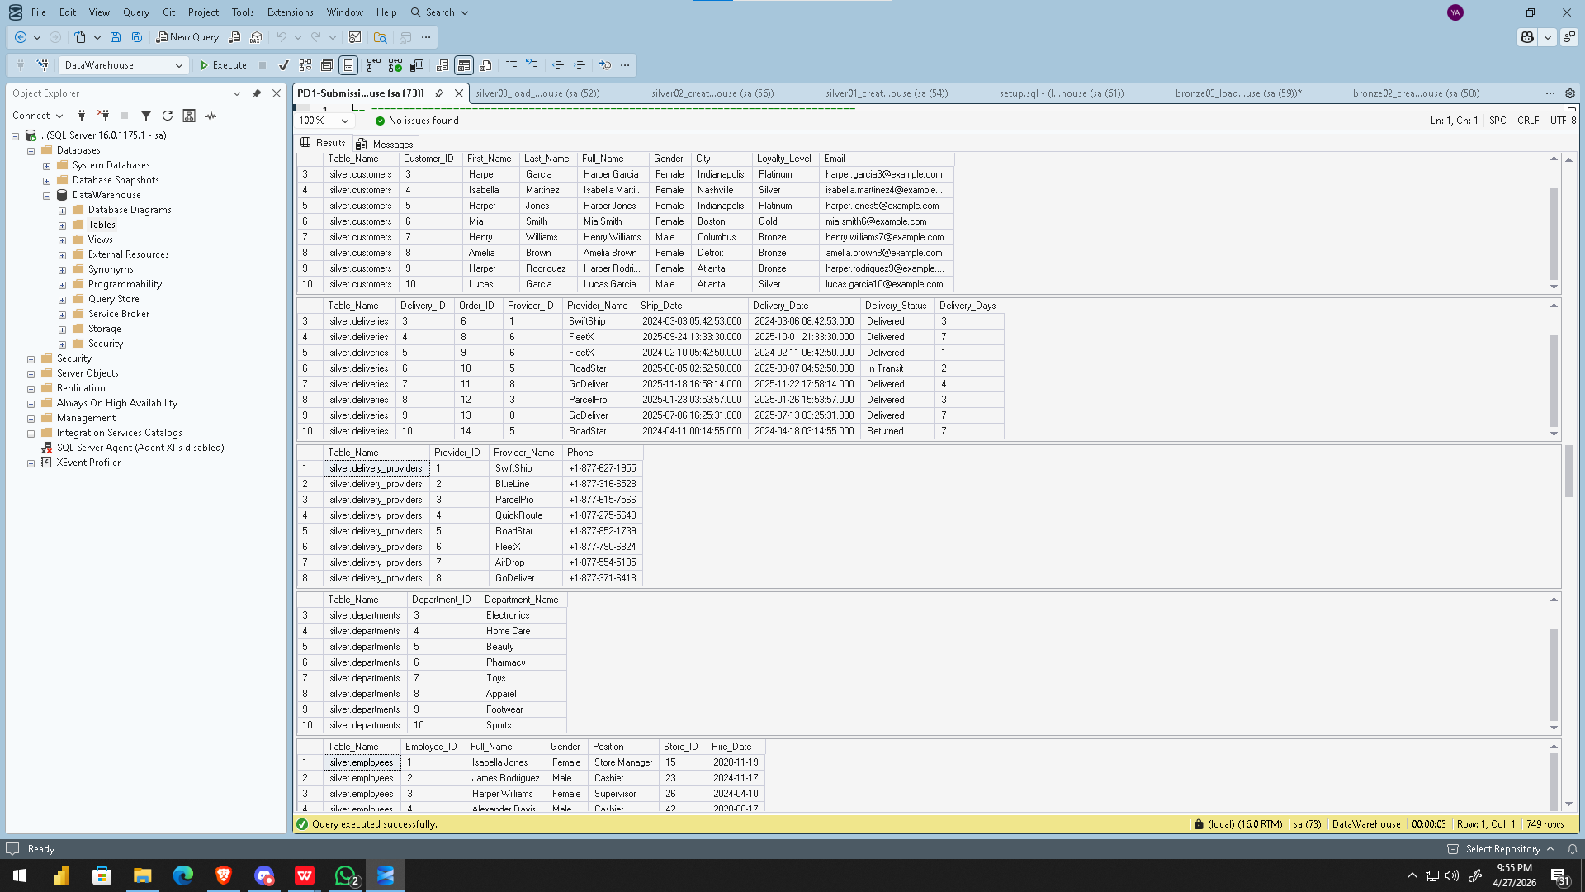
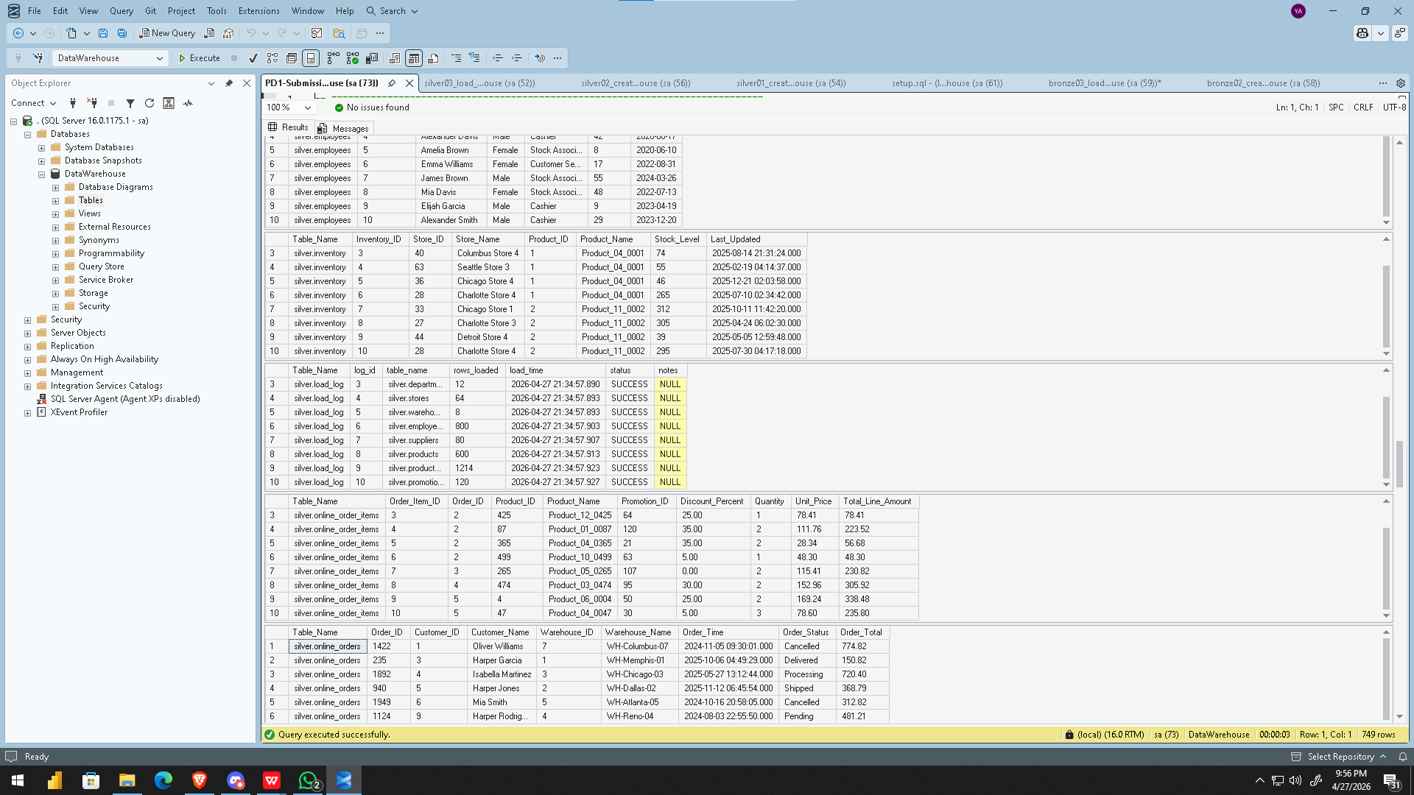
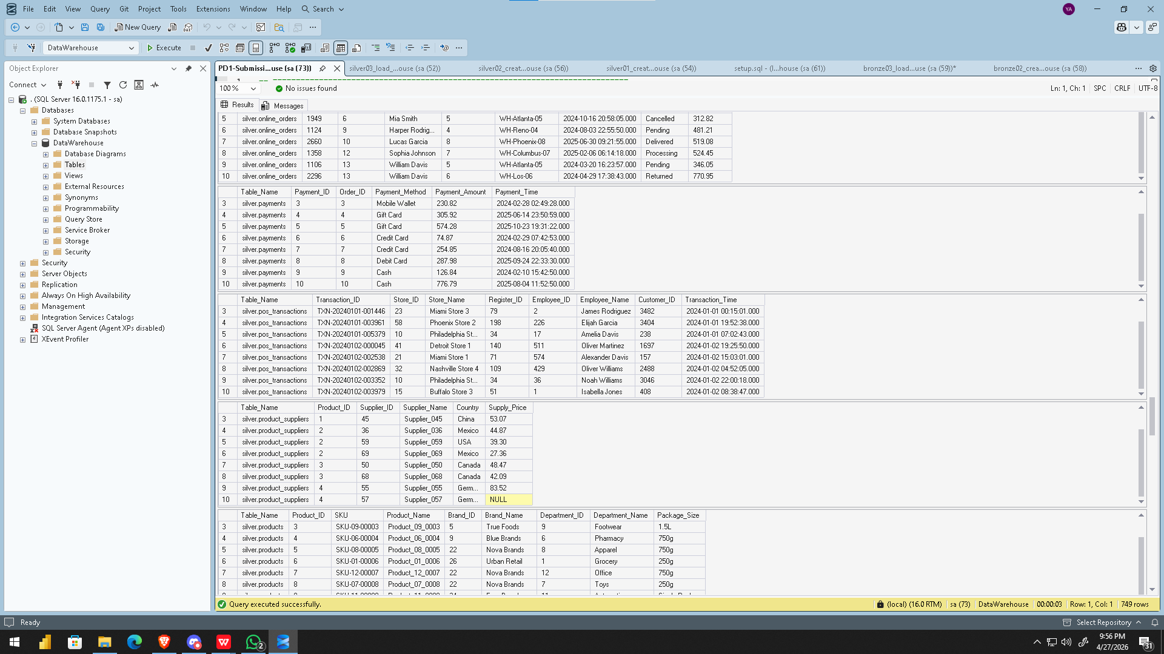
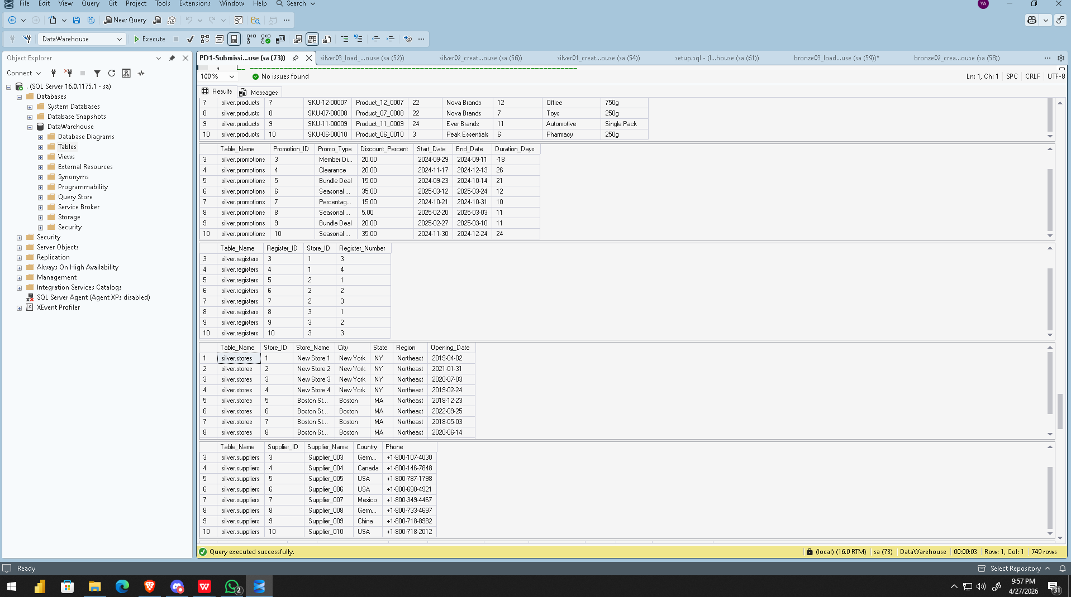
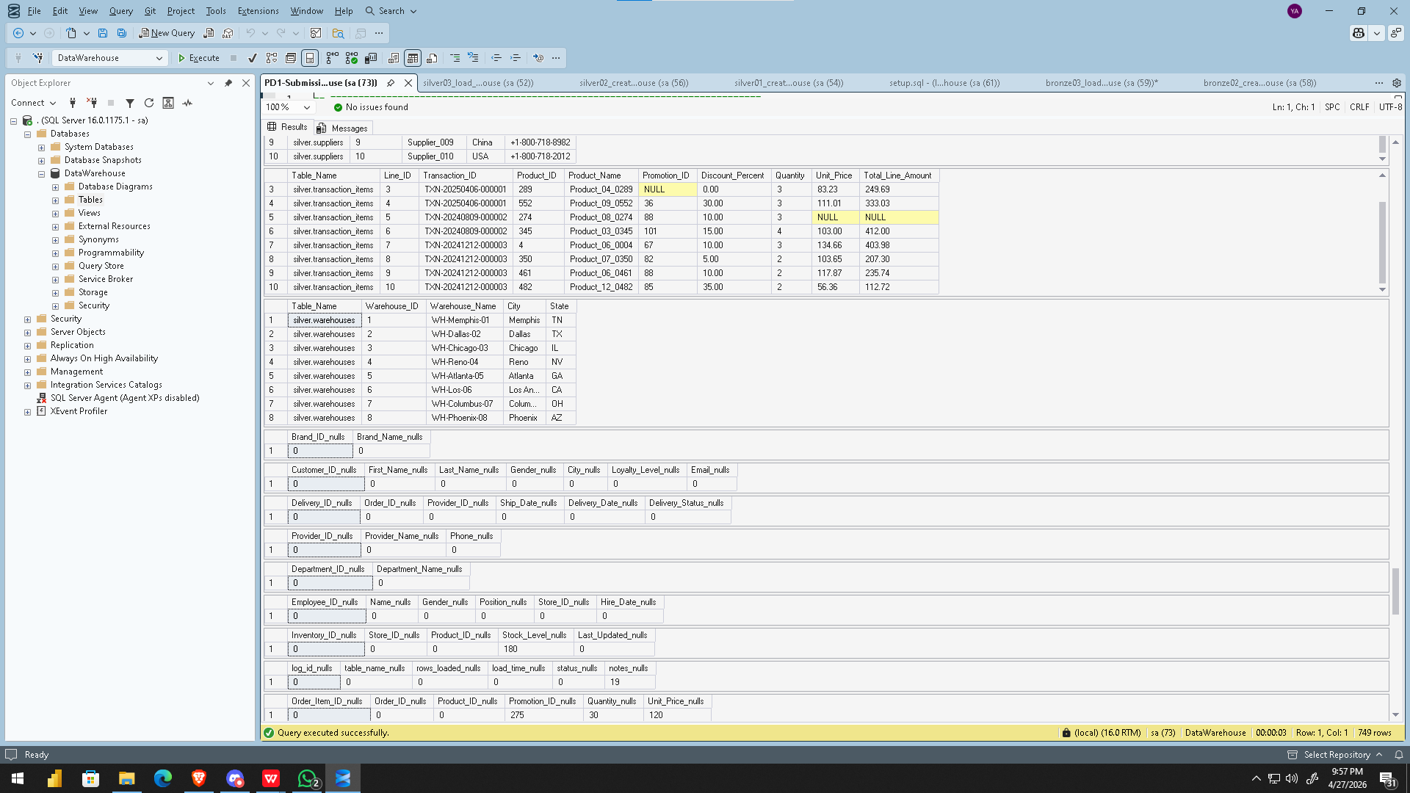
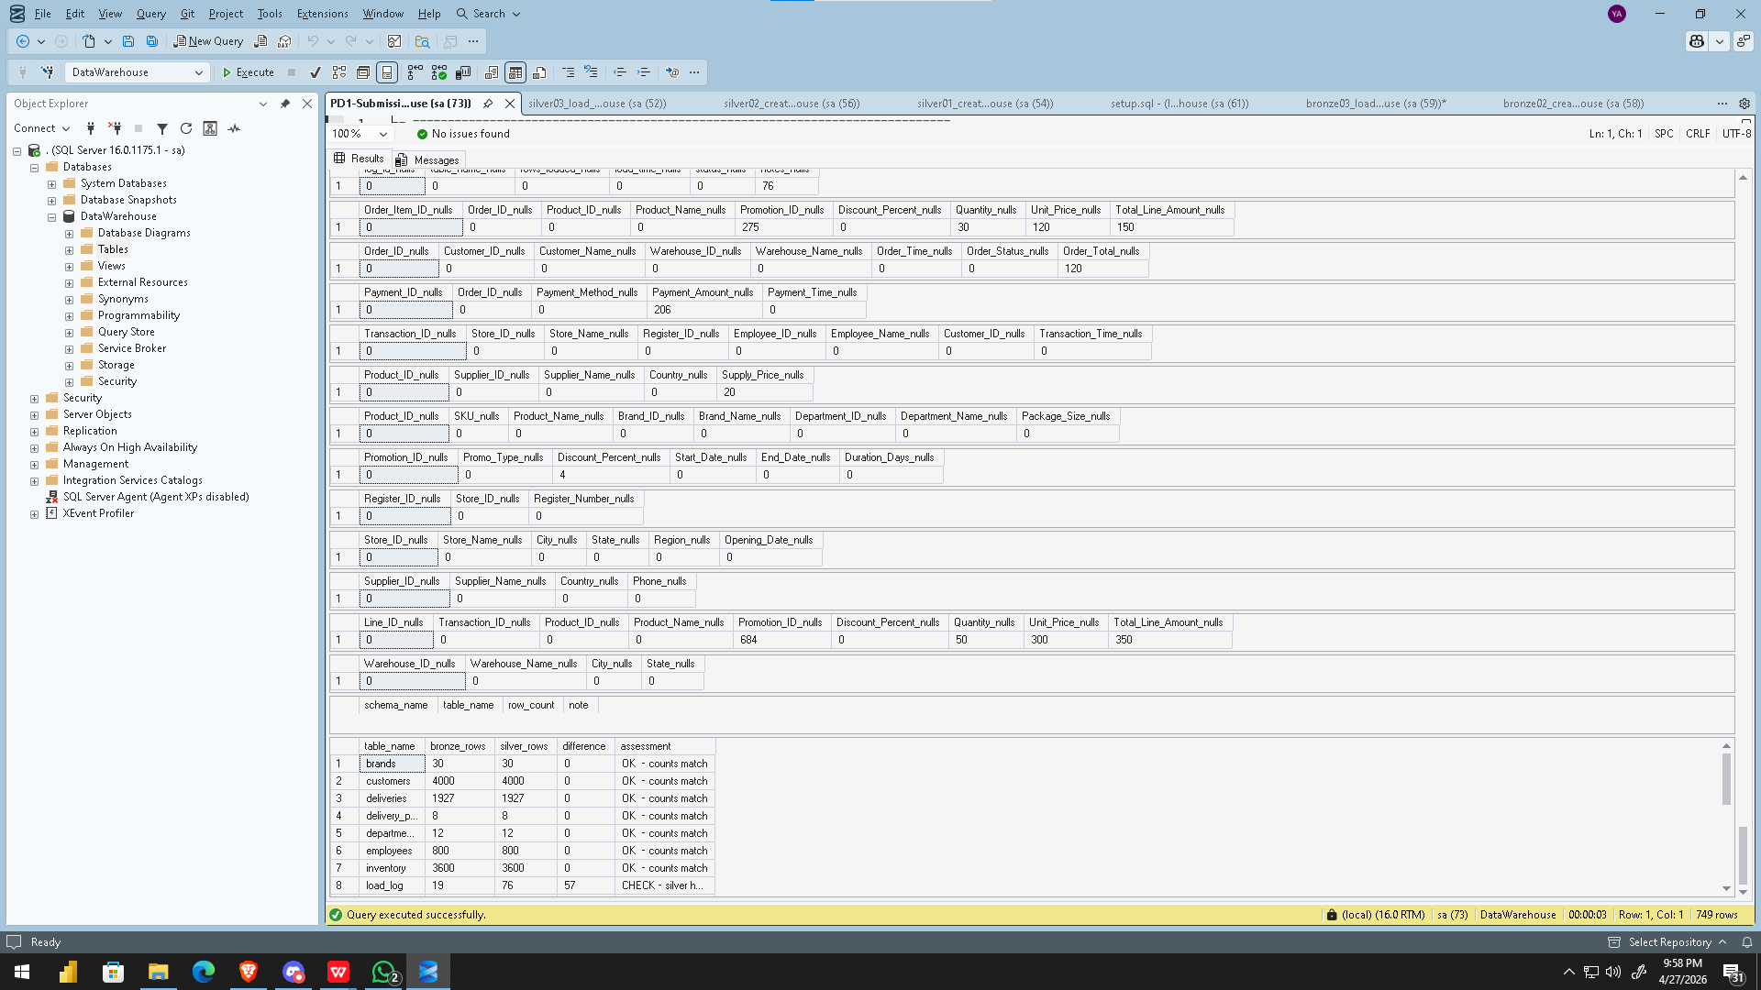

5.2 Messages Tab
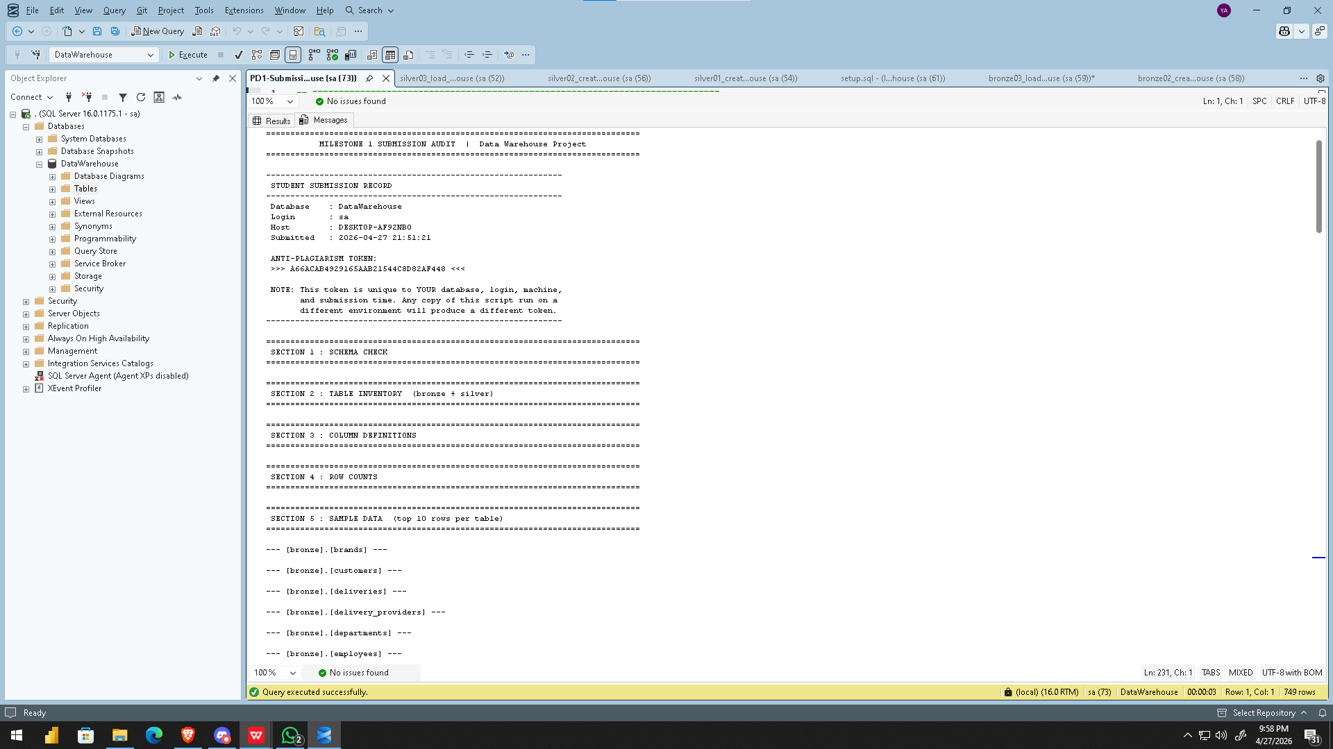
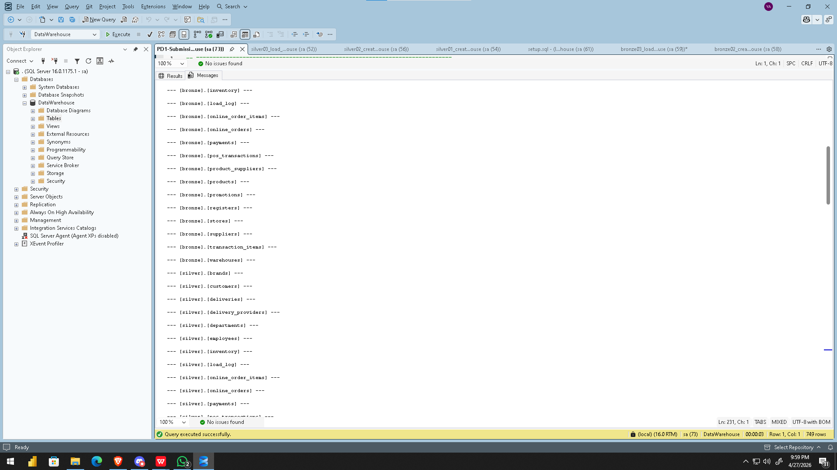
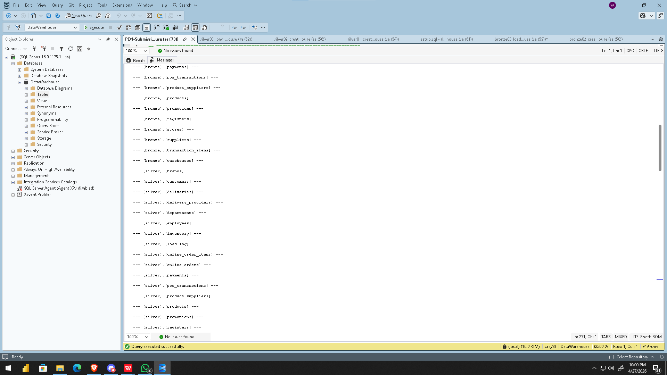
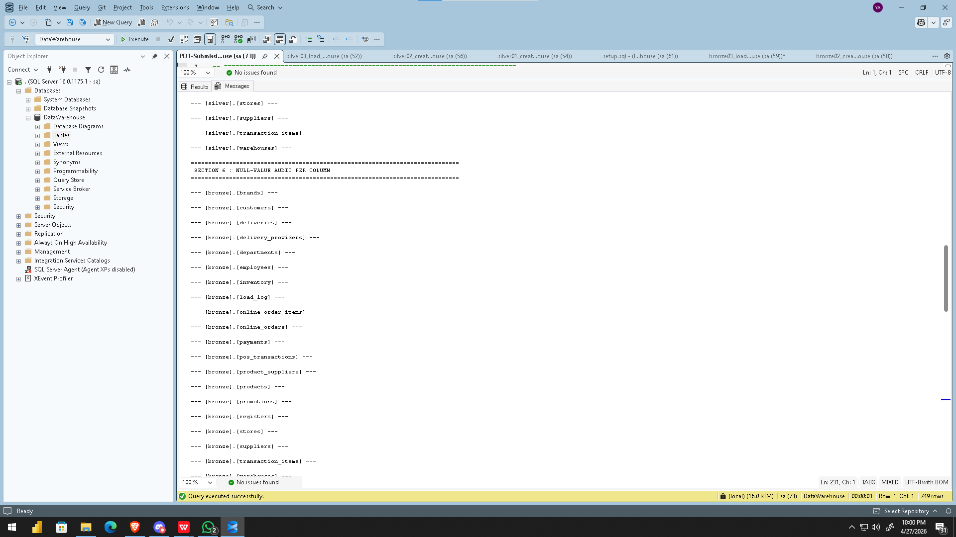
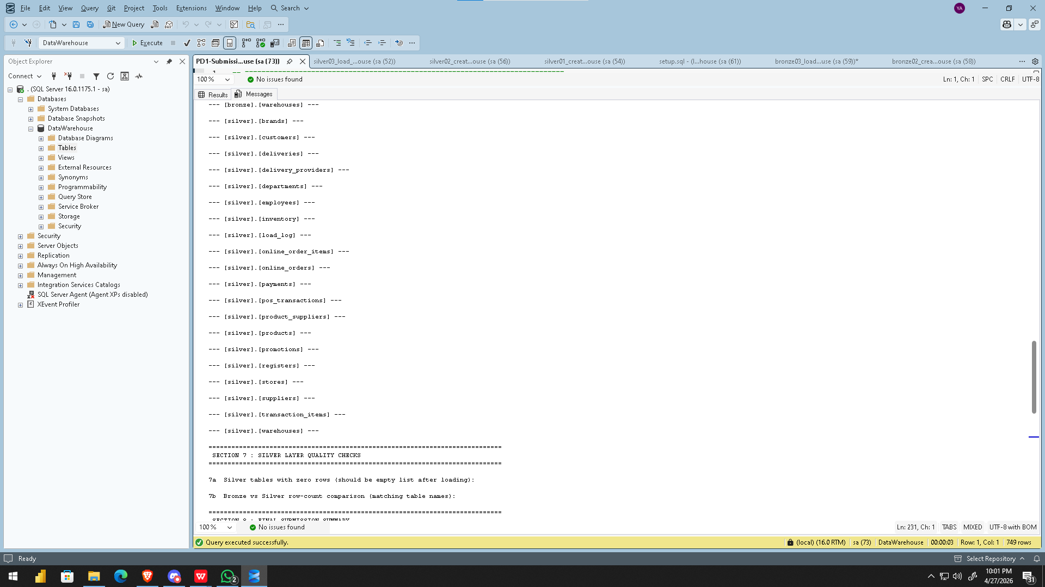
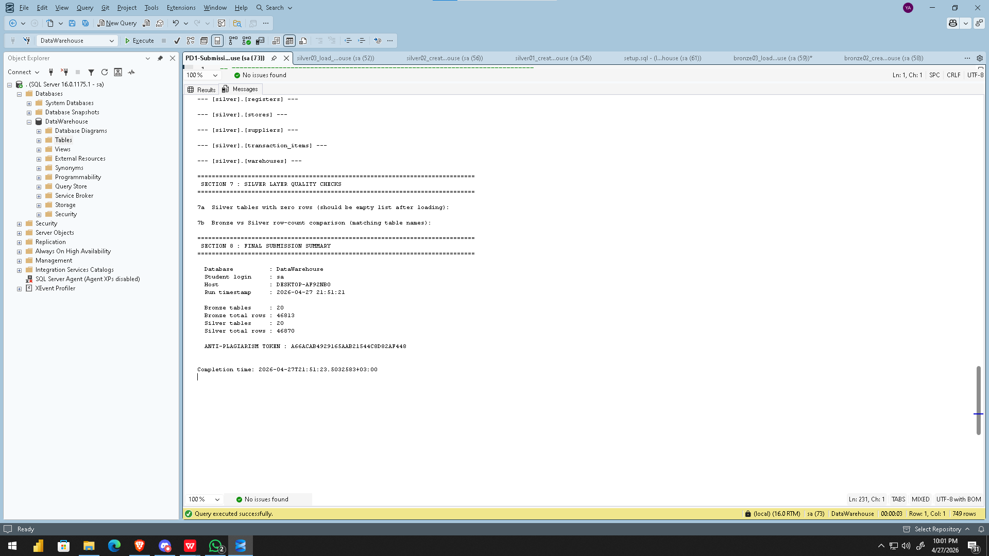

🥇 GOLD LAYER

5. Gold Layer
The Gold layer is the final and business-facing tier of the Medallion Architecture. It reads from the Silver layer and exposes data modeled as star schemas, following Kimball's dimensional modeling principles. All tables in this layer carry surrogate keys, conformed dimensions, and referential integrity enforced through foreign key constraints. The Gold layer is the exclusive source for the Power BI dashboard.

5.1 Technical Specifications
Aspect | Specification
Schema Name | gold
Object Type | Tables (11 total)
Load Method | Batch Processing, Full Load, DELETE & INSERT
Transformations | Data Integration, Surrogate Key Generation, Business Logic
Data Model | Galaxy Schema — 2 Star Schemas with 4 Conformed Dimensions
Automation | Stored procedure: gold.load_gold
Source | Reads from silver schema tables

5.2 Galaxy Schema Design
The Gold layer implements a Galaxy Schema (Fact Constellation) consisting of two independent star schemas that share a set of conformed dimensions. Conformed dimensions are built once and reused across both fact tables, enabling consistent cross-schema analysis in Power BI.

5.3 Conformed Dimensions (Shared Across Both Star Schemas)
The following four dimensions are conformed — they are defined once and referenced by both fact_store_sales and fact_online_sales, ensuring a single consistent version of each entity across the entire warehouse.

Dimension | Grain | Surrogate Key | Key Columns
dim_date | One row per calendar day | Date_Key (YYYYMMDD INT) | Full_Date, Day, Month, Month_Name, Quarter, Year, Weekday, Is_Weekend
dim_customer | One row per customer | Customer_Key (IDENTITY) | Customer_ID, First_Name, Last_Name, Full_Name, Gender, City, Loyalty_Level, Email
dim_product | One row per product | Product_Key (IDENTITY) | Product_ID, SKU, Product_Name, Brand_Name, Department_Name, Package_Size
dim_promotion | One row per promotion | Promotion_Key (IDENTITY) | Promotion_ID, Promo_Type, Discount_Percent, Start_Date, End_Date

5.4 Star Schema 1 — Store Sales
This star schema models in-store point-of-sale transactions. The fact table grain is one row per transaction line item, linking to the store where the sale occurred, the employee who processed it, the product sold, the customer (if identified), and any promotion applied.

Component | Details
Fact Table | gold.fact_store_sales
Grain | One row per POS transaction line item
Measures | Quantity, Unit_Price, Sales_Amount
Degenerate Dimension | Transaction_ID (natural key retained for traceability)
Schema-Specific Dims | dim_store (Store_Key, Store_ID, Store_Name, City, State, Region, Opening_Date)
 | dim_employee (Employee_Key, Employee_ID, Full_Name, Gender, Position, Hire_Date)
Conformed Dims Used | dim_date, dim_customer (nullable — walk-in customers), dim_product, dim_promotion (nullable)

5.5 Star Schema 2 — Online Sales
This star schema models online order transactions. The fact table grain is one row per online order line item, linking to the fulfilling warehouse, the order status, the payment method used, the product ordered, the customer, and any promotion applied.

Component | Details
Fact Table | gold.fact_online_sales
Grain | One row per online order line item
Measures | Quantity, Unit_Price, Sales_Amount
Degenerate Dimensions | Order_ID, Order_Item_ID (natural keys retained)
Schema-Specific Dims | dim_warehouse (Warehouse_Key, Warehouse_ID, Warehouse_Name, City, State)
 | dim_order_status (Order_Status_Key, Status_Name, Description)
 | dim_payment_method (Payment_Method_Key, Method_Name, Provider)
Conformed Dims Used | dim_date, dim_customer (nullable), dim_product, dim_promotion (nullable)

5.6 Gold Layer Tables Summary
Table | Type | Used By | Row Count (approx.)
gold.dim_date | Conformed Dimension | Both schemas | Derived from transaction dates
gold.dim_customer | Conformed Dimension | Both schemas | 4,000
gold.dim_product | Conformed Dimension | Both schemas | 600
gold.dim_promotion | Conformed Dimension | Both schemas | 120
gold.dim_store | Schema 1 Dimension | fact_store_sales | 64
gold.dim_employee | Schema 1 Dimension | fact_store_sales | 800
gold.dim_warehouse | Schema 2 Dimension | fact_online_sales | 8
gold.dim_order_status | Schema 2 Dimension | fact_online_sales | Derived (4 statuses)
gold.dim_payment_method | Schema 2 Dimension | fact_online_sales | Derived from payments
gold.fact_store_sales | Fact Table | Star Schema 1 | 14,962 (line items)
gold.fact_online_sales | Fact Table | Star Schema 2 | 7,151 (line items)

5.7 Implementation Notes
The gold.load_gold stored procedure loads all dimensions and fact tables in the correct dependency order. Facts are cleared first using TRUNCATE TABLE (fast, no FK issue since they hold the references). Dimensions are then cleared using DELETE FROM, which bypasses the FK blocking restriction that TRUNCATE imposes. All three fact measures (Quantity, Unit_Price, Sales_Amount) are wrapped with ISNULL(..., 0) to handle any NULL values propagated from the Silver layer. Surrogate keys are generated automatically via IDENTITY(1,1) on all dimension tables.

5.8 Gold Layer Validation Queries
The following queries were run to validate the Gold layer after executing gold.load_gold:

-- Row counts for all gold tables
SELECT 'dim_date' AS table_name, COUNT(*) AS row_count FROM gold.dim_date UNION ALL
SELECT 'dim_customer' , COUNT(*) FROM gold.dim_customer UNION ALL
SELECT 'dim_product' , COUNT(*) FROM gold.dim_product UNION ALL
SELECT 'dim_promotion' , COUNT(*) FROM gold.dim_promotion UNION ALL
SELECT 'dim_store' , COUNT(*) FROM gold.dim_store UNION ALL
SELECT 'dim_employee' , COUNT(*) FROM gold.dim_employee UNION ALL
SELECT 'dim_warehouse' , COUNT(*) FROM gold.dim_warehouse UNION ALL
SELECT 'dim_order_status' , COUNT(*) FROM gold.dim_order_status UNION ALL
SELECT 'dim_payment_method' , COUNT(*) FROM gold.dim_payment_method UNION ALL
SELECT 'fact_store_sales' , COUNT(*) FROM gold.fact_store_sales UNION ALL
SELECT 'fact_online_sales' , COUNT(*) FROM gold.fact_online_sales
ORDER BY table_name;

-- Referential integrity check — orphaned store sales
SELECT COUNT(*) AS orphan_store_sales FROM gold.fact_store_sales f
WHERE NOT EXISTS (SELECT 1 FROM gold.dim_date d WHERE d.Date_Key = f.Date_Key);

-- Referential integrity check — orphaned online sales
SELECT COUNT(*) AS orphan_online_sales FROM gold.fact_online_sales f
WHERE NOT EXISTS (SELECT 1 FROM gold.dim_date d WHERE d.Date_Key = f.Date_Key);

-- Cross-schema: customers who purchased both in-store and online
SELECT dc.Customer_ID, dc.Full_Name,
COUNT(DISTINCT fs.Sales_ID) AS store_line_items,
COUNT(DISTINCT fo.Online_Sales_ID) AS online_line_items
FROM gold.dim_customer dc
INNER JOIN gold.fact_store_sales fs ON fs.Customer_Key = dc.Customer_Key
INNER JOIN gold.fact_online_sales fo ON fo.Customer_Key = dc.Customer_Key
GROUP BY dc.Customer_ID, dc.Full_Name
ORDER BY store_line_items DESC;

5.9 Data Warehouse Schema Screenshots
The following screenshots show the Gold layer star schemas as rendered in SQL Server after executing the Gold layer scripts. Star Schema 1 (Store Sales) is shown first, followed by Star Schema 2 (Online Sales).

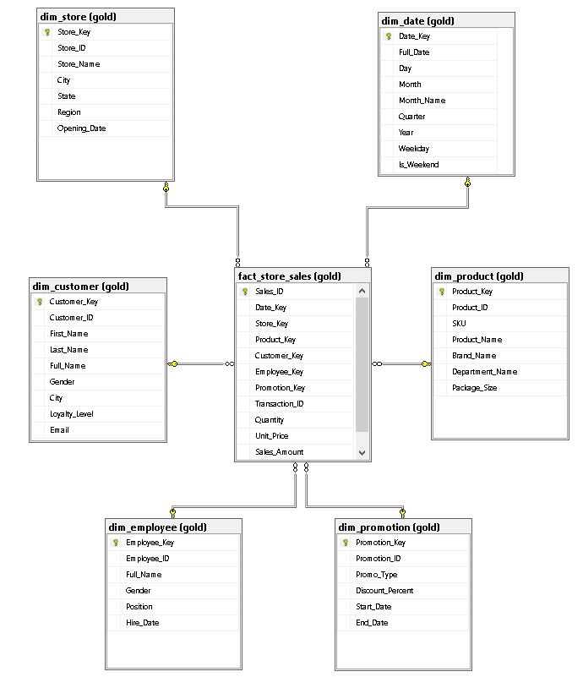

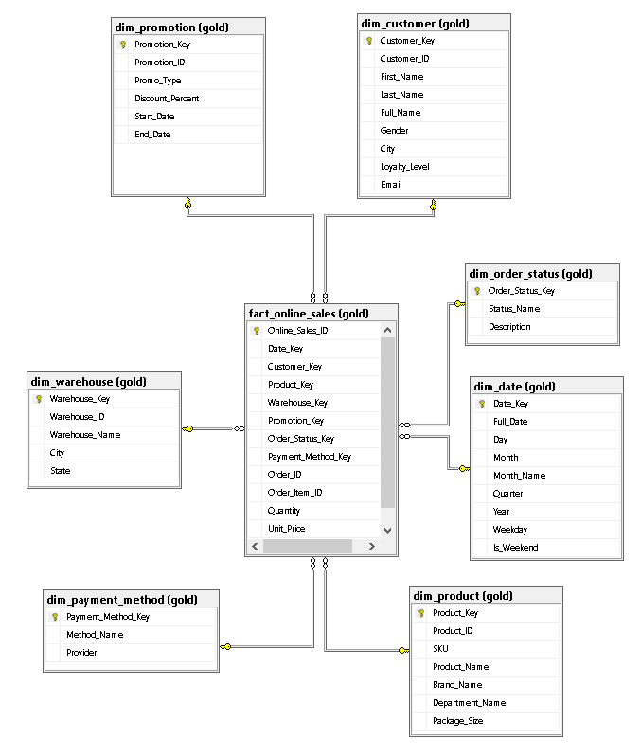

5.10 Gold Layer Technical Audit
The PD2_SubmissionScript was executed against the DataWarehouse database. The Results and Messages tab outputs are shown below.

