**Third year 2014-2015**

**Cairo University**

**Faculty of Engineering**

**Electronics and Electrical Communications Dept.**



**Digital Communications**

**Project #3**

**Hazem Mohamed Safwat**

Next the BER experimentally and theoretically on the same graph.

**BPSK:**

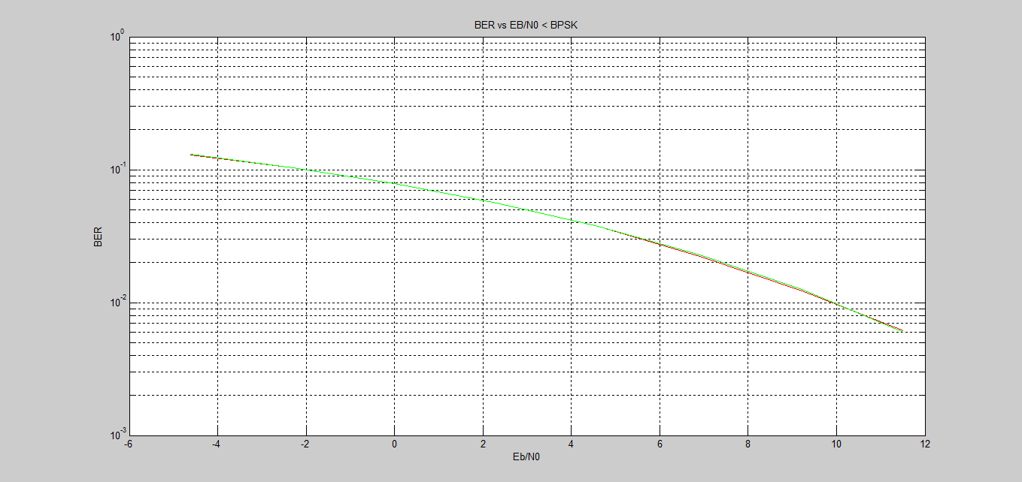

**QPSK:**

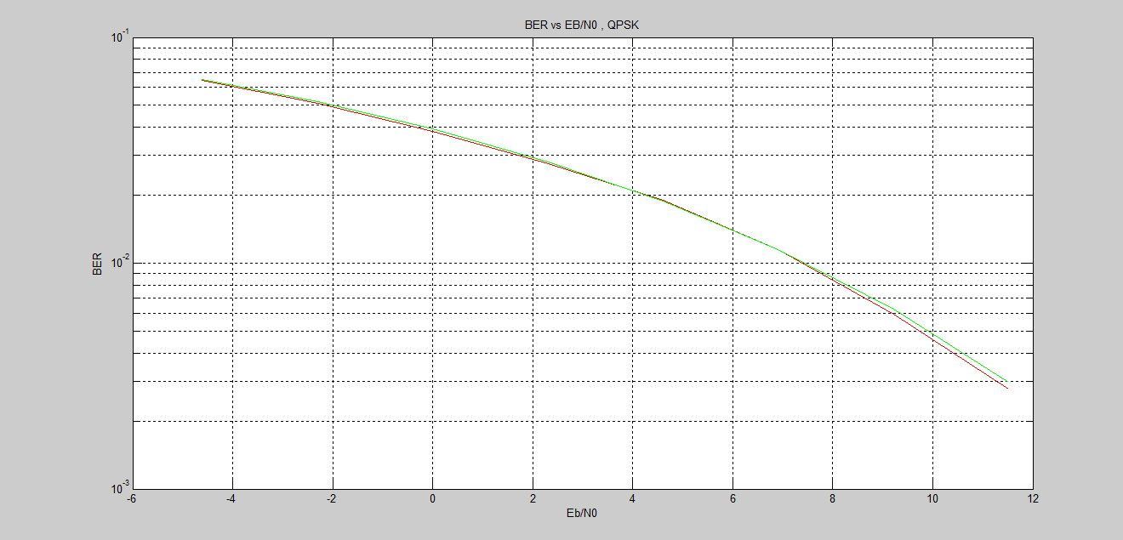

**8PSK:**

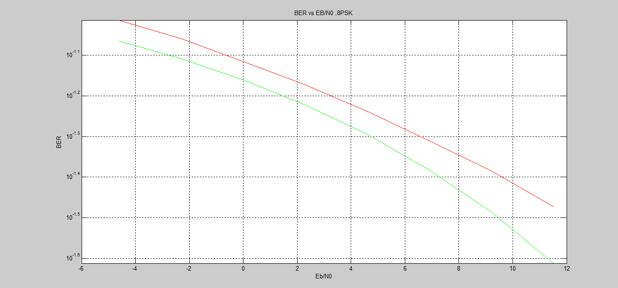

**16PSK first constellation:**

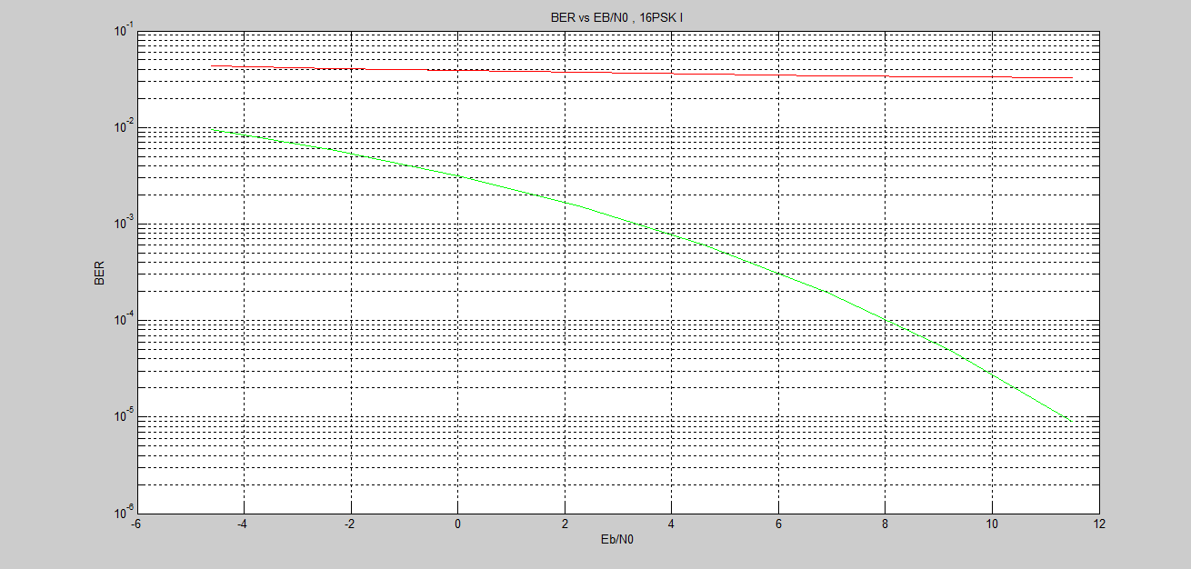

**16PSK second constellation:**

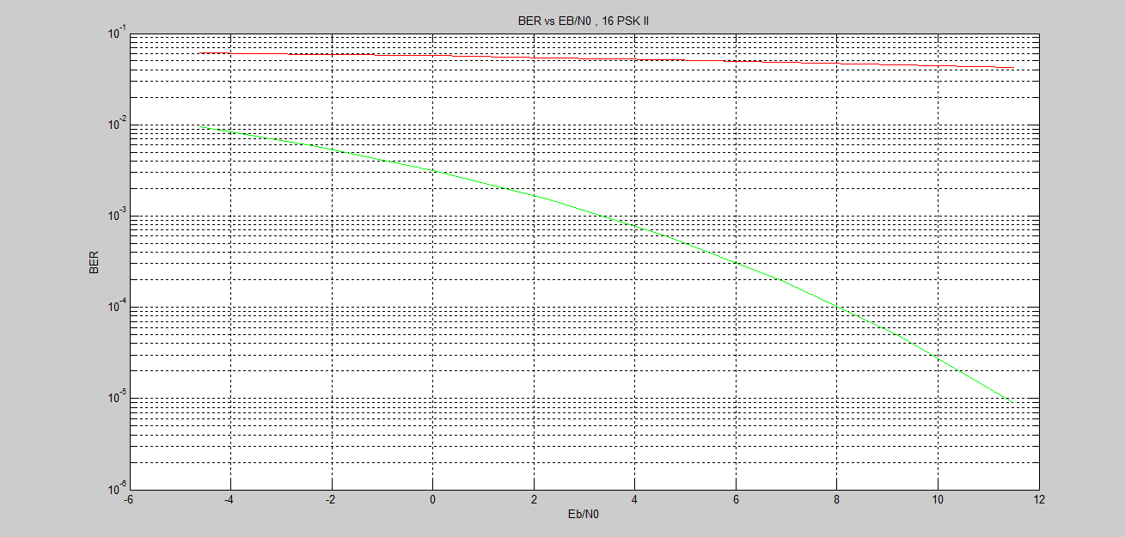

Second constellation has higher BER because one error in the symbol will cause more than one bit error. But in the first one a symbol error will cause one bit error always.

All BER on one graph:

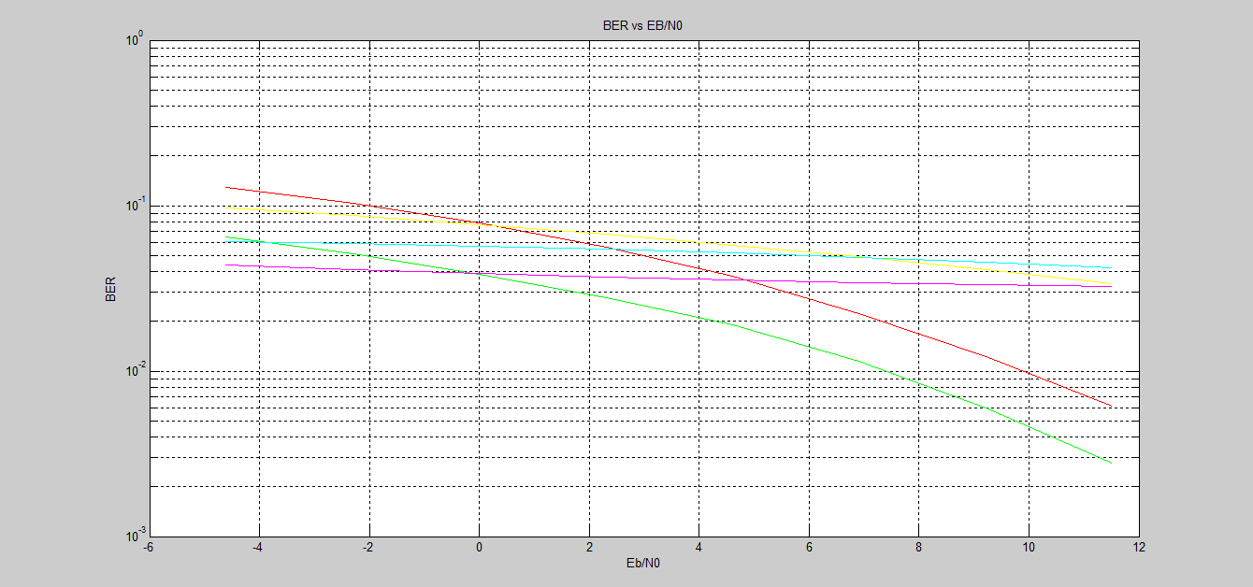

The M-ary PSK choice should be: QPSK.

To fulfill the requirements ( BW = 0.5 M , BER < .01 @ 5db )