
ARAB REPUBLIC OF EGYPT | WSIS+10 REVIEW
Egypt's Digital Decade
Overall review of the implementation of the WSIS outcomes, 1999 to 2014
Ministry of Communications and Information Technology
www.mcit.gov.eg
INSIDE THIS REVIEW
Contents

AT A GLANCE | 03
A DECADE IN REVIEW | 04
CONNECTIVITY AND ACCESS | 05
KEY FINDINGS AND WAY FORWARD | 06
HEADLINES
At a Glance

INDICATOR | 2013 VALUE | CHANGE
Mobile subscriptions | 99.7M | from 13.63M in 2005
Internet users | 38.75M | from 0.65M in 2000
ICT real GDP | EGP 52.3B | 3.4% of national GDP
A.T. Kearney rank | No. 4 | from No. 12 in 2005
International bandwidth | 181,854 Mbps | 97.32% yearly growth since 2001
Mobile penetration | 118.19% | three competing operators
Between 1999 and 2014 Egypt built one of the region's most dynamic information societies, moving from a newly founded ministry to a constitutional right to information access.
C2 INFRASTRUCTURE
The Mobile Leap

Mobile subscriptions jumped from 13.63M in 2005 to 99.7M in 2013, and mobile penetration hit 118.19% as three competing operators drove prices down.
The low usage mobile basket fell from USD 4.57 in late 2007 to USD 2.90 in 2010, while mobile broadband in households grew about 80% per year.
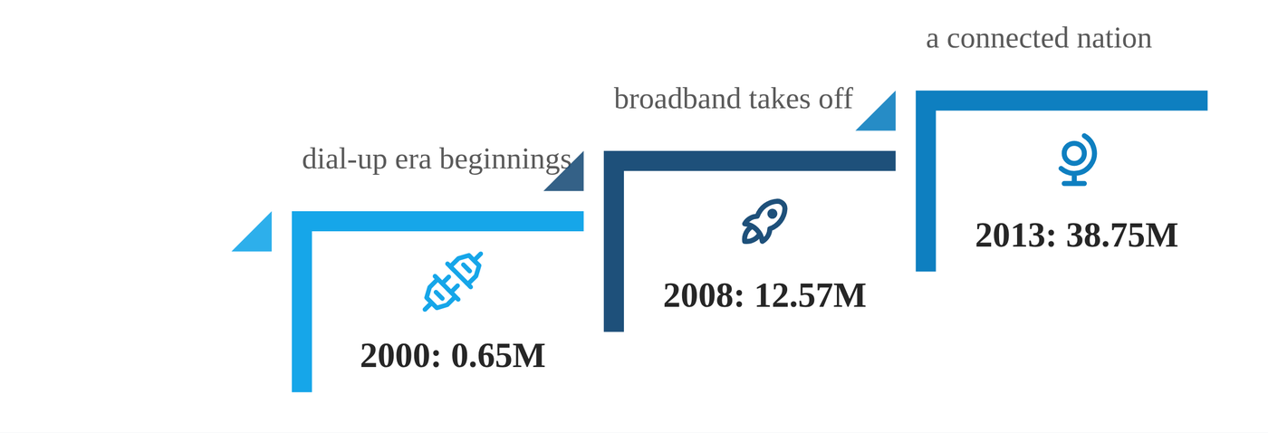
FIGURE 1
Internet users in millions, 2000 to 2013. From under a million to nearly forty million in thirteen years.
C1 GOVERNANCE
Climbing the Outsourcing Ranks

Multistakeholder committees shape every strategy, and post-2011 community dialogue produced about 55 amendments to the Telecommunication Regulation Law.
Outsourcing exports hit USD 1.487B a year by end 2011, with a target of USD 2.5B plus USD 1B from intellectual property.
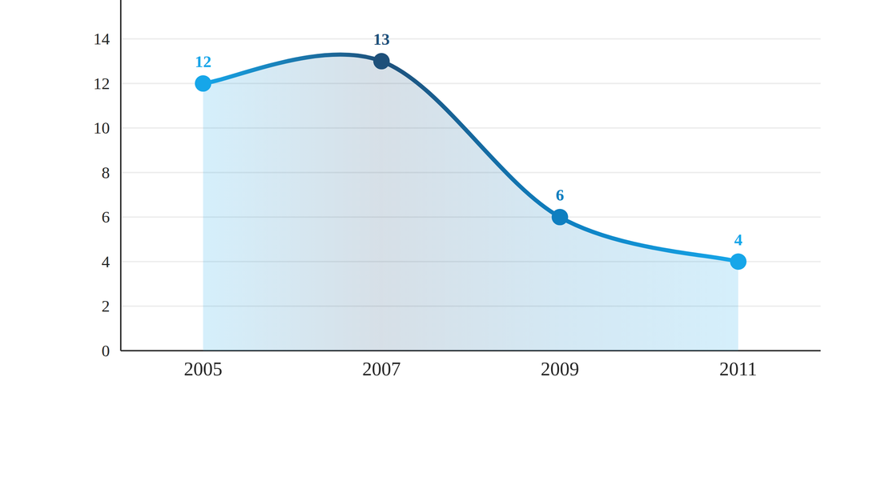
FIGURE 2
A.T. Kearney Global Services Location Index rank, 2005 to 2011 (lower is better). Egypt climbed from 12th to 4th.
FINDINGS
Key Findings

Mobile leapfrogged fixed lines: subscriptions rose from 13.63M to 99.7M while fixed lines fell to 6.82M.
Broadband became national policy: the eMisr plan targets 75% of households at 2 Mbps by 2016.
Outsourcing put Egypt on the world map: from 12th to 4th in the Kearney index between 2005 and 2011.
INDICATOR | VALUE | NOTE
Households online at home | 44.24% | from 18.59% in 2007
3G equipped mobiles | 27.3% | from 20.4% in 2011
Facebook users | 16.4M | from 4.2M in 2010
IT Clubs nationwide | 2,000+ | 36% in Upper Egypt
A fifteen year run from a new ministry to a constitutional right to information.

Thank You
Ministry of Communications and Information Technology
www.mcit.gov.eg

