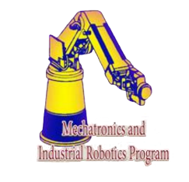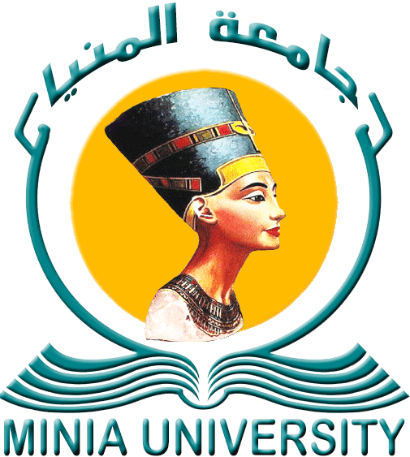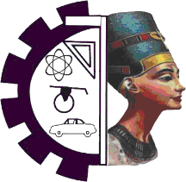

Minia University Faculty of Engineering Mechatronics and

Industrial Robotics Program

**Sign Language Translator (SLT)**

*A project submitted to the Mechatronics and Industrial Robotics Program as a partial fulfillment for the degree of B.Sc.*

Submitted by:

**Mahmoud Nageh**

**Hussien Hamdy**

**Hazem Mohammed**

**Mohammed Ashraf**

**Ahmed Emad**

**Mira Sameh**

**Mennatullah Youssef**

**Fatma Nasser**

Supervised by:

**Prof.Dr. Abou Hashema Ahmed**

**Prof.Dr. El Sadek Hassan**

**Prof.Dr. Mohammed Reda**

*15 July 2021*