**ATM Software Requirements:**

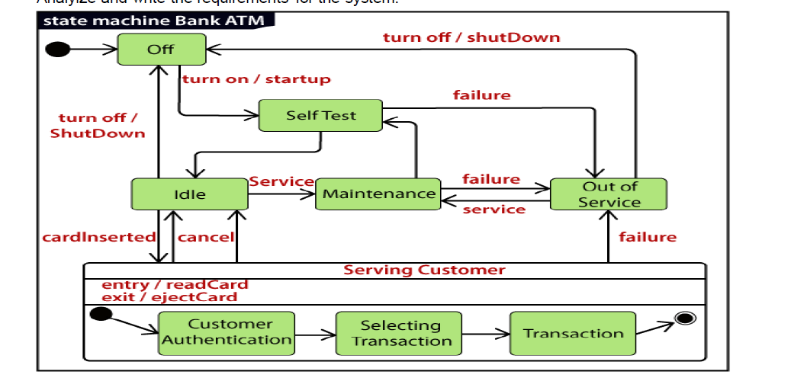

This image describes the main states for ATM Software which constant of 6 main states each state describe functionality for the ATM

States and Transitions:

1. Off State:

* Initial state when the ATM is turned off.
* Transitions to "Self-Test" upon turn on/startup.

**Pre-condition**: The ATM is shut down, and no power is supplied.

**Expected Result**: The ATM remains inactive until it is started up.

**Scenario**: The bank powers up the machine to make it functional.

2. Self-Test State:

* ATM performs a self-test to check its operational status.
* If the self-test is successful, it transitions to the "Idle" state.
* If the self-test fails, it transitions to "Out of Service".

**Pre-condition**: The ATM is powered on.

**Expected Result**: The ATM either becomes operational or goes out of service based on the test results.

**Scenario**: After turning on, the system checks itself and according to test results Will take action to move “idle” state or move to “out of service” if the system find any issue

3. Idle State:

* ATM waits for a customer to insert a card.
* Transitions to "Customer Authentication" once a card is inserted to check if the customer has the access to do operations or transaction or not.
* Can also transition to "Maintenance" if any issues accrue.

**Pre-condition**: The ATM has successfully passed the self-test.

**Expected Result**: The ATM waits for a user to insert a card or maintenance.

**Scenario**: A customer approaches the ATM and inserts their card to begin a transaction.

4. Maintenance State:

* Entered when the ATM requires service or maintenance.
* Can return to "Idle" once maintenance is complete or go to "Out of Service" if the issue happened.

**Pre-condition**: The system requires maintenance.

**Expected Result**: After maintenance the system go to “idle” or go to “out of service”

**Scenario**: Technical issues happened in ATM, and it is either fixed or taken out of service.

5. Out of Service State:

* ATM is not available for use.
* The system can transition to Maintenance after servicing.
* The system can be turned off.

**Pre-condition**: A failure has occurred, or the self-test was unsuccessful.

**Expected Result**: The system remains out of service until repaired.

**Scenario**: Technical issues happened in ATM , this issue makes the ATM Go out of service

6. Serving Customer state have 3 substate including (Customer Authentication State, Selecting Transaction State, Transaction State)

1.Customer Authentication State:

* ATM verifies the customer’s credentials.
* Once authenticated, transitions to "Selecting Transaction".
* The customer can cancel the transaction, returning the ATM to the "Idle" state.

**Pre-condition**: The user has inserted their card.

**Expected Result**: The user is either authenticated or denied access.

**Scenario**: A customer enters their PIN, and the system validates it.

2. Selecting Transaction State:

* The customer selects a transaction.
* Transitions to "Transaction" for completing the transaction.

**Pre-condition**: The customer has been successfully authenticated.

**Expected Result**: The user selects a valid transaction type.

**Scenario**: The customer selects to checking balance.

3. Transaction State:

* The ATM processes the transaction.
* Once completed, it returns to "Idle".
* Once any failure happened, it returns to “out of service”
* Card is ejected after the transaction, allowing the customer to leave.

**Pre-condition**: The user has selected a transaction.

**Expected Result**: The transaction is completed successfully, or an error occurs.

**Scenario**: The ATM show the many in the card for user and returns the card.