Chapter 9

Dimensional Modeling

Abstract
The purpose of dimensional modeling is to enable business intelligence (BI) reporting, query, and analysis. The key concepts in dimensional modeling are facts, dimensions, and attributes. There are different types of facts (additive, semiadditive, and nonadditive), depending on whether they can be added together. Dimensions can have different hierarchies, and have attributes that define the who, what, where, and why of the dimensional model. The grain, or level of granularity, is another key concept with dimensional modeling because it determines the level of detail. Facts, dimensions, and attributes can be organized in several ways (star, snowflake, multidimensional, and multifact star), called schemas. The choice of schema depends on variables such as the type of reporting that the model needs to facilitate and the type of BI tool being used. Building a dimensional model includes additional puzzle pieces such as calendar and time dimensions; and more complicated pieces such as conforming, degenerative, and role-playing dimensions; and consolidated fact tables.

Keywords
Additive facts; Conforming dimensions; Consolidated fact table; Degenerative dimensions; Dimensional model; Dimensional modeling; Fact table; Multi-fact star; Multidimensional schema; Role-playing dimensions; Snowflake schema; Star schema
Information in This Chapter:
• Dimensional modeling
• Facts
• Dimensions hierarchies and keys
• Schemas
• ER vs. dimensional modeling
• Purpose of dimensional
• Fact tables
• Consistency and conforming
• Advanced dimensions and facts

Introduction to Dimensional Modeling
Like enterprise relationship (ER) modeling, dimensional modeling is a logical design technique. Dimensional modeling is much better suited for business intelligence (BI) applications and data warehousing (DW). It depicts business processes throughout an enterprise and organizes that data and its structure in a logical way. The purpose of dimensional modeling is to enable BI reporting, query, and analysis. The hybrid dimensional-normalized model is best for supporting DW integration demands.
The key concepts in dimensional modeling are facts, dimensions, and attributes. There are different types of facts, depending on whether they can be added together. Dimensions can have different hierarchies, and have attributes that define the who, what, where, and why of the dimensional model. The grain, or level of granularity, is another key concept with dimensional modeling, as it determines the level of detail.
Facts, dimensions, and attributes can be organized in several ways, called schemas. The choice of schema depends on variables such as the type of reporting that the model needs to facilitate and the type of BI tool being used. Building a dimensional model includes additional puzzle pieces such as calendar and time dimensions, and more complicated pieces such as degenerative dimensions and consolidated fact tables.
In addition to explaining these concepts, this chapter will compare the approach between an ER model and a dimensional model.
See the book’s Website www.BIguidebook.com for data modeling templates.

High-Level View of a Dimensional Model
As shown in Figure 9.1, there are two key entities in a dimensional model: facts (measures) and dimensions (context). The example shows these elements:
• The fact Tbl_Fact_Store_Sales is at the core of the dimensional model.
• Four surrounding dimensions that define and put into context the store sales:
• On the upper right corner is the item Tbl_Dim_Item, which is what products were sold.
• Below that is the date, Tbl_Dim_Date, which is when those products were sold.
• On the lower left corner is the customer, Tbl_Dim_Customer, who bought the products.
• On the upper left corner is the buyer, Tbl_Dim_Buyer, who bought the product for the store.
In context, the example shows that when someone buys a product we can use this model to capture information about that business process. The details will be covered in much greater detail in the following sections.
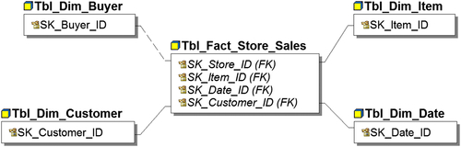
FIGURE 9.1 Dimensional modeling overview.

Facts
A fact is a measurement of a business activity, such as a business event or transaction, and is generally numeric. Examples of facts are sales, expenses, and inventory levels. Numeric measurements may include counts, dollar amounts, percentages, or ratios.
Facts can be aggregated or derived. For example, you can sum up the total revenue or calculate the profitability of a set of sales transactions. Facts provide the measurements of how well or how poorly the business is performing. A fact is also referred to as organizational performance measure.
Fact tables are normalized and contain little redundancy. Fact table record counts can become very large. Ninety-percent of the data in a dimensional model is typically located in the fact tables. The key dimensional modeling design concerns when working with the data in fact tables are how to minimize and standardize it and make it consistent.

Fact Table Keys
Fact tables are composed of two types of columns: keys and measures. The first, the key column, consists of a group of foreign keys (FK) that point to the primary keys of dimensional tables that are associated with this fact table to enable business analysis. The relationships between fact tables and the dimensions are one-to-many, as explained in the ER modeling section of Chapter 8.
Figure 9.2 shows the key columns in a fact table of sales (Fact_OnlineSales):
• DateKey—Date and time purchase was made
• StoreKey—Online store in which purchase was made
• ProductKey—Product that was bought
• CustomerKey—Customer who made purchase
• PromotionKey—Sales promotion
• CurrencyKey—Currency used to make purchase
The primary key of a fact table is typically a multipart key consisting of the combination of foreign keys that can uniquely identify the fact table row. This key may also be referred to as a compound or concatenated key. The multipart key may be a subset of the foreign keys such as in our example: DateKey, StoreKey, ProductKey, and CustomerKey may uniquely identify each row in the sales fact table.
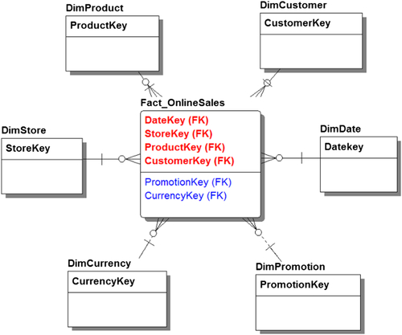
FIGURE 9.2 Fact table—keys.
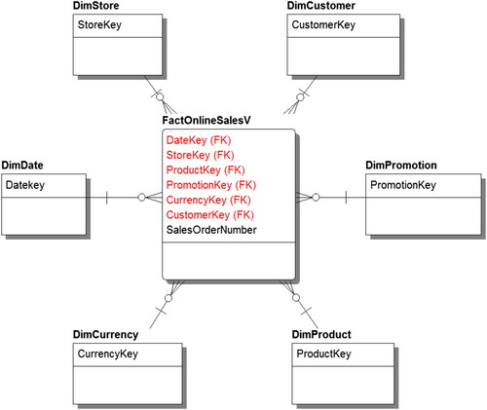
FIGURE 9.3 Fact tables—primary key with degenerative dimensions.
You have two alternatives if there is no combination of foreign keys that creates the uniqueness required for creating a primary key:
• First, the operational systems that record the business transactions or events used to populate fact tables typically create unique identifiers related to those transactions. Examples of these identifiers are a sales order number, invoice number, and shipment tracking number. These identifiers are called degenerative dimensions and are discussed later in this chapter. If combining this identifier with a subset of foreign keys creates uniqueness, then this multipart key will become the primary key. Figure 9.3 illustrates this type of primary key with the columns DateKey, StoreKey, ProductKey, and CustomerKey paired with SalesOrderNumber becoming the primary key.
• Second, if you cannot identify unique rows with any of the methods discussed so far, create a primary key based on a surrogate key. A surrogate key, which is often generated by the database system using an IDENTITY data type, is an integer whose value is meaningless. Figure 9.4 illustrates this approach. The OnlineSalesKey column is the surrogate key that was created as the primary key. A best practice is to index each of the foreign keys in the fact table because this will speed up query performance by improving joins and filters.
One of the key best practices you need to implement is that foreign keys should never be null. Performing analysis requires joining various dimensions to a fact table, and you need to have the value of the foreign key in order to guarantee valid business results. Each of the foreign keys points back to a corresponding dimension, which provides attributes relevant to the internet sales event such as who the customer is, where he or she lives, his or her age, and other demographic attributes.
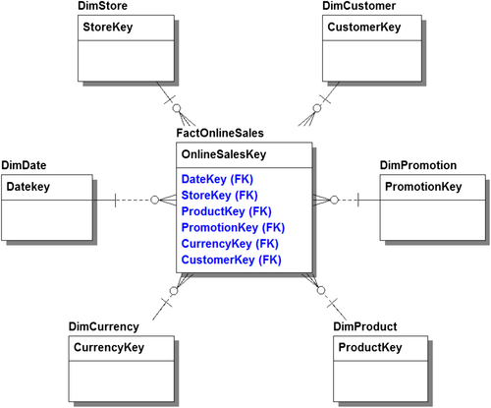
FIGURE 9.4 Fact table—primary key is a surrogate key.

Fact Table Measures
The second type of column in a fact table is the actual measures of the business activity such as the sales revenue and order quantity. Every measurement has a grain, which is the level of detail in the measurement of an event such as a unit of measure, currency used, or ending daily balance of an account. For example, the grain of currency could be to the dollar amount, or be more granular and include cents. Granularity is determined by its data source.
The circled portion in Figure 9.5 shows several measures of an internet sale: SalesQuantity, SalesAmount, ReturnAmount, ReturnQuantity, DiscountAmount, DiscountQuantity, and TotalCost that apply to a customer for a product purchased at a specific time. All of these measures are related to the business event (the sale) that the fact represents and they have a level of granularity related to that event.
When creating and defining columns and measures, ensure that all rows have a single, uniform grain. In other words, they must be relevant. If the example is buying a product, you must have measures that are relevant to that particular purchase in order for the query and the report to make any sense to a business person. In this example, the fact table should have total cost rather than unit cost when comparing it with sales quantity and sales amount; otherwise, business ratios and aggregating orders will result erroneous measures.
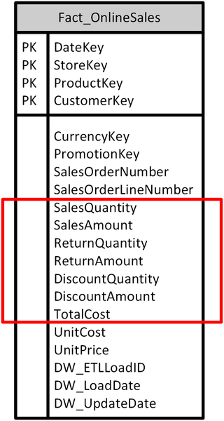
FIGURE 9.5 Fact table—granularity.
It’s an accepted best practice to store the lowest, or the most detailed grain captured in the business process. In Figure 9.5, this would be storing order line level detail rather than summarized order header details. Historically, data warehousing and business intelligence used summarized data, so queries and reports were less detailed. That practice was based on infrastructure and processing limitations that no longer are applicable. Now, it’s an established practice to store at the lowest transactional level of detail that’s available from a transactional or operational systems. This enables the most flexibility, because as soon as you summarize something, you lose the detail, making the data less useful. Granularity allows extensibility; having the lowest level of detail allows you to aggregate and manipulate facts or measures.

Types of Facts
After you’ve defined the measures and their level of grain in the facts, you need to determine the numeric attributes of the types of measures that are being stored in the fact. There are three types of measures: additive, semiadditive, and nonadditive.

Additive Facts
An additive fact is the easiest to define and manage. It’s simply a measure of the fact table that can be added across all dimensions. The simplest example of an additive fact is the quantity of items you bought in an online store—such as the number of books. Additive measures enable the fact to be aggregated by all applicable dimensions, which in our example is customer, store, product, and date.

Semiadditive Facts
Semiadditive facts are measurements in the fact table that can be added across some dimensions but not others. Examples of these measures are bank account balances, the number of students attending a class, or inventory levels. You can’t simply add 12 months of account balances and get how much money somebody has in a bank account. In this case, you would average those balances over 12 months. However, at the point in time that they were measured (at the end of the month), you could add the account balances of all your customers and get the total account balances at that point in time.

Nonadditive Facts
Nonadditive facts are measures in fact tables that can’t be added across any dimensions. Examples of these include unit prices, ratios, and temperatures; even though they are numbers they aren’t supposed to be added. In a real-life example, a client of mine was taking samples of water levels in a particular state, and those ratios and water levels couldn’t just be added together. They had to look at them from a scientific perspective. Nonadditive facts can’t be added like a typical SQL query that is simply summed across a column.
It’s important to understand the concepts of additive, semiadditive, and nonadditive facts because aggregating or summarizing data is a big part of reporting and analysis. It’s one of the key benefits of using dimensional models, and one of the things for which it is most often used. After you define measures and determine whether they are additive, nonadditive, or semiadditive facts, you need to establish how they can be analyzed in BI. It is the BI team’s responsibility to ensure that the business people performing the analysis know what type of measure they are accessing to prevent the risk of using data inappropriately.

Dimensions
A dimension is an entity that establishes the business context for the measures (facts) used by an enterprise. Dimensions define the who, what, where, and why of the dimensional model, and group similar attributes into a category or subject area. Examples of dimensions are product, geography, customers, employees, and time. Whereas facts are numeric, dimensions are descriptive in nature (although some of those descriptions, such as a product list price, may be numeric). Creating a dimension enables facts to store attributes in a single place, rather than multiplying them redundantly across the rows of the fact tables. The way they are connected is through the foreign key in the fact tables, which links back to the dimension table. This is a level of normalization—it eliminates redundancy.
Another benefit of dimensions is that in addition to saving storage space and reducing bandwidth for repeatedly moving those attributes across the network, it enables dimensional attributes to change without having to alter the underlying facts—avoiding potentially complex and time-consuming processing.
Dimensions keep the database from being overrun with redundant data. With all the attributes in a dimension table, they don’t have to be repeated in the fact tables. Take Amazon, for example. The data for an individual sale will contain the product identification number, but will not repeat all the attributes of the product (color, description, reviews, etc.). Those attributes are in a dimension, and each individual sale of that product just points to them.
From a business perspective, the key purpose of dimensions it to use their attributes to filter and analyze data based on performance measures. In Figure 9.6, the dimension is a product, DimProduct, with its attributes including name, weight, size, color, and list price. When the product dimension is joined with a sales fact table, a business person could examine sales based on one or more of these specific product attributes, such as analyzing sales by color or size.
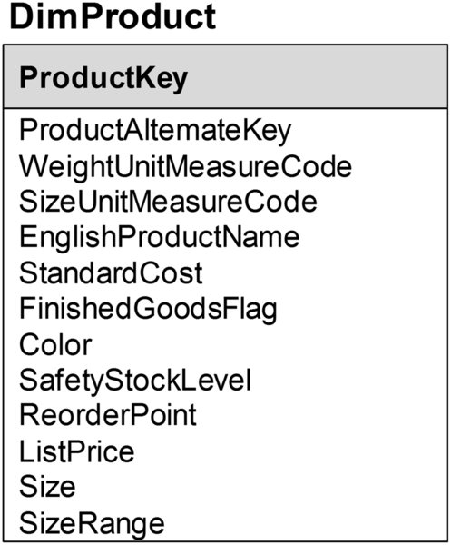
FIGURE 9.6 Dimension—basic example.
To be useful in analysis a dimensional attribute needs these key characteristics:
• Descriptive, so business people and those designing the BI applications can understand it.
• Complete, with no missing values.
• Unique, because it’s critical that values are uniquely identifiable.
• Valid, so the data is useful to the business.

Dimension Hierarchy
Another aspect of the business context created by dimensions is that they are often hierarchical; they group things together in ways that an enterprise would measure itself. These hierarchies represent many-to-one relationships. Examples of hierarchies include:
• Organizational structures, such as a marketing or sales organization.
• Product or service categories.
• Geographic groupings such as sales territories.
• Time. Years breaks down to quarters, months, weeks, hours, days, minutes, on down to seconds. This is the classic hierarchy.
Figure 9.7 shows the geography dimension DimGeography with attributes that define a hierarchy. The highest level of the hierarchy is a country or region (CountryRegionCode) that then breaks down to a state or province (StateProvinceCode), then breaks down to a city, and finally into a postal code. This example works for the United States and Canada, but may need to be modified for other countries.
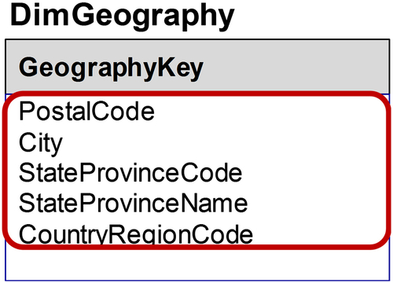
FIGURE 9.7 Dimensional hierarchy.
The geography example shows the hierarchy and how, using BI terminology, you can drill up and down and across. For example, you can view sales at the country level or drill down to the detailed state level, city level, and finally down to postal code. This allows you to aggregate the data. You would use a SQL “Group By” for example, if the data was organized correctly to group the data by a particular column or attribute within that hierarchy and to sum the data appropriately. That summing would use additive facts or measures.

Dimension Keys and Surrogate Keys
A key concept in constructing dimensions is that each row of a dimension table is unique. In a dimension table, the primary keys are a single field compared to facts, which use a grouping of foreign keys as their primary key.
Figure 9.8 shows two dimensions, DimProduct and DimGeography. Each has single fields, ProductKey for DimProduct and GeographyKey for DimGeography that are used as the primary key for those respective tables.
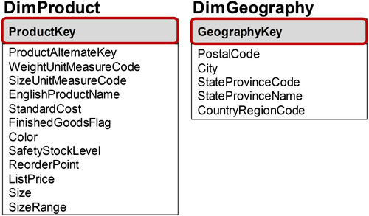
FIGURE 9.8 Dimension keys.

Surrogate Keys
One of the best practices to emerge for dimensions is using a surrogate key as the primary key as depicted in Figure 9.8. A surrogate key, which is often generated by the database system, is an integer whose value is meaningless (see the following section on smart keys for an explanation). Date and time dimensions are accepted exceptions to the meaningless value criteria, and are covered later in this chapter.
Note: if the maximum number of rows in a table is greater than 2.1 billion, you need to use a bigint or equivalent data type rather than int.
In Chapter 8, we discussed how the processes for designating a primary key for ER modeling involves selecting a key that uniquely identifies the entity. If there is more than one possibility they are called candidate keys, and the keys not selected are alternate keys. Even though transactional systems will have already created primary keys that can be used in a dimensional model, it has become best practice to designate that key as an alternate key and create a surrogate key as the primary key instead.
The reasons to create a surrogate key are:
• When gathering dimensional data from multiple source systems, there are often inconsistent or incompatible primary keys used across these systems.
• Primary keys from source systems often change over time with different naming or numbering conventions being used at different times. Additionally, over time, source applications may be replaced by newer systems, or mergers may create the need to replace systems.
• Primary key consistency may be maintained by source systems for shorter periods than the enterprise analytical needs dictate.
• Source systems may be using smart keys.
An additional best practice is to maintain the source system’s primary key as an alternate key in the dimension. This is also called the source system’s natural key. If there are multiple source systems with natural keys you should add an attribute that identifies the source system. This results in a multipart alternate key to identify the natural keys. In Figure 9.9, CustomerSK is the primary key in the customer dimension, CustomerNK is the natural key in the dimension and primary key in the source system, SOR_NK is the SOR (systems of record) indicator and the multipart alternate key is the SOR_NK and CustomerNK columns.
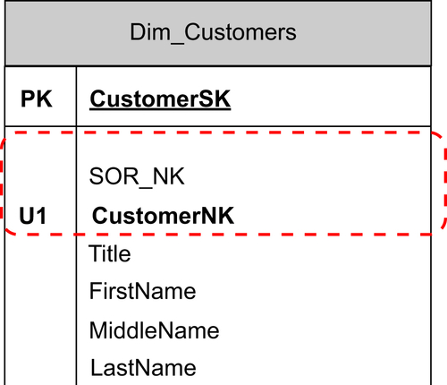
FIGURE 9.9 Surrogate and natural keys.

Smart Keys
Operational and transactional systems sometimes define or identify items such as products with smart keys. These are alphanumeric strings, maybe 24 or 40 characters in length. The character string is typically divided into substrings. The substrings have meaning, hence the word smart key. For example, the first three characters might designate what manufacturing plant the product was built in. The next five characters might designate the materials that were used to construct the product. The next 10 might designate the size or some other characteristics of the construction of the product, and so on.
In the 1990s and 2000s, when some operational systems were developed, smart keys were a way to put a lot of intelligence in the key, especially because of limited memory and storage. But today that intelligence has worked against most of the operational systems. There are two main reasons for this:
• First, in most operational systems, the smart keys change over time. The substrings and their meanings and definitions change. So when you’re trying to get historical view of that smart key, you’ll have considerable inconsistencies.
• Second, because each operational system has its own arbitrary definition of what those smart keys mean, when you had an enterprise that had multiple operational systems (and many enterprises do), there were inconsistencies in the keys that made it difficult to uniquely identify a product across an enterprise.
The solution to the smart key problem was to create the surrogate key—a meaningless key that would be the consistent and unique identifier in a dimension.

Not Null Values
The foreign keys used as the primary key in fact tables should never contain null values. For an example of how a null value gets assigned, suppose a row in a sales fact table has a null value in the customer identifier column that is the foreign key linked to the customer dimension. The null value was input into that column when, loading the data from the source systems, the ETL process could not find a customer associated with that sale because the value was unknown, missing or invalid.
Null values are confusing to both people and BI tools. If you understand SQL, you know there’s a difference between querying results when joining on keys with null or nonnull values. Using our example again, a join between a sales fact and a customer dimension would only include the sales rows that had a value (nonnull) in the customer key. This means that if a business person was trying to analyze total sales she would be missing those sales with null customer keys. This condition clearly results in misleading analysis that potentially creates business risk. And this condition can be exacerbated if other foreign keys also have nulls.
The best practices that address this potential business risk include:
• Create row(s) in each dimension that are used when dimensional values are unknown, missing, invalid, or other conditions in which referential integrity is not met.
• Because the numbering convention for surrogate keys is a positive integer, use negative integers such as −999 for “missing” row keys.
• Dimensional rows have surrogate keys along with attributes used for naming and describing them. Create a standard name and description for these rows used across all dimensions, e.g., “Missing,” “Unknown,” or “Invalid.”
• At a minimum, designate one row per dimension table for missing values, but if it is important to be able to identify different conditions then use multiple rows. If there are multiple conditions handled then use standard numbering and naming for each of these conditions across all dimensions.
This may seem trivial, but BI tools, just like SQL queries with joins, will result in misleading or inaccurate results if nulls exist in the fact table foreign keys. This exposes the business to needless risks.

Benefits
The primary benefit of using a surrogate key as a dimension’s primary key is to provide an identifier that is consistent and unique across source systems and time, and that is independent of business systems. An additional benefit of the surrogate key is that, being integer-based, it is a great data type to index and join in a relational model.
To summarize, dimensions should have the following characteristics:
• Unique rows
• Surrogate keys used as primary keys
• Non-NULL primary keys

Schemas
You’ve now learned about dimensions, facts and attributes. It’s time to put those pieces together and fill out the dimensional data model jigsaw puzzle. There are three types of schemas for building a dimensional model: star schema, a snowflake schema, and multidimensional schema.
You choose which schema to use when building the dimensional model by considering these questions:
• What kind of analysis are you trying to perform on that data and how complex is it?
• What are the analytical requirements and restrictions?
• How consistent is the data you want to query and analyze?
• What BI tool do you plan to use? Although different tools may appear to show the same type of data, results, and graphs, they can be very different under the covers, and rely on a specific schema for the best results.

Star Schema
The star schema is the most common schema for dimensional models. It is a fact table surrounded by multiple dimension tables, as shown in Figure 9.10.
The example shows a fact, FactInternetSales; this example is about selling products online. The multiple dimension tables for this fact are:
• DimSalesTerritory—where the sales territory is located
• DimPromotions—what promotions are selling products
• DimCurrency—what currency is being used, such as dollars or pounds
• DimCustomer—who’s buying it
• DimDate—when it’s being sold
• DimProduct—what products they are selling
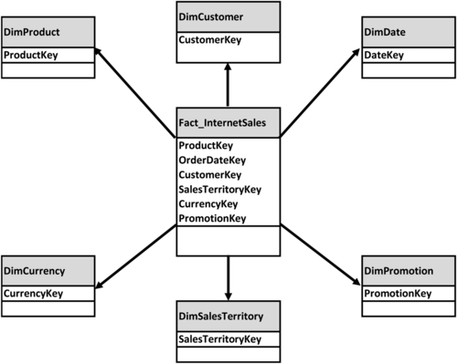
FIGURE 9.10 Star schema.
And, of course, filtering or grouping by attributes in different dimension tables enables a business person to analyze who is buying what, where are they located, when they are buying, and if they are buying using promotions.
The star schema is a compromise between a fully normalized and a denormalized model. Fact tables are where the majority of the data stored in the dimensional model is located, so it’s important that facts are stored in normalized tables. This normalization is essential for minimal redundancy, ease of maintenance, and improved query performance.
Dimensions, on the other hand, are denormalized tables containing attributes that are often spread out across multiple tables if a 3NF data model is used. In Figure 9.10, each of the dimensions listed has descriptive attributes in a denormalized or “flattened” table. Even hierarchies that have each of their levels represented by a separate entity in an ER model are flattened into one dimensional table in a star schema.
The advantages of the star schema are that it’s great for query, performance, and analytics. It supports tasks that business people normally perform when they are using pivot tables in spreadsheets, so it is very intuitive to them. It’s easy for business people to use and has fast query performance because BI tools are built to take advantage of the star schema construct.

Snowflake Schema
The second type of dimension schema is the snowflake. It takes the star schema, with the facts surrounded by denormalized dimensions, one step further by normalizing the hierarchies within a particular dimension. Each level in the dimensional hierarchy becomes its own dimensional table with parent keys created to link the hierarchical structure together. The fact table stores the foreign key to the lowest level of the dimensional hierarchy.
Figure 9.11 illustrates a snowflake schema where the sales fact FactInternetSales, is linked to the product dimension, DimProduct. If this was a star schema, the fact would just point back to DimProduct, just as the first table above it does in Figure 9.10. But in a snowflake schema, the dimensional product table is split into subsequent levels of a product hierarchy. Its parts include:
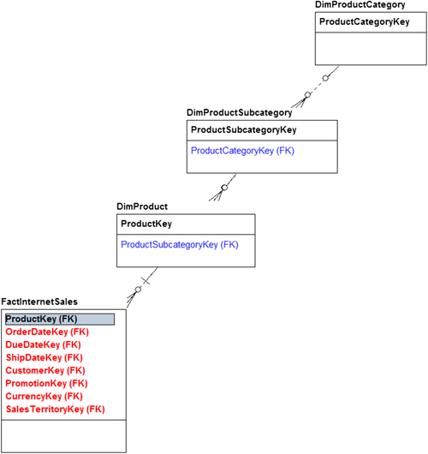
FIGURE 9.11 Snowflake schema.
• DimProduct, which is the core or bottom level of the hierarchy. If this was a bike store this might be the specific bike, biking shorts, or water bottle sold.
• DimProductSubcategory, the next level, which rolls out of various products into subcategories. For the bike store, the bike-related subcategories might be road, mountain, and hybrid.
• DimProductCategory, the highest level of the hierarchy. For the bike store, the top-level categories might be bikes, clothing, and accessories.
In this example, the product dimension in a star schema is split into three tables representing the three levels of the hierarchy—product, product subcategory, and product category in a snowflake schema. Summarizing by product data for internet sales would require joining the sales fact table to each level of the product hierarchy until the highest level required for the summarization is reached.
This approach is most often used with dimensions that have a very large number of rows with deep hierarchies that are relatively static. If the number of levels in the hierarchy is relatively constant, developers prefer this type of model, because it’s closer to the ER model used in the source systems.
Some BI tools are built specifically to leverage snowflake schemas. The tools use metadata—definitions about the dimensional snowflake model—in order to generate reports and queries. Most BI tools, however, will require the BI developer to “flatten” the hierarchy (see Chapter 14).
Although developers prefer snowflake schemas because they’re easier to design, business people find them more difficult to use in analysis. For this reason, the practice is generally discouraged in the dimensional modeling domain. But it still gets used because of the advantages and speed it offers with a particular BI product. Chapter 10 will cover the reasons why it is used.

Multidimensional Schema
The third dimensional model is the multidimensional schema. It is a hierarchical database that consists of one structure, a multidimensional array. To help understand a multidimensional schema, conceptualize it as a spreadsheet pivot table, which is an approximation of a multidimensional cube. It contains all the detailed and summarized data at the various levels in an array. It’s like a big Rubik’s Cube,® as shown in Figure 9.12.
The example shows sales facts with dimensions for product, date, and geography; there can be many additional dimensions on the other “sides” of the cube. Each cell of the cube is an actual measure. Depending on what data someone needs to get in that cube, the combination of the different dimensions would get them to the cell with the data they need in that multidimensional array. Dimensional attributes and hierarchies are defined in the multidimensional product’s metadata.
Star and snowflake schemas are traditionally stored in relational databases (see Chapter 7 for discussions of other options), whereas multidimensional schemas are stored in multidimensional databases, also called online analytical processing (OLAP) cubes. Whereas relational databases use SQL and specific structural standards—tables, columns, foreign keys—multidimensional database structures vary widely and are proprietary. Multidimensional databases store and aggregate data at the various levels in the hierarchy. They enable drill up and drill down, meaning you can go from the lowest level or the most detail, all the way to summarize data, then back down again through the hierarchy. These databases are specifically designed to understand the multidimensional arrays, the hierarchies, what can be added, what’s semiadditive, and what’s not additive in the cube. Just as tables, columns, constraints, and so on need to be defined for a relational database, the facts, dimensions, hierarchies, and so on need to be defined in the multidimensional database’s metadata repository.
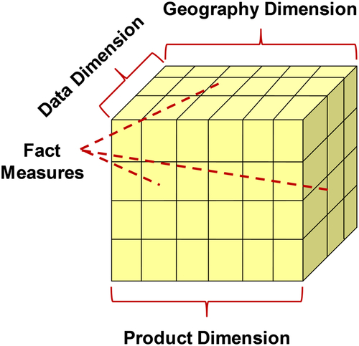
FIGURE 9.12 Multidimensional schema.

Multifact Star Models
Examples of dimensional models, whether star, snowflake, or multidimensional, usually depict them with a single fact table surrounded by dimensions. Although this is a popular illustration and a terrific approach that simplifies explanations, the reality is that data in an enterprise requires multiple facts. Examples of facts are sales, expenses, inventory, and the many other business events associated with running an enterprise.
Figure 9.13 shows two facts: store sales and store inventory (Tbl_Fact_Store_Sales and Tbl_Fact_Store_Inventory). On the right side are three dimensions that both facts share: the item dimension, the date dimension, and the buyer dimension. The shared dimensions are referred to as conformed dimensions, a concept covered later in this chapter.
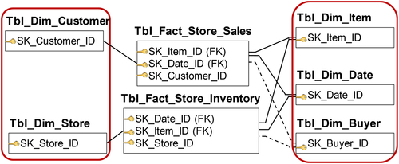
FIGURE 9.13 Multifact star models.
On the left side of the example are the customer and store dimensions that are not shared across the two facts. The Tbl_Dim_Customer is related to Tbl_Fact_Store_Sales, whereas the Tbl_Dim_Store is related to Tbl_Fact_Store_Inventory.
In a real-world example there might be hundreds or thousands of tables with many different combinations of dimensions sharing various combinations of facts. Although the models get complex, it helps to visualize subsets of the data models as a stars to better understand and validate the models.

Entity Relationship versus Dimensional Modeling
ER and dimensional models both depict the same business processes, but as Figure 9.14 shows, the ER model has significantly more entities and relationships than the dimensional model. (You’re not expected be able to see the details in the example, this is just to show, at a high level, the difference in complexity.) You saw a similar comparison of ER and dimensional modeling in the previous chapter: Figure 8.3.
In the dimensional model, the dimensions are denormalized and the facts are normalized. Further, in the dimensional model only a subset of facts is selected from the operational system based on analytical need and to reduce complexity. The dimensional model is clearly simpler, easier to navigate, and more understandable than the ER model.
It’s important to note that most operational systems today are purchased, whereas most analytical systems are custom-built by the information technology group. So, most information technology groups will be familiar with, or will be using the dimensional modeling approach as opposed to the ER model approach.

Comparing Approaches
ER modeling, sometimes referred to as normalized modeling, is the standard for transactional systems (also called operational or online transactional processing (OLTP) systems). Dimensional modeling is the best practice for BI and OLAP systems. The reason for this stems from how the two systems process and manipulate data.
The data in operational systems is being constantly updated. The main job of these workhorses is transaction throughput. They have to maintain and update a large number of records, so they have to be able to handle high amounts of consistent throughput with large volumes.
Compare that with the BI and reporting systems, which are generally not updating data. Rather, they are copying, extracting, transforming, and loading from operational systems. They are not doing real-time updates like operational systems. The focus is not on transactional throughput once the data is loaded. The focus is on query performance, and gathering and aggregating large sets of data. That’s a critical operation. Transactional systems update a small number of data records quite often, whereas BI systems gather and aggregate large sets of data records, but not so often—sometimes over large spans of time. The data from the BI system then get used for reports. See Table 9.1 for a summary of the differences.
The operational system and its accompanying normalized models have minimal redundancy to support the high transaction throughput. Its limited indexes and efficient use of storage space eliminate the need for consistent data, also contributing to the fast transaction throughput. The system is able to update and maintain records instantaneously.
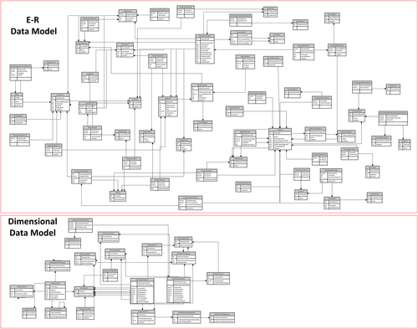
FIGURE 9.14 ER and dimensional models.
Table 9.1
Comparing Operational and BI
Operational Systems | BI and Analytics
Normalized models are standard for OLTP | Dimensional models are standard for BI and OLAP
Highly volatile | Generally not updated
Transaction throughput (updating and maintaining numerous records) is critical | Query performance (gathering and aggregating large sets of records) is critical
Characteristics supporting use of normalized models: | Characteristics supporting use of dimensional models:
Minimal redundancy (normalization) | Increased redundancy (denormalization)
Limited index use | Increased index use
Efficient use of storage space | Increased storage space
Eliminate inconsistent data | Consolidate inconsistent data
Few maintenance concerns | Increased maintenance issues
On the other hand, in BI reporting, there is a lot of redundancy. After all, the warehouse and data marts and whatever else you store on the reporting side are all copies of data that originally was in the operational systems. The BI system depends heavily on indexes and partitioning because it needs much more storage space for reporting, whereas the operational system only needs internal consistency—it doesn’t have to be consistent with other systems’ data. BI needs to have consistent data consolidated from multiple operating systems, so the inconsistency might not be just in the individual system, but across the various systems. Many of the dimensional constructs are set up to support consistent information.
Because the operational system has no redundancy and limited index usage, there are fewer maintenance concerns. A BI system, however, has more maintenance issues than an operational system because it’s storing data over a long period of history, and data does not age well.

Why the Structures Matter
An important questions is: why do these structures matter for data modeling? Each structure has its purpose, and you need the right structure for the job at hand. The choice is highly dependent on the way the data is used and the type of data warehousing or business intelligence tool. The best practice is to use a normalized ER model for OLTP systems. An operational data store often mirrors the OLTP structure and is geared for operational reporting of OLTP systems.
BI applications and BI-related data stores, on the other hand, are better served with dimensional data models. BI tools will give the best performance with star or snowflakes in querying the relational database. Or, if the BI application is a multidimensional model, then you need to select the proper BI tool that uses that particular multidimensional model.
Figure 9.15 shows, on the ER side, a smaller subset of data with a store’s database implemented in an ER model. This example shows a business process. At the top of the example, the customer makes a call; this call has a type. That customer call is related to the customer, which then relates to a customer order entity, which then relates to order line item entity, which then relates to where that line item was chosen, which is out of stock. Then, the example relates that to the manufacturer of the catalog that the item was in. It’s very process-oriented, and the entities are updated as the business activities progress through a particular business process.
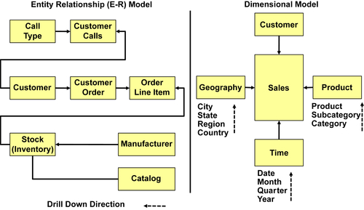
FIGURE 9.15 ER versus dimensional example.
On the dimensional side of the example, the subset of the store’s database looks very different from the ER side. At the center of it, the fact is a sales cell. The sales fact table and has four keys to the customer, the geography, the time, and the product. So whereas on the left side in the ER model there is a process- and application-specific design, the right side with the dimensional model has a data- and subject area–driven design. The dimensional model has fewer tables, is more understandable, and is less process-focused.

Purpose of Dimensional Modeling
Now that you understand why dimensional modeling is the best choice for BI, it’s important to understand its purpose and how it fits in with business reporting. The business people in an enterprise will probably never see the actual data models, but they certainly will use the reports or dashboards that are built. So it’s important that the models can help generate clear, effective reporting and analysis that will ultimately help business people view the data and make informed decisions for the enterprise. Dimensional modeling is well-suited to the generation of exactly the kind of information business people need to see. Common business uses for these models are displaying the facts (measures) and dimensions in BI reports, OLAP analyses, or spreadsheets. This visualization of the data is very common to the millions of spreadsheet jocks who are analyzing data every day.

Mapping to a Business Report
Figure 9.16 shows a business report displaying top employees and top stores ranked by sales revenue. The sales revenue of the top employees is displayed both in tabular form and by a bar chart. The top store sales revenue is displayed in a tabular form and in a pie chart. Facts (measures) are displayed as numbers in the table and graphically as the size of the bars or pie slices. The list of employee and store names are attributes from the Employee and Store dimensions, respectively. Although not displayed in this example, it would be common for the report to provide filters allowing the business person to select specific attributes of either employees or stores for more detailed analysis. Chapter 14 discusses BI interface design options.
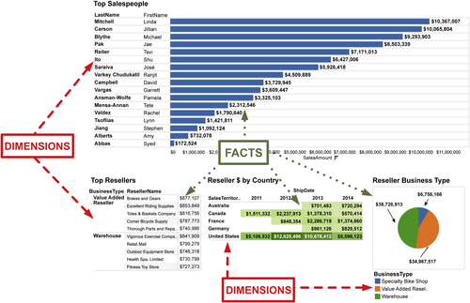
FIGURE 9.16 Mapping to a business report.

Mapping to an OLAP Analysis or Spreadsheet
Figure 9.17 provides a view that a business user would see with a data discovery tool, OLAP cube, or spreadsheet pivot table. Dimensions are displayed as labels and headers in this type of interface. In the example, the dimensions are the sales territories, product categories, product subcategories, and time (fiscal year). The main body of the report shows the actual sales revenue numbers. The example also shows, on the left under the measure group, the measures or facts listed, and under that the dimensions such as customer, date, employee, product, and sales territory. The visual aspects of the spreadsheet, pivot table, or OLAP cube are set up specifically to leverage the dimensional model.
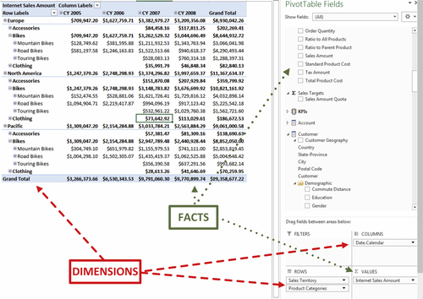
FIGURE 9.17 Mapping to an OLAP analysis.

Fact Tables
There are three types of fact tables in dimensional modeling: transaction, periodic, and accumulating fact.
• Transaction fact tables are the most common in dimensional modeling. They record a business event or transaction, one record at a time, with all the data associated with the event. An example is a sales transaction, such as the purchase of a book on Amazon. The purchase is recorded in the transaction fact table for sales.
• Periodic fact tables record snapshots of data for specific time, such as inventory levels at the end of a quarter or account balances at the end of the month. Each row represents a fact at a specific point in time.
• Accumulating fact tables store a record for the entire lifetime of the event, showing the activity as it progresses. An example of this, using an internet sales order, is where you record the first event, the order, then you record subsequent dates and events such as when the order was placed, when a credit card transaction was processed, when the order was shipped, various states during the shipping, then finally when it is delivered to the customer. These are called role-playing date dimensions with events referred to in our example as the order date, ship date, and delivered date.
Table 9.2 shows that each of these types of facts has different properties or characteristics.
Grain: The granularity of each table highlights the first difference. The most detailed grain is stored in a transaction table, where you get a row for every business event related to that fact. Periodic has less detail, with one row covering an entire time period. For example, rather than showing every transaction in your banking account, it shows one row related to the end of month or end of period balance. Finally, the least-detailed grain and fewest rows is the one where you’re accumulating facts. For example, you placed an order, and all the dates related to the order data are requested, filled, shipped, etc., and all placed on the same record. That record is updated and in place.
Date dimension: The date dimension for these three facts shows a similar decrease in the level of granularity as it progresses from the transaction table to the accumulating table. For example, the transaction table might show the date of a sale, the periodic table might show Q1 sales because it’s just the end of the period, and finally the accumulating fact table might show all the dates of the various stages of a sales cycle for example.
Number of dimensions: The number of dimensions is the least in the transaction, the most in the accumulating, and in between in the periodic.
Facts: The difference in the facts, similarly, is that they are based on individual transactions (you made a deposit to your checking account), entire periods of time (your monthly balance), or numerous events over the lifetime of an event (the many steps involved when applying for a mortgage with a bank).
Measurement: In the transaction table, the numbers are always additive—you can add up all of the deposits you made to your checking account. In periodic, they’re semiadditive, or an average number. So, the bank can find the average of your 12 monthly balances. In the accumulating table, the numbers have to be derived. For example, it would derive the difference in time between the date you first contacted the bank about applying for a mortgage and when you signed the final paperwork.
Conforming dimensions and facts, and database size: All three types of fact tables have conformed dimensions and conformed facts. The database size is the largest for a transaction table, since it needs to store a huge volume of transactions; the size is smallest for accumulating, and in between for a periodic table.
Table 9.2
Comparison of Fact Tables Types
Property | Transaction | Periodic | Accumulating
Grain | One row per transaction | One row per time period | One row per lifetime of an event
Date dimension | Lowest level of granularity | End-of-period granularity | Multiple per row
Number of dimensions | Least | Average | Most
Facts | Transaction related | Period related | Numerous events over lifetime
Measurement | Additive | Not additive, average | Need to derive
Conforming dimensions | Yes | Yes | Yes
Conforming facts | Yes | Yes | Yes
Database size | Largest | Smaller | Smallest

Achieving Consistency
Keeping data consistent is a recurring theme in DW and BI. Businesses that make decisions based on inconsistent data tend to make expensive mistakes. Data consistency leads us to one of the key differences between operational and DW/BI systems: that the operational system only has to keep data consistent within itself. On the other hand, a DW or BI environment needs to make the data consistent across multiple operational systems, and also, sometimes, external to the enterprise.

Conforming Dimensions
This need for consistency brings us to conforming dimensions—dimensions that are consistent and conformed across the enterprise. This ensures that any fact that links, for example, to the customer dimension, will get consistent customer information; all reporting and analytics is consistent because of these conformed dimensions.
There are several dimension-related terms used in the industry today:
• Master data management (MDM)
• Customer data integration (CDI)
• Product information management (PIM)
There are other buzzwords used as well. All of them center on the idea of creating a master list of customers, products, suppliers, organizations, locations, and time. All of these are dimensions, and all fall into the category of conforming the dimensions to be able to do reporting and analytics.
You always define the dimensions at the most granular or detailed level possible. Sometimes that’s referred to as the atomic level. And each conformed dimension has a surrogate key as the primary key, and every row in the dimension is unique. When you conform or make them consistent, you can get consistent reporting.

Conforming Facts
Accompanying conformed dimensions is conformed facts. Conforming in this context also means standardizing—defining standard definitions for facts, measures, or key performance indicators (KPIs). Defining a fact, measure, or KPI means defining the business rules, formulas or algorithms, allocations, filters, and whatever else is necessary to transform a piece of data into a piece of information that’s useful for the business. The examples include calculating revenue, profit, standard cost, price, margin, and so on. All of these calculations are done in businesses on a daily basis.
There are two traps to avoid when it comes to standardizing facts: “single version of the truth” and politics.
First, you’ve likely heard of the phrase “single version of the truth” when learning about enterprise resource planning (ERP) systems and data warehousing. It’s simplistic to think of one interpretation of a fact or measure or KPI. At an operational level, which means at the most detailed level of running a business, there are different interpretations or definitions of facts based on the business context. This is not to be confused with making numbers up or having different interpretations because you don’t understand them. There can be different numbers for revenue and profit if they are calculated differently at various parts of a business chain, based on different sets of business processes, and created for different business groups. The sales force, marketing group, and manufacturing group all sell, market, or build the same products, but based on where you are in the business cycle within the company, you would look at the revenue or profit calculations differently, because that’s how it would be assigned or allocated to your business group.
This means you’re not going to get a single definition of a profit margin; you’re going to get different definitions of profit margin for many different processes. However, each process needs to have the same measures across that process, which is where the consistency comes in.
The second trap to avoid is thinking that numbers are detached from politics. Often, technical people think that all they need to know about business rules, formulas, and algorithms is getting the numbers and writing them up. The reality, however, is that there is a time-consuming process of getting everyone to agree on what those measures across the enterprise are. If the numbers have historically been manually calculated in spreadsheets, then the business rules and relationships need to be documented and used in designing the data model. Once a number is in a data model and shared, it’s visible, it’s transparent, and it has to be agreed upon. Take the time to get the right measurements documented within your data model.

Advanced Dimensions and Facts
Dimensional modeling uses many concepts, relationships, and approaches in constructing some very sophisticated business models that support business processes. Some of the terms used in dimensional modeling, like “degenerative,” can sound esoteric and obscure. As you learn more about advanced dimensional modeling and need to implement it in the real world, however, you’ll see how important it is to understand these terms and how they apply. It’s important to realize these aren’t just esoteric concepts, but are actually very useful in representing the business and supporting the reporting and analytics.

Date (or Calendar) Dimension
Date dimensions are not only a best practice, but also a workhorse in dimensional modeling because almost every fact has at least one date and most queries are examining a date-related measure. In spite of this, many people do not understand the need for a date dimension. Let’s start with why this type of dimension was created.
Dates are not as easy as they look because there is a lot more going on behind the scenes than one thinks. When business people look at the date of a sales transaction they immediately know what the year, quarter, and month of that sale. They will also know if the sale occurred in the period that they wish to analyze, for example last month, last quarter, or comparing this month to the comparable month last year. The business person is performing date substring manipulation and data arithmetic without being aware of it.
Almost every fact table has at least one attribute that is a date. That attribute may be stored as a DATE data type “2004-10-27,” more commonly as a DATETIME data type in the format “2004-10-27 23:40:01.918” or infrequently as an alphanumeric character string.
The following are just some of the potential date substring manipulations, calculations, or business rules that need to be applied to every date on every row for almost every query or analysis performed in BI:
• Selecting dates for specific calendar periods such as a month, quarter, or year. This requires a function to extract the specific DATE substring being filtered on for every applicable date on every row in the fact table(s) being examined to determine if there is a match. And if the period is more detailed than a year, then every level in the hierarchy (year-quarter-month-day) above the period needs to be included in the substring comparison.
• Selecting or comparing dates with DATETIME data type is not same as comparing dates with DATE data type. Many dates in a DW have a DATETIME data type because the transaction system recorded that level of detail when the transaction occurred, and that detail is brought into the DW. However, much of the analysis an enterprise conducts is DATE-based. SQL converts the date of “2004-10-27” to the default time of “2004-10-27 00:00:00.000” before it can compare it with a DATETIME data type. It does this so they can match; they must have the same data type. So, an event “2004-10-27 23:40:01.918” would not be selected at all, which then makes the data erroneous if the business analysis was selecting items by DATE. Therefore, every time a date with a DATETIME data type is compared, it needs to be converted to a DATE data type.
• Switching between standard and fiscal calendar dates if they are different from each other. There are formulas based on governmental rules that convert standard calendars dates to the fiscal calendar that an enterprise is using.
• Assigning holidays or time periods that have a significance to an enterprise is typically determined by creating look-up tables or manually coding the list of dates in reports or spreadsheets.
• Selecting calendar periods that are calculated by date functions such as quarter, week in year and day in year.
Before the introduction of a date dimension concept in dimensional modeling, every BI application had to perform these date operations every time a query was performed.

Designing a Date Dimension
Figure 9.18 depicts a fact table (Fact_Store_Sales) with a foreign key (Date_SK) linking to a calendar date dimension (Dim_Date). Although the composition of a data dimension varies between enterprises based on filters and date headings for reports used by business people, the designs follow specific design standards and conventions.
The two columns that are mandatory in a date dimension are the primary key and a full date value. In our example, these are Date_SK the primary (and surrogate) key, and Date_Value full date value.
For the first mandatory column, primary key, the date dimension is the one exception to the dimensional modeling rule that a dimensional table’s surrogate key should be a meaningless integer. The best practice is that the date’s surrogate key is an integer in the form of YYYYMMDD with YYYY = four-digit year (1991), MM = two-digit month (03), and DD two-digit day (03) yielding 19910303 in this example.
If a meaningless surrogate key such as a database IDENTITY data type is used, then the key assigned to any date would vary based on the starting date assigned to the dimension. This means that different dimensional tables have different values assigned to a date, resulting in inconsistency. In contrast, using the convention of YYYMMDD guarantees that a specific date has the same value in every date dimension table. For example, March 3, 1991, would be 19910303 on every date dimension table no matter when it was generated or by whom.
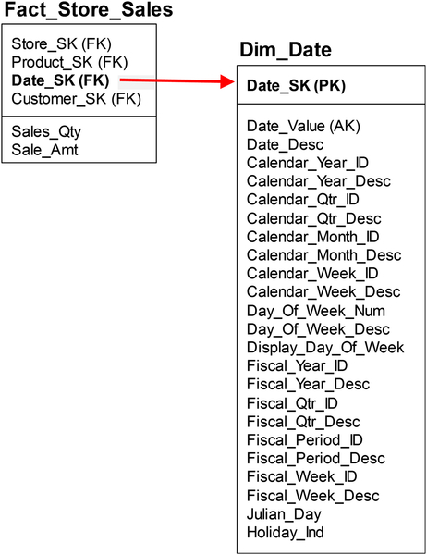
FIGURE 9.18 Date dimension.
There are several advantages to using this smart key:
• It is universally understood
• It conforms to ISO 8601 date and time international exchange standard.
• Most importantly, this convention establishes date dimension consistency, which helps enable data sharing in an enterprise.
The second mandatory column, which has the full date value typically stored on a DATE data type column, is essential because it is used as the look-up column in the ETL processes that assign the fact table date foreign keys. In our example, the ETL process matches the sales date from the source system sales data with the corresponding row from the date dimension (Dim_Date) and then assigns the foreign key (Date_SK) value to the sales fact table (Fact_Store_Sales).
In addition to the two mandatory columns, various columns are populated to enable filtering, aggregating, grouping, and labeling dates in reporting and analytics. These columns may be numeric or alphanumeric based on business needs.
Some of the common date attributes include:
• Calendar periods derived from date substring: year, month, and day.
• Multiple columns representing variations of the same calendar period, such as a full name of a month “September,” a three-character abbreviation “Sep,” Polish translation “Wrzesień,” numeric 9, character equivalent of month number “09” and other variations.
• Calendar periods derived from date functions: quarter, week number in year, day number in year, day number in month, day number in week, etc.
• Columns that are used as flags indicating if a day is a week day, weekend day, holiday, etc. These flags will vary by enterprise, country, business line, and even across years for “floating” holidays. This might result in country-specific or business-specific date dimensions used when the data is analyzed. Note that the use of these specific date dimensions in the BI environment has no impact on extract, transform and load (ETL) processes that load fact tables or the underlying fact table designs.
• Seasonal periods that are specific to the enterprise may also be flagged. For example, a greeting card company may flag key card-buying seasons such as the period of time leading up to Mother’s Day, whereas an agricultural-focused firm such as a farm equipment or a fertilizer manufacturer would have growing seasons.
Enterprises may have two calendars: a standard and a fiscal calendar. The standard calendar would begin on the first day of the applicable year, such as January 1 in the United States. The fiscal calendar is set up for governmental and tax reporting purposes. There are specific rules that define the specific parameters such as beginning date of the year, each quarter’s start date, and the length of each quarter. When the standard and fiscal calendars are different, then date dimensions will have both the standard and fiscal equivalents of the calendar periods for each date row.

Benefits
Using a date dimension in your BI architecture allows simplification and consolidation. For example, using the date dimension means the following need to take place only once:
• A date surrogate foreign key is assigned to every date field when it is loaded from source systems.
• Data substring and data calculations are performed when the date dimension is loaded.
• Standard and fiscal calendar conversions are created when the date dimension is loaded.
• All business-specific calendar identifiers such as holidays are input into the date dimension as the singular look-up table.
Contrast this with BI reports or business analysis without the date dimension. They need to perform these same date operations on each date field on each row in a query every time they are performed. These date operations might be repeated thousands or millions of times for each report or analysis and countless amount of times across an enterprise!
The benefits of using the date dimension also include the following:
• Query speed is faster because you’re performing the date operations once when loading the date dimensions versus countless times, as discussed above. Although each date operation takes a minimal amount of time, it adds up to be more significant than one would think.
• Productivity is increased for both the business people and information technology staff who do not have to repeatedly and redundantly code these date operations manually into every BI dashboard, report, query, or spreadsheet.
• Consistency is increased because the date is defined once and used across the enterprise without different interpretations or chance of errors.
• Analytics are enhanced because of all the prebuilt date dimension attributes that will be immediately available to every BI application for business people to use in filtering, aggregating, grouping and labeling calendar periods.
It seems like such a simple concept, but a date dimension is one of the bedrock ideas in dimensional modeling yielding significant business and technology benefits.

Time Dimension
Much of the business analysis conducted in an enterprise, such as period-over-period, year-to-date, or quarter-to-date analysis involves only the date portion of the DATETIME data type. The actual time of day that a sale occurred, for example, is typically not needed because most enterprise performance metrics are summarized by day, week, quarter, or year. Examples of performance analysis that use time of day include capacity planning and labor utilization, but typically time-of-day data is not pertinent and can actually be confusing and misleading.
This has led to two approaches on how to handle time of day.

Time-of-Day as a Fact
First, if time-of-day analysis is irrelevant or is only done on a limited basis in your enterprise then time is treated as a fact. For every date in a fact table, create two columns. The first column should have a foreign key linked to the calendar date dimension that would be used in business analysis when time of day is irrelevant. The second column should contain both the date and time. There are several pragmatic reasons to retain the time of day even if there does not appear to be a business analytical need:
• Enable reconciliation of the fact’s date with the transactional system’s date.
• Enable the occasional time-of-day analysis by directly using the fact column with the full DATETIME. Because this type of analysis is seldom done there is no need to accommodate it with a time dimension (the other approach to handling time of day).
• If conditions change and time-of-day analysis becomes a business requirement, then having the fact attributes with DATETIME allows this type of analysis to be retrofitted by using the second approach below.
The example depicted in Figure 9.19 shows the FactStoreSales table with both of these columns. First, foreign key OrderDateKey that links to the date dimension DimOrderDate. Second, the OrderDate column containing the full DATETIME data.

Time-of-Day as a Dimension
With the second approach, time is managed as a dimension because there is a need for the business to analyze performance measure by the time of day. This approach stores three columns in the fact table for every date that needs to be analyzed by the business. The two columns discussed in the other time-of-day approach—foreign key linked to the data dimension and a column storing the full DATETIME—are included in this approach. The third column is a foreign key to a time dimension, as shown in Figure 9.20, which expands the previous example by adding the Order_TimeKey (foreign key) linked to Dim_Time (time dimension.)
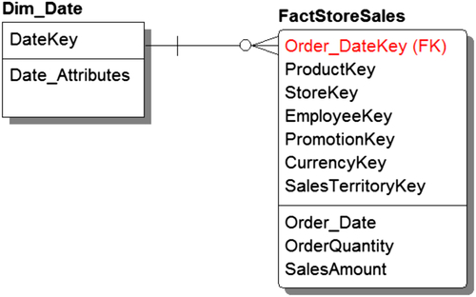
FIGURE 9.19 Time as a fact.
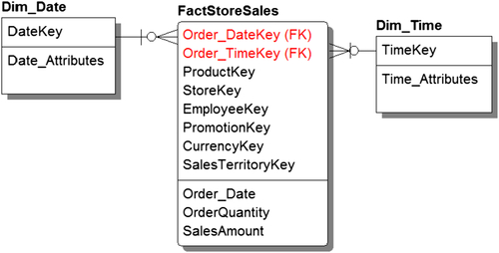
FIGURE 9.20 Time as a dimension.
The initial question when designing the time dimension is what level of grain is needed for the time-of-day analysis: hours, minutes, seconds, or hundredths of seconds? The number of rows grows significantly as the level of detail increases: for hours is 24, minutes is 1440, and seconds is 86,400. The grain of the time dimension should be whatever is required for time-of-day analysis and no more. It is not that the database or BI tools will get overwhelmed by keeping data to the second, but that the visualizations and interactions with the BI tool get more cumbersome if the level of detail goes beyond the business need.
The time dimension’s primary key is a surrogate key, typically starting at zero (0). It also includes a column containing the time of day with a time data type or the equivalent based on the database being used. Additional columns would be used for filtering and descriptive purposes in analysis. Figure 9.21 illustrates a sample time dimension with a grain of an hour. Time_SK is the surrogate key, Time_Value is the time-of-day valued column and the remaining columns examples are 12 hour time; military time; am or pm; and a sample textual description. The selection of the descriptive columns is based on business analytical requirements.
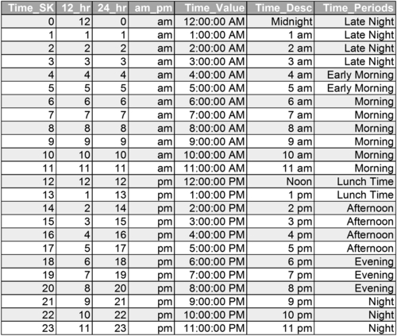
FIGURE 9.21 Time dimension—hour grain.
Figure 9.22 illustrates a time dimension with a grain of a minute. In the example, the time dimension has the required surrogate key Time_SK and time-of-day value stored in Time_Value. The example has a list of filter and descriptive columns, but an enterprise needs to build the columns necessary to support their required time-of-day business analysis.

Time Periods
Time-of-day analysis is performed in industries such as retail (online and at stores), restaurants, utilities, telecommunication, and media (online, cable, and radio) when examining consumer behavior. Examples include examining existing performance metrics and campaign impact using time of day.
Often this time-of-day analysis is conducted on time periods based on banded ranges of time. For example, as illustrated in Figure 9.23, a food chain or media company has created a schema to analyze the time of day in these time bands: morning commute is 6:00–9:00 am, late morning is 9:00–11:30 am, lunch is 11:30–2:30 pm, school release is 2:30–4:00 pm and afternoon commute is 4:00–7:00 pm. Although the fact tables and time dimension contain a grain to the minute of the day detail, the time-of-day grain is the time periods. The businesses in these scenarios are not concerned with what happens exactly at 6:16 AM because that level of detail is “noise” and is not something the business needs to act on.
There are two approaches to supporting time-of-day analysis using time bands. First, if using time as a dimension, add more columns to the time dimension with the appropriate time band descriptions as illustrated in Figure 9.23. From a pragmatic perspective, it is unlikely that the time bands will stay static or that there will be only one way to group time periods into bands, but a dimensional table enables an enterprise to add as many additional columns as necessary.
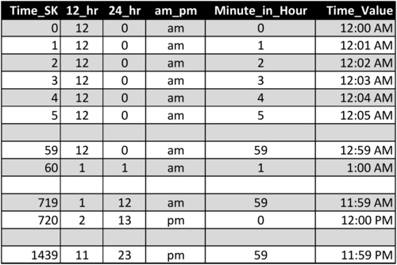
FIGURE 9.22 Time dimension—minute grain.
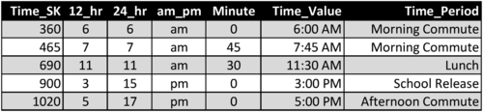
FIGURE 9.23 Time dimension with time bands.
Use the second approach when implementing time in fact tables without a time dimension. With this approach create a value-band dimension to define the association with time and time-of-day periods.
Either approach is preferable to manually coding time periods into each BI application or SQL query performed on these data because the manual coding is redundant, may be inconsistent, is not likely to be documented, and is not as easily modified.

Date and Time Dimensions across Time Zones
If an enterprise’s operations span multiple time zones, it is a best practice to record time in two fact tables with two different time zones. The first time tracked is in the local time zone where the fact occurs, such as where a call center is located or where a package is shipped from. The second time zone corresponds to a global standard time that is used as a baseline to calculate offsets. An example of this schema is depicted in Figure 9.24.
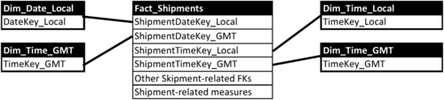
FIGURE 9.24 Time zones.
Typically, you choose one of two global standards: Greenwich Mean Time (GMT) or the enterprise headquarters’ local time zone. If the headquarters is in Hong Kong, for example, the company could pick that up as the local time, making it their global standard as an alternative to GMT. As long as everything is standardized, it won’t matter what time zones the various manufacturing plants, branches, or offices are located in. The system will record the local and global time of events, so the business can coordinate its view of when things occurred.
The business reasons for expressing the time in two time zones is because of the two types of time-of-day analysis that is performed:
• The business groups, which could be call centers and shipping warehouses in this example, will examine their performance metrics such as response time and workforce resource-balancing analysis in the context of their local time zone.
• Enterprise senior management and global business groups such as logistics and sales will examine performance metrics over 24-hour periods using a global standard time zone as a baseline for meaningful analysis.
Alternative approaches, such as storing a time zone indicator or hour offset from a baseline such as GMT, would rely on manual coding date calculations in BI applications and spreadsheets to enable the analysis. Manual coding has many disadvantages compared to using dimensional filtering; these include a longer time to code attributes, higher maintenance costs, and inconsistencies in the analysis.

Role Playing Dimensions
There are instances when a fact table references a dimension multiple times as a foreign key. Examples of this are:
• Multiple dates associated with different events such as order, shipment, and delivery are captured in an accumulating fact table.
• Multiple address-related columns identifying different address such as shipping and billing locations.
• Multiple persons such as a customer and sales person related to a sales fact or an employee and her manager in workforce-related analysis.
Each of these foreign keys linked the same dimension to signify a different role for that dimension. For example, the date could signify an order, shipment, or delivery date. The term “role-playing” describes a physical dimension being used in different business contexts.
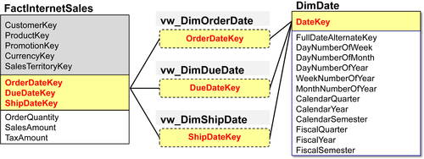
FIGURE 9.25 Role-playing dimension approaches.
Although this concept is easy to understand, it is a different matter for relational databases; although a fact table can have multiple columns with foreign keys linked back to the same dimension, these columns cannot be used in the same query. For example, you would not be able query the date dimension from a sales table by filtering a ship date and delivery date.
To support role-playing dimensions, there needs to be a database entity associated with each role. There are two different approaches to creating role-playing dimensional entities:
• Create separate tables for each role
• Create views for each role using a single dimension
Creating views for each role is clearly the best practice. For example, see the elements in Figure 9.25.
• Date dimension, Dim_Date. You’d store it once, and it would create views for every role to which it applies.
• Internet sales fact, FactInternetSales. This has three different role dates reporting originally back to Dim_Date. The views defined for each of those date roles are:
• dimension order date view, vDimOrderDate
• dimension due date view, vDimDueDate
• dimension ship date view, vDimShipDate
• To sum up, we only store Dim_Date once, we create a view for each role, and the fact tables and foreign key go back to vDimOrderDate, vDimDueDate, and vDimShipDate versus the original Dim_Date.
Creating views eliminates maintaining and updating multiple physical tables, saves space, and enables the multiple-way join that is required for business analysis.

Degenerative Dimensions
Operational systems track transactions and business events by using business process documents such as a purchase order, invoice, travel reservation, or concert ticket. All of these process documents have reference identifiers such as order, invoice, and reservation numbers that are unique and used as primary keys to entities in their supporting operational schemas.
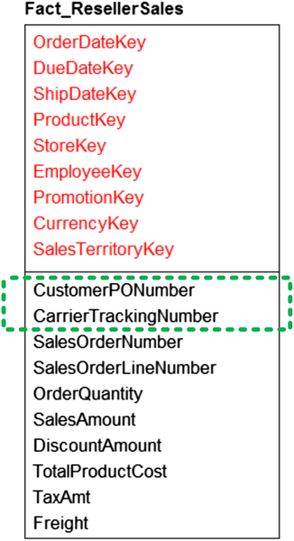
FIGURE 9.26 Degenerative dimension example.
Figure 9.26 illustrates a reseller sales fact listing the foreign keys linking to store (StoreKey), employee (EmployeeKey), order date (OrderDateKey), and the other dimensions that uniquely identify the transaction. There are several measures such as order quantity and sales amount. There are two attributes CustomerPONumber and CarrierTrackingNumber that represent the unique identifiers for the customer purchase order and carrier tracking number for the sale. In the operation system, these attributes would be foreign keys to operational-related entities, but in a dimensional model they would not be linked to any dimension. In the dimensional model, there would not be any requirements for these dimensions because the attributes associated with these entities in the operation system are already stored in other dimensions. For example, the purchase order would have customer-created attributes that would be stored in customer and address-related dimensions.
These attributes are essentially foreign keys that do not link to any dimensions and are referred to as degenerative dimensions. This concept often causes confusion, but it’s really just a dimension whose attributes exist elsewhere. Although it is tempting to create dimensions for each of these attributes, this information would be redundant with other dimensions. Separating out, for example, the carrier tracking number or customer purchase order number in our example illustrates the duplication, because the same attributes would be stored in the reseller sales fact and in a purchase order dimension.
So is there any case in which you would replicate that data? The answer is you wouldn’t. The best practice is to not make this a separate dimension, to place it in the transaction table after the dimension foreign keys, and before the numeric attributes. The example of Fact_ResellerSales shows the two foreign keys that are the primary key of the sales order number and line item number; we then have a series of foreign keys pointing to the various dimensions.
The example shows two degenerative dimensions—the carrier tracking number and customer PO number—followed by the real measures related to the internet sales. Realize that these degenerative dimensions are not additive numbers; they are merely identifiers that are used for a business process that we are not tracking within this dimensional model. But, we retain these numbers because it’s a link back to the operational system, and if we want to audit our results or tie it back, we need to have these numbers. And, some business people, rather than querying off, for example, the sales order number, may actually be querying off the customer PO number. Degenerative dimensions enable that kind of querying.

Event Tables
Facts almost always have measures, but there are exceptions. These exceptions occur when a business event does not create or monitor any quantifiable measures. These facts are either called factless fact or event tables.
Examples of factless facts or events are students attending a class or patients visiting a doctor. In both cases, there’s no direct measure associated with either of those events. There is tuition paid for the student to attend that class and a bill generated for the doctor’s visit, but both of these are associated with other facts and are based on other attributes such as what courses the student is registered for and what procedures the doctor performs. And bills will be generated whether the student attends a class or the patient skips an appointment.
Just because there is no direct measure associated with a factless fact it does not mean that the event is not worth tracking. For example, a teacher may take attendance in class and place an X next to a student’s name.
The approach to tracking these factless facts is depicted in Figure 9.27. The example illustrates that an attribute is created as a dummy counter fact set to 1 or 0; 1 means it happened, the student showed up to class. This enables the connectivity between the fact table and a dimension—the counting of these events. This factless fact table is the best practice for capturing events that have no natural numeric measurements.
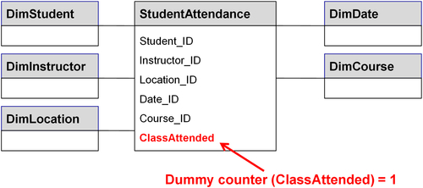
FIGURE 9.27 Event table example.
The example shows an event or factless fact table:
• It has a StudentAttendance fact with foreign keys to the student, the instructor, the class location, the date of the class, and the course itself.
• In the StudentAttendance fact are all those foreign keys listed, then the last item, the class attended, is the dummy counter, set to 1 or 0.
• If the student shows up, all those foreign keys are populated with a 1.
• If you’re also keeping track, you could put zeroes down if a student didn’t show up.
• With a list of each student from every class session, you could sum up for that particular date how many students showed up by summing on the class attended.
• You could filter on the 0 values to determine who didn’t attend the class.
• Then you could aggregate by filtering on the 1s to perform trend analysis
Implementing a dummy counter attribute in the factless fact table enables business analysis of events even though these business events do not naturally have a numeric measurement associated with them.

Consolidated Fact Tables
As we have discussed, fact tables store data about transactions or business events representing specific business processes. Fact tables are normalized and are correlated to business entities in the operational systems’ ER data models. This is exactly how a data warehouse schema should be designed if best practices are followed; however, when the data is transformed into a schema supporting data marts or cubes there may be exceptions to these rules that are called consolidated facts.
Consolidated fact tables are fact tables that are separate and distinct in operational systems, business processes, and data warehouses that are consolidated or combined to facilitate reporting and analysis. The example in Figure 9.28 illustrates a fact table (Fact_SalesPerformance) combining the sales measure (ActualSales), forecasted sales (ForecastedSales), a calculated variance (ForecastVariance), and the foreign keys to several conformed dimensions—product, customer, geography, and measurement period.
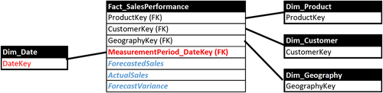
FIGURE 9.28 Consolidated facts example.
Another common use for consolidated fact tables is budget-to-actual expense performance analysis.
The origins of consolidating these facts stems from the type of business analysis performed and the capabilities of the reporting tools (especially from the early days of BI) and spreadsheets used by a business. Comparing budgets or forecasts to actual performance is quite a common type of business analysis, so there is a very strong need to facilitate that analysis. The easiest method available to many reporting tools and spreadsheets is to simply consolidate these facts into one table (i.e., denormalized or flattened tables).
The two key considerations when consolidating fact tables are that the facts share conformed dimensions and they have the same grain. Obtaining the same level of detail or grain typically requires aggregating one of the underlying fact tables. For example, budgeting or forecasting sales or expenses may be at the weekly or monthly grain, whereas sales might be recorded in real time and expenses may be logged on a daily basis. If one of the facts in the consolidated fact table is aggregated, then the underlying detail is not available to anyone using the consolidated fact table for analysis.
It is a best practice to maintain separate fact tables in the DW schema and only consolidate the fact tables in BI-related data stores such as data marts and cubes.

Dimensional Modeling Recap
Dimensional models are a set of two entities:
• Facts, which record the measures of business events (such as sales) occurring in an enterprise
• Dimensions, which represent the who, what, where, and when of these business events
The example in Figure 9.29 sums up what you’ve learned in this chapter by showing everything about an internet sale:
• FactInternetSales is the fact/business event, which is associated with some dimensions:
• Products that are sold, DimProduct
• Customers who buy them, DimCustomer
• Currency the customers use, DimCurrency
• Date of the sale, DimDate
• Promotion associated with the sale, DimPromotion
• Territory in which the sale was made, DimSalesTerritory
All reporting and analytics is geared toward this dimensional model. The whole science of dimensional modeling, not only developing the model, but also in doing reporting and querying, the extract transform and load tools, and the BI tools, uses the dimensional model. Although the business people in your company may never see the actual data models you create, they will become very familiar with the reports and dashboards they help generate. Unless those models can generate clear, effective reporting and analysis, they won’t help the business view the data and use it to make informed decisions that affect operations. Dimensional modeling is the key to generating this critical business information.
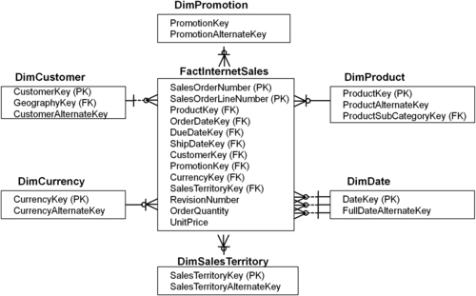
FIGURE 9.29 Dimensional modeling recap.

