

THE POSTS AND TELECOMMUNICATIONS INSTITUTE OF TECHNOLOGY

DEPARTMENT OF INFORMATION TECHNOLOGY 1

DISTRIBUTED DATABASE SYSTEM

Hà Nội - 2025

GROUP: 7
MEMBERS: NGUYỄN TUẤN MINH - B22DCKH077
NGUYỄN XUÂN KIÊN - B22DCKH062
NGUYỄN VIỆT HOÀNG - B22DCVT214
LÊ ĐỨC MẠNH - B22DCAT184

TOUR COMPANY

TABLE OF CONTENTS
TABLE OF CONTENTS 2
I. Requirement Analysis 3
1. Real-world Scenario 3
2. Database Applications 3
3. Database Constraints and Requirements 3
II. ERD 4
III. Logical design and normalize 6
1. Relational Schema 6
2. Normalize 7
IV. Fragmentation 8
1. Horizontal fragmentation 8
2. Vertical fragmentation 9
a. Staff (P-S#, D#, Role, Salary): 9
b. Booking(B#, P-C#, Sc#, Status, BookingDate, CustomerAmount, TotalAmount) 11
c. Service(Se#, Pr#, Cost, Name, Description) 11
d. Tour(T#, Name, Cost, Description, DurationDay, InsuranceInclude) 14
V. Allocation 18
1. Allocation Fragments 18
a. Staff 18
b. Booking 19
c. Service 19
d. Tour 19
e. Person 20
2. Allocation Table 20

Requirement Analysis

Real-world Scenario
The system is designed as a distributed database to support a travel agency operating across multiple functional sites (HR, Booking, Finance, and Tour). The primary goal is to manage customer profiles, tour itineraries, and booking transactions while ensuring localized data access performance through decentralization. Each functional site acts as a "site" in the distributed network, managing its own local operations while remaining part of the global database.

Database Applications
The database system supports core business applications, categorized by the following operations:
- Adding New Data: Creating new tour packages, registering new customer profiles, and inserting booking requests directly at the local branch sites.
- Modifying Data: Updating booking statuses (e.g., from "Pending" to "Confirmed"), adjusting payment details, or modifying employee roles and tour schedules.
- Deleting Data: Removing expired tour schedules, canceling bookings, or clearing inactive customer records to maintain data relevance.
- Querying Data from Multiple Sites: Retrieving comprehensive customer history across different regions.
- Analyzing sales performance and staff salaries across multiple branch sites.
- Checking tour availability (Schedules) stored at various nodes to facilitate cross-branch bookings.

Database Constraints and Requirements
- Consistency: The system must enforce high consistency, particularly during the booking process, to prevent overbooking by monitoring Max slots and Customer amount across the Booking, Finance, and Tour sites.
- Availability and Performance: Data is fragmented based on functional responsibility (HR, Booking, Finance, Tour) to ensure that each site can access its local operational data with minimal latency, optimizing performance for its core tasks (e.g., HR data at the HR site, booking data at the Booking site).
- Integrity: Referential integrity must be maintained across all functional sites; for instance, a Booking (at the Booking site) must reference a valid Customer (from the Customer/Booking context) and Schedule (from the Tour site) regardless of where that data is physically stored.

ERD
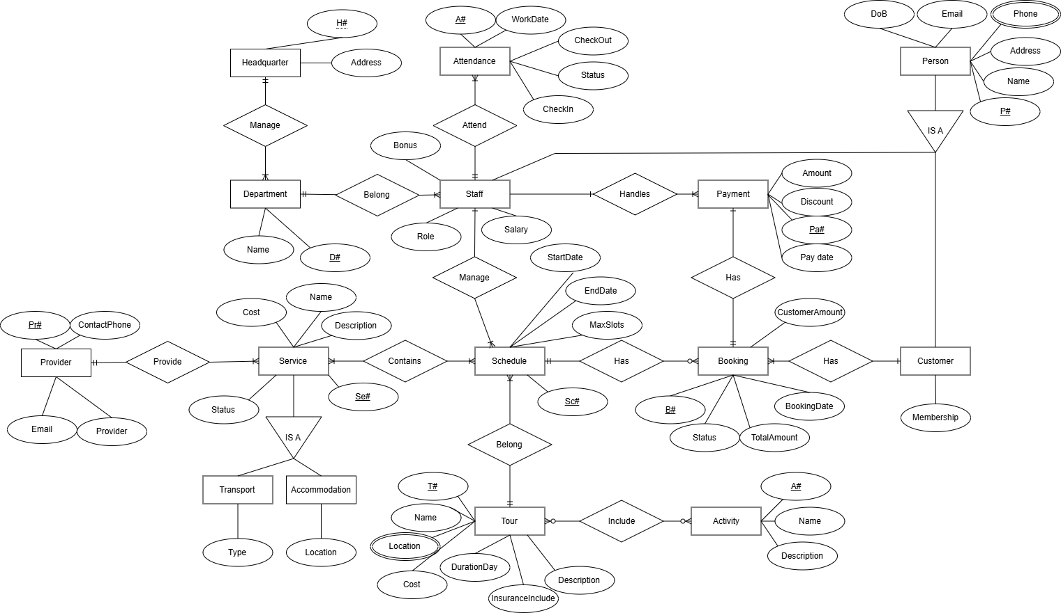

- Headquarter: Saving the information of the servers
- Address: Saving the servers address
- Department: Saving the department information of the company
- Person: Saving the information of the user in general
- DoB: Saving the date of birth of the person
- Staff: Saving the staff information
- Salary: Saving the salary information of the customer
- Bonus: Saving the information of the bonus salary
- Role: Saving the role information of the staff in the company
- Attendance: Saving the clock-in/out history for each employee.
- WorkDate, CheckIn, CheckOut, Status: Saving the date, checkin and checkout time on that date and the status off that shift.
- Customer: Saving the customer information
- Membership: Saving the rank of the customer base on the frequency of the tour they participate
- Booking: Saving the booking information of the customer
- Status: Saving the information about the booking(Pending, Paid)
- CustomerAmount: Saving the number of customers in the group
- TotalAmount: Saving the amount off that tour (= Cost off service + cost of tour)
- Payment: Saving the booking payment information
- Amount: Saving the total cost after payment
- Discount: Saving the discount in that payment
- Pay date: Saving when the payment is created
- Service: Saving the information of all the services related to the tour:
- Cost: Saving the cost of the service
- Provider: Saving the provider of the information:
- Provider: Saving provider name
- ContactPhone, Email: Saving information to contact to the provider
- Transport: Saving the transport information related to the tour (bus, ship, air plane)
- Accommodation: Saving the information of the place the customer rent
- Activity: Saving the activity of the tour that the customer can participate
- Tour: Saving the information of the tour
- Location: Saving all the place included in the tour (Ex: in Tour Ha Noi - Da Nang will save Ha Noi, Ninh Binh, Thanh Hoa, …, Da Nang)
- Cost: Saving the cost of the tour
- DurationDay: Saving how long the tour will take
- InsuranceInclude: Saving if this tour has insurance
- Schedule: Saving the details information of the tour
- Start/ end date: Saving the Start/ end date of the tour that the customer brought
- Max slots: Saving the maximum number of the schedule

Logical design and normalize

Relational Schema
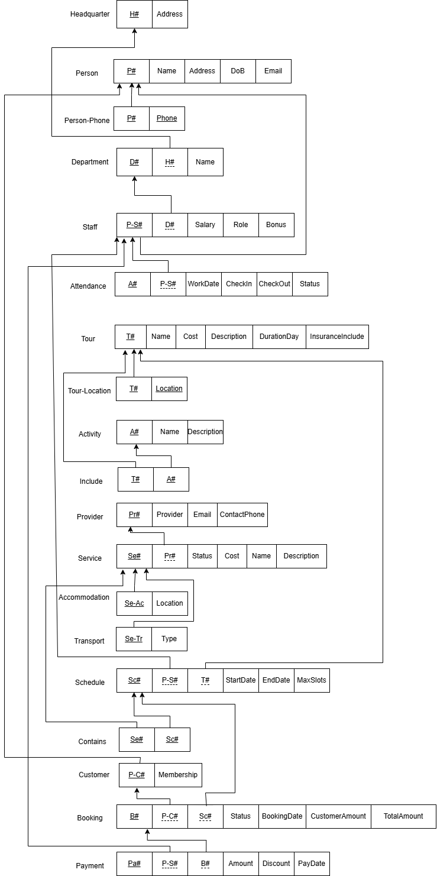

Normalize
- Headquarter(H#, Address)
=>{F1 = H# -> Address}
- All attributes is atomic -> 1NF
- All non-prime attribute are fully functional dependent on the key -> 2NF
- No non-prime attribute is transitively dependent on any key -> 3NF
- Every determinant must be a superkey -> BCNF
- Person(P#, H#, Address, Name, DoB, Email)
=>{F2=P# -> H#, Address, Name, Dob, Email}
- All attributes is atomic -> 1NF
- All non-prime attribute are fully functional dependent on the key -> 2NF
- No non-prime attribute is transitively dependent on any key -> 3NF
- Every determinant must be a superkey -> BCNF
- Person-Phone(P#, Phone) -> BCNF
- Department(D#, Name) ⇒ BCNF
- Staff(P-S#, D#, Role, Salary, Bonus)
=>{F3 = P-S# -> D#, Role, Salary}
- All attributes is atomic -> 1NF
- All non-prime attribute are fully functional dependent on the key -> 2NF
- No non-prime attribute is transitively dependent on any key -> 3NF
- Every determinant must be a superkey -> BCNF
- Attendance(A#, P-S#, WorkDate, CheckIn, CheckOut, Status)
=>{F4=A# -> P-S#, WorkDate, CheckIn, CheckOut, Status}
- All attributes is atomic -> 1NF
- All non-prime attribute are fully functional dependent on the key -> 2NF
- No non-prime attribute is transitively dependent on any key -> 3NF
- Every determinant must be a superkey -> BCNF
- Tour(T#, Name, Cost, Description, DurationDay, InsuranceInclude)
=> {F5 = T# -> Name, Cost, Description, DurationDay, InsuranceInclude}
- All attributes is atomic -> 1NF
- All non-prime attribute are fully functional dependent on the key -> 2NF
- No non-prime attribute is transitively dependent on any key -> 3NF
- Every determinant must be a superkey -> BCNF
- Tour-Location(T#, Location) => BCNF
- Activity(A#, Name, Description)
=> {F6 = A# -> Name, Description}
- All attributes is atomic -> 1NF
- All non-prime attribute are fully functional dependent on the key -> 2NF
- No non-prime attribute is transitively dependent on any key -> 3NF
- Every determinant must be a superkey -> BCNF
- Include(T#, A#) => BCNF
- Service(Se#, Pr#, Cost, Name, Description)
=> {F7 = Se# -> Pr#, Cost, Name, Description}
- All attributes is atomic -> 1NF
- All non-prime attribute are fully functional dependent on the key -> 2NF
- No non-prime attribute is transitively dependent on any key -> 3NF
- Every determinant must be a superkey -> BCNF
- Provider(Pr#, ContactPhone, Email, Provider)
=>{F8 = Pr# -> ContactPhone, Email, Provider}
- All attributes is atomic -> 1NF
- All non-prime attribute are fully functional dependent on the key -> 2NF
- No non-prime attribute is transitively dependent on any key -> 3NF
- Every determinant must be a superkey -> BCNF
- Accomodation(Se-Ac#, Location) => BCNF
- Transport(Se-Tr#, Type) => BCNF
- Schedule(Sc#, T#, P-S#, StartDate, EndDate, MaxSlots)
=> {F9 = Sc# -> T#, P-S#, StartDate, EndDate, MaxSlots}
- All attributes is atomic -> 1NF
- All non-prime attribute are fully functional dependent on the key -> 2NF
- No non-prime attribute is transitively dependent on any key -> 3NF
- Every determinant must be a superkey -> BCNF
- Contains(Se#, Sc#) => BCNF
- Customer(P-C#, Membership) => BCNF
- Booking(B#, P-C#, Sc#, Status, BookingDate, CustomerAmount, TotalAmount)
=>{F10 = B# -> P-C#, Sc#, Status, BookingDate, CustomerAmount, TotalAmount}
- All attributes is atomic -> 1NF
- All non-prime attribute are fully functional dependent on the key -> 2NF
- No non-prime attribute is transitively dependent on any key -> 3NF
- Every determinant must be a superkey -> BCNF
- Payment(Pa#, P-S#, B#, Amount, Discount, Paydate)
=>{F11 = Pa# -> P-S#, B#, Amount, Discount, Paydate}
- All attributes is atomic -> 1NF
- All non-prime attribute are fully functional dependent on the key -> 2NF
- No non-prime attribute is transitively dependent on any key -> 3NF
- Every determinant must be a superkey -> BCNF

Fragmentation

Horizontal fragmentation
In the design of this distributed database system, Horizontal Fragmentation is strategically applied to enhance performance and ensure data localized efficiency. This approach involves partitioning tables into subsets of rows based on specific criteria or roles, allowing each site to store only the data relevant to its local operations.
Primary Horizontal Fragmentation:
- Staff_HR_Guide is fragmentation based on Role attribute in Staff table:

Derived Horizontal Fragmentation
- Person is fragmentation based on P-S# and P-C# in the Staff and Customer Table.
- Person_Phone is Derived Horizontal Fragmentation of Person

- Person_Staff_Guide is fragmentation based on Person_Staff if P# = P-S# and Role = ‘Guide’:

Vertical fragmentation

Staff (P-S#, D#, Role, Salary):
Application table
S# | Application | Query | Table | Frequency
 |  |  |  | HR | Finance
1 | Employee Salary Statistics | Salary, Bonus | Staff | 2 | 8
2 | Department Staff Statistics | D#, Role |  | 10 | 5
3 | Add New Employee | D#, Role, Salary, Bonus |  | 8 | 0
4 | Update Employee Salary | Salary, Bonus |  | 1 | 9

Attribute table
D# | a1
Role | a2
Salary | a3
Bonus | a4

 | a1 | a2 | a3 | a4
q1 | 0 | 0 | 1 | 1
q2 | 1 | 1 | 0 | 0
q3 | 1 | 1 | 1 | 1
q4 | 0 | 0 | 1 | 1

AA matrix
 | a1 | a2 | a3 | a4
a1 | 23 | 23 | 8 | 8
a2 | 23 | 23 | 8 | 8
a3 | 8 | 8 | 28 | 28
a4 | 8 | 8 | 28 | 28
+) a3:
cont(a3, a1) = 816
cont(a1, a3, a2) = 816 + 816 - 1186 = 446
cont(a2, a3) = 816
=> a3, a1, a2
+) a4:
cont(a4, a3) = 1696
cont(a3, a4, a1) = 1696 + 816 - 816 = 1696
cont(a1, a4, a2) = 816 + 816 - 1186 = 446
cont(a2, a4) = 816
=> a4, a3, a1, a2
CA matrix
 | a4 | a3 | a1 | a2
a4 | 28 | 28 | 8 | 8
a3 | 28 | 28 | 8 | 8
a1 | 8 | 8 | 23 | 23
a2 | 8 | 8 | 23 | 23
+) Case 1:
TA = {a4}, BA = {a3, a1, a2} => TQ = {}, BQ = {q2}, OQ = {q1, q3, q4}
CTQ = 0, CBQ = 15, COQ = 28 => Z = 0x15 - 28x28 = -784
+) Case 2:
TA = {a4, a3}, BA = {a1, a2} => TQ = {q1, q4}, BQ = {q2}, OQ = {q3}
CTQ = 10, CBQ = 15, COQ = 8 => Z = 10x15 - 8x8 = 86
+) Case 3:
TA = {a4, a3, a1}, BA = {a2} => TQ = {q1, q4}, BQ = {}, OQ = {q2, q3}
CTQ = 20, CBQ = 0, COQ = 23 => Z = 0x20 - 23x23 = -529
=> Case 2: 2 Fragments:
Staff1(P-S#, D#, Role)
Staff2(P-S#, Salary, Bonus)

Booking(B#, P-C#, Sc#, Status, BookingDate, CustomerAmount, TotalAmount)
Application table:
S# | Application | Query | Table | Frequency
 |  |  |  | Finance | Booking
5 | Peding Booking Statistics | Status, TotalAmount | Booking | 8 | 2
6 | Listing Vacant Schedule | Sc#, CustomerAmount |  | 5 | 35
7 | Create New Booking | P-C#, Sc#, Status, BookingDate, CustomerAmount, TotalAmount |  | 3 | 17
8 | Booking Payment | Status, TotalAmount |  | 22 | 3

Attribute table:
P-C# | a1
Sc# | a2
Status | a3
BookingDate | a4
CustomerAmount | a5
TotalAmount | a6

 | a1 | a2 | a3 | a4 | a5 | a6
q5 | 0 | 0 | 1 | 0 | 0 | 1
q6 | 0 | 1 | 0 | 0 | 1 | 0
q7 | 1 | 1 | 1 | 1 | 1 | 1
q8 | 0 | 0 | 1 | 0 | 0 | 1

AA matrix:
 | a1​ | a2​ | a3​ | a4​ | a5​ | a6​
a1 | 20 | 20 | 20 | 20 | 20 | 20
a2 | 20 | 60 | 20 | 20 | 60 | 20
a3 | 20 | 20 | 55 | 20 | 20 | 55
a4 | 20 | 20 | 20 | 20 | 20 | 20
a5 | 20 | 60 | 20 | 20 | 60 | 20
s6 | 20 | 20 | 55 | 20 | 20 | 55
+) a3:
a3a1a2 = 3800
a1a3a2 = 3800 + 5400 - 4000 = 5200
a1a2a3 = 5400 => Pick
+) a4:
a4a1a2a3 = 2400
a1a4a2a3 = 2400 + 4000 - 4000 = 2400
a1a2a4a3 = 4000 + 3800 - 5400 = 2400
a1a2a3a4 = 3800 => pick
+) a5:
a5a1a2a3a4 = 4000
a1a5a2a3a4 = 4000 + 8800 - 4000 = 8800 => pick
a1a2a5a3a4 = 8800 + 5400 - 5400 = 8800
a1a2a3a5a4 = 5400 + 4000 - 3800 = 5600
a1a2a3a4a5 = 4000
+) a6:
a6a1a5a2a3a4 = 3800
a1a6a5a2a3a4 = 3800 + 5400 - 4000 = 5200
a1a5a6a2a3a4 = 5400 + 5400 - 8800 = 2000
a1a5a2a6a3a4 = 5400 + 7650 - 5400 = 7650 => pick
a1a5a2a3a6a4 = 7650 + 3800 - 3800 = 7650
a1a5a2a3a4a6= 3800
CA matrix:
 | a1​ | a5​ | a2​ | a3​ | a6​ | a4​
a1 | 20 | 20 | 20 | 20 | 20 | 20
a5 | 20 | 60 | 60 | 20 | 20 | 20
a2 | 20 | 60 | 60 | 20 | 20 | 20
a3 | 20 | 20 | 20 | 55 | 55 | 20
a6 | 20 | 20 | 20 | 55 | 55 | 20
a4 | 20 | 20 | 20 | 20 | 20 | 20
+) Case 1: TA={a1}, BA={a5, a2, a3, a6, a4}
=> TQ={}, BQ={q5, q6, q8},Q={q7}
=> CTQ=0, CBQ=75, COQ=20 => Z = 0x75 - 20x29 = -400
+) Case 2: TA={a1, a5}, BA={ a2, a3, a6, a4}
=> TQ={}, BQ={q5, q8},Q={q6, q7}
=> CTQ=0, CBQ=35, COQ=60 => Z = 0x35 - 60x60 = -3600
+) Case 3: TA={a1, a5, a2}, BA={ a3, a6, a4}
=> TQ={q6}, BQ={q5, q8},Q={a7}
=> CTQ=40, CBQ=35, COQ=20 => Z = 40x30 - 20x20 = 1000
+) Case 4: TA={a1, a5, a2, a3}, BA={a6, a4}
=> TQ={q6}, BQ={},Q={q5, q7, q8}
=> CTQ=40, CBQ=0, COQ=55 => Z = 40x0 - 55x55 = -3025
+) Case 5: TA={a1, a5, a2, a3, a6}, BA={a4}
=> TQ={q5, q6, q8}, BQ={},Q={q6}
=> CTQ=75, CBQ=0, COQ=20 => Z = 75x0 - 20x20 = -400
=> Select Case 3: 2 Fragments:
Booking1(B#, P-C#, Sc#, CustomerAmount)
Booking2(B#, Status, BookingDate, TotalAmount)

Service(Se#, Pr#, Cost, Name, Description)
Application table
S# | Application | Query | Table | Frequency
 |  |  |  | Booking | Tour
9 | Add New Service | Provider, Email, ContactPhone, Name, Cost | Service | 2 | 8
10 | Update Service price | Name, Cost |  | 8 | 2
11 | Service Statistics | Name, Cost, Description |  | 25 | 5
12 | Update Status of a Productor | P#, Status |  | 3 | 17

Attribute table:
Name | a1
Cost | a2
Description | a3
P# | a4
Status | a5

 | a1 | a2 | a3 | a4 | a5
q1 | 1 | 1 | 1 | 1 | 1
q2 | 1 | 1 | 0 | 0 | 0
q3 | 1 | 1 | 1 | 0 | 0
q4 | 0 | 0 | 0 | 1 | 1

AA matrix:
 | a1 | a2 | a3 | a4 | a5
a1 | 50 | 50 | 40 | 10 | 10
a2 | 50 | 50 | 40 | 10 | 10
a3 | 40 | 40 | 40 | 10 | 10
a4 | 10 | 10 | 10 | 30 | 30
a5 | 10 | 10 | 10 | 30 | 30
+) a3:
a3a1a2 = 5800
a1a3a2 = 5800 + 5800 - 6800 = 4800
a1a2a3 = 5800 => Pick
+) a4:
a4a1a2a3 = 2000 => pick
a1a4a2a3 = 2000 + 2000 - 6800 = -2800
a1a2a4a3 = 2000 + 1800 - 5800 = -2000
a1a2a3a4 = 1800
+) a5:
a5a4a1a2a3 = 2100 => Pick
a4a5a1a2a3 = 2100 + 2000 - 2000
a4a1a5a2a3 = 2000 + 2000 - 6800 = -2800
a4a1a2a5a3 = 2000 + 1800 - 5800 = -2000
a4a1a2a3a5 = 1800

CA matrix:
 | a5 | a4 | a1 | a2 | a3
a5 | 30 | 30 | 10 | 10 | 10
a4 | 30 | 30 | 10 | 10 | 10
a1 | 10 | 10 | 50 | 50 | 40
a2 | 10 | 10 | 50 | 50 | 40
a3 | 10 | 10 | 40 | 40 | 40
+) Case 1: TA = {a5}, BA = {a4, a1, a2, a3}
TQ = {} => CTQ = 0
BQ = {q2, q3} => CBQ = 40
OQ = {q1, q4} => COQ = 30
=> 0x40 -30x30 = -900

+) Case 2: TA = {a5, a4}, BA = {a1, a2, a3}
TQ = {q4} => CTQ = 20
BQ = {q2, q3} => CBQ = 40
OQ = {q1} => COQ = 10
=> 20x40 -10x10 = 700

+) Case 3: TA = {a5, a4, a1}, BA = {a2, a3}
TQ = {q4} => CTQ = 20
BQ = {} => CBQ = 0
OQ = {q1, q2, q3} => COQ = 50
=> 20x0 -50x50 = -2500

+) Case 4: TA = {a5, a4, a1, a2}, BA = {a3}
TQ = {q2, q4} => CTQ = 30
BQ = {} => CBQ = 0
OQ = {q1, q3} => COQ = 40
=> 30x0 -40x40 = -1600

=> Case 2: 2 Fragments:
Service1(Se#, P#, Status)
Service2(Se#, Name, Cost, Description)

Tour(T#, Name, Cost, Description, DurationDay, InsuranceInclude)
Application table:
S# | Application | Query | Table | Frequency
 |  |  |  | Booking | Tour
13 | Listing Tour | Name, Cost, Description | Tour | 18 | 2
14 | Create New Tour | Name, Cost, Description, DurationDay, InsuranceIncluded, Status |  | 0 | 5
15 | Check Tour Availability and Policy | DurationDay, InsuranceIncluded, Status |  | 5 | 15
16 | Check Insurance Status | InsuranceIncluded |  | 0 | 10

Attribute table:
Name | a1
Cost | a2
Description | a3
DurationDay | a4
InsuranceIncluded | a5
Status | a6

Query | a1 | a2 | a3 | a4 | a5 | a6
q13 | 1 | 1 | 1 | 0 | 0 | 0
q14 | 1 | 1 | 1 | 1 | 1 | 1
q15 | 0 | 0 | 0 | 1 | 1 | 1
q16 | 0 | 0 | 0 | 0 | 1 | 0

AA matrix:
 | a1 | a2 | a3 | a4 | a5 | a6
a1 | 25 | 25 | 25 | 5 | 5 | 5
a2 | 25 | 25 | 25 | 5 | 5 | 5
a3 | 25 | 25 | 25 | 5 | 5 | 5
a4 | 5 | 5 | 5 | 25 | 25 | 25
a5 | 5 | 5 | 5 | 25 | 35 | 25
a6 | 5 | 5 | 5 | 25 | 25 | 25

+) a3:
cont(a3, a1) = 3900
cont(a1, a3, a2) = 3900 + 3900 - 3900 = 3900
cont(a2, a3) = 3900
=> a3, a1, a2
+) a4:
cont(a4, a3) = 1500
cont(a3, a4, a1) = 1500 + 1500 - 3900 = -900
cont(a1, a4, a2) = 1500 + 1500 - 3900 = -900
ccont(a2, a4) = 1500
=> a4, a3, a1, a2
+ ) a5:
cont(a5, a4) = 4400
cont(a4, a5, a3) = 4400 + 1600 - 1500 = 4500
cont(a3, a5, a1) = 1600 + 1600 - 3900 = -700
cont(a1, a5, a2) = 1600 + 1600 - 3900 = -700
cont(a2, a5) = 1600
=> a4, a5, a3, a1, a2
+ ) a6:
cont(a6, a4) = 3900
cont(a4, a6, a5) = 3900 + 4400 - 4400 = 3900
cont(a5, a6, a3) = 4400 + 1500 - 4400 = 1500
cont(a3, a6, a1) = 1500 + 1500 - 3900 = -900
cont(a1, a6, a2) = 1500 + 1500 - 3900 = -900
cont(a2, a6) = 1500
=> a6, a4, a5, a3, a1, a2

CA
 | a6 | a4 | a5 | a3 | a1 | a2
a6 | 25 | 25 | 25 | 5 | 5 | 5
a4 | 25 | 25 | 25 | 5 | 5 | 5
a5 | 25 | 25 | 35 | 5 | 5 | 5
a3 | 5 | 5 | 5 | 25 | 25 | 25
a1 | 5 | 5 | 5 | 25 | 25 | 25
a2 | 5 | 5 | 5 | 25 | 25 | 25

+) Case 1: TA={a6}, BA={a4, a5, a3, a1, a2}
=> TQ={}, BQ={},Q={q13, a14, q15, q16}
=> CTQ=0, CBQ=0, COQ=55 => Z = 0x0 - 55x55 = -3025
+) Case 2: TA={a6, a4}, BA={a5, a3, a1, a2}
=> TQ={}, BQ={},Q={q13, a14, q15, q16}
=> CTQ=0, CBQ=0, COQ=55 => Z = 0x0 - 55x55 = -3025
+) Case 3: TA={a6, a4, a5}, BA={a3, a1, a2}
=> TQ={q16, q15}, BQ={q13},Q={a14}
=> CTQ=30, CBQ=20, COQ=5 => Z = 30x20 - 5x5 = -575
+) Case 4: TA={a6, a4, a5, a3}, BA={a1, a2}
=> TQ={q16, q15}, BQ={},Q={a13, q14}
=> CTQ=30, CBQ=0, COQ=25 => Z = 30x0 - 25x25 = -625
+) Case 5: TA={a6, a4, a5, a3, a1}, BA={a2}
=> TQ={q16, q15}, BQ={},Q={a13, q14}
=> CTQ=30, CBQ=0, COQ=25 => Z = 30x0 - 25x25 = -625

=> Case 3: 2 Fragments:
Tour1 (T#, DurationDay, InsuranceIncluded, Status)
Tour2 (T#, Name, Cost, Description)

Allocation
There are 4 sites:
- Site HR: Responsible for managing the company's organizational structure and personnel.
- Site Finance: Dedicated to handling all financial transactions, including revenue and payroll.
- Site Booking: Acts as the primary point of sale and customer service.
- Site Tour: Manages the operational logistics, partners, and itineraries of the tours.

Based on the distinct operational focus of each site, data allocation is strategically designed to place data closest to where it is most frequently accessed, thereby minimizing remote network traffic and optimizing local response times.

Because of lacking size and cost parameters, we choose the Heuristic method to allocate data to the site that has the highest access frequency.

Allocation Fragments

Staff
S# | Application | Query | Table | Frequency
 |  |  |  | HR | Finance
1 | Employee Salary Statistics | Salary, Bonus | Staff | 2 | 8
2 | Department Staff Statistics | D#, Role |  | 10 | 5
3 | Add New Employee | D#, Role, Salary, Bonus |  | 8 | 0
4 | Update Employee Salary | Salary, Bonus |  | 1 | 9
Staff1(P-S#, D#, Role)
Staff2(P-S#, Salary, Bonus)
=> Site Frequency table:
 | Query | Site HR | Site Finance
Staff1 | q2, q3 | 18 | 5
Staff2 | q1, q3, q4 | 11 | 17
- Staff1 max at Site HR => Allocate to HR
- Staff2 max at Site Finance => Allocate to Finance

Booking
S# | Application | Query | Table | Frequency
 |  |  |  | Finance | Booking
5 | Peding Booking Statistics | Status, TotalAmount | Booking | 8 | 2
6 | Listing Vacant Schedule | Sc#, CustomerAmount |  | 5 | 35
7 | Create New Booking | P-C#, Sc#, Status, BookingDate, CustomerAmount, TotalAmount |  | 3 | 17
8 | Booking Payment | Status, TotalAmount |  | 22 | 3
Booking1(B#, P-C#, Sc#, CustomerAmount)
Booking2(B#, Status, BookingDate, TotalAmount)
 | Query | Site Finance | Site Booking
Booking1 | q6, q7 | 8 | 52
Booking2 | q5, q7, q8 | 33 | 23
- Booking1 max at Site Booking=> Allocate to Booking
- Booking2 max at Site Finance => Allocate to Finance

Service
S# | Application | Query | Table | Frequency
 |  |  |  | Booking | Tour
9 | Add New Service | Provider, Email, ContactPhone, Name, Cost | Service | 2 | 8
10 | Update Service price | Name, Cost |  | 8 | 2
11 | Service Statistics | Name, Cost, Description |  | 25 | 5
12 | Update Status of a Productor | P#, Status |  | 3 | 17
Service1(Se#, P#, Status)
Service2(Se#, Name, Cost, Description)
 | Query | Site Booking | Site Tour
Service1 | q9, q12 | 5 | 25
Service2 | q9, q10, q11 | 35 | 15
- Service1 max at Site Tour=> Allocate to Tour
- Service2 max at Site Booking => Allocate to Booking

Tour
S# | Application | Query | Table | Frequency
 |  |  |  | Booking | Tour
13 | Listing Tour | Name, Cost, Description | Tour | 18 | 2
14 | Create New Tour | Name, Cost, Description, DurationDay, InsuranceIncluded, Status |  | 0 | 5
15 | Check Tour Availability and Policy | DurationDay, InsuranceIncluded, Status |  | 5 | 15
16 | Check Insurance Status | InsuranceIncluded |  | 0 | 10
Tour1 (T#, DurationDay, InsuranceIncluded, Status)
Tour2 (T#, Name, Cost, Description)
 | Query | Site Booking | Site Tour
Tour1 | q14, q15, q16 | 5 | 30
Tour2 | q13, q14 | 18 | 7
- Tour1 max at Site Tour=> Allocate to Tour
- Tour2 max at Site Booking => Allocate to Booking

Horizontal Fragmentation
We have 4 fragments:
- : This fragment contains P-S#, D#, Role attributes of all the Guide. Used for calling P-S# when create a new Booking
- : This fragment contains P#, H#, Address, Name, DoB, Email attributes of all the Staff
- : This fragment contains P#, H#, Address, Name, DoB, Email attributes of all the Customer
- :

Consider Person_Staff frequency table:
Site | Read | Write
HR | 37 | 3
Finance | 28 | 2
Booking | 10 | 0
Tour | 5 | 0
- Site HR and Finance has lots of Read transactions but very few Write transaction
=> Replica Person_Staff at Site HR and Site Finance

Frequency Table:
 | Site HR | Site Finance | Site Booking | Site Tour
Person_Customer | 0 | 10 | 30 | 0
Person_Staff_Guide | 10 | 5 | 30 | 0
Person_Phone_Customer | 0 | 15 | 25 | 0
Person_Phone_Staff | 15 | 10 | 5 | 0
Staff_HR_Guide | 5 | 0 | 25 | 0
- Person_Customer max at Site Booking => Allocate at Booking
- Person_Staff_Guide max at Site Booking => Allocate at Booking
- Person_Phone_Customer max at Site Booking => Allocate at Booking
- Person_Phone_Staff max at Site HR=> Allocate at HR
- Staff_HR_Guide max at Site Booking => Allocate at Booking

Allocation Table
- Headquarter(H#, Address)
Frequency Table:
 | Site HR | Site Finance | Site Booking | Site Tour
Headquarter | 10 | 0 | 0 | 0
- Headquarter is accessed only on Site HR => Allocate to HR

- Department(D#, Name)
 | Site HR | Site Finance | Site Booking | Site Tour
Department | 9 | 0 | 0 | 0
- Person-Phone is accessed only on Site HR => Allocate to HR

- Attendance(A#, P-S#, WorkDate, CheckIn, CheckOut, Status)
 | Site HR | Site Finance | Site Booking | Site Tour
Department | 9 | 0 | 0 | 0
- Department is accessed only on Site HR => Allocate to HR

- Tour-Location(T#, Location) => BCNF
 | Site HR | Site Finance | Site Booking | Site Tour
Tour-Location | 0 | 0 | 10 | 19
- Tour-Location max at Site Tour=> Allocate at Tour

- Activity(A#, Name, Description)
 | Site HR | Site Finance | Site Booking | Site Tour
Activity | 0 | 0 | 7 | 20
- Activity max at Site Tour=> Allocate at Tour

- Include(T#, A#) => BCNF
 | Site HR | Site Finance | Site Booking | Site Tour
Include | 0 | 0 | 7 | 20
- Include max at Site Tour=> Allocate at Tour

- Provider(Pr#, ContactPhone, Email, Provider)
 | Site HR | Site Finance | Site Booking | Site Tour
Provider | 0 | 0 | 0 | 21
- Provider is accessed only on Site HR => Allocate to HR

- Accomodation(Se-Ac#, Location)
 | Site HR | Site Finance | Site Booking | Site Tour
Accomodation | 0 | 0 | 14 | 20
- Accomodation max at Site Tour=> Allocate at Tour

- Transport(Se-Tr#, Type)
 | Site HR | Site Finance | Site Booking | Site Tour
Accomodation | 0 | 0 | 9 | 19
- Accomodation max at Site Tour=> Allocate at Tour

- Schedule(Sc#, T#, P-S#, StartDate, EndDate, MaxSlots)
 | Site HR | Site Finance | Site Booking | Site Tour
Schedule | 0 | 9 | 24 | 5
- Schedule max at Site Booking => Allocate at Booking

- Contains(Se#, Sc#)
 | Site HR | Site Finance | Site Booking | Site Tour
Contains | 0 | 5 | 18 | 12
- Contains max at Site Booking => Allocate at Booking

- Customer(P-C#, Membership)
 | Site HR | Site Finance | Site Booking | Site Tour
Customer | 0 | 10 | 20
- Customer max at Site Booking => Allocate at Booking

- Payment(Pa#, P-S#, B#, Amount, Discount, Paydate)
 | Site HR | Site Finance | Site Booking | Site Tour
Payment | 0 | 23 | 11
- Payment max at Site Finance => Allocate at Finance

Result

Site HR
- Headquarter(H#, Address)
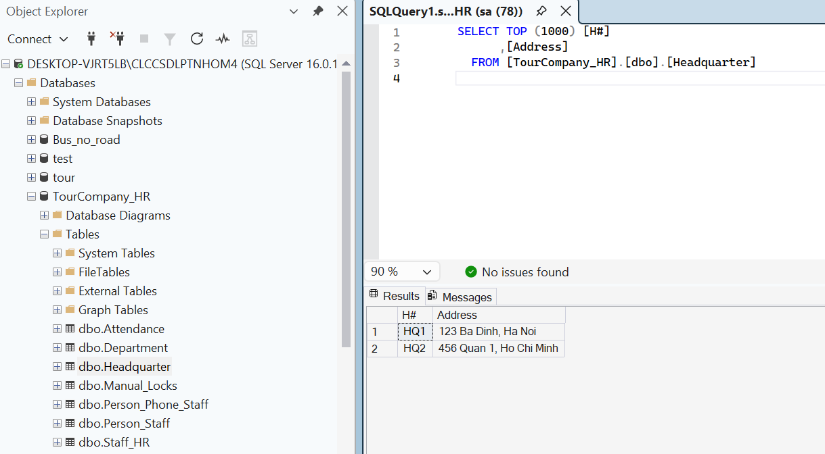

- Department(D#, Name)
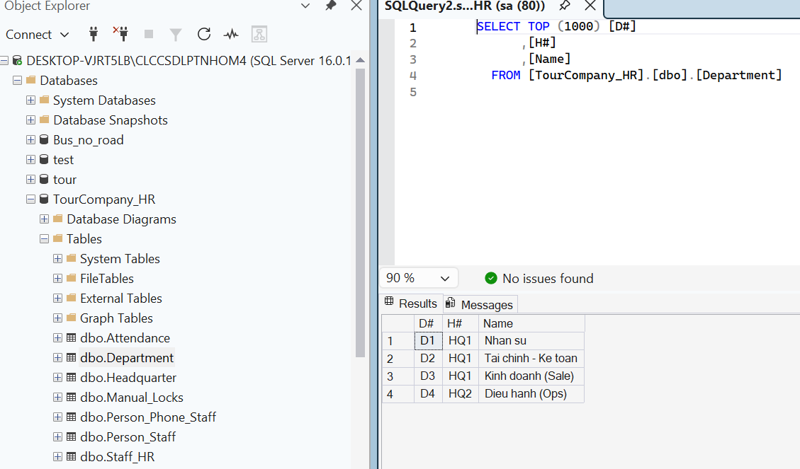

- Person_Staff(P#, H#, Address, Name, DoB, Email)
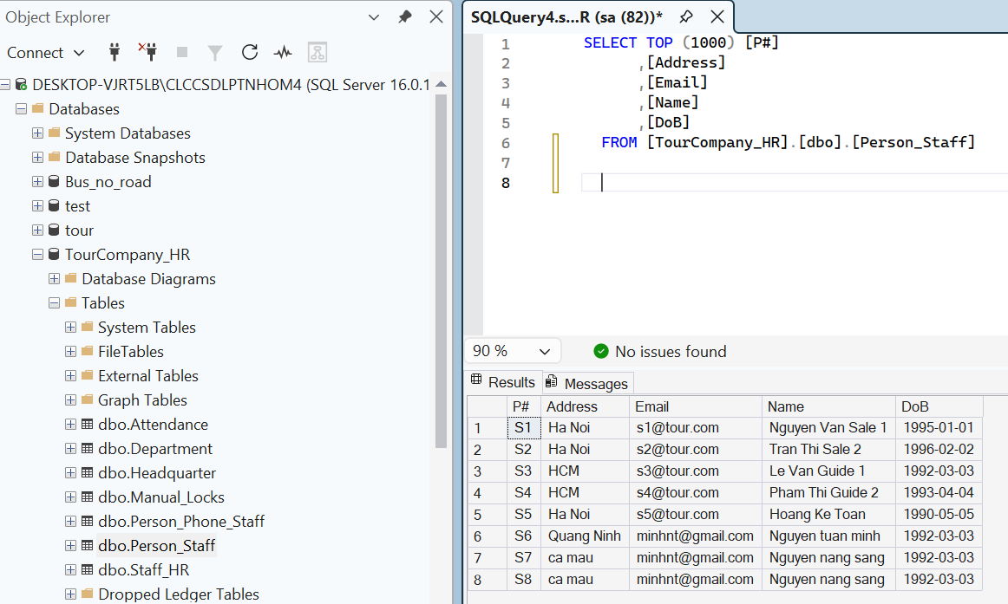

- Person-Phone_Staff(P#, Phone)
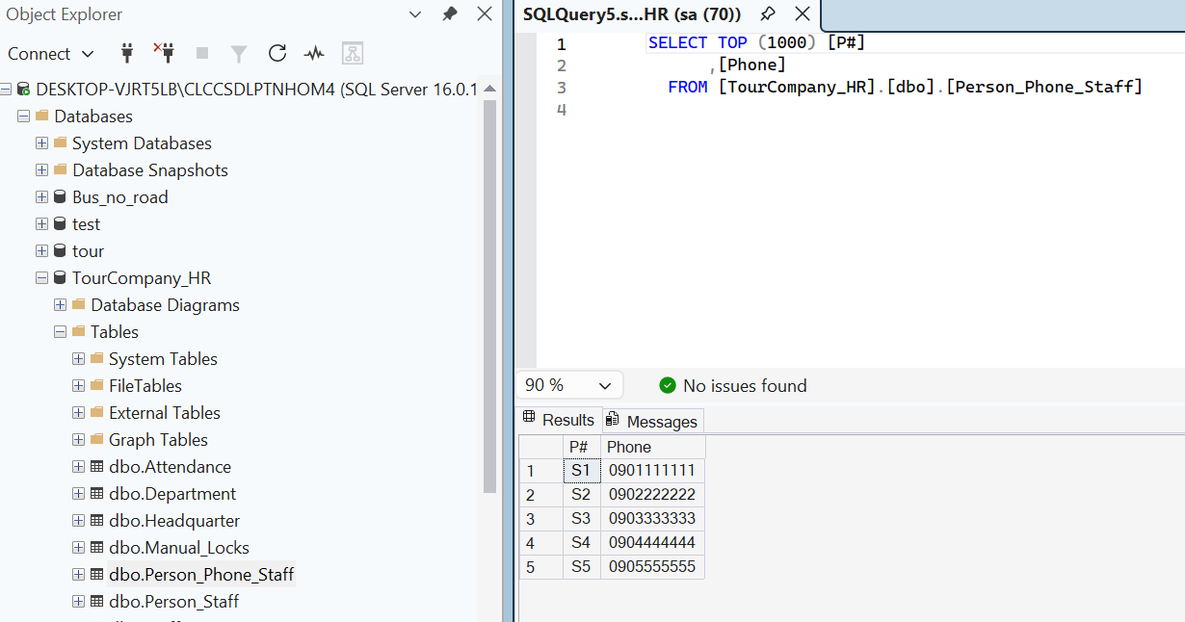

- Attendance(A#, P-S#, WorkDate, CheckIn, CheckOut, Status)
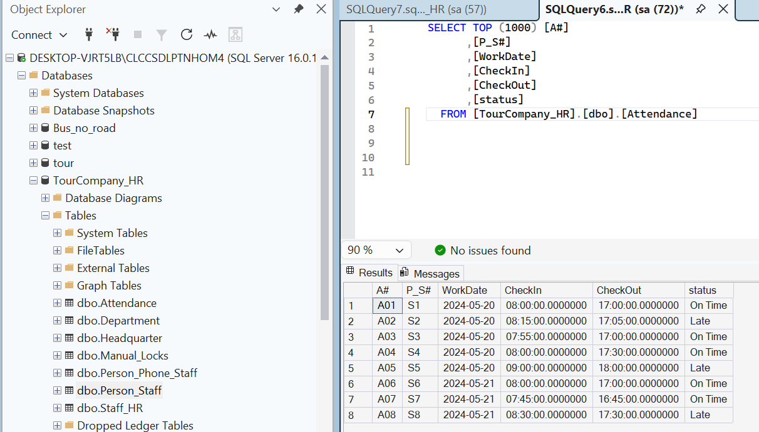

- Staff1(P-S#, D#, Role) -> Change name to Staff_HR
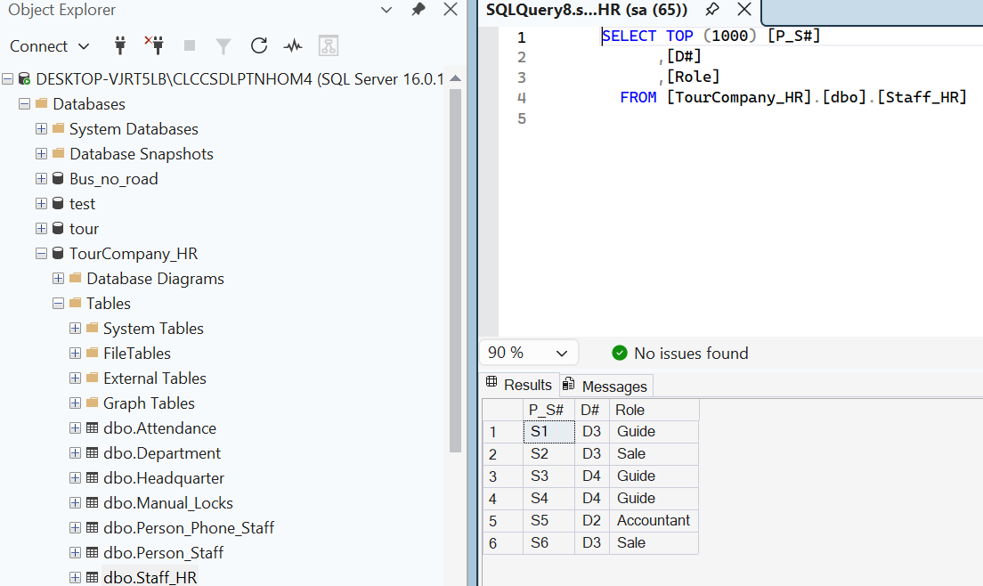

Site Finance
- Person_Staff(P#, H#, Address, Name, DoB, Email)
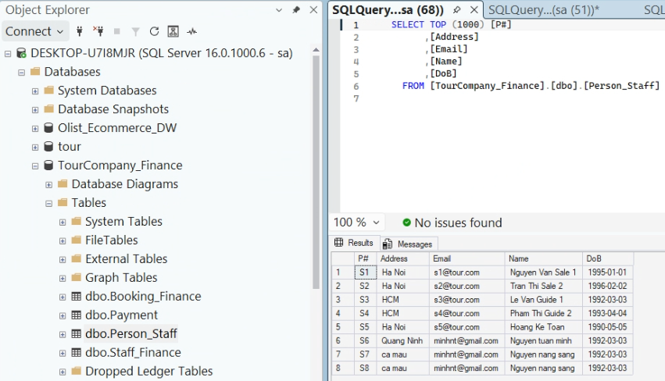
- Staff2(P-S#, Salary, Bonus) -> Change name to Staff_Finance
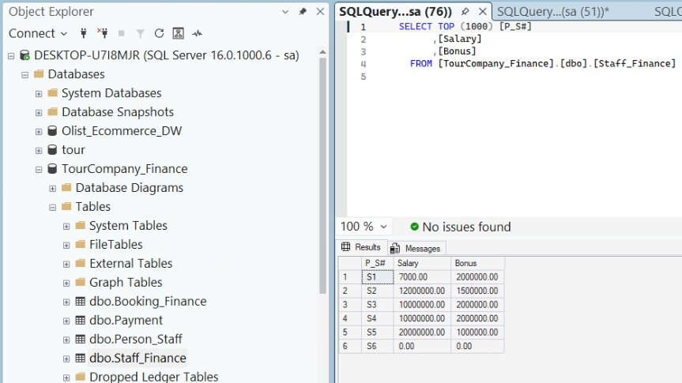
- Booking2(B#, Status, BookingDate, TotalAmount) -> Change name to Booking_Finance
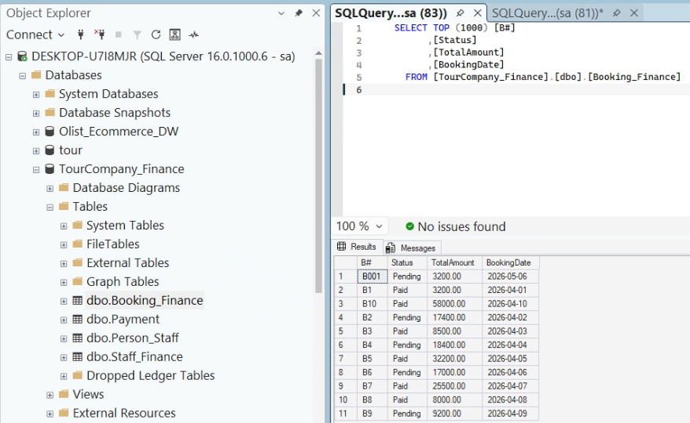
- Payment(Pa#, P-S#, B#, Amount, Discount, Paydate)
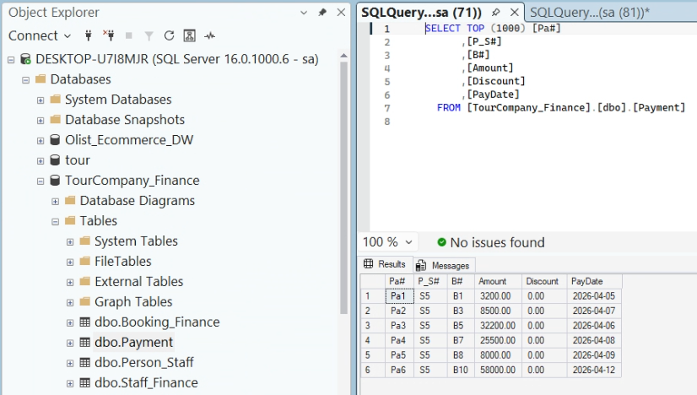

Site Booking
- Person_Customer(P#, H#, Address, Name, DoB, Email)
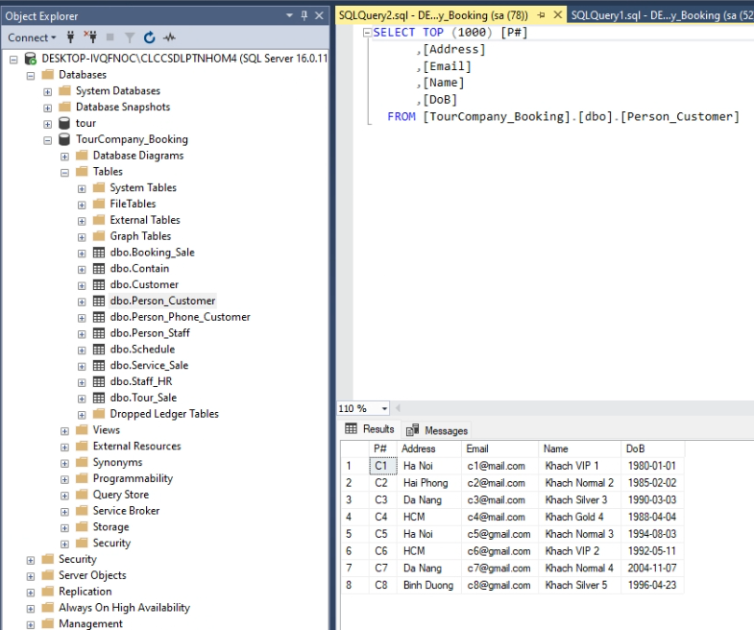
- Person_Phone_Customer(P#, Phone)
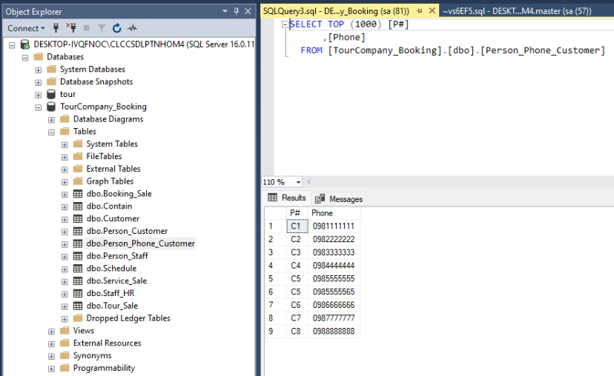
- Customer(P-C#, Membership)
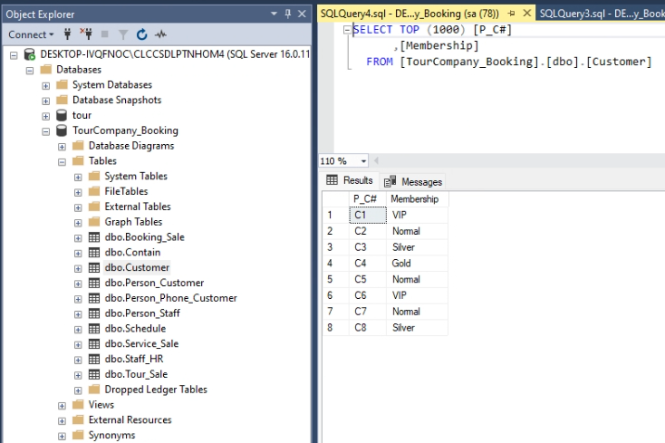
- Person_Staff(P#, H#, Address, Name, DoB, Email)
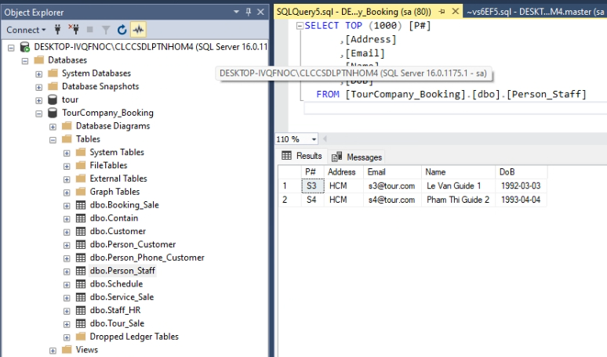
- Staff_HR_Guide(P-S#, D#, Role) -> Change name to Staff_HR
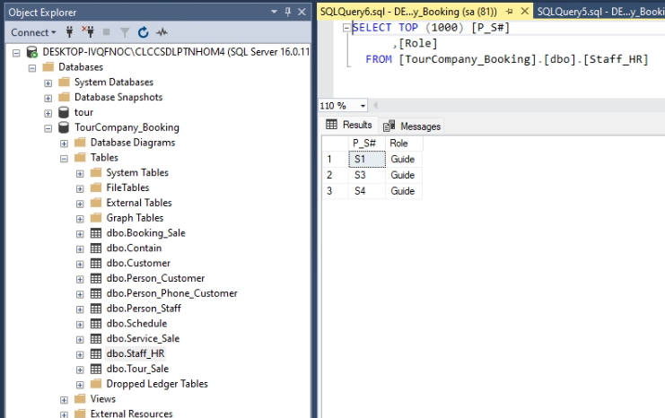
- Tour2 (T#, Name, Cost, Description) -> Change name to Tour_Sale
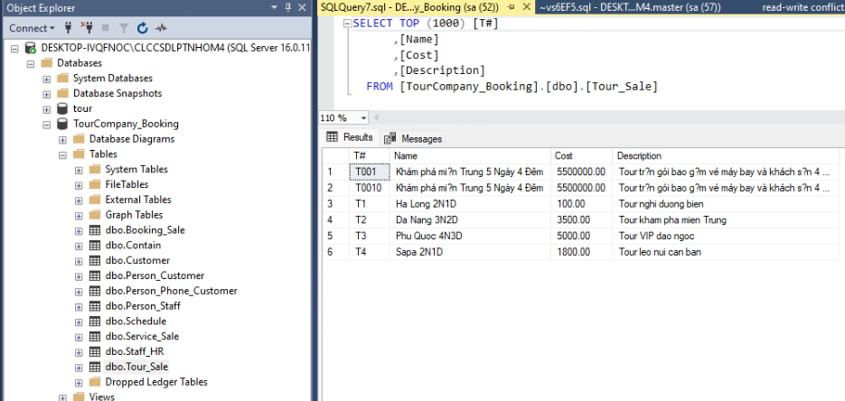
- Schedule(Sc#, T#, P-S#, StartDate, EndDate, MaxSlots)
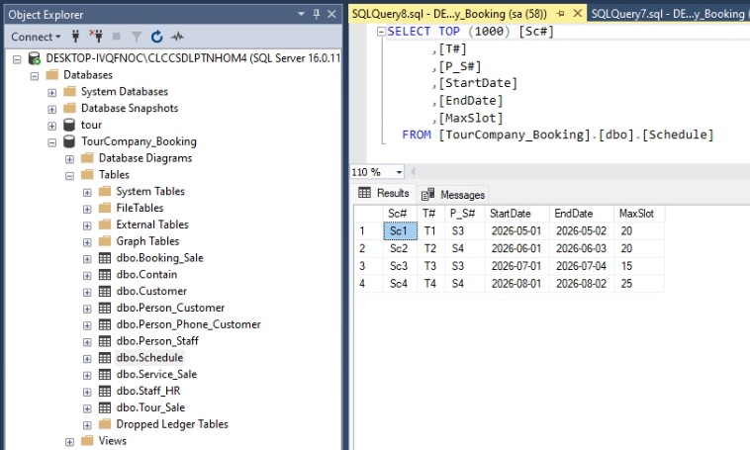
- Booking1(B#, P-C#, Sc#, CustomerAmount) -> Change name to Booking_Sale
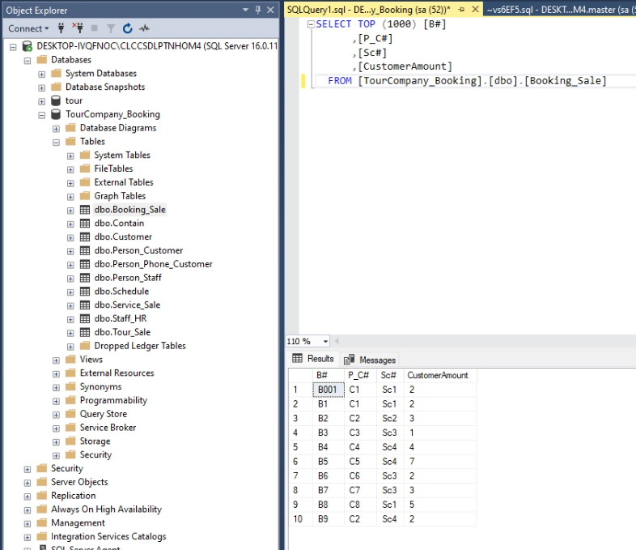
- Contains(Se#, Sc#)
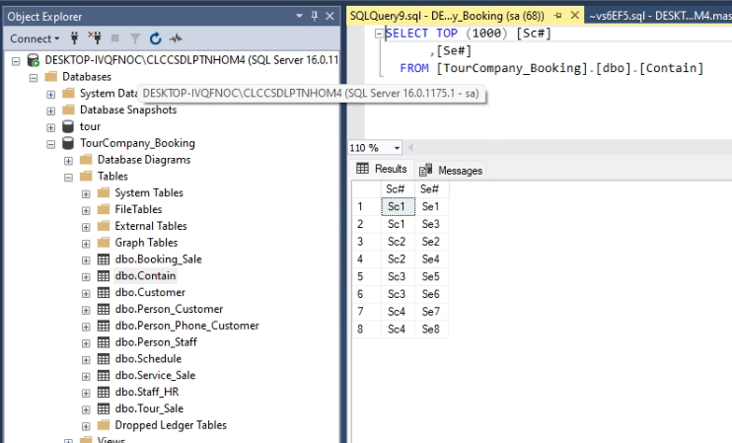
- Service2(Se#, Name, Cost, Description) -> Change name to Service_Sale
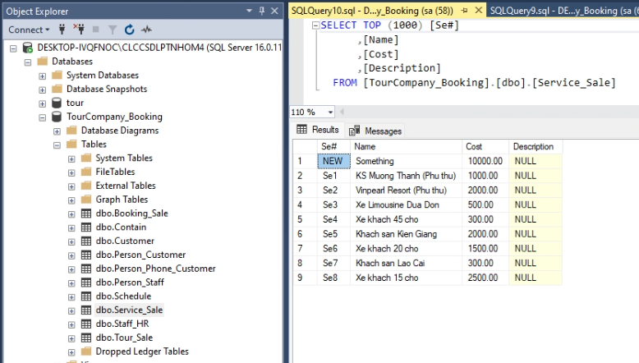

Site Tour
- Service1(Se#, P#, Status) -> Change name to Service_Manage
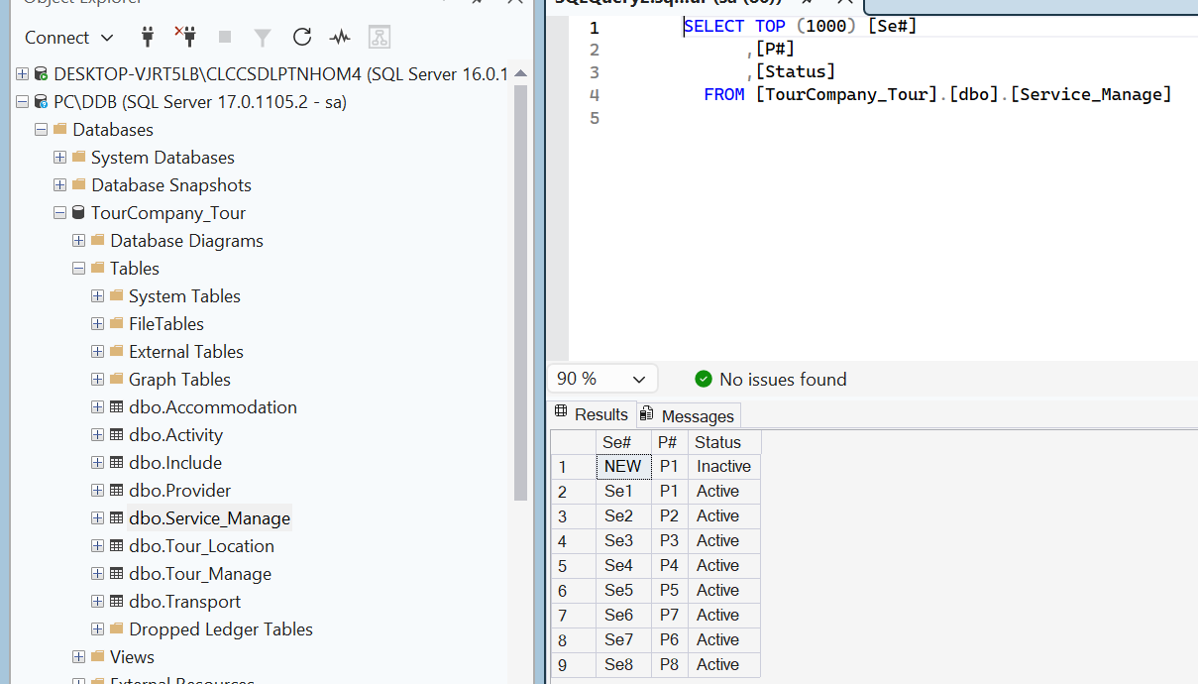

- Provider(Pr#, ContactPhone, Email, Provider)
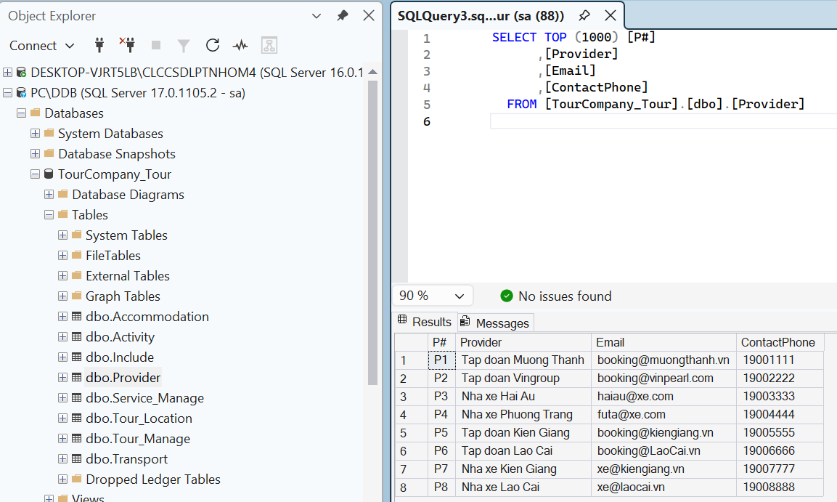

- Transport(Se-Tr#, Type)
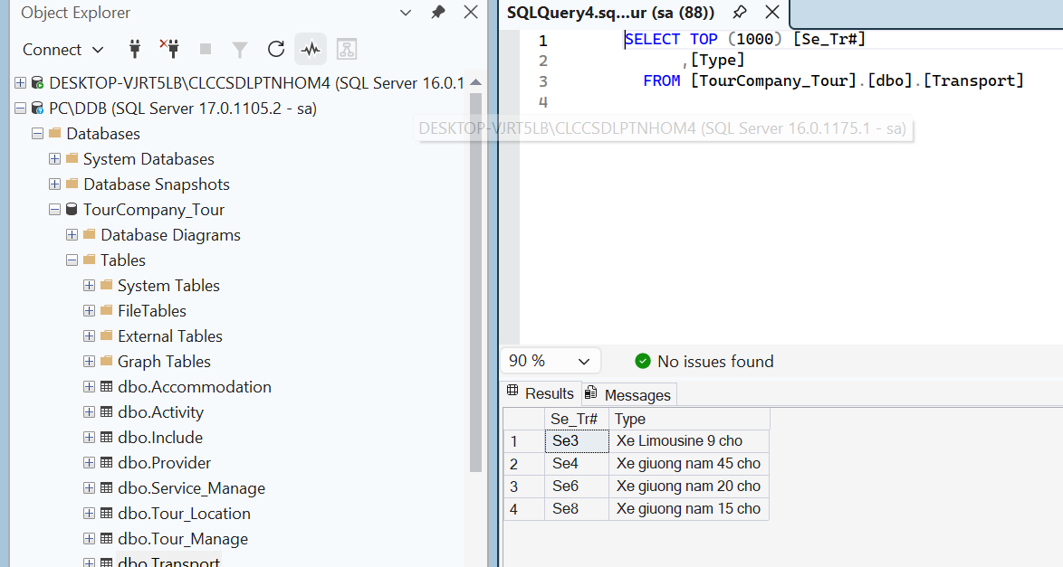

- Accomodation(Se-Ac#, Location)
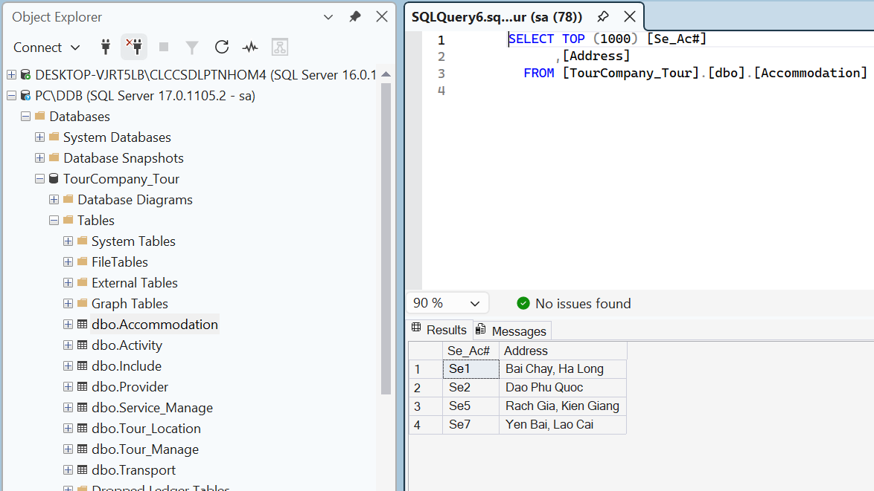

- Tour1 (T#, DurationDay, InsuranceIncluded, Status) -> Change name to Tour_Manage
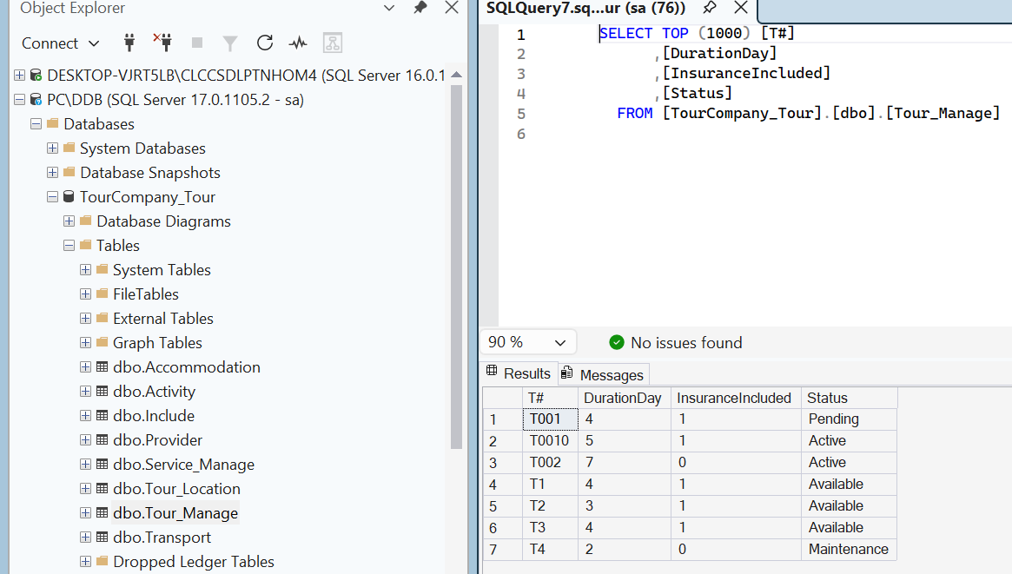

- Tour-Location(T#, Location)
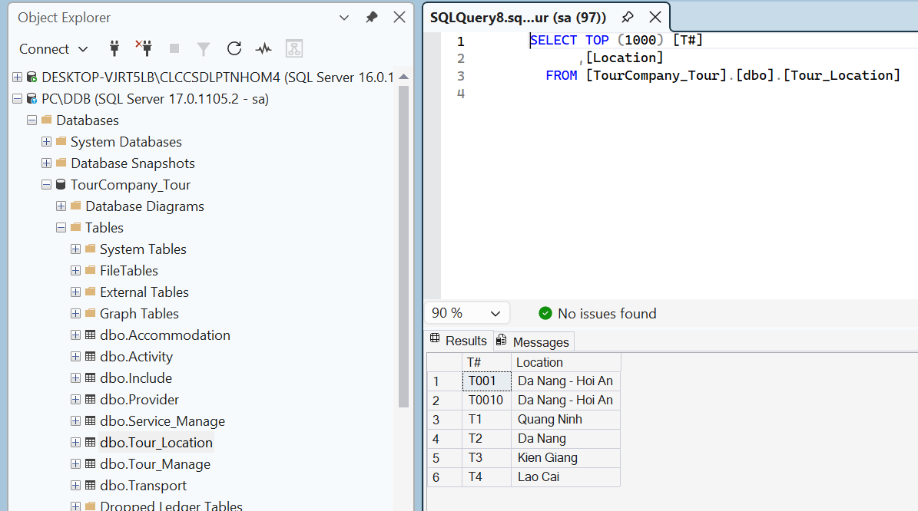

- Activity(A#, Name, Description)
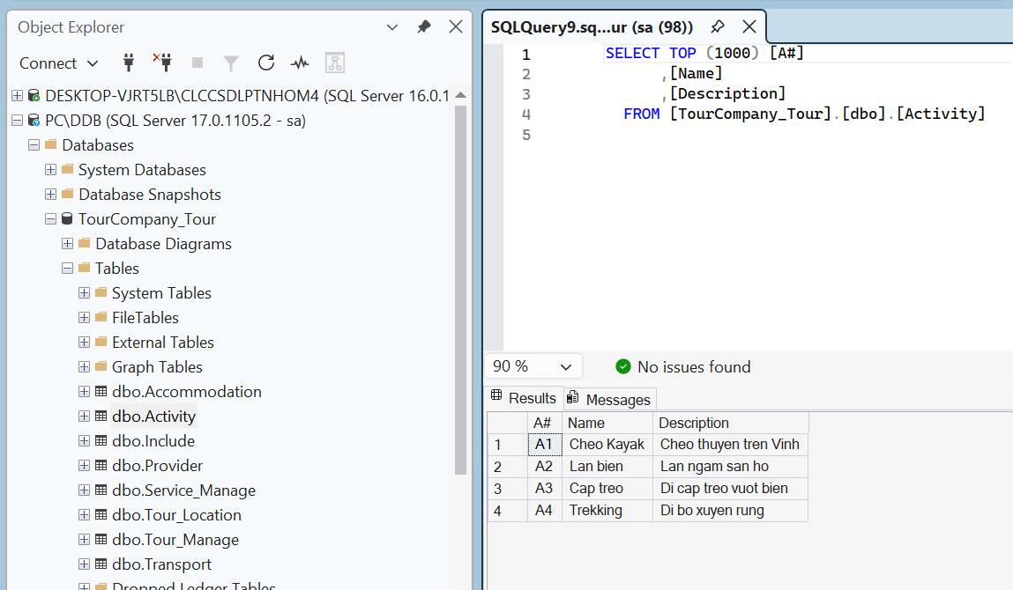

- Include(T#, A#)
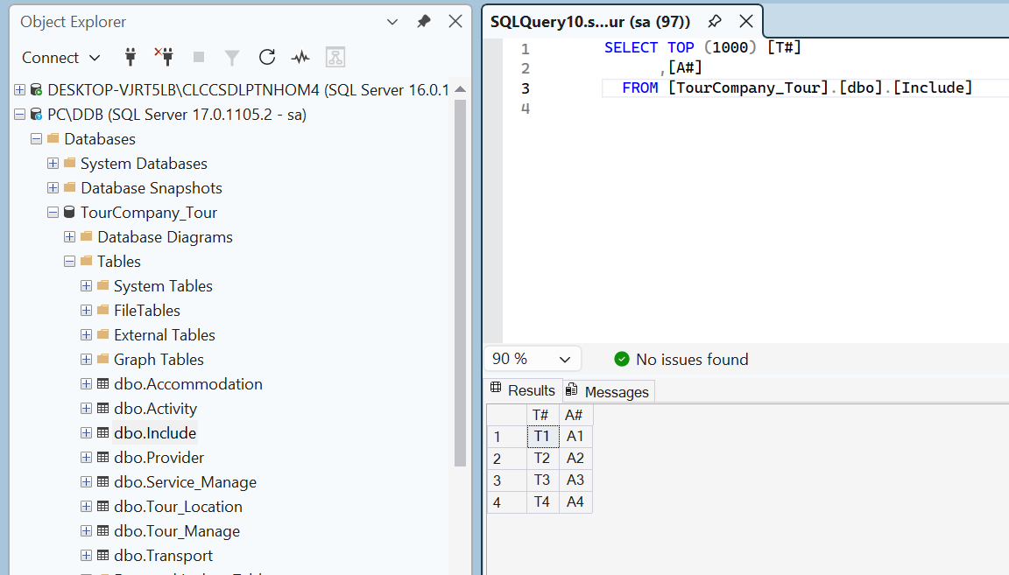

Concurrerncy Control and Failure Recovery

Concurrency control

Update - Update conflict:
- Site HR and Site Finance update Salary in Staff_Finance table in the same row. Site Finance starts first and Site HR starts right after because waitfor delay in Site Finance is higher than Site HR to control that both of the transaction is running at the same time:
- Salary before using transaction:
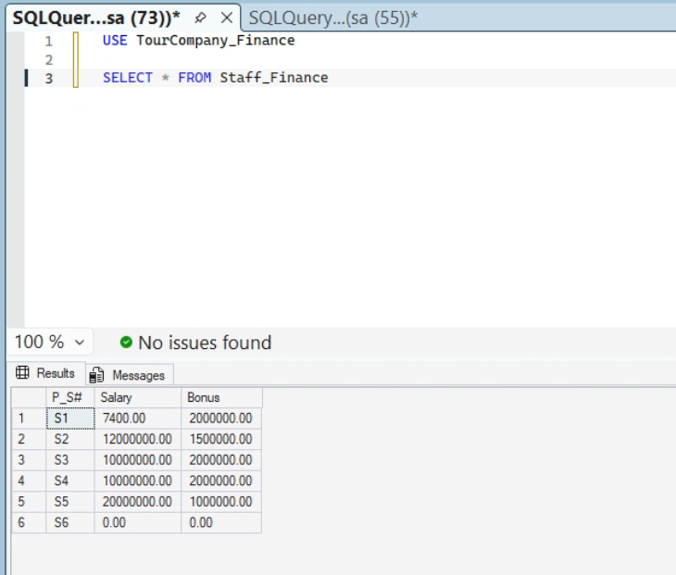
- Site HR:
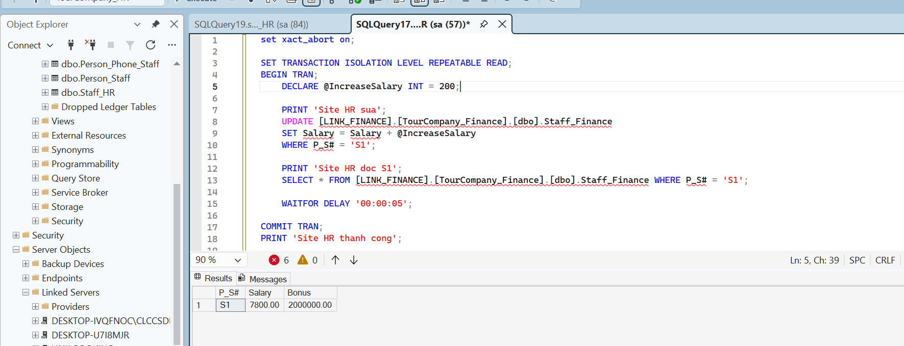
- Site Finance:
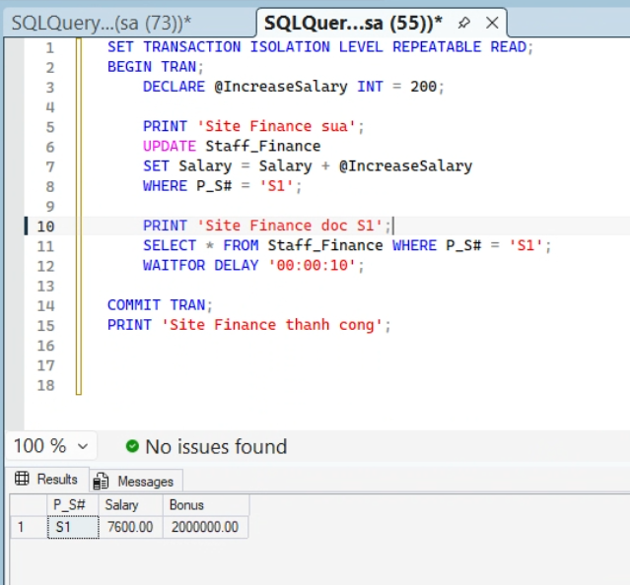
- Explain: Site Finance locks the row so that Site HR have to wait for Site Finance to commit. This leads to Site Finance finishing first and prints Salary from 7400 increase to 7600. Then Site HR takes 5 seconds after Site Finance finishing and prints Salary = 7800

Update - Read conflict:
- Site HR reads data 2 times in a transaction and Site Finance will update data between 2 reads using a transaction. Site HR starts first and Site Finance starts right after:
- Salary before using transaction:
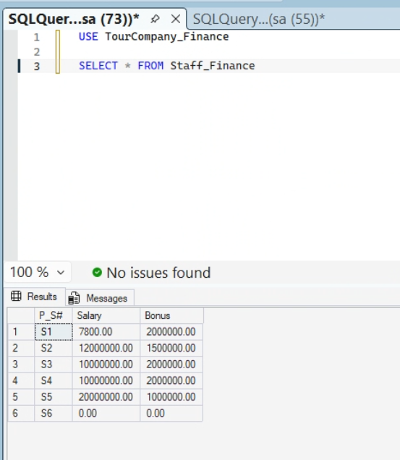
- Site HR:
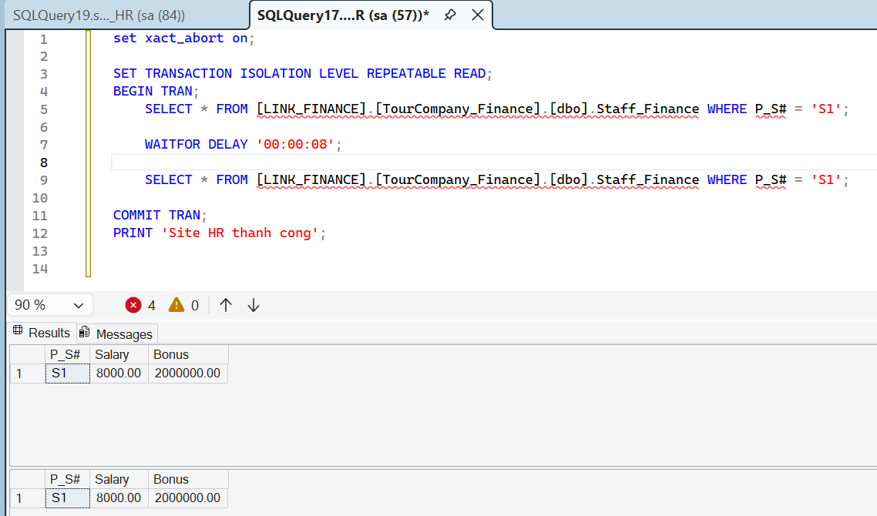
- Site Finance:
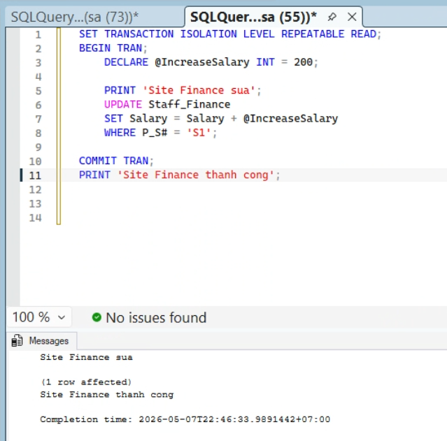
- Explain: Site HR runs select command before waiting for 8 seconds. Site Finance running simultaneously and updates first. Site HR then finish the second select command and both the select commands returns the same result to avoid Non-repeatable read error

Write - write conflict:
- Site Tour and site Booking add a Booking at the same time
Booking_Sale table before:
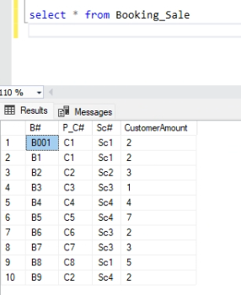
- No conflict scenario
Site Tour:
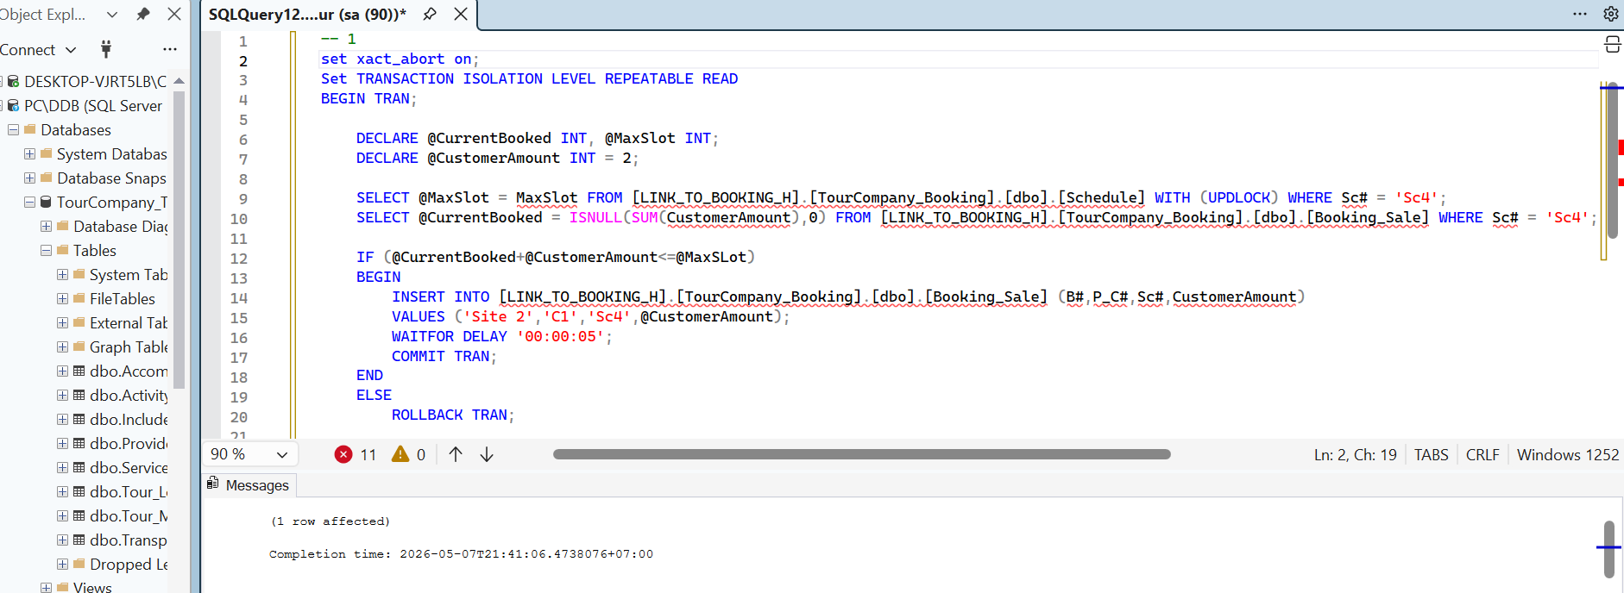
Site Booking:
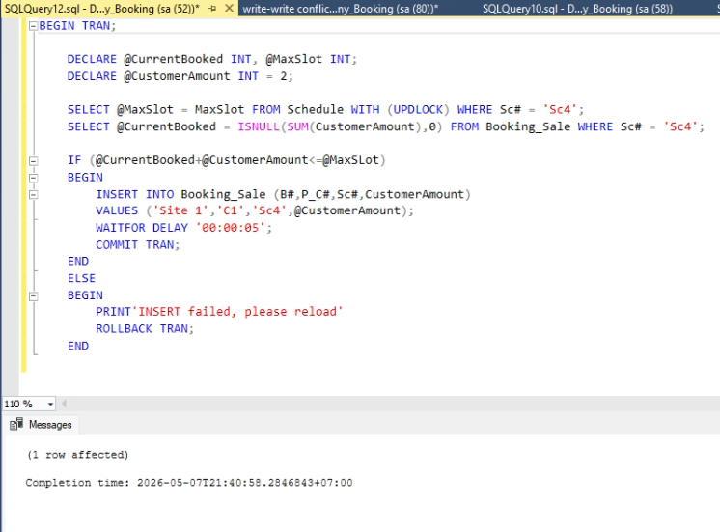
Both sites add a new booking to the Booking_Sale table. Since there is no conflict, both sites successfully add their Booking:
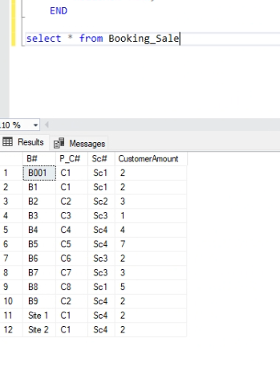
- Conflict scenario:
Site Tour
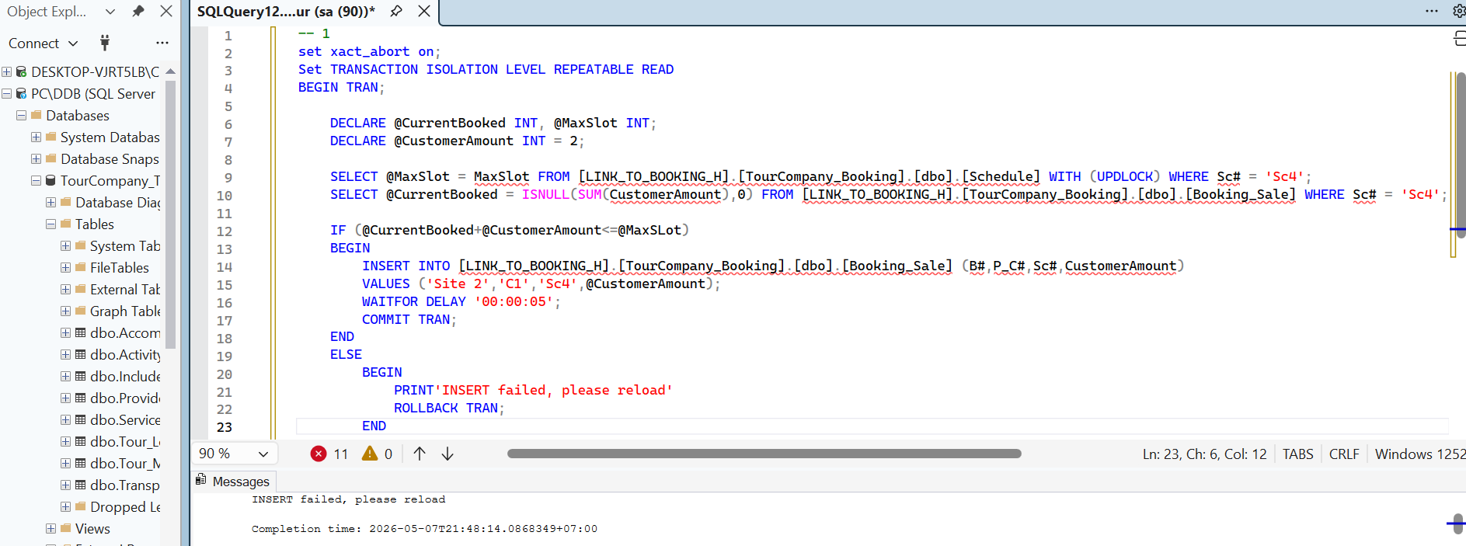
Site Booking
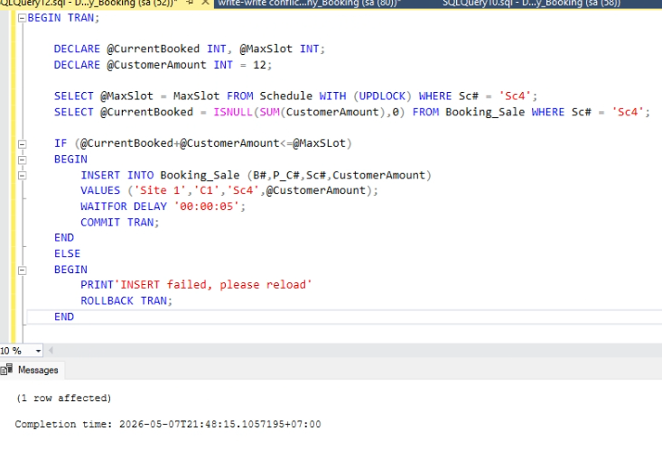
Both sites try to add a new Booking to Booking_Sale. But since Site Booking adds a Booking that exceeds the maximum number of tourists in a Schedule, the query run on site Tour will be rolled back. The table after the scenario:
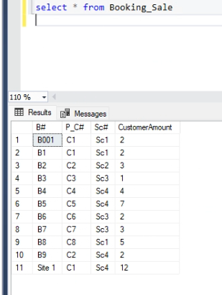

Read - write conflict
- Site Tour try to read the table Schedule and Booking while site Booking write a query on the table Booking:
- The table before the scenario:
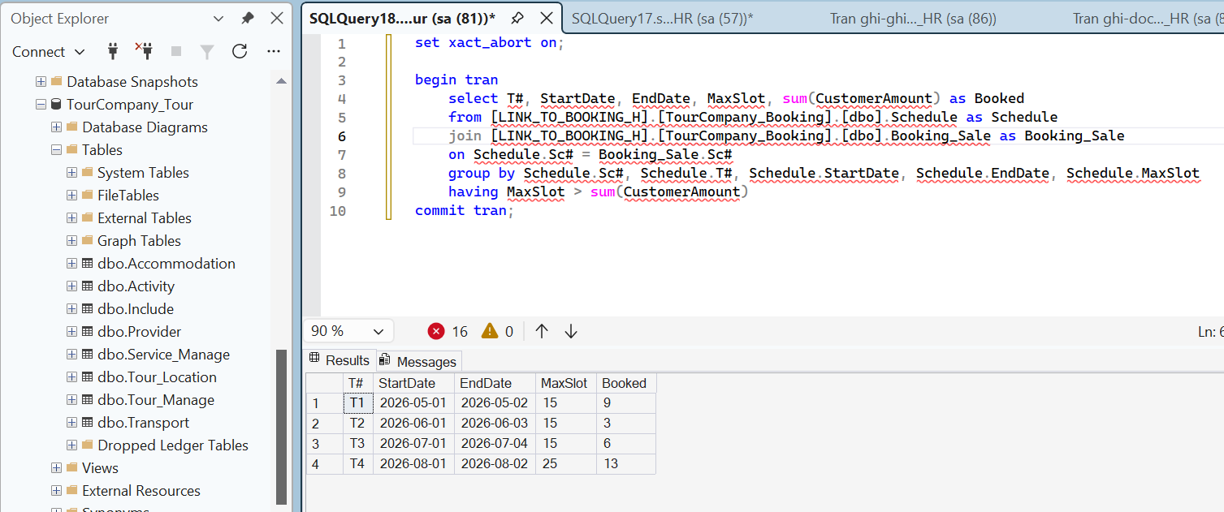
- Site Booking add a Booking to the Booking tabl
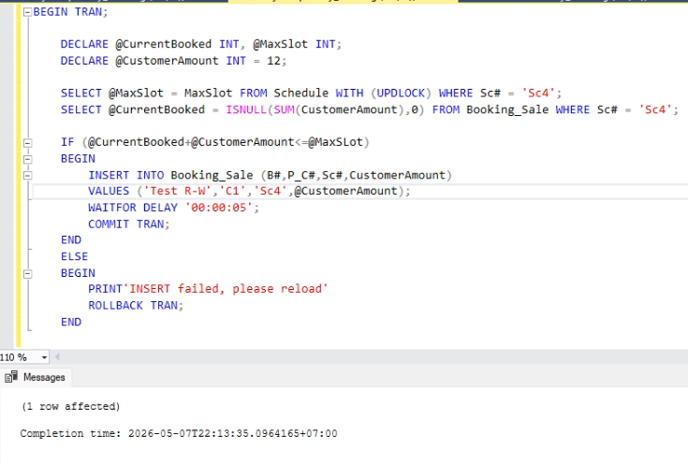
- Site Tour read the Schedule and Booking Table:
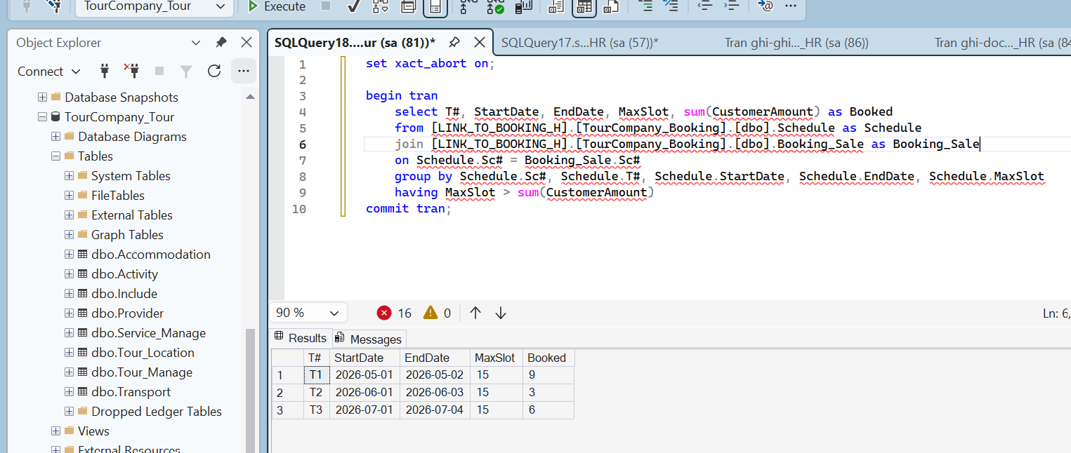
Since the read query requires site Tour to read both Schedule and Booking table, when site Booking runs a write query, site Tour will be delayed until the query on site Booking completes. And since site Booking add a Booking that make Schedule with T# = ‘T4’ have the MaxSlot equals to Booked, so that Schedule will not shown up in site Tour query

Deadlock:
- Both Site HR and Site Finance read a data row and update it in a transaction. There is a delay between reading and updating. Site Finance starts first and Site HR starts right after:
- Before using transactions:
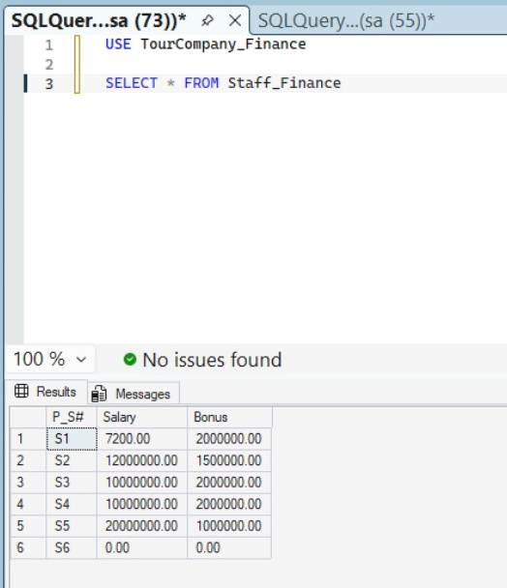
- Site HR:
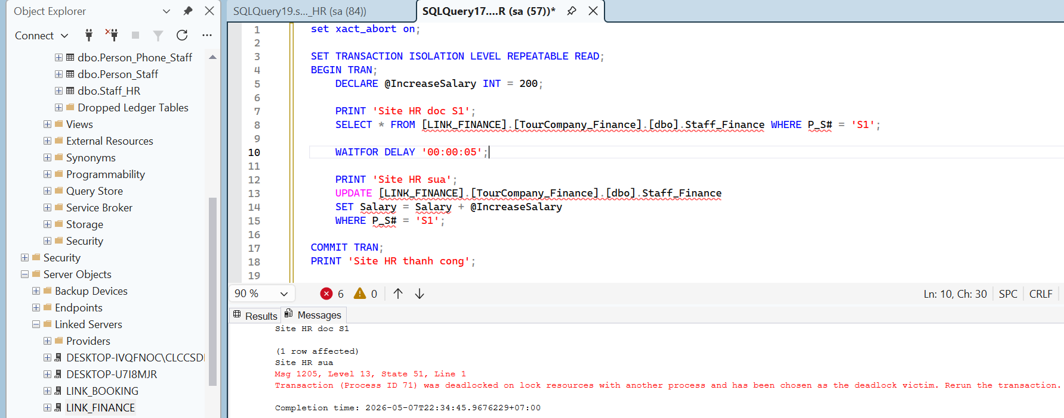
- Site Finance:
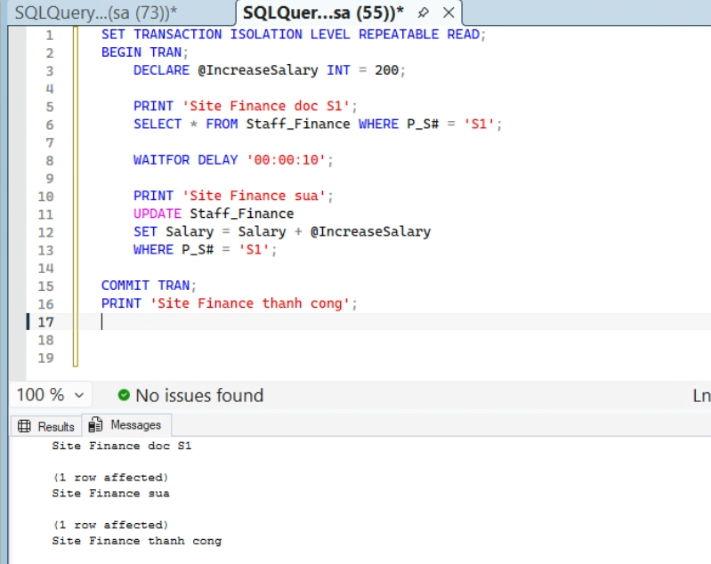
- Salary after using transaction:

- Explain: Site Finance reads a row and acquires a Shared Lock (S-Lock) and it holds this lock until the transaction finishes. Site HR reads the exact same row. Since S-Locks are compatible with each other, Site HR is also granted an S-Lock on that row. Site Finance tries to update the row. To write data, it needs to upgrade its lock to an Exclusive Lock (X-Lock). However, it cannot get the X-Lock because Site HR is still holding its S-Lock. Site A enters a WAIT state. Site B also attempts to update the row, requesting an X-Lock. It gets blocked by Site Finance's existing S-Lock. A circular wait is formed (Site Finance waits for Site HR, and Site HR waits for Site Finance). The system detects this deadlock and automatically kills one of the transactions (the "victim") so the other can proceed.

- Reverse HR and Finance: Both Site HR and Site Finance read a data row and update it in a transaction. There is a delay between reading and updating. Site HR set DEADLOCK_PRIORITY high and set Site Finance DEADLOCK_PRIORITY low . Site HR starts first and Site Finance starts right after:
- Before using transactions:

- Site HR:
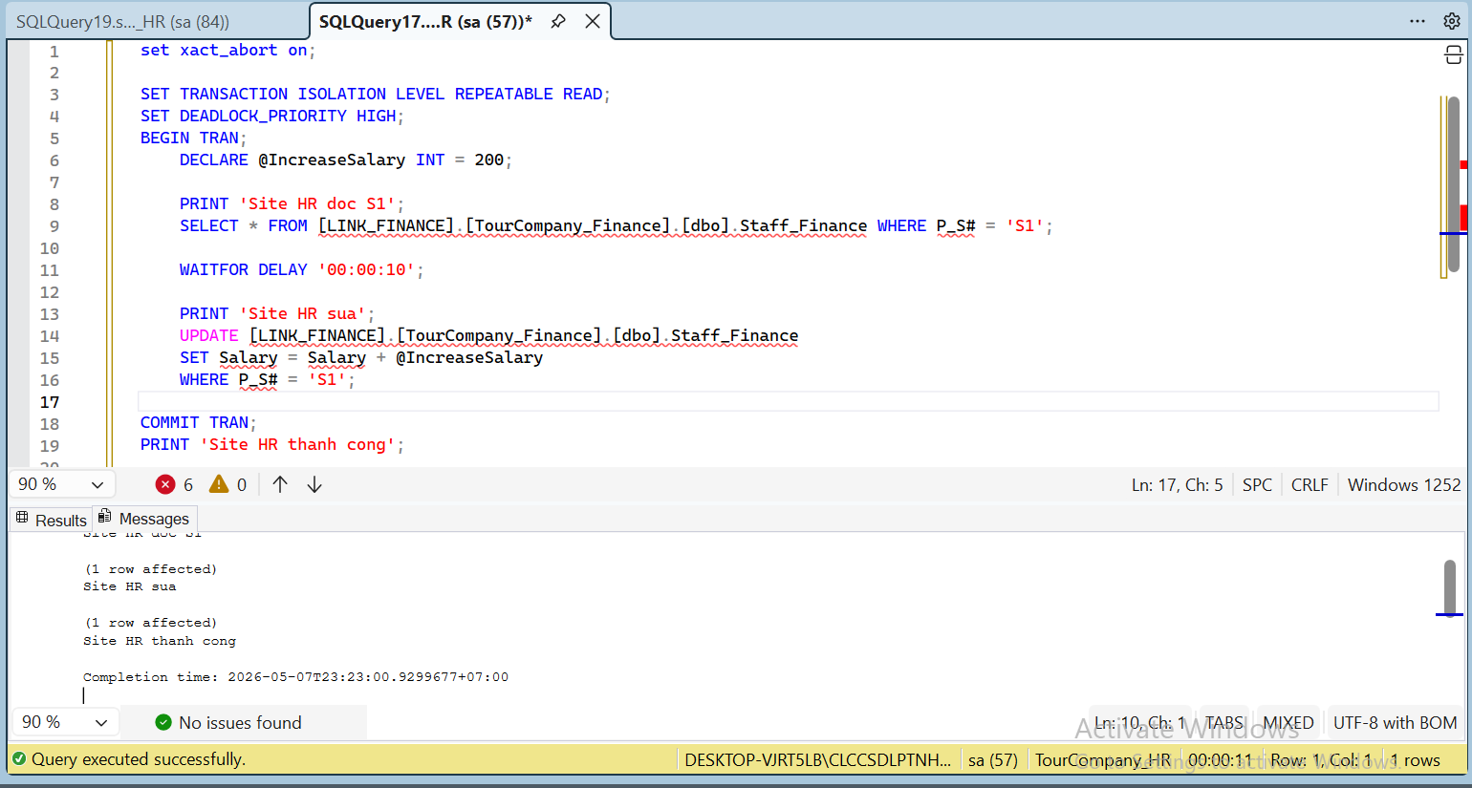
- Site Finance:
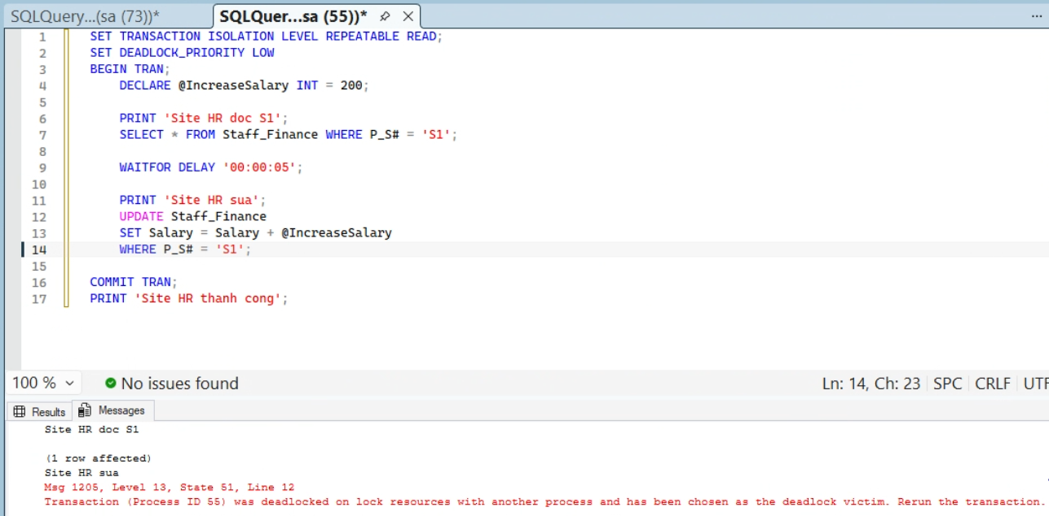
- Salary after using transaction:
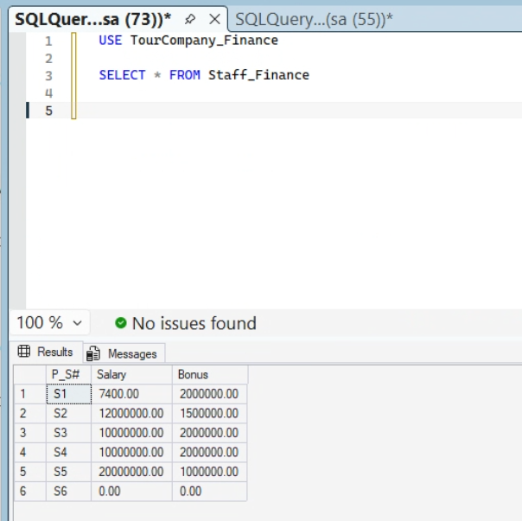
- Explain: If not using DEADLOCK_PRIORITY on both sites, the result will be the same as the non-reverse case because Site Finance owns the Salary attribute so the system will prioritize it over Site HR.

- Both site Tour and site Booking update 2 rows on the same table
- Site Tour:
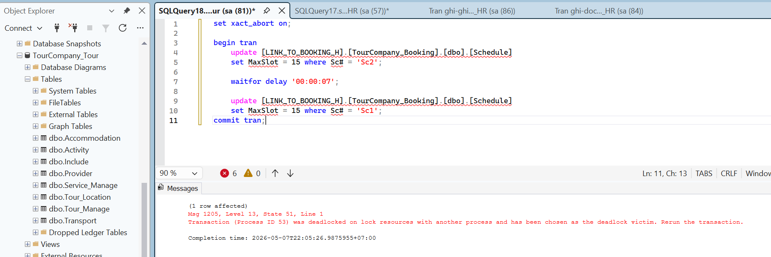
- Site Booking:
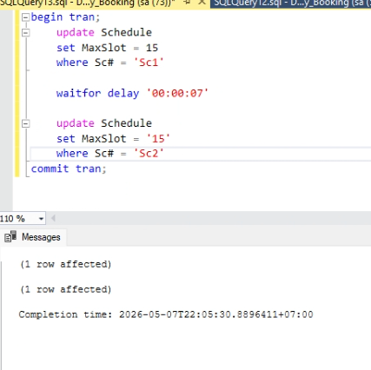
Since site Booking hold the key for the row with Sc# = ‘Sc1’ and site Tour hold the key for row with Sc# = ‘Sc2’, both queries run into a deadlock. Then, site Tour has been chosen as the deadlock victim, and the transaction on site Tour will be rolled back. To change the site chosen to be the deadlock victim, we can run the command:
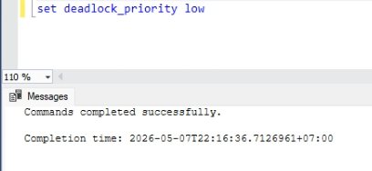

Failure recovery
- Site Booking run an update query to the Payment table on site Finance:
- Scenario: Connection lost after commit
The table before scenario:
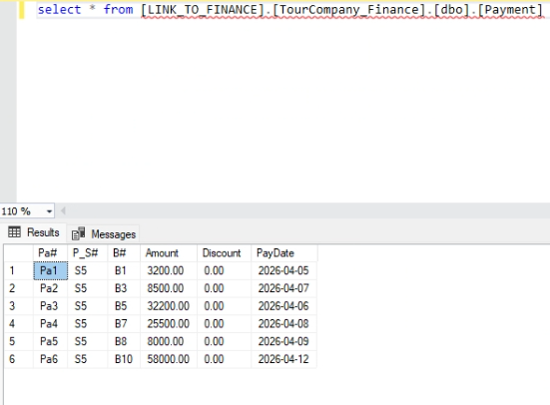
Site Booking run the update transaction, then disconnect:
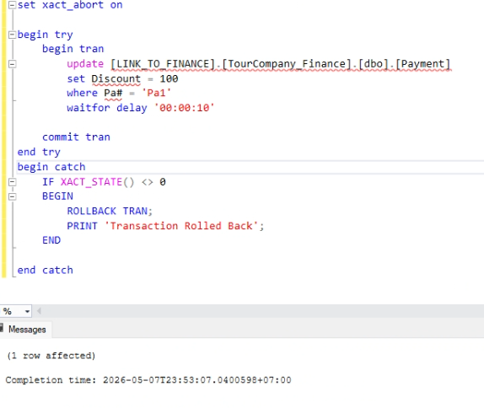
The table after the scenario:
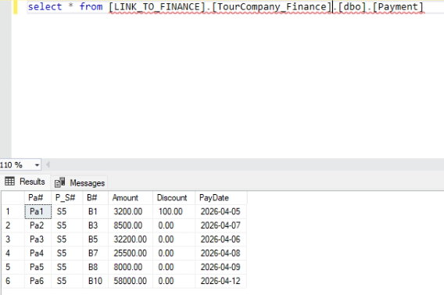

- Scenario: Connection lost before commit
The table before scenario:
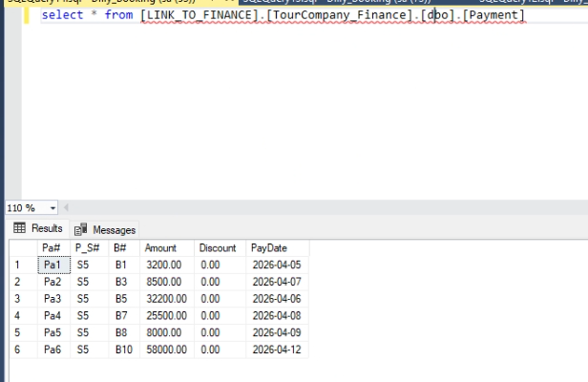
Site Booking runs an update query to the Payment table, while the query waits in the waitfor delay block, the connection between 2 sites is shut off. After that, the system return connection error, and since we have xact_abort set to on, the transaction is automatically rollback on both sites
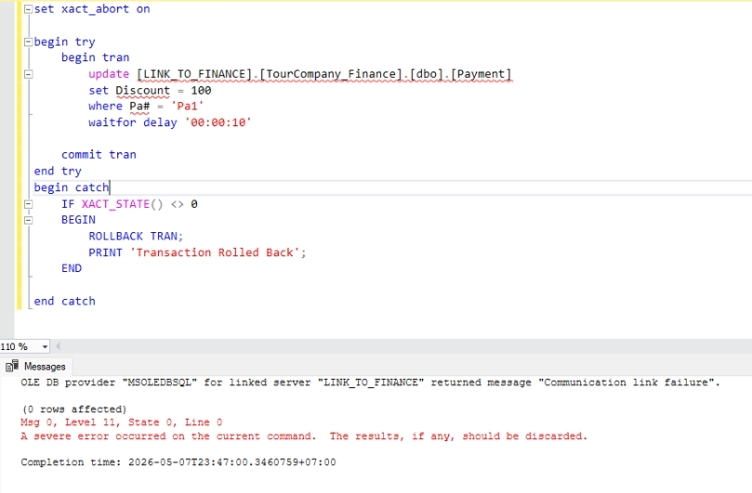
After:
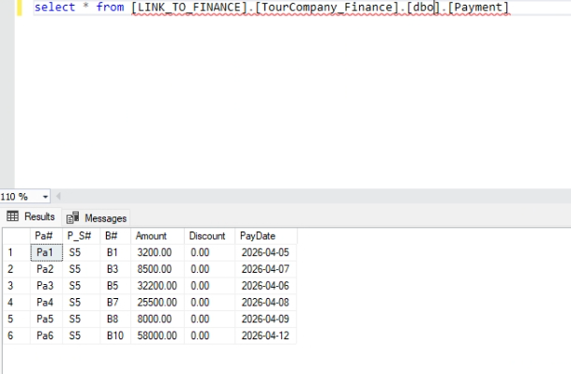

- Non-blocking:
- Site HR run a read query to site Finance, meanwhile site Booking is shutdown:
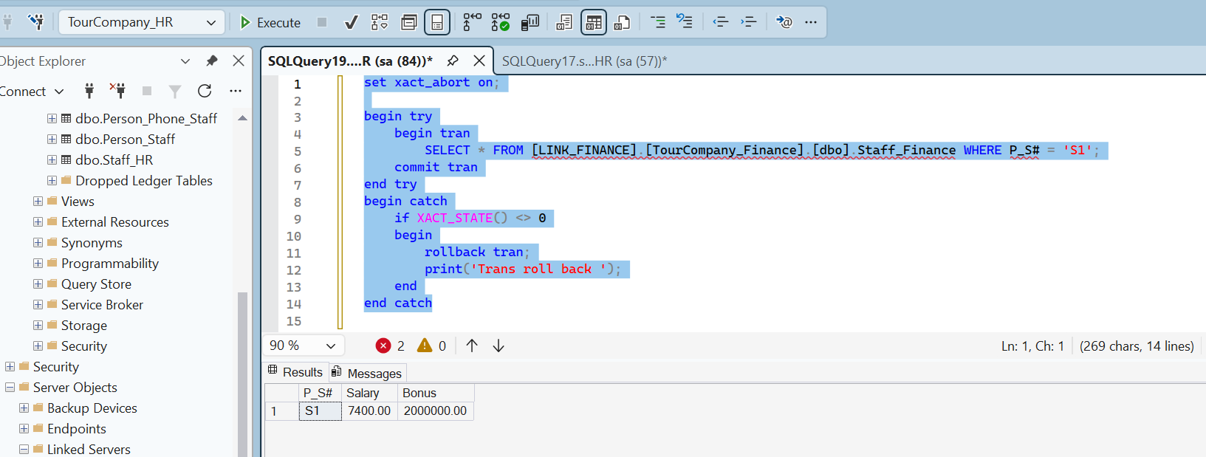
The query can run normally even when site Booking is down

