

THE POSTS AND TELECOMMUNICATIONS INSTITUTE OF TECHNOLOGY

DEPARTMENT OF INFORMATION TECHNOLOGY 1

MULTI MEDIA DATABASE SYSTEM

Hà Nội - 2025

GROUP: 10
MEMBERS: NGUYỄN TUẤN MINH - B22DCKH077
NGUYỄN XUÂN KIÊN - B22DCKH062
NGUYỄN VIỆT HOÀNG - B22DCVT214

REPORT
TABLE OF CONTENT
I. Introduction 3
II. System Architecture & Workflow 5
1. System Block Diagram 5
2. Database Schema Design 6
III. Feature for Speaker characteristic 9
1. Features using 9
a. MFCC (Mel-Frequency Cepstral Coefficients) - [13 dimensions]: 9
b. Silence Ratio - [1 dimension]: 11
c. Harmonicity (Harmonics-to-Noise Ratio) - [1 dimension]: 11
d. Spectral Centroid Mean - [1 dimension]: 12
2. Extraction Method 13
3. Storage Method and Query 13
4. Demo 14
IV. Feature for Content 26
1. Features using 26
a. Term Frequency (TF) 27
b. Inverse Document Frequency (IDF) 27
c. The Final Score (TF-IDF) 27
2. Extract method 27
3. Storage Method and Query 28
4. Demo 29

Introduction
The goal of this project is to design, implement, and evaluate a comprehensive database system for audio content storage and retrieval. The dataset is an audio dataset consisting of at least 500 audio files containing speeches, lectures, or narrated stories with specific content. The audio files must have a suitable duration to convey the content of a particular topic. Each file should address one topic and be spoken or presented by a single speaker.
To construct or collect an audio dataset consisting of at least 500 audio files containing speeches, lectures, or narrated stories with specific content. We use train-clean-100.tar.gz [6.3G] (training set of 100 hours "clean" speech ) in https://www.openslr.org/12:
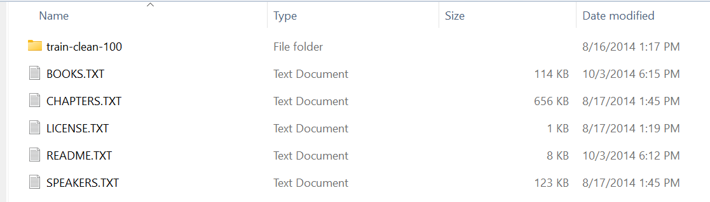
- These numbers below is reader ID
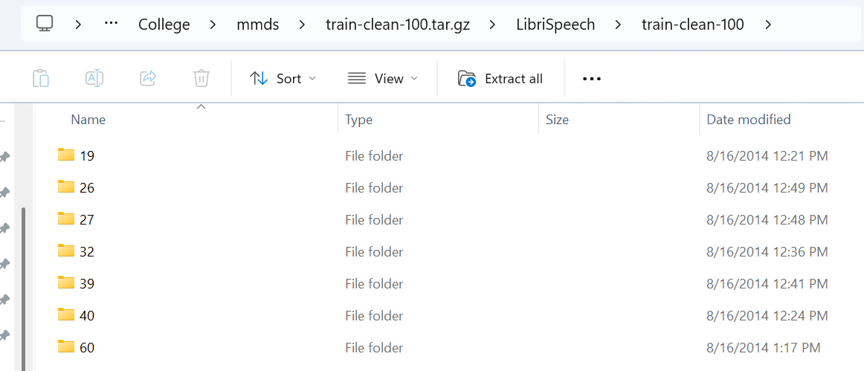
- These numbers below are IDs of the chapters read by the previous selected speaker.
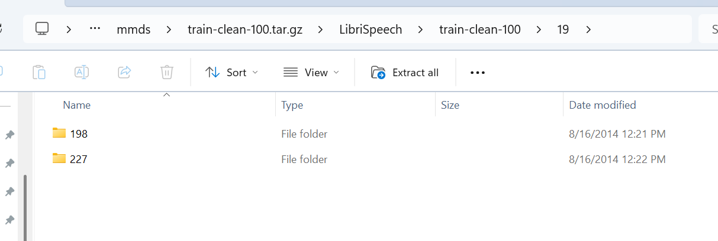
- These files are audio files with each file containing 1 sentence and the duration varies between 5 and 30 seconds
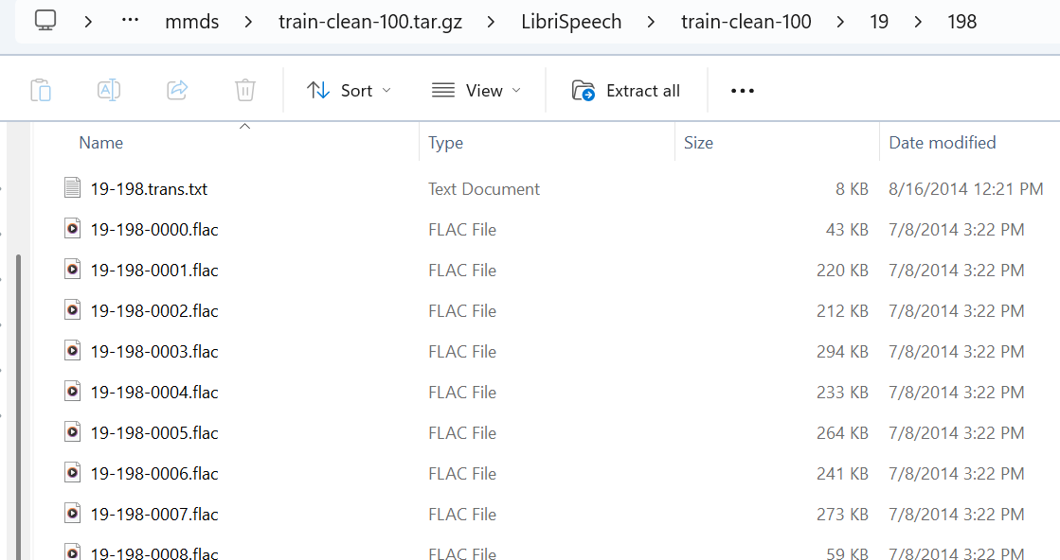
Since an audio file containing only 1 sentence doesn't provide enough context for effective querying, we decided to merge the first 10 audio files of each chapter—recorded by the same speaker—into a single new file.
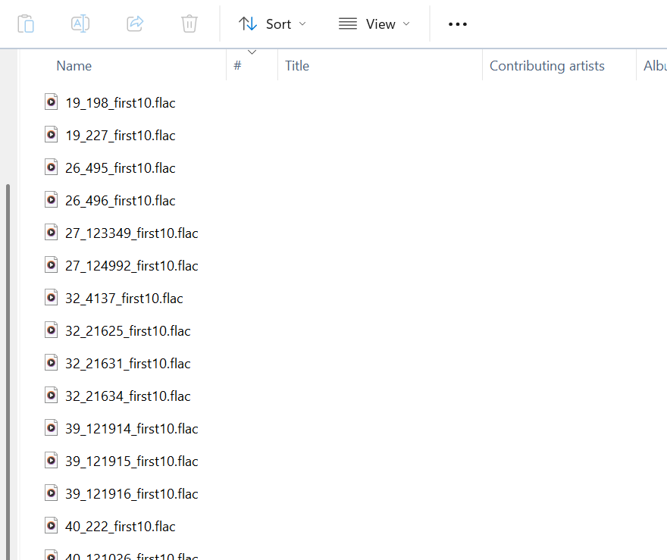

System Architecture & Workflow

System Block Diagram
The system follows a modular architecture that integrates speech recognition, audio signal processing, and relational database management.
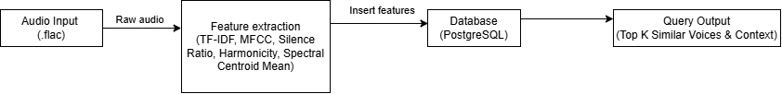
The workflow consists of three primary layers:
- Data Acquisition Layer: Handles raw audio files (LibriSpeech dataset).
- Feature Extraction Layer:
- Content Extraction: Utilizes the Whisper model to convert speech into text, followed by TF-IDF vectorization.
- Speaker Extraction: Uses MFCC (Mel-frequency cepstral coefficients), Silence Ratio, Harmonicity and Spectral Centroid Mean to capture unique vocal signatures, represented as a 16-dimensional vector.
- Storage & Retrieval Layer: Managed by PostgreSQL with the pgvector extension and an Inverted Index structure.

Database Schema Design
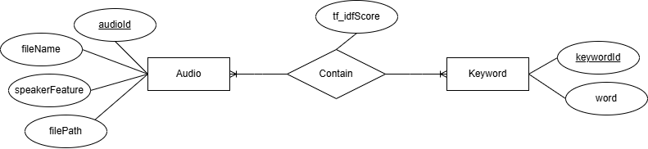
- Change name Contain to InvertedFile
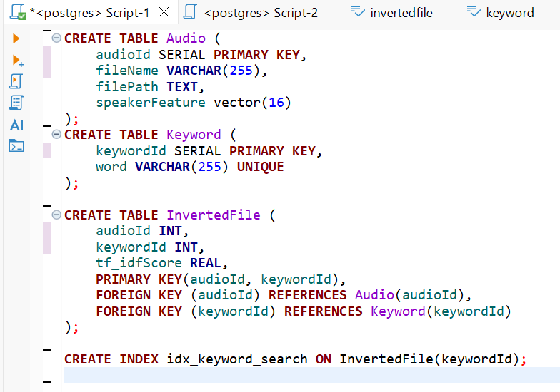
- Audio: Acts as the central repository for audio metadata and speaker voice features.
- fileName (varchar): Saving file title
- filePath (varchar): Saving file path in computer
- speakerFeature (vector): A 16-dimensional vector storing the average MFCC, Silence Ratio, Harmonicity and Spectral Centroid Mean.
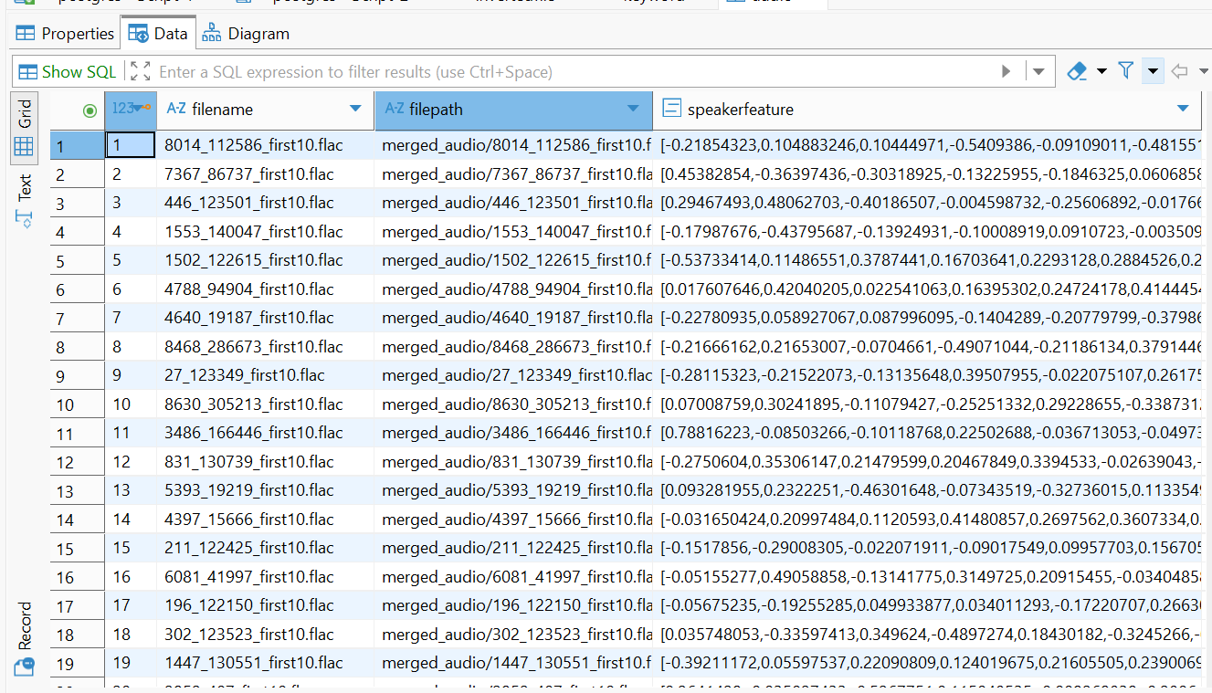
- Keyword: Stores a unique vocabulary extracted from the entire audio corpus.
- word (varchar): Saving keyword
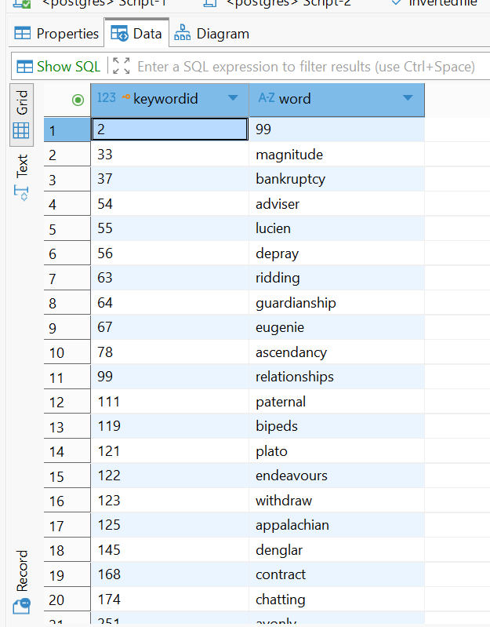
- Contain (Change name to InvertedFile): It maps keywords to specific audio files and stores the TF-IDF Score, which represents the importance of a word within a specific document.
- tf_idfScore (real): Saving tf_idf score of the keyword in the corresponding audio file
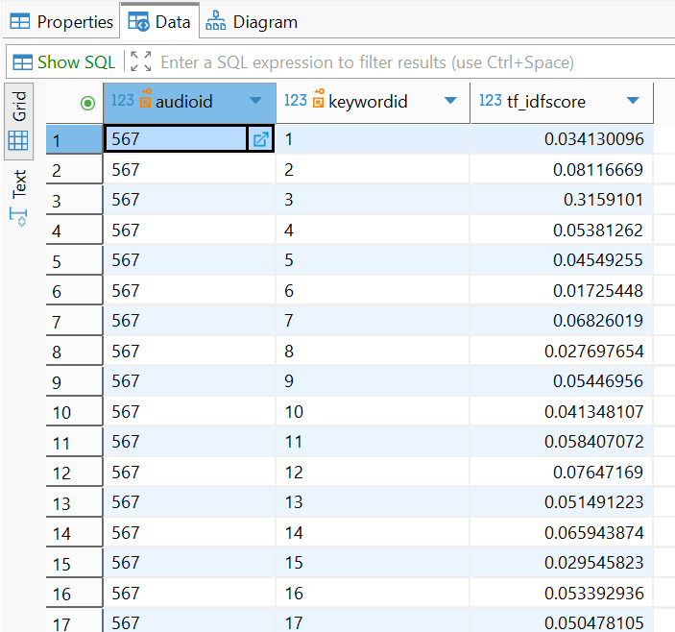

Feature for Speaker characteristic

Features using
To accurately represent a speaker's voice, the system extracts a 16-dimensional continuous feature vector from each audio file. This vector is a composite of four distinct audio characteristics:

MFCC (Mel-Frequency Cepstral Coefficients) - [13 dimensions]:
MFCCs (Mel-Frequency Cepstral Coefficients) act as the "acoustic fingerprint" of a person's voice. Just like a guitar and a piano sound completely different even when playing the exact same note because of their physical shapes, human voices sound different because of the unique shape of our physical "instrument" — our throat, tongue, teeth, and nasal cavity. MFCCs are a set of 13 numbers that mathematically describe the physical shape and resonance of a speaker's vocal tract.
- MFCC 1 (The DC Component / Overall Energy): The first coefficient (often denoted as  or  depending on the indexing scheme) represents the overall energy or the average log-energy of the audio frame. It indicates how loud the speech is at a given moment. In our system, this helps the model understand the overall intensity envelope of the spoken audio.
- MFCC 2 to MFCC 4 (Broad Spectral Shape & Formants):
The lower-order coefficients capture the broad shape of the spectral envelope. These coefficients are highly correlated with the formants (the resonant frequencies of the vocal tract).
- They define the macro-structure of the sound, carrying the crucial information needed to distinguish broad classes of sounds, such as different vowels (e.g., distinguishing an "a" from an "i").
- They reflect the physical positioning of the tongue and the jaw during speech articulation.
- MFCC 5 to MFCC 13 (Fine Spectral Details & Timbre):
The higher-order coefficients represent increasingly finer details of the spectral envelope.
- Rather than representing broad vowel sounds, these coefficients capture the subtle, high-frequency variations in the voice.
- They are responsible for encoding the timbre (tone color) and the unique resonant characteristics of an individual's throat and nasal passages.
- These details are vital for differentiating complex consonant sounds (like fricatives and plosives) and are the primary drivers for recognizing a specific speaker's unique voice signature.
The system extracts these 13 numbers using a process that mimics how the human ear works:
- Hearing like a Human (The Mel-Scale): Computers naturally analyze sound linearly, but human ears do not. We are much better at detecting small changes in low pitches (bass) than in high pitches (treble). The system first applies a "Mel-filter" to the audio so the computer analyzes the sound exactly the way a human ear hears it.
- Extracting the 13 Coefficients: It then runs a mathematical transformation to pull out 13 specific values. The first few numbers capture the broad shape of the mouth (like distinguishing an "Ah" from an "Ee"), while the higher numbers capture the tiny, unique vibrations of the individual's throat.
- Averaging: The system calculates the average of these 13 numbers across the entire clean audio clip. This gives us a stable, overall summary of the person's core voice tone.
MFCCs are the absolute core of our 16-D feature vector because they answer the question: "What does the physical voice sound like?" While other features (like the Silence Ratio) tell us about a person's behavioral habits or speaking rhythm, the 13 MFCCs tell us about their physical biology.

Silence Ratio - [1 dimension]:
The Silence Ratio is a straightforward measure of how much "quiet time" or background noise exists in an audio recording compared to actual speaking. The Silence Ratio looks at the timing. A high Silence Ratio means the speaker takes frequent pauses, speaks slowly, or hesitates often. A low Silence Ratio means the person speaks continuously and quickly with very few breaks.
The system calculates this ratio using a simple energy check on the raw audio:
- Energy Check: It breaks the audio into very short segments and checks the volume (energy level) of each segment.
- Finding the Silence: If the volume of a segment is extremely low (below a set threshold of 0.01), it is counted as "silence" or background noise.
- The Ratio: The system divides the number of these "silent" segments by the total number of segments in the entire audio file. This gives us a percentage of silence.
We include the Silence Ratio because it captures a speaker's behavioral habits rather than just their physical voice. Features like MFCCs are great at measuring the shape of a person's throat and mouth, but they don't tell us how that person speaks.

Harmonicity (Harmonics-to-Noise Ratio) - [1 dimension]:
Harmonicity measures how "clear" or "musical" a voice is compared to the background noise or breathiness in the sound. When humans speak, the sounds we make are a mix of two things:
- Harmonic sounds: These are the clear, stable, and pitched tones (like when you sing or hold a vowel like "Ahhh").
- Noise/Percussive sounds: These are the unpitched, scratchy, or breathy sounds (like a whisper, a sigh, or harsh consonants like "Shhh" or "T").
Harmonicity gives us a score of how much "clear tone" exists in the speaker's voice. A high harmonicity score means the voice is clear and resonant, while a low score indicates a voice that is breathy, raspy, or hoarse.
Two-step process calculate:
- Step 1 - Separation: The system uses a technique called HPSS: (Harmonic-Percussive Source Separation) to literally split the audio signal into two separate tracks: one track containing only the stable, pitched voice (Harmonics), and the other containing only the noise, breaths, and clicks (Percussives).
- Step 2 - Energy Measurement: The system then calculates the average physical energy (RMS - Root Mean Square) of only the Harmonic track. If the speaker has a strong, clear voice, this harmonic energy value will be high.
We include Harmonicity because it captures the "texture" of the voice, something that other features might miss. While the 13 MFCCs do a great job of identifying the physical shape of the speaker's mouth and throat, they don't explicitly measure vocal cord health or speaking style.

Spectral Centroid Mean - [1 dimension]:
The Spectral Centroid measures the "brightness" or "darkness" of a sound. A higher value means the voice sounds brighter, sharper, or more nasal, while a lower value indicates a voice that is deeper, warmer, and more chest-heavy.
The system calculates this "brightness score" in three simple steps:
- Frequency Analysis: It analyzes the clean audio (after silence is removed) to see the exact mix of low-pitch and high-pitch energy present in the voice.
- Finding the Balance: For every tiny fraction of a second (each audio frame), it calculates that frequency "balancing point" (the centroid).
- Averaging (The Mean): Finally, it averages all these individual balancing points together to get a single, stable number. This number represents the overall, natural tone of the speaker throughout the entire recording.
We include the Spectral Centroid Mean because it perfectly captures the overall "color" of the speaker's voice. While MFCCs map the detailed physical shape of the mouth and throat, the Spectral Centroid acts as a quick, powerful summary of the voice's texture.

Extraction Method
The feature extraction process is implemented in Python using the Librosa library. The workflow is as follows:
- Audio Loading & Preprocessing: The audio file is loaded at a consistent sample rate.
- Frame-level Extraction: The system processes the audio in short, overlapping frames. For each frame, it calculates the 13 MFCCs, the spectral centroid, and the harmonic components.
- Silence Detection: A threshold-based algorithm analyzes the signal amplitude to identify silent frames, calculating the overall silence ratio.
- Temporal Aggregation (Mean Calculation): Because the audio length varies, the system calculates the mean value of the MFCCs, Harmonicity, and Spectral Centroid across all time frames. This reduces the dynamic sequence into a static feature representation.
- Vector Concatenation & Normalization: The 13 MFCC means and the 3 supplementary means are concatenated into a single 16-element array. Finally, L2 Normalization is applied to the vector. This ensures that the overall volume (loudness) of the original audio file does not skew the distance calculations during the retrieval phase.

Storage Method and Query
Storage: KD-Tree:
The system stores the 16-dimensional speaker features in a structure called a KD-Tree (K-Dimensional Tree). This tree, along with a dictionary that links the data to the audio file names, is saved locally as a binary .pkl file. This allows the entire structure to be loaded directly into the computer's RAM.
Think of the KD-Tree as a highly organized, multi-level sorting system. We build the tree by these following steps:
- The algorithm looks at all the audio vectors and picks the first feature
- It finds the median value for that feature and splits the dataset in half: files with a lower value go to the left branch, and files with a higher value go to the right branch.
- It then moves down to the next level, picks the second feature, and splits those branches in half again.
- It repeats this alternating process until every single audio file is sorted into a "leaf" (the very end of a branch).
We use it for speed. If we kept the vectors in a standard database table, finding a match would require comparing the new voice against every single audio file in the system one by one (this is called linear scanning). By using a KD-Tree loaded in RAM, the system can quickly "skip" entire branches of data that are obviously not a match. This cuts the search time down drastically, making the system fast and scalable.
Query: K-Nearest Neighbors & Euclidean Distance
When a user inputs a new audio file, it is converted into a 16-D target vector. To find the  most similar voices, the system uses a KD-Tree structure. Instead of comparing the input to every single file in the database, the KD-Tree performs a search step-by-step:
- Step 1: Distance Calculation (Euclidean) As the system visits a node in the tree, it calculates the Euclidean Distance between the 16-D target vector and the node's vector.
- Step 2: Maintaining the Top-K List The system maintains a running list of the  closest voices found so far. Every time a new distance is calculated, the system sorts the list. If the new voice is closer than the worst match in this list, it replaces the worst one.
- Step 3:Diving Down the Tree At each node, the tree splits the data based on a specific feature axis. The system compares the target's value to the node's value to decide whether to search the left branch (smaller values) or the right branch (larger values).
- Step 4: Skipping Irrelevant Branches After checking the closest branch, the system calculates the geometric distance to the splitting boundary. If this boundary is further away than the worst match currently in our Top-K list, it means the other branch cannot possibly contain a better match. The system then completely ignores that branch.

Demo
Saving parameters
- Node Class
class KDNode:
def __init__(self, point, audio_id, left=None, right=None, axis=0):
self.point = point
self.audio_id = audio_id
self.left = left
self.right = right
self.axis = axis
- Every node stores the 16-D audio vector, the ID of the audio file (audio_id), and which feature dimension was used to split the data (axis). It also holds links to the left (smaller values) and right (larger values) branches.
- Extracting the "Raw" Features
def extract_raw_features(file_path):
try:
y_raw, sr = librosa.load(file_path, sr=SAMPLE_RATE)

# 1. Silence Ratio
rms_raw = librosa.feature.rms(y=y_raw, frame_length=N_FFT, hop_length=HOP_LENGTH)
silence_ratio = np.sum(rms_raw < 0.01) / float(rms_raw.shape[1])

# 2. Silence Removal
intervals = librosa.effects.split(y_raw, top_db=20)
if len(intervals) == 0:
return None
y_clean = np.concatenate([y_raw[start:end] for start, end in intervals])

# 3. Clean Audio Features
mfccs = librosa.feature.mfcc(y=y_clean, sr=sr, n_mfcc=N_MFCC, n_fft=N_FFT, hop_length=HOP_LENGTH)
mfcc_mean = np.mean(mfccs, axis=1)

centroid = librosa.feature.spectral_centroid(y=y_clean, sr=sr, n_fft=N_FFT, hop_length=HOP_LENGTH)
centroid_mean = np.mean(centroid)

y_harmonic, _ = librosa.effects.hpss(y_clean)
harmonicity = np.mean(librosa.feature.rms(y=y_harmonic, frame_length=N_FFT, hop_length=HOP_LENGTH))

return np.concatenate((mfcc_mean, [silence_ratio, harmonicity, centroid_mean]))

except Exception as e:
print(f"Error processing {file_path}: {e}")
return None
- It takes a single audio file and calculates its pure, unadjusted mathematical values (13 MFCCs, Silence Ratio, Harmonicity, and Spectral Centroid). Notice that it does not normalize the data here.
- Fetching the Exact File List
def main():
print(f"--- 1. Reading file list from {MODEL_FILE} ---")
if not os.path.exists(MODEL_FILE):
print("Error: Model pkl file not found!")
return

with open(MODEL_FILE, "rb") as f:
model_data = pickle.load(f)

audio_dict = model_data["audio_dict"]
filenames = list(audio_dict.values())
- Instead of blindly scanning a folder, the system opens an existing KD-Tree database to get the exact list of audio files it already knows about.
- Gathering the Dataset
print(f"--- 2. Extracting raw features from {len(filenames)} files ---")
raw_vectors = []
for fname in filenames:
fpath = os.path.join(AUDIO_DIR, fname)
vec = extract_raw_features(fpath)
if vec is not None:
raw_vectors.append(vec)
- The script loops through every single audio file from that list, extracts its raw 16-D vector using the function extract_raw_features, and collects all of them into one list
- Calculating parameters
if not raw_vectors:
print("No data available for calculation!")
return

all_vectors = np.array(raw_vectors)
means = np.mean(all_vectors, axis=0)
stds = np.std(all_vectors, axis=0) + 1e-6
- It looks at all the collected data and calculates the Average (means) and the Spread/Variation (stds) for each of the 16 features. The + 1e-6 adds a microscopically small number to the standard deviation to ensure the computer never accidentally tries to divide by zero later on.
- Saving the Parameters
print(f"--- 3. Saving parameters to {SCALER_FILE} ---")
scaler_data = {
"means": means,
"stds": stds
}

with open(SCALER_FILE, "wb") as f:
pickle.dump(scaler_data, f)

print("\nCOMPLETE! The scaler_params.pkl file has been created successfully.")
- It saves these calculated "golden rulers" into a new file called scaler_params.pkl
Building Tree
- Node Class
class KDNode:
def __init__(self, point, audio_id, left=None, right=None, axis=0):
self.point = point
self.audio_id = audio_id
self.left = left
self.right = right
self.axis = axis
- Every node stores the 16-D audio vector, the ID of the audio file (audio_id), and which feature dimension was used to split the data (axis). It also holds links to the left (smaller values) and right (larger values) branches.
- Building the Tree
def build_kdtree(points, ids, depth=0):
if len(points) == 0:
return None
k = len(points[0])
axis = depth % k
combined = list(zip(points, ids))
combined.sort(key=lambda x: x[0][axis])

median_idx = len(combined) // 2
median_point, median_id = combined[median_idx]

left_branch = build_kdtree(
[x[0] for x in combined[:median_idx]],
[x[1] for x in combined[:median_idx]], depth + 1)
right_branch = build_kdtree(
[x[0] for x in combined[median_idx + 1:]],
[x[1] for x in combined[median_idx + 1:]], depth + 1)

return KDNode(median_point, median_id, left_branch, right_branch, axis)
- It organizes the raw data into a smart, searchable tree. At each step (depth), it chooses one of the 16 features (the axis), sorts all the audio files based on that feature, and picks the middle one (median). The middle file becomes the parent node, the smaller half goes to the left branch, and the larger half goes to the right branch. It repeats this process until every point is placed.
- Data Loading & Formatting
def main():
excel_file = "../audio_features_report.xlsx"
output_file = "local_kdtree_model.pkl"

print("1. Loading Data from Excel...")
if not os.path.exists(excel_file):
print(f"Error: {excel_file} not found.")
return

df = pd.read_excel(excel_file)
points = []
ids = []
audio_dict = {}

print("2. Formatting Vectors...")
for idx, row in df.iterrows():
audio_id = idx + 1
audio_dict[audio_id] = row['File_Name']
vector = np.array(ast.literal_eval(row['MFCC_Mean_Vector']))

points.append(vector)
ids.append(audio_id)
- This section reads Excel (we extract features to an Excel file first to confirm the data). Since the 16-D vectors are saved as text strings in Excel, it uses ast.literal_eval to convert them back into mathematical arrays (numpy). It also assigns a unique audio_id to each file and creates a dictionary (audio_dict) to remember which ID belongs to which file name.
- Exporting the Model
print("3. Building KD-Tree...")
kd_tree_root = build_kdtree(points, ids)

model_data = {
"tree_root": kd_tree_root,
"audio_dict": audio_dict
}

print(f"4. Saving to {output_file}...")
with open(output_file, 'wb') as f:
pickle.dump(model_data, f)

print("Done! Tree is ready for searching.")
- It calls the build_kdtree function to construct the complete tree. Then, it uses the pickle library to serialize both the finished tree and the dictionary into a binary file (.pkl). This is crucial because it means the system only has to do the heavy lifting of building the tree once. Future searches can just load this .pkl file instantly.
Query through tree
- Node Class
class KDNode:
def __init__(self, point, audio_id, left=None, right=None, axis=0):
self.point = point
self.audio_id = audio_id
self.left = left
self.right = right
self.axis = axis

- Euclidean Distance
def euclidean_distance(p1, p2):
return np.sqrt(np.sum((np.array(p1) - np.array(p2)) ** 2))
- It calculates the straight-line physical distance between the input voice vector and a database voice vector. A smaller distance means the voices sound more similar.
- The Search Algorithm

def search_kdtree(root, target, k=5):
best_nodes = []

def search(node):
if node is None: return

dist = euclidean_distance(target, node.point)
best_nodes.append((dist, node))
best_nodes.sort(key=lambda x: x[0])
if len(best_nodes) > k:
best_nodes.pop()

axis = node.axis
diff = target[axis] - node.point[axis]
close_branch = node.left if diff < 0 else node.right
far_branch = node.right if diff < 0 else node.left

search(close_branch)

if len(best_nodes) < k or abs(diff) < best_nodes[-1][0]:
search(far_branch)

search(root)
return best_nodes
- Instead of checking every single file, it dives into the tree, calculates distances, and keeps a running list of the top  matches. The most important part is the pruning at the end: it calculates if the other side of the tree is too far away to matter. If it is, it skips that whole branch.
- Extraction & Normalization
def extract_and_normalize(file_path, means, stds):
try:
y_raw, sr = librosa.load(file_path, sr=SAMPLE_RATE)
rms_raw = librosa.feature.rms(y=y_raw, frame_length=N_FFT, hop_length=HOP_LENGTH)
silence_ratio = np.sum(rms_raw < 0.01) / float(rms_raw.shape[1])

intervals = librosa.effects.split(y_raw, top_db=20)
if len(intervals) == 0: return None
y_clean = np.concatenate([y_raw[start:end] for start, end in intervals])

mfccs = librosa.feature.mfcc(y=y_clean, sr=sr, n_mfcc=N_MFCC, n_fft=N_FFT, hop_length=HOP_LENGTH)
mfcc_mean = np.mean(mfccs, axis=1)

centroid = librosa.feature.spectral_centroid(y=y_clean, sr=sr, n_fft=N_FFT, hop_length=HOP_LENGTH)
centroid_mean = np.mean(centroid)

y_harmonic, _ = librosa.effects.hpss(y_clean)
harmonicity = np.mean(librosa.feature.rms(y=y_harmonic, frame_length=N_FFT, hop_length=HOP_LENGTH))

raw_vector = np.concatenate((mfcc_mean, [silence_ratio, harmonicity, centroid_mean]))

standardized = (raw_vector - means) / stds

norm = np.linalg.norm(standardized)
l2_vector = standardized if norm == 0 else standardized / norm
return l2_vector

except Exception as e:
print(f"Error: {e}")
return None
- When a brand new audio file is uploaded, this function first extracts its raw 16 features. Then, it uses the saved Mean and Standard Deviation from the original database to standardize this new voice. This guarantees that the new audio file is placed into the exact same mathematical scale as the database, allowing the KD-Tree to compare them fairly.
- Main Pipeline
def main():
model_file = "local_kdtree_model.pkl"
scaler_file = "scaler_params.pkl"

if not os.path.exists(model_file) or not os.path.exists(scaler_file):
print("Error: Missing .pkl file!")
return

# Nạp dữ liệu
print("[1/3] Push Tree & parameters into RAM...")
with open(model_file, "rb") as f:
model_data = pickle.load(f)
with open(scaler_file, "rb") as f:
scaler_data = pickle.load(f)

kd_tree_root = model_data["tree_root"]
audio_dict = model_data["audio_dict"]
GLOBAL_MEANS = scaler_data["means"]
GLOBAL_STDS = scaler_data["stds"]

# Nhập file truy vấn
query_audio_path = r"D:\College\mmds\merged_all_test.flac"
if query_audio_path.startswith(('"', "'")) and query_audio_path.endswith(('"', "'")):
query_audio_path = query_audio_path[1:-1]

if not os.path.exists(query_audio_path):
print("Error: None exist file")
return

# Xử lý
print(f"[3/3] Analize voice...")
query_vector = extract_and_normalize(query_audio_path, GLOBAL_MEANS, GLOBAL_STDS)

if query_vector is None: return

# In kết quả theo phong cách test_query.py
print(f"\n{'=' * 80}")
print(f"SEARCHING KD-TREE FOR: {os.path.basename(query_audio_path)}")
print(f"{'=' * 80}\n")

top_results = search_kdtree(kd_tree_root, query_vector, k=3)

for rank, (dist, node) in enumerate(top_results, 1):
f_name = audio_dict.get(node.audio_id, "Unknown File")

# Công thức tính % tương đồng từ khoảng cách Euclide
similarity_pct = max(0.0, (1 - (dist ** 2) / 2)) * 100

# Phân tích các đặc trưng khớp nhất
feature_diffs = np.abs(query_vector - node.point)
closest_indices = np.argsort(feature_diffs)[:3]
driving_features = [FEATURE_NAMES[i] for i in closest_indices]

print(f"[{rank}] {f_name}")
print(f" ├─ Similarity: {similarity_pct:.2f}% (Distance: {dist:.4f})")
print(f" └─ Strongest Matches: {driving_features[0]}, {driving_features[1]}, {driving_features[2]}\n")
- It boots up the system by loading the "frozen" KD-Tree and Normalization parameters (.pkl files) into the computer's RAM. It then feeds the new audio file into the extraction function. Finally, it passes the perfectly formatted 16-D vector into the KD-Tree search engine and prints out the Top 3 matching voices, along with their similarity percentages and the specific features that drove the match.
- Running test:
- Using file in the dataset (6147_34605_first10.flac)
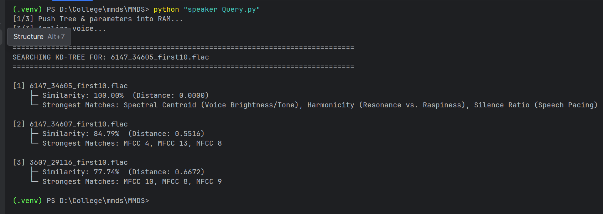
- Using file outside dataset
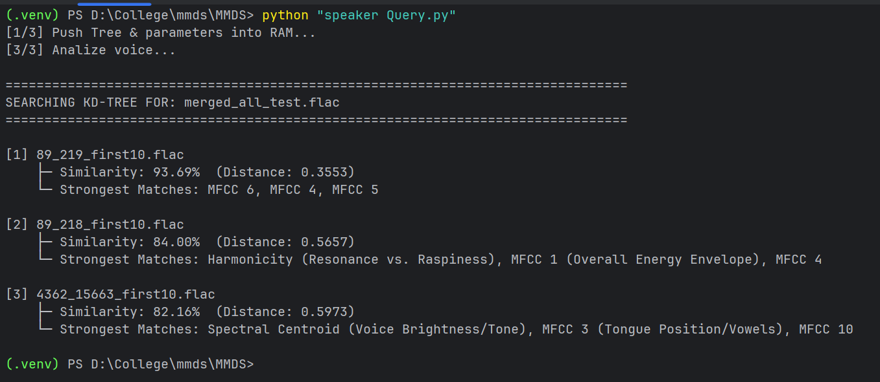

Feature for Content

Features using
TF-IDF stands for Term Frequency-Inverse Document Frequency, it is a mathematical scoring system used to figure out how "important" or "meaningful" a specific word is to a single document when compared to a whole database of documents. It highlights the unique keywords that define a document's core topic, while actively ignoring common, meaningless words.
Imagine you have a transcript of a lecture about "Machine Learning." If you only count how many times each word appears, the top words will probably be "the", "a", "is", and "to." If a user searches for "Machine Learning," the system wouldn't know which file to return because every single file in the database contains the words "the" and "is."
TF-IDF solves this problem by balancing two rules:
- Rule 1: If a word appears many times in a specific file, it is probably important to that file's topic.
- Rule 2: However, if that same word appears in every file in the database, it is actually just a common vocabulary word and has no distinguishing value.
By applying these rules, TF-IDF gives high scores to topic-specific words (like "algorithm" or "database") and gives a score of zero to common stop-words.
The TF-IDF score is created by multiplying two separate metrics together: TF and IDF.

Term Frequency (TF)
This measures how frequently a specific word () appears inside a single document (). The more it appears, the higher the TF score.

Inverse Document Frequency (IDF)
This measures how rare or unique the word is across the entire database of documents . It uses a logarithmic scale to penalize words that show up everywhere.
Logic check: If the word "the" appears in all 500 documents in our database, the fraction becomes 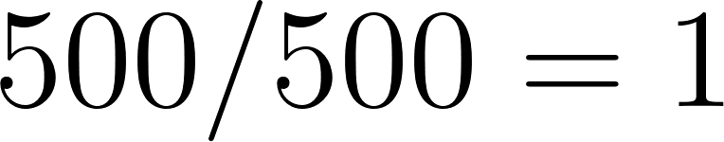. The logarithm of  is  (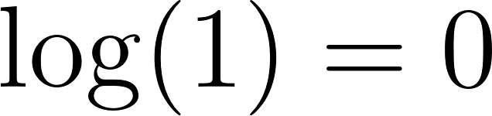). Therefore, the IDF score for "the" becomes , completely wiping out its importance.

The Final Score (TF-IDF)
Finally, the two values are multiplied together to get the final weight of the word for that specific document:

Extract method
Here is how the system extracts the content step-by-step:
- Step 1: Transcription (The Whisper Model) The system feeds these audio files into an advanced, offline Speech-to-Text artificial intelligence model. It "listens" to the audio and transcribes the spoken words into a single string of plain English text.
- Step 2: Text Processing and Tokenization It cleans the text by removing punctuation and making everything lowercase. Then, it splits the sentences into individual words—a process called "tokenization."
- Step 3: Applying the TF-IDF Algorithm The system gathers the processed transcripts from all the audio files across the entire dataset. It feeds this massive collection of words into a Python-based TF-IDF tool. The tool scans every transcript, counts the word frequencies, compares them against the whole dataset, and calculates the final TF-IDF decimal score for every single word.
Once this extraction and calculation phase is complete, the resulting data is ready to be saved into the database using the Inverted Index strategy.

Storage Method and Query
We use an Inverted Index stored inside a PostgreSQL database:
- The Keyword Table: Stores every unique word found across all files, assigning each a unique ID.
- The Audio Table: Stores the metadata for each audio file.
- The InvertedFile Table: Instead of storing zeros, this table only records actual matches. It connects an Audio ID to a Keyword ID and saves the specific TF-IDF score for that pair.
By organizing the data this way, the database remains lightweight. We also apply a B-Tree Index to the keywords, allowing the system to look up words in milliseconds, even if the vocabulary grows to hundreds of thousands of words.
When a user uploads a new audio file to search for similar content, the system follows a logical matching process:
- Step 1: Extract Query Words by using the Whisper model to transcribe the new, unknown audio file into text. It then extracts the unique vocabulary words from this transcript.
- Step 2: Database Lookup The system takes these query words and searches for them in the Keyword table. If it finds a match, it looks into the InvertedFile table to see which audio files in our database also contain these words.
- Step 3: Calculating the Match Score The system uses an SQL query to sum up the TF-IDF scores of the matched words for each file.
- Example: If the query and a database file both share the word "the" (TF-IDF = 0), the score goes up by 0. But if they both share the word "database" (TF-IDF = 0.8), the file's total match score increases significantly.
- Step 4: Ranking The system ranks the audio files based on their total match_score in descending order. The Top 3 files with the highest accumulated scores are returned to the user.

Demo
- Input and transcript
input_file = r"D:\College\mmds\merged_all_test.flac"

if not os.path.exists(input_file):
print(f"Error: Input file '{input_file}' not found.")
return

print(f"\n[3/4] Processing input audio: '{os.path.basename(input_file)}'")
print(" Listening and transcribing audio to text...")

# Transcribe the audio file into a text string
transcribe_result = stt_model.transcribe(input_file, language="en", fp16=False)
input_text = transcribe_result["text"].lower()
input_words = tuple(set(input_text.split()))
- The AI listens to the input audio file and converts the spoken words into a long string of text. The code then converts the text to lowercase, chops it into individual words, and removes any duplicates.
- Database Query:
if input_words:
query = """
SELECT a.fileName, SUM(i.tf_idfScore) as match_score
FROM InvertedFile i
JOIN Keyword k ON i.keywordId = k.keywordId
JOIN Audio a ON i.audioId = a.audioId
WHERE k.word IN %s
GROUP BY a.audioId, a.fileName
ORDER BY match_score DESC
LIMIT 3;
"""
try:
cursor.execute(query, (input_words,))
top_3_results = cursor.fetchall()
- It sends your spoken keywords to the database's Inverted Index. The SQL query finds every file that contains those words, adds up their TF-IDF scores to calculate a total match_score, sorts them from highest to lowest, and grabs the top 3 most relevant audio files.
- Display:
print("\n" + "=" * 50)
print("TOP 3 CONTENT MATCHES (BASED ON TF-IDF)")
print("=" * 50)

if top_3_results:
for rank, (file_name, score) in enumerate(top_3_results, 1):
print(f" Rank {rank}: {file_name}")
print(f" -> Similarity Score: {score:.4f}\n")
else:
print("No matching content found in the database for these keywords.")

except Exception as e:
print(f"Query execution failed: {e}")
conn.rollback()
else:
print("No words were recognized in the input audio to perform a query.")
- Running test
- Using file in the dataset (6147_34605_first10.flac)
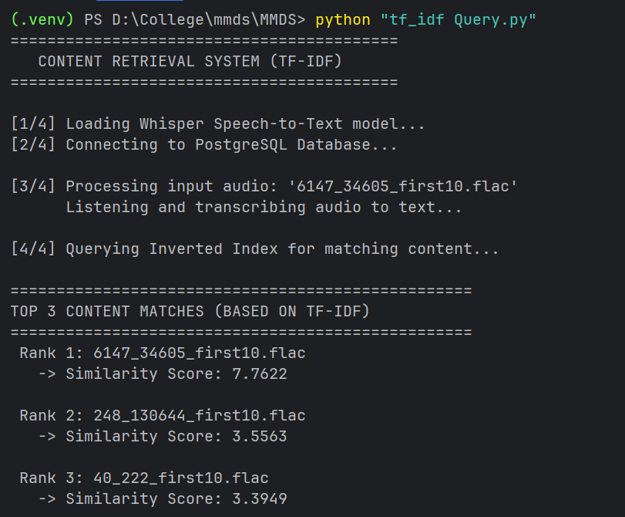
- Using file outside dataset
