**PE07: Programming Exercise**

**Instruction**

Setting up a local web application backend using Kubernetes and Minikube provides an efficient environment for development and testing. The ability to replicate production-like settings locally simplifies deployment and debugging, enhancing overall development workflow.

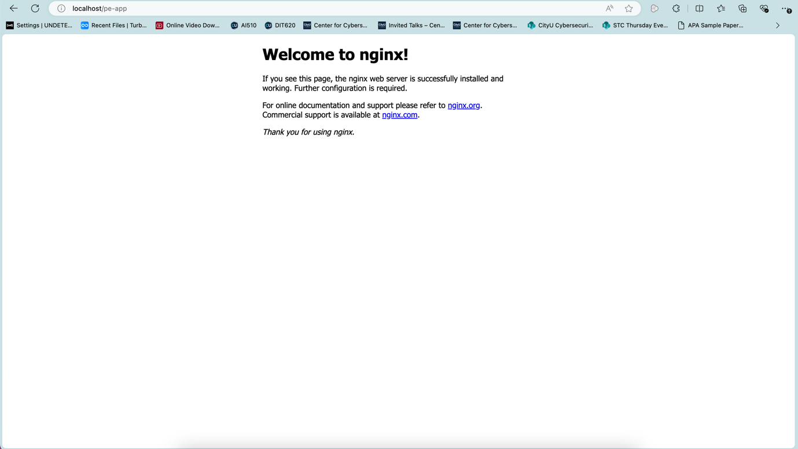

Github: <https://github.com/hazhar463/ai510-summer-2024-pe07.git>