Lab #4a:

CLIENT-SIDE SCRIPTING (JAVASCRIPT)
Topic | Web page development using HTML and Scripting (JavaScript)
Domain of Learning | Psychomotor (P2: Set; P3: Guided Respond; P4: Mechanism)
Learning objective | To apply HTML and JavaScript effectively to develop interactive, functional, and visually appealing web pages, demonstrating a thorough understanding of syntax, structure, event handling, and DOM manipulation to enhance user experience.
Lab activity objective | Apply HTML tags and JavaScript functions effectively to meet specific requirements, demonstrating a solid understanding of event handling, loops, and DOM manipulation in web development.
Name | MOHAMAD HAZIM DANIEL BIN MARZUKI
Matrix Number | CI230093

Instruction: Answer all questions.

- Write an HTML with JavaScript statements to change the content of the <p> to “Hello there!”.

<div id="myElement">
<p>Welcome to my website!</p>
</div>

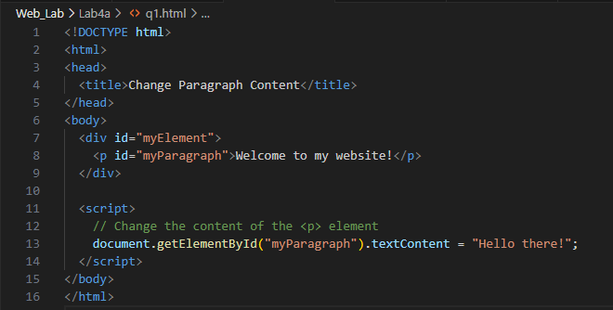


- Based on the HTML code below, write an HTML with a JavaScript function named checkInput() that uses if else condition to validate if the number entered is lower or higher than 10. If it is lower than 10, then make an alert of “The number is lower than 10”, otherwise “The number is higher than 10”. If the user entered other than numbers (eg:alphabets), alert “Please insert a number!”.

<input type="text" id="userInput" placeholder="Enter a number">
<button onclick="checkInput()">Check</button>

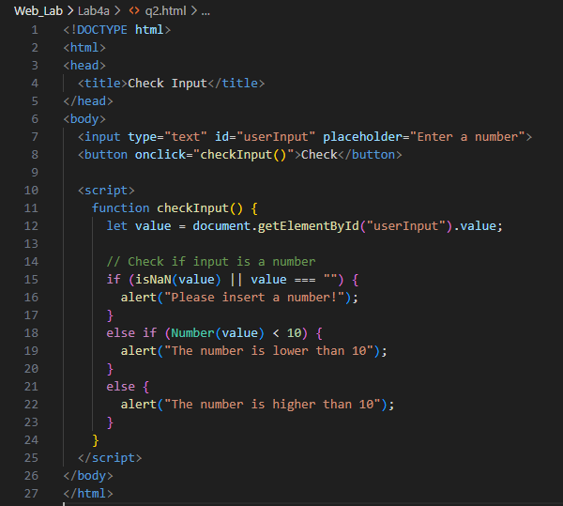
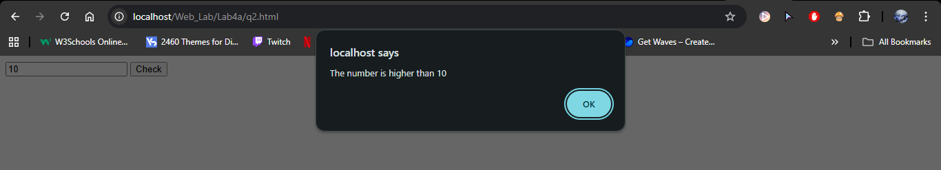

- Complete the JavaScript code below to produce the expected output. Write your answer in a complete HTML code.
<p id="demo"></p>

<script>
let text = "";

for (let i = 0; //complete your answer here) {
text += "The number is " //complete your answer here
}

document.getElementById("demo").innerHTML = text;
</script>

Expected output:

The number is 1
The number is 2
The number is 3
The number is 4
The number is 5

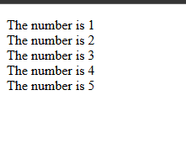

- Push all codes to your GitHub repository.

- Copy your answer and screenshot the output in Microsoft Word. Include your GitHub repository link. Submit through Author in PDF format.

Assessment:

A. JavaScript Functionality and Code Quality (CLO2 - Psychomotor)

Criteria | Excellent (5) | Good (4) | Satisfactory (3) | Needs Improvement (1-2) | Unsatisfactory (0) | Marks
Use of Functions (P4) | Creates and applies multiple well-structured functions, demonstrating clear understanding and purpose (e.g., reusable functions for events or DOM updates). | Uses functions effectively with minor improvements needed, demonstrating understanding of basic function structure. | Uses functions but with limited complexity or minimal reusability. | Basic functions are implemented but lack proper structure or purpose. | No functions applied in the code. | ___/5 x 5
Use of For Loops (P4) | Implements `for` loops efficiently, utilizing them for DOM manipulation or repetitive tasks, showing complete comprehension. | `For` loops are present and functional, though could be optimized or improved. | Basic `for` loops are used correctly but lack complexity or flexibility. | Minimal use of `for` loops; lacks comprehension of loop structures. | No `for` loops used in the code. | ___/5 x 6
Code Quality (P2) | Code is well-organized, readable, and follows best practices with clear comments. | Generally well-organized code with minor readability issues. | Code is functional but lacks readability or structure. | Poorly organized code with minimal comments or structure. | Code is unorganized and hard to follow. | ___/5 x 4
Total |  |  |  |  |  | /15

B. Presentation and Understanding of Concepts (CLO3 - Affective)

Criteria | Excellent (5) | Good (4) | Satisfactory (3) | Needs Improvement (1-2) | Unsatisfactory (0) | Marks
Clarity and Confidence (A1) | Presents with clarity, confidence, and engages the audience effectively. | Generally clear with minor confidence issues. | Presentation is adequate but lacks confidence. | Lacks clarity and confidence, minimal engagement. | Presentation is difficult to follow. | ___/5 x 2
Explanation of JavaScript Concepts (A2) | Demonstrates thorough understanding of JavaScript concepts, effectively justifying code choices. | Good understanding with justification for most choices. | Basic understanding with minimal justification. | Limited understanding, struggles to justify choices. | Lacks understanding of JavaScript concepts. | ___/5 x 3
Total |  |  |  |  |  | /5

