Food Batch Handoff Design
The supplier records dispatch and the named retailer acknowledges receipt. Both can check the history of the same batch when a delivery is disputed.

The problem
A supplier sends food to a retailer. The supplier records when the batch leaves, and the retailer records when it arrives. If their records disagree, staff have to compare delivery notes to work out what happened.

Comparison with current practice
In 2025, Tesco and ten suppliers used QR codes that capture batch numbers and use-by dates (GS1 UK, 2025). Scanning the label identifies the batch. Our design keeps the batch identifier and adds a shared delivery record.
If the supplier marks B-104 as dispatched, both parties can see whether the retailer has acknowledged delivery. An unconfirmed batch still needs investigation. It could be in transit, or staff might have forgotten to record its arrival.

Proposed business model
The supplier would pay to register and dispatch each batch, and the retailer would pay to record receipt. Both businesses would need to train staff. The supplier could follow up on outstanding deliveries, while the retailer would control its own acknowledgement.
If both businesses trust one organisation to manage a shared database, that option may cost less. The case for blockchain depends on how much they value independent control of their entries.

Benefits and limitations
A shared history could reduce time spent comparing paperwork. Its accuracy still depends on the people entering the data. A receipt for the wrong batch or an overlooked defect would leave a misleading record.

Proposed workflow
- The supplier registers B-104 and names the receiving retailer.
- When the batch leaves, the supplier marks it as dispatched.
- The retailer checks the delivery against its label and requests confirmation.
- The contract records receipt only if the batch was dispatched and the request comes from the named retailer.
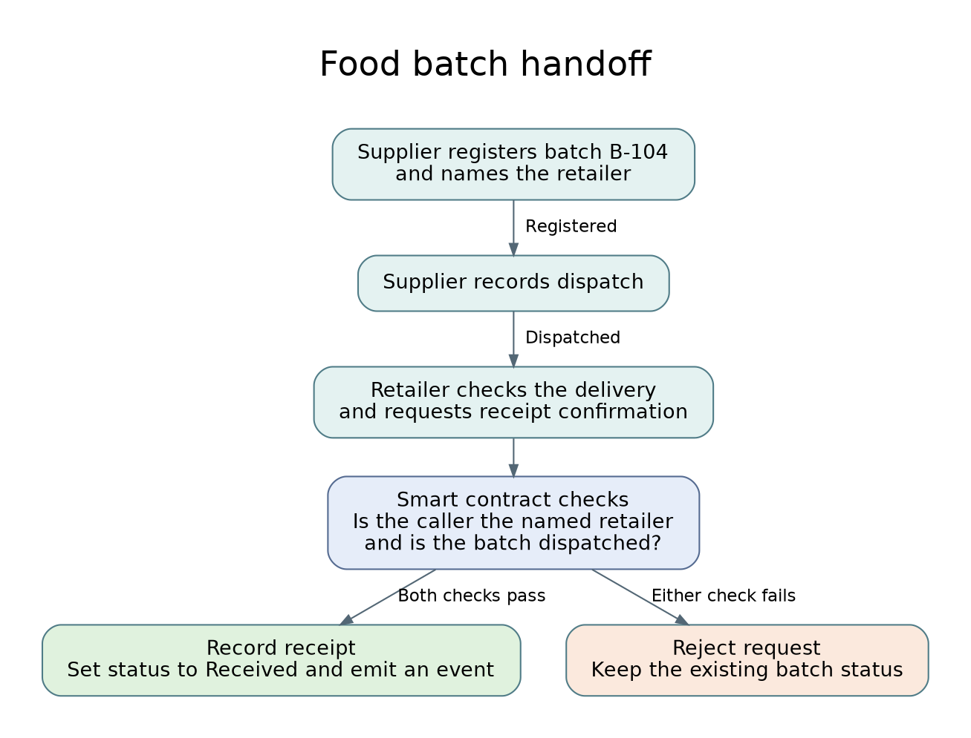
Figure 1. The smart contract accepts or rejects the receipt request.

Technology and verification

How the app recognizes the receiver

Cryptographic method
We chose the Elliptic Curve Digital Signature Algorithm (ECDSA) because the central security question is who authorized a change. The supermarket’s wallet signs the receipt transaction with its private key. Ethereum uses the signature to identify the sending account. Changing the signed batch identifier would invalidate the signature for that account (Ethereum.org, n.d.-b).
The smart contract then compares the sender’s address with the retailer recorded for B-104. Another shop could submit a correctly signed transaction of its own, but the address check would reject it. The same rule prevents the farm from confirming on the supermarket’s behalf.

A recent development that could reduce fees
Ethereum’s Dencun upgrade introduced blobs in March 2024. A layer-2 rollup can use blobs to publish data for many transactions together at lower cost (Ethereum.org, n.d.-a). A live version could use such a rollup so that individual handoffs share the publishing cost. The classroom prototype will use Ganache to demonstrate the rules. Actual fee savings would need to be measured on the chosen network.

How we will test the handoff
Action | Expected result
Supplier registers B-104 and names retailer | Registered
Named retailer confirms before dispatch | Rejected. Still Registered.
Supplier marks B-104 as dispatched | Dispatched
Different account confirms receipt | Rejected. Still Dispatched.
Named retailer confirms after dispatch | Received
Named retailer confirms again | Rejected. Still Received.

References
Ethereum.org (n.d.-a) Danksharding. https://ethereum.org/roadmap/danksharding/ (Accessed 10 November 2026).
Ethereum.org (n.d.-b) Ethereum accounts. https://ethereum.org/developers/docs/accounts/ (Accessed 10 November 2026).
GS1 UK (2025) Tesco in early trials of next generation barcodes in move set to reshape UK retail, 23 April. https://www.gs1uk.org/insights/news/Tesco-in-early-trials-of-next-generation-barcodes (Accessed 10 November 2026).

