**Lab 1**

*Project 1: Share Your Travel Photos*

**Overview**

This project is the first step in the creation of a travel photo sharing website. The page you are given is augmented by this project to add a Related Photos section to the page.

**Instructions**

1. Open chapter02-project01.html in the editor of your choice, so you can start making changes.

2. Open a browser and direct it to the same file (or double click the file in most operating systems). You should see a page like the top part of Figure 2.23.

3. Start by adding a link to Related Photos, in the unordered list that currently contains Descriptions and Reviews. (You can make the href attribute point to # for the moment.)

4. Now go down to the bottom of the page and add the new Related Photos <section>.

5. In the new section add three images from the ones provided in the images folder. Use the small images related-square1.jpg, related-square2.jpg, and related-square3.jpg in the src of your <img> tag, but link to the large images with almost the same names.

**Test**

1. Firstly, test your page by seeing if it looks like the one in Figure 2.23.

2. Now check that the link correctly links the Related Photos link to the newly

defined section, and that clicking on the related images brings up the larger

versions.

3. Validate the page by either using a built-in tool in your editor, or pasting the HTML into http://validator.w3.org/ and ensure that it displays the message: This document was successfully checked as HTML5!

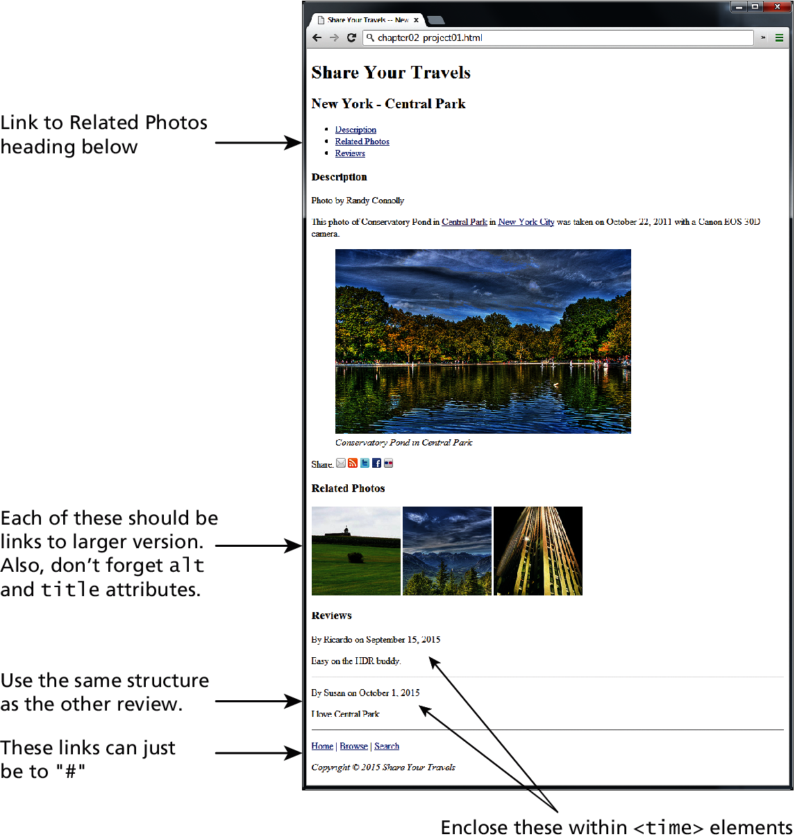

**Figure 2.23**

*Project 2: Book Rep Customer Relations Management*

**Overview**

This project is the first step in the creation of a CRM website. In this project you will be augmenting the provided page to use semantic HTML5 tags.

**Instructions**

1. Open chapter02-project02.html in the editor of your choice, and in a browser. In this project the look of your page will remain unchanged from how it looks at the start as shown in Figure 2.24.

2. Reflect on why adding semantic markup is a worthwhile endeavor, even if the final, rendered page looks identical.

3. Replace and supplement generic HTML tags like <div> with semantic tags like <article>, <nav>, or <footer> (for example). Some parts make sense to wrap inside a tag such as <section> or <figure>.

**Test**

1. Firstly, test your page side by side with the original in a browser to make sure it looks the same.

2. Validate the page by either using a built-in tool in your editor, or pasting the HTML into http://validator.w3.org/ and seeing if it passes. You will notice to pass it must do many extra things like have alt attributes on <img> tags.

*Project 3: Art Store*

**Overview**

This project is the first step in the creation of an art store website. Unlike the previ- ous exercises, your task is to create an HTML page from scratch based on the image in Figure 2.25.

**Instructions**

1. Define your own chapter02-project03.html file in the editor of your choice, and open it in a browser.

2. Add markup and content, making best guesses as to what HTML markup to use.

3. Remember to try and get in the habit of using semantic markup, since it adds meaning and has no visual impact.

**Test**

1. Display your page in a browser, and determine if it looks like Figure 2.25. 2. Validate the page by pasting the HTML into http://validator.w3.org/ and seeing if it passes.



**Figure 2.24**

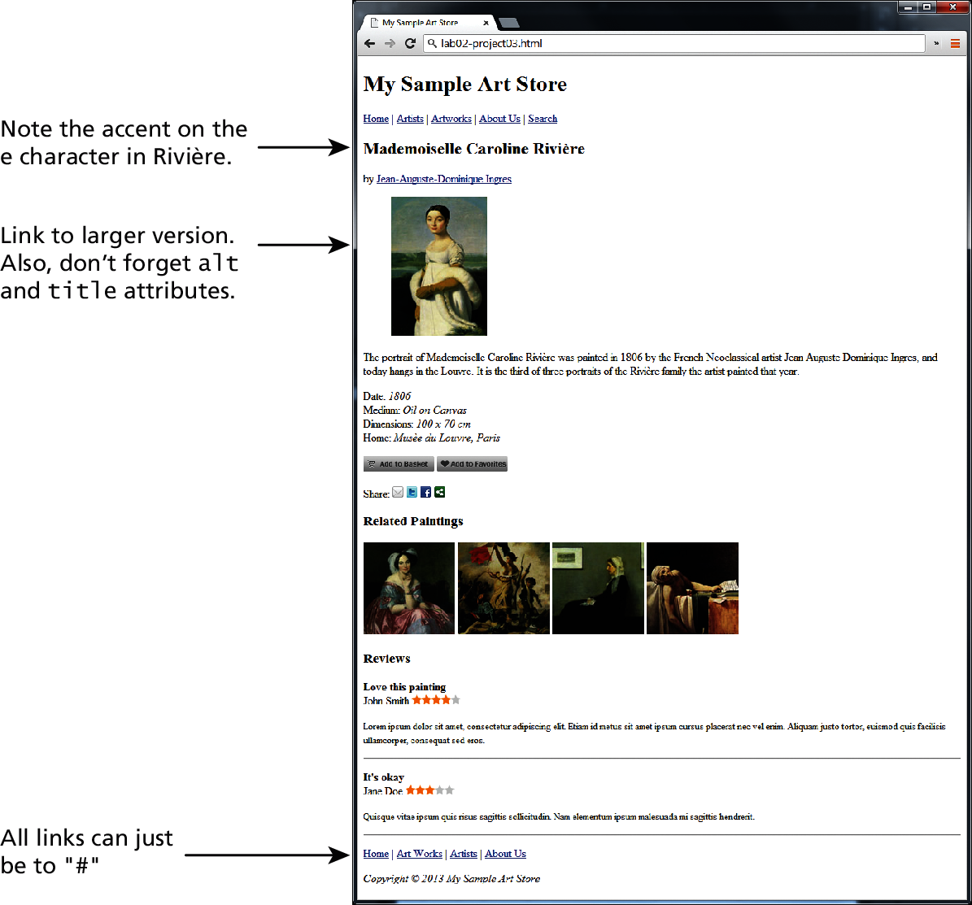

**Figure 2.25**

Reference: Connolly, Randy. *Fund of Web Development GE*. P.Ed Australia, 20141110.