ChirpStack Milesight Sensor Manual
  - Sign in, prepare a device profile, and add a sensor
This guide follows the ChirpStack v4.11.1 interface at https://chirpstack.camartcctv.com. It covers sign-in, Milesight device profiles and decoders, device registration, activation, and the first uplink.

Before you start
Have ready | Why it matters
ChirpStack account | Use an account authorized for the target Tenant and Application. Do not put the password in this manual.
Milesight sensor details | Get the exact model, firmware version, DevEUI, join method, LoRaWAN MAC version, device class, region, and reporting interval from the device label and product documentation.
Network configuration | Know the tenant, Application, frequency plan and channels used by the gateway. Check whether a matching Device Profile already exists.
Provisioning credentials | For OTAA, obtain the root key or keys from the secure provisioning source. For ABP, obtain the device address and session keys.

Sign in
1. Open the server. Visit https://chirpstack.camartcctv.com.
2. Enter your account. Type your authorized username or email and password, then select Submit.
3. Confirm access. The workspace should show the Tenant navigation. Make sure the target Tenant and Application are available.
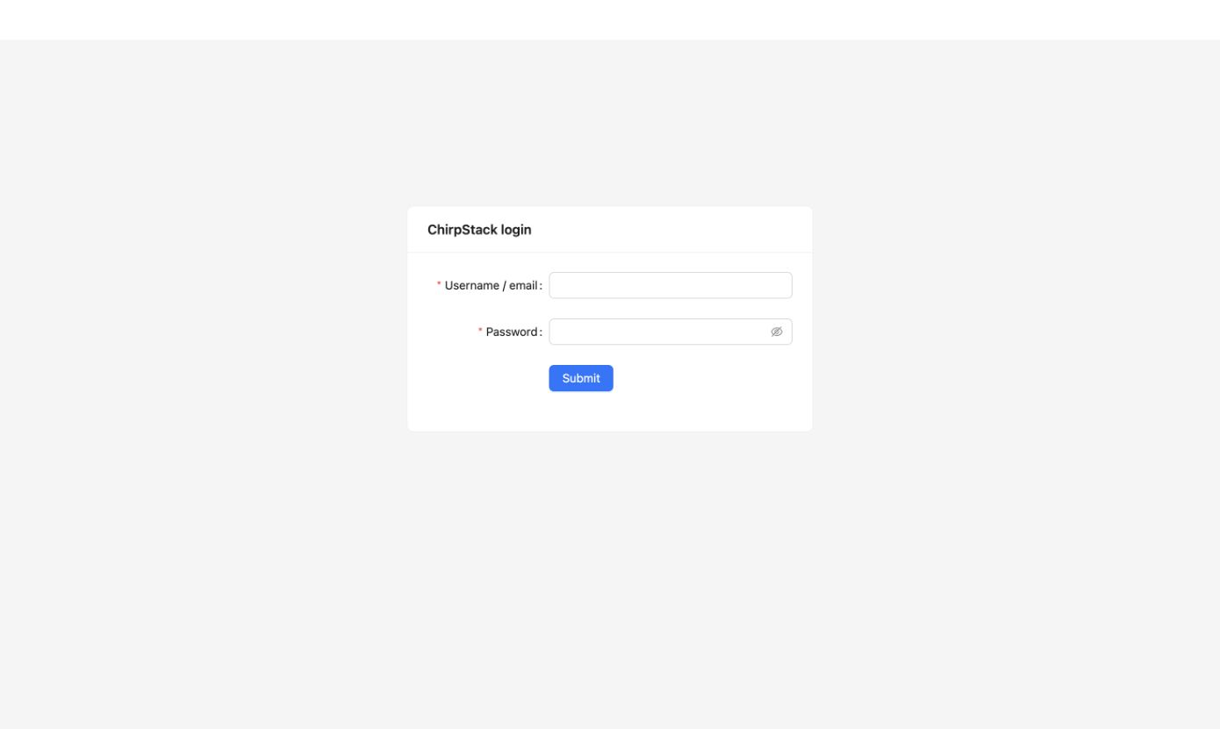
ChirpStack login page. Use the account credentials issued to you.

Prepare a Milesight Device Profile
A Device Profile is required before adding the sensor. It tells ChirpStack the sensor's radio capabilities, join method, and payload codec. In Tenant > Device Profiles, use an existing profile only when its model and settings match the sensor; otherwise select Add device profile.
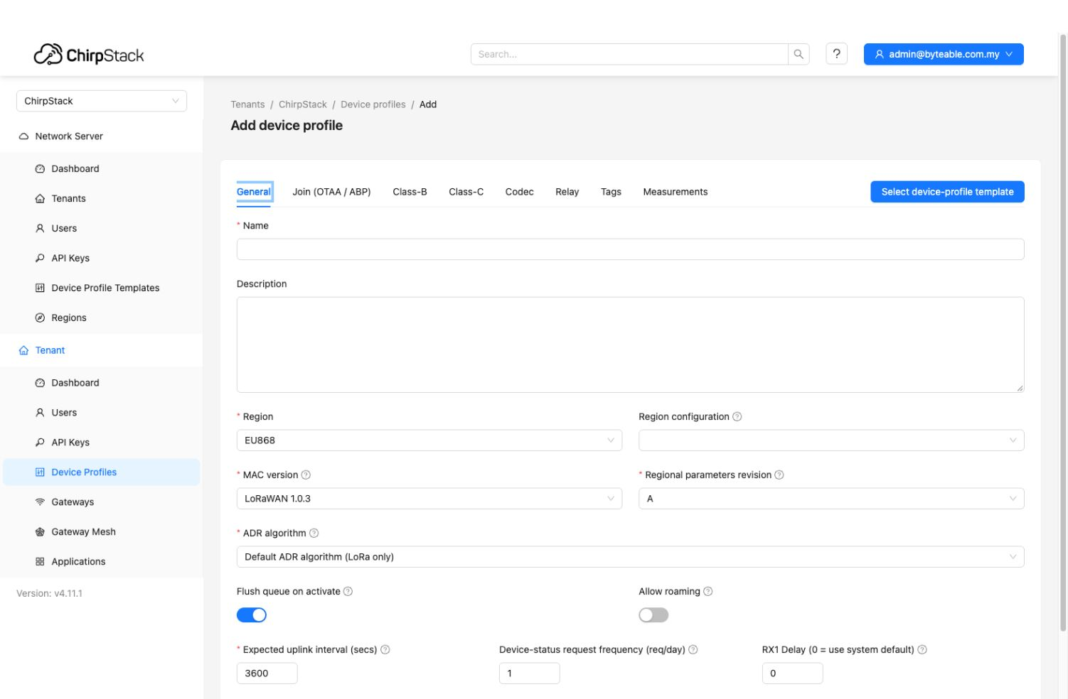
Add device profile, General tab. Values shown are form defaults; set them for the actual sensor and network.

Populate the General tab
Field | How to set it
Name and Description | Use a model-specific name, optionally with region and join method, such as EM300-TH AS923 OTAA. Note the firmware or hardware variant in Description.
Region and configuration | Match the sensor's frequency plan and the gateway/network configuration. Existing profiles here include AS923, but choose the actual deployment plan. Do not leave the screenshot's EU868 default without checking.
MAC version and revision | Use the exact LoRaWAN MAC version and regional parameters revision specified for this sensor and firmware. Existing profiles vary, so do not copy another model's value or rely on the default.
ADR and timing | Use the deployment's ADR algorithm. Set Expected uplink interval to the sensor's reporting period in seconds. Keep RX1 delay and device-status frequency aligned with the device/network plan.

Other tabs In Join (OTAA / ABP), enable Device supports OTAA for an OTAA sensor; turn it off for ABP. Enable Class-B or Class-C only if the model and deployment use that class. Save with Submit after completing Codec on the next page.

Add the Milesight payload decoder
Milesight publishes model-specific payload decoders in its SensorDecoders GitHub repository: github.com/Milesight-IoT/SensorDecoders. Select the folder and decoder file for the exact sensor model and revision.
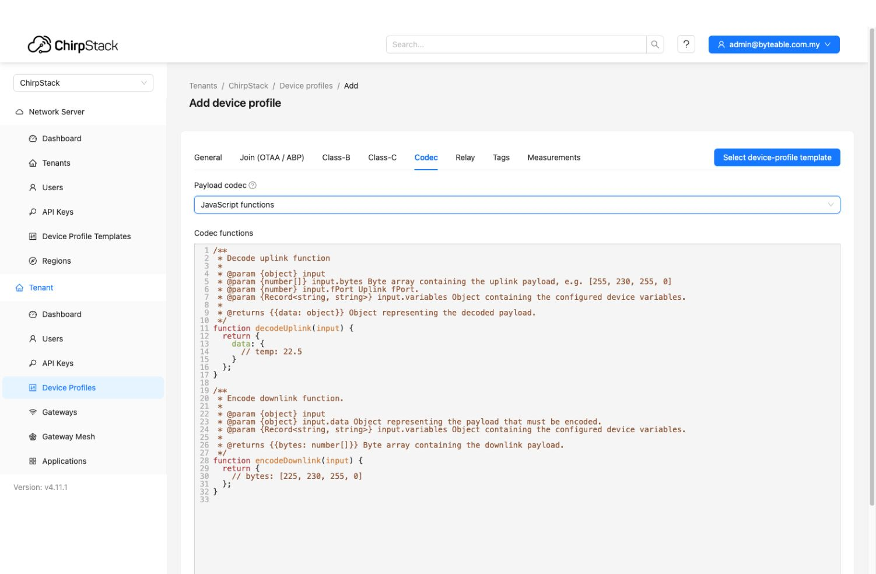
Device Profile Codec tab with JavaScript functions selected. Replace the sample functions with the model's decoder.
1. Open Codec. On the Device Profile form, select Codec, then set Payload codec to JavaScript functions.
2. Find the model decoder. In Milesight's repository, open the matching product-series and model folder. Use the model's decoder JavaScript file, not a different sensor or a cellular variant.
3. Paste the ChirpStack v4 code. Replace the sample Codec functions with the model-specific decoder. Retain the ChirpStack v4 decodeUplink(input) wrapper and all helper functions it calls. Remove wrappers for other platforms when Milesight's file includes them.
4. Save and verify. Select Submit, then add a sensor using this profile. After its first uplink, check Events for decoded data fields and compare them with the sensor's expected measurements.
One profile per configuration Sensors may share a profile when model, firmware behavior, region, join method, class, and decoder are compatible. If any of these differ, create a separate profile so future devices use the correct settings.

Choose an Application and add a Milesight sensor
A device belongs to an Application. Select the existing Application that owns the device data and integrations.
1. Open Applications. In the left navigation, go to Tenant > Applications.
2. Open the target Application. Select the Application that should contain this device. If none exists, create one with Add application.
3. Start device creation. In the Application, select Add device. The form opens on the Device tab.
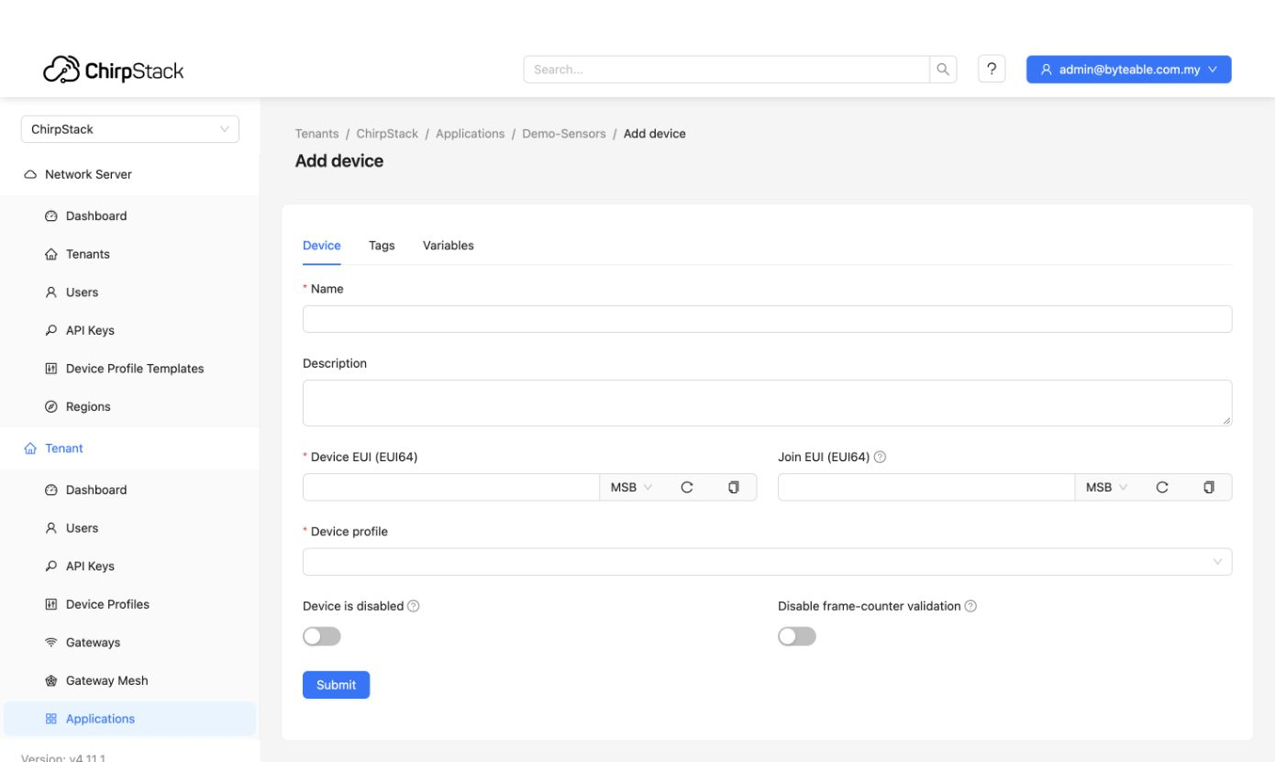
Add device form. Required identity and profile fields are marked with an asterisk.

Complete the Device tab
Field | What to enter
Name | A clear label such as site, asset, and model. This name appears in lists and events.
Description | Optional operational context such as location or installation notes. Never put passwords or keys here.
Device EUI (EUI64) | Enter the 16-character DevEUI. Match the MSB or LSB selector to the vendor's format; reverse bytes only when the device documentation says to.
Join EUI (EUI64) | Optional in many deployments. Enter the vendor or Join Server value when required. ChirpStack uses it for external Join Server routing; follow the deployment configuration.
Device profile | Choose the Milesight model profile you checked or created on the previous pages. Confirm its region, MAC version, revision, join method, class, and decoder match this sensor.
Device options | Leave Device is disabled off for active devices. Keep frame-counter validation on unless approved troubleshooting requires a temporary change.

Before Submit Check the DevEUI, EUI byte order, Application, and Device Profile against the device label and network plan. Tags and Variables are optional; never use them for secrets. Select Submit to create the record, then configure activation credentials.

Set the activation method
The Device Profile determines whether the device uses OTAA or ABP. Use the same activation method and LoRaWAN version in ChirpStack and the device firmware.
Method | Where in ChirpStack | Provisioning values
OTAA | Open the device, then choose OTAA keys. ChirpStack documentation calls this Keys (OTAA). | For LoRaWAN 1.0.x, set the AppKey. For LoRaWAN 1.1, set both AppKey and NwkKey. Use the same root keys programmed into the device. Enter JoinEUI when the Join Server or device setup requires it.
ABP | Open the device, then choose Activation. | Enter DevAddr and session keys. LoRaWAN 1.0.x uses NwkSKey and AppSKey; LoRaWAN 1.1 uses NwkSEncKey, SNwkSIntKey, FNwkSIntKey, and AppSKey. Do not enter OTAA root keys in ABP fields.

Protect keys LoRaWAN keys are secrets. Keep them out of this manual, screenshots, tickets, and ordinary notes. Store and enter them using the approved secrets-handling process.

Verify the first join
1. Check the gateway. Confirm that a gateway for the device's region is connected and active.
2. Start the device. Power it on or trigger its join procedure within gateway coverage.
3. Review activity. Open the device's Events or LoRaWAN frames view. For OTAA, look for an accepted join followed by an uplink, then confirm Last seen updates.

Common checks
Symptom | Check
No frames appear | Confirm the device is transmitting, the gateway is online, and both use the same regional frequency plan and channels.
Join is rejected | Compare DevEUI, JoinEUI routing, OTAA root keys, Device Profile activation type, and LoRaWAN MAC version with device configuration.
Profile is missing | Create or request a Device Profile under Tenant > Device Profiles with the correct region, LoRaWAN versions, class, and activation method.
Uplink has raw bytes only | Check the profile's Codec tab. Select JavaScript functions and install the Milesight decoder for the exact sensor model; then inspect a new uplink.

Official references
ChirpStack documentation - Devices
ChirpStack documentation - Device profile
Milesight - ChirpStack V4 Integration
Milesight SensorDecoders on GitHub

