PRODUCT REQUIREMENTS DOCUMENT

Global Energy Crisis
Command Center

Interactive Economics Dashboard Application
2026 Iran War | Strait of Hormuz Blockade | Real-Time Data

Version 1.0 | April 11, 2026
Classification: Internal | Status: Draft

Table of Contents

Executive Summary
The Global Energy Crisis Command Center is a cutting-edge, interactive web application that provides real-time economic analysis and visualization of the 2026 energy crisis triggered by the Iran war and the closure of the Strait of Hormuz. This is the most significant disruption to global energy markets in history, and this application serves as the definitive analytical tool for understanding its cascading economic impacts.

Product Name: Global Energy Crisis Command Center
Version: 1.0 (MVP)
Platform: Web Application (React SPA)
Target Users: Economists, policy analysts, journalists, students, investors, general public
Tech Stack: React 18+, Tailwind CSS utilities, vanilla SVG charts, zero backend dependencies
Data Sources: IEA, EIA (US), OECD, ECB, IEEFA, UN Trade & Development, S&P Global, Kpler, CNBC

Key Value Propositions
- 14 interactive analytical panels covering every dimension of the crisis
- Real-time economic simulation with adjustable parameters (oil price, duration, severity)
- Supply chain cascade visualization showing non-obvious second/third-order effects
- Probability-weighted scenario modeling with 4 distinct geopolitical outcomes
- Stagflation risk dashboard tracking 8 critical macro indicators in real-time
- 100% open-source with zero paid dependencies or API keys required

Problem Statement

Context
The 2026 Iran war and subsequent closure of the Strait of Hormuz has created what the International Energy Agency calls the "largest supply disruption in the history of the oil market." The crisis has shut in 9.1 million barrels per day of oil production, blocked 20% of global oil and LNG flows, damaged 40+ major energy infrastructure assets, and sent Brent crude above $100/barrel.
The economic impacts cascade far beyond energy: fertilizer trade (33% disrupted), helium supply (40% from the Gulf), petrochemicals, shipping routes, aviation, food prices, and industrial output are all severely affected. The UN projects global trade growth halving from 4.7% to 1.5-2.5%.

The Gap
Existing tools for tracking this crisis are fragmented across dozens of sources (IEA trackers, EIA outlooks, ECB projections, shipping monitors). No single application provides an integrated, interactive view of the full economic picture — from oil price dynamics to country-level vulnerability to supply chain cascades to scenario modeling. This application fills that gap.

Feature Specification
The application consists of 14 interactive panels, organized into a tabbed interface. Each panel is designed to provide a specific analytical lens on the crisis.

# | Panel Name | Purpose | Priority | Phase
1 | Overview Dashboard | Executive summary with 6 KPI cards + oil chart + briefing | High | MVP
2 | Hormuz Monitor | Shipping traffic collapse visualization + ceasefire status | High | MVP
3 | GDP/CPI Heatmap | Country-by-country GDP revisions + inflation forecasts | High | MVP
4 | Stagflation Dashboard | 8 macro indicators tracking stagflation risk | High | MVP
5 | Supply Chain Cascade | Interactive node graph of 19 supply chain dependencies | High | MVP
6 | Scenario War Room | 4 probability-weighted geopolitical scenarios | High | MVP
7 | Oil Price Chart | Interactive Brent/WTI 7-month trajectory with events | High | MVP
8 | Supply Disruption | 7 gauges showing disrupted commodity flows | Medium | MVP
9 | Country Vulnerability | 8-country vulnerability index with detailed breakdowns | Medium | MVP
10 | Economic Simulator | 3-slider interactive model: oil price, duration, severity | High | MVP
11 | Crisis Timeline | 12-event expandable timeline with severity ratings | Medium | MVP
12 | Policy Tracker | Filterable feed of 11 global government responses | Medium | MVP
13 | Historical Comparison | 6 major energy crises since 1973 compared side-by-side | Medium | MVP
14 | Energy Transition | 7 indicators tracking green energy acceleration/regression | Medium | MVP

Screen Mockups & UI Specifications
The following wireframe mockups illustrate the core interface design, layout, and data presentation for each major panel. The application uses a dark theme (background #0a0a0f) with a red accent (#ff3b30) creating an urgent, data-rich command center aesthetic.

4.1 Overview Dashboard
The primary landing screen. Features 6 KPI stat cards in a 2-column grid, a situation briefing panel, and an interactive oil price chart with hover tooltips. The header includes a pulsing live indicator and real-time clock.
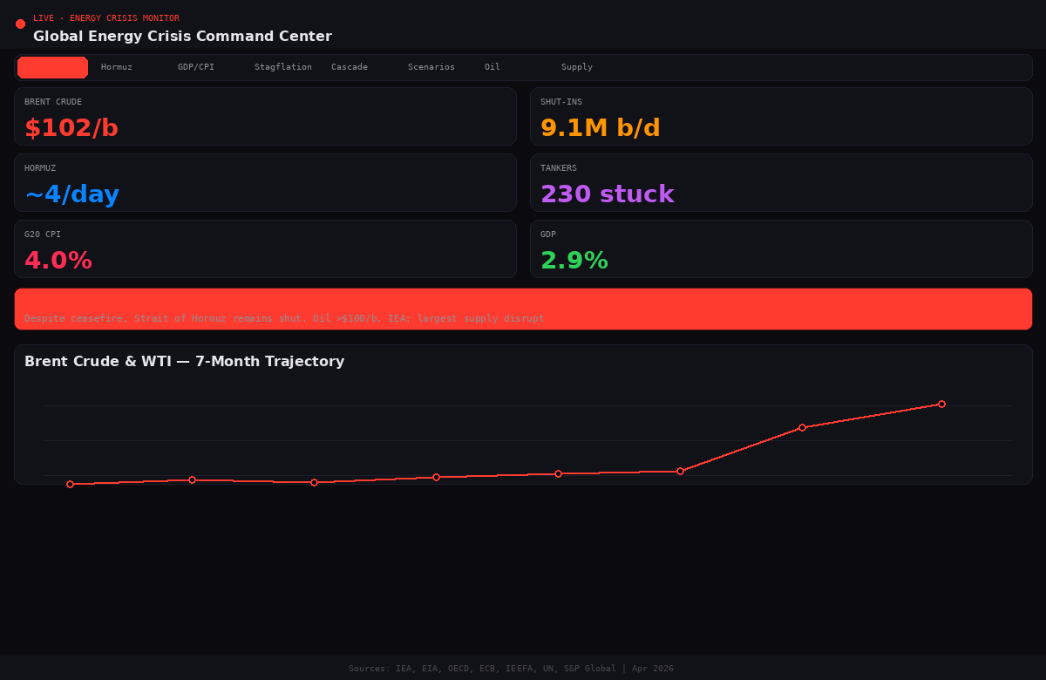

4.2 Hormuz Shipping Monitor
Visualizes the catastrophic decline in Strait of Hormuz shipping traffic from 140 vessels/day pre-war to approximately 4/day post-ceasefire. Includes real-time ceasefire status panel showing tankers waiting (230), Iran toll charges ($2M in yuan/crypto), sea mine status, and recovery estimates. Horizontal bar chart enables instant visual comparison of traffic levels across 9 time periods.
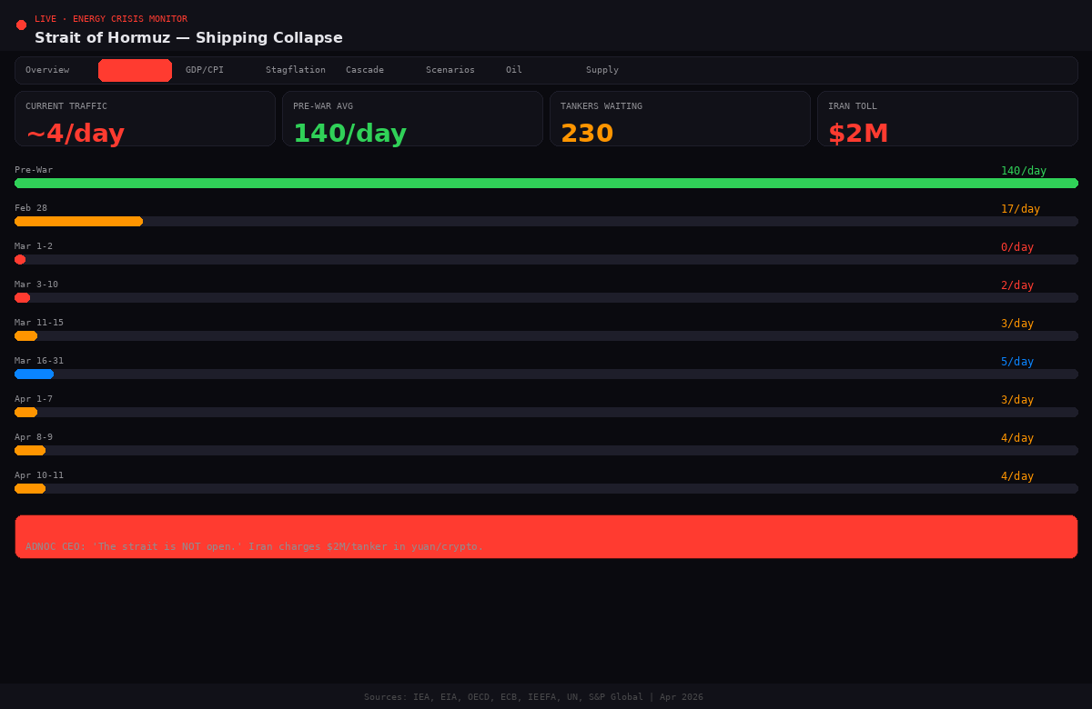

4.3 GDP & Inflation Impact Heatmap
Sortable data grid showing 8 regions/countries with dual-bar visualization comparing GDP revision severity and 2026 inflation forecasts. Users can toggle between sorting by GDP hit or inflation severity. Data sourced from OECD and ECB March 2026 projections. Color-coded from blue (moderate) through orange to red (severe).
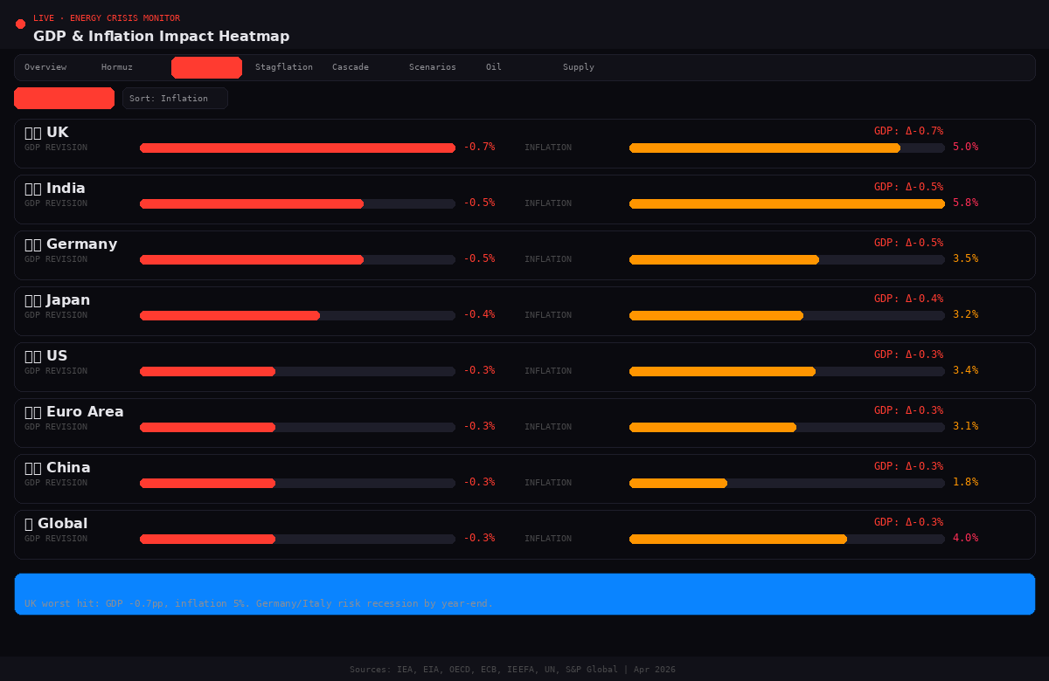

4.4 Scenario War Room
Four probability-weighted scenarios (Swift Resolution 15%, Baseline 45%, Prolonged Blockade 30%, Major Escalation 10%) presented as selectable cards. Each scenario reveals projected oil price (6-month average), GDP impact, inflation addition, trade impact, and estimated recovery timeline. A visual probability distribution bar at the bottom allows instant comparison.
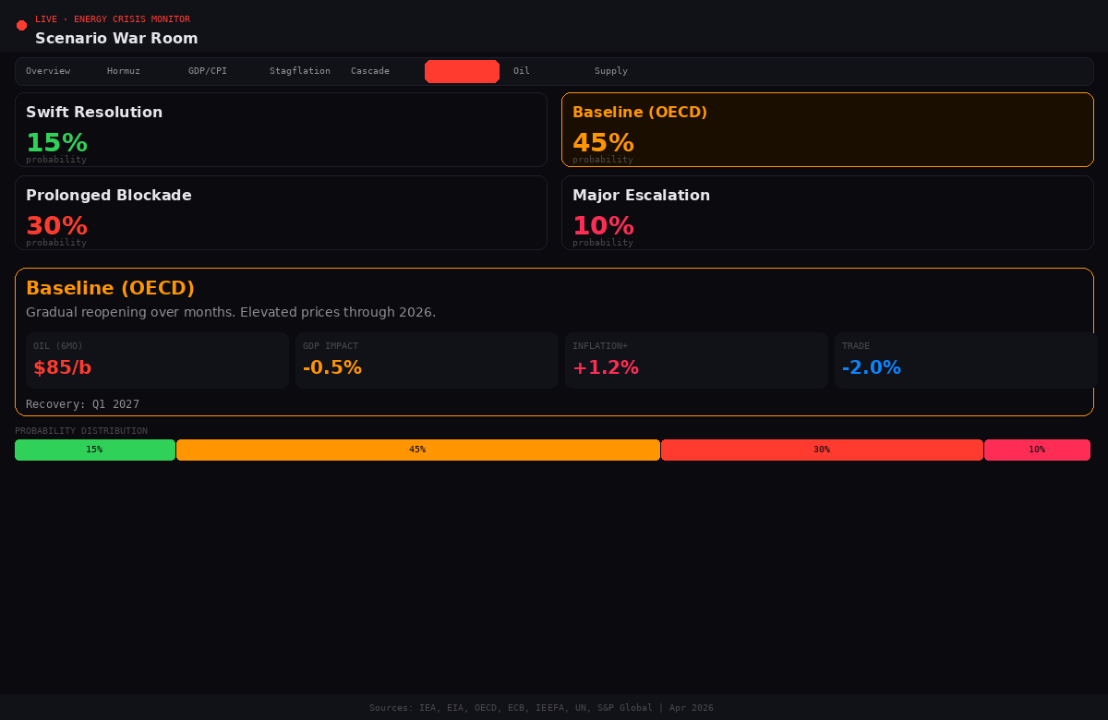

4.5 Supply Chain Cascade Explorer
Interactive node-based explorer with 19 interconnected supply chain nodes. Users tap any node to see its disruption level (0-100%), upstream causes, and downstream effects. Reveals non-obvious cascading relationships like: Helium shortage (40% from Gulf) cascading into semiconductor manufacturing and MRI machine operations globally. Each node shows a description and colored disruption bar.
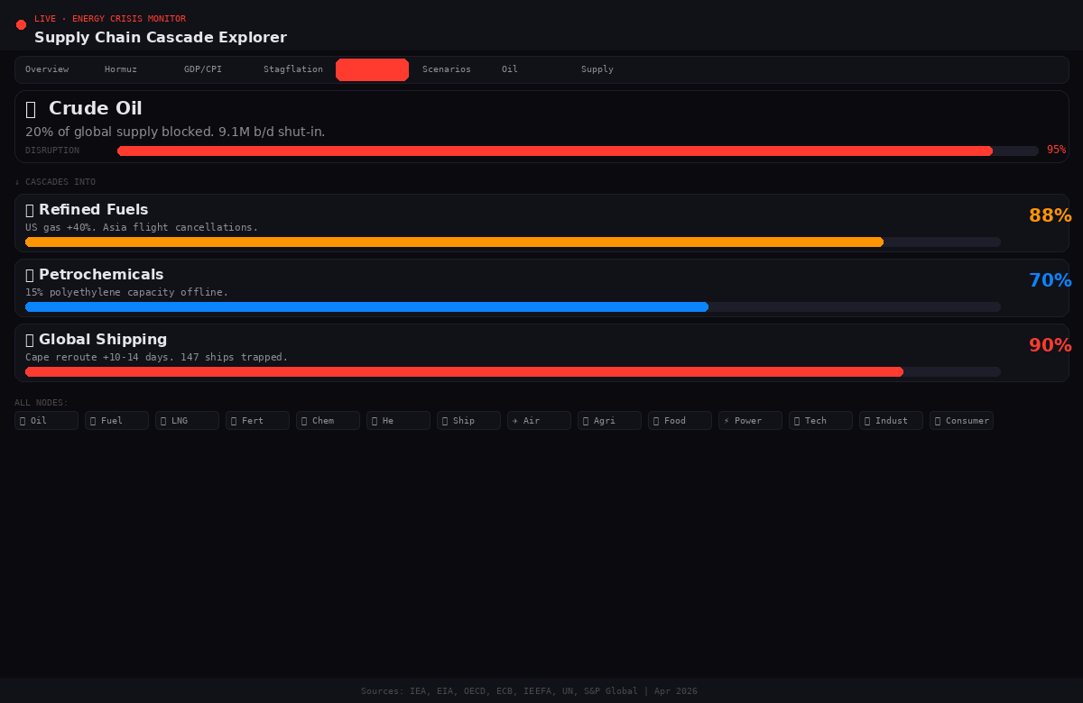

4.6 Economic Impact Simulator
Three interactive range sliders (Oil Price $70-160, Duration 1-18 months, Severity 10-100%) that dynamically compute five output metrics: GDP impact, added inflation, trade slowdown, food price rise, and estimated job impact. All calculations update in real-time as sliders are dragged, enabling rapid what-if analysis. Outputs displayed as large-font stat cards for immediate readability.
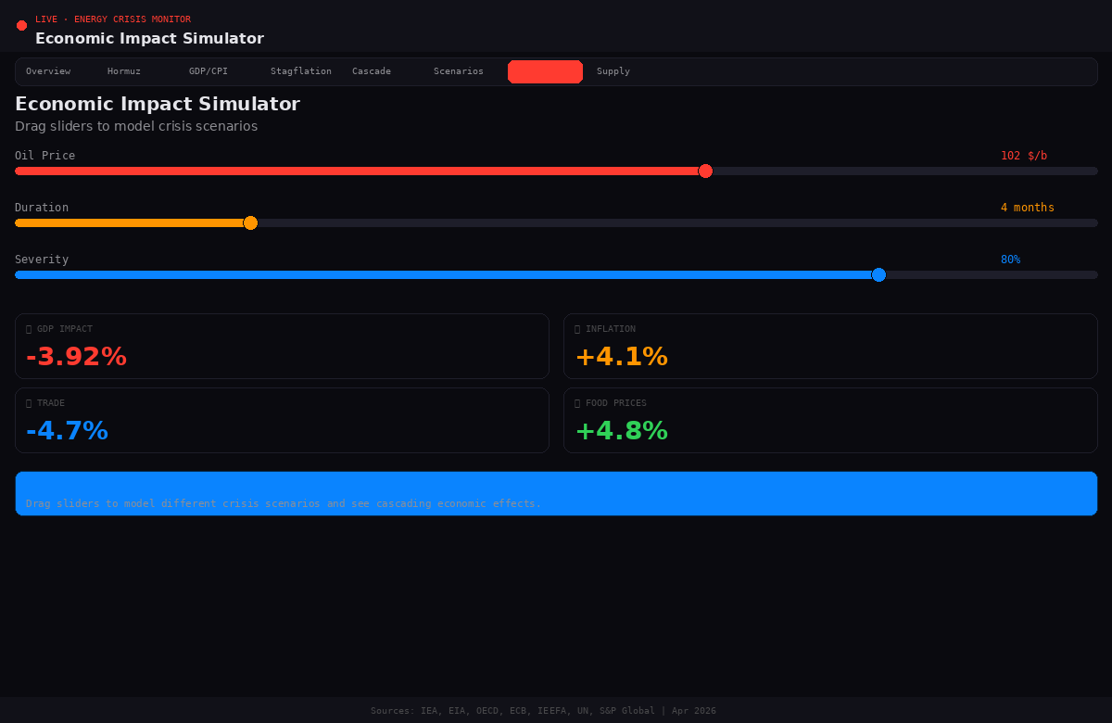

Data Architecture

Data Sources & Methodology
Data Point | Source | Update Frequency | Methodology
Oil prices (Brent/WTI) | EIA Short-Term Energy Outlook | Monthly + daily spot | Official EIA STEO data
Production shut-ins | EIA STEO April 2026 | Monthly | EIA assessment methodology
GDP forecasts | OECD Interim Report Mar 2026 | Quarterly | OECD macro modeling
Euro area inflation | ECB Staff Projections Mar 2026 | Quarterly | HICP-based projections
G20 inflation/GDP | OECD Economic Outlook | Semi-annual | Harmonized projections
Shipping traffic | S&P Global, Kpler, MarineTraffic | Daily | AIS tracking data
Country vulnerability | Energy World Mag / IEEFA | Ad hoc | 7-factor composite index
Policy responses | IEA Policy Response Tracker | Continuous | Country reporting
Supply chain impacts | IEEFA, UN Trade & Dev | Weekly | Expert analysis + trade data
Scenario probabilities | Composite analyst consensus | Weekly | Multi-source synthesis

Data Model
All data is embedded as static JSON constants within the React application. This architectural decision was made for the MVP to ensure zero backend dependencies, instant loading, and full offline capability. The data model consists of 12 primary data structures:

Data Structure | Records | Key Fields | Used By
OIL_HISTORY | 8 | month, brent, wti, event | Oil Price Chart, Overview
DISRUPTION_DATA | 7 | shutInPeak, globalOilPct, etc. | Supply Disruption
VULNERABLE_COUNTRIES | 8 | name, score, fossil, importDep | Country Vulnerability
POLICY_RESPONSES | 11 | country, action, type | Policy Tracker
TIMELINE | 12 | date, label, desc, severity | Crisis Timeline
HISTORICAL_CRISES | 6 | year, name, priceChange, gdpHit | Historical Comparison
HORMUZ_TRAFFIC | 9 | date, daily, label | Hormuz Monitor
GDP_FORECASTS | 8 | region, pre, post, delta, inflation26 | GDP Heatmap
SUPPLY_CHAIN_CASCADE | 19 | id, label, impact, children, desc | Cascade Explorer
SCENARIOS | 4 | id, name, probability, oil6mo, etc. | Scenario War Room
STAGFLATION_INDICATORS | 8 | name, current, preCrisis, danger | Stagflation Dashboard
CEASEFIRE_STATUS | 5 | transits, tankersWaiting, toll, etc. | Hormuz Monitor

Technical Specification

Architecture
Attribute | Specification
Framework | React 18+ (functional components with hooks)
State Management | React useState/useEffect (no external state library)
Styling | Inline CSS-in-JS with CSS variables for theming
Charts | Custom SVG-based charts (no charting library dependency)
Animations | CSS @keyframes + transition properties
Build | Single-file SPA (.jsx) — no build step required for artifact rendering
Bundle Size | ~30KB uncompressed (single component, zero dependencies)
Browser Support | Chrome 90+, Firefox 90+, Safari 15+, Edge 90+
Mobile | Responsive design, touch-optimized (tap interactions)
Accessibility | Semantic HTML, keyboard navigable tabs, sufficient color contrast

Design System
Token | Value | Usage
Background | #0a0a0f | Primary app background
Panel | #111118 | Card/panel backgrounds
Border | #1e1e2a | All borders and dividers
Accent (Red) | #ff3b30 | Primary action, alerts, critical data
Warning (Orange) | #ff9500 | Secondary emphasis, medium severity
Success (Green) | #30d158 | Positive indicators, pre-war baselines
Info (Blue) | #0a84ff | Informational, neutral data
Cyan | #64d2ff | Tertiary accent, LNG data
Purple | #bf5af2 | Special categories (helium, jobs)
Text Primary | #e5e5ea | Main body text
Text Secondary | #8e8e93 | Labels, descriptions
Text Muted | #48484a | Timestamps, footnotes
Font: Display | System UI (-apple-system, Segoe UI) | Headings, values
Font: Data | Monospace (system monospace) | Numbers, labels, timestamps

Interaction Design

Interaction Patterns by Panel
Panel | Primary Interaction | Secondary Interaction | Feedback
Oil Price Chart | Hover/tap data points | View event markers | Tooltip with month, Brent, WTI, event
Hormuz Monitor | Scroll bar chart | Read status panel | Color-coded bars + insight box
GDP Heatmap | Toggle sort (GDP/Inflation) | Scan dual bars | Immediate re-sort with animation
Stagflation | Scan indicators | Read insight box | Danger/safe icons per indicator
Cascade Explorer | Tap nodes | Navigate up/downstream | Node detail + children list
Scenario War Room | Select scenario card | Read probability bar | Card highlight + detail panel
Simulator | Drag 3 sliders | Read 5 output metrics | Real-time calculation updates
Country Vulnerability | Tap country buttons | Read breakdown | Score + dual progress bars
Policy Tracker | Filter by type | Scan feed | Color-coded type badges
Timeline | Tap events | Read descriptions | Expand/collapse + severity dots

Navigation Architecture
The application uses a horizontally-scrollable tab bar with 14 tabs. Each tab renders a dedicated panel component. Tab switching triggers a CSS fadeIn animation (0.25s ease) for smooth transitions. The active tab is highlighted with the accent color (#ff3b30) background. Tab order is designed for progressive information depth: Overview (executive summary) → Specific analyses (Hormuz, GDP, Stagflation) → Deep-dive tools (Cascade, Scenarios, Simulator) → Reference data (Timeline, Policy, History, Transition).

Non-Functional Requirements
Requirement | Target | Rationale
Initial Load Time | < 1.5 seconds | Single-file SPA with zero API calls; instant render
Interaction Latency | < 16ms (60fps) | All calculations are simple arithmetic; CSS transitions
Offline Capability | 100% functional offline | Zero backend dependencies; all data embedded
Bundle Size | < 35KB uncompressed | No external charting or state management libraries
Mobile Performance | Smooth on iPhone 12+ | Optimized touch targets, efficient re-renders
Data Currency | Data as of April 11, 2026 | Embedded data snapshot; manual update process
Browser Compatibility | 95%+ global browser share | Standard React + CSS; no experimental APIs
Accessibility | WCAG 2.1 AA (partial) | Keyboard navigation, color contrast, semantic HTML

Competitive Landscape
This section analyzes existing tools and identifies how the Energy Crisis Command Center differentiates itself.

Competitor | Strengths | Gaps We Fill
IEA Policy Tracker | Official source, country-level detail | No economic simulation, no cascade analysis, no scenarios
HormuzTracker.com | Real-time shipping data | Shipping only; no macro, no GDP, no supply chain
Bloomberg Terminal | Comprehensive financial data | Expensive ($25K/yr), not public, no educational focus
EIA STEO Reports | Authoritative US energy data | PDF-only, no interactivity, US-centric
OECD Economic Outlook | Rigorous macro modeling | No energy-specific drill-down, no real-time updates
Our Application | Free, interactive, 14 panels, simulation, cascade, scenarios | Single integrated view across all dimensions

Product Roadmap

Phase 1: MVP (Current)
All 14 panels implemented as a single-file React application with embedded static data. Delivered as a Claude Artifact for immediate use. Full interactivity with no backend dependencies.

Phase 2: Live Data Integration
- Connect to EIA API for real-time oil price data
- Integrate MarineTraffic or AIS data for live Hormuz shipping counts
- Add FRED API integration for macro indicators (CPI, GDP, unemployment)
- Implement server-side data caching with 15-minute refresh intervals
- Add push notifications for critical threshold breaches

Phase 3: Advanced Analytics
- Monte Carlo simulation engine for scenario probability refinement
- ML-based oil price forecasting using LSTM neural networks
- Natural language briefing generation (AI-powered daily summaries)
- Collaborative annotation system for analyst commentary
- Exportable PDF/PNG reports for stakeholder distribution

Risk Analysis
Risk | Probability | Impact | Mitigation
Data becomes stale | High | High | Phase 2 live data integration; manual update protocol
Crisis resolves rapidly | Low | Medium | App retains historical value; pivot to retrospective analysis
Source data discrepancies | Medium | Medium | Multi-source validation; transparent source attribution
Mobile performance issues | Low | Low | Single-file architecture; minimal re-renders; CSS animations
User overwhelm (14 panels) | Medium | Medium | Progressive disclosure via tabs; Overview as landing page
Geopolitical sensitivity | Medium | High | Neutral, data-driven framing; transparent sourcing

Success Metrics & KPIs
Metric | Target (30 days) | Measurement
User Engagement | > 3 panels explored per session | Tab switch analytics
Session Duration | > 4 minutes average | Time on page tracking
Simulator Usage | > 40% of users interact with sliders | Interaction event tracking
Return Visits | > 25% weekly return rate | Cookie-based user tracking
Share Rate | > 10% of users share/screenshot | Share button + referral tracking
Educational Impact | Qualitative feedback surveys | Post-use questionnaire
Data Accuracy | < 2% deviation from official sources | Weekly source validation audit

Glossary of Key Terms
Term | Definition
b/d | Barrels per day — standard unit for oil production/consumption rates
Brent Crude | International benchmark oil price, based on North Sea production
WTI | West Texas Intermediate — US benchmark oil price
TTF | Title Transfer Facility — European natural gas benchmark (Dutch)
LNG | Liquefied Natural Gas — gas cooled to liquid form for shipping
HICP | Harmonised Index of Consumer Prices — EU inflation measure
Stagflation | Economic condition of simultaneous low growth and high inflation
Strait of Hormuz | 21-mile maritime chokepoint between Iran and Oman; carries ~20% of global oil
AIS | Automatic Identification System — ship tracking via radio transponders
DXA | Development Experience Assessment (or Document Exchange Architecture)
STEO | Short-Term Energy Outlook (EIA publication)
OECD | Organisation for Economic Co-operation and Development
ECB | European Central Bank
IEA | International Energy Agency
IEEFA | Institute for Energy Economics and Financial Analysis

END OF DOCUMENT
Global Energy Crisis Command Center PRD v1.0 | April 2026

