Supplementary figures

S1
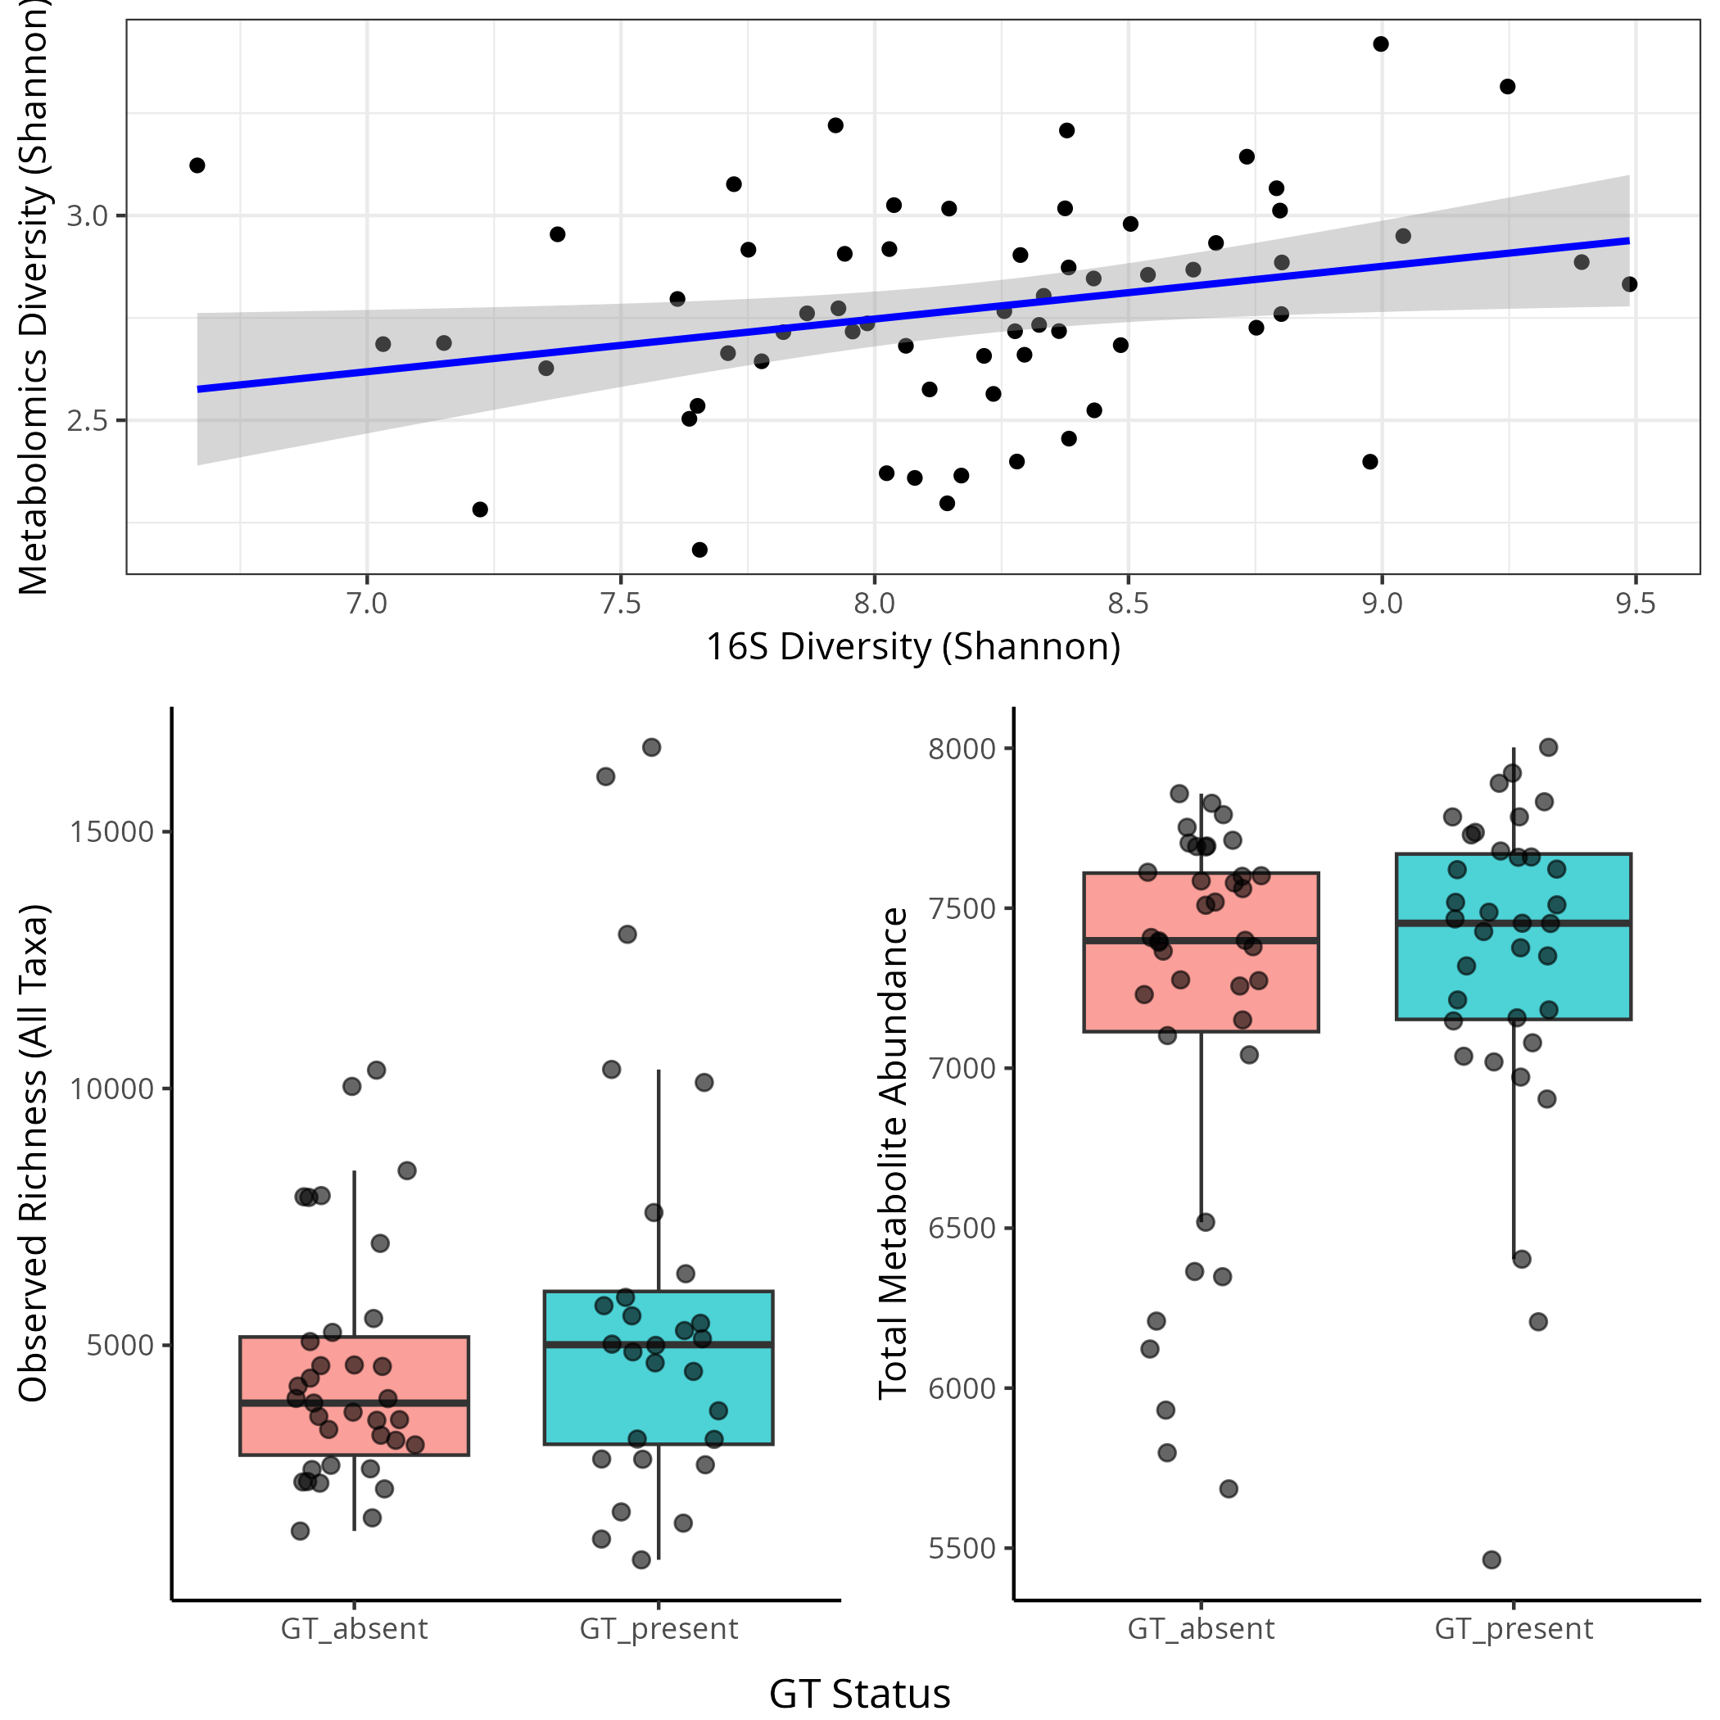
Figure S1- diversity and gt.

