JUST OOB, NO TEST/TRAIN SPLIT: (pto for that)

Running Random Forest for Taxonomic aggregation - Genus ...
Feature data dimensions: 34 141
Response variable length: 34
Response variable type: factor
Common samples: 34
Response levels: GT_absent GT_present
Response distribution: 14 20
Final dataset dimensions: 34 142
OOB Error Rate: 61.76 %
Number of features used: 141
Confusion Matrix:
GT_absent GT_present class.error
GT_absent 1 13 0.9285714
GT_present 8 12 0.4000000

Running Random Forest for Taxonomic aggregation - Family ...
Feature data dimensions: 34 88
Response variable length: 34
Response variable type: factor
Common samples: 34
Response levels: GT_absent GT_present
Response distribution: 14 20
Final dataset dimensions: 34 89
OOB Error Rate: 52.94 %
Number of features used: 88
Confusion Matrix:
GT_absent GT_present class.error
GT_absent 2 12 0.8571429
GT_present 6 14 0.3000000

Running Random Forest for Taxonomic aggregation - Order ...
Feature data dimensions: 34 59
Response variable length: 34
Response variable type: factor
Common samples: 34
Response levels: GT_absent GT_present
Response distribution: 14 20
Final dataset dimensions: 34 60
OOB Error Rate: 50 %
Number of features used: 59
Confusion Matrix:
GT_absent GT_present class.error
GT_absent 4 10 0.7142857
GT_present 7 13 0.3500000

Running Random Forest for Taxonomic aggregation - Class ...
Feature data dimensions: 34 27
Response variable length: 34
Response variable type: factor
Common samples: 34
Response levels: GT_absent GT_present
Response distribution: 14 20
Final dataset dimensions: 34 28
OOB Error Rate: 44.12 %
Number of features used: 27
Confusion Matrix:
GT_absent GT_present class.error
GT_absent 5 9 0.6428571
GT_present 6 14 0.3000000

Running Random Forest for Taxonomic aggregation - Phylum ...
Feature data dimensions: 34 16
Response variable length: 34
Response variable type: factor
Common samples: 34
Response levels: GT_absent GT_present
Response distribution: 14 20
Final dataset dimensions: 34 17
OOB Error Rate: 44.12 %
Number of features used: 16
Confusion Matrix:
GT_absent GT_present class.error
GT_absent 6 8 0.5714286
GT_present 7 13 0.3500000

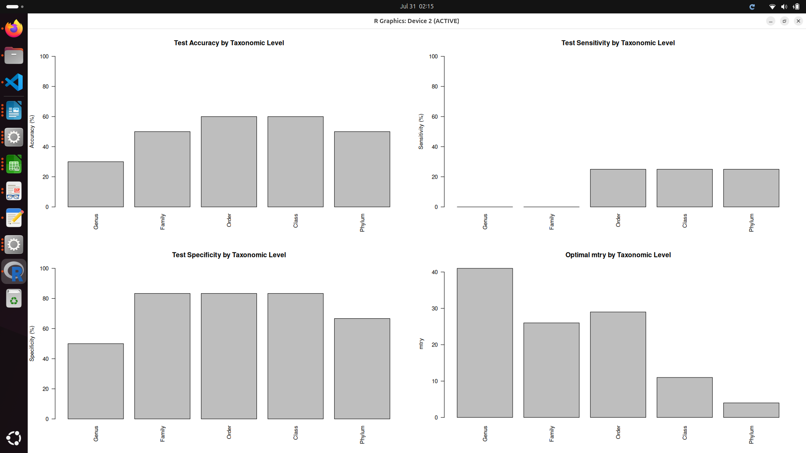
Key Findings:

1. Test Accuracy (Top Left)
- Order and Class perform best (~60% accuracy)
- Genus performs worst (~30% accuracy)
- Family and Phylum are intermediate (~50% accuracy)

2. Sensitivity (Top Right) - Ability to detect GT_present
- Very poor sensitivity for Genus and Family (~0%)
- Much better sensitivity for Order, Class, and Phylum (~25%)
- This suggests the models struggle to correctly identify GT_present samples

3. Specificity (Bottom Left) - Ability to detect GT_absent
- Excellent specificity for Family, Order, and Class (~80-85%)
- Lower specificity for Genus (~50%) and Phylum (~65%)
- Models are good at correctly identifying GT_absent samples

4. Optimal mtry (Bottom Right)
- Genus uses most features (mtry ~40) - but performs poorly
- Higher taxonomic levels use fewer features (mtry decreases as you go up)
- Phylum uses very few features (mtry ~3) but maintains decent performance

Interpretation:
The pattern suggests:
- Class imbalance issue: High specificity but low sensitivity indicates the models are biased toward predicting GT_absent
- Overfitting at lower levels: Genus level has too many features for the small sample size (34 samples)
- Sweet spot at mid-levels: Order and Class levels provide the best balance
- Supports the paper's hypothesis: Higher taxonomic levels are more reliable than species/genus level
This aligns perfectly with your paper's rationale - species-level resolution is unreliable, and aggregating to higher taxonomic levels (Order/Class) gives better predictive performance!

The sensitivity is low because your models are heavily biased toward predicting GT_absent. Looking at your results:
- High Specificity (~80-85%): Models correctly identify most GT_absent samples
- Low Sensitivity (~0-25%): Models miss most GT_present samples
This happens because:
- Imbalanced training: Even with stratified sampling, you have more GT_present (20) than GT_absent (14) samples
- Random Forest bias: RF tends to favor the majority class in imbalanced datasets
- Conservative predictions: The algorithm finds it "safer" to predict GT_absent
SMOTE (Synthetic Minority Oversampling Technique) creates synthetic samples of the minority class to balance your dataset. Let me add it:

