OnStep controlled 20kg equatorial telescope mount

Harry Bowman 6/11/21

Overview
This telescope mount and control box was designed to handle an interchangeable telescope of up to 20kg while using open source software.
The mount is designed primarily with 5mm aluminium plates and the drive axles are 20mm wide. It Is powered by 2 NEMA 17 motors with 1:100 gear box feeding into a toothed belt system of 180:20 giving a total gear reduction of 900.

The controller is powered by a RobotDyn STM32F303CC and takes 24V at 3A. This powers 3 drv8825 motor drivers for Right Ascension, Declination, and Focus. It has pin-outs for ST4, Multi Molex and a USB. It has a RTC/EEPROM and WIFI. The controller uses OnStep configured for the servos and chip. The drv8825 is set up for 32 micro steps with 200 servo steps for a total 16000 steps per degree, the motor shaft speed is150Rpm at 2.5 rps with a tracking resolution of 0.23 arc-seconds.

The whole system is powered by a Raspberry Pi running Astroberry to allow telescope tracking control and camera control and allowing IC2 integration and battery support for remote area viewing.
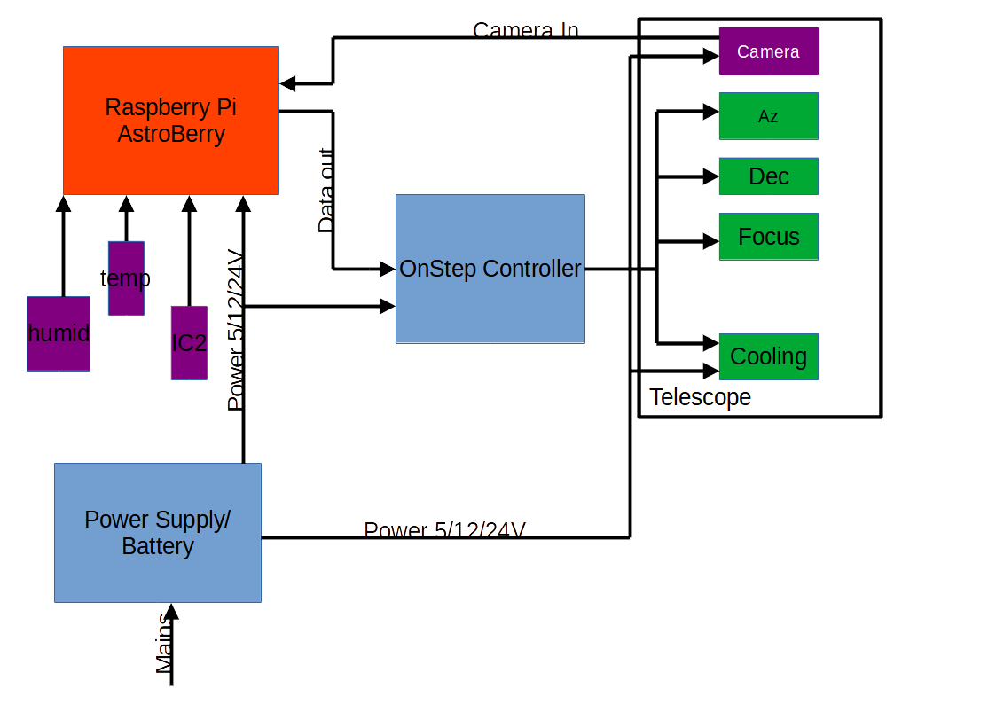

Parts List:

OnStep Controller:

Base Components:
1 X RobotDyn STM32F303CC
1 X DS3231 RTC Module with EEPROM
1 X LM2596S 3A Step Down Buck Converter Module
1 X CP2012 UART to TTL microUSB board
3 X Stepper Drivers for Axis1 (RA/Alt), Axis2 (Dec/Az), and Axies3 (Focus), drv8825
3 X 50V 100uF electrolytic capacitors, to protect the drivers from back voltage if the motors are turned manually.
3 X Motors, Exact specs will vary, depending on your mount's physical dimensions, required torque, current and voltage. Check the Construction page on the Wiki for more details).
1 X 3A mains AC to 12VDC power supply. It has to be a regulated power supply, not the old cube style unregulated "wall warts". Input voltage can also be 24V, if you adjust the LM2596 correctly.
As well, you will also need connectors for the motors, such as RJ45, female DIN or mini-DIN connectors.
1 X glass fuse, 5x20 mm (3A), or use a case mounted screw-in type fuse
1 X WeMos D1 Mini WiFi Module (~ $3.5), for WiFi control of OnStep using the Android App. Highly recommended.
1 X 3.3V buzzer, active or passive (each has a different setting in Config.h). If you use the passive buzzer, you will need a 470 Ohm resistor.
2 X red LED
3 X 470 ohm Resitors

Shopping List:
RobotDyn STM32F303CC
DS3231S RTC with EEPROM Module https://protosupplies.com/product/ds3231s-rtc-with-eeprom-module/
3a step down converter https://protosupplies.com/product/xl4015-adjustable-dc-dc-step-down-module/
wifi https://protosupplies.com/product/esp8266-esp-01-wifi-module/
usb https://protosupplies.com/product/ft232rl-usb-to-ttl-serial-interface-adapter/

capacitors x 3 https://www.jaycar.com.au/100uf-50v-bipolar-electrolytic-capacitor/p/RY6825
resistors x 3 https://www.jaycar.com.au/470-ohm-10-watt-wire-wound-resistor/p/RR3372?pos=1&queryId=b323c3e022d63a6aae5e0635b155f718
buzzer https://www.jaycar.com.au/mini-piezo-buzzer-3-16v/p/AB3462
LEDs (red) x 2 https://www.jaycar.com.au/red-5mm-led-flashing-50mcd-round-diffused/p/ZD0240?pos=6&queryId=e6fc5bbffec762daec6002764d6a63d4&sort=relevance
switch https://www.jaycar.com.au/dpdt-standard-toggle-switch/p/ST0572

Equatorial Mount:
5mm sheet aluminium
8 X bearings:
4 X 20mm out 10mmshaft
4 X 40 mm out 20mm shaft
2 X 180 tooth pulley
2 X 20 tooth pulley
2 X NEMA 17 Stepper Motors + 1:100 Gearbox
Assorted M size screws (5/10)
1 X 175mm long 10mm threaded rod
all other parts can be 3D printed

Astropi and Power supply:
.….

