 | Business Unit:  Site/Area: |  | Work Permit No: | Date:
 | TASK NAME:
 | TASK DESCRIPTION:

Prepared by: | Approved by: |  |  |  |  |  |  |  |  |  |  | Sign:
Reviewed by: | Review Date: |  |  |  |  |  | Review No.: |  |  |  |  | Sign:
MINIMUM PPE | ADDITIONAL PPE REQUIRED
PPE: | Goggles |  | Full Face Shield |  | Gloves |  |  | Fall Arrest Systems |  | Hearing Protection |  | Barricades |  | High Visibility Vest |  | Lighting |  | Other
PPE: | Double  Eye Protection |  | Welding Face Shield |  | Harness |  |  | Dust Mask/ respirator |  | Welding Screen |  | Erect Warning Signs |  | Fire  Extinguisher |  | Personal Locks or Tag

Permit Required |  |  |  | Have You? |  |  |  | Does the job involve prescribed High Risk activities?
General |  |  |  | Visited the Worksite ? |  |  |  | Confined space work
Excavation / Dig |  |  |  | Checked for relevant procedures ? |  |  |  | Cranage and Lifting
Confined Space Entry |  |  |  | Reviewed applicable MSDS sheets? |  |  |  | Scaffolding
Hot Works |  |  |  | Communicated with work interfaces? |  |  |  | Trenching and excavation
Working with Height |  |  |  | Had new members review the SWMS? |  |  |  | Use of plant and equipment
Vicinity Authority |  |  |  | Checked inspection & tagging is current? |  |  |  | Working at Height
Isolation |  |  |  | Legislation that is applicable: |  |  |  | Work in potentially contaminated or flammable atmosphere
 |  |  |  | State/ Territory OSH ACT | Other: |  |  | Non Routine work activities, or novel construction methods
 |  |  |  | State/ Territory OSH REG’s |  |  |  | If YES: See supervisor to obtain relevant SWMS or to assist in creating new SWMS

List Equipment and or Plant Required |  |  | Crew sign on
 |  |  | NAME |  | SIGNATURE |  | NAME |  | SIGNATURE
Competence, Qualification/ Training required to complete work safely:
Isolated, Try Start Performed. Verified by: |  |  | Supv |  | Supv |  | Witness |  | Witness

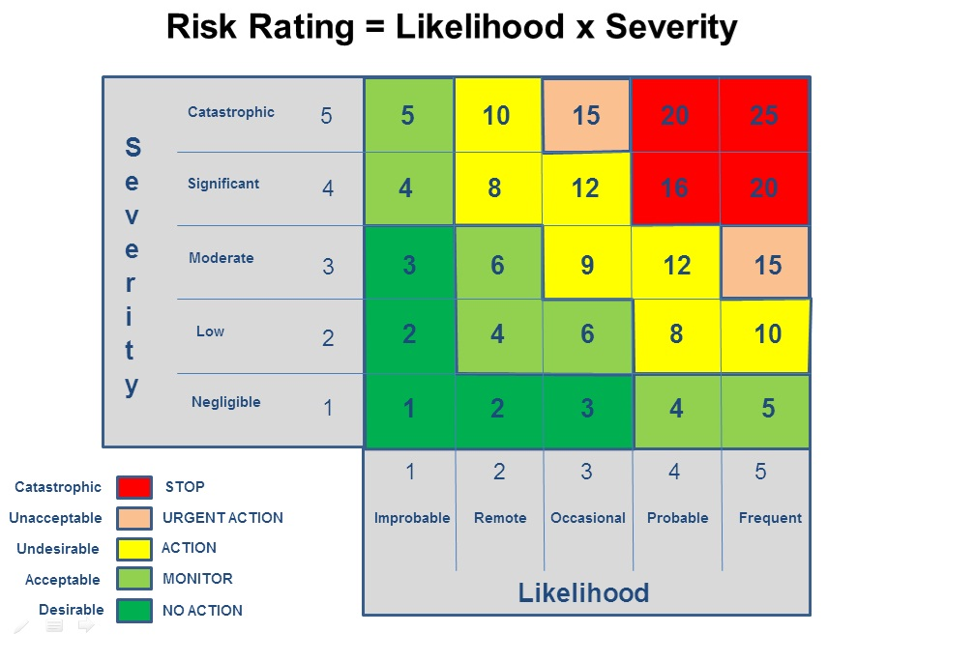
Potential Hazards |  | This list may not identify all potential hazards present. Visit the job site to ensure all hazards are identified. If a potential hazard has no impact on the job, mark the box with "NP" for not present. If a potential hazard impacts on the job/task, tick the box and implement appropriate control measures in the SWMS.
 | BARRIERS & SIGNAGE  Are barriers required to be in place?  Open holes, excavation. Persons working above etc |  |  | GRAVITY  Is there a potential for falling objects?  Secured tools, kick boards installed where applicable |  | PRESSURE  Is there stored pressure?  Is stored pressure restrained? (whip checks)
 | CLIMATIC  Are temperature and weather conditions a consideration? |  |  | HAZ SUBSTANCE  Is the use of chemicals, acids, solvents or hazardous materials required? Containment, spill kits, MSDS available |  | RADIATION  Is there the potential for burn or exposure to radiant sources?  X-Ray?
 | CONFINED SPACE  Are you required to work within a confined space?  Permits, rescue plans |  |  | HEALTH  Are there any health implications?  Heat, cold, fumes, chemicals etc. |  | VEHICULAR  Can vehicle enter the task area?  Will vehicles used during the task present hazard to task or others?
 | ELECTRICAL  Does the work involve electrical isolation or live equipment?  Overhead lines, Switchboards, power tools etc. |  |  | HOT - COLD SURFACES  Are there any hot or cold surfaces that could cause burns, injury or damage equipment? |  | VIBRATION  Can vibration impact on of persons/ equipment/ ground stability/ structures?
 | ERGONOMIC  Is manual lifting involved?  Pulling, pushing, and or lifting?  Is your work area non restricted? |  |  | ISOLATION  Are isolations required?  Consider Locking/ Tagging requirements |  | WASTE- HOUSEKEEPING  Is the work area free of Slip/ Trip/ Fire hazards?
 | EXCAVATIONS  Are excavations required?  Barricades, access egress. |  |  | LIGHTING  Is adequate lighting available to perform the task safely? |  | WORK SURFACE  Are there slip trip hazards?  Loose/ wet/ or uneven ground. Obstacles.
 | FLORA / FAUNA  Are there any environmental considerations? Local land issues. Chemical impact.  Could the task impact or be impacted by local fauna? |  |  | MECHANICAL  Has all plant and equipment been checked prior to use.  Is there any pinch/ crush hazards, sharp edges? |  | WORKING AT HEIGHT  Is working at heights require?  EWP’s, Harnesses etc available
 | FLYING OBJECT  Can objects be ejected under pressure? |  |  | NOISE  Will excess noise pose a problem to hearing and/or communications? |  | OTHER
Emergency Response: The SWMS should consider egress routes, location of nearest safety shower/eye wash, BA, alarm, shutdown switch, fire equipment, etc
TICK WHICH CODE OF PRACTICE(S) IS APPLICABLE TO TASK.
Hazardous Substances |  | Electrical Practices for construction work |  | Excavation |  | Manual Handling |  | Moving Plant on Construction Sites |  | Noise Management & protection of hearing
Work in hot and cold environments |  | Work near over power lines |  | Prevention of falls in workplace |  | Abrasive Blasting |  | Other:

 |  | Site: |  |  |  |  | Work Permit No: | Date:
 |  | TASK:
Step # | Job Step |  | Hazard. |  | Risk Rank | Control |  |  | Residual Risk | Responsible Person
SAFE WORK METHOD STATEMENT (JSA) AMMENDMENTS

Step # | Change Made | Date | Name | Signature

