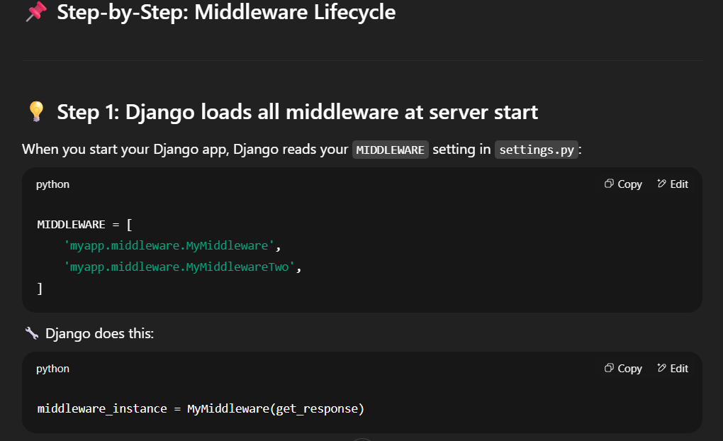
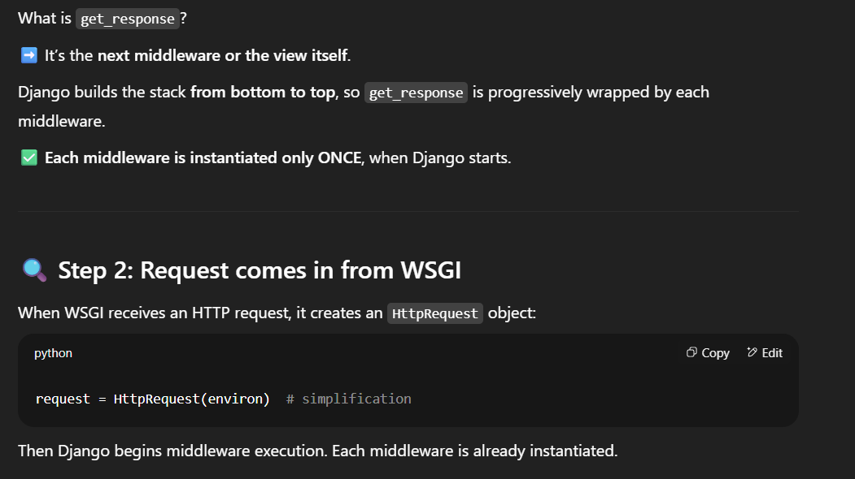

Here the already instantiated middleware is used to call the middleware_inst(request:Httprequestobj)

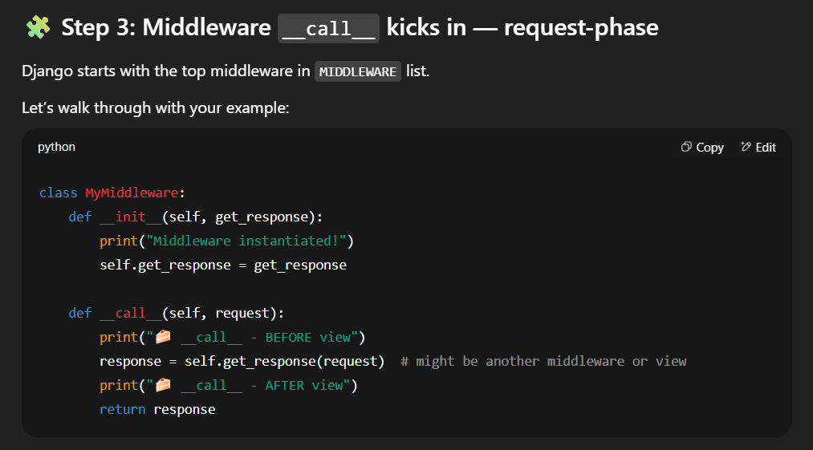
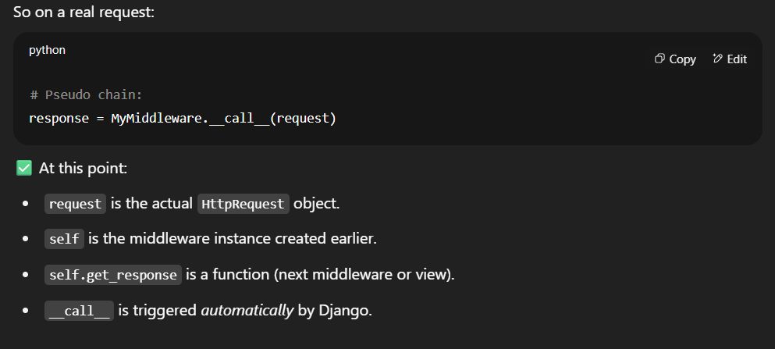
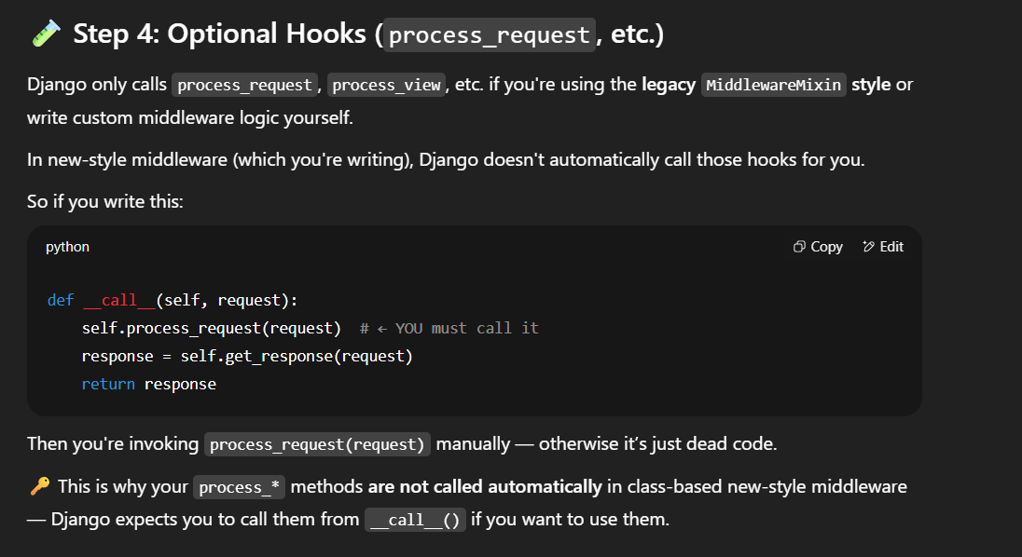

✅ Final Middleware Chain in Action
Let’s say you have:
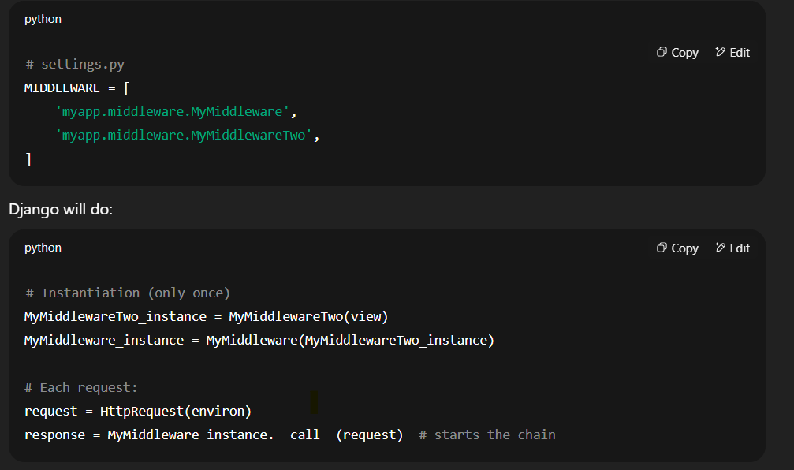
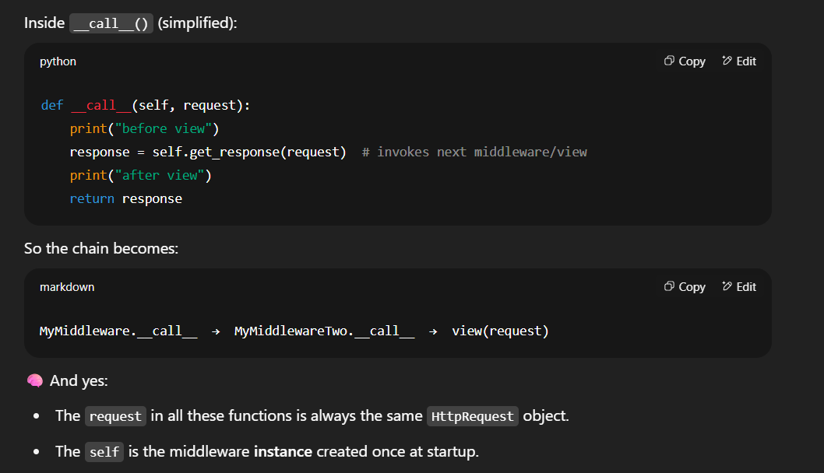

NOW THERE ARE TWO WAY , THE ABOVE DONE USING __call__ DUNDER MENTOD
AND THE OTHER ONE
USING A MiddlewareMixin CALSS

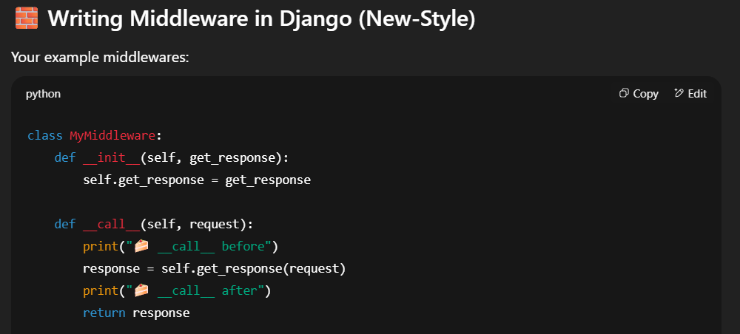
The below only happenes if we are using MiddlewareMixin t or legacy type middleware
The bwlo hooks are called in the order by the Django framework ….
NOTE in the new style mentioned above there is not concept of hooks everything gets called or excuted from the __call__ de=unbder method as it already have the request and the response objects available
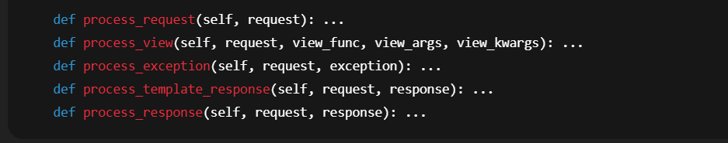
Detailed order:
- MyMiddleware.process_request
- MyMiddlewareTwo.process_request
- MyMiddleware.process_view
- MyMiddlewareTwo.process_view
- View executes
- If exception, process_exception methods run in reverse middleware order
If any process_request or process_view returns an HttpResponse, the view is skipped and response-phase hooks begin.Django ProjectStack Overflow+3Django Project+3Django Project+3
3. Response Flow
After view returns a response:
- If it is a TemplateResponse, Django invokes process_template_response(request, response) on middlewares in reverse order:
  - MyMiddlewareTwo.process_template_response
  - MyMiddleware.process_template_response
- Django then calls response.render(), if applicable.Stack Overflow+15Django Project+15Django Project+15
- Finally, every middleware's process_response(request, response) runs in reverse:
  - MyMiddlewareTwo.process_response
  - MyMiddleware.process_response

⚖️ Example: Legacy-Style vs New-Style Middleware
