**第十三届立创EDA出品省赛模拟题一（2022）**

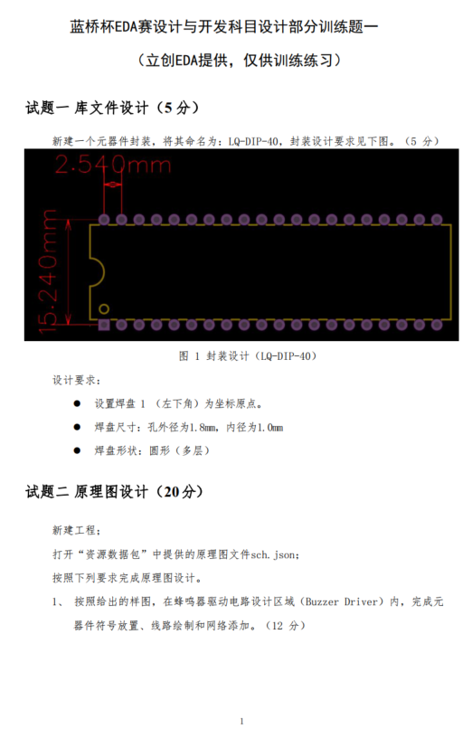

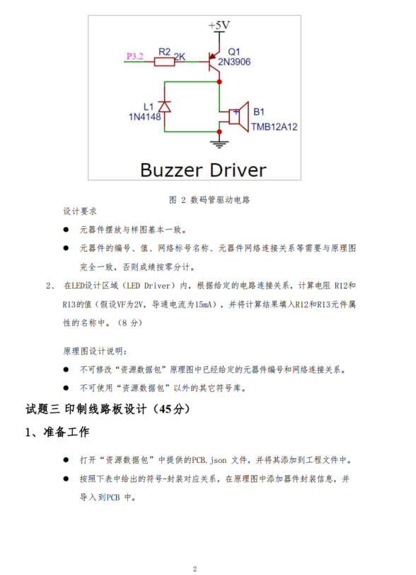

**-**

**-**

**-**

|  |  |
| --- | --- |
| **元器件标号** | **封装** |
| B1 | BUZ-TH_BD12.0-P7.60-D0.6-FD |
| C1、C3 | CAP-TH_BD5.0-P2.00-D0.8-FD |
| C2、C5 | CAP-TH_L7.0-W3.0-P5.00-D0.9 |
| C4 | CAP-TH_L5.0-W2.5-P2.54-D0.7 |
| C6、C7 | C0805 |
| D1~D8 | LED0805_BLUE |
| J1、J2 | HDR-M-2.54_1X20 |
| KEY1~KEY4、RST | KEY-SMD_4P-L6.0-W6.0-P3.90-LS10.0 |
| L1 | DO-35_BD2.0-L4.0-P8.00-D0.5-FD |
| LCD1 | LCD1602 |
| LED1 | LED-TH_BD3.0_BLUE |
| LED2 | LED-TH_BD3.0_GREEN |
| LED3 | LED0805_BLUE |
| LED4 | LED0805_GREEN |
| LED5 | LED-TH_BD3.0_RED |
| Q1 | TO-92-3_L4.9-W3.7-P1.27-L |
| R1、R2、R11、R12、R13、R16 | RES-TH_BD2.4-L6.3-P10.30-D0.6 |
| R3~R10、R114、R15 | R0805 |
| RN1 | RES-ARRAY-TH_9P-P2.54-D1.0 |
| RP1 | RES-ADJ-TH_3296W |
| SW1 | SW-TH_SS-12D02-VG4 |
| U1 | SENSOR-TH_DHT11 |
| U2 | DIP-40_L52.0-W13.7-P2.54-LS15.2-BL |
| U3 | SOIC-16_L9.9-W3.9-P1.27-LS6.0-BL |
| U4 | SOP-16_L10.0-W3.9-P1.27-LS6.0-BL |
| USB1 | MICRO-USB-SMD_5P_C40957 |
| X1 | HC-49US_L11.5-W4.5-P4.88 |

