**第十三届省赛第二场真题（2022）**

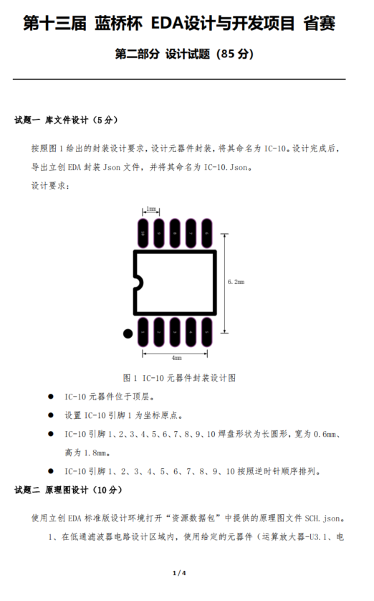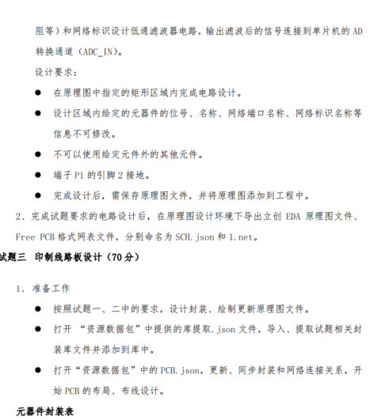



|  |  |  |
| --- | --- | --- |
| 序号 | 位号 | 封装 |
| 1 | B1 | BAT-SMD_CR1220-2 |
| 2 | C1,C2 | C0805 |
| 3 | C3,C4,C5,C6,C7,C11,C12, C13,C16 | C0805 |
| 4 | C8 | C0805 |
| 5 | C9,C10,C15 | CAP-D5.0× H5.5 |
| 6 | C14 | C0805 |
| 7 | D1,D2 | DO-35_BD2.0-L4.2-P8.20-D0.5-RD |
| 8 | DC1 | DC-IN-TH_DC005 |
| 9 | H1 | HDR-F-2.54_1X4 |
| 10 | JP1,JP2 | JUMPER2 |
| 11 | KEY1,KEY2 | KEY-SMD_4P-L6.0-W6.0-P3.90-LS10.0 |
| 12 | LED1 | LED-SEG-TH_FJ5461AH |
| 13 | LED4 | LED-TH_BD3.0_RED |
| 14 | LED5 | LED-TH_BD3.0_GREEN |
| 15 | LED6 | LED-TH_BD3.0_BLUE |
| 16 | P1 | CONN-TH_2P-P5.08 |
| 17 | Q1,Q2,Q3,Q4 | SOT-23-3_L2.9-W1.6-P1.90-LS2.8-TR-CW |
| 18 | R1 | R0805 |
| 19 | R2,R4,R6,R7,R8,R9,R10,R13 ,R27,R30,R31,R32,R33,R35 | R0805 |
| 20 | R3,R5,R34 | R0805 |
| 21 | R11,R12,R14,R15,R16,R17 R18,R19,R28,R29 | R0805 |
| 22 | R20,R21,R22,R23,R24,R25,R 26 | R0805 |
| 23 | U1 | SOT-25_L2.9-W1.6-P0.95-LS2.8-BL |
| 24 | U2 | SOP-8_L5.3-W5.3-P1.27-LS8.0-BL |
| 25 | U3 | SOIC-8_L4.9-W3.9-P1.27-LS6.0-BL |
| 26 | U4 | SOIC-8_L5.0-W4.0-P1.27-LS6.0-BL |
| 27 | U6 | SOP-28_L17.9-W7.5-P1.27-LS10.3-BL |
| 28 | U7 | IC-10 |
| 29 | X1 | OSC-49U-1 |
| 30 | X2 | XTAL-DT38 |

