Team: Moore Hazzard

Members: Gordon Hazzard & Jordan Moore

# Sprint 1 – Checking RDT 1.0

## Property 1: “It is possible to transmit all of the data in the sender’s buffer to the receiver’s buffer.”

Below is a series of snapshots that confirms the first property. The images depict the transmission of 2 sets of Data via 2 Packets.

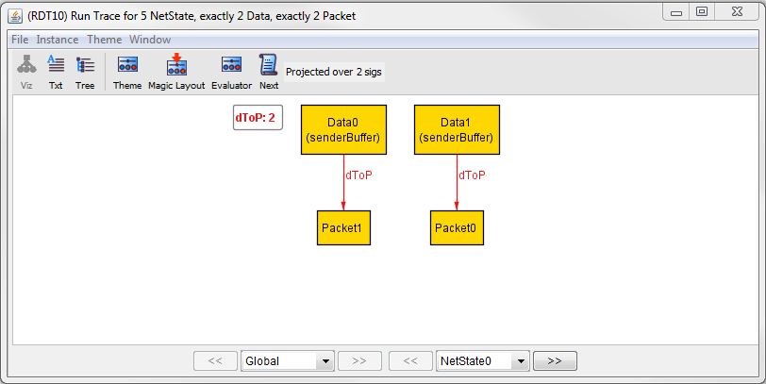

This is the initial state. All Data objects are in the senderBuffer and none are in the receiverBuffer. Additionally none of the Data have been packaged into a Packet yet, though their future mapping is shown via the Global signature.

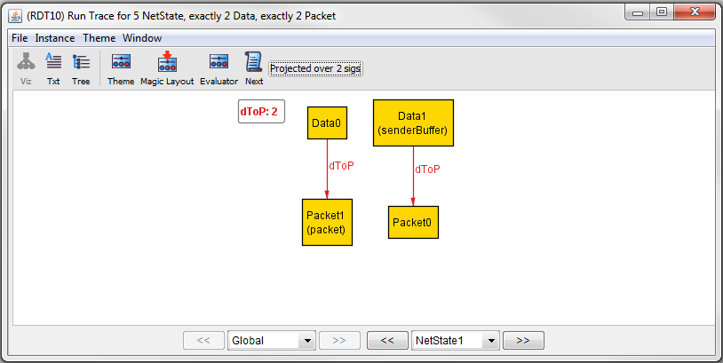

In the next state, Data0 has been removed from the senderBuffer and made into a Packet, specifically the packet that it is designated to map to in the Global signature. This state shows that Data0 is in the process of being transmitted.

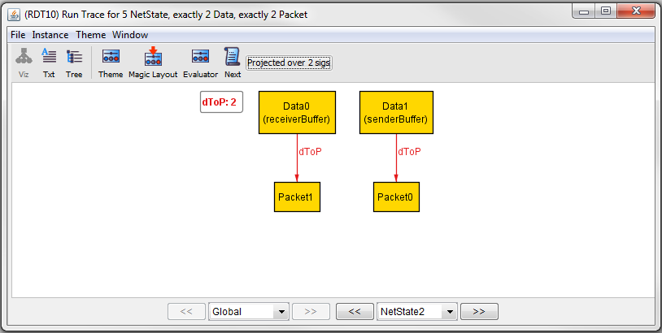

This state shows that the Data transfer of Data0 has been successful. Data0 is now in the receiverBuffer, Data1 is still in the senderBuffer, and no Packets are being exchanged.

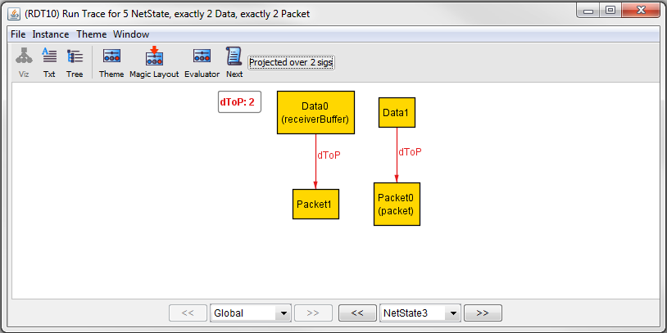

This state mimics State 1, with the only difference being Data1 is the Data object being transferred.

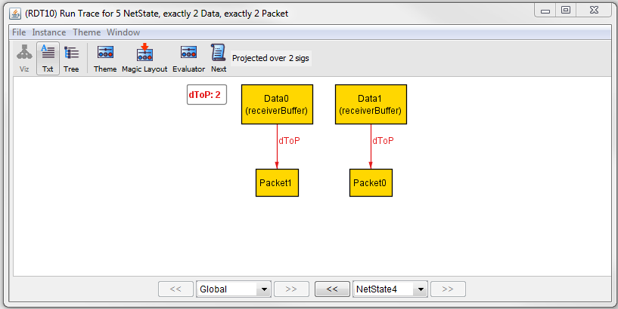

Finally, this state shows the end result with all Data objects in the receiverBuffer, none in the senderBuffer, and no packets still floating around in transmission.

## Property 2: “It is *always* possible to transmit all of the data in the sender’s buffer to the receiver buffer.”

Below is a snapshot confirming the second property. No counterexamples were found indicating that this version of RDT does not have a flaw.

