#include<stdio.h>
#include<stdlib.h>

int main()
{
FILE *f1,*f2;
char ca,cb;

f1=fopen("x.c","r");
if (f1==NULL)
{
printf("cannot open file");
exit(0);

/* code */
}
f2=fopen("outputs1.c","w");
ca=getc(f1);

while(ca!=EOF)
{
if (ca==' '||ca==' ')
{
putc(' ',f2);

while(ca==' '||ca==' ')
ca=getc(f1);
/* code */
}
if (ca=='/')
{

cb=getc(f1);
if (cb=='/')
{
while(ca!='\n')
ca=getc(f1);

/* code */
}
else if (cb=='*')
{
do{
while(ca!='*')
ca=getc(f1);
ca=getc(f1);
}while(ca!='/');
/* code */
}
else
{
putc(ca,f2);
putc(cb,f2);
}
/* code */
}
else putc(ca,f2);
ca=getc(f1);
}
fclose(f1);
fclose(f2);
return 0;

}

INPUT:
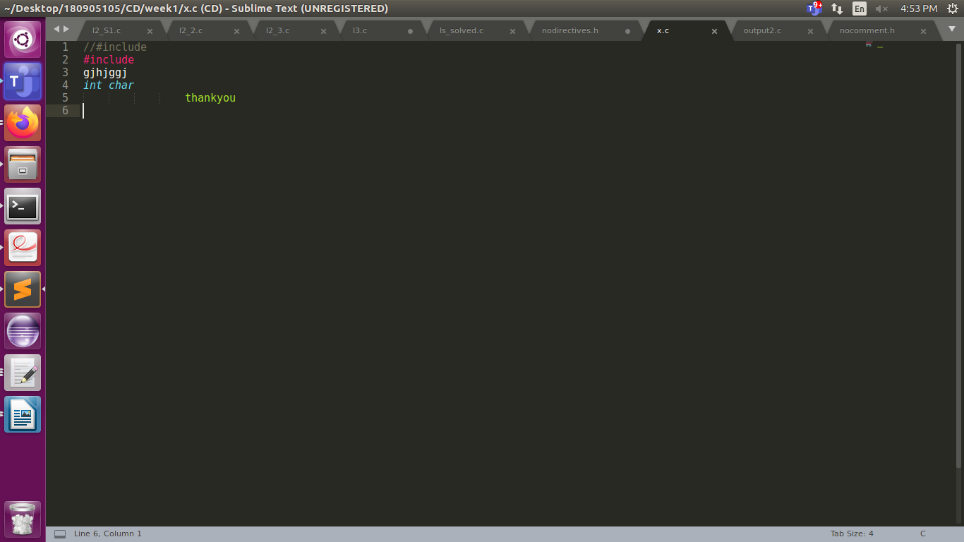

OUTPUT:
REMOVAL OF COMMENTS AND EXTRA TABS AND SPACES
