#include<stdio.h>
#include<stdlib.h>
void printkey(FILE *f){

const char *key[]={"int","char"};
int c=getc(f);

while (c!=EOF)
{
char buff[30];
int j=-1;
if (isalpha(c))
{

/* code */

while(c!=EOF && isalpha(c))
{
buff[++j]=c;
c=getc(f);
//printf("%d\n",c);

}
buff[++j]='\0';
//printf("%s\n",buff );
for(int i=0;i<sizeof(key)/sizeof(char *);i++)
{
//printf("%s\n",buff );
//printf("check\n");
if ((strcmp(key[i],buff))==0)
{
for (j = 0; buff[j]!='\0'; j++)
{
if(buff[j] >= 'a' && buff[j] <= 'z')
{
buff[j] = buff[j] -32;
}
}
printf("%s\n",buff);
/* code */
}
}

}
c=getc(f);
}
}
int main(){
FILE *f1;

f1=fopen("x.c","r");
if (f1==NULL)
{
printf("cannot open file");
exit(0);

/* code */
}
printkey(f1);

}

INPUT:
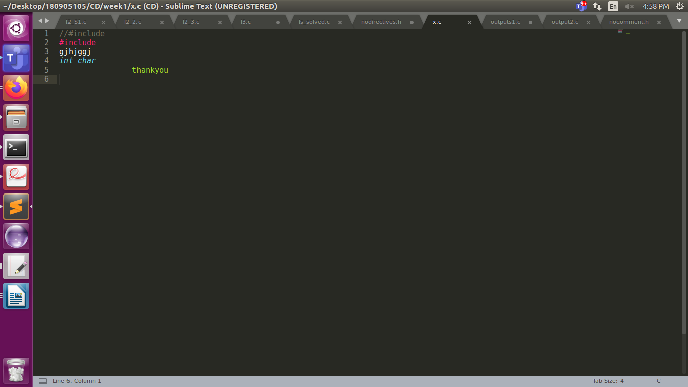

output: the keywords printed in uppercse
