Q1)//server code
// server program for udp connection
#include <stdio.h>
#include <strings.h>
#include <sys/types.h>
#include <arpa/inet.h>
#include <sys/socket.h>
#include <netinet/in.h>
#include <unistd.h>
#define PORT 5000
#define MAXLINE 1000
// Server code
int main()
{
char buffer[100];
int servsockfd, len, n;
struct sockaddr_in servaddr, cliaddr;
bzero(&servaddr, sizeof(servaddr));
// Create a UDP Socket
servsockfd = socket(AF_INET, SOCK_DGRAM, 0);
servaddr.sin_addr.s_addr = htonl(INADDR_ANY);
servaddr.sin_port = htons(PORT);
servaddr.sin_family = AF_INET;
// bind server address to socket descriptor
bind(servsockfd, (struct sockaddr *)&servaddr, sizeof(servaddr));
while (1)
{
//receive the datagram
len = sizeof(cliaddr);
n = recvfrom(servsockfd, buffer, sizeof(buffer), 0, (struct sockaddr *)&cliaddr, &len);
buffer[n] = '\0';
puts(buffer);
//Echoing back to the client
sendto(servsockfd, buffer, n, 0, (struct sockaddr *)&cliaddr, sizeof(cliaddr));
}
getchar();
// close the descriptor
close(servsockfd);
}
//client code
#include <stdio.h>
#include <strings.h>
#include <sys/types.h>
#include <arpa/inet.h>
#include <sys/socket.h>
#include <netinet/in.h>
#include <unistd.h>
#include <stdlib.h>
#define PORT 5000
#define MAXLINE 1000

int main()
{
char buffer[100];
// char *message = "Hello Server";
char *rows[3];
rows[0] = "1 0 0";
rows[1] = "0 1 0";
rows[2] = "0 0 1";
int sockfd, n, len;
struct sockaddr_in servaddr, cliaddr;
// clear servaddr
bzero(&servaddr, sizeof(servaddr));
servaddr.sin_addr.s_addr = htonl(INADDR_ANY);
servaddr.sin_port = htons(PORT);
servaddr.sin_family = AF_INET;
// create datagram socket
sockfd = socket(AF_INET, SOCK_DGRAM, 0);
for (int i = 0; i < 3; i++)
{
sendto(sockfd, rows[i], MAXLINE, 0, (struct sockaddr *)&servaddr, sizeof(servaddr));
len = sizeof(cliaddr);
}

close(sockfd);
}

SERVER and CLIENT:
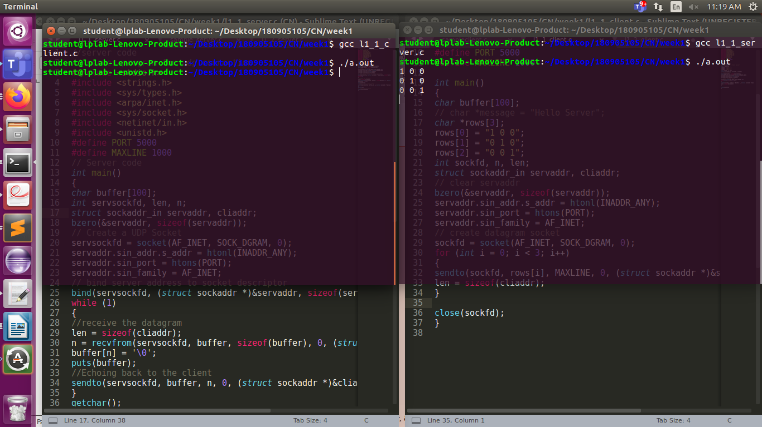

Q2)
// TCP Server program
#include <stdio.h>
#include <netdb.h>
#include <netinet/in.h>
#include <stdlib.h>
#include <string.h>
#include <sys/socket.h>
#include <sys/types.h>
#define MAX 80
#define PORT 8080
#define SA struct sockaddr

// Function designed for chat between client and server.
void servfunc(int sockfd)
{
char *a[50],*b[50];

unsigned long addr;short port;

char buff[MAX];
int n;
// infinite loop for chat
for (;;) {
bzero(buff, MAX);

// read the message from client and copy it in buffer
read(sockfd, buff, sizeof(buff));

// print buffer which contains the client contents
printf("From client: %s\t", buff);
sprintf(b,"%d",port);

for (int j = 0; buff[j]!='\0'; j++)
{
if(buff[j] >= 'a' && buff[j] <= 'z')
{
buff[j] = buff[j] -32;
}
}

printf("To client : %s\n",buff);
write(sockfd, buff, sizeof(buff));

// if msg contains "quit" then server exit and session ended.
if (strncmp("QUIT", buff, 4) == 0) {
printf("Exited...\n");
break;
}
}
}

// Driver function
int main()
{
int sockfd, connfd, len;
struct sockaddr_in servaddr, cli;

// socket create and verification
sockfd = socket(AF_INET, SOCK_STREAM, 0);
if (sockfd == -1) {
printf("socket creation failed...\n");
exit(0);
}
else
printf("Socket successfully created..\n");
bzero(&servaddr, sizeof(servaddr));

// assign IP, PORT
servaddr.sin_family = AF_INET;
servaddr.sin_addr.s_addr = htonl(INADDR_ANY);
servaddr.sin_port = htons(PORT);

// Binding newly created socket to given IP and verification
if ((bind(sockfd, (SA*)&servaddr, sizeof(servaddr))) != 0) {
printf("socket bind failed...\n");
exit(0);
}
else
printf("Socket successfully binded..\n");

// Now server is ready to listen and verification
if ((listen(sockfd, 5)) != 0) {
printf("Listen failed...\n");
exit(0);
}
else
printf("Server listening..\n");
len = sizeof(cli);

// Accept the data packet from client and verification
connfd = accept(sockfd, (SA*)&cli, &len);
if (connfd < 0) {
printf("server acccept failed...\n");
exit(0);
}
else
printf("server acccept the client...\n");
printf("Client Port no: %d\n\t",cli.sin_port);
printf("Client IP: %lu\n",cli.sin_addr.s_addr);
// Function for chatting between client and server
servfunc(connfd);

// After sending exit message close the socket
close(sockfd);
}
//TCP Client program

#include <netdb.h>
#include <stdio.h>
#include <stdlib.h>
#include <string.h>
#include <sys/socket.h>
#define MAX 80
#define PORT 8080
#define SA struct sockaddr
void clifunc(int sockfd)
{
char buff[MAX];
int n;
for (;;) {
bzero(buff, sizeof(buff));
printf("Enter the string : ");
n = 0;
while ((buff[n++] = getchar()) != '\n')
;
write(sockfd, buff, sizeof(buff));

bzero(buff, sizeof(buff));
read(sockfd, buff, sizeof(buff));
printf("From Server : %s", buff);
if ((strncmp(buff, "QUIT", 4)) == 0) {
printf("exited..\n");
break;
}
}
}

int main()
{
int sockfd, connfd;
struct sockaddr_in servaddr, cli;

// socket create and verification
sockfd = socket(AF_INET, SOCK_STREAM, 0);
if (sockfd == -1) {
printf("socket creation failed...\n");
exit(0);
}
else
printf("Socket successfully created..\n");
bzero(&servaddr, sizeof(servaddr));

// assign IP, PORT
servaddr.sin_family = AF_INET;
servaddr.sin_addr.s_addr = inet_addr("127.0.0.1");
servaddr.sin_port = htons(PORT);

// connect the client socket to server socket
if (connect(sockfd, (SA*)&servaddr, sizeof(servaddr)) != 0) {
printf("connection with the server failed...\n");
exit(0);
}
else
printf("connected to the server..\n");

// function for client
clifunc(sockfd);

// close the socket
close(sockfd);
}
SERVER:
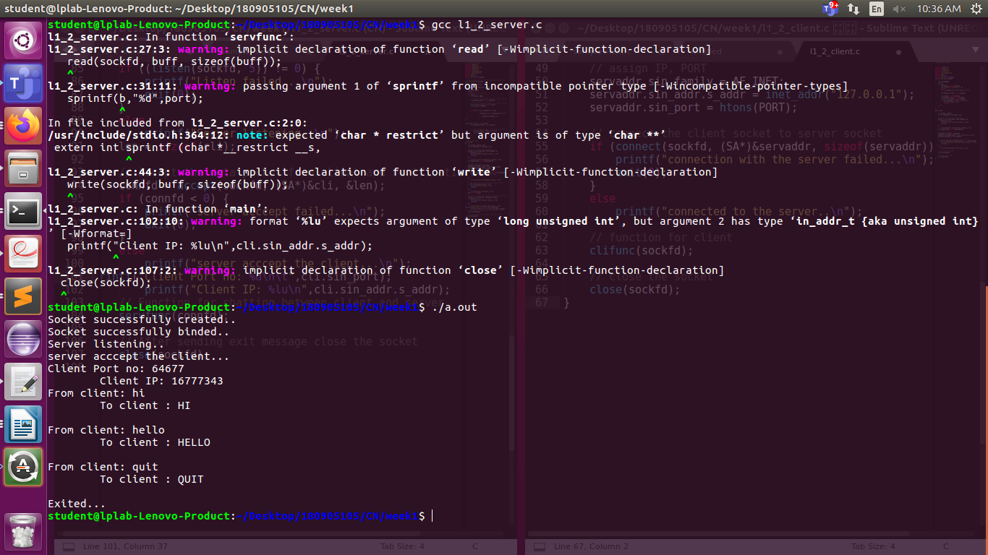

CLIENT:
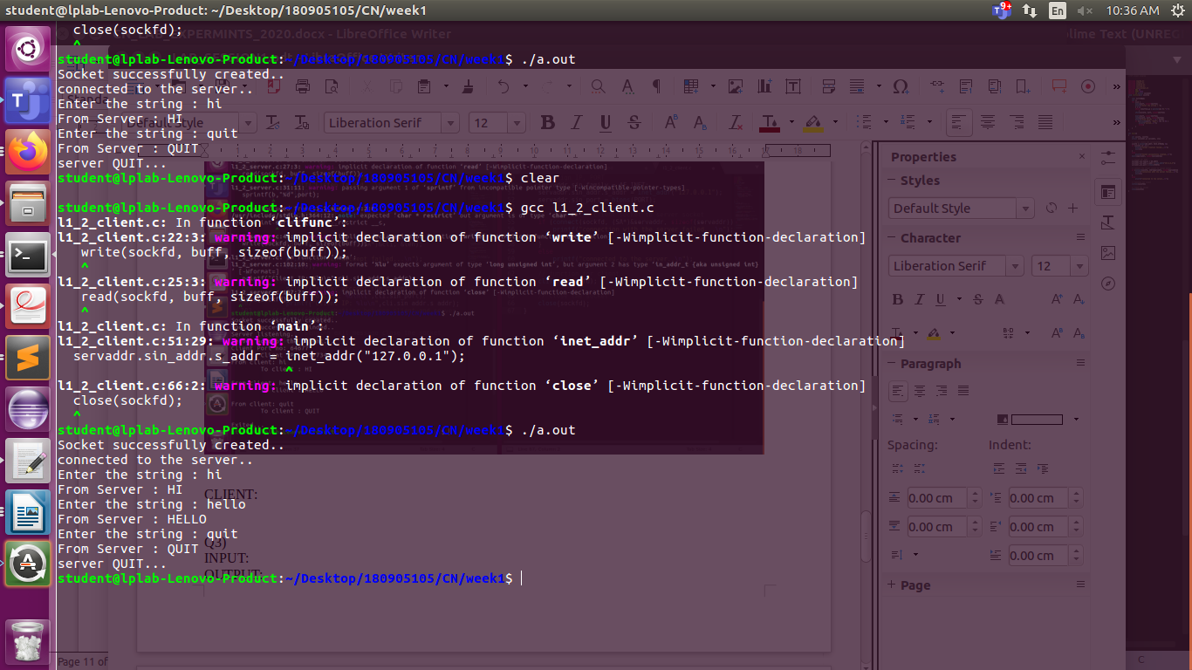

Q3)
INPUT:
OUTPUT:
Q4)
INPUT:
OUTPUT:

