HRITIK BANSAL, 180905105, CSE A, B1
LAB7:

Q1)
Modify the above Producer-Consumer program so that, a producer can produce at the
most 10 times more than what the consumer has consumed.

#include <stdlib.h>
#include <stdio.h>
#include <pthread.h>
#include <semaphore.h>
#include <unistd.h>

int buf[10], f=0, r=0, value;
sem_t mutex, full, empty;

void * produce(void * arg)
{
for (int i=0;i<20;i++)
{
sem_wait(&empty);
sem_wait(&mutex);
printf("Produced item: %d\n",i);
buf[(++r)%10]=i;
sleep(1);
sem_post(&mutex);
sem_post(&full);
sem_getvalue(&full, &value);
printf("Value: %d\n", value);
}
}

void * consume(void * arg)
{
int item;
for (int i=0;i<20;i++)
{
sem_wait(&full);
sem_getvalue(&full, &value);
printf("Value: %d\n", value);
sem_wait(&mutex);
item=buf[(++f)%10];
printf("Consumed item: %d\n",item);
sleep(1);
sem_post(&mutex);
sem_post(&empty);
}
}

void main()
{
pthread_t t1,t2;
sem_init(&mutex, 0, 1);
sem_init(&full, 0, 1);
sem_init(&empty, 0, 10);
pthread_create(&t1, NULL, produce, NULL);
pthread_create(&t2, NULL, consume, NULL);
pthread_join(t1, NULL);
pthread_join(t2, NULL);
}
Output:
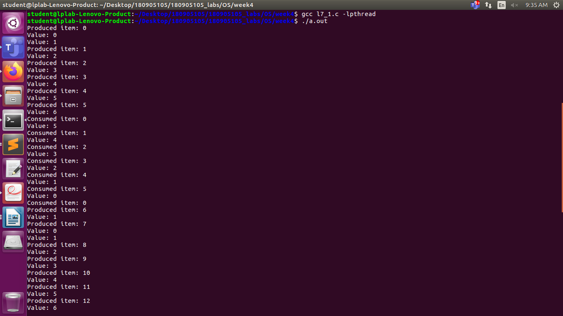

Q2)Write a C Program for the first readers-writers problem using semaphores.

#include <stdlib.h>
#include <stdio.h>
#include <pthread.h>
#include <semaphore.h>

sem_t wrt;
pthread_mutex_t mutex;
int cnt = 1;
int numreader = 0;

void *writer(void *wno)
{
sem_wait(&wrt);
cnt = cnt * 2;
printf("Writer %d modified count to %d\n", (*((int *)wno)), cnt);
sem_post(&wrt);
}
void *reader(void *rno)
{
pthread_mutex_lock(&mutex);
numreader++;

if (numreader == 1)
sem_wait(&wrt);

pthread_mutex_unlock(&mutex);
printf("Reader %d: read count as %d\n", *((int *)rno), cnt);
pthread_mutex_lock(&mutex);

numreader--;

if (numreader == 0)
sem_post(&wrt);

pthread_mutex_unlock(&mutex);
}

int main()
{
pthread_t read[10], write[5];
pthread_mutex_init(&mutex, NULL);
sem_init(&wrt, 0, 1);

int a[10] = {1, 2, 3, 4, 5, 6, 7, 8, 9, 10};

for (int i = 0; i < 10; i++)
pthread_create(&read[i], NULL, (void *)reader, (void *)&a[i]);

for (int i = 0; i < 5; i++)
pthread_create(&write[i], NULL, (void *)writer, (void *)&a[i]);

for (int i = 0; i < 10; i++)
pthread_join(read[i], NULL);

for (int i = 0; i < 5; i++)
pthread_join(write[i], NULL);

pthread_mutex_destroy(&mutex);
sem_destroy(&wrt);
return 0;
}

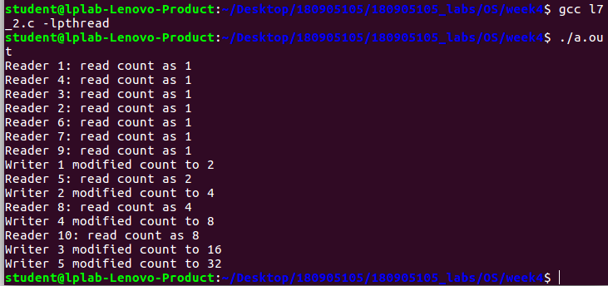
Output:

Q3)Write a code to access a shared resource which causes deadlock using improper use of
semaphore.

#include <stdlib.h>
#include <stdio.h>
#include <unistd.h>
#include <pthread.h>
#include <sys/sem.h>

#define PERM 0660

int semId;

int initSem(int id, int num, int initVal)
{
return semctl(id, num, SETVAL, initVal);
}

int P(int id, int num)
{
struct sembuf operationList[1];
operationList[0].sem_num = num;
operationList[0].sem_op = -1;
operationList[0].sem_flg = 0;
return semop(id, operationList, 1);
}

int V(int id, int num)
{
struct sembuf operationList[1];
operationList[0].sem_num = num;
operationList[0].sem_op = 1;
operationList[0].sem_flg = 0;
return semop(id, operationList, 1);
}

void* func1(void* no)
{
printf("Thread A trying to lock 0...\n");
P(semId, 0);
printf("Thread A locked 0.\n");
usleep(5 * 1000);
printf("Thread A trying to lock 1...\n");
P(semId, 1);
printf("Thread A locked 1.\n");
V(semId, 0);
V(semId, 1);
}

void* func2(void* no)
{
printf("Thread B trying to lock 1...\n");
P(semId, 1);
printf("Thread B locked 1.\n");
usleep(50 * 1000);
printf("Thread B trying to lock 0...\n");
P(semId, 0);
printf("Thread B locked 0.\n");
V(semId, 0);
V(semId, 1);
}

int main(int argc, char* argv[])
{
semId = semget(ftok(argv[0], 'A'), 2, IPC_CREAT | PERM);
initSem(semId, 0, 1);
initSem(semId, 1, 1);

pthread_t t[2];
pthread_create(&t[0], NULL, func1, NULL);
pthread_create(&t[1], NULL, func2, NULL);
for (int i = 0 ; i < 2 ; i++)
pthread_join(t[i], NULL);

printf("This is not printed in case of deadlock\n");
semctl(semId, 0, IPC_RMID, 0);
semctl(semId, 1, IPC_RMID, 0);
return 0;
}

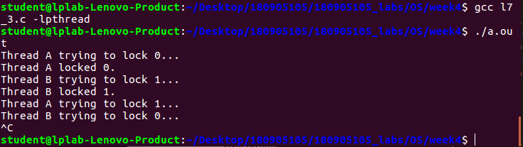
OUTPUT:

Q4)Write a program using semaphone to demonstrate the working of sleeping barber
problem.

#include <stdlib.h>
#include <stdio.h>
#include <unistd.h>
#include <pthread.h>
#include <semaphore.h>

#define MAX_CUSTOMERS 25

sem_t waitingRoom;
sem_t barberChair;
sem_t barberPillow;
sem_t seatBelt;
int allDone = 0;

void randwait(int secs)
{
int len;
len = (int) ((drand48() * secs) + 1);
sleep(len);
}

void* customer(void *number)
{
int num = *(int *)number;
printf("Customer %d leaving for barber shop.\n", num);
randwait(5);
printf("Customer %d arrived at barber shop.\n", num);
sem_wait(&waitingRoom);
printf("Customer %d entering waiting room.\n", num);
sem_wait(&barberChair);
sem_post(&waitingRoom);
printf("Customer %d waking the barber.\n", num);
sem_post(&barberPillow);
sem_wait(&seatBelt);
sem_post(&barberChair);
printf("Customer %d leaving barber shop.\n", num);
}

void* barber(void *junk)
{
while (!allDone)
{
printf("The barber is sleeping\n");
sem_wait(&barberPillow);

if (!allDone)
{
printf("The barber is cutting hair\n");
randwait(3);
printf("The barber has finished cutting hair.\n");
sem_post(&seatBelt);
}
else printf("The barber is going home for the day.\n");
}
}

int main(int argc, char *argv[])
{
pthread_t btid;
pthread_t tid[MAX_CUSTOMERS];
long RandSeed;
int i, numCustomers, numChairs;
int Number[MAX_CUSTOMERS];

if (argc != 4)
{
printf("Use: SleepBarber <Num Customers> <Num Chairs> <rand seed>\n");
exit(-1);
}
numCustomers = atoi(argv[1]);
numChairs = atoi(argv[2]);
RandSeed = atol(argv[3]);

if (numCustomers > MAX_CUSTOMERS)
{
printf("The maximum number of Customers is %d.\n", MAX_CUSTOMERS);
exit(-1);
}
printf("A solution to the sleeping barber problem using semaphores.\n");
srand48(RandSeed);

for (i = 0; i < MAX_CUSTOMERS; i++)
Number[i] = i;

sem_init(&waitingRoom, 0, numChairs);
sem_init(&barberChair, 0, 1);
sem_init(&barberPillow, 0, 0);
sem_init(&seatBelt, 0, 0);
pthread_create(&btid, NULL, barber, NULL);

for (i = 0; i < numCustomers; i++)
pthread_create(&tid[i], NULL, customer, (void *)&Number[i]);

for (i = 0; i < numCustomers; i++)
pthread_join(tid[i], NULL);

allDone = 1;
sem_post(&barberPillow);
pthread_join(btid, NULL);
}
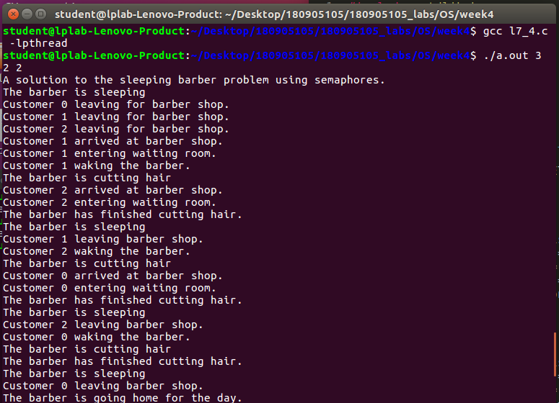
Output:

