HRITIK BANSAL, CSE A, B1, 180905105

LAB 8
Q1)Write a multithread program that generates the Fibonacci Series:

#include <stdlib.h>
#include <stdio.h>
#include <pthread.h>
#include <string.h>

void *thread_code(void* param)
{
int n = *((int*)param);
int arr[n];
arr[0] = 0;
arr[1] = 1;
for (int i = 2; i < n; i++)
arr[i] = arr[i - 2] + arr[i - 1];
int *sol = (int *)calloc(n, sizeof(int));
memcpy(sol, arr, sizeof(int) * n);
return sol;
}

void main()
{
int n;
printf("Enter no. of terms: ");
scanf("%d", &n);
void *arr;

pthread_t thread;
pthread_create(&thread, 0, &thread_code, (void*)&n);
printf("Thread created!\n");
pthread_join(thread, &arr);

int *arr2 = arr;
for (int i = 0; i < n; i++)
printf("%d ", (int)arr2[i]);
printf("\n");
}
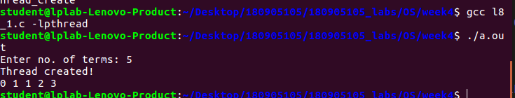
output:

Q2)Write a multithread program that calculates the summation of non-negative integers

#include <stdlib.h>
#include <stdio.h>
#include <pthread.h>
#include <string.h>

void* thread_code(void* n)
{
int sum = 0;
int limit = *((int*)n);
for (int i = 1; i <= limit; i++)
sum += i;
*((int*)n) = sum;
}

void main()
{
int n, num;
printf("Enter no. of elements: ");
scanf("%d", &n);
num = n;
pthread_t thread;
pthread_create(&thread, 0, &thread_code, (void*)&n);
pthread_join(thread, NULL);
printf("Sum of all non-negetive numbers from 1 to %d = %d\n", num, n);
}

OUTPUT:
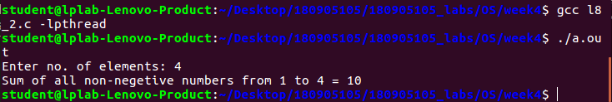

Q3)Write a multithread program for generating prime number from a given starting number to a given ending number

#include <stdlib.h>
#include <stdio.h>
#include <pthread.h>
#include <string.h>

void *prime(void* arr)
{
int n1 = *((int*)arr);
int n2 = *(((int*)(arr + sizeof(int))));
printf("Prime numbers: ");
for (int i = n1; i <= n2; i++)
{
int flag = 0;
for (int j = 2; j <= i / 2; j++)
{
if ((i % j) == 0)
{
flag = 1;
break;
}
}
if (flag == 0)
printf("%d ", i);
}
printf("\n");
}

int main()
{
int arr[2];
printf("Enter lower limit: ");
scanf("%d", &arr[0]);
printf("Enter upper limit: ");
scanf("%d", &arr[1]);
pthread_t thread;
pthread_create(&thread, 0, &prime, (void*)arr);
pthread_join(thread, NULL);
}

output:
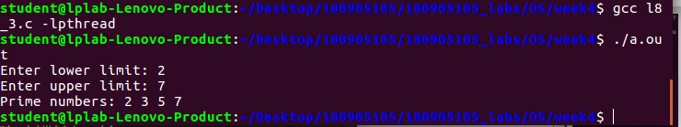

Q4)Write a multithread program that performs the sum of even numbers and odd numbers inan input array

#include <stdlib.h>
#include <stdio.h>
#include <pthread.h>
#include <string.h>

void * even(void *brr)
{
int *arr = (int*)brr;
int size = arr[0];
int sum = 0;
for (int i = 1; i <= size; i++)
if (arr[i] % 2 == 0)
sum += arr[i];
return (void *) sum;
}

void * odd(void *brr)
{
int *arr = (int*)brr;
int size = arr[0];
int sum = 0;
for (int i = 1; i <= size; i++)
if (arr[i] % 2 != 0)
sum += arr[i];
return (void *) sum;
}

int main()
{
int n, e, o;
printf("Enter size of array: ");
scanf("%d", &n);
int arr[n + 1];
arr[0] = n;
printf("Enter elements:\n");
for (int i = 1; i <= n; i++)
scanf("%d", &arr[i]);

pthread_t t1, t2;
pthread_create(&t1, 0, &even, (void *)arr);
pthread_create(&t2, 0, &odd, (void *)arr);
pthread_join(t1, (void*) &e);
pthread_join(t2, (void*) &o);
printf("Sum of even numbers = %d\n", (int)e);
printf("Sum of odd numbers = %d\n", (int)o);
}

OUTPUT:
