HRITIK BANSAL, CSE A, B1, 180905105
Q1)
/* s-> a|>|(t)
t->stprime
tprime->,stprime|eps
*/

#include <stdio.h>
#include <stdlib.h>
#include <string.h>
int curr = 0;
char str[100];
void s();
void t();
void tprime();

void invalid()
{
printf("---ERROR!---\n");
exit(0);
}
void valid()
{
printf("---SUCCESS!----\n");
exit(0);
}
void s(){
if(str[curr]=='a')
{curr++;return;}
else if(str[curr]=='>')
{curr++; return;}
else if(str[curr]=='('){
curr++;
t();

if (str[curr]==')')
{
curr++;
return;
/* code */
}
else{invalid();}
}
else{invalid();}
}
void t(){
s();
tprime();

}
void tprime(){
if(str[curr]==',')
{curr++;
s();
tprime();}

}

int main()
{
printf("Enter String: ");
scanf("%s", str);
s();
if(str[curr] == '$')
valid();
else
invalid();
}
INPUT/OUTPUT:
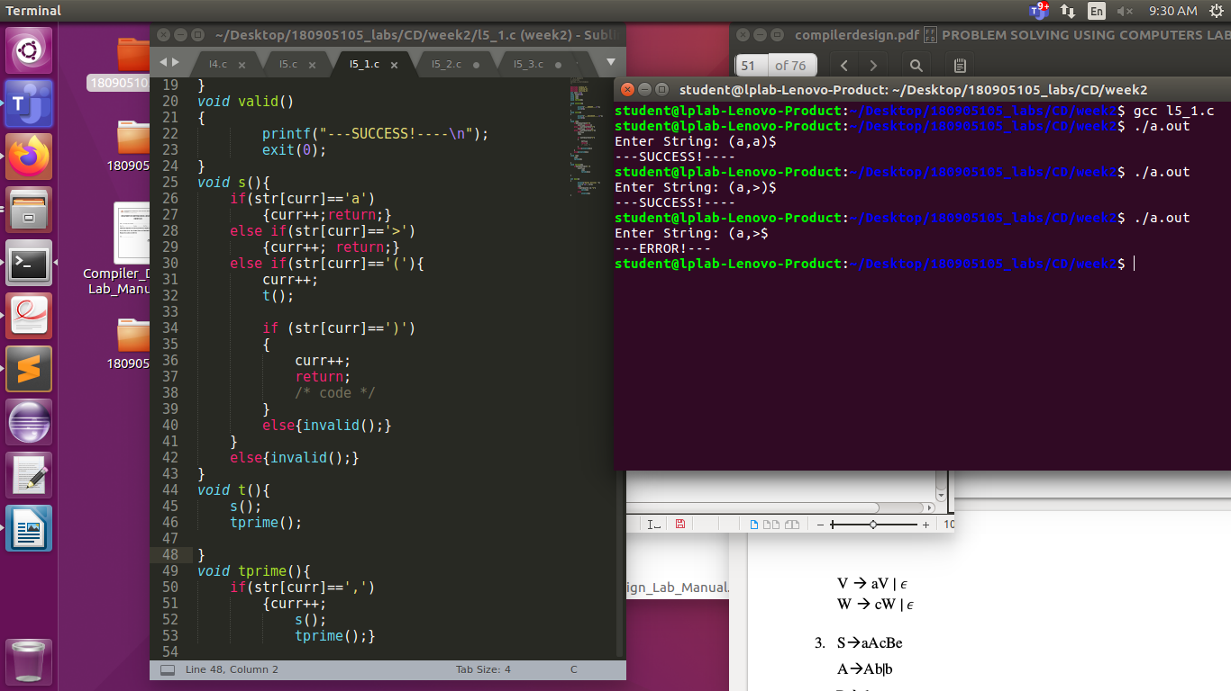
Q2)
/*s->uvw
u->(s)|asb|d
v->av
w->cw

*/
#include <stdio.h>
#include <stdlib.h>
#include <string.h>
int curr = 0; char str[100];
void s();
void u();
void v();
void w();

void invalid()
{
printf("---ERROR!---\n");
exit(0);
}
void valid()
{
printf("---SUCCESS!----\n");
exit(0);
}
void s(){
u();
v();
w();

}
void u(){
if (str[curr]=='(')
{
curr++;
s();
if (str[curr]==')')
{curr++;return;;
/* code */
}
else invalid();
/* code */
}
else if (str[curr]=='a')
{
curr++;
s();
if (str[curr]=='b')
{ curr++;
return;

/* code */
}
else invalid();
}
else if (str[curr]=='d')
{
curr++;
return;
/* code */
}
else invalid();
}
void v(){
if (str[curr]=='a')
{
curr++;
v();
return;
}

}
void w(){
if (str[curr]=='c')
{
curr++;
w();
return;
}
}
int main()
{
printf("Enter String: ");
scanf("%s", str);
s();
if(str[curr] == '$')
valid();
else
invalid();
}
INPUT/OUTPUT:

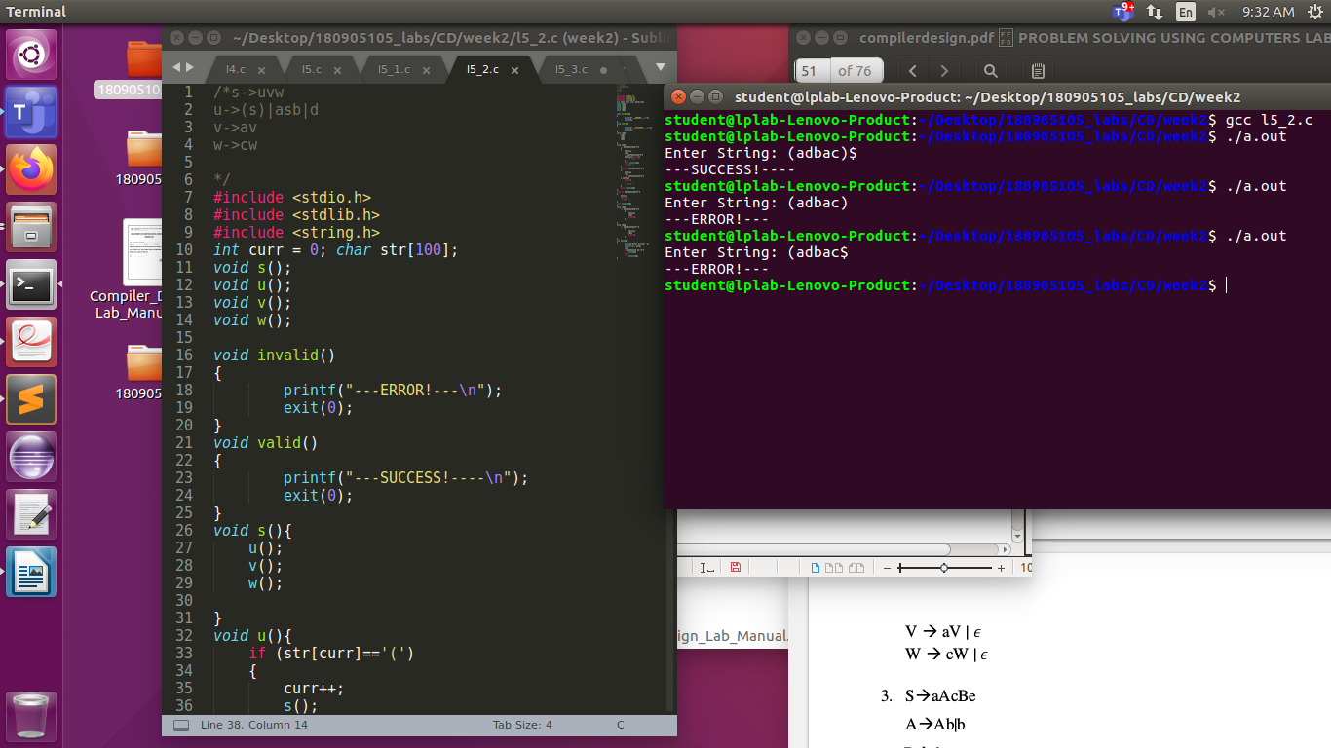

Q3)
/*s->aAcBe
A->bAprime
aprime->baprime|eps
b->d*/

#include <stdio.h>
#include <stdlib.h>
#include <string.h>
int curr = 0; char str[100];
void s();
void a();
void aprime();
void b();
void invalid()
{
printf("---ERROR!---\n");
exit(0);
}
void valid()
{
printf("---SUCCESS!----\n");
exit(0);
}
void s(){
if (str[curr]=='a')
{
curr++;
a();
if (str[curr]=='c')
{
curr++;
b();
if (str[curr]=='e')
{
curr++;
return;
}
else invalid();
}
else invalid();

}
else invalid();
}
void a(){
if (str[curr]=='b'){
curr++;
aprime();
}

}
void aprime(){
if (str[curr]=='b'){
curr++;
aprime();
}

}
void b(){
if (str[curr]=='d'){
curr++;
return;
}
else invalid();
}
int main()
{
printf("Enter String: ");
scanf("%s", str);
s();
if(str[curr] == '$')
valid();
else
invalid();
}
INPUT/OUTPUT:
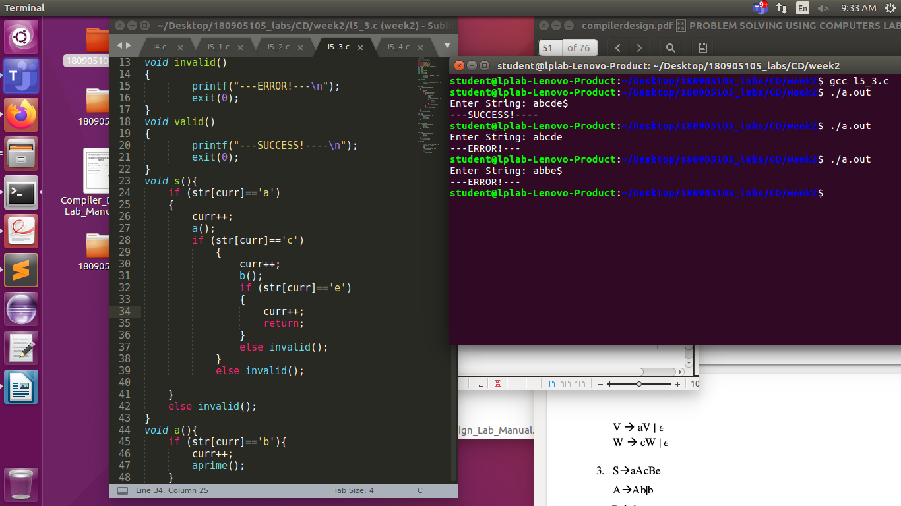
Q4)
/*
s->(l)|a
l->slprime
lprime->,slprime()|eps
*/

#include <stdio.h>
#include <stdlib.h>
#include <string.h>
int curr = 0; char str[100];
void s();
void l();
void lprime();

void invalid()
{
printf("---ERROR!---\n");
exit(0);
}
void valid()
{
printf("---SUCCESS!----\n");
exit(0);
}
void s(){
if (str[curr]=='('){
curr++;
l();
if (str[curr]==')'){
curr++;
return;
}
else invalid();
}
else if (str[curr]=='a'){
curr++;
return;}
else invalid();
}
void l(){
s();
lprime();
}
void lprime(){
if (str[curr]==','){
curr++;
s();
lprime();
return;}

}
int main()
{
printf("Enter String: ");
scanf("%s", str);
s();
if(str[curr] == '$')
valid();
else
invalid();
}

INPUT/OUTPUT:
