HRITIK BANSAL, CSE A,ROLL NO. 15, B1, 180905105.
Q1)
#include<stdio.h>
#include<unistd.h>
#include<stdlib.h>
#include<fcntl.h>
#include<sys/types.h>
#include<sys/stat.h>

int main(int argc, char **argv[])
{
char c;
int a=open(argv[1],O_RDONLY);

while(read(a,&c,sizeof(c))==1){
char ca[100000];
int i=0;

while((c!='\n')&&(c!=EOF))
{
ca[i++]=c;
read(a,&c,sizeof(c));
}
ca[i]='\0';

if(strstr(ca,argv[2]))
{
printf("%s\n",ca);
}
}}
INPUT:
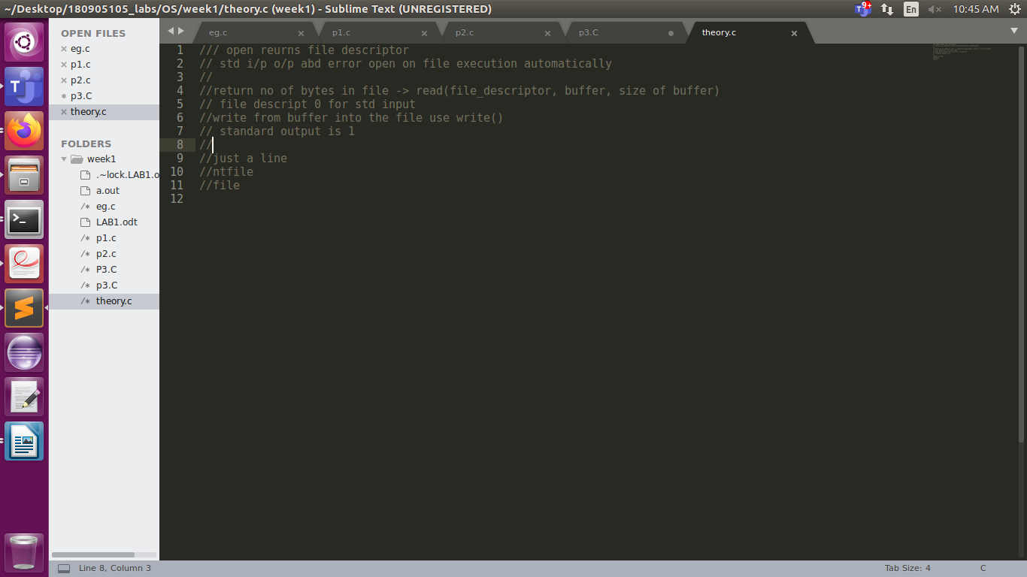
OUTPUT:
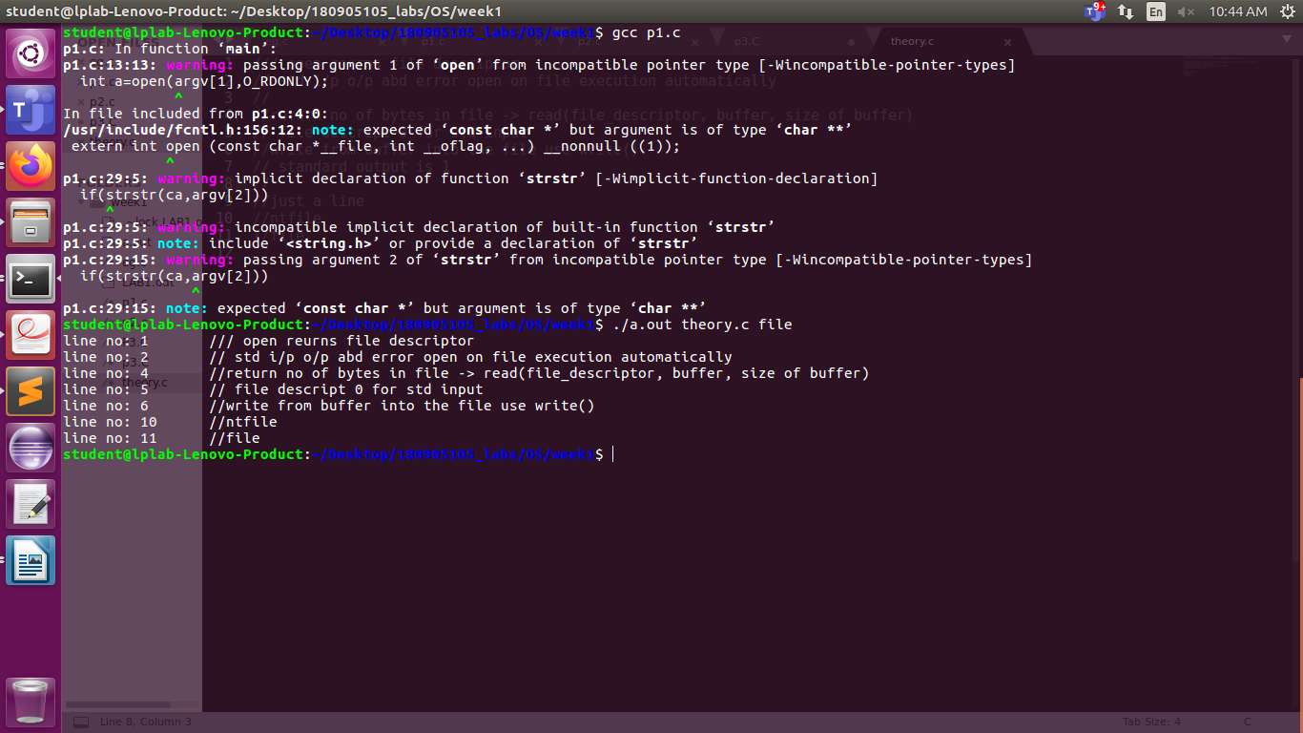
Q2)
#include<stdio.h>
#include<unistd.h>
#include<stdlib.h>
#include<fcntl.h>
#include<sys/types.h>
int main(int argc, char *argv[])
{

int i=2;
char c;
int a1=atoi(argv[1]);

printf("%d files entered\n",a1);
a1=a1+2;
int z=0;
printf("enter any key\n");

char c2;
int o=read(0,&c2,1);
printf("enter no of lines");
int b;
scanf("%d",&b);
printf("%s\n",argv[i] );
while(i<=a1){

int out=open(argv[i++],O_RDONLY);

while((read(out,&c,sizeof(c))==1))
{
/* code */
int co=0;
char ca[100000];
int k=0;

while((c!='\n')&&(c!=EOF))
{
ca[k++]=c;
read(out,&c,sizeof(c));
}
ca[k]='\0';

printf("%s\n",ca);
z+=1;
if (z%b==0)
{
printf("enter any key\n");

o=read(0,&c2,1);
/* code */
}

}

}
INPUT:

OUTPUT:
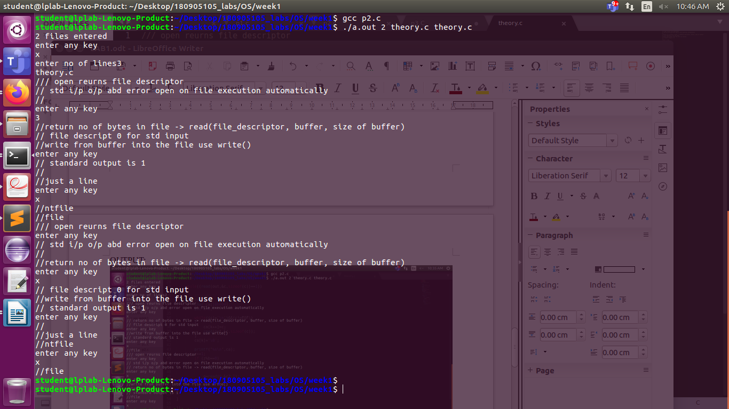
Q3)
#include<stdio.h>
#include<unistd.h>
#include<stdlib.h>
#include<fcntl.h>
#include<sys/types.h>

int main()
{
char c = '@';
double d = 8.44;
int a = 32;
int l=7;
char str[6]="hritik";
printf("%c\n",c);
printf("%d\n", c);
printf("%s\n",str);
printf("%e\n", d);
printf("%f\n", d);
printf("%d \n",a);
printf("%o\n",a );
printf("%x\n",a);
printf("%#x\n",a);
}

INPUT/OUTPUT:
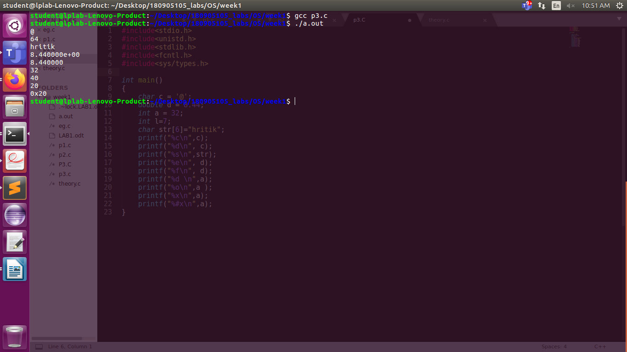
Q4)
#include<stdio.h>
int main(){
FILE *fp1 = fopen("theory.c","r");
FILE *fp2 = fopen("f2.txt","w");
if(fp1 == NULL)
return 0;
do{
char c = fgetc(fp1);
if(feof(fp1))
break;
fputc(c,fp2);
}while(1);
fclose(fp1);
fclose(fp2);
return(0);
}

(input output on next page)!

FILE1:
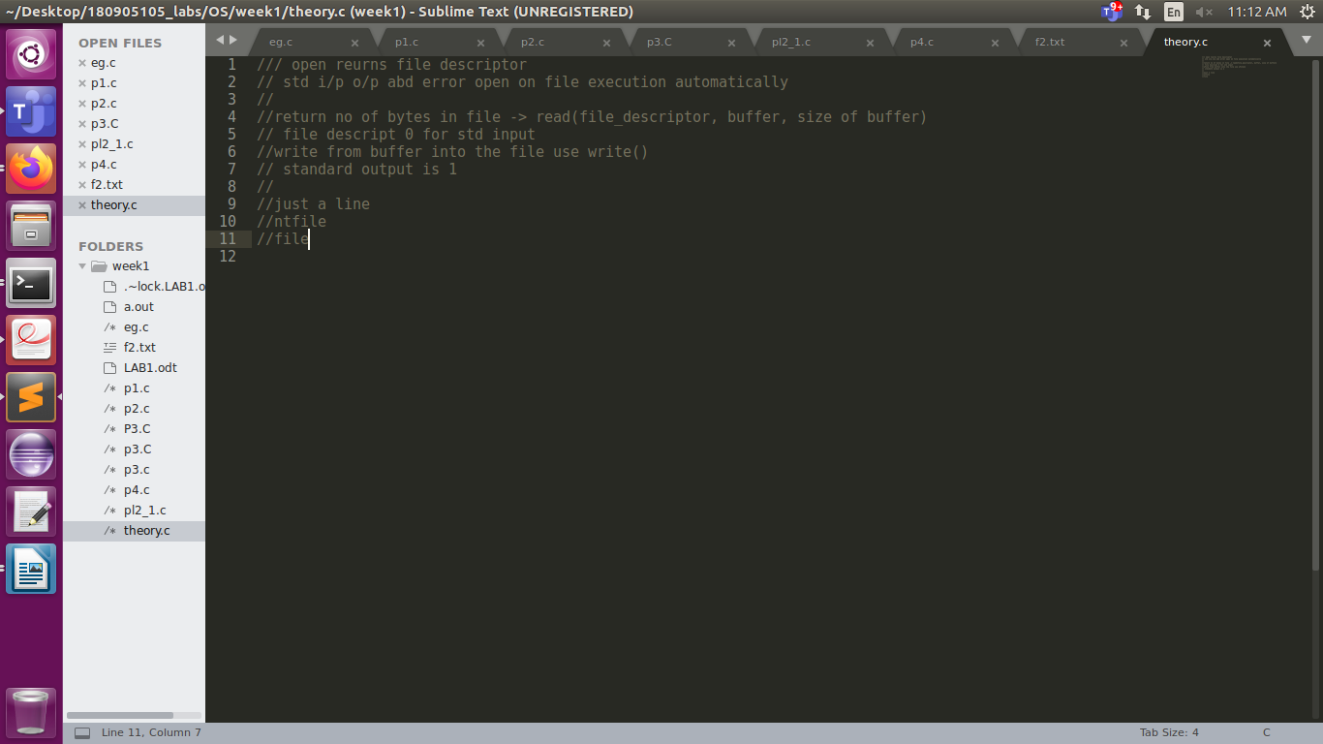
FILE 2:
you can see here file2 was empty before execution, after execution it had the contents of the first file in it
