HRITIK BANSAL, CSE A, 180905105, B1
Q1)
#include <stdio.h>
#include <unistd.h>
#include <sys/stat.h>
#include <sys/types.h>
#include<dirent.h>
int main()
{ DIR * dp;
struct dirent * entry;
struct stat statbuf;
if((dp = opendir("../week1")) == NULL) {
printf("Cannot open directory \n");
return 0;
}
chdir("../week1");
while((entry = readdir(dp)) != NULL)
{
lstat(entry->d_name,&statbuf);
if(!S_ISDIR(statbuf.st_mode)){
printf("%s ",entry->d_name);
printf( (S_ISDIR(statbuf.st_mode)) ? "d" : "-");
printf( (statbuf.st_mode & S_IRUSR) ? "r" : "-");
printf( (statbuf.st_mode & S_IWUSR) ? "w" : "-");
printf( (statbuf.st_mode & S_IXUSR) ? "x" : "-");
printf( (statbuf.st_mode & S_IRGRP) ? "r" : "-");
printf( (statbuf.st_mode & S_IWGRP) ? "w" : "-");
printf( (statbuf.st_mode & S_IXGRP) ? "x" : "-");
printf( (statbuf.st_mode & S_IROTH) ? "r" : "-");
printf( (statbuf.st_mode & S_IWOTH) ? "w" : "-");
printf( (statbuf.st_mode & S_IXOTH) ? "x" : "-");
printf("\n\n");
} }}
OUTPUT:
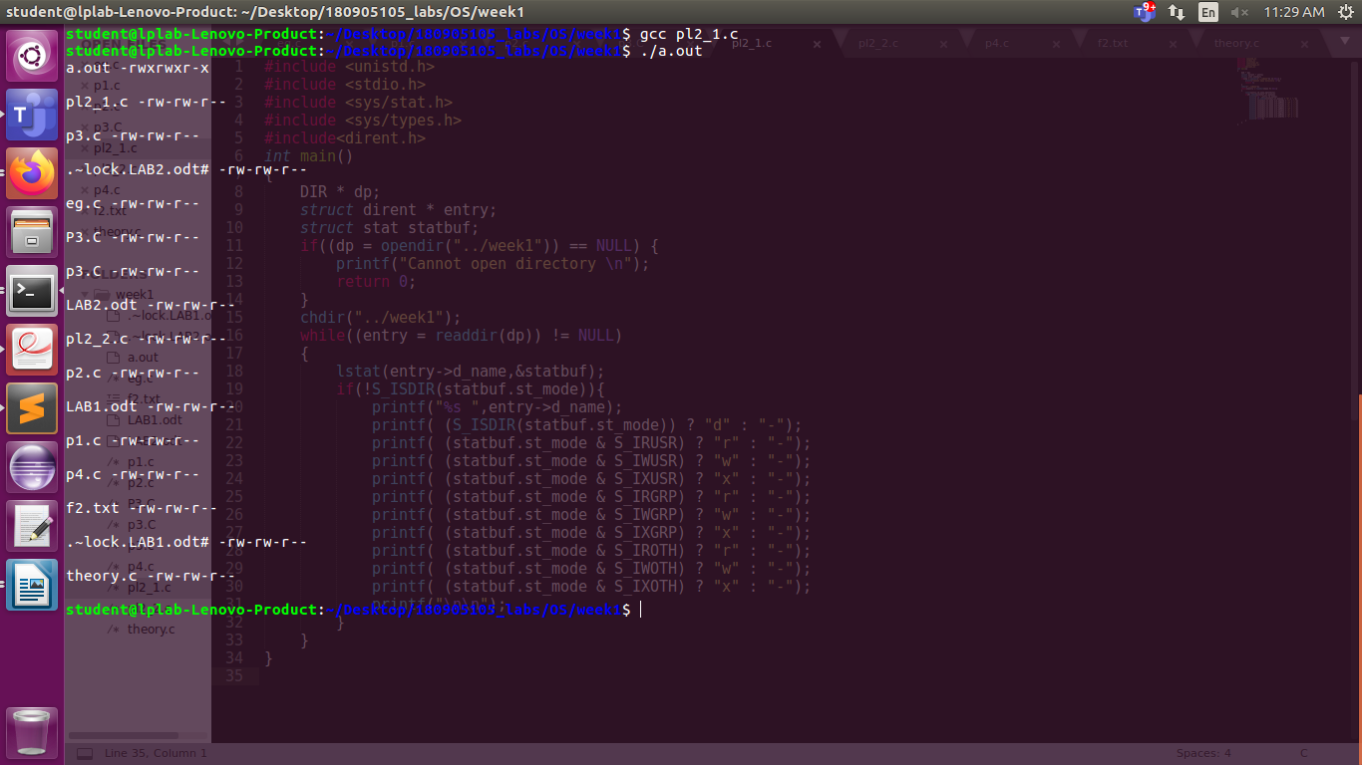
Q2)
#include <stdio.h>
#include<unistd.h>
#include<dirent.h>
#include <string.h>
#include <sys/stat.h>
#include <stdlib.h>
void printDir(char *dir,int depth)
{
DIR * dp;
struct dirent * entry;
struct stat statbuf;
if((dp = opendir(dir)) == NULL) {
printf("Cannot open directory \n");
return;
}
chdir(dir);
while((entry = readdir(dp)) != NULL) {
lstat(entry->d_name,&statbuf);
if(S_ISDIR(statbuf.st_mode)){
if(strcmp(".",entry->d_name) == 0 || strcmp(".." , entry->d_name ) == 0 )
continue;
printf("%*s%s/\n",depth,"",entry->d_name );
printDir(entry->d_name,depth+4);
}
else{
printf("%*s%s/\n",depth,"",entry->d_name);
}
}
chdir("..");
closedir(dp);
}
int main() {
printDir("../week1",0);
}
OUTPUT:

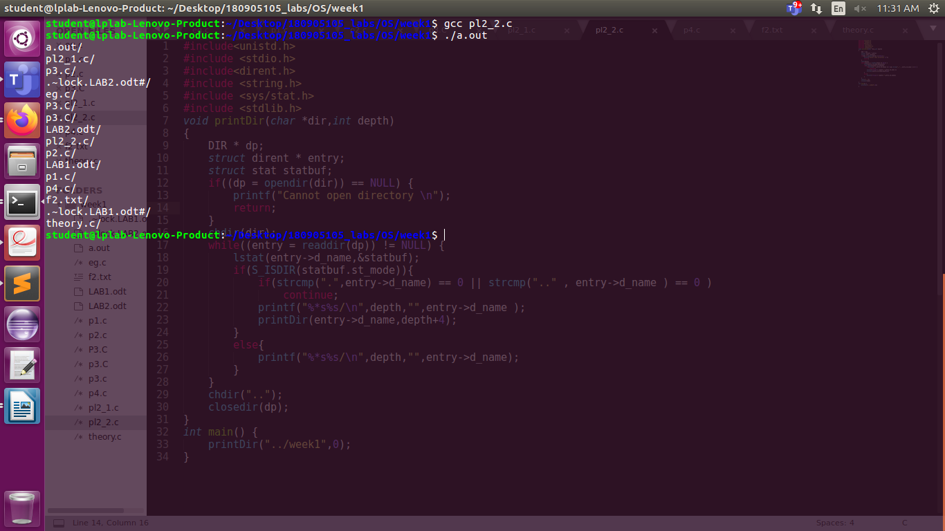

Q3) dpkg -l
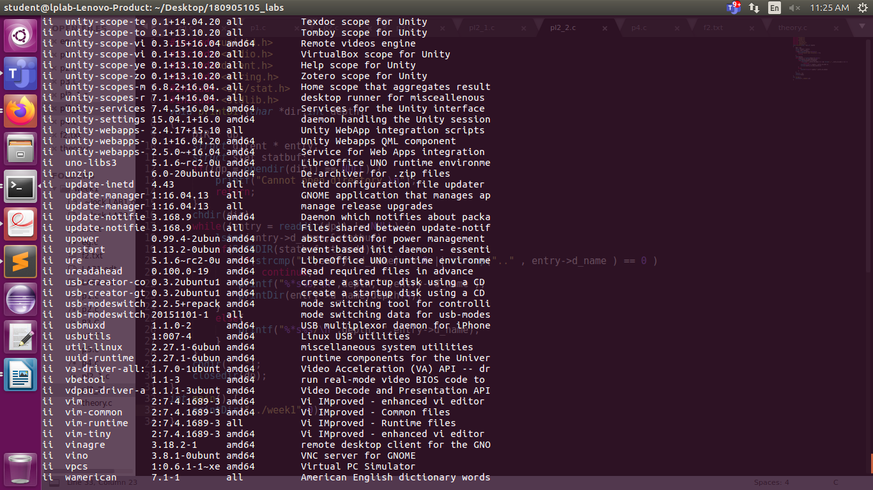

Q4) rpm -qa | wc -l

