HRITIK BANSAL, 180905105 CSE A, B1
LAB3:

Q1) #include<stdio.h>
#include <stdlib.h>
#include<sys/wait.h>
int main(){
int status;
pid_t pid;

int i=0,j=0;
pid=fork();
if (pid==-1)
{
printf("child not created\n");
}
if (pid==0)
{
while(j<4){
printf("the child process is ecxecuting\n");
j++;}}
else
{

while(i<2){
printf("the parent process is ecxecuting\n");

i++;}
wait(&status);
while(i<5){
printf("the parent process is ecxecuting\n");

i++;}
}
exit(0);
}

output:
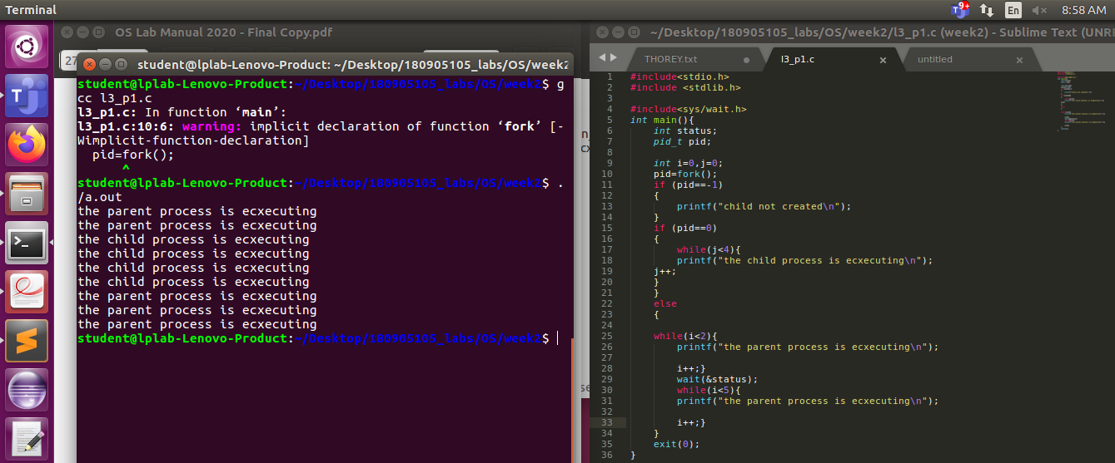
Q2) #include<stdio.h>
#include <stdlib.h>

#include<sys/wait.h>
int main(){
int status;
pid_t pid;

int i=0,j=0;
pid=fork();
if (pid==-1)
{
printf("child not created\n");
}
if (pid==0)
{
printf("\n\n");
while(j<4){
printf("the child process is ecxecuting QUESTION 2\n");
j++;
}
printf("\n\n NEW PROCESS (output of Q1) ASSIGNED TO child\n");
execl("./obj","obj",NULL);
printf("\n\n THIS WILL NOT BE EXECUTED\n");
}
else
{
printf("\n\n");

while(i<2){

printf("the parent process is ecxecuting QUESTION 2\n");

i++;}
wait(&status);
while(i<5){
printf("the parent process is ecxecuting QUESTION 2\n");

i++;}
}
exit(0);
}

output:
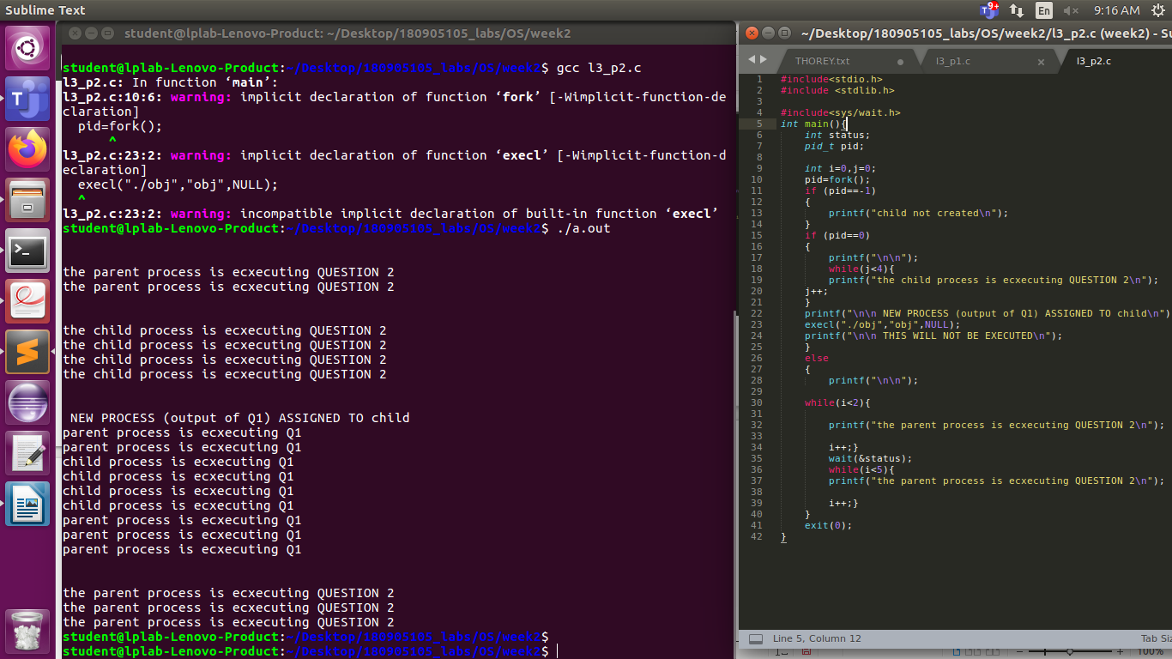
Q3)
#include<stdio.h>
#include <stdlib.h>

#include<sys/wait.h>
int main(){
int status;
pid_t pid;

int i=0,j=0;
pid=fork();
if (pid==-1)
{
printf("child not created\n");
}
if (pid==0)
{ printf("CHILD PROCESS\n");
printf("PROCESS ID %d \n",getpid());
printf("PARENT ID %d \n",getppid());

}
else
{ wait(&status);
printf("\n\n");
printf("PARENT PROCESS\n");
printf("PROCESS ID %d \n",getpid());

exit(0);
}}
output:
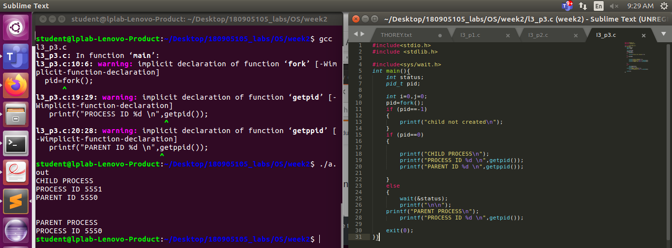
Q4)#include<stdio.h>
#include <stdlib.h>
#include<sys/wait.h>
int main(){
int status;
pid_t pid;

int i=0,j=0;
pid=fork();
if (pid==-1)
{
printf("child not created\n");
}
if (pid==0)
{

printf("CHILD PROCESS ID %d \n",getpid());
printf("PARENT ID %d OF CHILD %d \n",getppid(),getpid());
sleep(5);
printf("\nZOMBIE CHILD %d \n",getpid());
printf("ADOPTING PARENT ID %d OF ZOMBIE CHILD %d \n",getppid(),getpid());
exit(0);
}
else
{

printf("\n\n");
printf("PARENT PROCESS ID %d \n",getpid());
exit(0);
}
;
exit(0);}

output:
