HRITIK BANSAL, 180905105 CSE A, B1

Q1) #include<stdio.h>
#include <stdlib.h>
#include<sys/wait.h>
int main(){
int status;
pid_t pid;

int i=0,j=0;
pid=fork();
if (pid==-1)
{
printf("child not created\n");
}
if (pid==0)
{
while(j<4){
printf("the child process is ecxecuting\n");
j++;}}
else
{

while(i<2){
printf("the parent process is ecxecuting\n");

i++;}
wait(&status);
while(i<5){
printf("the parent process is ecxecuting\n");

i++;}
}
exit(0);
}

output:
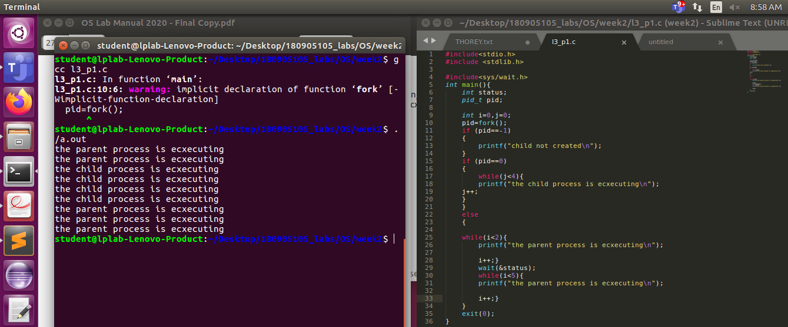
Q2) #include<stdio.h>
#include <stdlib.h>

#include<sys/wait.h>
int main(){
int status;
pid_t pid;

int i=0,j=0;
pid=fork();
if (pid==-1)
{
printf("child not created\n");
}
if (pid==0)
{
printf("\n\n");
while(j<4){
printf("the child process is ecxecuting QUESTION 2\n");
j++;
}
printf("\n\n NEW PROCESS (output of Q1) ASSIGNED TO child\n");
execl("./obj","obj",NULL);
printf("\n\n THIS WILL NOT BE EXECUTED\n");
}
else
{
printf("\n\n");

while(i<2){

printf("the parent process is ecxecuting QUESTION 2\n");

i++;}
wait(&status);
while(i<5){
printf("the parent process is ecxecuting QUESTION 2\n");

i++;}
}
exit(0);
}

output:
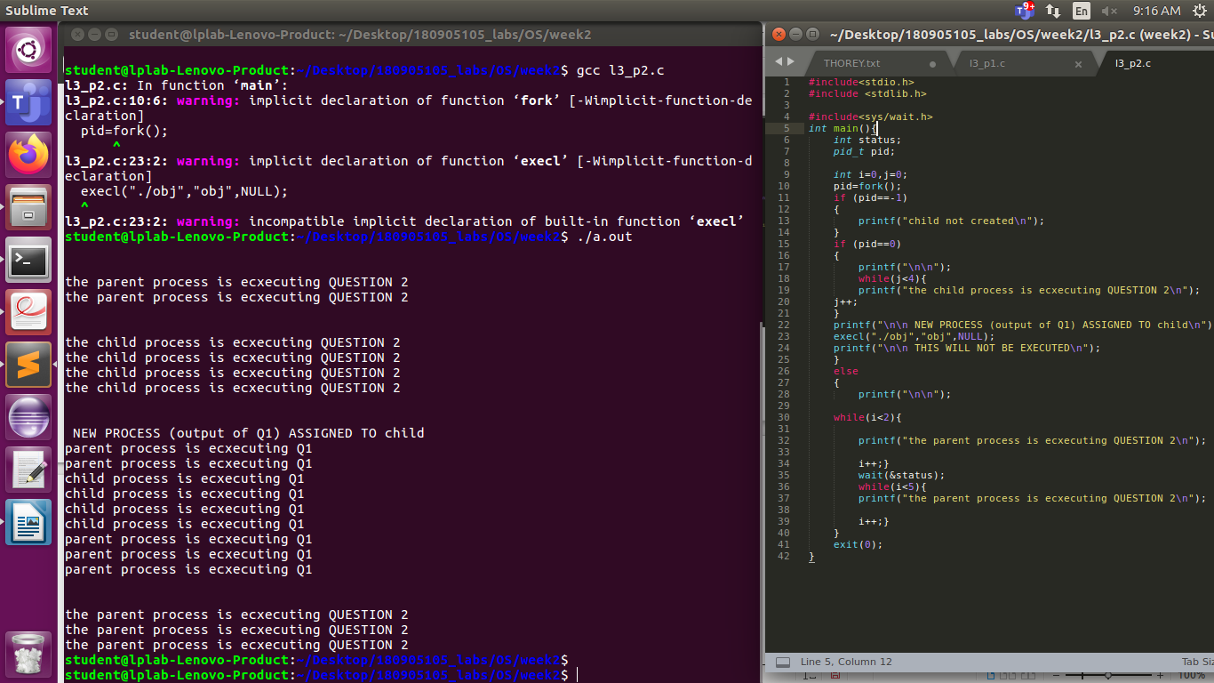
Q3)
#include<stdio.h>
#include <stdlib.h>

#include<sys/wait.h>
int main(){
int status;
pid_t pid;

int i=0,j=0;
pid=fork();
if (pid==-1)
{
printf("child not created\n");
}
if (pid==0)
{ printf("CHILD PROCESS\n");
printf("PROCESS ID %d \n",getpid());
printf("PARENT ID %d \n",getppid());

}
else
{ wait(&status);
printf("\n\n");
printf("PARENT PROCESS\n");
printf("PROCESS ID %d \n",getpid());

exit(0);
}}
output:
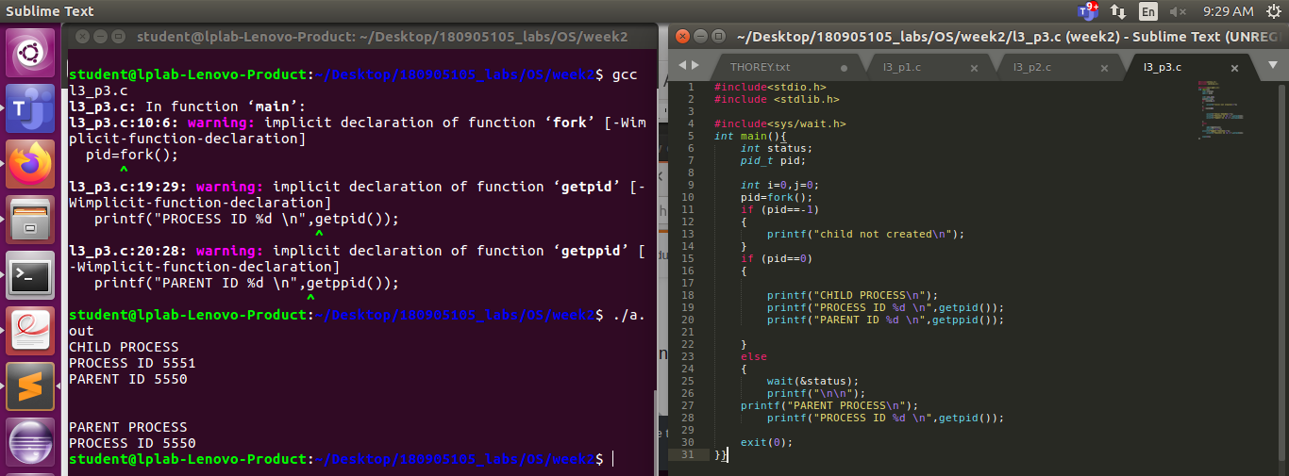
Q4)#include<stdio.h>
#include <stdlib.h>
#include<sys/wait.h>
int main(){
int status;
pid_t pid;

int i=0,j=0;
pid=fork();
if (pid==-1)
{
printf("child not created\n");
}
if (pid==0)
{

printf("CHILD PROCESS ID %d \n",getpid());
printf("PARENT ID %d OF CHILD %d \n",getppid(),getpid());
sleep(5);
printf("\nZOMBIE CHILD %d \n",getpid());
printf("ADOPTING PARENT ID %d OF ZOMBIE CHILD %d \n",getppid(),getpid());
exit(0);
}
else
{

printf("\n\n");
printf("PARENT PROCESS ID %d \n",getpid());
exit(0);
}
;
exit(0);}

output:
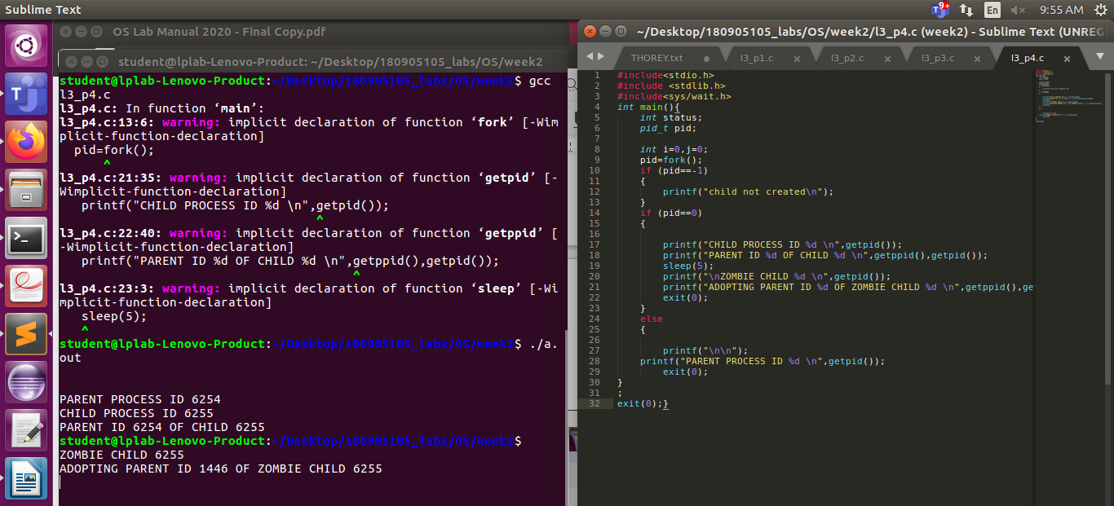
LAB NO 4:
Q1)#include <sys/stat.h>
#include <stdio.h>
#include <unistd.h>
#include <sys/types.h>

int main(int argc, char** argv)
{
struct stat sb;
int ret;
ret = stat(argv[1], &sb);
if (ret) {
perror("unable to fetch stat");
return 1;
}
printf("Inode: %ld\n", sb.st_ino);
return 0;
}

output:
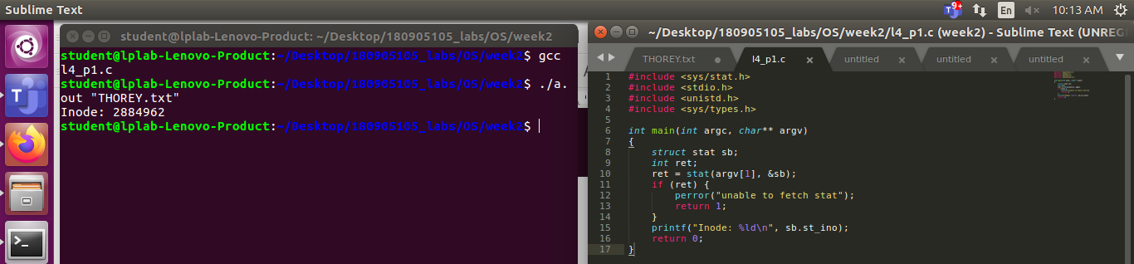

Q2) #include <stdio.h>
#include <sys/types.h>
#include <sys/stat.h>
#include <unistd.h>
#include <stdlib.h>

int main(int argc, char* argv[]) {
struct stat sb;
int ret;
if(argc < 2){
printf("FILE NAME NOT ENTERED\n");
return 1;
}
ret = stat(argv[1], &sb);
if(ret) {
perror("stat");
return 1;
}
printf("st_dev: %ld\n", sb.st_dev);
printf("st_ino: %ld\n", sb.st_ino);
printf("st_size: %ld\n", sb.st_size);
printf("st_uid: %d\n", sb.st_uid);
printf("st_nlink: %ld\n", sb.st_nlink);
return 0;
}
output:
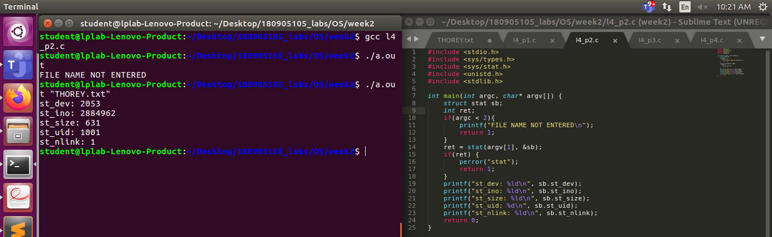
Q3)#include <stdio.h>
#include <sys/types.h>
#include <sys/stat.h>
#include <unistd.h>
#include <stdlib.h>

int main(int argc, char *argv[])
{
struct stat sb,sb2;
int ret,ret2;
//there are 2 types of links, soft and hardlink.
//symbolic link is just a pointer. it is a softlink
//we create a hardlink here
link(argv[1], argv[2]);
printf("NEW HARDLINK CREATED %s \n", argv[2]);
//checking inodes of both
ret = stat(argv[1], &sb);
printf("Inode for original file: %ld\n", sb.st_ino);
ret2 = stat(argv[2], &sb2);
printf("Inode for hardlink: %ld\n", sb2.st_ino);
//enter to unlink
getchar();
unlink(argv[2]);
printf("FILE HAS BEEN UNLINKED\n");
return 0;
}
OUTPUT:
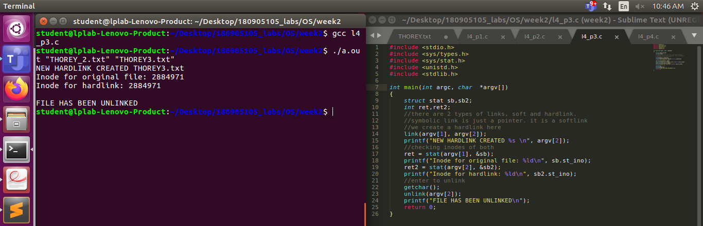
Q4)
#include <stdio.h>
#include <sys/types.h>
#include <sys/stat.h>
#include <unistd.h>
#include <stdlib.h>

int main(int argc, char *argv[])
{
struct stat sb,sb2;
int ret,ret2;
//there are 2 types of links, soft and hardlink.
//symbolic link is just a pointer. it is a softlink
//we create a hardlink here
symlink(argv[1], argv[2]);
printf("NEW HARDLINK CREATED %s \n", argv[2]);
//checking inodes of both
ret = stat(argv[1], &sb);
printf("Inode for original file: %ld\n", sb.st_ino);
ret2 = stat(argv[2], &sb2);
printf("Inode for hardlink: %ld\n", sb2.st_ino);
//enter to unlink
getchar();
unlink(argv[2]);
printf("FILE HAS BEEN UNLINKED\n");
return 0;
}
Output:
