HRITIK BANSAL, 180905105 CSE A, B1

LAB NO 4:
Q1)#include <sys/stat.h>
#include <stdio.h>
#include <unistd.h>
#include <sys/types.h>

int main(int argc, char** argv)
{
struct stat sb;
int ret;
ret = stat(argv[1], &sb);
if (ret) {
perror("unable to fetch stat");
return 1;
}
printf("Inode: %ld\n", sb.st_ino);
return 0;
}

output:
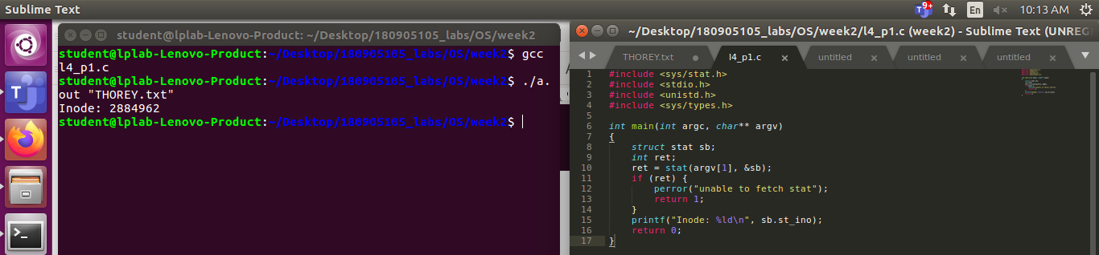

Q2) #include <stdio.h>
#include <sys/types.h>
#include <sys/stat.h>
#include <unistd.h>
#include <stdlib.h>

int main(int argc, char* argv[]) {
struct stat sb;
int ret;
if(argc < 2){
printf("FILE NAME NOT ENTERED\n");
return 1;
}
ret = stat(argv[1], &sb);
if(ret) {
perror("stat");
return 1;
}
printf("st_dev: %ld\n", sb.st_dev);
printf("st_ino: %ld\n", sb.st_ino);
printf("st_size: %ld\n", sb.st_size);
printf("st_uid: %d\n", sb.st_uid);
printf("st_nlink: %ld\n", sb.st_nlink);
return 0;
}
output:
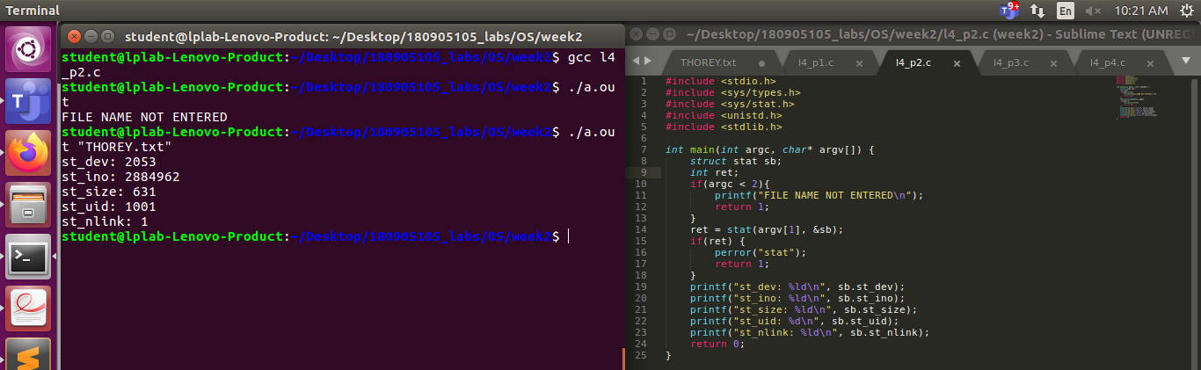
Q3)#include <stdio.h>
#include <sys/types.h>
#include <sys/stat.h>
#include <unistd.h>
#include <stdlib.h>

int main(int argc, char *argv[])
{
struct stat sb,sb2;
int ret,ret2;
//there are 2 types of links, soft and hardlink.
//symbolic link is just a pointer. it is a softlink
//we create a hardlink here
link(argv[1], argv[2]);
printf("NEW HARDLINK CREATED %s \n", argv[2]);
//checking inodes of both
ret = stat(argv[1], &sb);
printf("Inode for original file: %ld\n", sb.st_ino);
ret2 = stat(argv[2], &sb2);
printf("Inode for hardlink: %ld\n", sb2.st_ino);
//enter to unlink
getchar();
unlink(argv[2]);
printf("FILE HAS BEEN UNLINKED\n");
return 0;
}
OUTPUT:
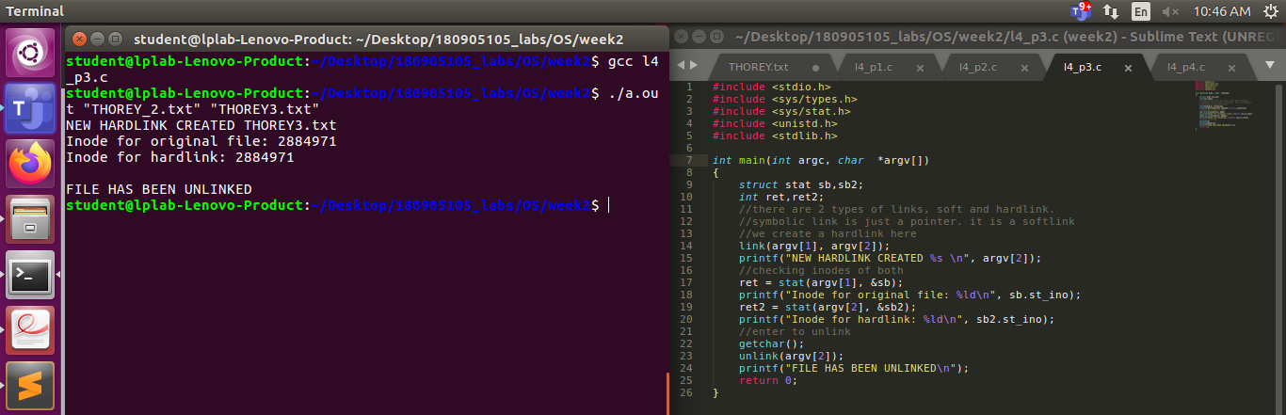
Q4)
#include <stdio.h>
#include <sys/types.h>
#include <sys/stat.h>
#include <unistd.h>
#include <stdlib.h>

int main(int argc, char *argv[])
{
struct stat sb,sb2;
int ret,ret2;
//there are 2 types of links, soft and hardlink.
//symbolic link is just a pointer. it is a softlink
//we create a hardlink here
symlink(argv[1], argv[2]);
printf("NEW HARDLINK CREATED %s \n", argv[2]);
//checking inodes of both
ret = stat(argv[1], &sb);
printf("Inode for original file: %ld\n", sb.st_ino);
ret2 = stat(argv[2], &sb2);
printf("Inode for hardlink: %ld\n", sb2.st_ino);
//enter to unlink
getchar();
unlink(argv[2]);
printf("FILE HAS BEEN UNLINKED\n");
return 0;
}
Output:
