HRITIK BANSAL, CSE A, B1, 15, 180905105
LAB5:
Q1) //producer
#include <stdlib.h>
#include <stdio.h>
#include <string.h>
#include <unistd.h>
#include <sys/types.h>
#include <sys/stat.h>
#include <fcntl.h>
#include <limits.h>

#define FIFO_NAME "/tmp/my_fifo"
#define BUFFER_SIZE PIPE_BUF
#define TEN_MEG (1024*1024*10)

int main(int argc, char *argv[])
{
int pipe_fd;
int res;
int open_mode = O_WRONLY;
int bytes_sent = 0;
char buffer[BUFFER_SIZE + 1];
if (access(FIFO_NAME, F_OK) == -1) {
res = mkfifo(FIFO_NAME, 0777);
if (res!=0) {
fprintf(stderr, "Could not create fifo%s\n", FIFO_NAME);
exit(EXIT_FAILURE);
}
}
printf("Process %d opening FIFO WRONLY\n", getpid());
pipe_fd = open(FIFO_NAME, open_mode);
printf("Process %d opening FIFO O_WRONLY\n", getpid());
pipe_fd = open(FIFO_NAME, open_mode);
printf("Process %d result %d\n", getpid(), pipe_fd);
if (pipe_fd != -1) {
while (bytes_sent < TEN_MEG) {
res = write(pipe_fd, buffer, BUFFER_SIZE);
if (res == -1) {
fprintf(stderr, "Write error on pipe\n");
exit(EXIT_FAILURE);
}
bytes_sent += res;
}
(void)close(pipe_fd);
}
else {
exit(EXIT_FAILURE);
}
printf("Process %d finished\n",getpid());
exit(EXIT_SUCCESS);
}
// consumer
#include <stdlib.h>
#include <stdio.h>
#include <string.h>
#include <unistd.h>
#include <sys/types.h>
#include <sys/stat.h>
#include <fcntl.h>
#include <limits.h>

#define FIFO_NAME "/tmp/my_fifo"
#define BUFFER_SIZE PIPE_BUF

int main(int argc, char *argv[])
{
int pipe_fd;
int res;
int open_mode = O_RDONLY;
char buffer[BUFFER_SIZE + 1];
int bytes_read = 0;
memset(buffer,'\0',sizeof(buffer));
printf("Process %d opening read-only FIFO\n", getpid());
pipe_fd = open(FIFO_NAME, open_mode);
printf("Process %d result %d\n", getpid(), pipe_fd);
if(pipe_fd!=-1)
{
do {
res = read(pipe_fd, buffer, BUFFER_SIZE);
bytes_read += res;
} while (res > 0);
(void)close(pipe_fd);
}
else
{
perror("pipe");
exit(EXIT_FAILURE);
}
printf("Process %d finished\nBytes read = %d\n", getpid(), bytes_read);
exit(EXIT_SUCCESS);
return 0;
}

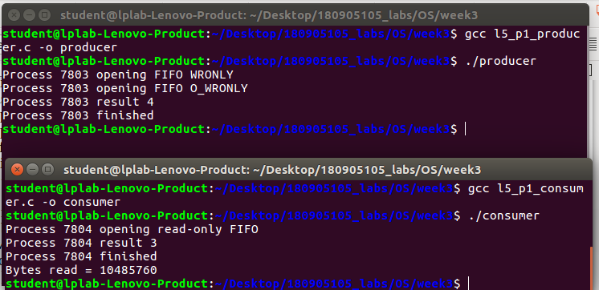
output:

Q2)
#include <stdlib.h>
#include <stdio.h>
#include <string.h>
#include <unistd.h>
#include <sys/types.h>
#include <sys/stat.h>
#include <fcntl.h>
#include <wait.h>

int main(int argc, char *argv[])
{
int fd[2];
pid_t pid;
char buf;
if(argc!=2)
{
printf("Invalid no. of arguments\n");
exit(EXIT_FAILURE);
}
if(pipe(fd)==-1)
{
perror("pipe");
exit(EXIT_FAILURE);
}
pid = fork();
if(pid==-1)
{
perror("fork");
exit(EXIT_FAILURE);
}
else if(pid==0) //child process
{
printf("Reading in child...\n");
close(fd[1]); //close unused write end
while(read(fd[0], &buf, 1)>0)
write(STDOUT_FILENO, &buf, 1);
write(STDOUT_FILENO, "\n", 1);
close(fd[0]);
printf("Child ended\n");
exit(EXIT_SUCCESS);
}
else //parent process
{
printf("\nWriting in parent...\n");
close(fd[0]); //close unused read end
write(fd[1], argv[1], strlen(argv[1]));
close(fd[1]); //reader will see EOF
wait(NULL); //wait for child to terminate
printf("Parent ended\n");
exit(EXIT_SUCCESS);
}
return 0;
}

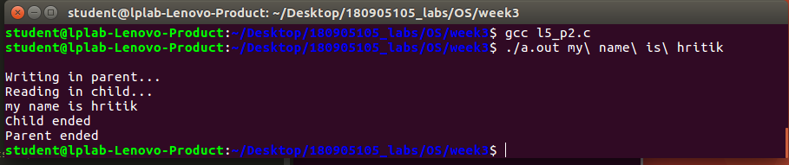
output:

Q3)//write end
#include <stdio.h>
#include <string.h>
#include <fcntl.h>
#include <sys/stat.h>
#include <sys/types.h>
#include <unistd.h>

int main()
{
int fd;
char * myfifo = "/tmp/myfifo";

mkfifo(myfifo, 0777);

char arr1[80], arr2[80];
while (1)
{
fd = open(myfifo, O_WRONLY);
printf(">> ");
fgets(arr2, 80, stdin);
write(fd, arr2, strlen(arr2)+1);
close(fd);

fd = open(myfifo, O_RDONLY);
read(fd, arr1, sizeof(arr1));

printf("User2: %s\n", arr1);
close(fd);
}
return 0;
}

//read end
#include <stdio.h>
#include <string.h>
#include <fcntl.h>
#include <sys/stat.h>
#include <sys/types.h>
#include <unistd.h>

int main()
{
int fd1;

char * myfifo = "/tmp/myfifo";
mkfifo(myfifo, 0777);

char str1[80], str2[80];
while (1)
{
fd1 = open(myfifo,O_RDONLY);
read(fd1, str1, 80);

printf("User1: %s\n", str1);
close(fd1);

fd1 = open(myfifo,O_WRONLY);
printf(">> ");
fgets(str2, 80, stdin);
write(fd1, str2, strlen(str2)+1);
close(fd1);
}
return 0;
}

output:
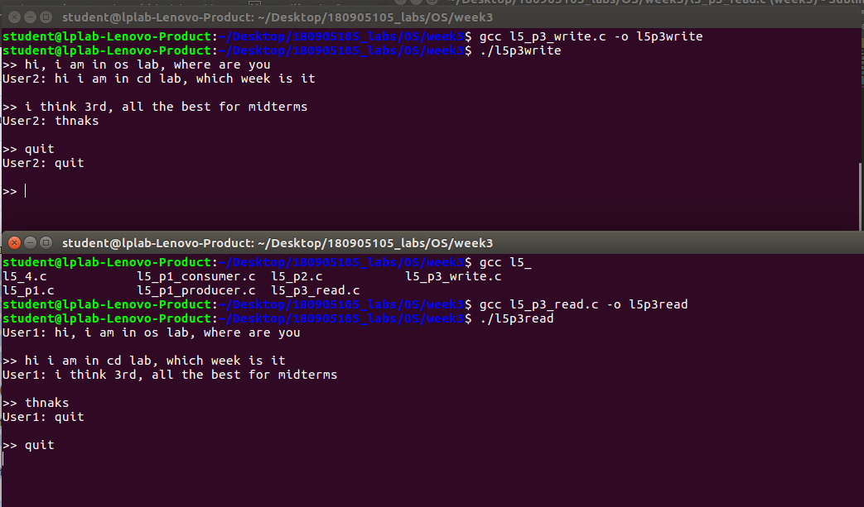

Q4)
#include <stdlib.h>
#include <stdio.h>
#include <string.h>
#include <fcntl.h>

int main(int argc, char** argv) {
if (argc < 3) {
printf("Less Arguments.\n");
printf("Usage: %s <bin_file_name> <string_to_write_there>\n", argv[0]);
exit(-1);
}
FILE* f = fopen(argv[1], "wb");
fwrite(argv[2], strlen(argv[2]),1,f);
close(f);
printf("Written the file.\n\n");

f = fopen(argv[1], "rb");
char buff[strlen(argv[2])];
fread(buff, strlen(argv[2]),1,f);
for(int i = 0; i < strlen(argv[2]); ++i) printf("%x ", buff[i]);
close(f);
return 0;
}
output:
