Q1)//server code
// server program for udp connection
#include <stdio.h>
#include <strings.h>
#include <sys/types.h>
#include <arpa/inet.h>
#include <sys/socket.h>
#include <netinet/in.h>
#include <unistd.h>
#define PORT 5000
#define MAXLINE 1000
// Server code
int main()
{
char buffer[100];
int servsockfd, len, n;
struct sockaddr_in servaddr, cliaddr;
bzero(&servaddr, sizeof(servaddr));
// Create a UDP Socket
servsockfd = socket(AF_INET, SOCK_DGRAM, 0);
servaddr.sin_addr.s_addr = htonl(INADDR_ANY);
servaddr.sin_port = htons(PORT);
servaddr.sin_family = AF_INET;
// bind server address to socket descriptor
bind(servsockfd, (struct sockaddr *)&servaddr, sizeof(servaddr));
while (1)
{
//receive the datagram
len = sizeof(cliaddr);
n = recvfrom(servsockfd, buffer, sizeof(buffer), 0, (struct sockaddr *)&cliaddr, &len);
buffer[n] = '\0';
puts(buffer);
//Echoing back to the client
sendto(servsockfd, buffer, n, 0, (struct sockaddr *)&cliaddr, sizeof(cliaddr));
}
getchar();
// close the descriptor
close(servsockfd);
}
//client code
#include <stdio.h>
#include <strings.h>
#include <sys/types.h>
#include <arpa/inet.h>
#include <sys/socket.h>
#include <netinet/in.h>
#include <unistd.h>
#include <stdlib.h>
#define PORT 5000
#define MAXLINE 1000

int main()
{
char buffer[100];
// char *message = "Hello Server";
char *rows[3];
rows[0] = "1 0 0";
rows[1] = "0 1 0";
rows[2] = "0 0 1";
int sockfd, n, len;
struct sockaddr_in servaddr, cliaddr;
// clear servaddr
bzero(&servaddr, sizeof(servaddr));
servaddr.sin_addr.s_addr = htonl(INADDR_ANY);
servaddr.sin_port = htons(PORT);
servaddr.sin_family = AF_INET;
// create datagram socket
sockfd = socket(AF_INET, SOCK_DGRAM, 0);
for (int i = 0; i < 3; i++)
{
sendto(sockfd, rows[i], MAXLINE, 0, (struct sockaddr *)&servaddr, sizeof(servaddr));
len = sizeof(cliaddr);
}

close(sockfd);
}

SERVER and CLIENT:
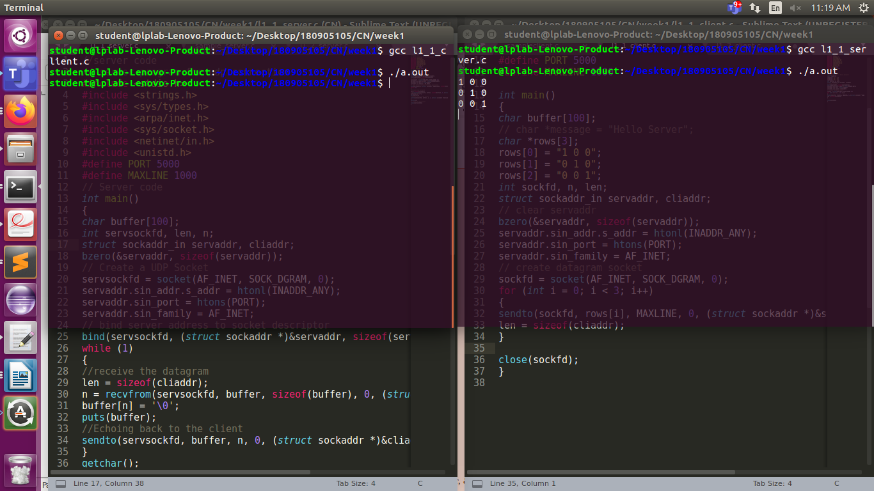

Q2)
// TCP Server program
#include <stdio.h>
#include <netdb.h>
#include <netinet/in.h>
#include <stdlib.h>
#include <string.h>
#include <sys/socket.h>
#include <sys/types.h>
#define MAX 80
#define PORT 8080
#define SA struct sockaddr

// Function designed for chat between client and server.
void servfunc(int sockfd)
{
char *a[50],*b[50];

unsigned long addr;short port;

char buff[MAX];
int n;
// infinite loop for chat
for (;;) {
bzero(buff, MAX);

// read the message from client and copy it in buffer
read(sockfd, buff, sizeof(buff));

// print buffer which contains the client contents
printf("From client: %s\t", buff);
sprintf(b,"%d",port);

for (int j = 0; buff[j]!='\0'; j++)
{
if(buff[j] >= 'a' && buff[j] <= 'z')
{
buff[j] = buff[j] -32;
}
}

printf("To client : %s\n",buff);
write(sockfd, buff, sizeof(buff));

// if msg contains "quit" then server exit and session ended.
if (strncmp("QUIT", buff, 4) == 0) {
printf("Exited...\n");
break;
}
}
}

// Driver function
int main()
{
int sockfd, connfd, len;
struct sockaddr_in servaddr, cli;

// socket create and verification
sockfd = socket(AF_INET, SOCK_STREAM, 0);
if (sockfd == -1) {
printf("socket creation failed...\n");
exit(0);
}
else
printf("Socket successfully created..\n");
bzero(&servaddr, sizeof(servaddr));

// assign IP, PORT
servaddr.sin_family = AF_INET;
servaddr.sin_addr.s_addr = htonl(INADDR_ANY);
servaddr.sin_port = htons(PORT);

// Binding newly created socket to given IP and verification
if ((bind(sockfd, (SA*)&servaddr, sizeof(servaddr))) != 0) {
printf("socket bind failed...\n");
exit(0);
}
else
printf("Socket successfully binded..\n");

// Now server is ready to listen and verification
if ((listen(sockfd, 5)) != 0) {
printf("Listen failed...\n");
exit(0);
}
else
printf("Server listening..\n");
len = sizeof(cli);

// Accept the data packet from client and verification
connfd = accept(sockfd, (SA*)&cli, &len);
if (connfd < 0) {
printf("server acccept failed...\n");
exit(0);
}
else
printf("server acccept the client...\n");
printf("Client Port no: %d\n\t",cli.sin_port);
printf("Client IP: %lu\n",cli.sin_addr.s_addr);
// Function for chatting between client and server
servfunc(connfd);

// After sending exit message close the socket
close(sockfd);
}
//TCP Client program

#include <netdb.h>
#include <stdio.h>
#include <stdlib.h>
#include <string.h>
#include <sys/socket.h>
#define MAX 80
#define PORT 8080
#define SA struct sockaddr
void clifunc(int sockfd)
{
char buff[MAX];
int n;
for (;;) {
bzero(buff, sizeof(buff));
printf("Enter the string : ");
n = 0;
while ((buff[n++] = getchar()) != '\n')
;
write(sockfd, buff, sizeof(buff));

bzero(buff, sizeof(buff));
read(sockfd, buff, sizeof(buff));
printf("From Server : %s", buff);
if ((strncmp(buff, "QUIT", 4)) == 0) {
printf("exited..\n");
break;
}
}
}

int main()
{
int sockfd, connfd;
struct sockaddr_in servaddr, cli;

// socket create and verification
sockfd = socket(AF_INET, SOCK_STREAM, 0);
if (sockfd == -1) {
printf("socket creation failed...\n");
exit(0);
}
else
printf("Socket successfully created..\n");
bzero(&servaddr, sizeof(servaddr));

// assign IP, PORT
servaddr.sin_family = AF_INET;
servaddr.sin_addr.s_addr = inet_addr("127.0.0.1");
servaddr.sin_port = htons(PORT);

// connect the client socket to server socket
if (connect(sockfd, (SA*)&servaddr, sizeof(servaddr)) != 0) {
printf("connection with the server failed...\n");
exit(0);
}
else
printf("connected to the server..\n");

// function for client
clifunc(sockfd);

// close the socket
close(sockfd);
}
SERVER:
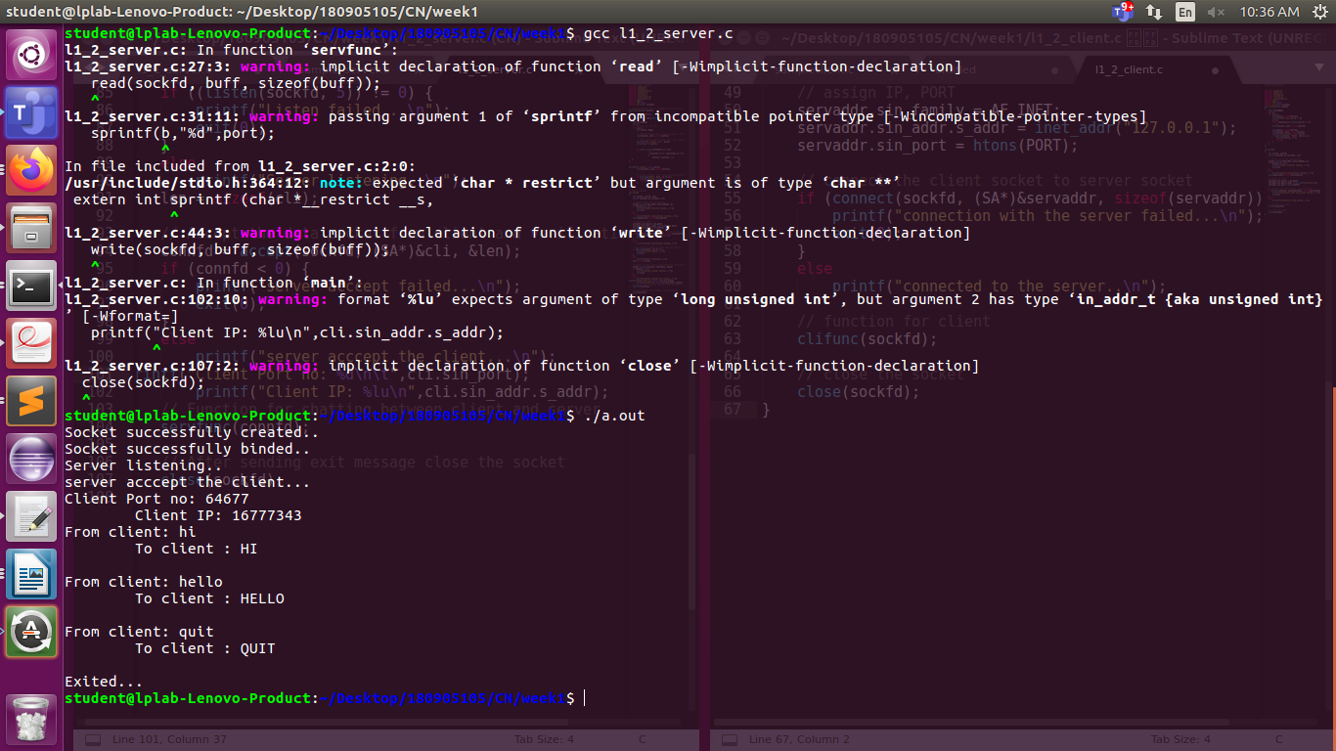

CLIENT:
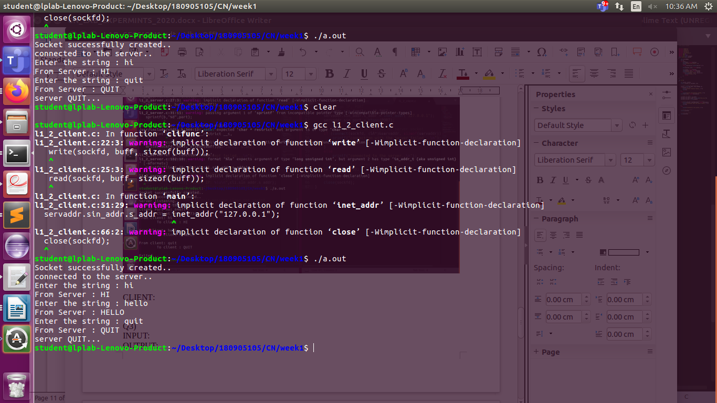

Q3)
//server code

#include <stdio.h>
#include <stdlib.h>
#include <string.h>
#include <unistd.h>
#include <ctype.h>
#include <sys/socket.h>
#include <sys/types.h>
#include <netinet/in.h>
#include <arpa/inet.h>

#define MAXSIZE 150
#define PORT 5000
#define MAXLINE 1000

typedef struct obj {
double a,b,r;
char op;
char ans[10];
}obj1,*obj_ptr;

void main()
{
int sockfd,newsockfd,retval;
socklen_t actuallen;
int recedbytes,sentbytes, sentans;
struct sockaddr_in serveraddr,clientaddr;
obj_ptr buffer = (obj_ptr)malloc(sizeof(obj1));
sockfd=socket(AF_INET,SOCK_STREAM,0);

if(sockfd==-1)
{
printf("\nSocket creation error");
}

serveraddr.sin_family=AF_INET;
serveraddr.sin_port=htons(PORT);
serveraddr.sin_addr.s_addr=htons(INADDR_ANY);
bind(sockfd,(struct sockaddr*)&serveraddr,sizeof(serveraddr));
puts("Server Running");

listen(sockfd,1);

actuallen=sizeof(clientaddr);
newsockfd=accept(sockfd,(struct sockaddr*)&clientaddr,&actuallen);

do{
recv(newsockfd,buffer,sizeof(obj1),0);
if(strcmp(buffer->ans, "stop") == 0)
{
puts("Stopping");
close(sockfd);
close(newsockfd);
} else {
printf("Client [%s:%d] requested: %.2lf %c %.2lf\n", inet_ntoa(clientaddr.sin_addr), ntohs(clientaddr.sin_port), buffer->a, buffer->op, buffer->b);
switch (buffer->op) {
case '+': buffer->r = buffer->a + buffer->b;
break;
case '-': buffer->r = buffer->a - buffer->b;
break;
case '*': buffer->r = buffer->a * buffer->b;
break;
case '/': buffer->r = buffer->a / buffer->b;
break;
case '%': buffer->r = buffer->a / buffer->b;
break;
default:
break;
}
sentbytes = send(newsockfd,buffer,sizeof(obj1),0);
}
}while(strcmp(buffer->ans, "stop") != 0);
}

//client code

#include <stdio.h>
#include <unistd.h>
#include <sys/socket.h>
#include <sys/types.h>
#include <netinet/in.h>
#include <sys/stat.h>
#include <fcntl.h>
#include <arpa/inet.h>
#include <string.h>
#include <stdlib.h>
#define MAXSIZE 150
#define PORT 5000
#define MAXLINE 1000

typedef struct obj {
double a,b,r;
char op;
char ans[10];
}obj1,*obj_ptr;

void main()
{
int sockfd,retval;char ch;
int recedbytes,sentbytes, recans;
struct sockaddr_in serveraddr;
obj_ptr buffer = (obj_ptr)malloc(sizeof(obj1));
obj_ptr buffer1 = (obj_ptr)malloc(sizeof(obj1));
sockfd=socket(AF_INET,SOCK_STREAM,0);
if(sockfd==-1)
{
printf("\nSocket Creation Error");

}
printf("\nSocket ID : %d\n",sockfd);
serveraddr.sin_family=AF_INET;
serveraddr.sin_port=htons(PORT);
serveraddr.sin_addr.s_addr=htonl(INADDR_ANY);
retval=connect(sockfd,(struct sockaddr*)&serveraddr,sizeof(serveraddr));
if(retval==-1)
{
printf("Connection error");
}
do{
printf("Do you want to request? Yes/Stop\n");
scanf("%c",&ch);
scanf("%[^\n]%*c",(buffer->ans));
if(strcmp(buffer->ans,"stop")==0) {
puts("Stopping");
sentbytes=send(sockfd,buffer,sizeof(buffer),0);
close(sockfd);
} else {
printf("Enter in form a op b : ");
scanf("%lf %c %lf",&buffer->a, &buffer->op, &buffer->b);
sentbytes=send(sockfd,buffer,sizeof(obj1),0);
recedbytes=recv(sockfd,buffer1,sizeof(obj1),0);
printf("Result is: %.2lf \n",buffer1->r);
}
}while(strcmp(buffer->ans, "stop") != 0);
}

CLIENT:

SERVER:

Q4)
// server code
#include <stdio.h>
#include <netdb.h>
#include <netinet/in.h>
#include <stdlib.h>
#include <string.h>
#include <sys/socket.h>
#include <sys/types.h>
#include<unistd.h>
#include<time.h>
#define MAX 80
#define PORT 8080
#define SA struct sockaddr
// Function designed for chat between client and server.
void servfunc(int sockfd)
{
char buff[MAX];
int n;
// infinite loop for chat
for (;;) {
bzero(buff, MAX);
// read the message from client and copy it in buffer
read(sockfd, buff, sizeof(buff));
// print buffer which contains the client contents
printf("From client: %s\t To client : ", buff);// Read server message from keyboard in the buffer
n=0;
/* Define temporary variables */
time_t current_time;
struct tm *local_time;
/* Retrieve the current time */
current_time = time(NULL);
/* Get the local time using the current time */
local_time = localtime(&current_time);
/* Display the local time */
char* bufft=asctime(local_time);
// and send that buffer to client
write(sockfd, bufft, sizeof(buff));
// if msg contains "Exit" then server exit and session ended.
if (strncmp("quit", buff, 4) == 0) {
printf("Server Exit...\n");
break;
}
}
}
// Driver function
int main()
{
int sockfd, connfd, len;
struct sockaddr_in servaddr, cli;
// socket create and verification
sockfd = socket(AF_INET, SOCK_STREAM, 0);
if (sockfd == -1) {
printf("socket creation failed...\n");
exit(0);
}
else
printf("Socket successfully created..\n");
bzero(&servaddr, sizeof(servaddr));
// assign IP, PORT
servaddr.sin_family = AF_INET;
servaddr.sin_addr.s_addr = htonl(INADDR_ANY);
servaddr.sin_port = htons(PORT);
// Binding newly created socket to given IP and verification
if ((bind(sockfd, (SA*)&servaddr, sizeof(servaddr))) != 0) {
printf("socket bind failed...\n");
exit(0);
}else
printf("Socket successfully binded..\n");
// Now server is ready to listen and verification
if ((listen(sockfd, 5)) != 0) {
printf("Listen failed...\n");
exit(0);
}
else
printf("Server listening..\n");
len = sizeof(cli);
// Accept the data packet from client and verification
connfd = accept(sockfd, (SA*)&cli, &len);
if (connfd < 0) {
printf("server acccept failed...\n");
exit(0);
}
else
printf("server acccept the client...\n");
int prt=ntohs (cli.sin_port);
printf("%d\n",prt);
// Function for chatting between client and server
servfunc(connfd);
// After sending exit message close the socket
close(sockfd);
}
client:

#include<unistd.h>
#include <netdb.h>
#include <stdio.h>
#include <stdlib.h>
#include<arpa/inet.h>
#include <string.h>
#include <sys/socket.h>
#define MAX 80
#define PORT 8080
#define SA struct sockaddr
void clifunc(int sockfd)
{
char buff[MAX];
int n;
for (;;) {
bzero(buff, sizeof(buff));
printf("Enter the string : ");
n = 0;
while ((buff[n++] = getchar()) != '\n');
write(sockfd, buff, sizeof(buff));
bzero(buff, sizeof(buff));
read(sockfd, buff, sizeof(buff));
printf("From Server : %s\n", buff);
if ((strncmp(buff, "quit", 4)) == 0) {
printf("Client Exit...\n");
break;
}
}
}
int main()
{
int sockfd, connfd;
struct sockaddr_in servaddr, cli;
// socket create and verification
sockfd = socket(AF_INET, SOCK_STREAM, 0);
if (sockfd == -1) {
printf("socket creation failed...\n");
exit(0);
}
else
printf("Socket successfully created..\n");
bzero(&servaddr, sizeof(servaddr));
// assign IP, PORT
servaddr.sin_family = AF_INET;
servaddr.sin_addr.s_addr = inet_addr("127.0.0.1");
servaddr.sin_port = htons(PORT);
// connect the client socket to server socket
if (connect(sockfd, (SA*)&servaddr, sizeof(servaddr)) != 0) {
printf("connection with the server failed...\n");
exit(0);
}
else
printf("connected to the server..\n");
// function for client
clifunc(sockfd);
// close the socket
close(sockfd);
}

CLIENT:
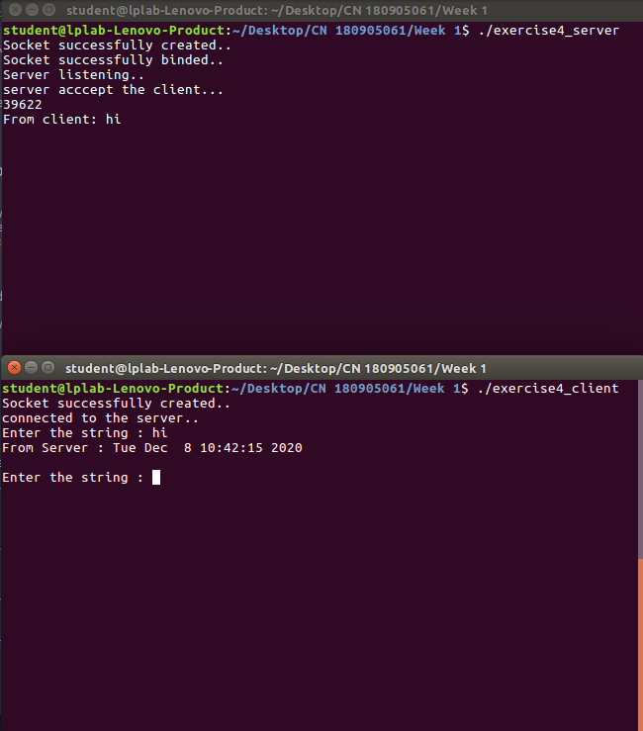

SERVER:

