Q)
#include <stdio.h>
#include <stdlib.h>
#include <ctype.h>
#include <string.h>
const char *keywords[] = {

"auto",

"double",

"int",

"struct",

"break",

"else",

"long",

"switch",

"case",

"enum",

"register",

"typedef",

"char",

"extern",

"return",

"union",

"continue",

"for",

"signed",

"void",

"do",

"if",

"static",

"while",

"default",

"goto",

"sizeof",

"volatile",

"const",

"float",

"short",

"unsigned",

"printf",

"scanf",
"true","false"

};
const char *datypes[]={"int","char","void","float","bool"};
int isdtype(char *w)
{
int i;
for(i=0;i<sizeof(datypes)/sizeof(char*);i++)
{
if(strcmp(w,datypes[i])==0)
{
return 1;
}
}
return 0;
}
int isKeyword(char *w)
{

int i;

for(i=0;i<sizeof(keywords)/sizeof(char*);i++)

{

if(strcmp(w,keywords[i])==0)

{

return 1;

}

}

return 0;
}
struct token
{
char lexeme[128];
unsigned int row,col;
char type[64];
};
struct sttable
{
int sno;
char lexeme[128];
char dtype[64];
char type[64];
int size;
};
int findTable(struct sttable *tab,char *nam,int n)
{
int i=0;
for(i=0;i<n;i++)
{
if(strcmp(tab[i].lexeme,nam)==0)
{
return 1;
}
}
return 0;
}
struct sttable fillTable(int sno,char *lexn,char *dt,char *t,int s)
{
struct sttable tab;
tab.sno=sno;
strcpy(tab.lexeme,lexn);
strcpy(tab.dtype,dt);
strcpy(tab.type,t);
tab.size=s;
return tab;
}
void printTable(struct sttable *tab,int n)
{
for(int i=0;i<n;i++)
{
printf("%d %s %s %s %d\n",tab[i].sno,tab[i].lexeme,tab[i].dtype,tab[i].type,tab[i].size);
}
}
static int row=1,col=1;
char buf[2048];
char dbuf[128];
int ind=0;
const char specialsymbols[]={'?',';',':',','};
const char arithmeticsymbols[]={'*'};
int charIs(int c,const char *arr)
{
int len;
if(arr==specialsymbols)
{
len=sizeof(specialsymbols)/sizeof(char);
}
else if(arr==arithmeticsymbols)
{
len=sizeof(arithmeticsymbols)/sizeof(char);
}
for(int i=0;i<len;i++)
{
if(c==arr[i])
{
return 1;
}
}
return 0;
}
void fillToken(struct token *tkn,char c,int row,int col, char *type)
{
tkn->row=row;
tkn->col=col;
strcpy(tkn->type,type);
tkn->lexeme[0]=c;
tkn->lexeme[1]='\0';
}
void newLine()
{
++row;
col=1;
}
int sz(char *w)
{
if(strcmp(w,"int")==0)
return 4;
if(strcmp(w,"char")==0)
return 1;
if(strcmp(w,"void")==0)
return 0;
if(strcmp(w,"float")==0)
return 8;
if(strcmp(w,"bool")==0)
return 1;
}
struct token getNextToken(FILE *fa)
{
int c;
struct token tkn=
{
.row=-1
};
int gotToken=0;
while(!gotToken && (c=fgetc(fa))!=EOF)
{
if(charIs(c,specialsymbols))
{
fillToken(&tkn,c,row,col,"SS");
gotToken=1;
++col;
}
else if(charIs(c,arithmeticsymbols))
{
fseek(fa,-1,SEEK_CUR);
c=getc(fa);
if(isalnum(c)){
fillToken(&tkn,c,row,col,"ARITHMETICOPERATOR");
gotToken=1;
++col;
}
fseek(fa,1,SEEK_CUR);
}
else if(c=='(')
{
fillToken(&tkn,c,row,col,"LB");
gotToken=1;
col++;
}
else if(c==')')
{
fillToken(&tkn,c,row,col,"RB");
gotToken=1;
col++;
}
else if(c=='{')
{
fillToken(&tkn,c,row,col,"LC");
gotToken=1;
col++;
}
else if(c=='}')
{
fillToken(&tkn,c,row,col,"RC");
gotToken=1;
col++;
}
else if(c=='[')
{
fillToken(&tkn,c,row,col,"LS");
gotToken=1;
col++;
}
else if(c==']')
{
fillToken(&tkn,c,row,col,"RS");
gotToken=1;
col++;
}
else if(c=='+')
{
int x=fgetc(fa);
if(x!='+')
{
fillToken(&tkn,c,row,col,"ARITHMETICOPERATOR");
gotToken=1;
col++;
fseek(fa,-1,SEEK_CUR);
}
else
{
fillToken(&tkn,c,row,col,"UNARYOPERATOR");
strcpy(tkn.lexeme,"++");
gotToken=1;
col+=2;
}
}
else if(c=='-')
{
int x=fgetc(fa);
if(x!='-')
{
fillToken(&tkn,c,row,col,"ARITHMETICOPERATOR");
gotToken=1;
col++;
fseek(fa,-1,SEEK_CUR);
}
else
{
fillToken(&tkn,c,row,col,"UNARYOPERATOR");
strcpy(tkn.lexeme,"++");
gotToken=1;
col+=2;
}
}
else if(c=='=')
{
int x=fgetc(fa);
if(x!='=')
{
fillToken(&tkn,c,row,col,"ASSIGNMENTOPERATOR");
gotToken=1;
col++;
fseek(fa,-1,SEEK_CUR);
}
else
{
fillToken(&tkn,c,row,col,"RELATIONALOPERATOR");
strcpy(tkn.lexeme,"++");
gotToken=1;
col+=2;
}
}
else if(isdigit(c))
{
fillToken(&tkn,c,row,col++,"NUMBER");
int j=1;
while((c=fgetc(fa))!=EOF && isdigit(c))
{
tkn.lexeme[j++]=c;
col++;
}
tkn.lexeme[j]='\0';
gotToken=1;
fseek(fa,-1,SEEK_CUR);
}
else if(c == '#')
{
while((c = fgetc(fa))!= EOF && c != '\n');
newLine();
}
else if(c=='\n')
{
newLine();
c = fgetc(fa);
if(c == '#')
{
while((c = fgetc(fa)) != EOF && c != '\n');
newLine();
}
else if(c != EOF)
{
fseek(fa, -1, SEEK_CUR);
}
}
else if(isspace(c))
{
++col;
}
else if(isalpha(c) || c=='_')
{
tkn.row=row;
tkn.col=col++;
tkn.lexeme[0]=c;
int j=1;
while((c=fgetc(fa))!=EOF && isalnum(c))
{
tkn.lexeme[j++]=c;
col++;
}
tkn.lexeme[j]='\0';
if(isKeyword(tkn.lexeme))
{
strcpy(tkn.type,"KEYWORD");
}
else
{
strcpy(tkn.type,"IDENTIFIER");
}
gotToken=1;
fseek(fa,-1,SEEK_CUR);
}
else if(c=='/')
{
int d=fgetc(fa);
++col;
if(d=='/')
{
while((c=fgetc(fa))!= EOF && c!='\n')
{
++col;
}
if(c=='\n')
{
newLine();
}
}
else if(d=='*')
{
do
{
if(d=='\n')
{
newLine();
}
while((c==fgetc(fa))!= EOF && c!='*')
{
++col;
if(c=='\n')
{
newLine();
}
}
++col;
}while((d==fgetc(fa))!= EOF && d!='/' && (++col));
++col;
}
else
{
fillToken(&tkn,c,row,--col,"ARITHMETIC OPERATOR");
gotToken=1;
fseek(fa,-1,SEEK_CUR);
}
}
else if(c=='"')
{
tkn.row=row;
tkn.col=col;
strcpy(tkn.type, "STRING LITERAL");
int k = 1;
tkn.lexeme[0] = '"';
while((c = fgetc(fa)) != EOF && c != '"')
{
tkn.lexeme[k++] = c;
++col;
}
tkn.lexeme[k] = '"';
gotToken = 1;
}
else if(c == '<' || c == '>' || c == '!')
{
fillToken(&tkn, c, row, col, "RELATIONALOPERATOR");
++col;
int d = fgetc(fa);
if(d == '=')
{
++col;
strcat(tkn.lexeme, "=");
}
else
{
if(c == '!')
{
strcpy(tkn.type, "LOGICALOPERATOR");
}
fseek(fa, -1, SEEK_CUR);
}
gotToken = 1;
}
else if(c == '&' || c == '|')
{
int d = fgetc(fa);
if(c == d)
{
tkn.lexeme[0] = tkn.lexeme[1] = c;
tkn.lexeme[2] = '\0';
tkn.row = row;
tkn.col = col;
++col;
gotToken = 1;
strcpy(tkn.type, "LOGICALOPERATOR");
}
else
{
fseek(fa, -1, SEEK_CUR);
}
++col;
}
else
{
++col;
}
}
return tkn;
}
int main()
{
FILE *fa, *fb;
int ca, cb;
fa = fopen("Input.c", "r");
if (fa == NULL){
printf("Cannot open file \n");
exit(0);
}

fb = fopen("out4.c", "w+");
ca = getc(fa);
while (ca != EOF){
if(ca==' ')
{
putc(ca,fb);
while(ca==' ')
ca = getc(fa);
}
if (ca=='/')
{
cb = getc(fa);
if (cb == '/')
{
while(ca != '\n')
ca = getc(fa);
}
else if (cb == '*')
{
do
{
while(ca != '*')
ca = getc(fa);
ca = getc(fa);
} while (ca != '/');
}
else{
putc(ca,fb);
putc(cb,fb);
}
}
else putc(ca,fb);
ca = getc(fa);
}
fclose(fa);
fclose(fb);
fa = fopen("out4.c", "r");
if(fa == NULL){
printf("Cannot open file");
return 0;
}
fb = fopen("temp.c", "w+");
ca = getc(fa);
while (ca != EOF)
{
if(ca=='"')
{
putc(ca,fb);
ca=getc(fa);
while(ca!='"')
{
putc(ca,fb);
ca=getc(fa);
}
}
else if(ca=='#')
{

while(ca!='\n')
{

ca=getc(fa);

}
ca=getc(fa);
}
putc(ca,fb);
ca = getc(fa);
}
fclose(fa);
fclose(fb);

fa = fopen("temp.c", "r");
fb = fopen("out4.c", "w");
ca = getc(fa);
while(ca != EOF){
putc(ca, fb);
ca = getc(fa);
}
fclose(fa);
fclose(fb);
remove("temp.c");
FILE *f1=fopen("out4.c","r");
if(f1==NULL)
{
printf("Error! File cannot be opened!\n");
return 0;
}

struct token tkn;
struct sttable st[10][100];
int flag=0,i=0,j=0;
int tabsz[10];
char w[25];
w[0]='\0';
while((tkn=getNextToken(f1)).row!=-1)
{
printf("<%s, %d, %d, %s>\n",tkn.lexeme,tkn.row,tkn.col,tkn.type);
if(strcmp(tkn.type,"KEYWORD")==0)
{
if(isdtype(tkn.lexeme)==1)
{
strcpy(dbuf,tkn.lexeme);
}
}
else if(strcmp(tkn.type,"IDENTIFIER")==0)
{
strcpy(w,tkn.lexeme);
tkn=getNextToken(f1);
printf("<%s, %d, %d, %s>\n",tkn.lexeme,tkn.row,tkn.col,tkn.type);
if((strcmp(tkn.type,"LB"))==0)
{
if(findTable(st[i],w,j)==0)
{
ind++;
st[i][j++]=fillTable(ind,w,dbuf,"func",-1);
}
}
if((strcmp(tkn.type,"LS"))==0)
{
if(findTable(st[i],w,j)==0)
{
tkn=getNextToken(f1);
printf("<%s, %d, %d, %s>\n",tkn.lexeme,tkn.row,tkn.col,tkn.type);
int s=0;
if(strcmp(tkn.type,"NUMBER")==0)
{
s=atoi(tkn.lexeme);
}
ind++;
st[i][j++]=fillTable(ind,w,dbuf,"id",sz(dbuf)*s);
}
}
else
{
if(findTable(st[i],w,j)==0)
{
ind++;
st[i][j++]=fillTable(ind,w,dbuf,"id",sz(dbuf));
}
}
}
else if(strcmp(tkn.type,"LC")==0)
{
flag++;
}
else if(strcmp(tkn.type,"RC")==0)
{
flag--;
if(flag==0)
{
tabsz[i]=j;
i++;
j=0;
ind=0;
}
}
}
int k=0;
printf("\n\n\nSYMBOL TABLEs STARTS HERE\n\n");

for(k=0;k<i;k++)
{
printTable(st[k],tabsz[k]);
printf("______________________________________________\n\n");
}
fclose(f1);

}

INPUT:
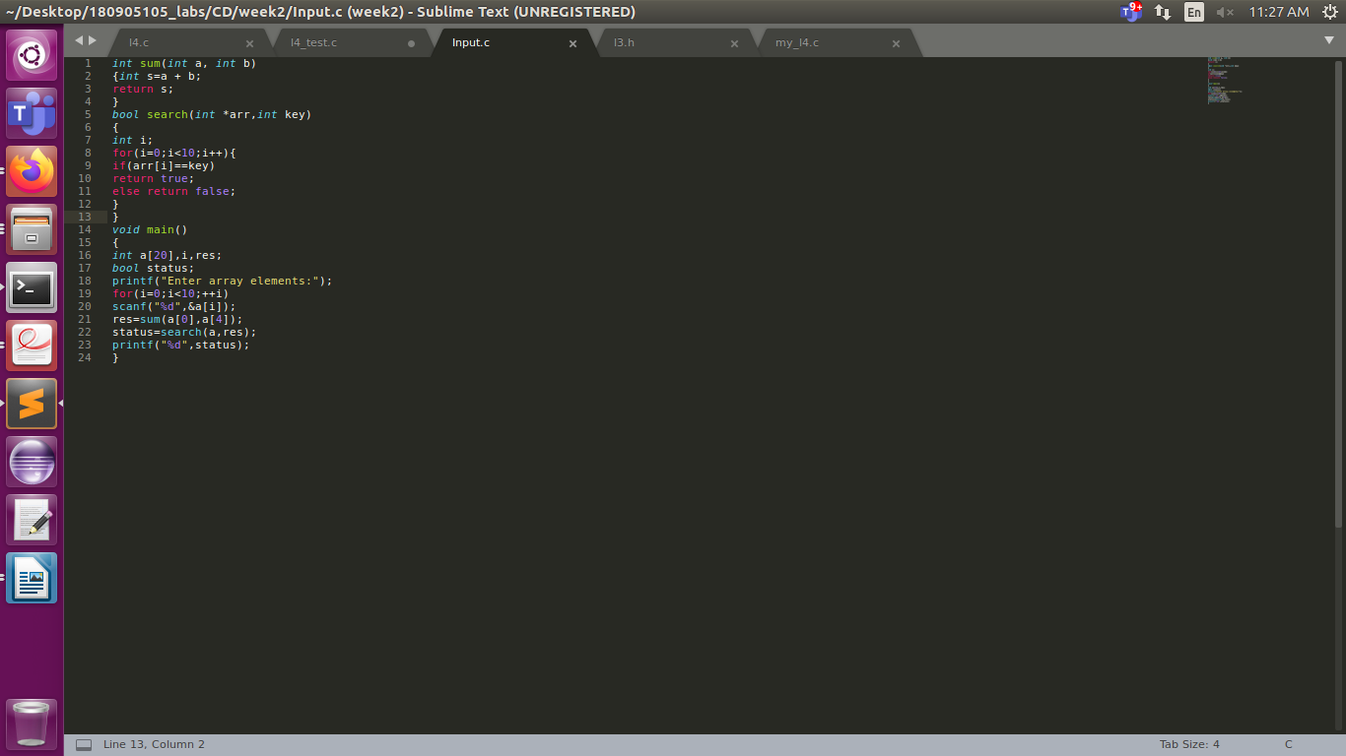
OUTPUT:
