Q3) HTTP RETRIEVAL
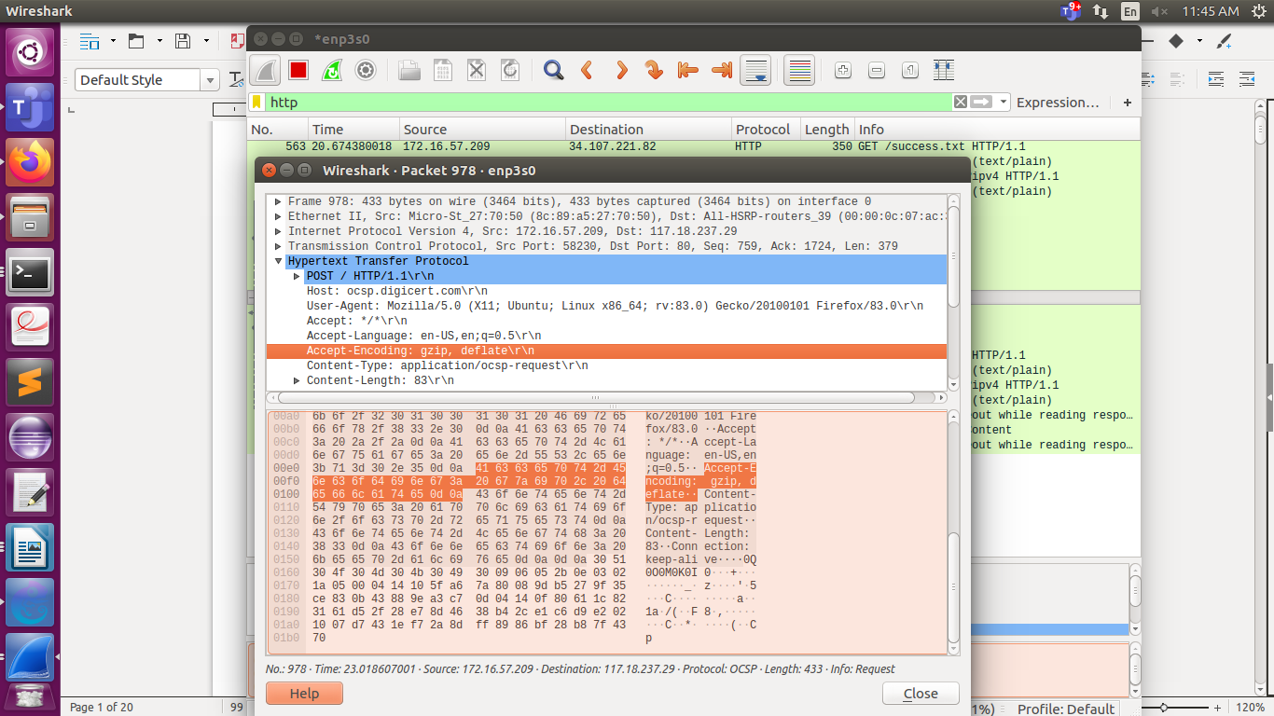
Q3.2)FTP
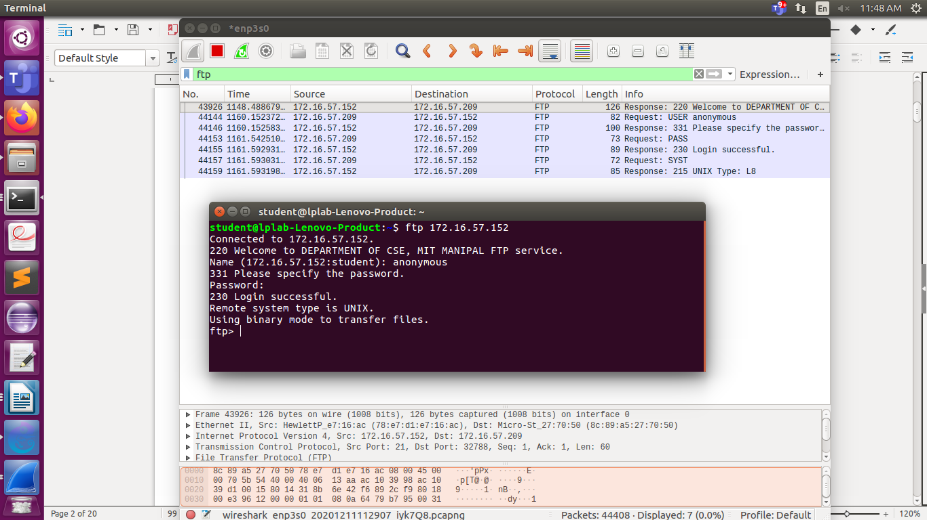

Q3.7) DNS, dig utilities.
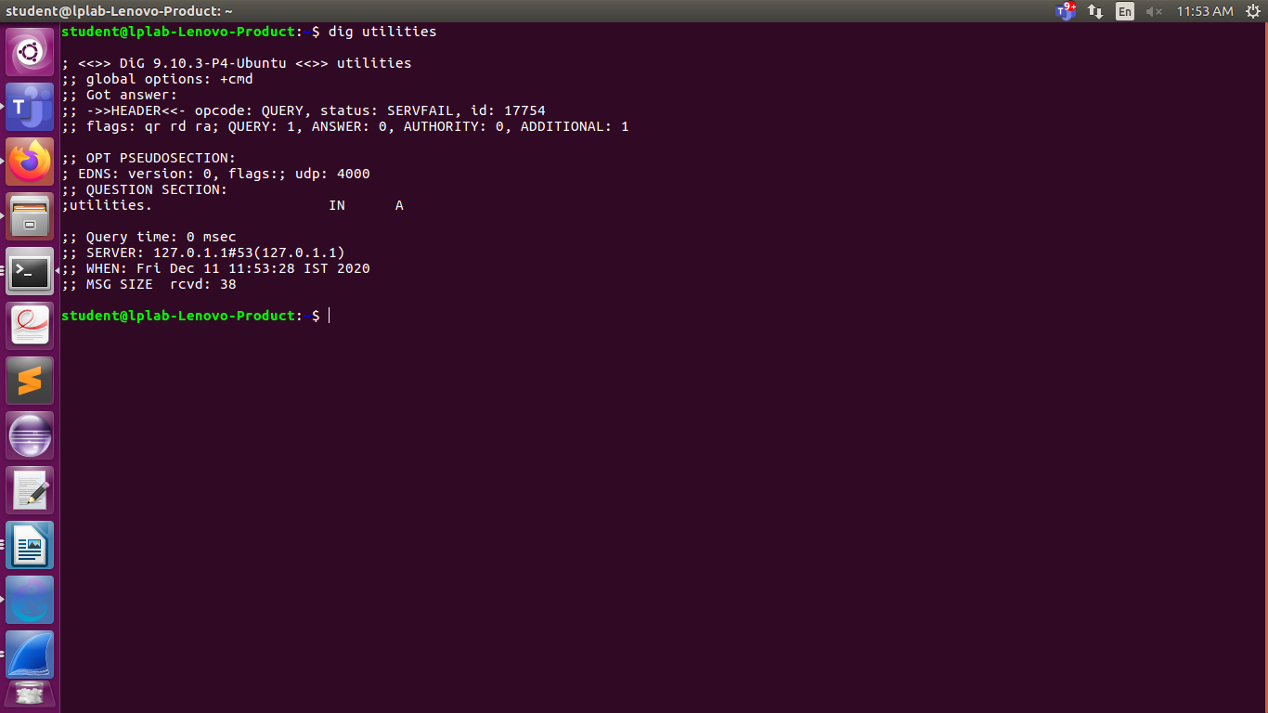

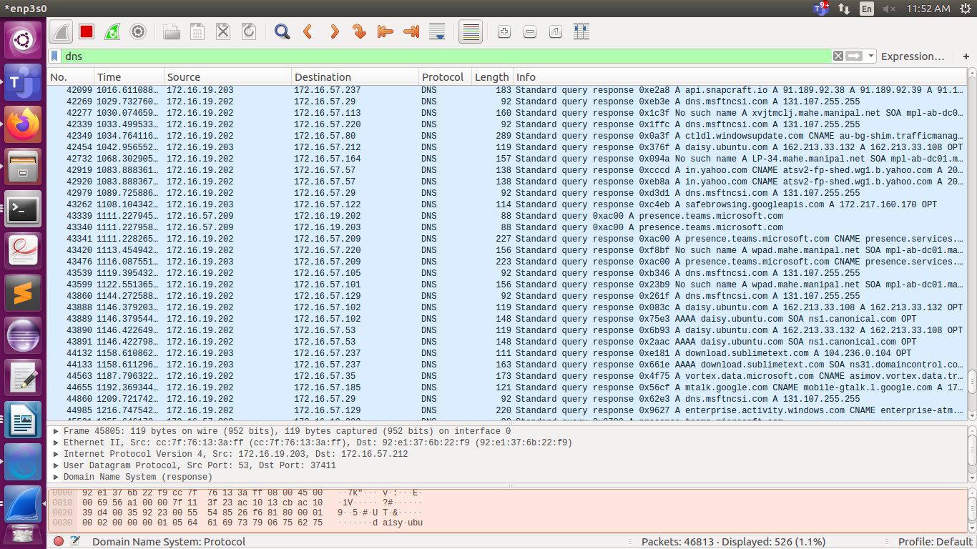

Q4.1)

NETWORK CONFIGURATION:
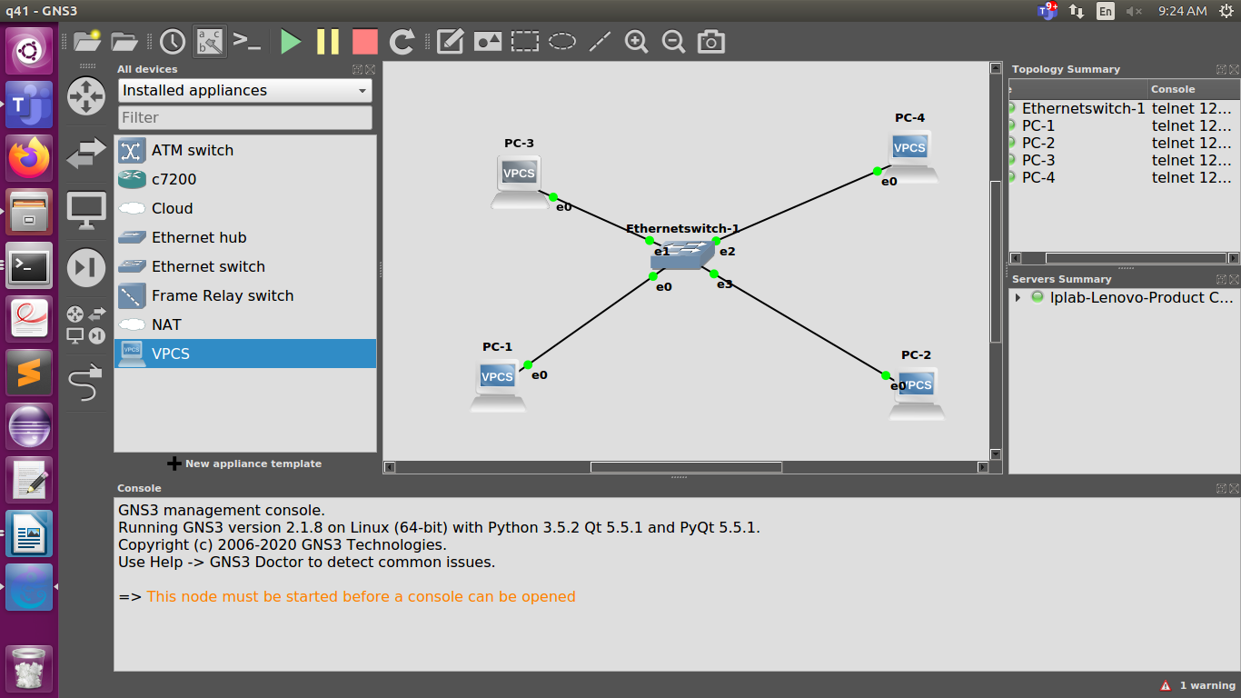

IP address configuration FOR THE 4 pcs:
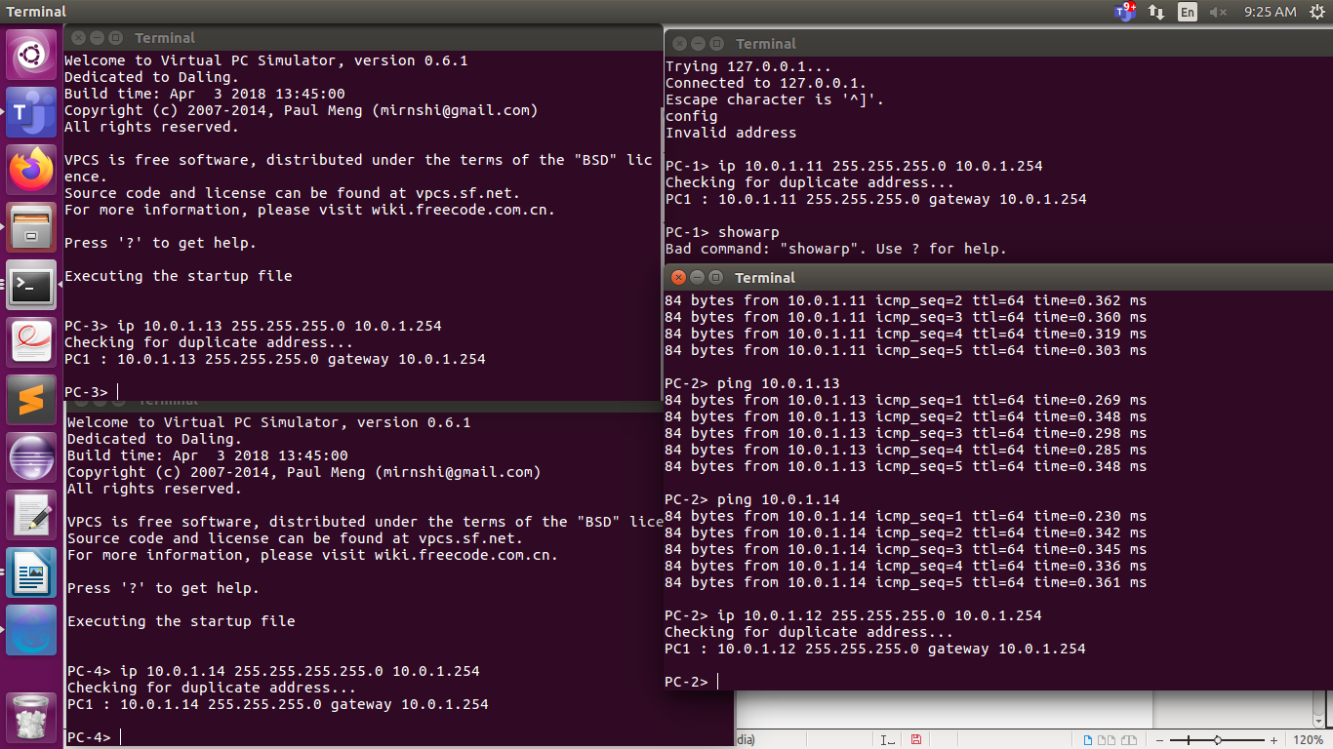

a)SHOW ARP ON PC1:
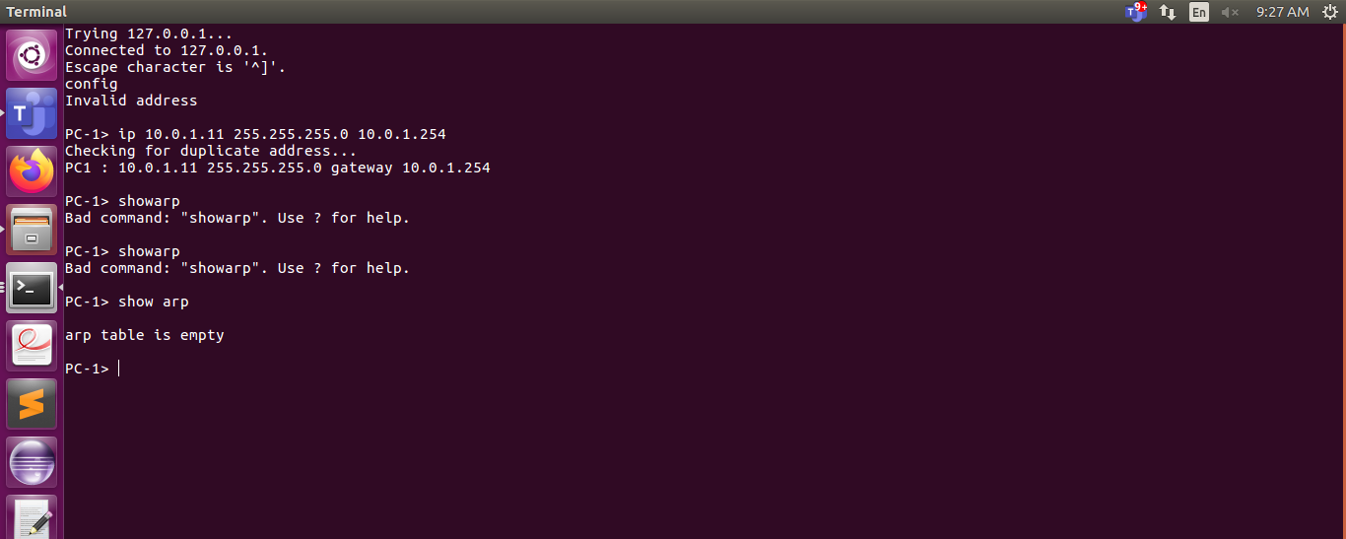
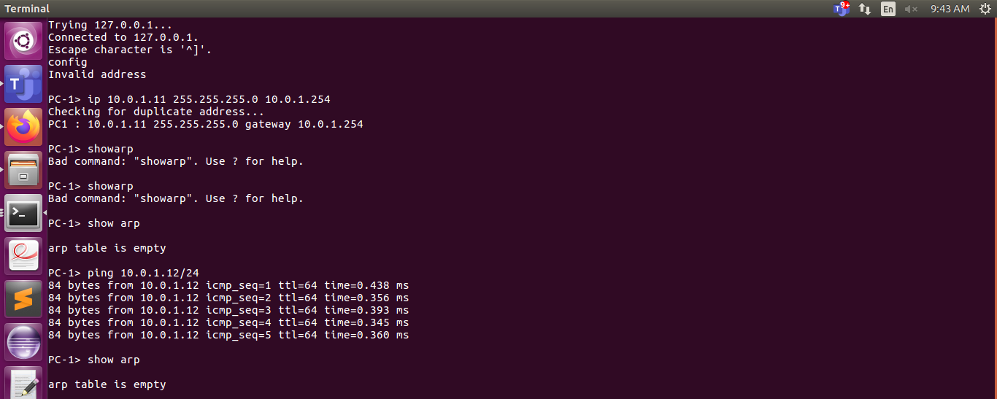
b)PC1 TO PC2 FILTER
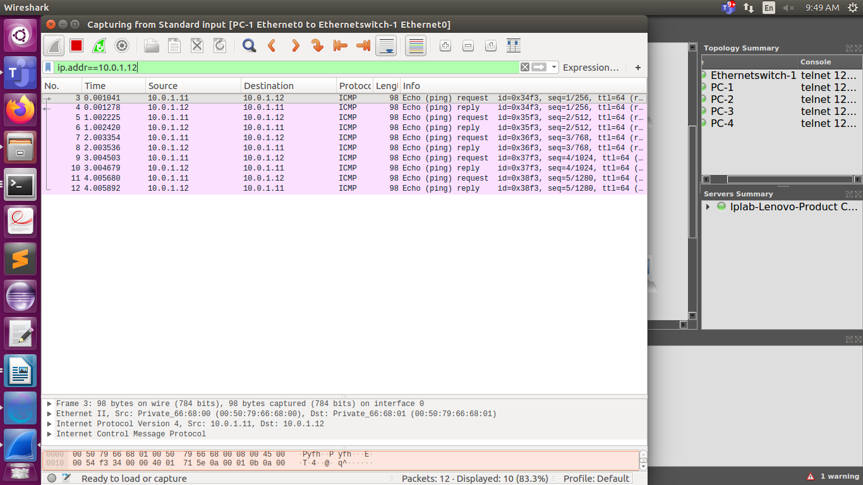

C)ARP ON PC1 AFTER THE PING TO PC2
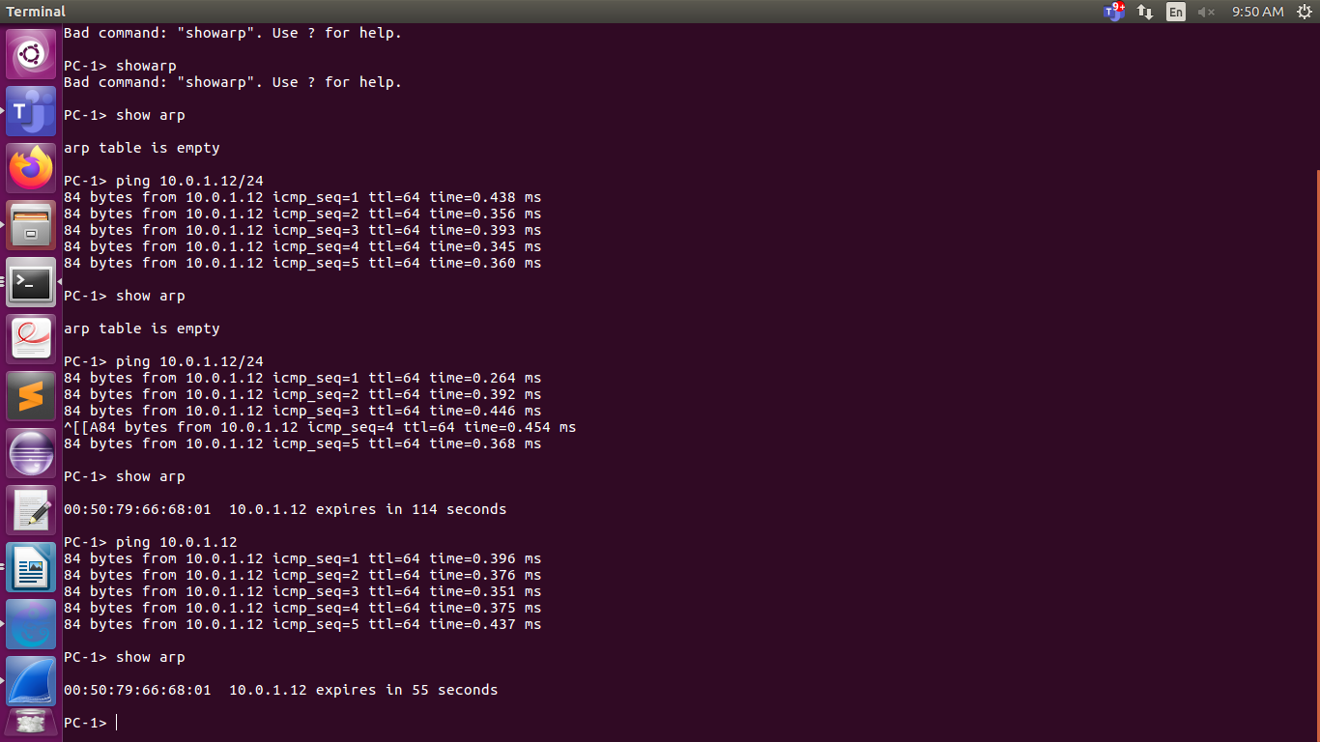

Q4.2)
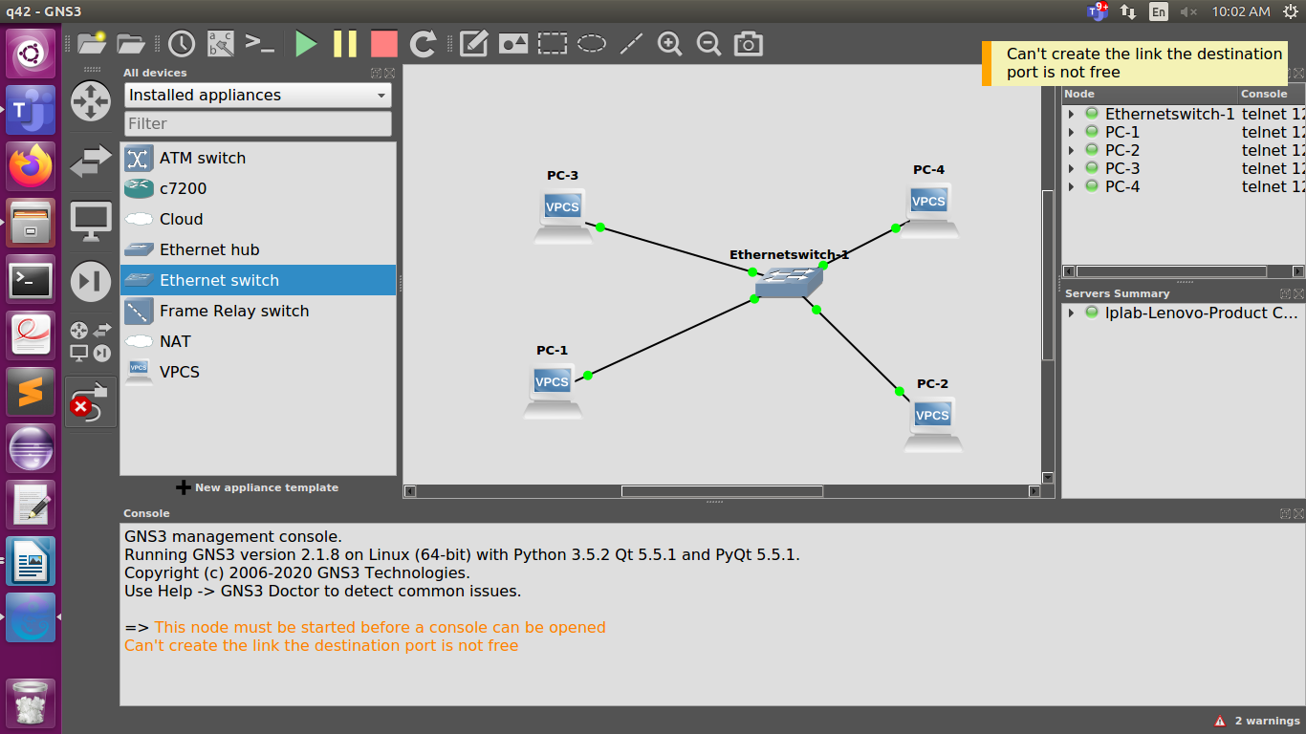

i. From PC1 ping PC3.
Ping was successful
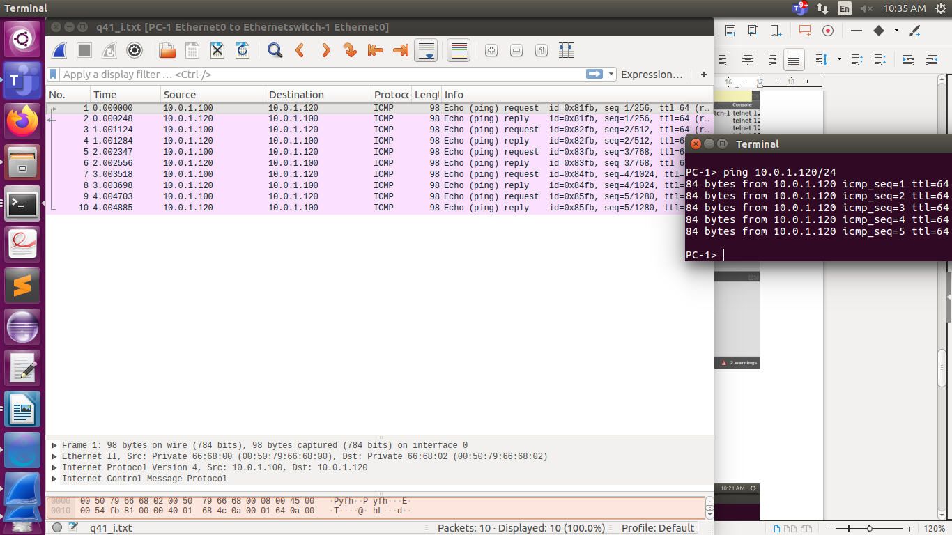

ii. From PC1 pingPC2.
Ping was successful
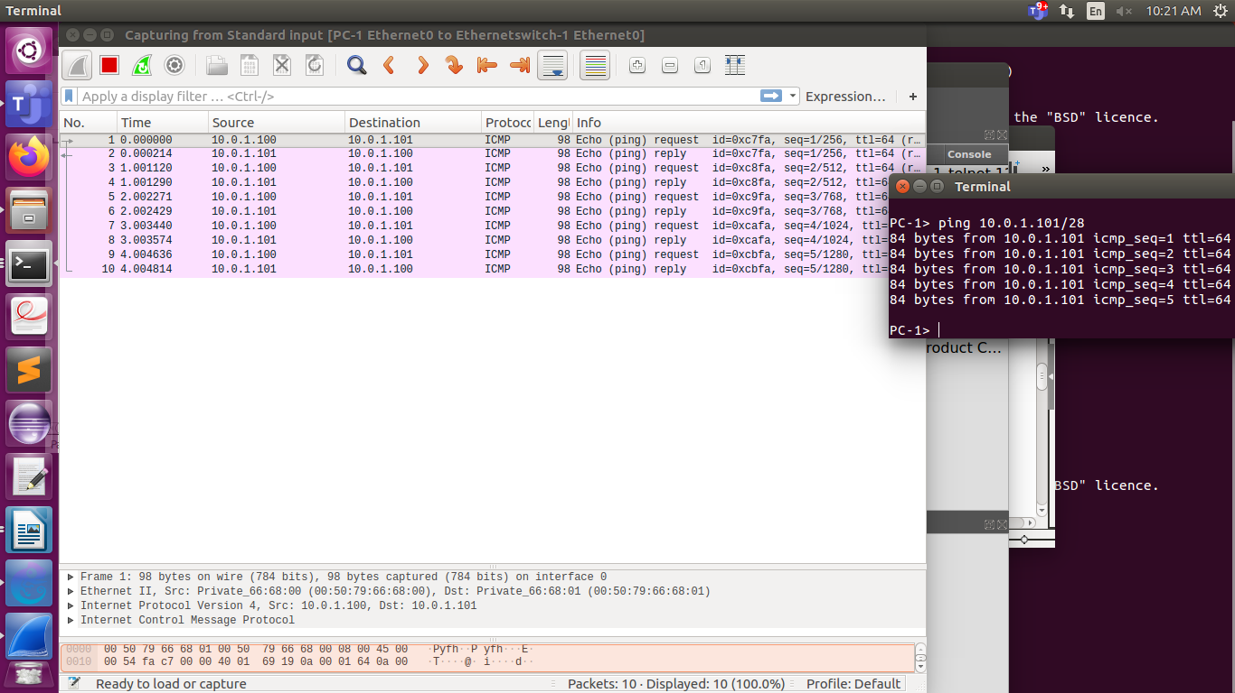
iii. From PC1 pingPC4.
The pings was not successful
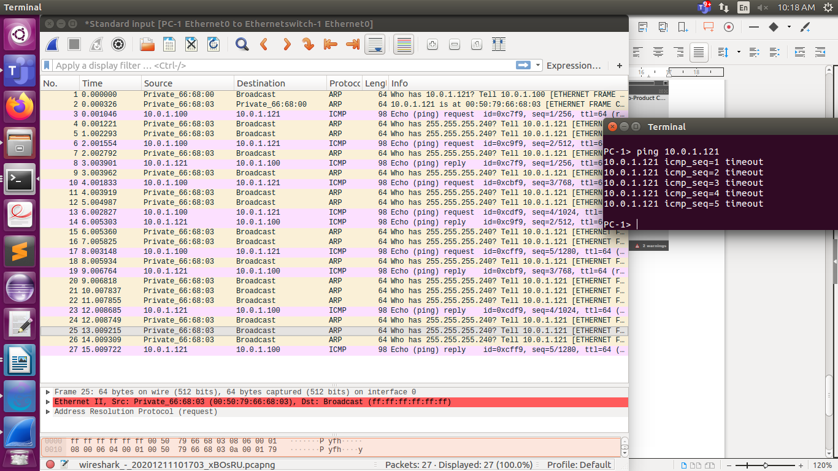

iv. From PC4 pingPC1.
Shows error message.
host (255.255.255.240) not reachable
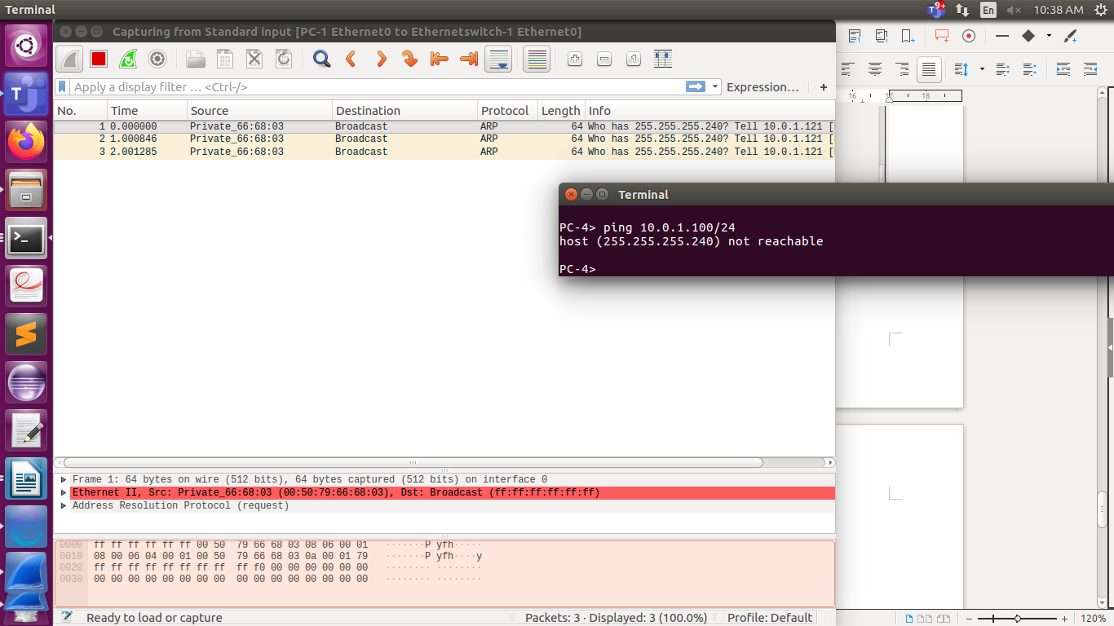
v. From PC2 ping PC4.
host (255.255.255.240) not reachable
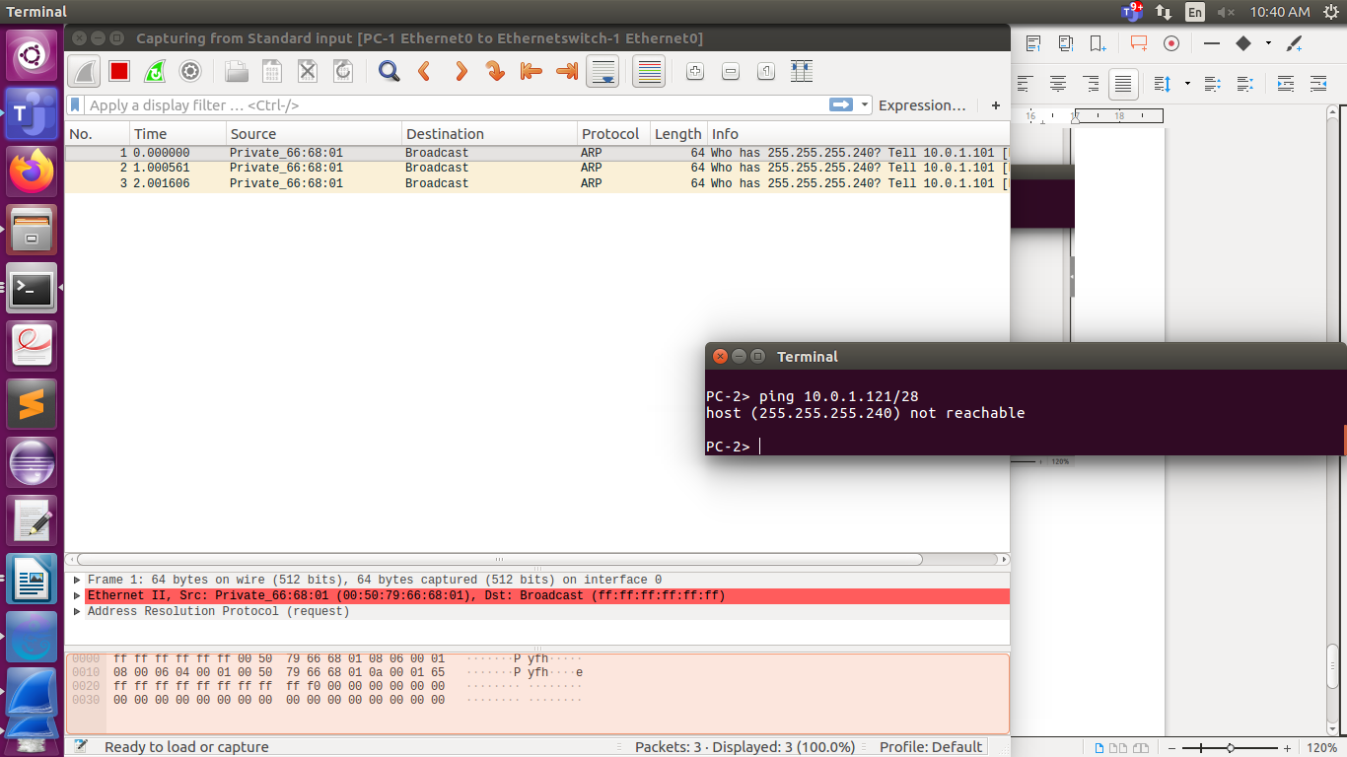

vi. From PC2 ping PC3.
host (255.255.255.240) not reachable
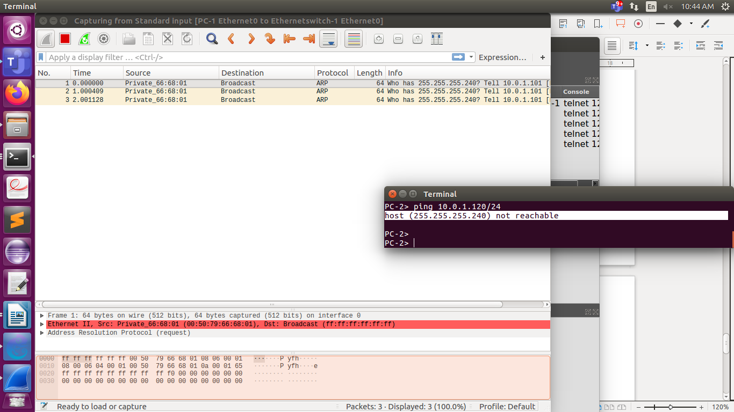

Q4.6)
NETWORK CONFIGURATION:
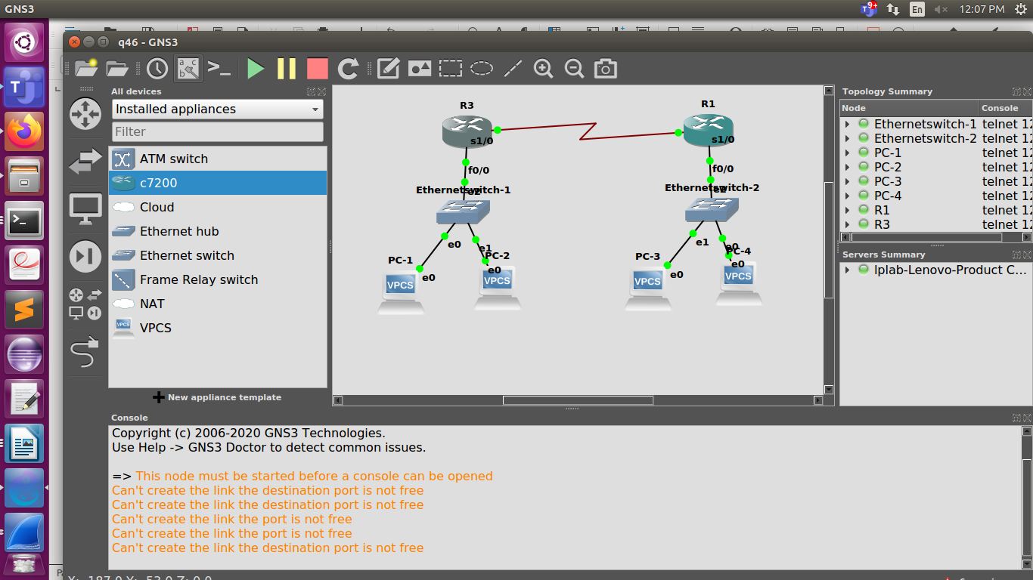
a)ping from pc2 on router 3 to pc 3 on router 1.
ping success full.
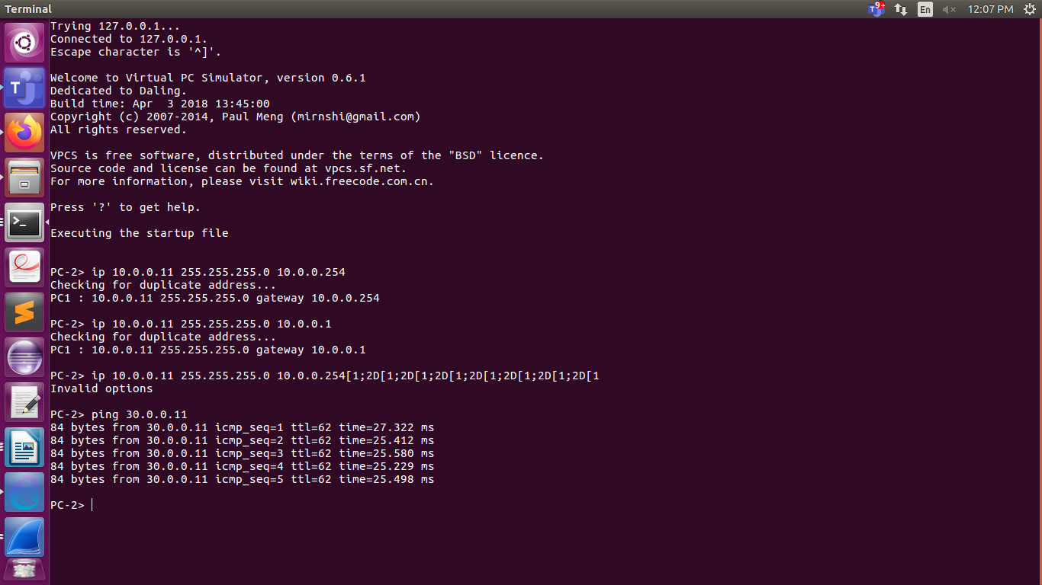
Ping from pc4 on router1 to pc1 on router 3
ping successfull
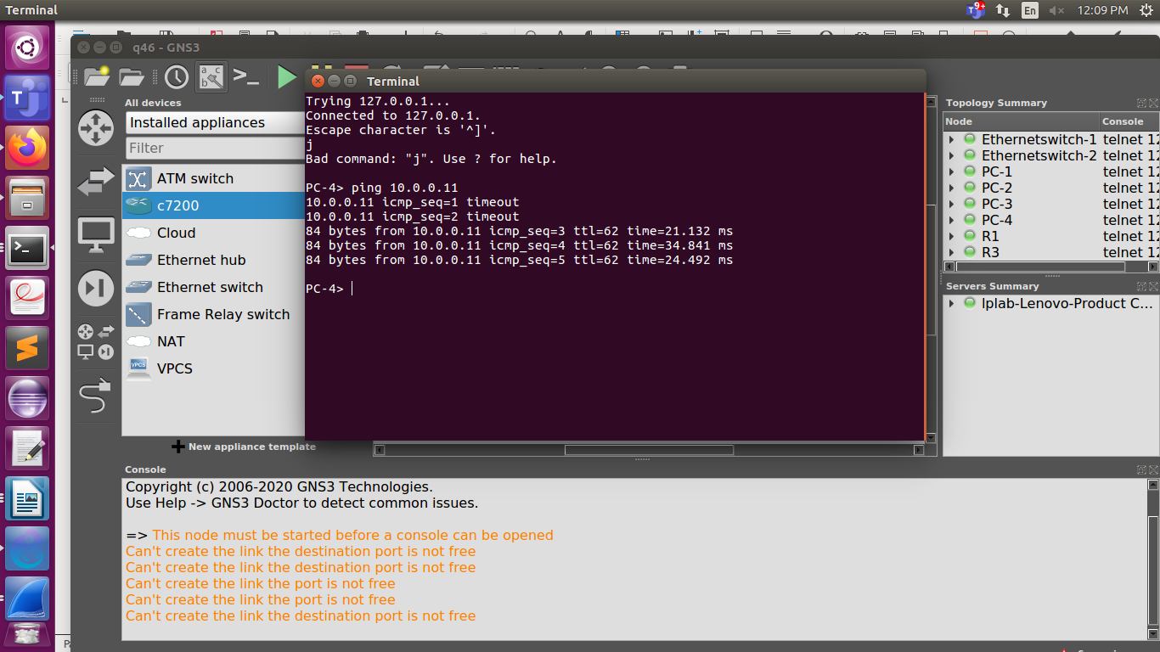
b)show arp for both cases


