HRITIK BANSAL, 180905105, CSE A, B1

LAB7:
Q1)
#include <stdio.h>
#include <stdlib.h>
#include <ctype.h>
#include <string.h>
#include "lex.c"
void program();
void declarations();
void dataType();
void idList();
void idListprime();
void assignStat();
void statPrime();

struct token tkn;
FILE *f1;
int main()
{
f1=preproccess("Input.c");
if(f1==NULL)
{
printf("Error! File cannot be opened!\n");
return 0;
}

while((tkn=getNextToken(f1)).row!=-1)
{
if(strcmp(tkn.lexeme,"main")==0)
{
program();
break;
}
}
fclose(f1);
}
void program()
{

if(strcmp(tkn.lexeme,"main")==0)
{
tkn=getNextToken(f1);
if(strcmp(tkn.lexeme,"(")==0)
{
tkn=getNextToken(f1);
if(strcmp(tkn.lexeme,")")==0)
{
tkn=getNextToken(f1);
if(strcmp(tkn.lexeme,"{")==0)
{
tkn=getNextToken(f1);
declarations();
assignStat();
if(strcmp(tkn.lexeme,"}")==0)
{
printf("Compiled successfully\n");
return;
}
else
{
printf("} missing at row=%d col=%d\n",tkn.row,tkn.col);
exit(1);
}
}
else
{
printf("{ missing at row=%d col=%d\n",tkn.row,tkn.col);
exit(1);
}
}
else
{
printf(") missing at row=%d col=%d\n",tkn.row,tkn.col);
exit(1);
}
}
else
{
printf("( missing at row=%d col=%d\n",tkn.row,tkn.col);
exit(1);
}
}
}
void declarations()
{
if(isdtype(tkn.lexeme)==0)
{
return;
}
dataType();
idList();
if(strcmp(tkn.lexeme,";")==0)
{
tkn=getNextToken(f1);
declarations();
}
else
{
printf("; missing at row=%d col=%d\n",tkn.row,tkn.col);
exit(1);
}
}
void dataType()
{
if(strcmp(tkn.lexeme,"int")==0)
{
tkn=getNextToken(f1);
return;
}
else if(strcmp(tkn.lexeme,"char")==0)
{
tkn=getNextToken(f1);
return;
}
else
{
printf("%s Missing dataType at row=%d col=%d\n",tkn.lexeme, tkn.row,tkn.col);
exit(1);
}
}
void idList()
{
if(strcmp(tkn.type,"IDENTIFIER")==0)
{
tkn=getNextToken(f1);
idListprime();
}
else
{
printf("Missing IDENTIFIER at row=%d col=%d\n",tkn.row,tkn.col);
}
}
void idListprime()
{
if(strcmp(tkn.lexeme,",")==0)
{
tkn=getNextToken(f1);
idList();
}
else
{
return;
}
}
void assignStat()
{
if(strcmp(tkn.type,"IDENTIFIER")==0)
{
tkn=getNextToken(f1);
if(strcmp(tkn.lexeme,"=")==0)
{
tkn=getNextToken(f1);
statPrime();
}
else
{
printf("= missing at row=%d col=%d\n",tkn.row,tkn.col);
exit(1);
}
}
else
{
return;
}}
void statPrime()
{
if(strcmp(tkn.type,"IDENTIFIER")==0)
{
tkn=getNextToken(f1);
if(strcmp(tkn.lexeme,";")==0)
{
tkn=getNextToken(f1);
return;
}
else
{
printf("; missing at row=%d col=%d\n",tkn.row,tkn.col);
exit(1);
}
}
else if(strcmp(tkn.type,"NUMBER")==0)
{
tkn=getNextToken(f1);
if(strcmp(tkn.lexeme,";")==0)
{
tkn=getNextToken(f1);
return;
}
else
{
printf("= missing at row=%d col=%d\n",tkn.row,tkn.col);
exit(1);
}
}
}

input: without error
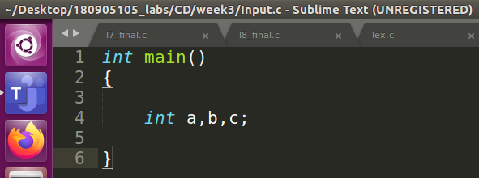

output:
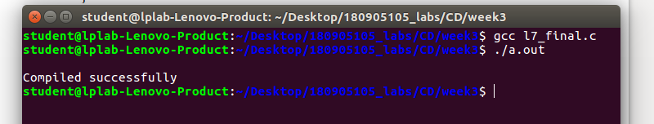

input:with error, } missing at end:
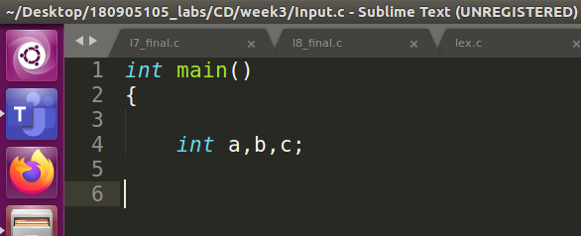

output:
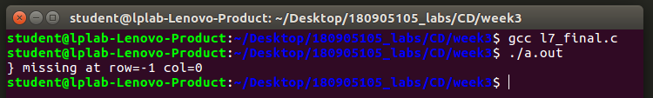

LAB8:
#include <stdio.h>
#include <stdlib.h>
#include <ctype.h>
#include <string.h>
#include "lex.c"
void program();
void declarations();
void datatype();
void idList();
void idListprime();
void assignstat();
void statementlist();
void statement();
void expn();
void eprime();
void simpleexp();
void seprime();
void term();
void tprime();
void factor();
void relop();
void addop();
void mulop();
struct token tkn;
FILE *f1;
char *rel[]={"==","!=","<=",">=",">","<"};
char *add[]={"+","-"};
char *mul[]={"*","/","%"};

int main()
{
f1=preproccess("Input.c");
if(f1==NULL)
{
printf("Error! File cannot be opened!\n");
return 0;
}

while((tkn=getNextToken(f1)).row!=-1)
{
if(strcmp(tkn.lexeme,"main")==0)
{
program();
break;
}
}
fclose(f1);
}

int isrel(char *w)
{
int i;
for(i=0;i<sizeof(rel)/sizeof(char*);i++)
{
if(strcmp(w,rel[i])==0)
{
return 1;
}
}
return 0;
}
int isadd(char *w)
{
int i;
for(i=0;i<sizeof(add)/sizeof(char*);i++)
{
if(strcmp(w,add[i])==0)
{
return 1;
}
}
return 0;
}
int ismul(char *w)
{
int i;
for(i=0;i<sizeof(mul)/sizeof(char*);i++)
{
if(strcmp(w,mul[i])==0)
{
return 1;
}
}
return 0;
}

void program()
{

if(strcmp(tkn.lexeme,"main")==0)
{
tkn=getNextToken(f1);
if(strcmp(tkn.lexeme,"(")==0)
{
tkn=getNextToken(f1);
if(strcmp(tkn.lexeme,")")==0)
{
tkn=getNextToken(f1);
if(strcmp(tkn.lexeme,"{")==0)
{
tkn=getNextToken(f1);
declarations();
statementlist();
if(strcmp(tkn.lexeme,"}")==0)
{
printf("\nCompiled successfully\n");
return;
}
else
{
printf("} missing at row=%d col=%d",tkn.row,tkn.col);
exit(1);
}
}
else
{
printf("{ missing at row=%d col=%d",tkn.row,tkn.col);
exit(1);
}
}
else
{
printf(") missing at row=%d col=%d",tkn.row,tkn.col);
exit(1);
}
}
else
{
printf("( missing at row=%d col=%d",tkn.row,tkn.col);
exit(1);
}
}
}
void declarations()
{
if(isdtype(tkn.lexeme)==0)
{
return;
}
datatype();
idList();
if(strcmp(tkn.lexeme,";")==0)
{
tkn=getNextToken(f1);
declarations();
}
else
{
printf("; missing at row=%d col=%d",tkn.row,tkn.col);
exit(1);
}
}
void datatype()
{
if(strcmp(tkn.lexeme,"int")==0)
{
tkn=getNextToken(f1);
return;
}
else if(strcmp(tkn.lexeme,"char")==0)
{
tkn=getNextToken(f1);
return;
}
else
{
printf("%s Missing datatype at row=%d col=%d",tkn.lexeme, tkn.row,tkn.col);
exit(1);
}
}
void idList()
{
if(strcmp(tkn.type,"IDENTIFIER")==0)
{
tkn=getNextToken(f1);
idListprime();
}
else
{
printf("Missing IDENTIFIER at row=%d col=%d",tkn.row,tkn.col);
}
}
void idListprime()
{
if(strcmp(tkn.lexeme,",")==0)
{
tkn=getNextToken(f1);
idList();
}
if(strcmp(tkn.lexeme,"[")==0)
{
tkn=getNextToken(f1);
if(strcmp(tkn.type,"NUMBER")==0)
{
tkn=getNextToken(f1);
if(strcmp(tkn.lexeme,"]")==0)
{
tkn=getNextToken(f1);
if(strcmp(tkn.lexeme,",")==0)
{
tkn=getNextToken(f1);
idList();
}
else
{
return;
}
}
}
}
else
{
return;
}
}
void statementlist()
{
if(strcmp(tkn.type,"IDENTIFIER")!=0)
{
return;
}
statement();
statementlist();
}
void statement()
{
assignstat();
if(strcmp(tkn.lexeme,";")==0)
{
tkn=getNextToken(f1);
return;
}
else
{
printf("; missing at row=%d col=%d",tkn.row,tkn.col);
exit(1);
}
}
void assignstat()
{
if(strcmp(tkn.type,"IDENTIFIER")==0)
{
tkn=getNextToken(f1);
if(strcmp(tkn.lexeme,"=")==0)
{
tkn=getNextToken(f1);
expn();
}
else
{
printf("= missing at row=%d col=%d",tkn.row,tkn.col);
exit(1);
}
}
else
{
printf("Missing IDENTIFIER at row=%d col=%d",tkn.row,tkn.col);
exit(1);
}
}
void expn()
{
simpleexp();
eprime();
}
void eprime()
{
if(isrel(tkn.lexeme)==0)
{
return;
}
relop();
simpleexp();
}
void simpleexp()
{
term();
seprime();
}
void seprime()
{
if(isadd(tkn.lexeme)==0)
{
return;
}
addop();
term();
seprime();
}
void term()
{
factor();
tprime();
}
void tprime()
{
if(ismul(tkn.lexeme)==0)
{
return;
}
mulop();
factor();
tprime();
}
void factor()
{
if(strcmp(tkn.type,"IDENTIFIER")==0)
{
tkn=getNextToken(f1);
return;
}
else if(strcmp(tkn.type,"NUMBER")==0)
{
tkn=getNextToken(f1);
return;
}
}
void relop()
{
if(strcmp(tkn.lexeme,"==")==0)
{
tkn=getNextToken(f1);
return;
}
if(strcmp(tkn.lexeme,"!=")==0)
{
tkn=getNextToken(f1);
return;
}
if(strcmp(tkn.lexeme,"<=")==0)
{
tkn=getNextToken(f1);
return;
}
if(strcmp(tkn.lexeme,">=")==0)
{
tkn=getNextToken(f1);
return;
}
if(strcmp(tkn.lexeme,"<")==0)
{
tkn=getNextToken(f1);
return;
}
if(strcmp(tkn.lexeme,">")==0)
{
tkn=getNextToken(f1);
return;
}
}
void addop()
{
if(strcmp(tkn.lexeme,"+")==0)
{
tkn=getNextToken(f1);
return;
}
if(strcmp(tkn.lexeme,"-")==0)
{
tkn=getNextToken(f1);
return;
}
}
void mulop()
{
if(strcmp(tkn.lexeme,"*")==0)
{
tkn=getNextToken(f1);
return;
}
if(strcmp(tkn.lexeme,"/")==0)
{
tkn=getNextToken(f1);
return;
}
if(strcmp(tkn.lexeme,"*")==0)
{
tkn=getNextToken(f1);
return;
}
}

INPUT: without error
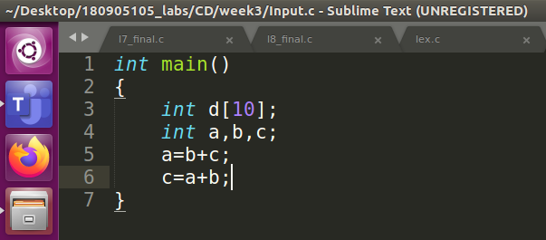

output:
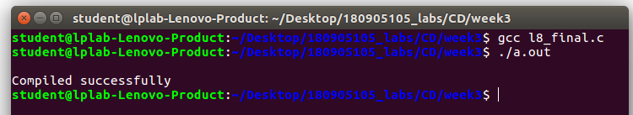

INPUT: with error, ( missing
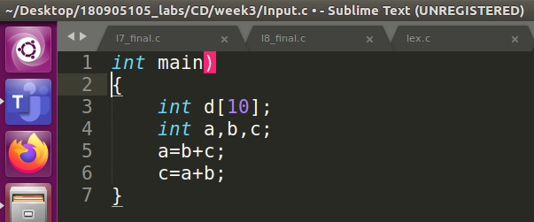

output:
